Access To HE Diploma – Trigonometry Answer Sheet
TRIGONOMETRY TASK TEMPLATES – Task 4
Student Name | Tarek Ahmed Umar
Student Number | 20545242
Unit Title | Trigonometry
Unit Code | WNI488
Assignment Title | Trigonometry
Submission Date | 13th February 2026

NB. Please use this answer sheet to submit your work for the Trigonometry assignment – task 4. You can write your solutions to task 4 questions here or copy and paste the photographic evidence of your task 4 solutions here, thanks.
Learning Outcome 4: Know how to use trigonometric identities | Assessment Criteria  4.1, 4.2
Task 4: Trigonometric Identities

Simplify expressions for object movement, lighting or rotations using identities such as:
- ${sin⁡}^{2}x+{cos⁡}^{2}x=1$
- and $tan⁡x=\frac{\sin{x}}{\cos{x}}$.

Use the identity ${sin⁡}^{2}θ+{cos⁡}^{2}θ=1$to simplify trigonometric expressions
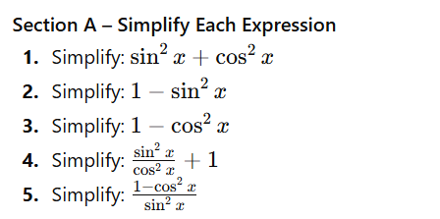

1.
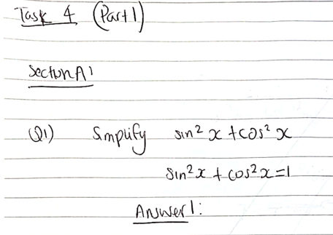
2.
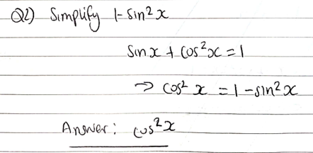
3.
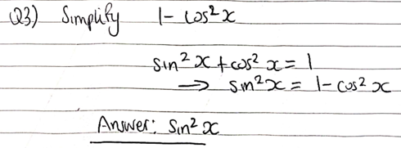
4.
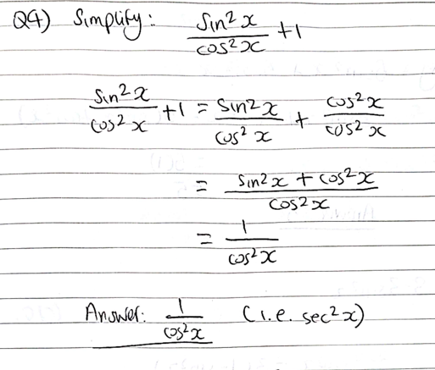
5.
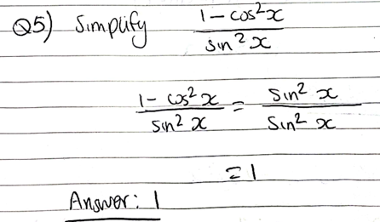

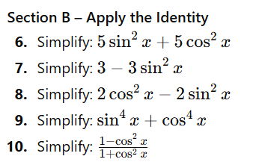
6.
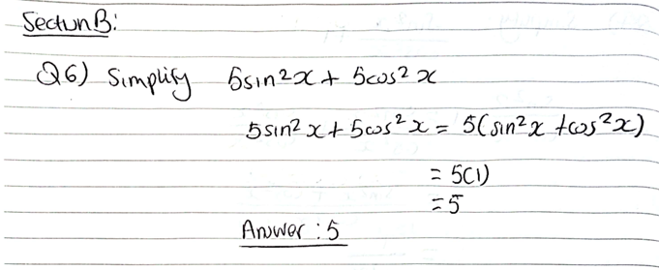
7.
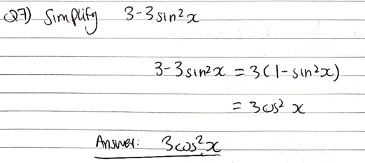

8.
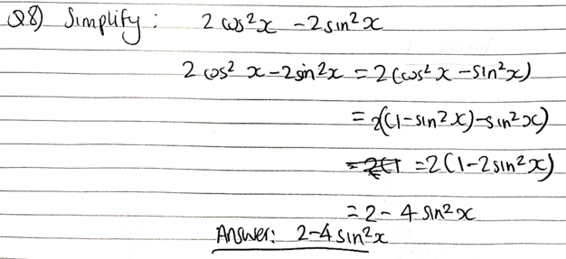

9.
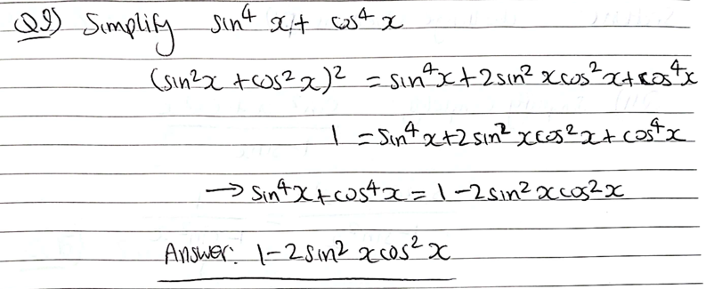

10.
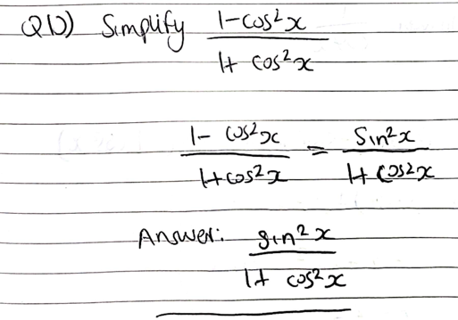
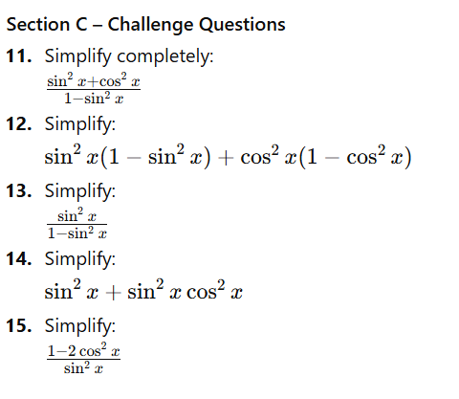

11.
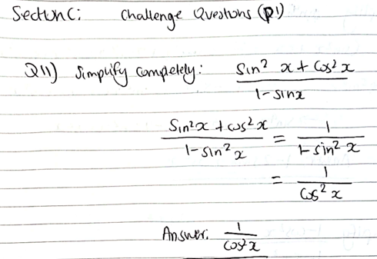

12.
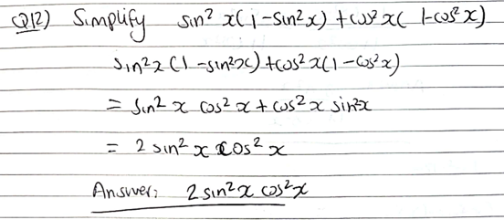

13.
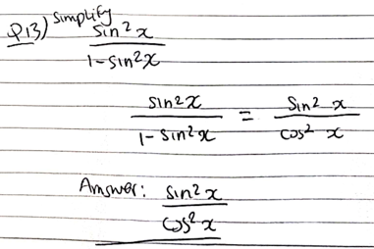
14.
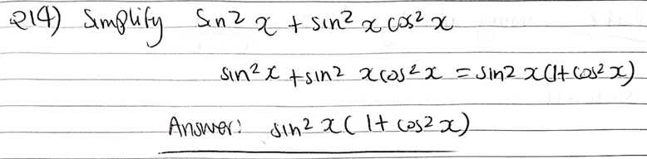
15.
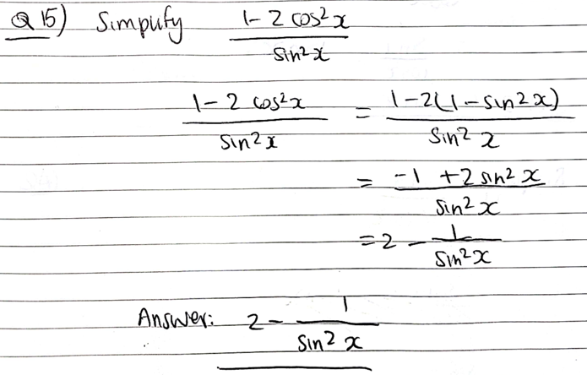

Use the identity $tan⁡(x)=\frac{sin⁡(x)}{cos⁡(x)}$to simplify trigonometric expressions

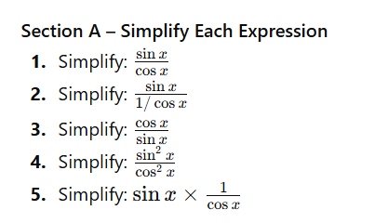
1.
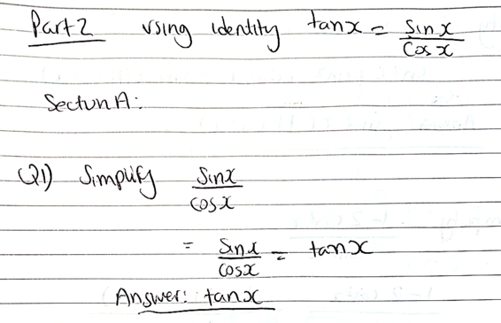
2.
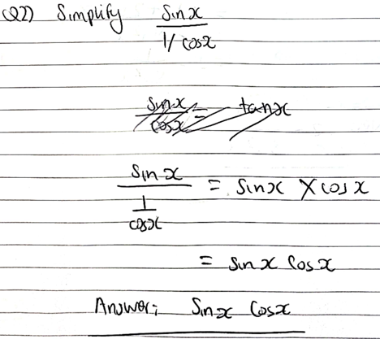
3.
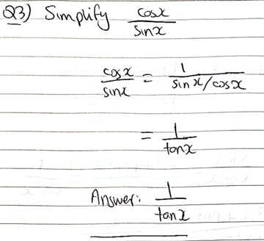

4.
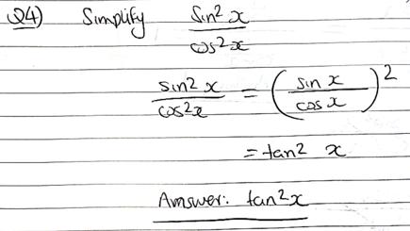

5.
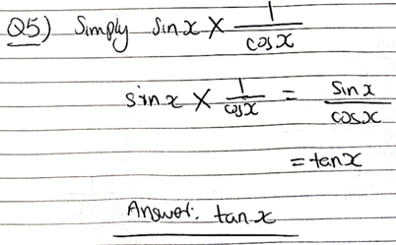

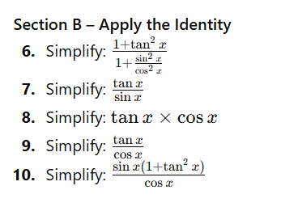
6.
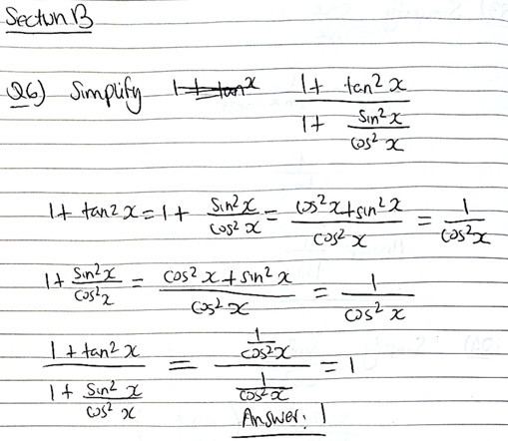

7.
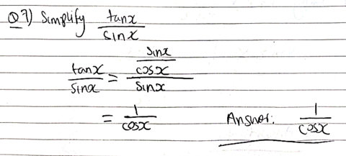

8.
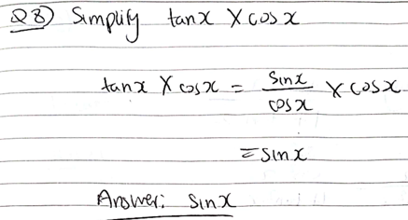

9.
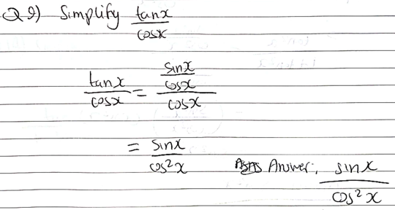

10.
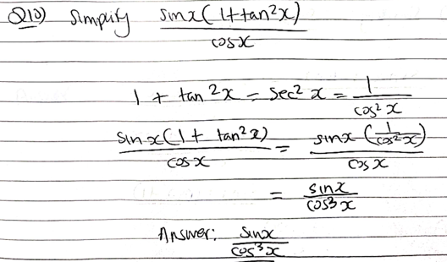

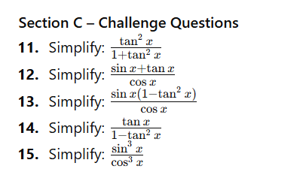

11.
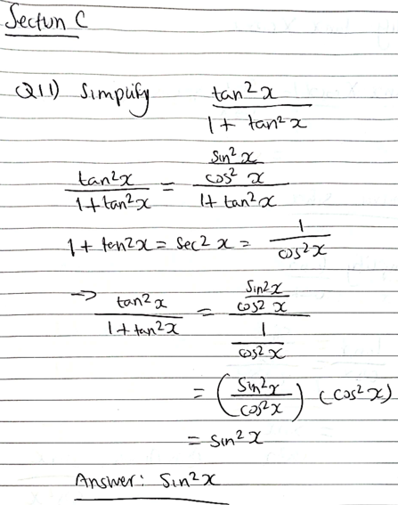

12.
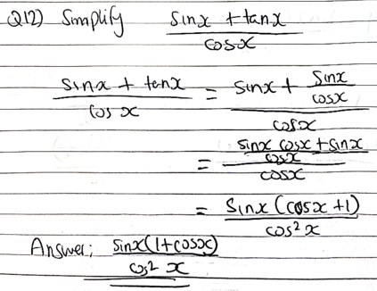

13.
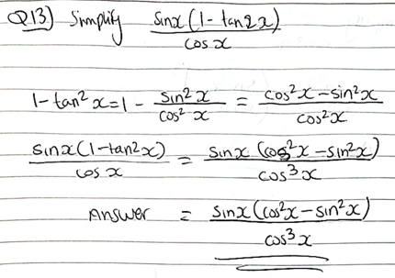

14.
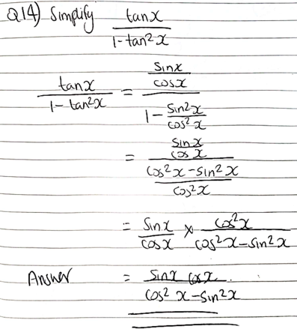

15.
