Techniue1 to block inbound port

Windows firewall open
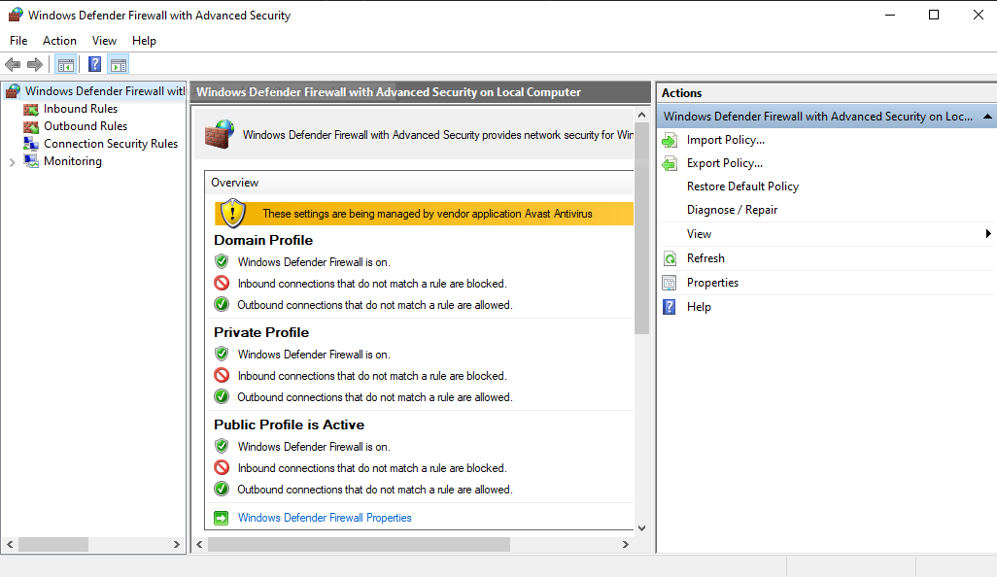
Creatog new inbound rule to block port
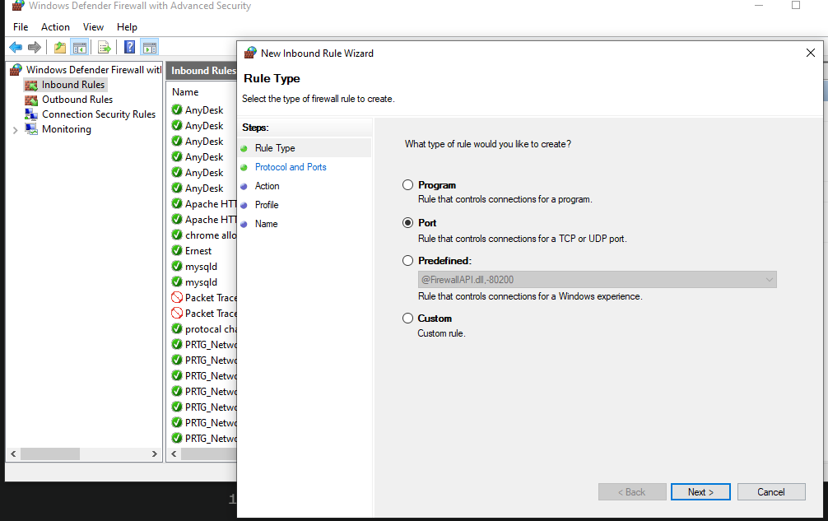

Blocking port 445
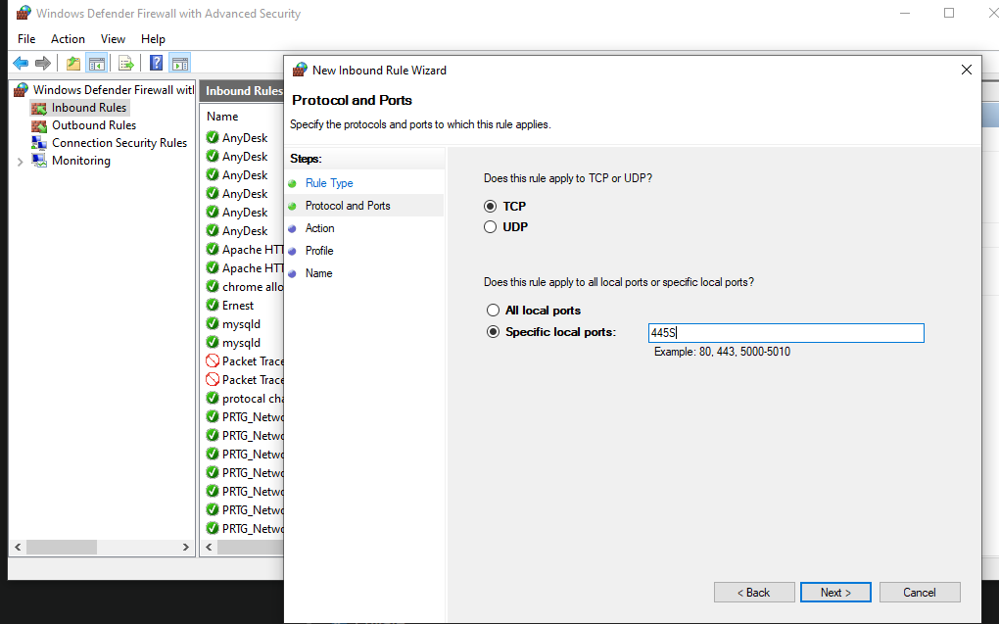
Blocking connection
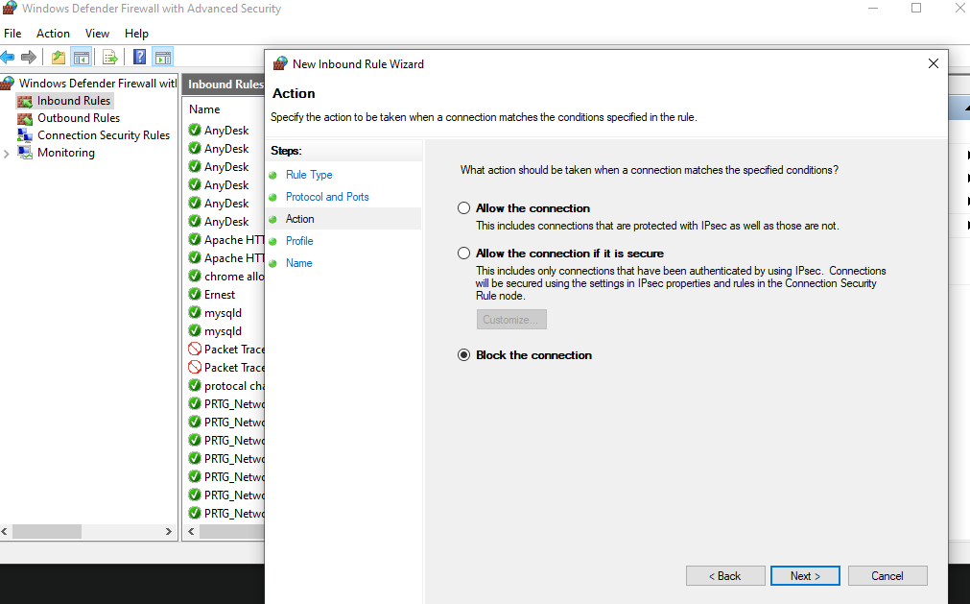

Blocking on all profiles
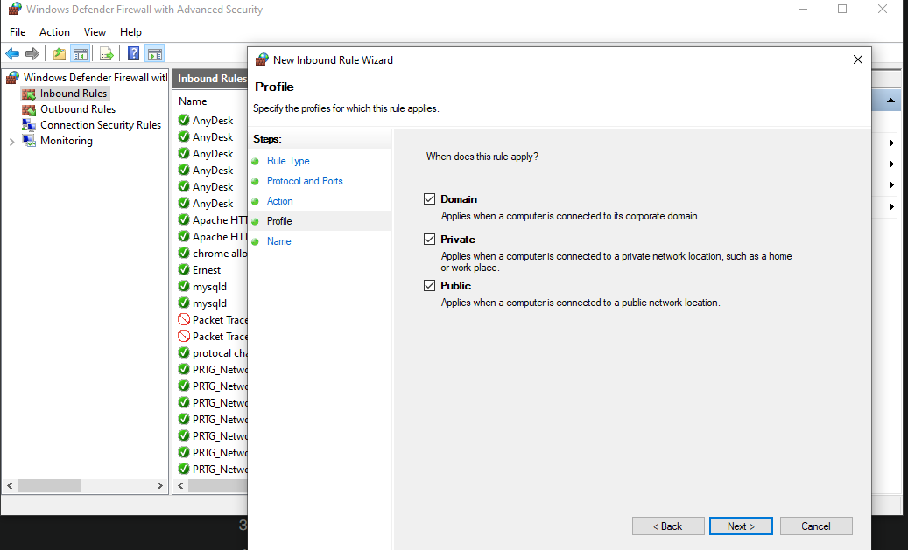

Title snad entails:
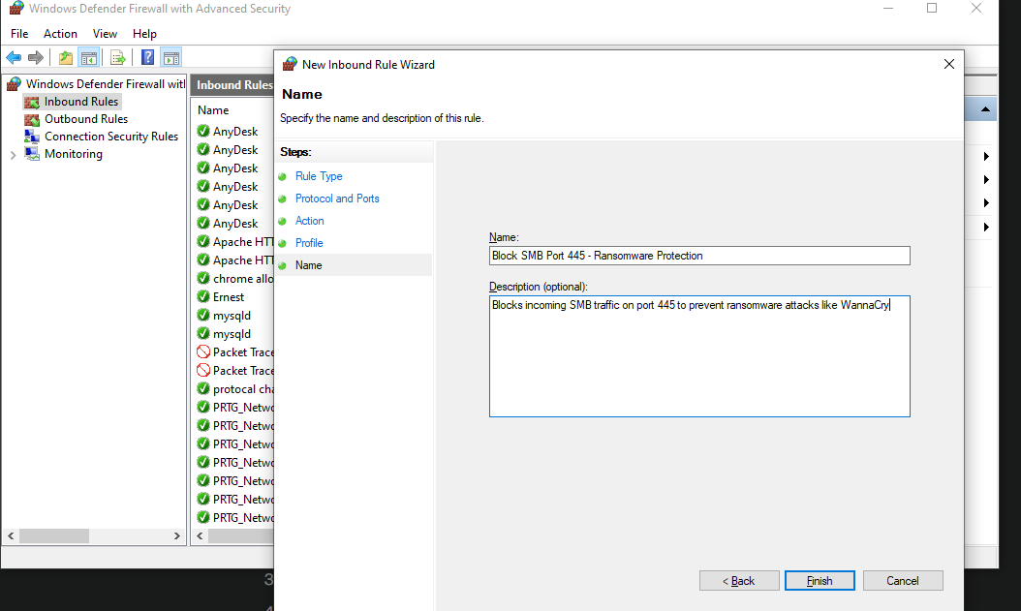

result ;
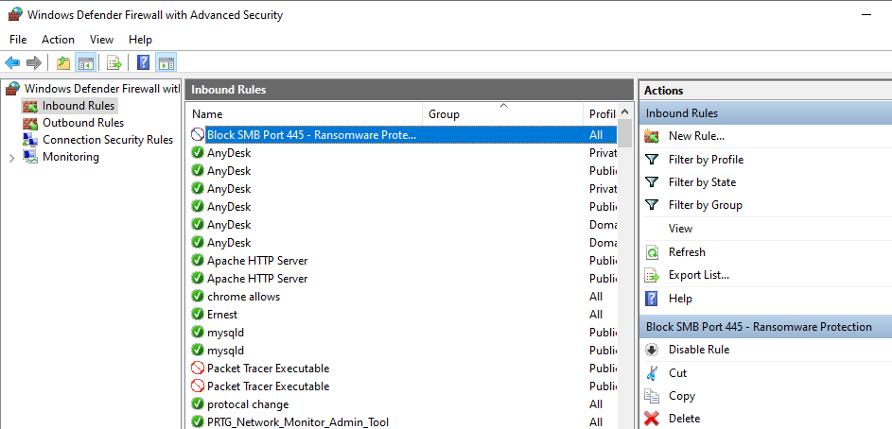
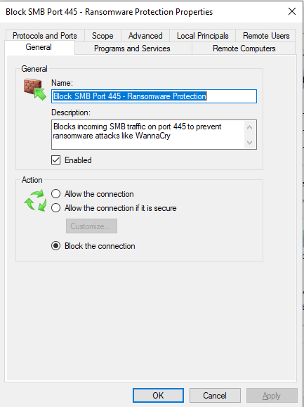

Windows Defender Firewall blocks unauthorized network traffic by filtering inbound/outbound connections. I blocked TCP port 445 (Server Message Block) which ransomware like WannaCry exploits to spread laterally across networks. By creating an inbound rule blocking this port on all profiles (Domain, Private, Public), external attackers cannot exploit SMB vulnerabilities to access file shares or deploy ransomware. The red block icon confirms active protection, preventing connection attempts on this commonly targeted port.

TECHNIQUE 2: Multi-Factor Authentication (Microsoft Account)

Going to account.microsoft.com to add 2fa security options

2fa is setup;
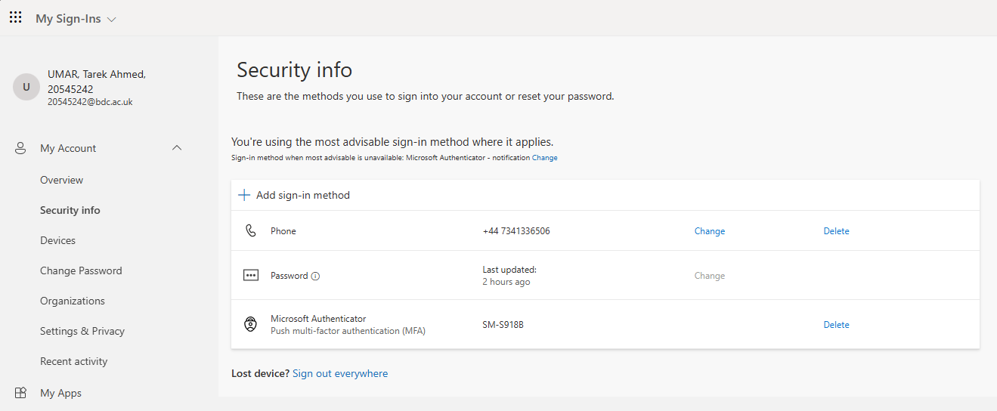
Multi-Factor Authentication prevents unauthorized access by requiring two verification factors: something you know (password) and something you have (phone). I enabled 2FA on my Microsoft account using Microsoft Authenticator, which generates time-based 6-digit codes refreshing every 30 seconds. Even if credentials are compromised through phishing or data breaches, attackers cannot access the account without physical possession of my authenticated device, mitigating 99.9% of automated credential-stuffing attacks

TECHNIQUE 3 : Windows File and Folder Permissions (Access Control)

Sensitive files in folder
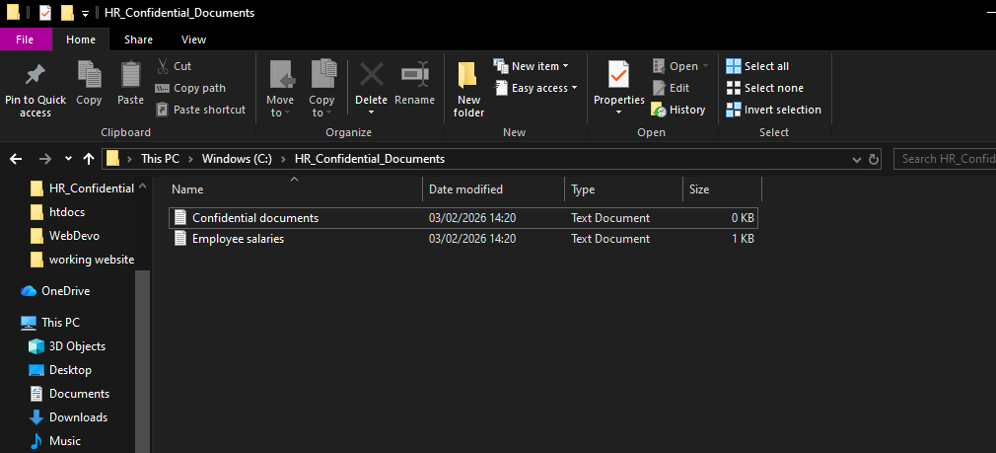
Cuirrently users have full acces;
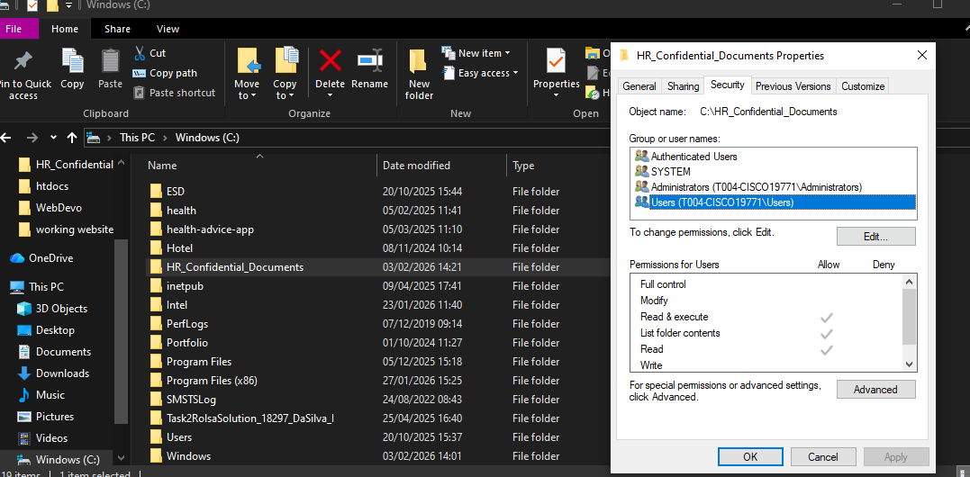
Users permisoons have been removed; 