Dsp-2
part-B
introduction:
In this part, we intend to observe the data for some activities like walking, running, jumping, and rotating using sensors like accelerometer, gyroscope, orientation, gravity etc. After observing the processed data from these sensors, we want to see how to classify these activities based on the data given and generalise it for different people.

Sensors used and activities taken for classification:
We have selected following activities for classification:
walking
running
jumping
rotating
Sensors from which we are taking the data are:
accelerometer, gyroscope, magnetic field sensor(compass), linear acceleration, orientation and gravity.

Method for collecting data:
All the sensors mentioned above are readily available in most android smart phones. To access the data obtained from these sensors, we have used an android app called AndroSensor.
Placement of phone: The phone is placed in the pocket preferrably not very loose one, so that the user can walk, run, etc naturally.
Format of data obtained: The app records the sensor data in a csv file which would be stored in the SD card of the mobile.
Sampling rate: 10 ms

Pre-processing:
The raw data given by the sensors will be in the form of X,Y,Z coordinates, for example the accelerometer gives the values for acceleration in X,Y and Z directions. To observe the patterns in the data for different activities we process this data to properly visualise the trends.
1) Magnitude: To simplify the data which is distributed over x,y and z coordinates for each sensor, we take the magnitude which is given by,
mag(a)=mag formula
2) FFT : To observe the various frequencies present in the sensor data we take and plot the Fast Fourier Transform (FFT) of the magnitude values for data of each sensor.
Tool used for plotting and visualise : Octave
Observations:
The trends observed by visualising the plots of the processed data from the sensors are:
1) Differences between walking and running:
i) The peaks in magnitude of accelerometer are more closely spaced while running than while walking (refer figure). For jumping, the peaks are a little more sparsely spaced than walking.

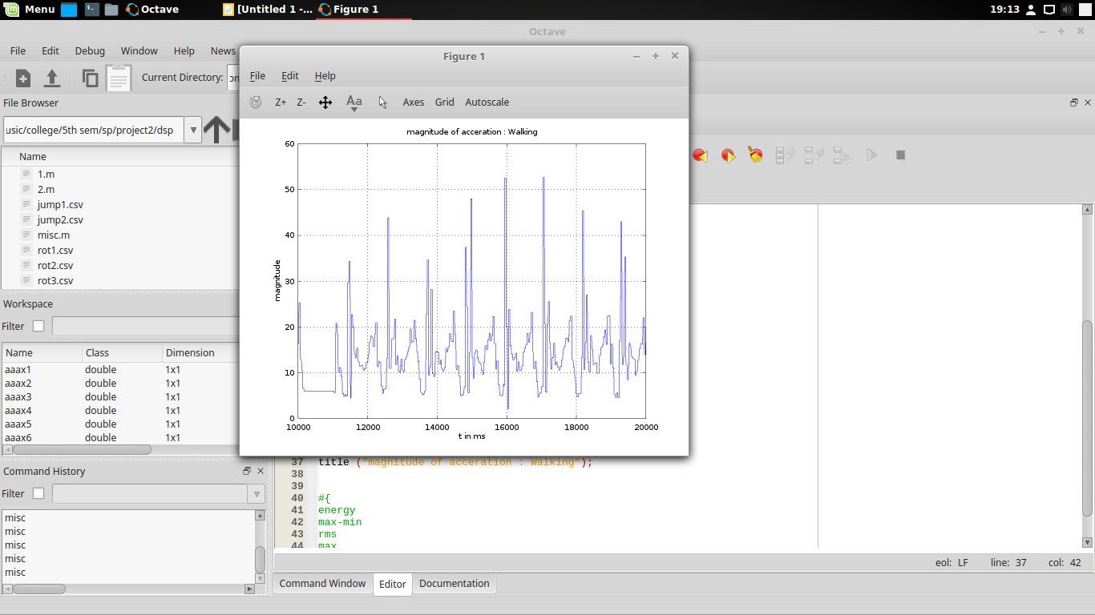

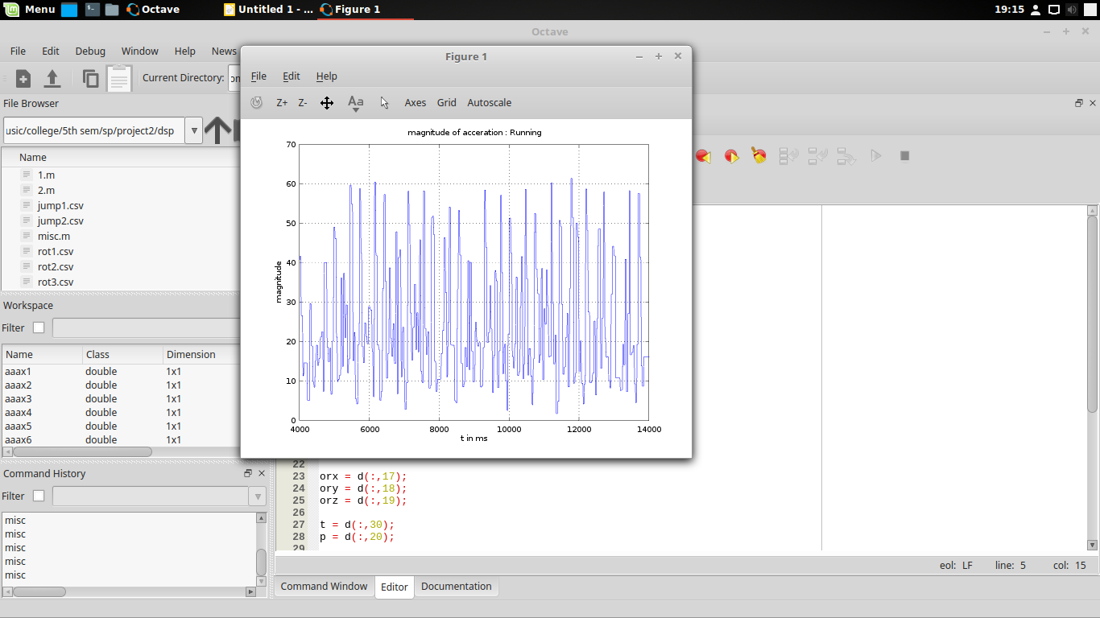

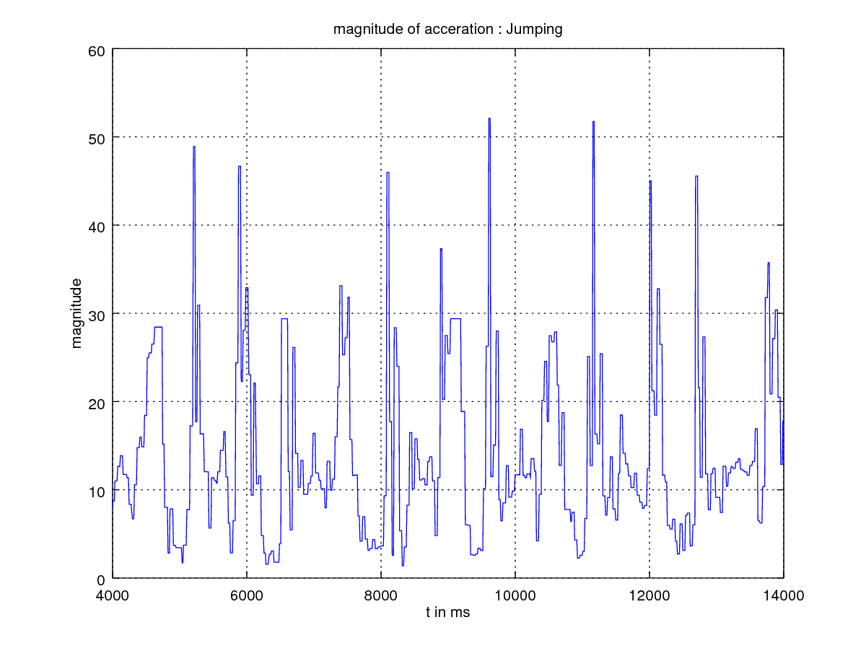

ii) Gyrometer variations have less amplitude while walking than in running.
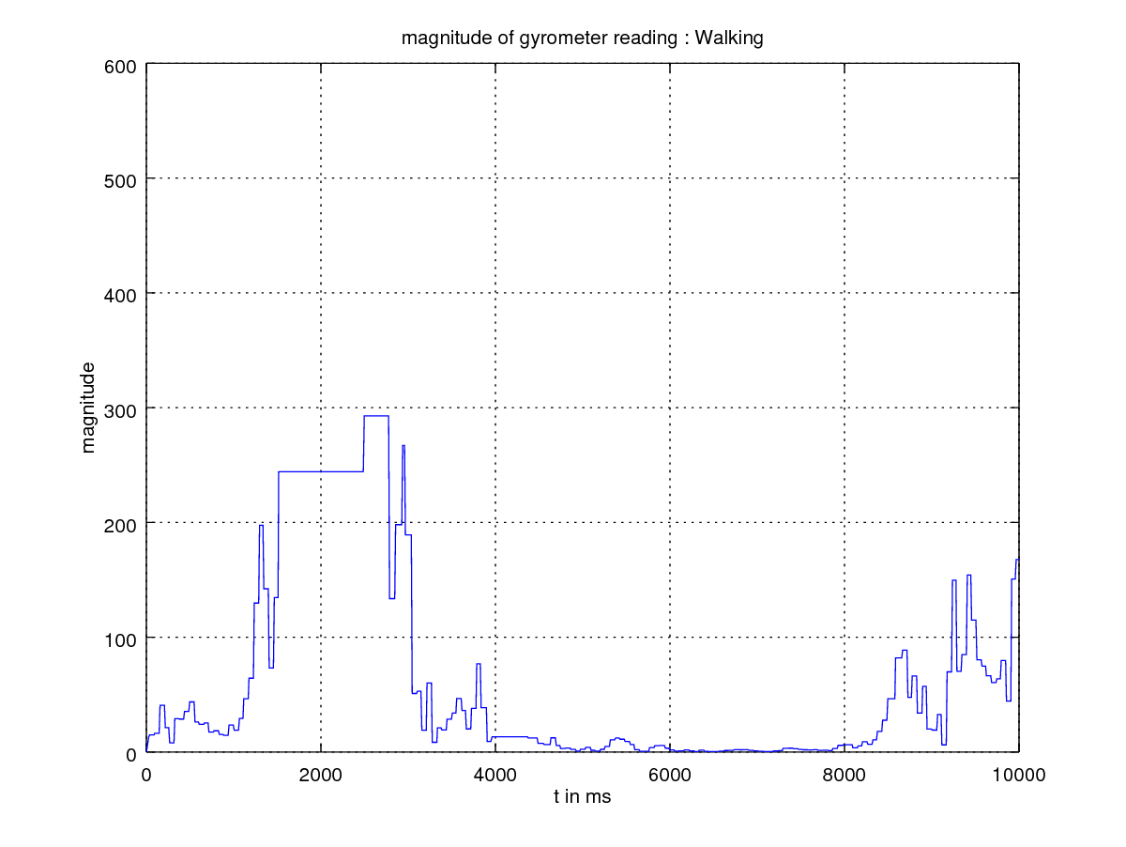
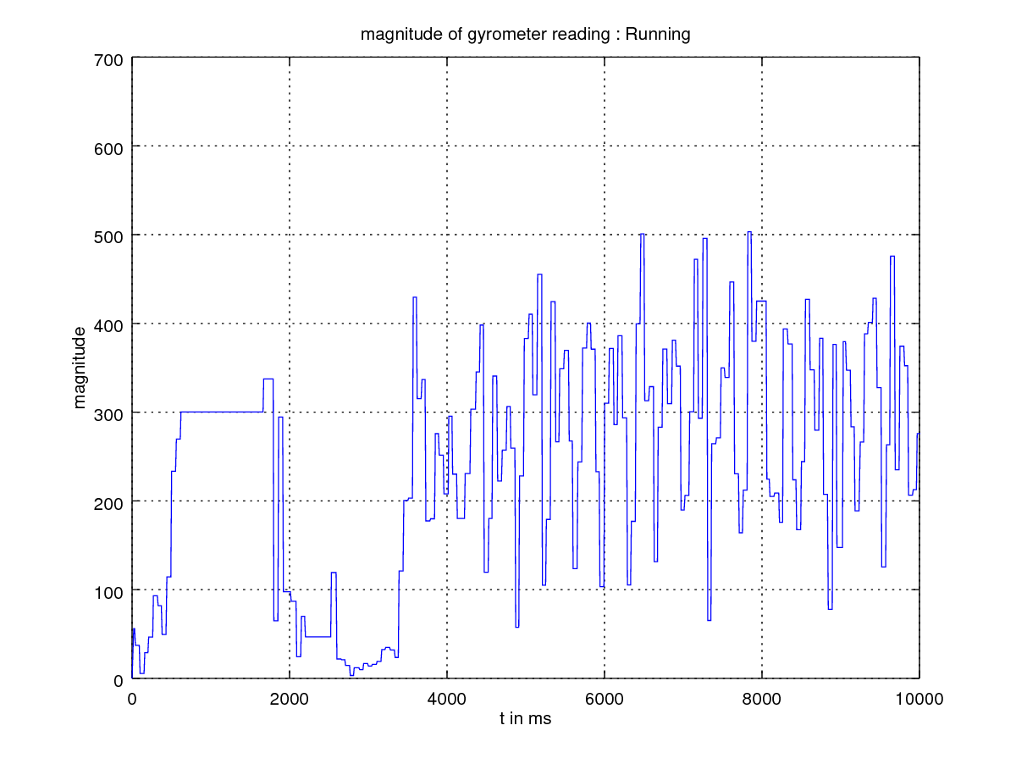

iii) The dominant peaks in magnitude of acceleration of walking occur at lesser frequencues than running.
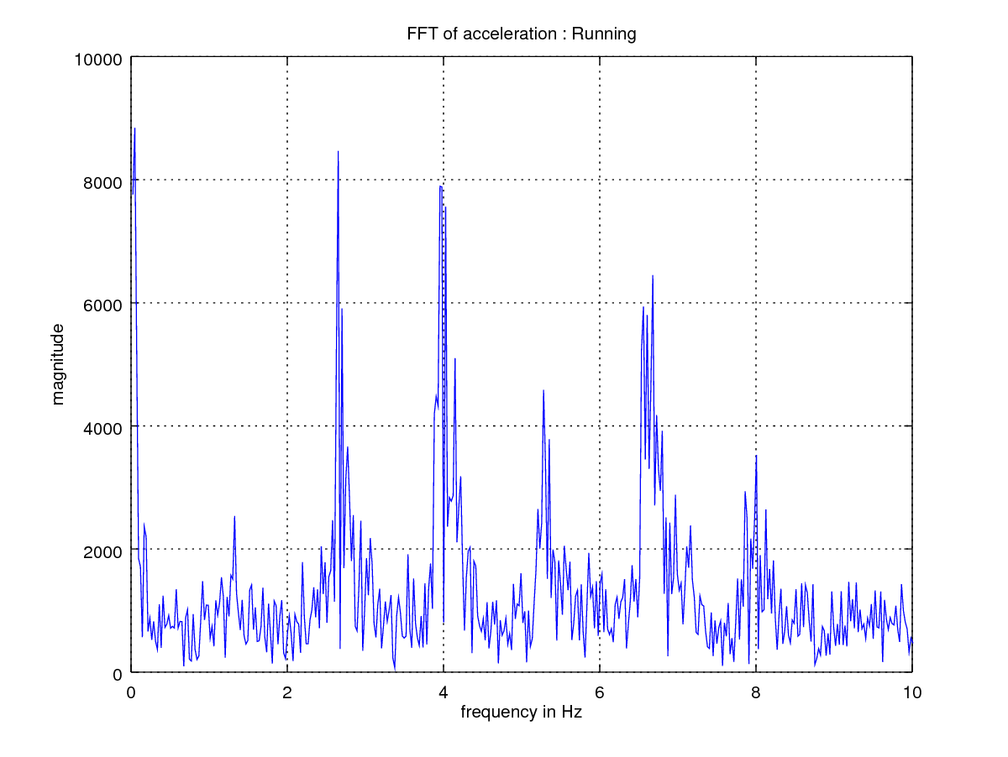

Training the classifier:
features used->
how is it trained ->

accuracy -> % and correlation matrix
Weights->
Conclusion:

