# Basic Electronics Lab

Lab 0, 2nd August 2018

Aravind Reddy V (IMT 2015 524)

Krishna Nagaraja (IMT 2015 512)

_____________________________________________________________________________________

### Gnuplot

Make sure to save as **rollnumber.PDF**

Some notes here. Optional. For example, the frequency and resistors used, and so on. Insert page breaks between each section. It’s in the Insert tab for Excel.

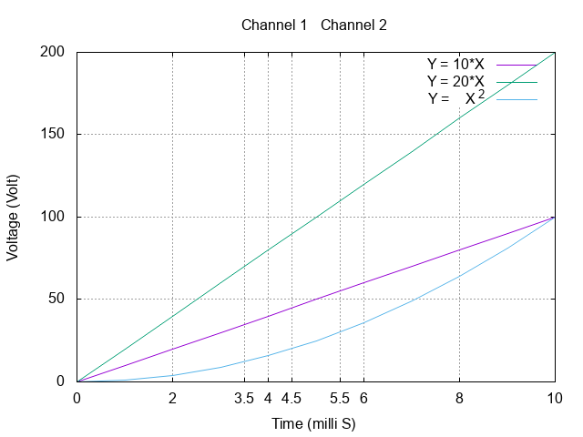

### IV Characteristics of Resistor

Resistor used: 1 Kilo Ohm

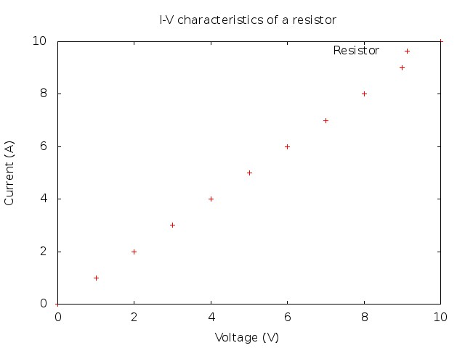

### Diodes: Full wave rectifier

This is a simulation experiment. You’ll be simulating circuits in Multisim soon. I think I stole the circuit from a lab pdf. Circuit is mandatory in simulation experiments, but it would be helpful to include it in other experiments, too!

Circuit:

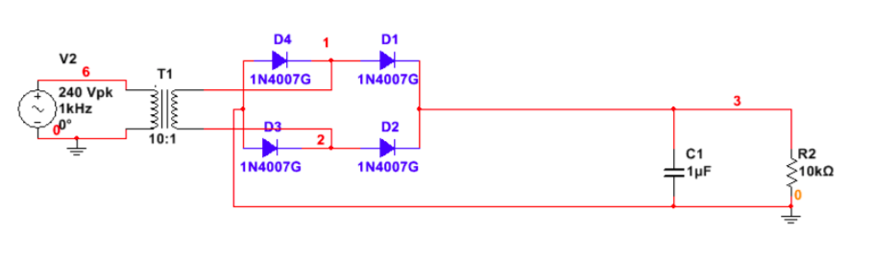

Graph:

