**COLLEGE MANAGEMENT SYSTEM**

**UNIVERSITY SCHOOL OF**

**INFORMATION AND COMMUNICATON TECHONOLGY**

**GGSIPU**

**SOFTWARE ENGINEERING PROJECT**

**INFORMATION TECHNOLOGY**

**PROJECT BY:**

1. **DEEPAK (14)**
2. **SARTHAK ROHILLA (52)**
3. **AKASH VERMA (53)**

College Management System

**Objective**

Main aim in developing college management system is to provide an easy way not only to automate all functionalities of a college, but also to provide full functional reports to top management of college with the finest of details about any aspect of college. It is a bridge between the college and students.

**Motivation behind College Management System Project**

Time is precious for all students and the students will not have to face any difficulty if the staff members can track all the problems related to their students, So that they can solve student’s problems on time and without wasting time. Idea is to reduce paper work and enhance efficiency. In case of manual system they need a lot of time, manpower.

## ****Project Statement****

 As most of the work is done manually or it is based on paper work such as class attendance, notes, asking for documents etc. These all processes take time. If we include all the work which will be based on online system, then it can reduce time and work. Under this system all the details will be produced by a single click on its user screen.

The project is based on carrying out various tasks which goes under college management. It will control all activities for a particular college.

**Benefits of CMS**

1. **For employees:**
2. Easy to create any kind of certificate.
3. Easy to query all related details of students and employees.
4. Easy to generate payroll of individual employee.
5. **For Management :**
6. Collective records of students of all branches.
7. Collective records of employees of all departments.
8. Easy approach to find the details information for any student.
9. Easy to handle all functionalities of college.
10. Easy to manage all actions(generating attendance report, fee reports etc)
11. All information can be synchronized in one place, And is distribute to department to manage properly.
12. CMS is beneficial for students only in the way that they can get all previous or current information when they need.
13. It is helpful to maintain the students record(admission record, fee record, marks record etc).

**ADVANTAGES OF CMS**

1. By using CMS you we can learn how you prepare your records in standard manner
2. Also you can find the previous session papers and the current news related to any students or employee.
3. By using this CMS administrator can manage all records in standard manner.
4. Also it can help to get all or particular student attendance information by teachers.
5. Also it can help to maintain the fees and accounting reports of the college in proper way.

**USER VIEW**

The front view of the system consists of different services provided by the system and a login page with which a user is prompted to login in to the system through his user name and password. Upon the student's login, his/her details are updated in to the system. When all data is entered, the student can not only view their details but also view their exams and report details. When the student's session ends, all data is saved. Staff can also login to the system with their id and password and has access to the system. There will be a special login name and password (to prevent students in updating their details other than profile) to allow the teacher to access all student data in a table form. Here, the administrator can add students and staff to the system and change student and staff details.

**SPECIFIC REQUIREMENTS**

1. Simple
2. Attractive
3. User Friendly
4. Consistent
5. Self-Explanatory
6. Robust

**Functional Requirements**

1. The administrator governs the working of the system.

2. The staff can view the student’s details.

3. A mechanism to uniquely identify each student

4. The students can view their marks/attendance/exam/schedules.

5. The system should have a login.

6. The system should have help feature.

**Department Information**

This module gives the information about

1. Course: This contains the information about the number of the courses offered by the college and number of seats present in each.
2. Staff: This contains the number of staff available in each department.
3. Infrastructure: This has the details of the assets allotted for each department.
4. Syllabus: This provides the academic syllabus of the students from different branches

**Staff Information**

This module deals mainly with

1. Profile: This provides personal details of the staff.
2. Attendance: This provides the staff with his/her attendance details.
3. Salary: This provides the staff with his/her salary details.
4. Feedback: This feature enables the staff to provide feedbacks to the management.
5. View Student Details: This provides the staff to view the student details.

**Student Information**

This module gives information about

1. Profile: This provides personal details of the student.
2. Attendance: This provides the student with his/her attendance details.
3. Marks: This provides the internal/external marks of a student.
4. Feedback: This feature enables the student to provide feedbacks to the management. Remarks: It contains the remarks written by the faculties about a student.
5. Change Password: Provides the student to change his/her password.

**Examination Branch**

This module contains the information about

1. Examination Form: This gives the information about the issue of the examination form.
2. Results: This contains the internal/externals marks of a student.
3. Attendance: It maintains the attendance of all the students (in order to issue the examination form). Schedule: This has the various examinations schedules/timetables.
4. Seating Arrangement: This has the seating arrangements for the various examinations.

## ****Project Details****

College Management System deals with all kind of student details, academic related reports, college details, course details, curriculum, batch details and other resource related details too. It tracks all the details of a student from the day one to the end of his course which can be used for all reporting purpose, tracking of attendance, progress in the course, completed semesters years, coming semester year curriculum details, exam details, project or any other assignment details, final exam result; and all these will be available for future references too. Our management system will have the databases of Courses offered by the college under all levels of graduation or main streams, teacher or faculty's details, batch execution details, students' details in all aspects. This system can facilitate us explore all the activities happening in the college. Different reports and Queries can be generated based of vast options related to students, batch, course, teacher / faculty, exams, semesters, certification and even for the entire college.

Students can get all the information by using their valid registration id and password.

College Management System will also help the college administrator. Administrator will able to get all the information regarding any faculty members on particular day and time. Admin will be able to see the login display panel of teachers, staff members, students etc.

Admin can add person, delete person, can give special permission. Admin can schedule classes, their lectures time. Teachers can get information of any students under their particular class. Teachers can also make query by using grade, percentage, can see list of students who comes under the category of attendance shortage and many more under this one roof.

Under student section, they can get any particular teacher’s notes of particular day and other information regarding their campus, such as placement session details, upcoming companies in particular month, their criteria, their venue details and many more. Student section will also include learning section, so that students can prepare for their exams.

Here almost all work is computerized. So the accuracy is maintained. Maintaining backup is very easy. It can do within a few minutes. Our system has two type of accessing modes, administrator and user. Student management system is managed by an administrator. It is the job of the administrator to insert update and monitor the whole process. When a user log in to the system, He would only view details of the student. He can't perform any changes.

The system can access by every students/faculties/employees of the institution through internet connected computers or internet enabled mobile devices with the aid of his user name and password. Every user will have a customized home page with his/her profile management facilities. Through links that displays in the home page the user can access different options of the website assigned to him .Though the system allows access to everyone there is a significant security risk involved in this project. Although a standard password policy will be followed in the designing of the system to prevent the possibilities of malicious activities of itching users. A self driven module in the proposed system will accomplish the automated tasks such as Email Alerts, SMS alerts, Notifications to the administrator etc.

Some of the features of the proposed system are

1. Student Admission

2. Student Fee management

3. Student Attendance Management

4. Staff Attendance Management

5. Staff Payroll Management

6. User Management

The main modules involved in this system are:

1. Login

2. Forms

3. Reports

Module wise description

Login module is used to check whether the user is an authorized person to use the system or not. For this the user should give the correct user name and password.

The different types of users are

1. Admin

2. Student

3. Employee

This module consists of the following sub modules

1. Student Registration Form

2. Student Fee Form

3. Student Marks Form

4. Student ID Form

5. Employee Detail Form

6. Employee Salary Form

7. Employee ID Form

8. Course Detail Form

The Student Registration Form is designed for registering the new student’s details and course details. The Student Fee Form is used to enter the student’s fee details. The Student Marks Form is designed for submitting the semester or exam marks of the students for a particular course or an individual student. The Student Id Form is used to create the identity number for each student for different course. The Employee details form is designed for entering the staff details and other relevant details. The Employee Id used to create the identity number for each student for different course. The salary form is used to derive the salary for employees. The Course details form is designed for entering the different course available in the campus and other relevant details.

All the above mentioned data are stored in the back end and can be retrieved as reports with filtering options. The Following are the reports can be taken from this system

1. Student Report

2. Employee Report

3. Course Detail Report

4. Fee Detail Report

5. Marks Detail Report

6. Generate Pay Slip

**DATA FLOW DIAGRAM OF COLLEGE MANAGEMENT SYSTEM**

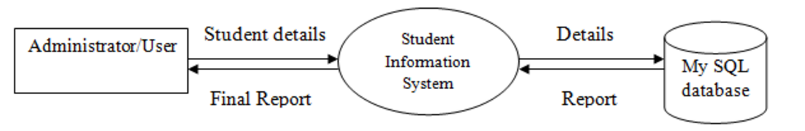

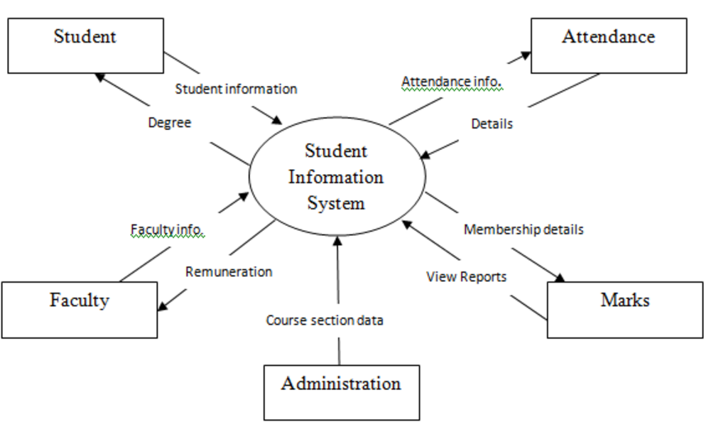

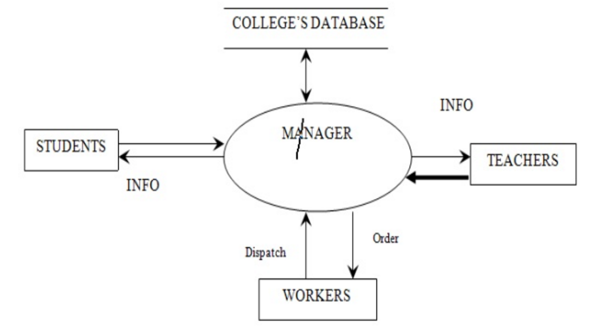

ER Diagram

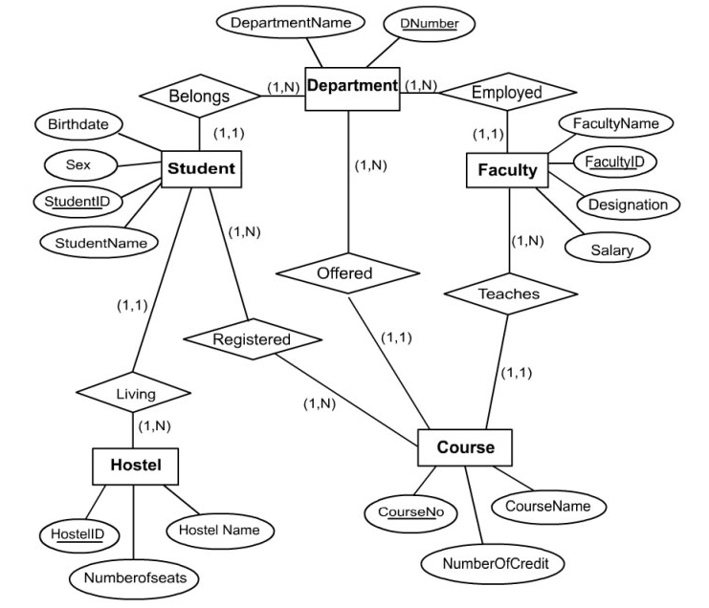

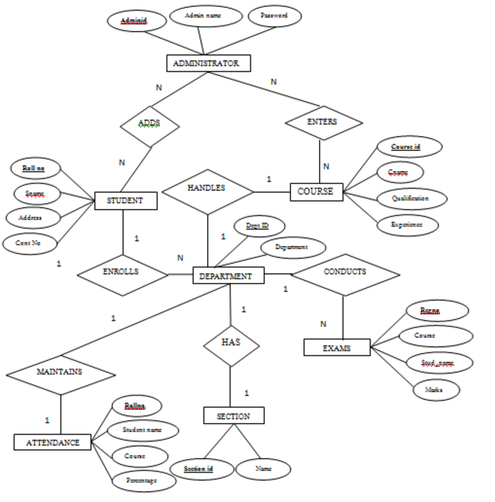

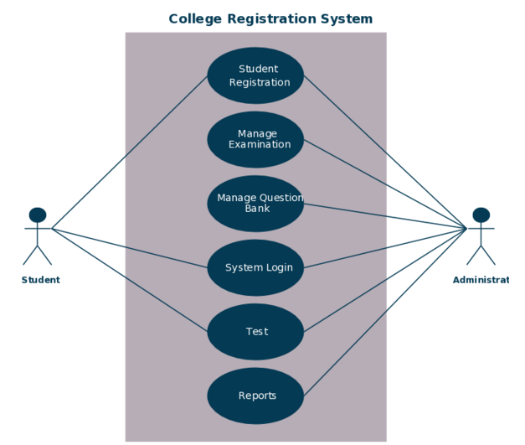

CONCLUSION

The College Management System is the system that deals with the issues related to a particular institution. This project is successfully implemented with all the features mentioned in system requirements specification. The application provides appropriate information to users according to the chosen service. The project is designed keeping in view the day to day problems faced by a college.