**ZeroDown Quick Start Process**

This ReadMe file and Quick Start Package will take you through the steps required to:

1. Install and setup the ZeroDown Software on Azure Stack;
2. Deploy a sample customer application on two sites;
3. Demonstrate the HA for Azure Stack solution as a proof of concept for your client.

The process flow to get everything up and running is as follows:

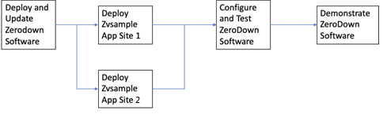

**Getting Started**

This Quick Start package provides access to:

* **Quick Start Videos** that walk through the steps to get the ZeroDown Software and ZenVault sample customer application set up for testing and demonstration purposes.
* **QuickStart Training** to deploy, configure, and then to demonstrate the HA solution in active/active mode across two separately located sites.

**Quick Start Videos**

YouTube reference video links are listed in Blue below.

* **QS1-Deploy-ZeroDown [Time 10m:38s)**QS Video to deploy ZDS in an Azure Stack Environment

<https://youtu.be/9b1ue2kw8Ds>

* **QS2-ZVSample-Deployment [Time 9m:06s]**QS Video to install ZenVault Sample application, test connections, and login

<https://youtu.be/rBEqdvCI-tE>

* **QS3-Config-ZeroDown [Time 7m:22s]**QS Video to configure ZeroDown Software

<https://youtu.be/89AoizhNrm4>

* **QS4-Demonstration.mp4 [Time 11m:06s]**

QS Video to walk through a typical demo of ZeroDown Software

<https://youtu.be/uxCNsJ0eLJU>

**License**

Copyright 2019 © ZeroDown® Software