Matrix Multiplication Performance Analysis
Using Single-Threaded and Multithreaded Implementations in Java

Abstract
This project implements matrix multiplication in Java in two ways: a single-threaded version, where one thread computes the entire result, and a multithreaded version, where the rows of the result matrix are divided among several threads. Both versions are executed on matrices of increasing size, their results are checked for correctness, and their execution times are compared using speedup. The project demonstrates how parallel programming can use multiple CPU cores and how thread overhead affects performance.

1. Objectives
- To implement matrix multiplication using a single thread.
- To implement multithreaded matrix multiplication by dividing the work among threads.
- To verify that both implementations produce identical results.
- To compare the performance of both versions for different matrix sizes and thread counts.
- To understand speedup and the effect of thread creation overhead.

2. Tools and Technologies
Component | Technology
Programming Language | Java (JDK 17 or above)
Concurrency | java.lang.Thread (start and join)
Libraries | java.util.Random, java.util.Arrays
Timing | System.nanoTime()
Execution | Command line (javac, java) or any Java IDE
Visualization | Terminal output and Matplotlib chart

3. System Overview
The program generates two random n x n matrices A and B using a fixed seed, so every run uses the same data. It multiplies them first with the single-threaded method and then with the multithreaded method, measures the time taken by each, checks that both results are equal using Arrays.deepEquals, and prints a comparison table with the speedup.
In the multithreaded method, the rows of the result matrix C are divided equally among t threads. Thread k computes rows k*n/t to (k+1)*n/t. Matrix B is only read, and each thread writes only to its own rows of C, so no locks or synchronization are needed.
Row Division Among Threads:
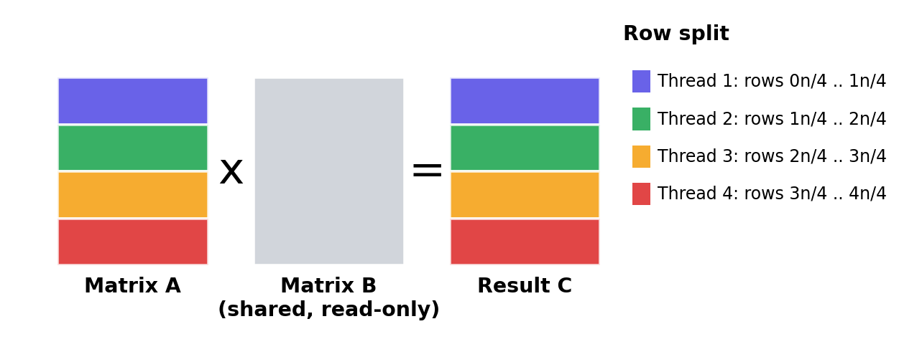
Figure 1: Rows of the result matrix divided among four threads
System Interface:
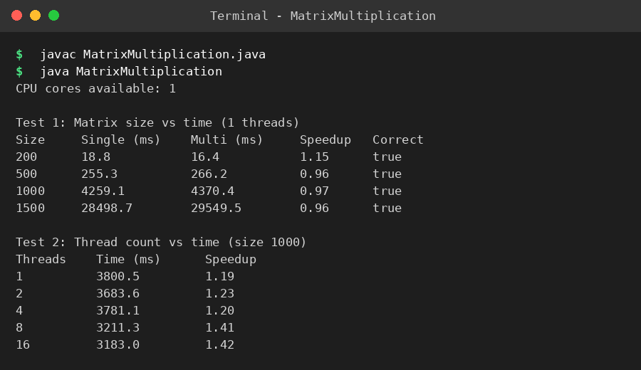
Figure 2: Program output in the terminal

4. Methodology
Data Generation: Random n x n matrices with values from 0 to 9 are created using a fixed seed, so results are repeatable.
Single-Threaded Algorithm: The standard triple loop computes C[i][j] += A[i][k] * B[k][j] for every cell. Time complexity is O(n^3).
Multithreaded Algorithm: t threads are created (by default one per available CPU core). Each thread computes its own block of rows, and the main thread waits for all of them using join().
Warm-up: A small multiplication is run first so that Java's JIT compilation does not distort the first measurement.
Measurement: System.nanoTime() is recorded before and after each multiplication. Speedup = single-threaded time / multithreaded time.
Verification: Arrays.deepEquals compares the two result matrices to confirm both versions are correct.
Experiments: Test 1 uses matrix sizes 200, 500, 1000 and 1500. Test 2 uses a fixed size of 1000 with 1, 2, 4, 8 and 16 threads.

5. Features
- Single-threaded and multithreaded implementations in one program.
- Thread count chosen automatically from the available CPU cores.
- Correctness check on every run.
- Execution time and speedup table for four matrix sizes.
- Thread-count experiment with 1, 2, 4, 8 and 16 threads.
- No shared writes, so no locks are required and there are no race conditions.
- Repeatable results through a fixed random seed.

6. Results and Visualization
The program was compiled and executed. The test machine reported 1 available CPU core. The table below shows the execution time for each matrix size, and the chart compares both versions.
Test 1: Matrix size vs time
Size | Single (ms) | Multi (ms) | Speedup | Correct
200 x 200 | 18.8 | 16.4 | 1.15 | true
500 x 500 | 255.3 | 266.2 | 0.96 | true
1000 x 1000 | 4259.1 | 4370.4 | 0.97 | true
1500 x 1500 | 28498.7 | 29549.5 | 0.96 | true

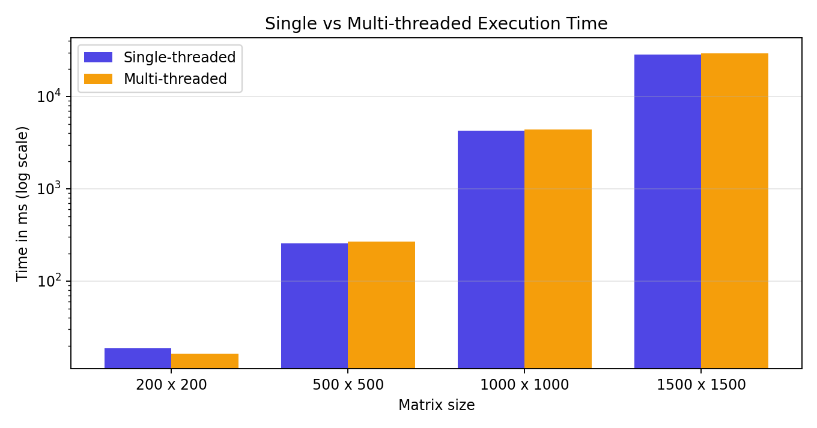
Figure 3: Single vs multithreaded execution time (log scale)
Test 2: Thread count vs time (size 1000)
Threads | Time (ms) | Speedup
1 | 3800.5 | 1.19
2 | 3683.6 | 1.23
4 | 3781.1 | 1.20
8 | 3211.3 | 1.41
16 | 3183.0 | 1.42

Observations:
- Correctness: the multithreaded result matched the single-threaded result for every matrix size (Correct = true).
- The test machine exposed only one CPU core, so the threads could not run in parallel. The multithreaded time is therefore almost the same as the single-threaded time (speedup between 0.96 and 1.15). This is expected, because parallel speedup needs more than one core.
- The small differences in Test 2 (1.19 to 1.42) are caused by JIT compilation and cache effects, not by parallel execution.
- Execution time increases sharply with matrix size, which is consistent with the O(n^3) complexity of the algorithm.
- On a multi-core computer, each thread can run on a separate core, so the multithreaded version is expected to finish faster for large matrices, while for small matrices the thread creation overhead can cancel the benefit.

7. Advantages
- Demonstrates parallel programming concepts clearly with simple code.
- Shows the practical effect of CPU cores and thread overhead on heavy computation.
- Needs no external libraries and runs on any system with Java.
- Correctness is verified, so the performance comparison is fair.
- Easy to extend with thread pools or other algorithms.

8. Conclusion
The project successfully implements single-threaded and multithreaded matrix multiplication in Java and compares their performance. Both versions produce identical results. The multithreaded version divides the rows among threads so that multiple cores can be used, and the measurements show that the actual gain depends on the number of available CPU cores and the size of the matrices. The project provides a clear foundation for further work in parallel and high-performance computing.

9. Future Scope
- Use an ExecutorService (thread pool) instead of manually created threads.
- Optimize the loop order (i-k-j) and use blocking or tiling for better cache usage.
- Implement faster algorithms such as Strassen's matrix multiplication.
- Use GPU computing (CUDA or OpenCL) for very large matrices.
- Add a graphical interface and run the experiments on multi-core machines.

