Titanic Survival Prediction
Using Machine Learning on Passenger Data

Abstract
This project predicts whether a passenger of the Titanic survived, using machine learning on passenger data. The dataset contains 891 passengers with details such as class, sex, age, fare and family size. The data is cleaned, a new feature is created, and three models (Logistic Regression, Decision Tree and Random Forest) are trained and compared. The models are evaluated using accuracy, a confusion matrix and a classification report. The best test accuracy obtained is 81.0%.

1. Objectives
- To analyse the Titanic passenger dataset and prepare it for machine learning.
- To predict whether a passenger survived using passenger details.
- To compare Logistic Regression, Decision Tree and Random Forest models.
- To evaluate the models using accuracy, confusion matrix, precision and recall.
- To identify which features influence survival the most.
- To predict survival for new passengers.

2. Tools and Technologies
Component | Technology
Programming Language | Python
Libraries | Pandas, Scikit-learn
Dataset | Titanic passenger dataset (891 records, 12 columns)
Models | Logistic Regression, Decision Tree, Random Forest
Evaluation | Accuracy, Confusion Matrix, Classification Report
Visualization | Matplotlib (charts in this report)
Execution | Command line, VS Code or Jupyter Notebook

3. System Overview
The system loads the passenger data, cleans it, converts text columns to numbers and creates a new feature called FamilySize. The six selected input features are Pclass, Sex, Age, Fare, Embarked and FamilySize, and the target to predict is Survived (0 = died, 1 = survived). The data is split into training and test sets, three models are trained, and the best model is used for evaluation and for predicting new passengers.
Workflow:
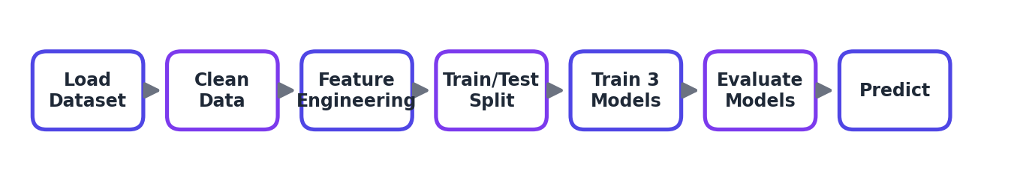
Figure 1: Machine learning workflow of the project
System Interface:
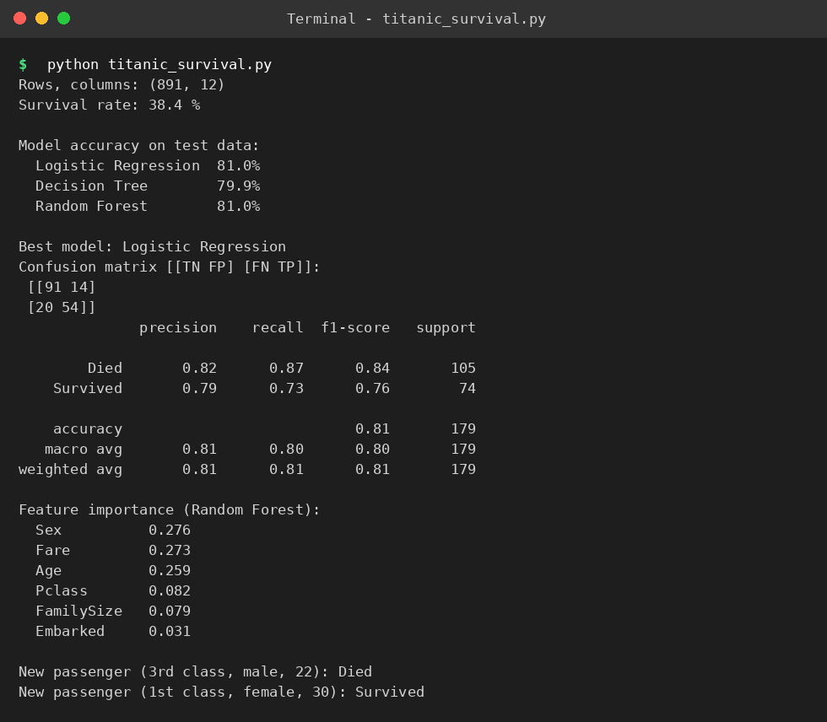
Figure 2: Program output in the terminal

4. Methodology
Data Collection: The Titanic dataset with 891 passengers and 12 columns is loaded using Pandas. Overall, 38.4% of the passengers survived.
Preprocessing: Missing Age values are filled with the median and missing Embarked values with the most common port. Sex is converted to numbers (male = 0, female = 1) and Embarked is converted (S = 0, C = 1, Q = 2). A new feature FamilySize = SibSp + Parch + 1 is created.
Model Design: The data is split 80% for training (712 passengers) and 20% for testing (179 passengers) with a fixed random state. Three models are trained: Logistic Regression, a Decision Tree limited to depth 4 to reduce overfitting, and a Random Forest with 200 trees.
Prediction: The model with the highest test accuracy is selected and used to predict survival for new passengers.
Evaluation: Accuracy, confusion matrix, precision, recall and F1-score are calculated, and the Random Forest feature importances show which inputs matter most.

5. Features
- Automatic loading of the dataset from a URL or a local CSV file.
- Handling of missing values in Age and Embarked.
- New feature FamilySize created from family information.
- Three algorithms trained and compared in a single run.
- Detailed evaluation with confusion matrix and classification report.
- Feature importance ranking.
- Survival prediction for new passengers.

6. Results and Visualization
The models were trained on 712 passengers and tested on 179 unseen passengers. Logistic Regression and Random Forest both reached 81.0% accuracy, and the Decision Tree reached 79.9%. The program selects the first model with the highest accuracy, which is Logistic Regression.
Model | Test Accuracy
Logistic Regression | 81.0%
Decision Tree | 79.9%
Random Forest | 81.0%

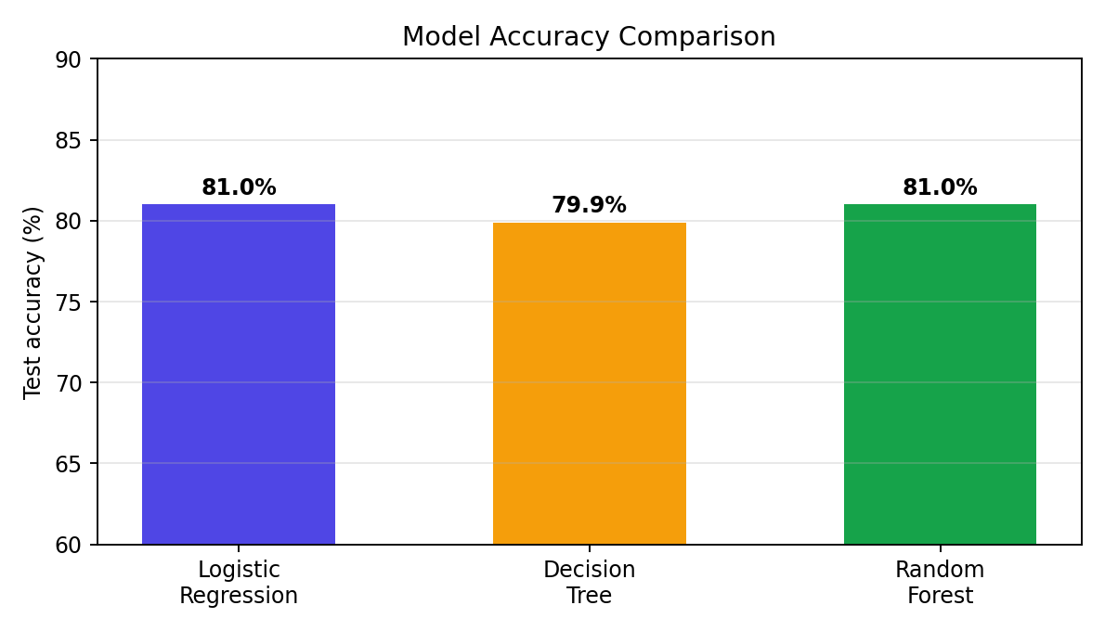
Figure 3: Accuracy comparison of the three models
Confusion Matrix and Classification Report
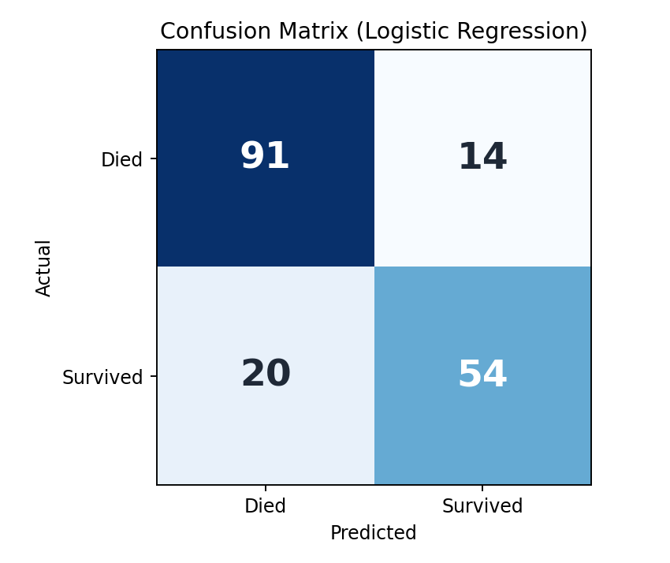
Figure 4: Confusion matrix of the best model
Of the 179 test passengers, 91 who died and 54 who survived were predicted correctly. 14 passengers were wrongly predicted to survive and 20 survivors were missed.
Class | Precision | Recall | F1-score | Support
Died | 0.82 | 0.87 | 0.84 | 105
Survived | 0.79 | 0.73 | 0.76 | 74
Accuracy |  |  | 0.81 | 179

Feature Importance
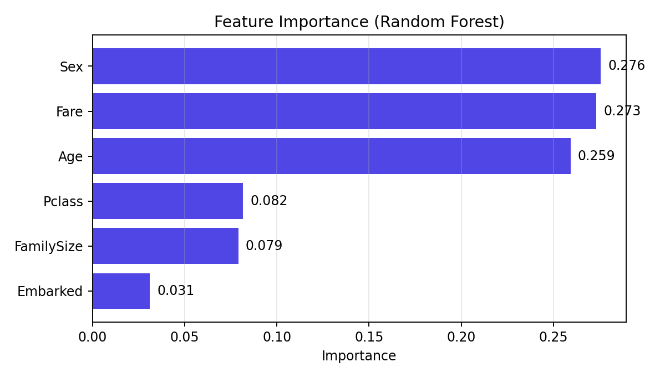
Figure 5: Feature importance from the Random Forest model
Observations:
- Sex is the strongest predictor, followed by Fare and Age, which matches the "women and children first" rule during the evacuation.
- Passenger class (Pclass) and family size also influence survival, while the port of embarkation matters least.
- Survivors have a lower recall (0.73) than non-survivors (0.87), so about a quarter of the actual survivors were missed.
- Sample predictions: a 22-year-old male in 3rd class is predicted to die, and a 30-year-old female in 1st class is predicted to survive.
- The accuracy figures come from a single test split of 179 passengers, so the two best models should be treated as equally good.

7. Advantages
- Simple and beginner-friendly machine learning pipeline.
- Compares several models to choose the best one fairly.
- Uses interpretable features that explain the predictions.
- Trains in seconds on a normal laptop.
- Results are reproducible because of the fixed random state.
- The same approach can be reused for other classification problems.

8. Conclusion
The project shows that machine learning can predict Titanic passenger survival with about 81% accuracy using only six passenger features. Data cleaning and feature creation prepared the data, and three models were compared using several evaluation measures. The analysis confirms that sex, fare, age and passenger class were the most important factors, and the project provides a complete example of a classification workflow.

9. Future Scope
- Use cross-validation for a more reliable accuracy estimate.
- Tune the models using GridSearchCV.
- Extract the title (Mr, Mrs, Miss) from the Name column as an extra feature.
- Try advanced models such as Gradient Boosting or XGBoost.
- Build a web interface (Streamlit or Gradio) so users can enter passenger details.
- Add charts of survival by sex and class during data analysis.

