BlockVote
A Blockchain-Based Decentralized E-Voting Application (dApp)

Abstract
BlockVote is a decentralized e-voting application (dApp) built on the Ethereum blockchain. The voting rules are written as a smart contract in Solidity, and a web interface built with HTML, JavaScript and ethers.js lets users interact with it through the MetaMask wallet. The admin adds candidates, registers eligible voters and controls the three phases of the election. Each registered voter can vote only once, and all votes are stored on the blockchain, which makes the result transparent and tamper-proof. The application was tested on a local blockchain and can be deployed on an Ethereum test network such as Sepolia.

1. Objectives
- To design a voting system that does not depend on a central authority.
- To implement a smart contract that enforces one vote per registered voter.
- To build a web interface for the admin and the voters.
- To provide transparent and tamper-proof records using blockchain.
- To test the complete election cycle: registration, voting and results.

2. Tools and Technologies
Component | Technology
Smart Contract Language | Solidity (version 0.8.20 and above)
Blockchain Platform | Ethereum (Sepolia test network)
Contract IDE | Remix IDE
Wallet | MetaMask
Frontend | HTML, CSS, JavaScript
Web3 Library | ethers.js (version 6)
Testing | Solidity compiler (solc) and Ganache local blockchain

3. System Overview
The voter or admin opens the web page, which uses ethers.js to talk to the smart contract through the MetaMask wallet. Reading data is free, while actions such as adding a candidate or casting a vote are transactions that the user signs in MetaMask. The smart contract stores the candidates, the list of registered voters, who has voted, the vote counts and the current phase of the election.
System Architecture:
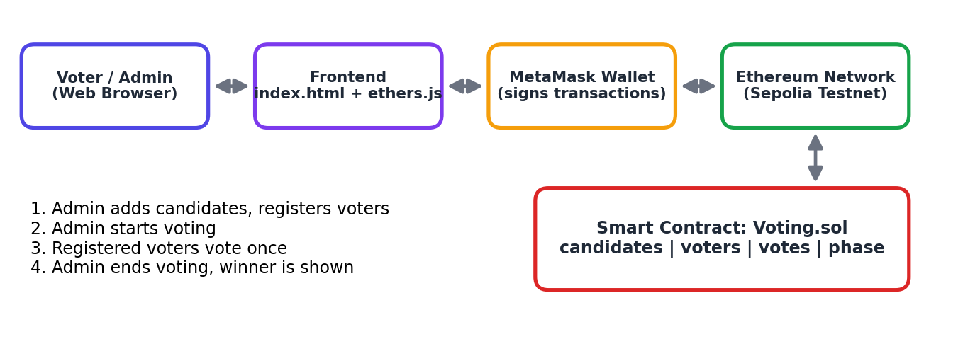
Figure 1: Architecture of the BlockVote dApp
The election has three phases: Registration, Voting Open and Ended. Each action is allowed only in the correct phase.
Smart Contract Functions:
Function | Used By | Purpose
addCandidate | Admin | Add a candidate (registration phase)
registerVoter | Admin | Register an eligible voter wallet
startVoting | Admin | Open voting (needs at least 2 candidates)
vote | Registered voter | Cast one vote for a candidate
endVoting | Admin | Close voting
getCandidates | Anyone | Read candidates and vote counts
getWinner | Anyone | Read the winner after the election ends

4. Methodology
Contract Design: The contract uses an enum for the phase, a struct for each candidate, and mappings isRegistered and hasVoted for the voters. Events are emitted when a voter is registered, a vote is cast and the phase changes.
Access Control: An onlyAdmin modifier restricts administrative functions to the account that deployed the contract. Require statements check that every action happens in the correct phase.
Voting Logic: The vote function checks that voting is open, the sender is registered, the sender has not voted and the candidate exists. It marks the voter as voted before increasing the vote count, which prevents double voting.
Frontend: The page connects to MetaMask using ethers.js, reads the election state with free view calls, and sends transactions for actions. After each confirmed transaction the page refreshes the status, candidate cards and results.
Deployment: The contract is compiled and deployed with Remix IDE using MetaMask on the Sepolia network. The deployed contract address is then pasted into the web page.
Testing: A test script on a local blockchain checked the main rules: voting before the start, a non-admin adding a candidate, a double vote, an unregistered voter, a non-admin ending the election, and the final tally. The web interface was also run against the local blockchain to capture the screenshots in this report.

5. Features
- Two roles: Admin and Voter.
- Three-phase election: Registration, Voting Open and Ended.
- One person, one vote enforced by the smart contract.
- Wallet-based identity using MetaMask.
- Live results with vote counts, percentages and progress bars.
- Automatic winner declaration after the election ends.
- Modern, responsive interface with a status tracker and notifications.
- Candidate names are displayed safely as plain text to avoid HTML injection.

6. Results and Visualization
The complete election cycle was run on a local blockchain with one admin, five registered voters and three candidates. The screenshots below show each stage of the application.
Home Page (before connecting the wallet):
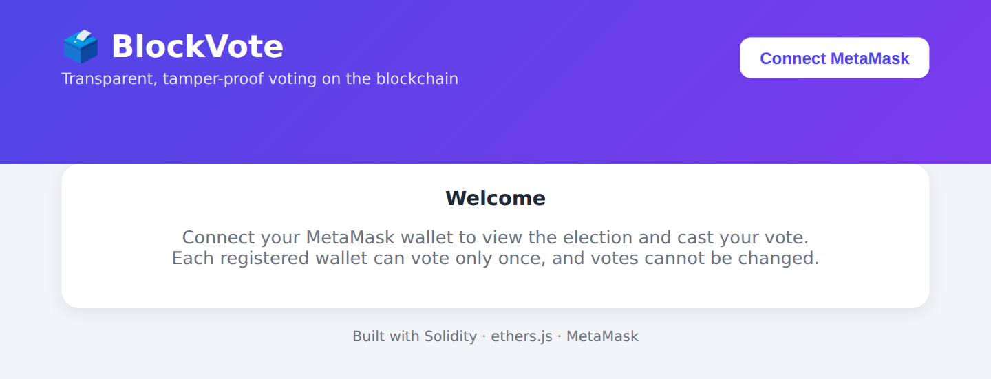
Figure 2: Welcome page of BlockVote
Admin Setup (Registration phase):
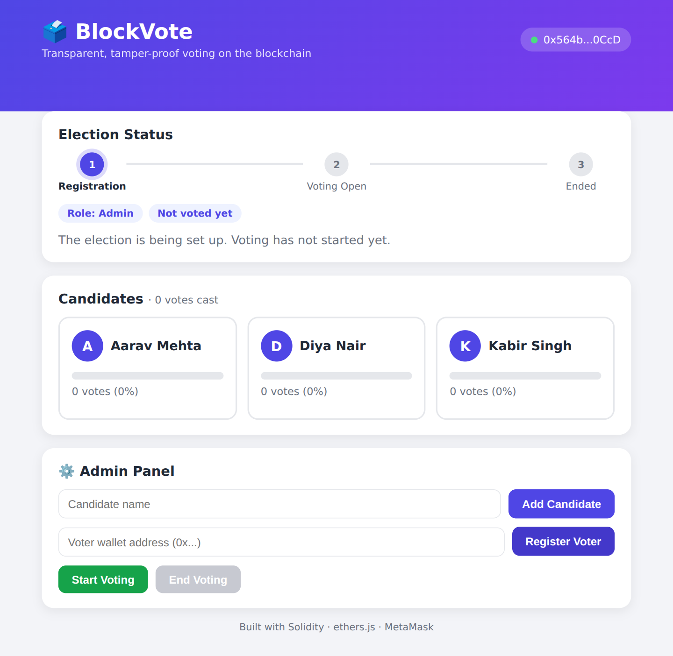
Figure 3: Admin view with three candidates added and the Admin Panel
Voter View (Voting open):
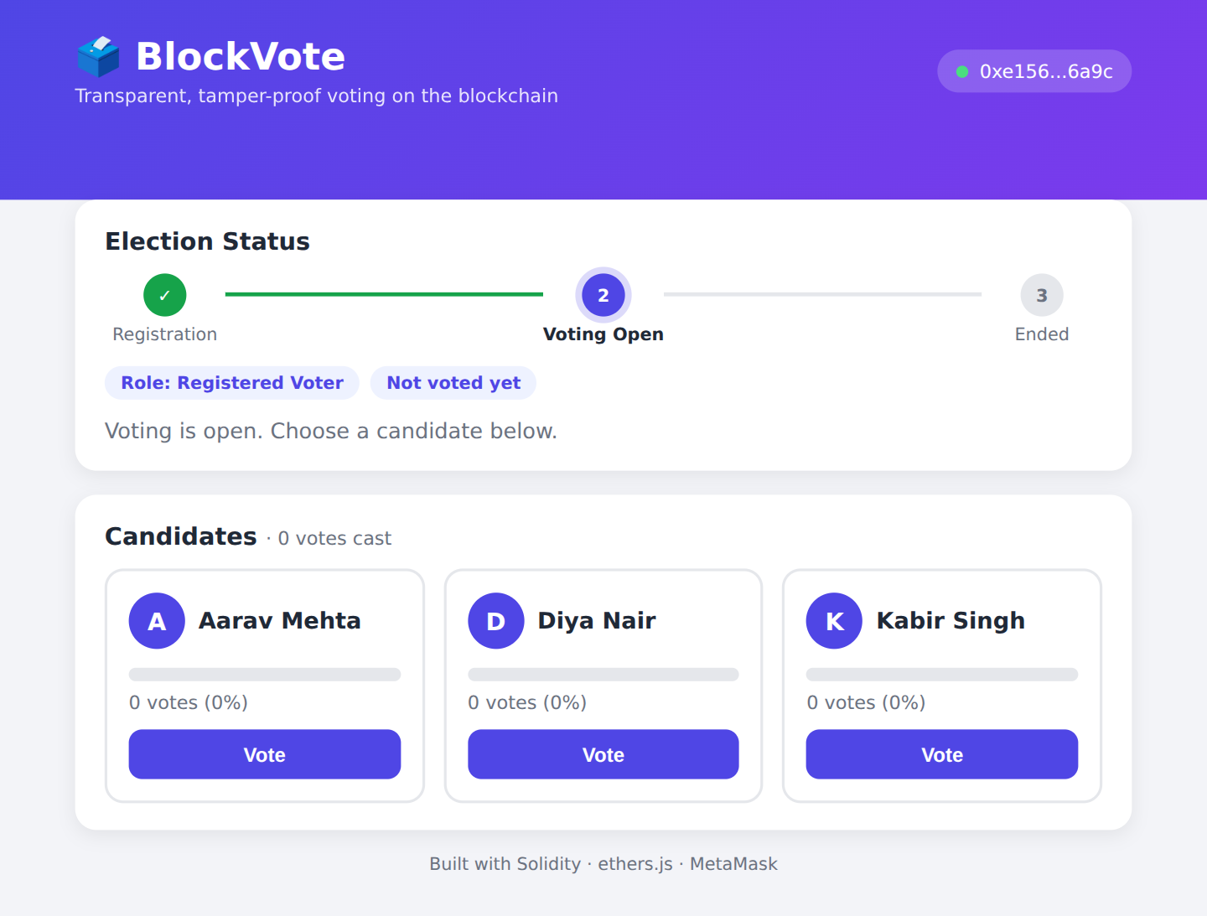
Figure 4: A registered voter sees the candidates and Vote buttons
After Voting:
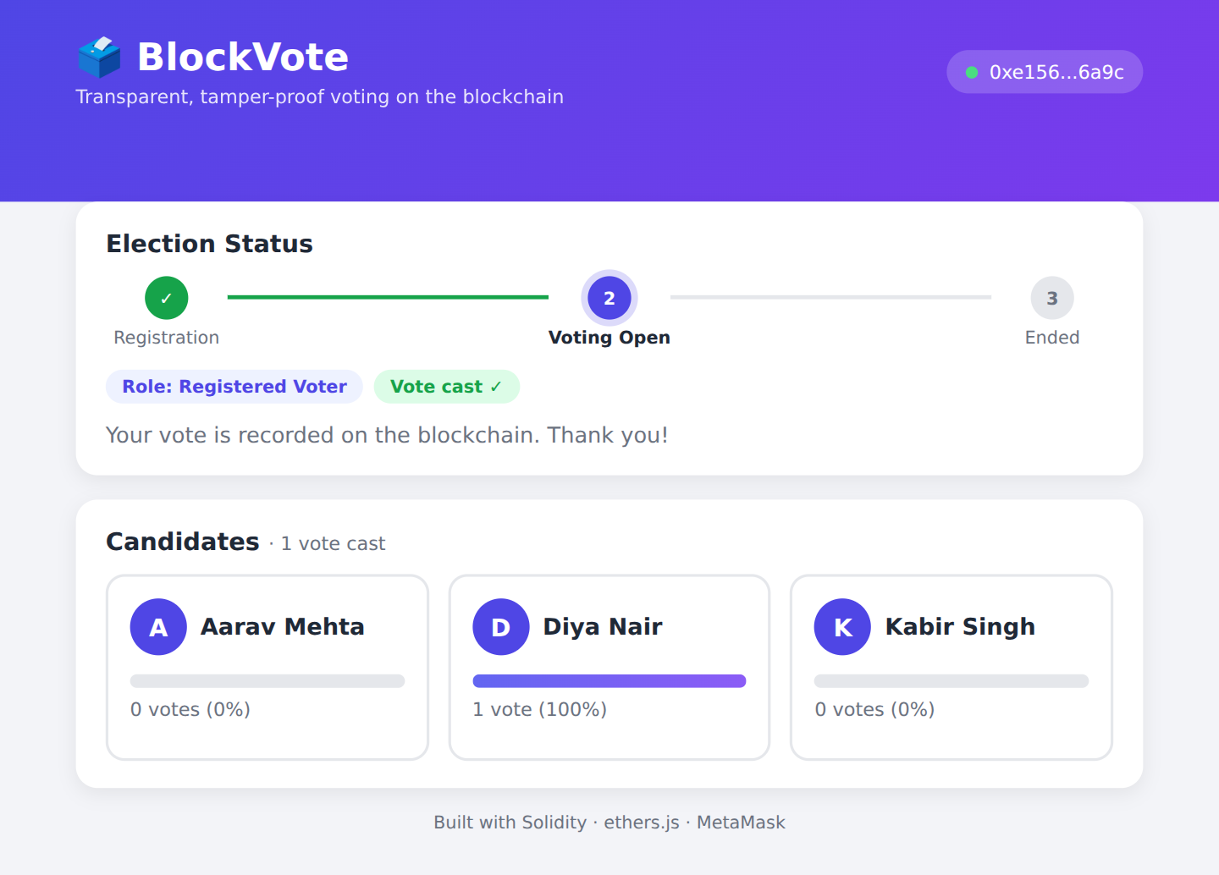
Figure 5: After voting, the Vote buttons disappear and the vote is counted
Final Result:
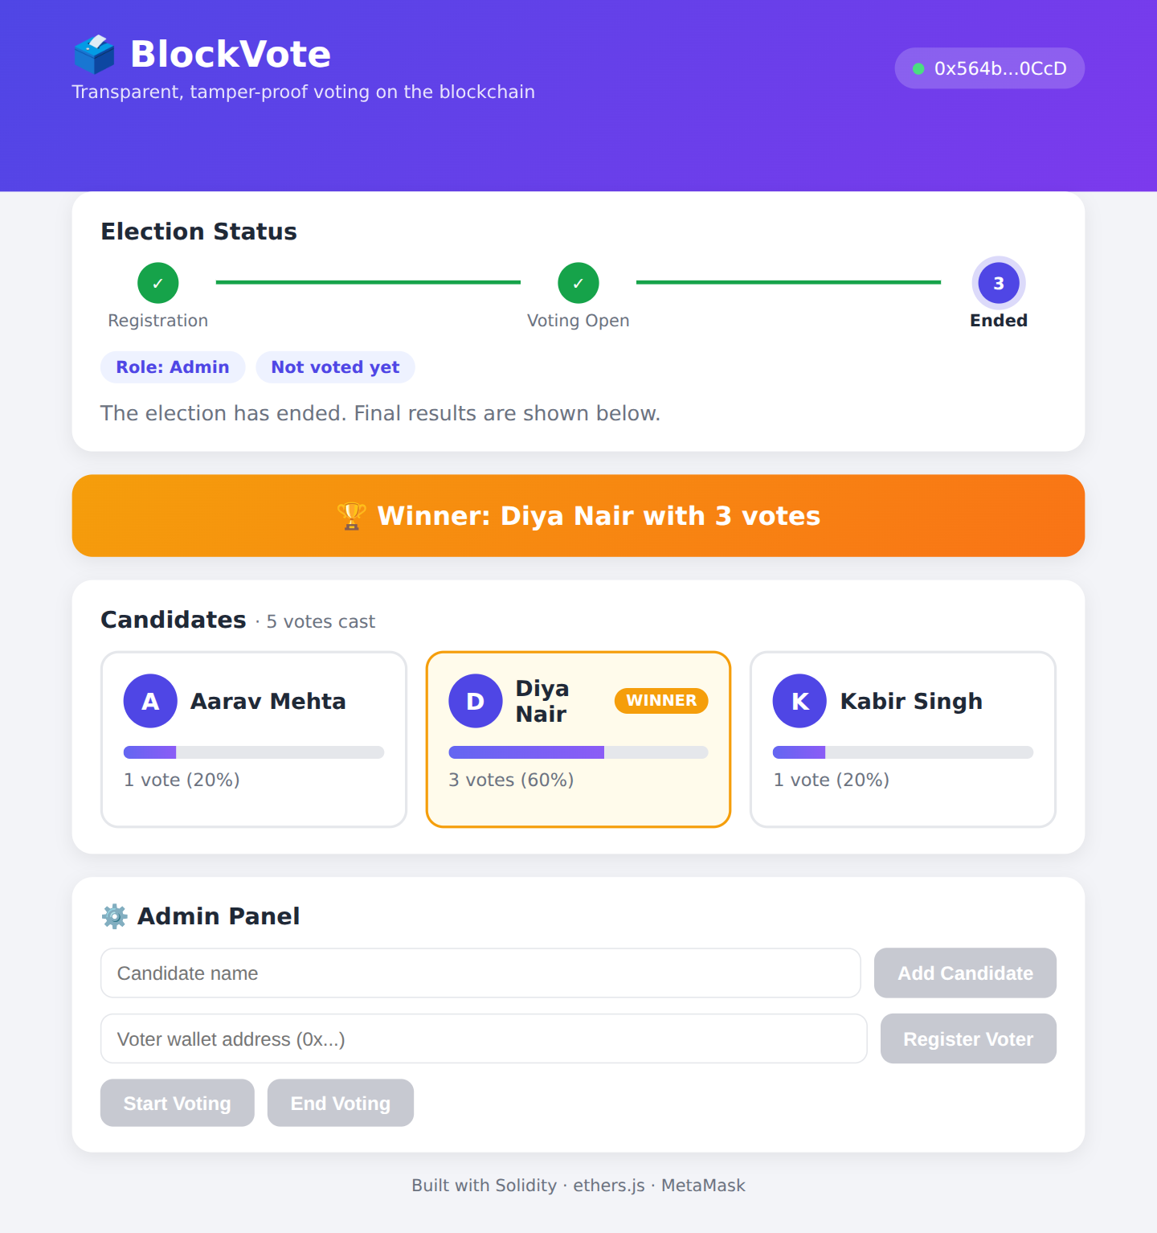
Figure 6: Election ended with the winner banner and final vote counts
Final tally: Diya Nair received 3 votes (60%), Aarav Mehta 1 vote (20%) and Kabir Singh 1 vote (20%). Diya Nair was declared the winner.
Smart Contract Test Results
Scenario | Expected | Result
Vote before voting starts | Rejected | Rejected
Non-admin adds a candidate | Rejected | Rejected
Registered voters vote | Counted | Counted
Same voter votes twice | Rejected | Rejected
Unregistered wallet votes | Rejected | Rejected
Non-admin ends the election | Rejected | Rejected
Final tally and winner | Correct | Correct

7. Advantages
- Transparency: anyone can verify the vote counts from the contract.
- Tamper-proof: recorded votes cannot be changed or deleted.
- Decentralized: no single server or authority controls the result.
- Rules are enforced automatically by the smart contract.
- Prevents double voting.
- Simple wallet-based login and an easy-to-use interface.

8. Conclusion
The BlockVote project successfully demonstrates a blockchain-based voting application in which the rules are enforced by a smart contract and the results are transparent and tamper-proof. The full election cycle of registration, voting and result declaration was tested, and the web interface makes the system easy to use. In its current form votes are pseudonymous rather than fully anonymous, and the admin decides who is registered, so the project serves as a strong foundation for a more secure voting system.

9. Future Scope
- Add a commit-reveal scheme or zero-knowledge proofs for ballot privacy.
- Verify voter identity using KYC or government ID before registration.
- Add a voting deadline using the block timestamp.
- Add batch registration of voters.
- Write automated tests with Hardhat.
- Deploy on a low-cost network to reduce gas fees.

