DIGITAL IMAGE FORENSICS AND METADATA ANALYZER
CSDF Mini Project — Design and develop a tool for digital forensic of images

Abstract
This project presents a simple Digital Image Forensics and Metadata Analyzer developed using Python. It allows a user to select an image, inspect basic properties, view available EXIF metadata, calculate MD5 and SHA-256 hashes, and save the results as a text report. The tool demonstrates basic image examination and file-integrity checking in a beginner-friendly graphical interface.
Digital images are frequently shared through social media, messaging applications, websites, and other digital platforms. Examining the technical properties of these images can help users record important information about a file. The analyzer combines image inspection, metadata extraction, hash calculation, and report generation in one application.

1. Objectives
The main objective of this project is to develop a simple tool for examining digital image files and collecting their technical information in an organized format.
The specific objectives are:
- To develop a simple tool for examining digital image files.
- To display image format, dimensions, file size, and color mode.
- To extract available EXIF metadata such as camera details and capture date.
- To calculate file hashes that can help verify whether file contents have changed.
- To save the analysis results as a forensic report.

2. Tools and Technologies
The project uses Python and its supporting libraries to implement the image examination workflow.
Technology | Purpose
Python | Main programming language
Tkinter | Graphical user interface
Pillow | Open and inspect image files and EXIF metadata
hashlib | Calculate MD5 and SHA-256 hashes
os | Read file name, path, and file size
VS Code | Code editing and execution

2.1 Python
Python is the main programming language used in this project. It provides a simple way to connect the graphical interface, image-processing library, hashing functions, and file-handling operations.
Its readable syntax makes the application easier to develop, understand, and maintain.

2.2 Tkinter
Tkinter is used to create the graphical user interface. It allows the application to display a window, provide file-selection controls, and present analysis results to the user.
The graphical interface makes the application easier to operate because users do not need to enter image paths manually through a command-line interface.

2.3 Pillow
Pillow is a Python imaging library used to open and inspect supported image files. It provides information such as image format, dimensions, color mode, and available EXIF metadata.
For example, an image may have a format such as JPEG or PNG and dimensions such as width and height in pixels. Pillow helps retrieve these properties for display in the application.

2.4 hashlib
The hashlib module is used to calculate MD5 and SHA-256 hash values. These values act as digital fingerprints of the file contents.
If the contents of a file change, the calculated hash will generally change as well. Comparing a newly calculated hash with a previously recorded value can therefore help identify changes in file contents.

2.5 os
The os module supports file-related operations, including obtaining information about a file's name, path, and size. These details help identify the selected image and present its properties in the report.

2.6 Visual Studio Code
Visual Studio Code is used as the development environment. It allows the developer to write Python code, organize project files, run the application, and investigate errors during development.

3. Project Overview
The user selects an image through the file picker. The program opens the image, displays a preview, reads its basic properties and available EXIF tags, and calculates hash values from the file bytes. The results appear in the application window. The user can then save the results to a text file.
The Digital Image Forensics and Metadata Analyzer is a desktop application that collects basic information about a selected image. Its purpose is to make common image examination tasks available through one interface.
The process begins when the user selects an image through the file picker. The application attempts to open the selected file and display an image preview. It then reads the image's basic properties, including file name, file path, file size, format, dimensions, and color mode.
The program also checks whether EXIF metadata is available. EXIF metadata may contain information such as camera details and capture date, depending on the image and how it was created or processed.
After collecting the available information, the application calculates MD5 and SHA-256 hash values from the selected file's bytes. These values are displayed along with the other analysis results.
Finally, the user can save the results as a text report. This report provides a record of the information collected during the examination.
The project follows a straightforward workflow so that users can understand how each operation contributes to the overall analysis. It focuses on collecting and documenting information rather than automatically deciding whether an image is genuine or manipulated.

4. System Design
System flow: Select Image → Read Image Properties → Extract Available EXIF Metadata → Calculate MD5 and SHA-256 → Display Results → Save Report.
The application runs locally on the computer. No database or internet connection is required.

5. Features
- Select and preview supported image files.
- Display file name, path, file size, format, dimensions, and color mode.
- Display available EXIF metadata or indicate when metadata is unavailable.
- Calculate MD5 and SHA-256 hash values.
- Save analysis results in a text report.
- Show an error message if the selected file cannot be analyzed.

6. Implementation
The application is implemented using Python and the libraries described in the Tools and Technologies section.
The graphical interface is created using Tkinter. It provides the controls required for selecting an image, viewing the analysis results, and saving a report.
Pillow is used to open the selected image and retrieve its properties and available EXIF metadata. The application obtains the information that can be read from the selected file and prepares it for display.
Python's hashlib module calculates the MD5 and SHA-256 digests from the selected file's bytes. These hash values are then included in the analysis results.
The application also uses file-handling functionality to obtain file information and write the collected results to a UTF-8 text file. UTF-8 is a text encoding that supports a wide range of characters.
Steps to Run the Application
- Install Python 3 on the computer.
- Open a terminal in the project folder.
- Install the required dependencies using the command:
python -m pip install -r requirements.txt
- Run the application using the command:
python image_forensics.py
- Select an image through the application interface.
- Review the image properties, available EXIF metadata, and hash values.
- Save the analysis results to a text report if required.
The actual output depends on the selected image and the information available within that file.

7. Screenshots / Final Output
The following is a representative preview of the expected application output. The values shown are illustrative; actual file details, hashes, and metadata will depend on the image selected when the program is run.
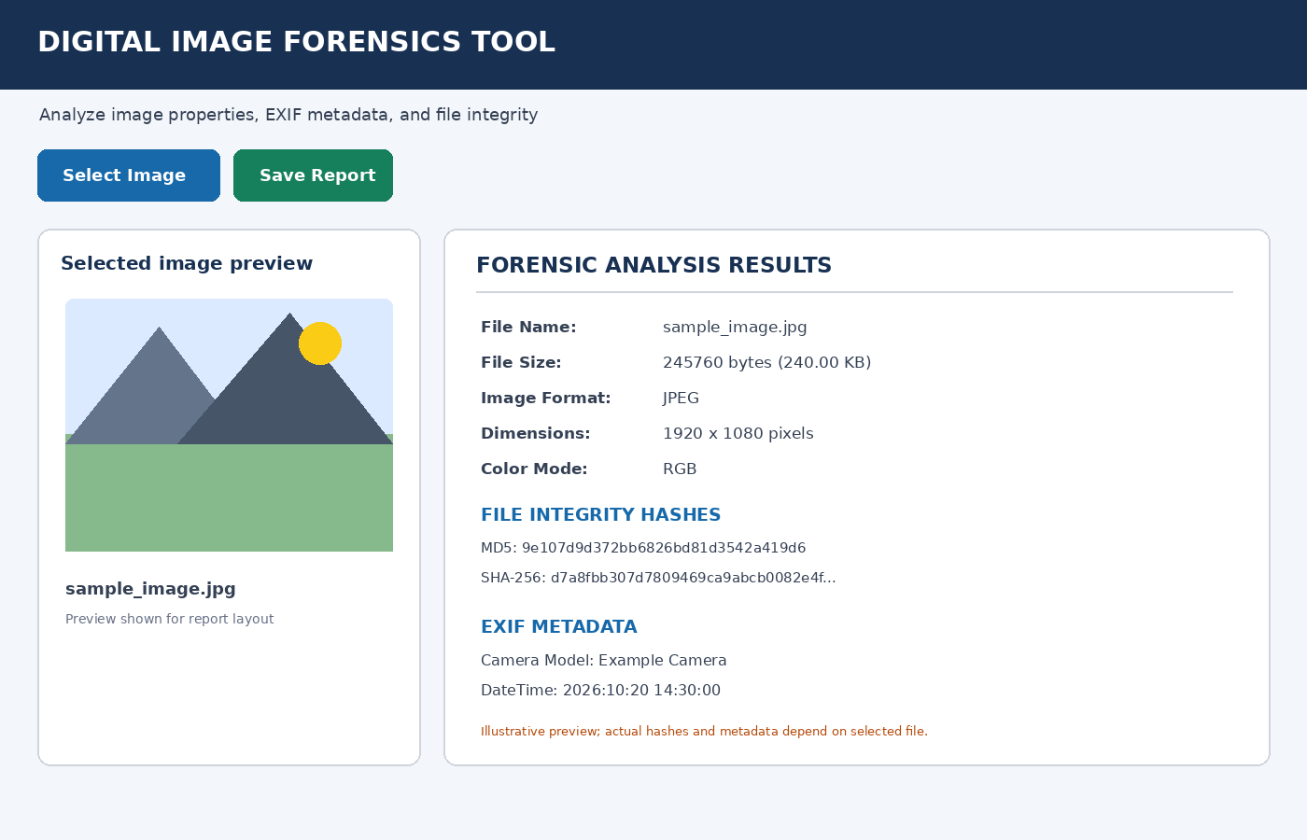
Figure 1: Digital Image Forensics Tool — sample output screen

Test Cases
Test ID | Test Input / Action | Expected Result | Status*
TC01 | Select a valid JPG image | Image preview and properties are displayed | To be tested
TC02 | Select a valid PNG image | Format and dimensions are displayed | To be tested
TC03 | Cancel file selection | Application remains open without crashing | To be tested
TC04 | Select image with no EXIF data | Message indicates no EXIF metadata found | To be tested
TC05 | Select an image and inspect hashes | MD5 and SHA-256 values are displayed | To be tested
TC06 | Click Save Report after analysis | A text report is saved to the chosen path | To be tested
TC07 | Try an unsupported or corrupt file | An error message is displayed | To be tested
*Run these cases on your computer and replace “To be tested” with Pass or Fail based on actual results.

9. Results and Discussion
The application is designed to present image properties, available metadata, and hash values in one place. The hash values can be recorded and compared during later checks to identify changes in file contents. A matching hash supports that the file bytes are unchanged relative to the recorded hash, assuming the same hashing algorithm is used.

10. Limitations
- Not all images contain EXIF metadata.
- A hash mismatch shows that file contents differ; it does not by itself prove malicious editing.
- The current version does not automatically detect deepfakes or identify every image manipulation.
- MD5 is included for demonstration; SHA-256 is preferred for stronger integrity checking.

11. Conclusion
The Digital Image Forensics and Metadata Analyzer demonstrates a basic forensic workflow by collecting image properties, extracting available metadata, calculating file hashes, and saving a report. It is a small, practical application that can be extended with duplicate-image comparison, metadata timelines, and more advanced forensic analysis.

12. Future Scope
- Add side-by-side comparison of two images and their hashes.
- Add more metadata fields and export reports to PDF.
- Add image error-level analysis as an exploratory aid, with clear limitations.
- Add batch processing for multiple image files.

