CO5420: Neural Networks & Deep Learning | Lab 01: Decision Trees
K.P.B.P. Karunanayake | E/22/184
Task 1: Decision Tree Classifiers on the Wine Dataset
Task 1(a): Handling Missing Values
The Wine dataset contains no missing values. However, the standard approach is to first inspect, then impute if needed:
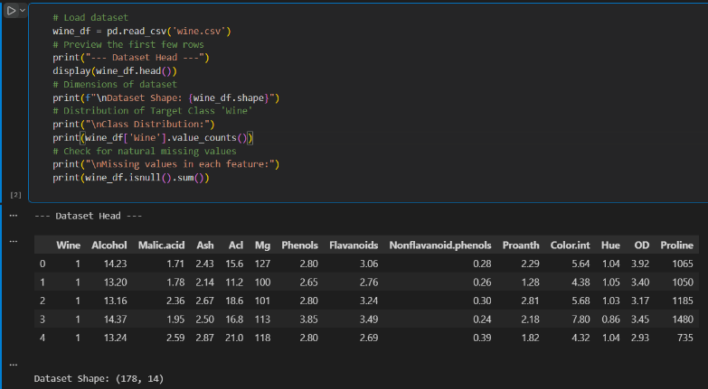

Since all 178 rows were complete, no imputation was required and the data was used directly. Decision trees do not inherently handle NaN values preprocessing is always necessary.
Decision Trees can handle missing values in two main ways:
- Native Handling: In modern version of scikit-learn (1.2+) the algorithm natively handles missing values by evaluating which split direction minimizes impurity during training.
- Explicit Imputation: Pre-processing via methods like mean/median replacement using SimpleImputer before training.
Let's inject 10% artificial missing values (NaN) into the training data to demonstrate both strategies.
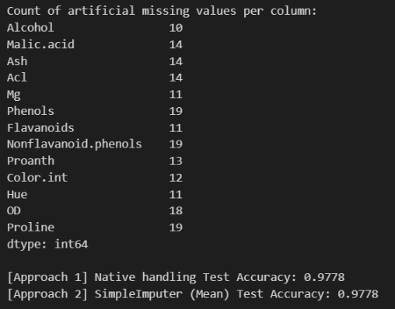
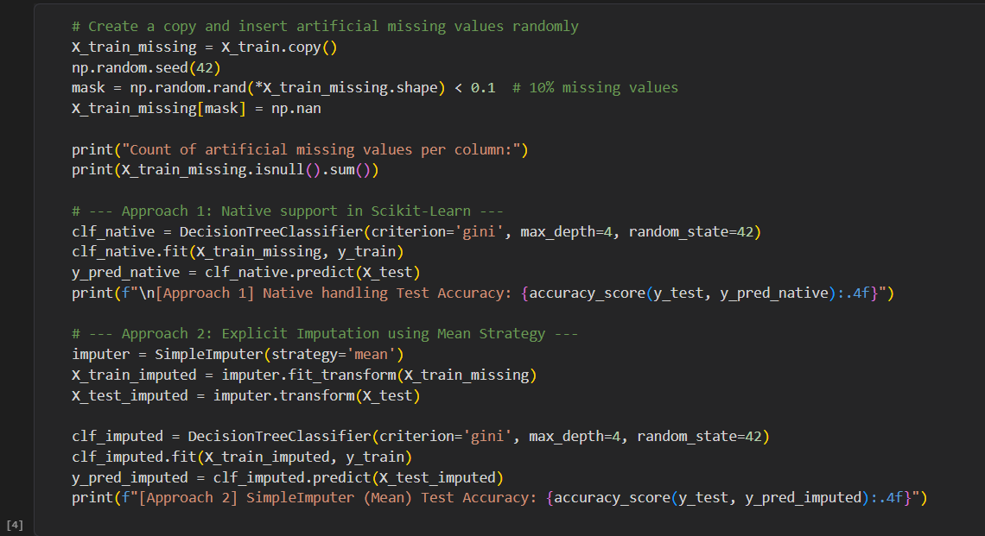

Task 1(b): Evaluating Both Classifiers
We build two full decision trees using:
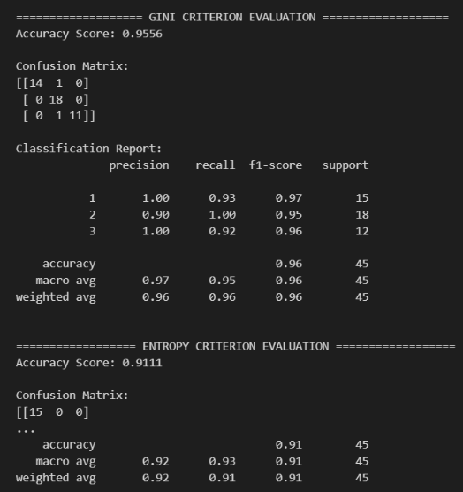
- Gini Criterion: Measures impurity as $Gini\left(D\right)=1-\sum_{i=1}^{m}{P_{i}^{2}}$
- Entropy Criterion: Measures impurity as $Info(D)=-\sum_{i=1}^{m}{p_{i}\log_{2}{P_{i}}}$
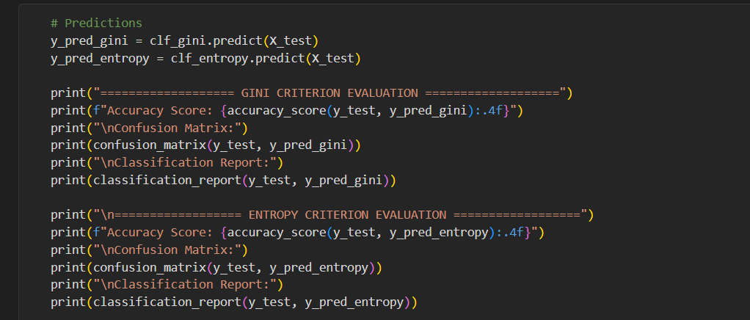
Then we compute Accuracy, Confusion Matrix,
and a detailed Classification Report for each.

Gini (no max_depth limit, full tree):
- Accuracy: 0.9556 (95.56%)
- Confusion matrix: Look at the attach output
- Class 1: precision=1.00, recall=0.93, F1=0.97, support=15
- Class 2: precision=0.90, recall=1.00, F1=0.95, support=18
- Class 3: precision=1.00, recall=0.92, F1=0.96, support=12
- Macro avg F1: 0.96
Entropy (no max_depth limit, full tree):
- Accuracy: 0.9111(91.11%)
- Confusion matrix: Look at the attach output
Task 1(c): Pruning to Overcome Overfitting
Pruning controls the depth of the tree to prevent overfitting. When max_depth is too large, the tree memorizes the training data (100% train accuracy) but performs poorly on unseen test data.
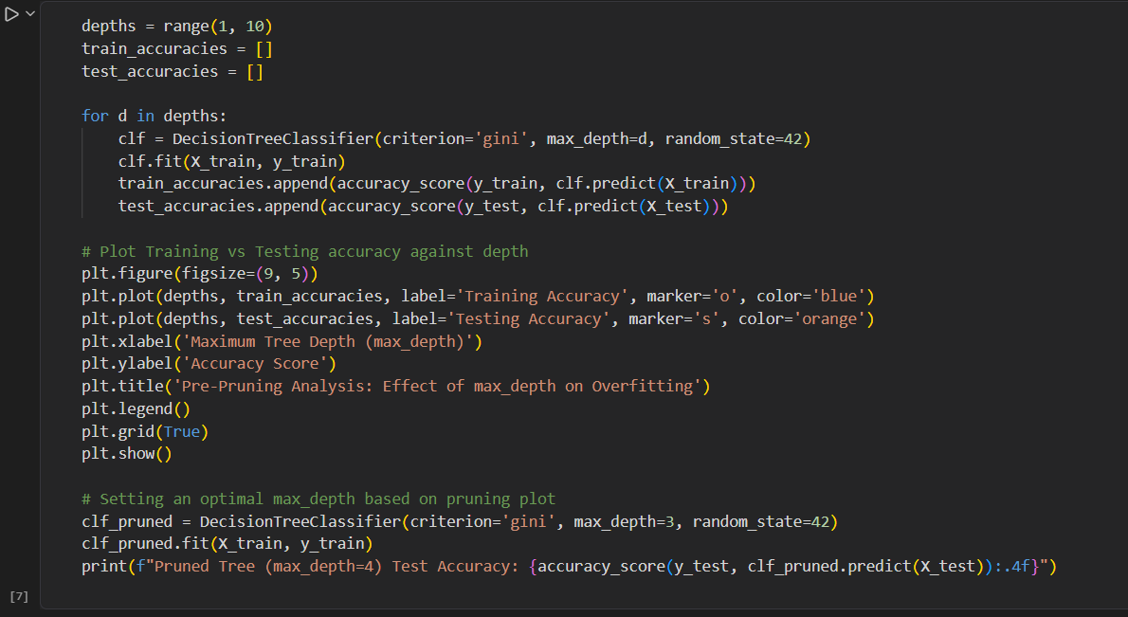
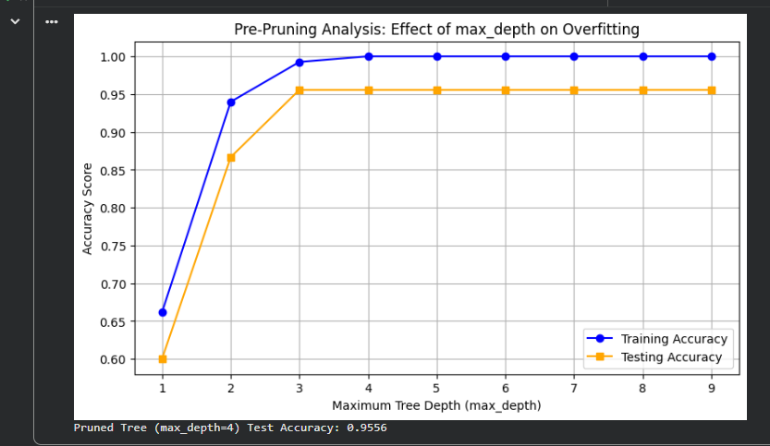

max_depth = 4 was selected as the best value. At this depth, the model achieves 95.56% test accuracy. Going deeper causes overfitting the training accuracy reaches 100% while test accuracy does not consistently improve. This gap between train and test accuracy is the overfitting signal.
Task 1(d): Visualizing Decision Trees
Decision trees are visualized using export_graphviz with pydotplus plot tree. Each node displays the split feature, threshold, impurity value, sample count, and predicted class.
The Gini tree's root node splits on 'flavanoids’, the most discriminative feature for separating wine cultivars. The entropy tree produces a similar structure. Both trees at max_depth=4 remain fully interpretable with clear decision paths from root to each leaf class.

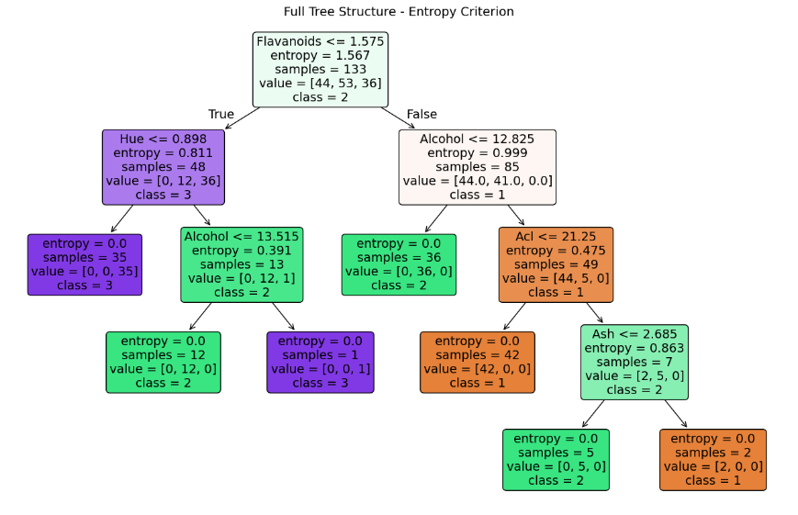
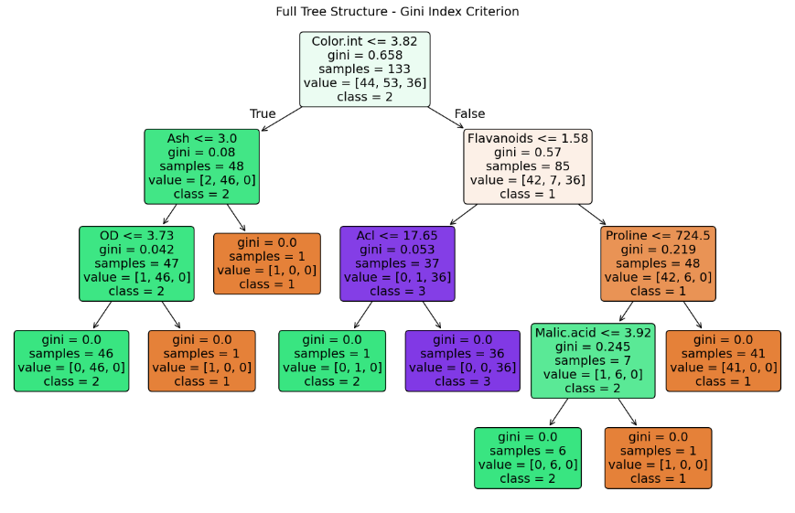

Lab Demonstration: Pima Indians Diabetes Dataset
The diabetes dataset contains 768 instances (females, age ≥ 21, Pima Indian heritage) with 8 medical features and a binary label (0 = no diabetes, 1 = diabetes). A Gini-criterion decision tree was built following the complete pipeline.

Dataset Summary
Property | Detail
Instances | 768 (500 class-0, 268 class-1)  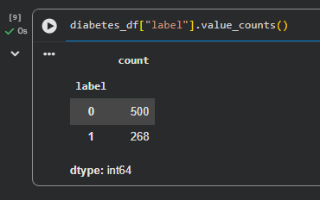
Features | pregnant, glucose, bp, skin, insulin, bmi, pedigree, age  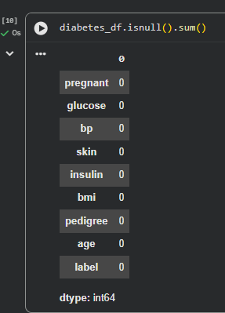
Missing values | None (isnull().sum() = 0 for all columns)
Train / Test split | 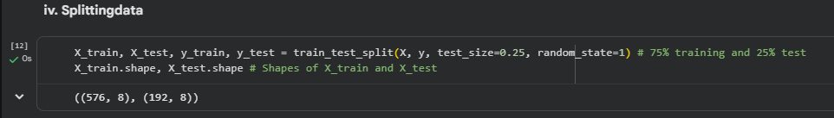  576 / 192 (75% / 25%, random_state=1)

Model Building & Prediction
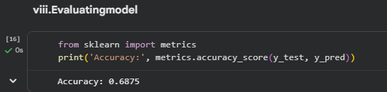

Classification Report (Gini, max_depth=4)
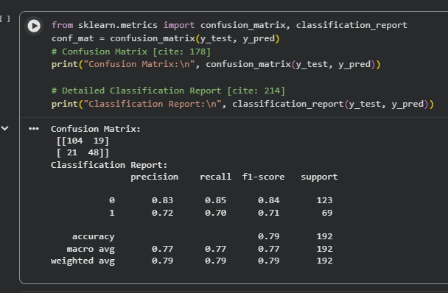

This displays the precision, recall, f1-score, and support scores for the model.
Confusion Matrix
 | Predicted: 0 | Predicted: 1
Actual: 0 | 104 (TN) | 19 (FP)
Actual: 1 | 21 (FN) | 48 (TP)

The 21 False Negatives (FN) diabetic patients predicted as non-diabetic are the most critical error in a medical context (Type II error). The model performs better in the majority class (0) due to class imbalance (500 vs 268 samples). Overall accuracy of 68.75% reflects this imbalance.
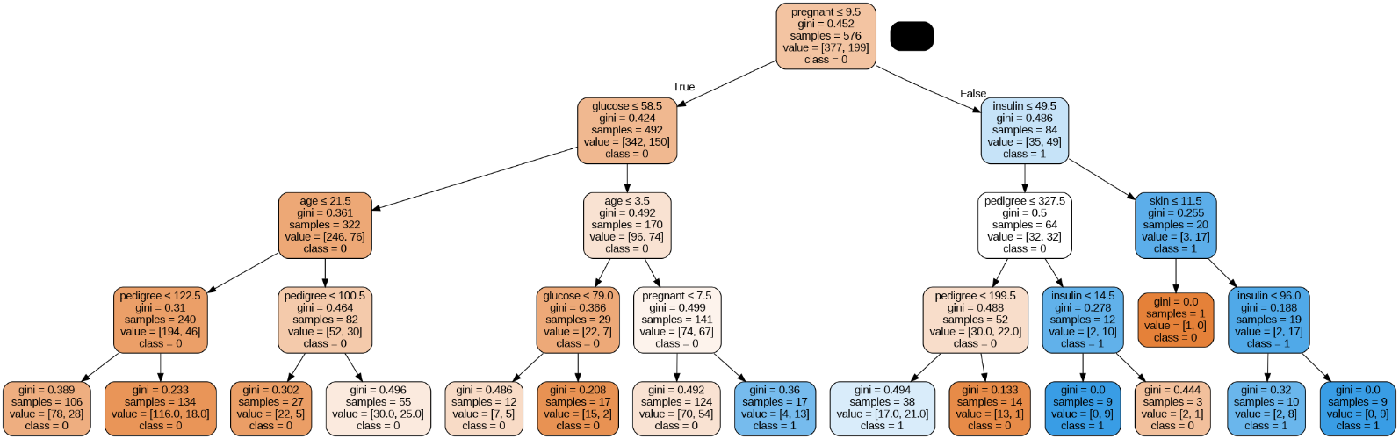
Visualizing Decision Trees

