Non-fatal Major Adverse Transplant Episodes After Lung Transplantation: An EHR-Based Feasibility Study
Ishanu Chattopadhyay, University of Kentucky
Dmytro Onishchenko, University of Kentucky
Girish Nair, University of Kentucky
Edward Cantu, University of Kentucky
Abstract
One-year survival after lung transplantation does not fully characterize recovery. We propose non-fatal Major Adverse Transplant Episode (MATE), a composite encompassing retransplantation, prolonged index hospitalization, dialysis after day 90, oxygen dependence after day 90, and recurrent unplanned readmissions. In an Epic COSMOS feasibility cohort of 27,469 recipients, 8,995 of 27,031 with state attribution (33.28%) met non-fatal MATE criteria. Hierarchical beta-binomial analysis identified substantial geographic heterogeneity (between-state SD, 7.6 percentage points), although estimates were not adjusted for patient case mix or data capture. Non-fatal MATE may complement survival-based outcomes and provide a framework for international assessment of post-transplant recovery, pending cross-system validation, reliable mortality ascertainment, and comparison with patient-reported quality of life.

One-year survival remains a dominant benchmark of success after lung transplantation, but survival alone can obscure large differences in what patients experience. A recipient alive one year after an uncomplicated recovery is counted identically to one who survives after months in the hospital, dialysis dependence, repeated unplanned admissions, or retransplantation. We propose the non-fatal Major Adverse Transplant Episode (MATE) as a complementary endpoint intended to distinguish survival from survival without severe sustained morbidity.
We evaluated national feasibility among 27,469 lung transplant recipients in the Epic COSMOS database [1]. The query was extracted on August 11, 2026. Qualifying procedure records in the source ranged from December 21, 1990, to July 22, 2026, and included recipients of all ages. Index transplantation was defined by the first qualifying procedure code, with at least one year of pre- and post-index observation specified for cohort eligibility. Mortality was not included because reliable one-year vital-status ascertainment was unavailable in this extraction; death remains a component of the proposed definitive clinical MATE endpoint, to be incorporated once validated data are available. non-fatal MATE was defined by five components: retransplant within 1 year; index hospitalization longer than 90 days; dialysis after day 90; oxygen dependence after day 90; and ≥4 unplanned readmissions within 1 year. Each component signals a substantial deviation from expected recovery, persistent morbidity, or recurrent clinically consequential utilization. Importantly, MATE was designed to capture the downstream consequences of the major complications encountered during the first year after lung transplantation. Rather than requiring reliable attribution of each hospitalization or adverse event to a specific complication, MATE captures their clinically consequential manifestations as prolonged hospitalization, late dialysis, oxygen dependence, recurrent admissions, or retransplantation.
Geographic coverage in Epic COSMOS was broad: 27,031 recipients (98.4%) had state attribution across the 50 states and District of Columbia, of whom 8,995 (33.28%) met non-fatal MATE criteria (Figure 1A). Because state sample sizes varied substantially, raw prevalence estimates have unequal precision, and extreme values in small cohorts may arise from sampling variation. We therefore used a hierarchical beta-binomial model [2] (Figure 1B) to obtain empirical-Bayes state estimates that shrink less precise estimates more strongly toward the fitted across-state mean, while providing 95% posterior intervals. This shrinkage adjusts for sample-size-dependent sampling uncertainty, not for patient case mix or clinical risk. The estimated mean state prevalence was 33.3%, with a between-state standard deviation of 7.6 percentage points and overdispersion ρ=0.026. The beta-binomial model fit markedly better than a common-rate binomial model (AIC 460.4 versus 913.0; ΔAIC=452.6), indicating heterogeneity beyond sampling variation. Pennsylvania, Texas, and Kentucky had raw prevalences of 26.81%, 35.96%, and 36.61%; corresponding shrinkage-adjusted estimates were 26.97% (95% posterior interval 24.76%–29.23%), 35.92% (34.17%–37.69%), and 36.24% (31.16%–41.48%), respectively. Heterogeneity remained substantial after excluding South Carolina, the highest-prevalence state (between-state SD 6.1 percentage points; ΔAIC=180.0). These estimates remain descriptive and unadjusted for case mix, center effects, EHR capture, or referral patterns and should not be interpreted as comparative state or center performance.
Non-fatal MATE differs from perioperative “textbook outcome” (TO), which has been proposed as a composite quality metric in lung transplantation and cardiothoracic surgery [3–5]. TO primarily summarizes an ideal perioperative course; a recipient may fail TO because of an early complication yet recover fully, while another may have an uncomplicated index hospitalization but subsequently develop complications and experience MATE. MATE therefore addresses a different target: patient-centered recovery across the first post-transplant year, with potential applications in comparative effectiveness research, quality improvement, and future risk-adjusted program-level benchmarking after external validation.
Although demonstrated here in a U.S. EHR cohort, the events comprising non-fatal MATE are clinically recognizable across transplant systems. A common recovery endpoint could support international studies, provided differences in coding, follow-up, practice patterns, and case mix are addressed through cross-national validation before program comparisons.
The key next step is prospective validation in the NIH PROMISE Study (U24HL163122) Lung Transplant Consortium (LTC), a prospective cohort currently accruing participants. We propose testing whether MATE status and burden at one year are associated with established patient-reported measures including LT-QOL, SF-12, and EQ-5D-5L, and whether MATE adds information beyond survival for subsequent mortality, graft dysfunction, healthcare utilization, and functional independence.
This analysis is a feasibility study. The COSMOS cohort may not be representative of all U.S. lung transplant recipients. EHR ascertainment may miss care delivered outside participating systems, and utilization-based components can reflect local practice patterns as well as patient health. The hierarchical state analysis accounts for sampling variability but remains unadjusted for case mix, center effects, EHR capture, or referral patterns and should not be interpreted causally. Oxygen prescription or DME evidence after day 90 does not necessarily establish persistent oxygen dependence. The components and their thresholds require external validation and patient input. Finally, death and missing patient-reported outcomes can induce selection and attrition bias; prospective analyses must prespecify the estimand and sensitivity analyses for these mechanisms [6].
As lung transplant survival improves, the relevant question increasingly becomes not simply whether a patient survives, but how that survival is experienced. The present findings support feasible EHR ascertainment of non-fatal MATE; validation and reliable mortality ascertainment are essential before extending this measure to MATE-free survival.

References
1. Tarabichi Y, Frees A, Honeywell S, et al. The Cosmos Collaborative: A Vendor-Facilitated Electronic Health Record Data Aggregation Platform. ACI Open. 2021;5(1):e36-e46. doi:10.1055/s-0041-1731004.
2. Marshall RJ. Mapping disease and mortality rates using empirical Bayes estimators. J R Stat Soc Ser C Appl Stat. 1991;40(2):283-294. doi:10.2307/2347593.
3. Halpern SE, Moris D, Gloria JN, et al. Textbook Outcome: Definition and Analysis of a Novel Quality Measure in Lung Transplantation. Ann Surg. 2023;277(2):350-357. doi:10.1097/SLA.0000000000004916.
4. Krischak MK, Au S, Halpern SE, et al. Textbook surgical outcome in lung transplantation: Analysis of a US national registry. Clin Transplant. 2022;36(4):e14588. doi:10.1111/ctr.14588.
5. Magouliotis DE, Androutsopoulou V, Zotos PA, et al. Beyond Mortality: Textbook Outcome as a Novel Quality Metric in Cardiothoracic Surgical Care. J Clin Med. 2025;14(21):7660. doi:10.3390/jcm14217660.
6. Jones M, Mishra GD, Dobson A. Analytical results in longitudinal studies depended on target of inference and assumed mechanism of attrition. J Clin Epidemiol. 2015;68(10):1165-1175. doi:10.1016/j.jclinepi.2015.03.011.

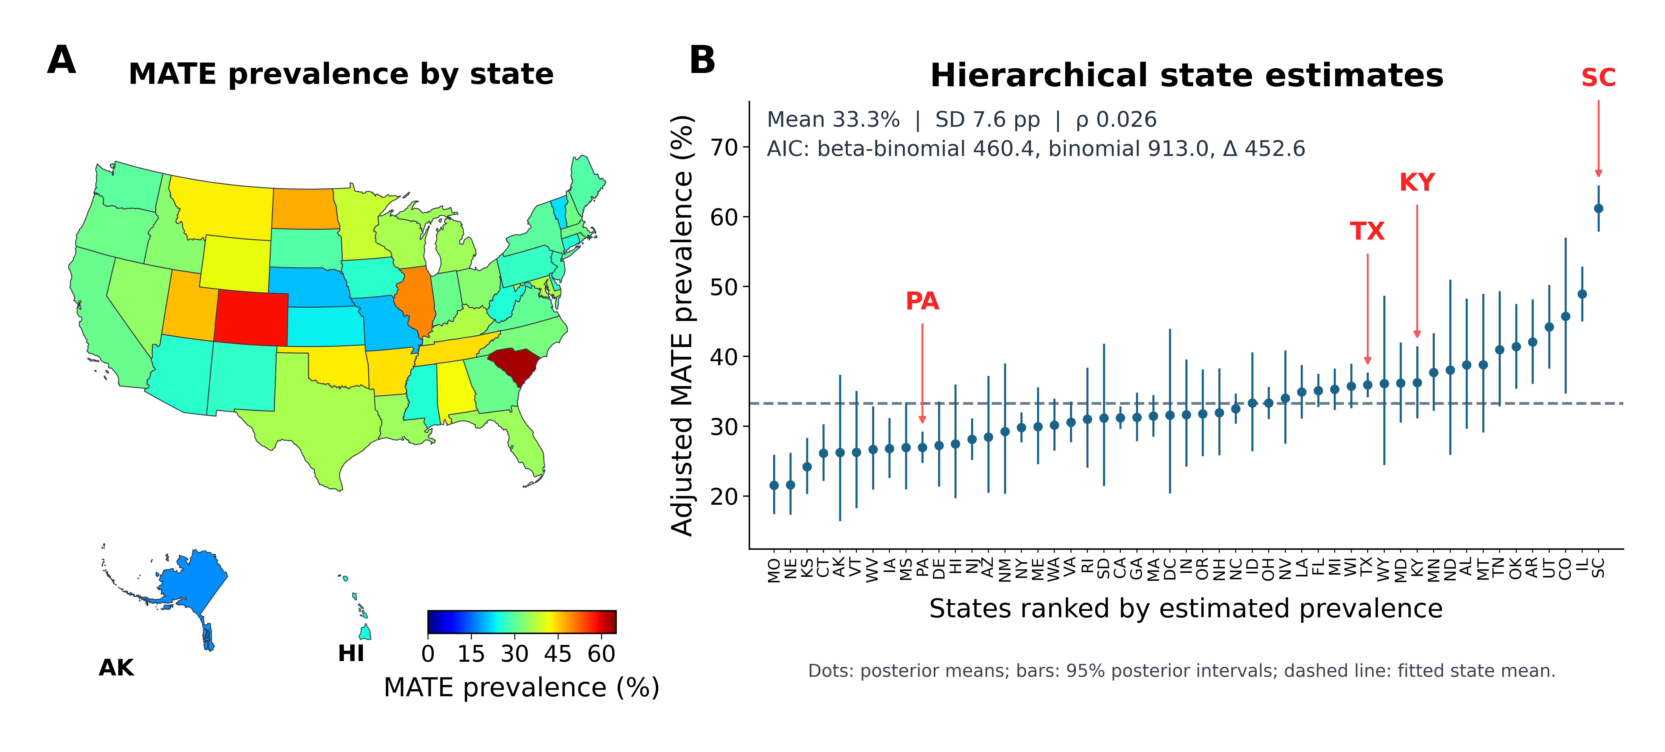
Figure 1. Geographic variation in non-fatal Major Adverse Transplant Episode (MATE). Among 27,031 lung transplant recipients across the 50 states and District of Columbia, 8,995 (33.28%) met non-fatal MATE criteria. (A) The choropleth displays observed state prevalence (MATE cases divided by recipients); no smoothing or risk adjustment. (B) A hierarchical beta-binomial model treats each state MATE count as a binomial observation with an underlying state prevalence drawn from a fitted beta distribution (parameters estimated by maximum marginal likelihood). States are ranked by empirical-Bayes posterior means (dots); vertical bars show 95% posterior intervals conditional on fitted parameters. Smaller cohorts shrink more toward the model mean (dashed line). Inset: Mean (33.3%) is the estimated average underlying state prevalence, not the pooled patient prevalence; SD (7.6 percentage points) measures between-state variation in underlying prevalences beyond binomial sampling variation; and ρ (0.026) is beta-binomial overdispersion (the implied within-state intraclass correlation). AIC (Akaike information criterion; lower is better) equals 460.4 for beta-binomial and 913.0 for a common-rate binomial; ΔAIC (452.6) favors the former. Arrows identify PA, TX, KY, and SC. Geographic comparisons are unadjusted for case mix, center effects, referrals, or differences in EHR capture.

