Beyond Survival After Lung Transplantation: Major Adverse Transplant Episode (MATE) as a Measure of Patient-Centered Recovery
To the Editor:
One-year survival remains a dominant benchmark of success after lung transplantation, but survival alone can obscure large differences in what patients experience. A recipient alive at one year after an uncomplicated recovery is counted identically to one who survives after months in the hospital, dialysis dependence, repeated unplanned admissions, or retransplantation. We propose the Major Adverse Transplant Episode (MATE) as a complementary endpoint intended to distinguish survival from survival without severe sustained morbidity.
MATE was developed as a pragmatic, scalable composite outcome using objective and readily obtainable data elements. In this analysis, MATE is defined by the occurrence of any of the following within the first year after lung transplantation: retransplantation; index transplant hospitalization >90 days; any dialysis/hemodialysis during days 91–365; ≥4 unplanned inpatient readmissions through day 365; or oxygen dependence/oxygen durable-medical-equipment (DME) evidence on or after day 90. These events are intended to capture substantial deviations from expected recovery, cumulative complication burden, or sustained post-transplant morbidity. The corresponding clinical construct, MATE-free survival, is being alive at one year without a major adverse recovery event; its estimation also requires reliable mortality data. MATE is not intended to replace patient-reported quality-of-life (QoL) measures, but to provide an EHR- and registry-ascertainable measure that can be validated against them.
We evaluated national feasibility among 27,469 lung transplant recipients in the Epic COSMOS database [1]. The query was extracted on August 11, 2026. Qualifying procedure records in the source ranged from December 21, 1990, to July 22, 2026, and included recipients of all ages. Index transplantation was defined by the first qualifying procedure code, with at least one year of pre- and post-index observation specified for cohort eligibility. Mortality was not included in this preliminary analysis because reliable vital-status ascertainment was unavailable. Within one year, 730 recipients (2.66%) underwent retransplantation, 525 (1.91%) had an index hospitalization >90 days, 4,113 (14.97%) had dialysis during days 91–365, 4,032 (14.68%) had ≥4 unplanned readmissions, and 3,833 (13.95%) had oxygen dependence after day 90. MATE was identified in 9,124 recipients (33.22%).
Geographic coverage in Epic COSMOS was broad: 27,031 recipients (98.4%) had state attribution across the 50 states and District of Columbia, of whom 8,995 (33.28%) met MATE criteria (Figure 1A). Because state sample sizes varied substantially, geographic heterogeneity was evaluated using a hierarchical beta-binomial model [2] (Figure 1B), which accounts for binomial sampling uncertainty and shrinks estimates from small states toward the population distribution. The estimated mean state prevalence was 33.3%, with a between-state standard deviation of 7.6 percentage points and overdispersion ρ=0.026. The beta-binomial model fit markedly better than a common-rate binomial model (AIC 460.4 versus 913.0; ΔAIC=452.6), indicating heterogeneity beyond sampling variation. Pennsylvania, Texas, and Kentucky had raw prevalences of 26.81%, 35.96%, and 36.61%; corresponding shrinkage-adjusted estimates were 26.97% (95% posterior interval 24.76%–29.23%), 35.92% (34.17%–37.69%), and 36.24% (31.16%–41.48%), respectively. Heterogeneity remained substantial after excluding South Carolina, the highest-prevalence state (between-state SD 6.1 percentage points; ΔAIC=180.0). These estimates remain descriptive and unadjusted for case mix, center effects, EHR capture, or referral patterns and should not be interpreted as comparative state or center performance.
MATE also differs from perioperative “textbook outcome” (TO), which has been proposed as a composite quality metric in lung transplantation and cardiothoracic surgery [3–5]. TO primarily summarizes an ideal perioperative course; a recipient may fail TO because of an early complication yet recover fully, while another may have an uncomplicated index hospitalization but subsequently develop complications and experience MATE. MATE therefore addresses a different target: patient-centered recovery across the first post-transplant year, with potential applications in comparative effectiveness research, quality improvement, and future risk-adjusted program-level benchmarking after external validation.
The key next step is prospective validation in the PROMISE Study Lung Transplant Consortium. We propose testing whether MATE status and burden at one year are associated with established patient-reported measures including LT-QOL, SF-12, and EQ-5D-5L, and whether MATE adds information beyond survival for subsequent mortality, graft dysfunction, healthcare utilization, and functional independence.
Limitations. This analysis is a feasibility study. EHR ascertainment may miss care delivered outside participating systems, and utilization-based components can reflect local practice patterns as well as patient health. The hierarchical state analysis accounts for sampling variability but remains unadjusted for case mix, center effects, EHR capture, or referral patterns and should not be interpreted causally. Oxygen prescription or DME evidence after day 90 does not necessarily establish persistent oxygen dependence. The components and their thresholds require external validation and patient input. Finally, death and missing patient-reported outcomes can induce selection and attrition bias; prospective analyses must prespecify the estimand and sensitivity analyses for these mechanisms [6].
As lung transplant survival improves, the relevant question increasingly becomes not simply whether a patient survives, but how that survival is experienced. MATE-free survival offers a transparent and scalable framework for quantifying that distinction using routinely collected clinical data.
References
1. Tarabichi Y, Frees A, Honeywell S, et al. The Cosmos Collaborative: A Vendor-Facilitated Electronic Health Record Data Aggregation Platform. ACI Open. 2021;5(1):e36-e46. doi:10.1055/s-0041-1731004.
2. Marshall RJ. Mapping disease and mortality rates using empirical Bayes estimators. J R Stat Soc Ser C Appl Stat. 1991;40(2):283-294. doi:10.2307/2347593.
3. Halpern SE, Moris D, Gloria JN, et al. Textbook Outcome: Definition and Analysis of a Novel Quality Measure in Lung Transplantation. Ann Surg. 2023;277(2):350-357. doi:10.1097/SLA.0000000000004916.
4. Krischak MK, Au S, Halpern SE, et al. Textbook surgical outcome in lung transplantation: Analysis of a US national registry. Clin Transplant. 2022;36(4):e14588. doi:10.1111/ctr.14588.
5. Magouliotis DE, Androutsopoulou V, Zotos PA, et al. Beyond Mortality: Textbook Outcome as a Novel Quality Metric in Cardiothoracic Surgical Care. J Clin Med. 2025;14(21):7660. doi:10.3390/jcm14217660.
6. Jones M, Mishra GD, Dobson A. Analytical results in longitudinal studies depended on target of inference and assumed mechanism of attrition. J Clin Epidemiol. 2015;68(10):1165-1175. doi:10.1016/j.jclinepi.2015.03.011.
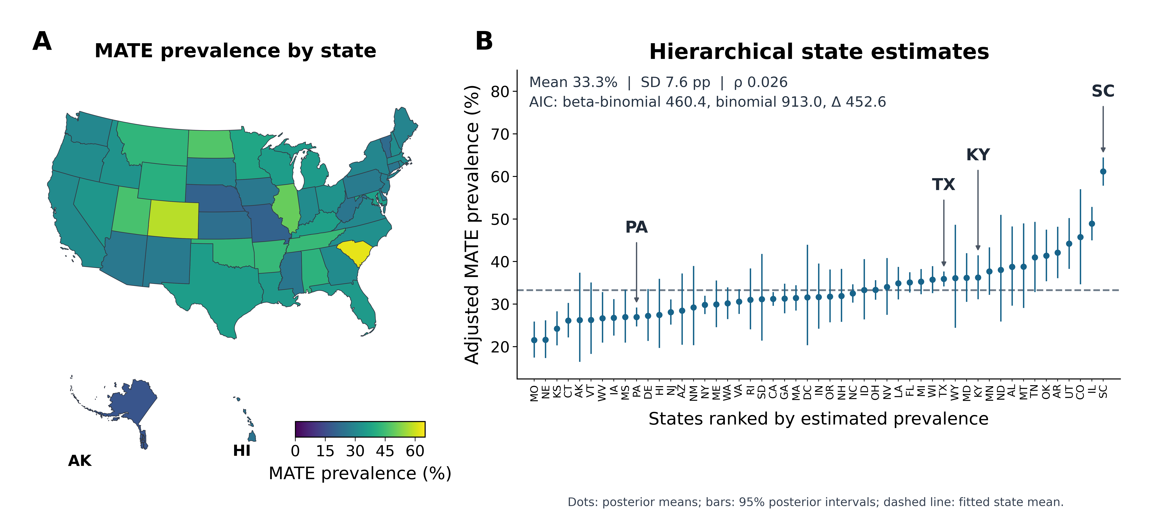
Figure 1. Geographic variation in Major Adverse Transplant Episode (MATE). Among 27,031 lung transplant recipients across the 50 states and District of Columbia, 8,995 (33.28%) met MATE criteria. (A) The choropleth displays observed state prevalence (MATE cases divided by recipients); no smoothing or risk adjustment. (B) A hierarchical beta-binomial model treats each state MATE count as a binomial observation with an underlying state prevalence drawn from a fitted beta distribution (parameters estimated by maximum marginal likelihood). States are ranked by empirical-Bayes posterior means (dots); vertical bars show 95% posterior intervals conditional on fitted parameters. Smaller cohorts shrink more toward the model mean (dashed line). Inset: Mean (33.3%) is the estimated average underlying state prevalence, not the pooled patient prevalence; SD (7.6 percentage points) measures between-state variation in underlying prevalences beyond binomial sampling variation; and ρ (0.026) is beta-binomial overdispersion (the implied within-state intraclass correlation). AIC (Akaike information criterion; lower is better) equals 460.4 for beta-binomial and 913.0 for a common-rate binomial; ΔAIC (452.6) favors the former. Arrows identify PA, TX, KY, and SC. Geographic comparisons are unadjusted for case mix, center effects, referrals, or differences in EHR capture.

