**Description**

The data is collected from the Forex Market, you are tasked to predict the future. Our hunting target is the most liquid (most traded) currency in the world -- EUR/USD, and fortunately you only need to prediction the Up or Down of this currency pair and we provide you with data containing information from 2008-01-01 to 2018-03-19, which we got from www.dukascopy.com Historical Data Feed.

Given historical currency performance and a lot of pricing features and most basic knowledge about market hours, can you predict the up and down of that day without being deceived by all the noise? And Forex market comes different from stock market for its unique global market. It may stay at a price for a while without a single trade for several minutes or even hours and then move dramatically as people starting to trade it more frequently.

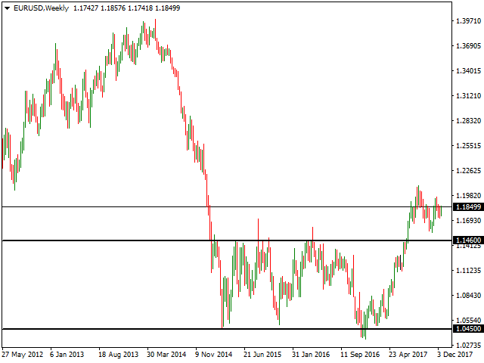

**Datasets**

In our dataset, we collected 5-min Bid price of EUR/USD from 2008-01-01 to 2018-03-19, and each 5-min price comes with over 200 features containing pricing, volatility and volume information of different kinds. And to help you have a better understanding of the dataset and to just try out some experiments, we also provided a much smaller subset of data.

The list of fields is below:

**Gmt time**: timestamp, marked as the starting time of that 5 min period;  
**Open**: Open price of that 5 min period;  
**High**: High price of that 5 min period;  
**Low:** Low price of that 5 min period;  
**Close**: Close price of that 5 min period;  
**Volume**: trading volume of that 5 min period, millions;  
**Body**: the length of body of candlestick plot;  
**Upper_tail**: the upper tail of candlestick plot;  
**Lower_tail**: the lower tail of candlestick plot;  
**SMA_50**: simple moving average of last 50 time periods;  
**SMA_20**: simple moving average of last 20 time periods;  
**ATR**: technical indicator ATR of last 50 time periods, a measure of volatility;  
**CCI**: technical indicator CCI of last 20 time periods;  
**SAR**: technical indicator SAR, a measure of trend;  
**Hour**: which hour the data was collected;  
**min**: which minute the data was collected;  
**Dayofweek**: the day of week the data was collected;  
**JPY**: if JPY started active trading;  
**AUD**: if AUD started active trading;  
**EUR**: if EUR started active trading;  
**GBP**: if GBP started active trading;  
**USD**: if USD started active trading;  
**return_1**, **return_2**,..., **return_96**: currency return during last 5 mins, 10 mins, 15 mins,…, 8 hours;  
**lag_return_1**, **lag_return_2**, …, **lag_return_96**: currency return before 5 mins, 10 mins, 15 mins,…, 8 hours;

**Evaluation**

Once the model can score a test data set, the result set should be submitted to the project/contest by selecting the Add a Submission button and upload the result.

The result will be scored and ranked based on the accuracy of the test result, which is the number of correct classified instances divided by the total number of instances.