These guidelines do not replace CONTRIBUTING.md, but enhance it for visually gifted contributors. For definite rules, please follow CONTRIBUTING.md on zeromq/zproject.

First visit github.com and login (you have to create and account it you don’t have one yet).

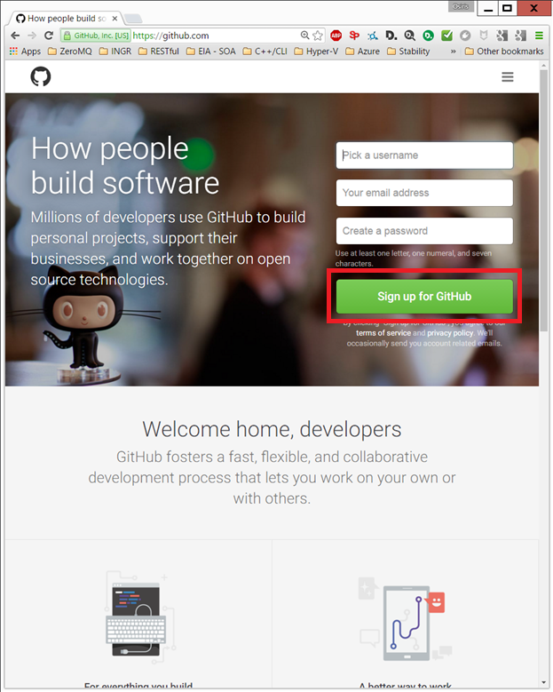

Sign in and then visit [github.com/zeromq/zproject](https://github.com/zeromq/zproject).

At the top right there is button fork with a count of how many forked versions there are.

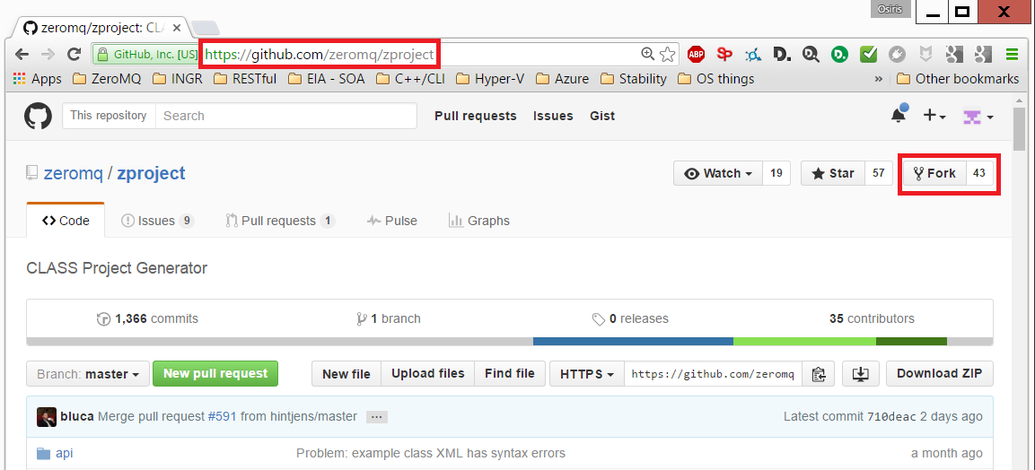  
Click on the Fork button and it will offer an icon with the account you are logged in in github.

If you have more than one account, it will ask which one you would like to use as the target for the fork:

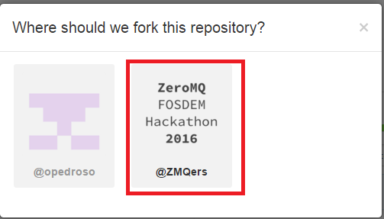  
Click on the selected one and the fork in be done in a few seconds.

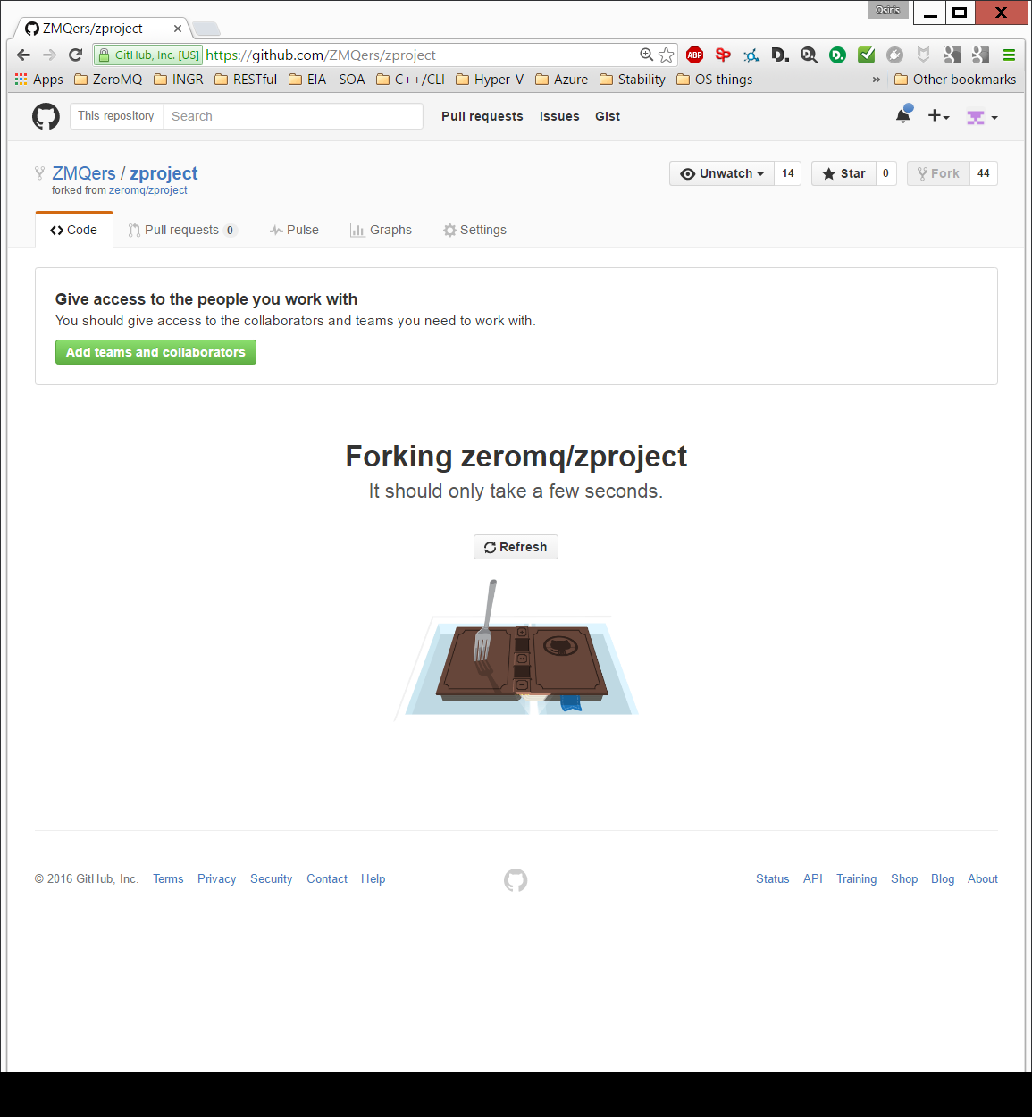

Then clone your forked repository to your disk (notice that you are cloning from ZMQers, not zeromq directly):

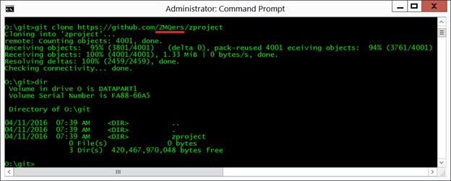

Change directory to the local clone and do a git remote add upstream zeromq/zproject, linking your forked project to the zeromq/zproject master:

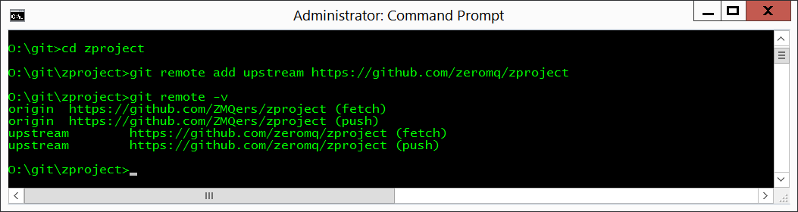

Then make your change to the local cloned copy of the source. Once you are happy with your changes, do git status to see what files your changes. In my case, I am adding this guide (CONTRIBUTING.docx) and adding reference to it in the zproject/README.txt (which then gets generated into README.md, both of which have to be checked in).

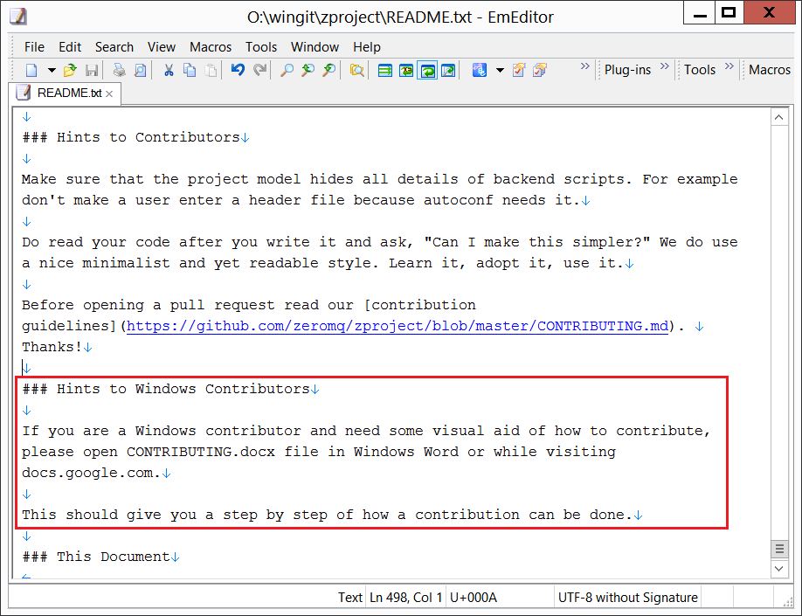

When done, do a git add [modified files], git commit and always enter the commit comments in this form (Problem line: line should not have more than 72 chars, Solution block lines should not have more than 80 chars; you can use [markdown](http://markdown-here.com/) in your text):

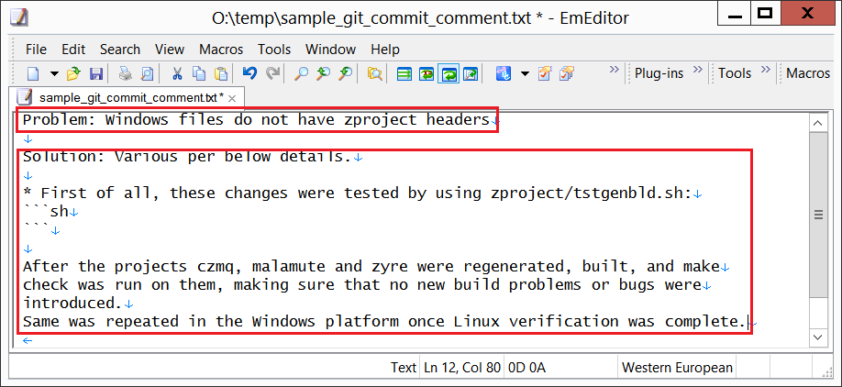

The back at [github.com/ZMQers/zproject](http://github.com/matjaz/zproject) you will see that it says a change was made and that it can be merged to zeromq/zproject.  
Then make your push request (button by message that says you made a change).  
Wait a couple of minutes and somebody with write rights will merge it to zeromq/zproject master.

You will get an email that your pull requested was merged and that is has become part of the master.