Contents

Three core facts: 1

Accounting equation 1

Expanded accounting equation 1

Financial statement 2

Income statement: 2

# 

# Three core facts:

1. Asset:

Asset has future value.

Asset Example (short terms): They make us benefited for a limited period.

* Cash
* Supplies:

Raw materials, paper cutter like small instruments

* Prepaid insurance/rent(previously paid for a certain period)
* Inventory/merchandise(products)

Asset Example (long terms) -> more than 5 years:

* Land
* Building
* Transport(company owned)
* Equipment

Accounts receivables (cash, Inventory, raw materials) can be short term/long term asset. It depends on duration of paying.

1. Liability:

Liability is promise/ responsibility to others.

There are two types of Liability like asset.

Short term:

* Accounts payable
* Notes payable.
* Interest payable
* Unearned revenue->If we get revenue from the buyer before supplying product/inventory (bus ticket)

1. Owners’ equity (self-proprietor)/ stock holders’ equity(limited company):

# Accounting equation

Asset=liability+ owners’ equity

# Expanded accounting equation

Asset=liability+ owners’ equity+ revenue-expenses

# 

# Financial statement

1. Income statement/Statement of comprehensive income
2. Equity statement/Statement of changes in equity
3. Balance sheet/ statement of financial position
4. Cash flow statement

# Income statement:

|  |  |  |
| --- | --- | --- |
| Leads corporation  Statement of comprehensive income  For the year ended December 2017 | | |
| **Revenue** |  |  |
| Service revenue |  | 500000000 |
| **Expenses** |  |  |
| Salaries | 200000000 |  |
| Rent | 100000000 |  |
| **Total expense** |  | 300000000 |
| **Net income** |  | 200000000 |

# Debit and credit against heads:

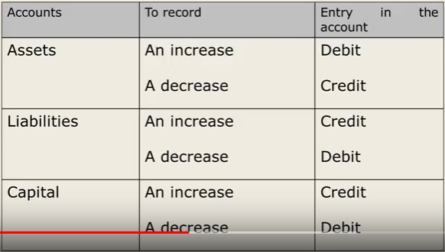

Asset, drawing, expense:

For increase-debit

For decrease-credit

Liability, Owners equity, revenue:

For increase-credit

For decrease-debit