Contents

Class Hierarchy 2

Checked Exception- 3

Unchecked Exception- 3

Quotes 3

Throws and throw 4

# Class Hierarchy

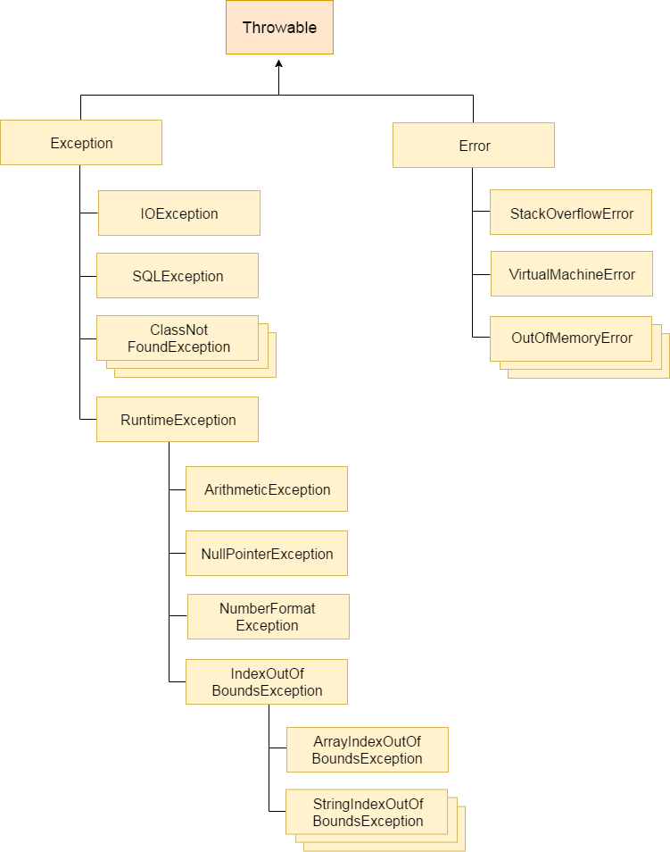

## Checked Exception-

> Shows compile time error message

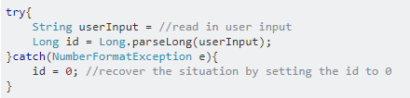

# Unchecked Exception-

> Shows runtime error message

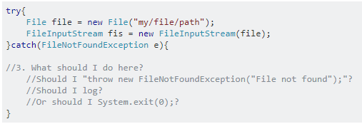

# Quotes

Joshua Bloch in "Effective Java" said that

Use checked exceptions for recoverable conditions and runtime exceptions for programming errors (Item 58 in 2nd edition)

# Throws and throw

