- INTRODUCTION

The aim of this paper is to compare the forecast performance of three structural econometric models; the ARIMAX model, the Kalman filter model and the non-parametric model in predicting stock market returns in South Africa, as a case study of an emerging economy. The regressors used in each of the models follow the specification suggested by Pesaran and Timmermann (1994, 1995). Nonetheless, this paper extends this specification by including the US stock return (S&P 500) as an important additional variable for explaining stock returns in an emerging economy. The comparison of the forecasting performance of the three structural econometric models is applied to the South African data as an example of an emerging economy. The proposed models have different functional forms or statistical representations and convey information on the relevance of specific explanatory variables to explain stock returns in South Africa. Each of the structural econometric models accounts for specific characteristics and properties of stock returns in general and in an emerging economy in particular. For example, the notion that stock returns are non-normally distributed should indicate the importance of the use of a distribution-free method with a non-parametric model to predict stock returns. In addition, the proposed models are multivariate and emphasise the role of the US stock market returns, among other macroeconomic and financial covariates, in modeling stock returns in emerging economies. This in line with the findings of many studies that emerging stock markets are influenced by advanced economies stock markets such as the US stock market (Bonga-Bonga and Makakabule, 2010).
Contrary to a number of studies that indicate the inability of structural models to outperform naïve models in forecasting economic and financial variables (Steiner and wallmeier, 1999; Duffee, 2002 and Ang and Piazzesi, 2003) ), this paper shows that structural econometric models that account for relevant characteristics and properties of stock returns do have a good forecasting performance. Moreover, the paper extends the studies by Pesaran and Timmermann (1994, 1995) by making use of multivariate models with three different functional and statistical representations that reflect the characteristics and properties of stock returns to model and predict stock returns in an emerging economy. Thus, linear, nonlinear and non-parametric functional forms are used to model and predict stock market returns in South Africa, as case study of an emerging economy. Both linear and nonlinear models belong to the class of parametric models.

The proposed linear functional specification is based on the ARIMAX (Autoregressive Integrated Moving Average-X) model, which is an ARIMA model augmented with exogenous variables. The ARIMAX model incorporates the characteristics of a long or short memory of stock returns and the importance of macroeconomic and financial variables in modelling stock returns. A number of studies support the characteristic of short or long memory depicted by stock markets returns (Cheung and Lai, 1995; Barkoulas and Baum, 1996; Henry, 2002) as well as the importance of macroeconomic variables in explaining stock market returns (Pesaran and Timmermann, 1995). By combining these two characteristics, ARIMAX model should be an important contender structural econometric model to predict stock returns in general and in emerging economy in particular. The nonlinear functional form used in this paper is based on the Kalman filter model, which is a time-varying parameter model that accounts for a nonlinear reaction of stock returns to macroeconomic variables (Bonga-Bonga and Makakabule, 2010). Moreover, the paper makes use of a non-parametric model as a distribution-free model, to circumvent the difficulty related to the choice of a specific functional form when modelling stock returns.

Thus, the contribution of this paper is twofold; firstly, it provides an insight on the important determinants of stock returns in an emerging economy such as South Africa. Secondly, by comparing the forecasting performance of the different proposed structural econometric models, the paper not only provides an insight as to which of the models is appropriate to predict stock returns but also conveys important information as to which characteristic of stock returns is dominant in an emerging economy, such as South Africa. Contrary to a number of studies that focus on univariate models in predicting stock market returns in South Africa, such as Bonga-Bonga and Mwamba (2010), this paper extends these studies by making use of multivariate models with different functional representations in order to identify the different drivers of stock returns and determine the predictive power of the different models in forecasting stock market returns in South Africa. Moreover, contrary to studies that made use of multivariate models to predict stock returns (Gupta et al., 2013; Pesaran and Timmermann, 1995), this paper compares the forecasting ability of the different structural econometric models that account for relevant characteristics and properties of stock returns.
It is important to note that the prediction of stock returns has been one of the most controversial topics in finance and economics. The controversy emanates mostly from the efficient market hypothesis paradigm, that is, securities markets reflect full information about individual stocks as well as public information, and these two sets of information are instantaneously incorporated into the security prices. The consequence of this paradigm is that stock prices are unpredictable and that investors are unable to achieve returns greater than those that could be obtained by holding a randomly selected portfolio of individual stocks (Malkiel, 2003). Notwithstanding the implication of the efficient market hypothesis and its consequence for the predictability of stock prices, empirical studies have discovered a number of patterns in stock prices that contradict the efficient market paradigm (see Malkiel, 2003 and Schwert, 2002 for critical surveys). For example, Lo and Mackinlay (1999) demonstrate that there is some degree of predictability in short-run stock prices due to the fact that stock prices do not behave as true random walks. The authors show that stock prices tend to move successively in the same direction, a pattern that can be exploited to make stock prices predictable.
Investors can benefit from the knowledge of the variables or drivers of stock returns or prices as they can anticipate any changes in those variables by relocating their portfolio. In addition, a good model selection of stock return predictability may provide guidance for proper portfolio allocation that may result in economic profit (Bonga-Bonga and Muteba Mwamba, 2011).
A large amount of literature has focused on the predictability of stock returns based on a combination of variables that reveal the evolution of financial markets and the macro-economy. Macroeconomic variables such as the aggregate wealth ratio, inflation rate and output are widely found to have predictive power for movement of stock returns (Campbell and Thompson, 2008; Hjalmarsson, 2004). Likewise, financial variables such as short-term interest rates, dividend yields and the term structure of interest rate spreads are among the important predictors of stock returns (Fama and Schwert, 1977; Campbell, 1987). Moreover, there are theoretical and empirical rationales supporting the use of macroeconomic variables in predicting stock returns. For example, Rapach, et al. (2005) indicate that macroeconomic variables influence the firm’s expected cash flows as well as its rate of discount, which are the important determinants of stock returns. In addition, a number of studies have indicated the importance of financial variables in predicting stock returns. For example, the dividend ratio model introduced by Dow (1920) has a long tradition in finance for the determination of stock returns.

Regarding functional form of stock return models, a number of authors support the use of time-varying models to represent and predict stock returns (Pesaran and Timmerman, 1995; Kanas, 2005; McMillan, 2004; McMillan and Speight, 2007). The choice of time-varying representations for stock returns is in line with an intertemporal equilibrium model of the economy, a model that supports the principle of time variation in determining equilibrium in the economy. For Pesaran and Timmerman (1995), the possibility that stock returns are time-varying should be consistent with the efficient market hypothesis. Moreover, in support of the use of a time-varying functional form to represent stock return models, Pesaran and Timmermann (1994, 1995) indicate that the use of a recursive model for predicting excess returns is sound and capable of correctly predicting the signs of the actual stock returns.

While there is considerable support for time-varying models for predicting stock returns, the different possible nonlinear or time-varying models make the choice of the appropriate model for stock returns cumbersome. Nonetheless, a number of authors have circumvented this problem with the application of the Bayesian Model Averaging methods (Avramov, 2002, Cremers, 2002). Moreover, another important way to circumvent the difficulty attached to the correct functional form of parametric model in general and time-varying model in particular is the application of non-parametric models. Unfortunately, a limited number of studies on developed and emerging market economies have addressed model uncertainty issues in predicting stock returns through the use of non-parametric models (Bonga-Bonga and Muteba Mwamba, 2011; Campbell and Yogo, 2006; Chung and Zhou, 1996). It is important to note that there are studies that have demonstrated the importance of a linear model in forecasting stock returns (Pointiff and Schall, 1998; Whitelaw, 1994). Thus, the selection of the right model for the prediction stock market returns in emerging market should be a matter of empirical analysis.

Another uncertainty related to the prediction of stock returns in the context of multivariate models is the choice of appropriate variables that determine and predict stock returns. A plethora of studies have documented the ability of the different variables that are capable of explaining movements in conditional expected stock returns (see Hawawini and Kein, 1995, for a survey of the literature). However, consensus has not been reached as to which variables are relevant to be included as regressors in stock returns equations. Nonetheless, in the context of this paper, use is made of the macroeconomic and financial variables proposed by Pesaran and Timmermann (1994, 1995) namely, interest rates, the dividend yield and inflation rates to explain stock returns. Pesaran and Timmermann (1995) justify the choice of these variables by their ability to directly or indirectly influence the equity risk premium. Moreover, the authors support the choice of these variables based on selection criteria, such as the Akaike and Schwarz information criteria. However, it is important to note that Pesaran and Timmermann (1994, 1995) suggest that these variables should be used in the context of a developed economy such as the US. For the purposes of the present study, which focuses on a small open economy, we suggest that an additional variable be added to those suggested by Pesaran and Timmerman (1994, 1995). This additional variable is the US stock market return. The reason for adding this variable is that a number of studies have documented the dependence of emerging market stock returns on the US stock returns and the risk of contagion that threatens emerging markets due to crises in the US (Didier, et al, 2007; Forbes et al. 2002 and Bonga-Bonga, 2011).

The remainder of the paper is arranged as follows: section 2 presents the methodologies used in the paper while section 3 discusses the data, estimation and the forecasting performance of the Kalman filter and non-parametric methods. Section 4 concludes the paper.

- METHODOLOGY
- Non-parametric Kernel Regression
A parametric regression model is often presented as in Equation 1 below, where and 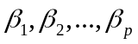 are parameters that need to be estimated by ordinary least square (OLS) or maximum likelihood (ML) methods, and 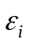is the error term. Parametric regression analysis requires not only the estimation of the model parameters but also a prior knowledge of the functional form of the model. The example model shown in Equation 1 below is a priori assumed to be linear in parameters. This prior knowledge of the functional form of the regression model as well as the assumption made about the probability distribution of the error terms make parametric regression models prone to misspecification and erroneous distributional assumptions.
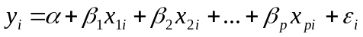 (1)
The two most commonly used methods of parameter estimation in regression analysis namely, the OLS and the ML, assume that the probability distribution of error term is normal. This strong assumption may overlook the occurrence of extreme events during financial crisis (Harvey and Newbold, 2003; Peiró, 1999). Nonetheless, the non-parametric regression model does not make such distributional assumption on the error term. Instead it assumes that the unknown probability distribution of the error term is approximated by what is termed the “kernel function” – hence the term “non-parametric kernel regression”. A kernel function is an estimator of the empirical distribution (of the underlying data) that satisfies three basic criteria: firstly, it must integrate to 1 in order to represent the unknown probability distribution; secondly, it must be symmetric from its mean and have a finite variance. Lastly, it does not require a prior knowledge of the functional form of the conditional mean (and variance). Therefore, in this paper we use the following expression to represent a regression model in the non-parametric framework.
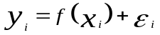 (2)
It is assumed that 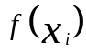 is at least a single differentiable polynomial of degree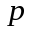, meaning that if is linear, then its first derivative will be constant and Equation 1 will nest a linear regression model. In contrast, if is not linear then its first derivative will not be constant, thus, Equation 2 will nest a non-linear regression model. When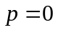, Equation 2 nests a local constant kernel regression model, also known as the Nadaraya-Watson model (Nadaraya, 1964). When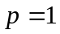, Equation 2 nests a local linear kernel regression model. It is worth noting that one does not need to make any a priori choice between the two competing types of kernel regression; the data itself suggests the appropriate kernel model from the two.
Unlike the parametric model represented in Equation 1, the non-parametric regression model in Equation 2 does not have parameters to be estimated by OLS or ML. However, two keys inputs are essential to non-parametric modelling, namely:
- The multivariate kernel function 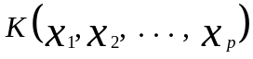 that replaces the unknown
probability distribution.
- The smoothing parameter or bandwidth 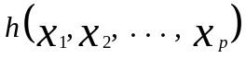that describes the
smoothness of the empirical probability distribution.
The non-parametric kernel regression model in Equation 2 is estimated from the following minimisation problem:
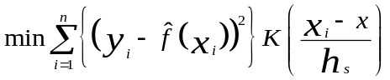 (3)
Where 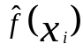 is the polynomial of degree equal to zero (for Nadaraya model) or one (for local linear model). 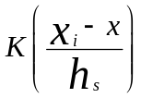 is the multivariate kernel function with 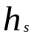as a multivariate bandwidth: the only parameter that needs to be estimated in non-parametric modelling using the least square cross-validation method, with 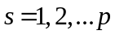. The least square cross validation approach to bandwidth selection consists of choosing those bandwidths that minimise the following cross-validation function:
(4)
Note that Equation (4) only involves the estimation of the leave-one-out 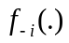 and not its derivatives; therefore we only need the conditions on 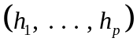that ensure consistent estimation of the derivatives of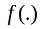. Li and Racine (2004) show that the bandwidths 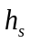obtained by the cross-validation method are optimal and that the squares cross-validation method should select large values of when is a linear and relatively small value of when is non-linear.

- Kalman filter model
The Kalman filter is a recursive procedure for computing the optimal estimator of the state vector at time t based on information available at time t, including information contained in the observed variables (Harvey, 1989). The state space model underlying the Kalman filter is the following:
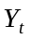 = H_{t}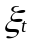+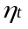 (5) representing the observation, signal or measurement equation.
=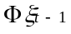+ (6) representing the transition or state equation.
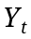 is the observation on the system, 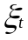 is the state vector and Ht and Φ are given parameters. The random variables 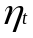 and 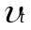 represent the measurement and state disturbance (noise), respectively.
p() ~ NID (0,Q)
p() ~ NID (0,R)
p() and p() are the probability distribution of the errors and respectively and
Q is the covariance of the measurement, while R is the covariance of the state noise.
If we assume that 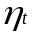 is normally distributed, then the model is a linear Gaussian state-space model. Thus, the distribution of 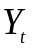conditional on 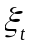and 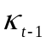, where 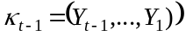, is given as:
Where H_{t}is the mean of the Gaussian distribution and 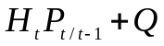 the variance of the distribution. 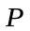is the mean square error matrix of the state variable such as:
Hamilton (1994) shows that parameters in the Kalman filter model are obtained by maximising the log likelihood function, given in Equation 9, with respect to the parameters in the matrices 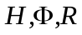and . Where 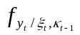 is the density function of conditional on past information on observed and state variables.

- ARIMAX models
Given the following ARIMA(p,d,q) model:
(10)
Where 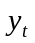is a given time series and 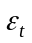is a white noise process.
An ARIMAX model is expressed as
(11)
Where 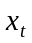is a covariate at time and 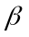is its coefficient. This specification indicates that with regards to ARIMAX models, the dependent variable is explained by its past evolution, by the effects of past shocks and other covariates. With more information provided by ARIMAX models compared to the class of ARIMA models, ARIMAX model may provide a better forecasting performance than a number of univariate models.
- DATA, ESTIMATION AND DISCUSSION OF RESULTS
As stated earlier, this paper endeavours to assess the prediction accuracy of stock market returns from three different multivariate structural models. To this end, the forecast performance of the Kalman filter model, the ARIMAX model and the non-parametric kernel regression model are compared among them. To assess whether the prediction performance of stock market returns depends on the sampling of the data, the paper makes use the monthly and quarterly frequencies over the period January 1970 and September 2011. The data used is as follows:
- Interest rate spread (SPREAD) represented by the difference between the yields on the ten-year government bond and the three-month treasury bill;
- The dividend yield (DIVALSI) related to the all-share index on the Johannesburg Stock Exchange;
- The stock return in the US (USRET) represented by the first difference of the natural logarithm of the S&P 500 and
- The South African stock returns (RET), computed as the first difference of the natural
logarithm of the all-share index.

The results of the Dickey-Fuller Generalised Least Square (DF-GLS) unit root test reported in Table 1 show that the null hypothesis of unit root is rejected at 1% or 5% levels for all the variables, thus, all the variables are stationary. The DF-GLS unit root is chosen because of its improved power over the traditional augmented Dickey-Fuller (ADF) test (Lai, 2008).

Table 1. DF-GLS unit root test

Variables |  | t-statistics (Monthly) |  |  | t-statistics (Quarterly)
SPREAD |  | 3.5987*** |  |  | 3.2829***
USRET |  | 18.1303*** |  |  | 10.1211***
RET |  | 3.4800*** |  |  | 2.3739**
DIVALSI |  | 2.0604** |  |  | 2.0399**
*** and ** denote rejection of the null hypothesis of unit root at 1% and 5% levels, respectively
Basic descriptive statistics reported in Table 2 below show that the null hypothesis of normality is rejected in all series except the spread at both monthly and quarterly levels, and that the stock market returns are very close to zero compared with that of the dividend yield and the interest rate spread. While the rejection of normality may suggest the use of a non-parametric model, however, it is important to note that use can be made of the quasi maximum likelihood estimation method, which maximises a simplified version of the actual log-likelihood function of both the data and the model for parametric estimation (Lindsay, 1988). In addition, the log-likelihood method can still be used for parametric estimation under the limit theorem hypothesis in the case of large sample observation as in this paper.
The results of the maximum likelihood estimation for the Kalman filter method for the monthly data are represented in Table 3. The in-sample estimation is based on the periods January 1970 to December 2003 from the following representation:
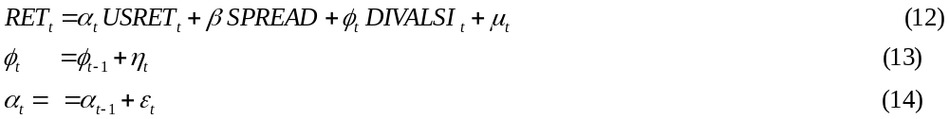
Table 2: Descriptive statistics

 | RETJSE |  | DIVALSI |  | RETSP500 |  | SPREAD
 | Quarterly | Monthly | Quarterly | Monthly | Quarterly | Monthly | Quarterly | Monthly
Mean | 0.0303 | 0.0044 | 4.2638 | 4.2522 | 0.016 | 0.0023 | 1.69 | 1.6554
Std Dev | 0.1201 | 0.0283 | 2.0031 | 1.9872 | 0.0823 | 0.0187 | 2.6025 | 2.5623
Kurtosis | 1.2271 | 2.3325 | 0.3572 | 0.2438 | 1.6113 | 3.1372 | -0.1981 | -0.2643
Skewness | -0.2979 | -0.8222 | 1.043 | 1.0213 | -0.8408 | -0.9386 | -0.3021 | -0.3295
Count | 167 | 499 | 167 | 499 | 167 | 499 | 167 | 499
J-B Stat | 11.7081 | 165.599 | 30.411 | 87.3204 | 35.5649 | 271.852 | 2.8557 | 10.5347
J-B Pbty | 0.0029 | 0 | 0 | 0 | 0 | 0 | 0.2398 | 0.0052
The above specification is based on the fact that a number of studies support the time-varying response of stock returns to the changes in dividend yields (Bonga-Bonga and Makakabule, 2010; Campbell and Diebold, 2009 and Chang, 2009)..
Tables 3 reports the result of the maximum likelihood estimation of Equations 12, 13, and 14 for coefficients that are statistically significant. This result is confirmed with Figure 1 and shows that stock returns in South Africa are positively related to stock returns in the US. Nonetheless, the coefficient of DIVALSI, although time-varying, is not statistically different to zero for most of the in-sample periods.
Table 3. Kalman filter estimation for monthly data

 | Dependent Variable: RET
Regressors |  |  |  |  | Coefficients
USRET |  |  |  |  | 0.611”
“ indicates the estimation of the final state coefficient of USRET.
Moreover, the results of the quarterly estimation of equations 12, 13 and 14 reported in Table 4 show that stock returns in the US and interest spread explain stock returns in South Africa.
Table 4. Kalman filter estimation for quarterly data

 | Dependent Variable: RET
Regressors |  |  |  |  | Coefficients
USRET  SPREAD |  |  |  |  | 0.6846”  0.0059*
“ indicates the estimation of the final state coefficient of USRET. * denotes statistically significant at 10% level

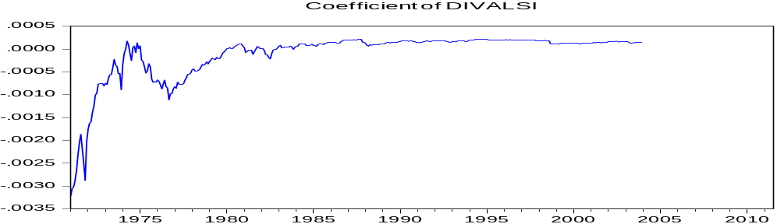

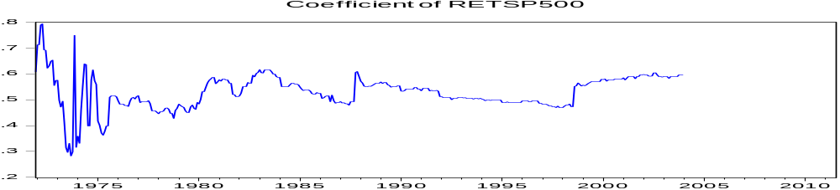
Figure 1 time-varying coefficients of USRET and DIVALSI
The importance of S&P 500 in predicting stock returns in South Africa is also confirmed with the results of the non-parametric kernel regression significance test based on the periods January 1970 to December 2003, as in Tables 5 and 6. It is important to note that this paper employs the resampling techniques proposed by Racine (1997) to obtain the null distribution of the test statistics based on non-parametric estimates of partial derivatives. Thus, the results reported in Tables 5 and 6 are obtained by generating 400 samples of the same size using the bootstrapping technique. As resampling techniques necessitate the estimation of the bandwidth for the non-parametric test of significance, the bandwidth estimations for each of the explanatory variables are reported along with the kernel regression significance test probability values (P-value). Tables 5 and 6 report the results of the coefficients that are statistically significant at 1% and 5% levels.

Table 5. Bandwidth and P-Value of the non-parametric test of significance: Monthly data

 | Dependent Variable: RET
Regressors |  |  |  | Bandwidth | P-Value
USRET |  |  |  | 0.096 | 0.0000

The bandwidths reported in Tables 5 and 6 are obtained by minimising the cross-validation function as in Equation 4. The estimated bandwidths reported in Tables 5 and 6 are optimal for each regressor, given that they have indeed smoothed the kernel density of each time series. Figures A1 and A2 in the appendix show how the kernel density of the statistically significant explanatory variables has been smoothed, given each one’s respective estimated bandwidth. The gradients of the explanatory variables for the quarterly estimation are reported in Figure A3 and show that they are time varying.
The ARIMAX estimation of the monthly data shows that the ARMAX (1,1) is the best model based on the Akaike Information Criteria (AIC) . Table 7 presents the estimation of the ARIMAX model for monthly data.
Table 6. Bandwidth and P-Value of the non-parametric test of significance: Quarterly data

 | Dependent Variable: RET
Regressors |  |  |  | Bandwidth | P-Value
USRET |  |  |  | 0.085 | 0.0005
DIVALSI |  |  |  | 0.927 | 0.09

Table 7 Estimation of the ARIMAX model for monthly data

 | Dependent Variable: RET
Regressors |  |  |  |  | Coefficients
USRET  RET(-1)  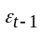 |  |  |  |  | 0.595***  0.913***  -0.901***
*** denotes significant levels at 1% level
While USRET remains an important variable that explains the stock returns in South Africa, the results reported in Table 7 show the importance of recent past stock return (one lag) and recent past shocks in explaining current stock returns in South Africa. This reality indicates the short memory as well as the Markov property of stock returns in South Africa for monthly data. As the Markov property of stock returns is established through the ARIMAX model for monthly data, this entails that ARIMAX model for quarterly data should have a very weak AR process. This is confirmed with the quarterly results reported in Table 8 where the AR(1) process is only statistically significant at the 10% level. Moreover, the results reported in Table 7 indicate the ability of the South African stock market to bounce back or to correct from past negative shocks. This is evident with monthly data.
Table 8 Estimation of the ARIMAX model for monthly data

 | Dependent Variable: RET
Regressors |  |  |  |  | Coefficients
USRET  SPREAD  RET(-1)  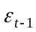 |  |  |  |  | 0.661***  0.0066**  0.673*  0.717**
***, ** and * denote significant levels at 1% , 5% and 10% levels, respectively..
The estimated structural models indicate the importance of the US stock returns in explaining stock returns in South Africa, an emerging economy. The US stock returns is the only variable explaining stock returns in South Africa for monthly data. These findings show that in the short-term (monthly sample) stock returns in the US influence the stock returns in South Africa to a greater extent. This reality provides the evidence of the bandwagon effect in the South African stock market from information deriving from the US stock market. Nonetheless, when the bandwagon effect persists in the long-term period (quarterly sample), the variables specific to emerging economies, such as dividend yields and interest spread, also become important drivers of their respective stock market returns.
The contagion of emerging stock markets to crisis from developed economies, especially from the US stock market is well documented (Shamiri and Isa, 2009 and Yiu et al., 2010). Global financial crisis that broke out in the US during 2007-2008 resulted in sharp decline in emerging economies stock markets at the outset of the crisis despite the fact that most of the emerging economies stock markets had sound fundamentals.
To assess the forecasting accuracy of three structural models in predicting stock returns in South Africa from a multivariate specification, the paper makes use of the Diebold Mariano (DM, 1995) statistic computed for the root mean square error (RMSE) as the loss function. The out-of-sample forecast performance is assessed for the periods January 2004 to December 2011.
It is important to note that the null hypothesis of the DM test is written as follows:
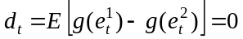 (15)
Where 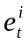 is the forecast error obtained from model and 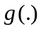refers to a particular loss function. 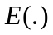 is the expectation operator. The DM uses the autocorrelation-corrected sample mean of 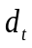to test for Equation 15. The DM test statistic is calculated as follows:
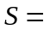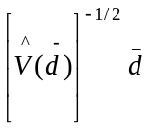 (16)
Where 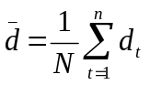 ; 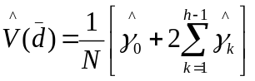 and 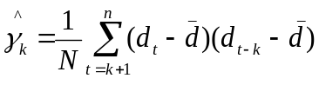
Under the null hypothesis of equal forecast accuracy, is asymptotically normally distributed. This implies that we reject the null hypothesis at the 5% level if 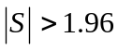(for the case of two-sided hypothesis test). In the case of the rejection of the null hypothesis, the alternative hypothesis will be interpreted as follows:
- A positive value for should indicate that model 2 performs better than model 1.
- A negative value for should indicate that model 1 outperforms model 2.
Table 9 presents the root mean square errors (RMSE) of the three models for a one-step-ahead-forecast for monthly and quarterly data.
Table 9 RMSE for structural models

Models |  | RMSE (Monthly data) | RMSE (Quarterly data)
ARIMAX |  | 0.000261 | 0.003909
Non-parametric |  | 0.0003005 | 0.01025
Kalman |  | 0.000266 | 0.004912
It is clear from the results of the RMSE in Table 9 that ARIMAX model provides the least loss function and probably the best forecast performance of the three models. Nonetheless, it is important to conduct the DM test statistics to assess whether the differences of the loss functions are statistically significant.
The DM results for the pair of competing models are presented in Table 10. The null hypothesis of equal forecast performance is rejected between non-parametric and ARIMAX, and non-parametric and Kalman filter. This indicates that both ARIMAX and Kalman filter models perform better than the non-parametric models for monthly and quarterly data. Nonetheless, the null hypothesis of equal performance is not rejected between the Kaman filter and ARIMAX model. Thus, the findings of the DM statistics show that the Kalman filter model is as good as the ARIMAX model in predicting stock returns in South Africa.
Table 10 DM statistics for pair competing models

Data sampling | Non-parametric / ARIMAX | Non-parametric / Kalman Filter | ARIMAX / Kalman Filter
Monthly data

DM-Statitistics | 3.0079 | 2.3394 | 0.00269
Probability | 0.00342 | 0.0193 | 0.9794
Quarterly data
DM-Statistics | 1.8943 | 3.902 | 0.4683
Probability | 0.05818 | 0.00000 | 0.6396

These findings provide important insights about stock returns in South Africa. Firstly, the US stock returns are the important drivers of tock returns in South Africa and that the relationship between the two stock returns is time-varying. This explains the contagion from developed to small or emerging market economies. Secondly, emerging market economies macroeconomic and financial variables are important drivers of their stock markets in the long run, nonetheless stock returns in the US will affect emerging market economies stock returns in the short and long run. Thirdly, the results of the DM statistics that reveals equal performance of the Kalman filter and ARIMAX models indicate the dominant characteristics of nonlinearity and Markov properties of stock returns with a considerable influence of external and internal information. A number of authors allude to these characteristics. For example Campbell and Diebold (2009) show that investor’s attitude towards risk and expected returns are nonlinear. Moreover, the influence of the US stock returns on stock markets in small open economies is well documented (Bonga-Bonga and Makakbule, 2010).

To assess whether a structural model proposed in this paper can outperform naïve models, the paper compares the forecast performance of the ARIMAX model with the benchmark autoregressive model of order one (AR(1)), as a naïve model for stock return prediction. Table 11 presents the RMSE of the two models and the DM statistics.

Table 11 Forecast performance of ARIMAX and benchmark autoregressive model (AR(1))

Forecast |  | DM statisitcs |  | RMSE (ARIMAX) |  | RMSE (AR(1))
1-step-ahead |  | 2.2326** |  | 0.016416 |  | 0.022226
** denotes rejection of the null hypothesis of equal forecast performance at 5% level of significance.

The results presented in Table 11 show that the null hypothesis of equal forecast performance between the AR(1) model and the ARIMAX model is rejected at 5% level supporting the alternative hypothesis the ARIMAX model outperform the random walk model. This result should be expected as the benchmark AR(1) model is a special case of the ARIMAX model.

- CONCLUSION

This paper endeavours to assess the forecast performance of three structural econometric models, namely the Kalman filter, the ARIMAX and the non-parametric models, to predict stock returns for an emerging market economy. The study uses the case of South Africa for this end. The paper emphasises the importance of including the US stock returns as a regressor in a multivariate model that aims to determine stock returns in an emerging market economy. The results obtained from the estimation of the three models show that the US stock returns are the important drivers of stock returns in South Africa, especially in the short horizon. Moreover, the paper shows the importance of an emerging market economy’s macroeconomic and financial variables in addition to the US stock returns in driving small economies stock returns in the long run. The results of the DM statistics show that the Kalman filter and ARIMAX models equally perform well in forecasting stock returns in South Africa and that both models outperform the non-parametric model. The results indicate the dominant characteristics of nonlinearity and Markov properties for stock market returns in South Africa, an emerging market economy.
REFERENCES
ANG, A. and PIAZZESI, M. (2003). A no-arbitrage vector autoregression of term structure dynamics with macroeconomic and laten variables. Journal of Monetary Economics, 50: 745-787.
AVRAMOV, D. (2002). Stock return predictability and model uncertainty. Journal of Financial Economics, 64: 423–458.
BARKOULAS J.T. and BAUM C. F. (1996). Long Term Dependence in Stock Returns. Economics Letters, 53(3): 253-259.
BONGA-BONGA, L. (2011). Testing for the purchasing power parity in a small open economy: a VAR-X approach. International Business & Economics Research, 10(12): 97-105.
BONGA-BONGA, L. and MAKAKABULE, M. (2010). Modeling stock returns in the South African stock exchange: A nonlinear approach. European Journal of Economics, Finance and Administrative Sciences, 19: 168-177.
BONGA-BONGA, L. and MUAMBA, J.M. (2011). The Predictability of Stock Market Returns in South Africa: Parametric versus Non-parametric Methods. South African Journal of Economics, 79(3): 301-311.
CAMPBELL, J.Y. (1987). Stock Returns and the Term Structure. Journal of Financial Economics, 18: 373-399.
CAMPBELL, J.Y. and YOGO, M. (2006). Efficient Tests of Stock Return Predictability. Journal of Financial Economics, 8(11): 27-60.
CAMPBELL, S. D. and DIEBOLD, F. X. (2009). Stock returns and expected business conditions: Half a century of direct evidence. Journal of Business and Economic Statistics, 27(2): 266- 278.
CAMPBELL, J.R. and THOMPSON, S.B. (2008). Predicting the Equity Premium out of Sample: Can Anything Beat the Historical Average?, Review of Financial Studies, 21: 1509 – 1531.
CHANG, K. L. (2009). Do macroeconomic variables have regime-dependent effects on stock return dynamics? Evidence from the Markov regime switching model. Economic Modelling, 26(6): 1283-1299.
CHEUNG, Y.W. and LAI, K.S. (1995). A Search for Long Memory in International Stock Market Returns”, Journal of International Money and Finance, 14(4): 597-615.
CHUNG, Y.P. and ZHOU, Z. (1996). The predictability of stock returns-a non-parametric approach. Econometric Reviews, 153: 299-330.
CREMERS, M. K. J. (2002). Stock return predictability: A bayesian model selection perspective. The Review of Financial Studies, 15: 1223–1249.
DIDIER, T. MAURO, P. and SCHMUKLER, S. L. (2007). Vanishing financial contagion?, Journal of Policy Modeling, 30(5): 775-791.
DOW, C. H. (1920). Scientific stock speculation. The Magazine of Wall Street.
DUFFEE, G. R. (2002). Term premia and interest rate forecasts inn affine models. Journal of Finance, 5: 405-443.
FAMA, E.F. and SCHWERT, GW. (1977). Asset Returns and Inflation. Journal of Financial Economics, 5: 115-146.
FORBES, K.J. and RIGOBON, R. (2002). No Contagion, Only Interdependence: Measuring Stock Market co-movement. Journal of finance, 57(5): 2223-2261.
GUPTA, R. HAMMOUDEH, S. SIMO-KENGNE, B.D. and SARAFRAZI, S. (2013). Can Sharia-based Islamic Stock Market returns be forecasted using large number of predictors and models?, Applied Financial Economics, 24(70): 1147-1157.
HAMILTON, J.D. (1994). Time Series Analysis, New Jersey: Princeton University Press.
HARVEY, D. I. and NEWBOLD, P. (2003). The Non-Normality of Some Macroeconomic Forecast Errors. International Journal of Forecasting, 1(94): 635-653.
HARVEY, A.C. (1989). Forecasting structural time series models and the Kalman filter, Cambridge: University press.
HAWAWINI, G. and KEIM, DB. (1995): “On the predictability of common stock returns: world-wide evidence”. In Jarrow, RA, Maksimovic, V and Ziemba, WT (Eds), Finance, Amsterdam: North-Holland.
HENRY, O. T. (2002). Long memory in stock returns: some international evidence. Applied Financial Economics, 12: 725-729
HJALMARSSON, E. (2010). Predicting Global Stock Returns. Journal of Financial and Quantitative Analysis, 45(1): 49-80.
KANAS, A. (2005). Non-linearity in the stock price-dividend relation. Journal of International Money and Finance, 24: 583-606.
MALKIEL, B. (2003). The Efficient Market Hypothesis and its Critics, Journal of Economic Perspectives, 17: 59-82.
MCMILLAN, D., G. and SPEIGHT, A. (2007). Non-Linear Long Horizon Returns Predictability: Evidence from Six South-East Asian Markets. Asia-Pacific Financial Markets, 13: 95-111.
MCMILLAN, D. G. (2004). Non-Linear Predictability of Short-Run Deviations in UK Stock Market Returns. Economics Letters, 84(2): 149-154.
LAI, K.S. (2008). The Puzzling unit Root in the Real Interest Rate and its Inconsistency with Intertemporal Consumption Behaviour. Journal of International Money and Finance, 27(1): 140-155.
LI, Q., and RACINE, J.S. (2004). Cross-Validated Local Linear Non-parametric Regression. Statistica Sinica, 14(2): 485- 512.
LO, A. and MACKINLAY, C. (1999). A Non-Random Walk Down Wall Street. Princeton: Princeton University Press.
PEIRÓ, A. (1999). Skewness in Financial Returns. Journal of Banking & Finance, 23(6): 847-862.
PESARAN, M. H., and TIMMERMANN, A. (1995). Predictability of Stock Returns: Robustness and Economic Significance. Journal of Finance, 50: 1201-1228.

PESARAN, M.H., and TIMMERMANN, A. (1994). Forecasting Stock Returns. An Examination of Stock Market Trading in the Presence of Transaction Costs. Journal of Forecasting, 13: 330-365.
RACINE, J. S. (1997). Consistent significance testing for non-parametric regression. Journal of Business and Economic Statistics, 15(3): 369–379.
RAPACH, D. WOHAR, M.E. and RANGVID, J. (2005). Macro Variables and International Stock Return Predictability. International Journal of Forecasting, 21: 137-166.
SHAMIRI, A. and Isa, Z. (2009). The US Crisis and the Volatility Spillover across South East Asia Stock Markets. International Research Journal of Finance and Economics, 34: 7-17.
SCHWERT, G. W. (2003). Anomalies and market efficiency in: G.M. Constantinides and M. Harris and R. M. Stulz (ed.), Handbook of the Economics of Finance, edition 1, volume 1, chapter 15: 939-974.
SMITH, B.L., WILLIAMS, B.M. and OSWALD, R.K. (2002). Comparison of parametric and non-parametric models for traffic flow forecasting. Transportation Research part C: Emerging Technologies, 10(4): 303-321.
STEINER, M. and WALLMEIER, M. (1999). Forecasting the correlation structure of German stock returns: a test of firm-specific factor models. European Financial Management, 5(1): 85-102.
YIU, M. S., HO, W.-Y. A. and CHOI, D. F. (2010). Dynamic Correlation Analysis of Financial Contagion in Asian Markets in Global Financial Turmoil. Applied Financial Economics, 20(4): 345-354.

Appendix

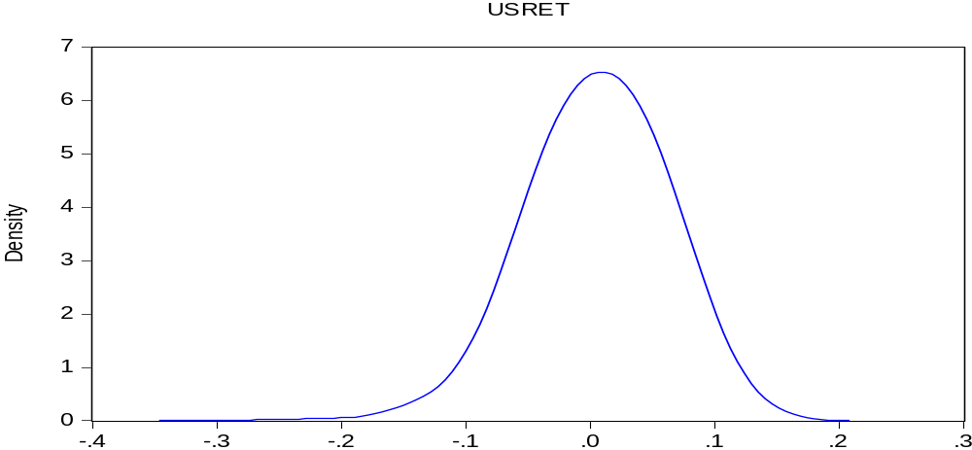

Figure A1: Kernel density of USRET (Epanechnikov, h = 0.077) quarterly data

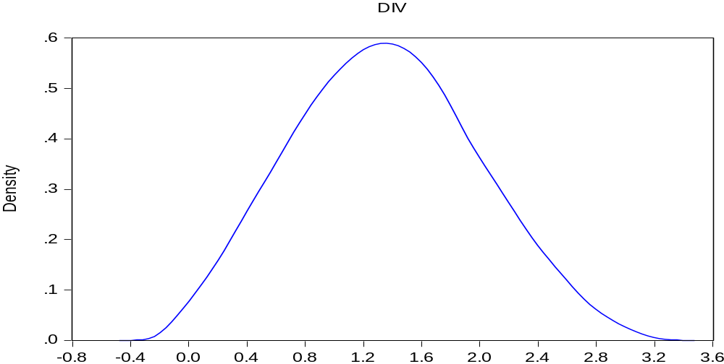

Figure A2: Kernel density of DIVALSI (Epanechnikov, h = 2637241) quarterly data

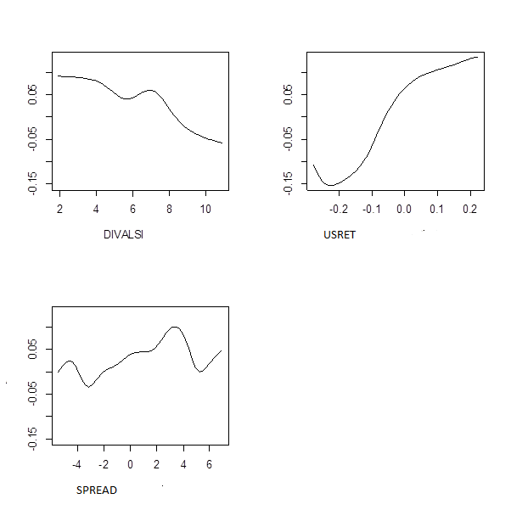

Figure A3: gradients of the explanatory variables

A structural econometric model combines economic theories with statistical models in an attempt to explain how endogenous variables are related to a set of observable and unobservable explanatory variables (Nevo and Whinston, 2010). Thus, structural econometric models are multivariate models with different statistical representations.

