Gecko Render

Here I provide a simple implantation of a graphical system. It consist of three classes:- Main, Display and Device.
The Main class initializes the display and enters the render loop. The Display class setup the display window while the Device class provides functionalities for pixel operations.
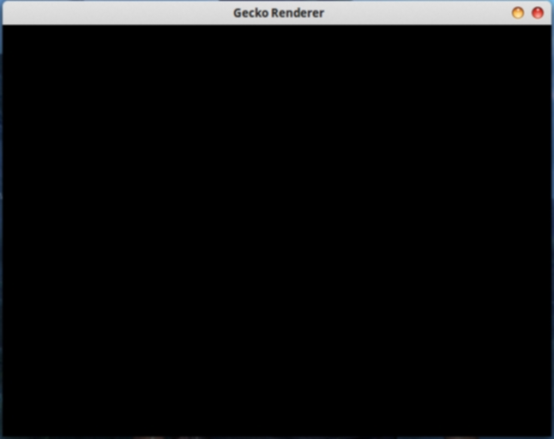

Task 1:
implement the drawPixel method of Device class in such a way that given the pixel coordinate (x, y) and color (a, r, g, b) the drawPixel method sets the pixel color at the right position on the screen.
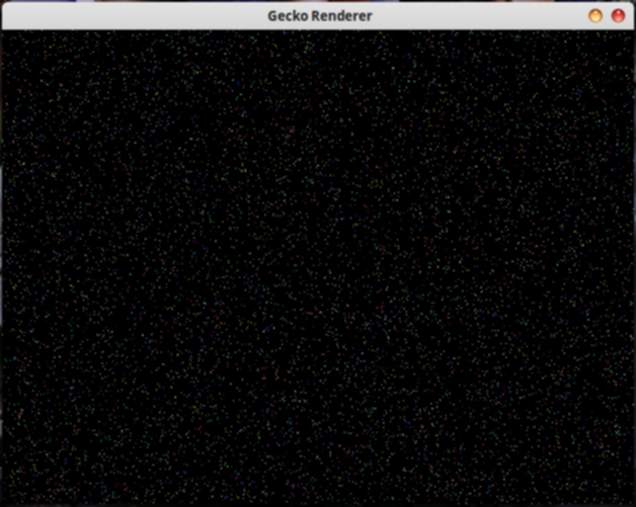

Task 2:
implement a drawLine method of the Device class using the bresenham's line drawing algorithm with integer only operation such that given the coordinate (x1, y1, x2, y2) and color (a, r, g, b) will draw line from point (x1, y1) to point (x2, y2) using the specified color.
