# Configure “Router 1”

## Reset to Factory Default

Reset the router to factory defaults.

## Connect to the router’s management interface:

Type 192.168.1.1 in your browser’s address bar.

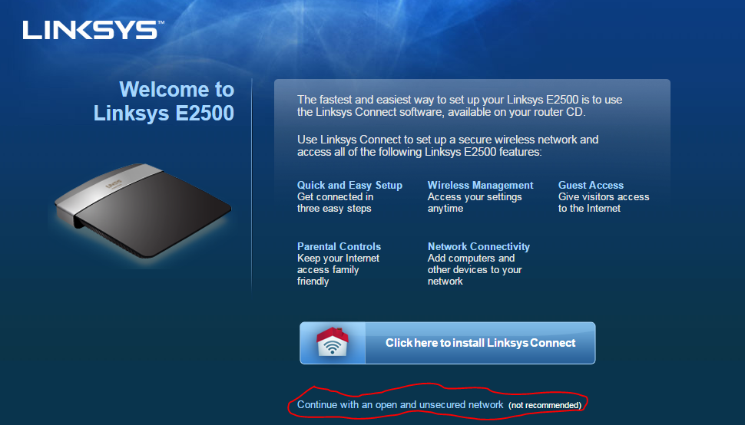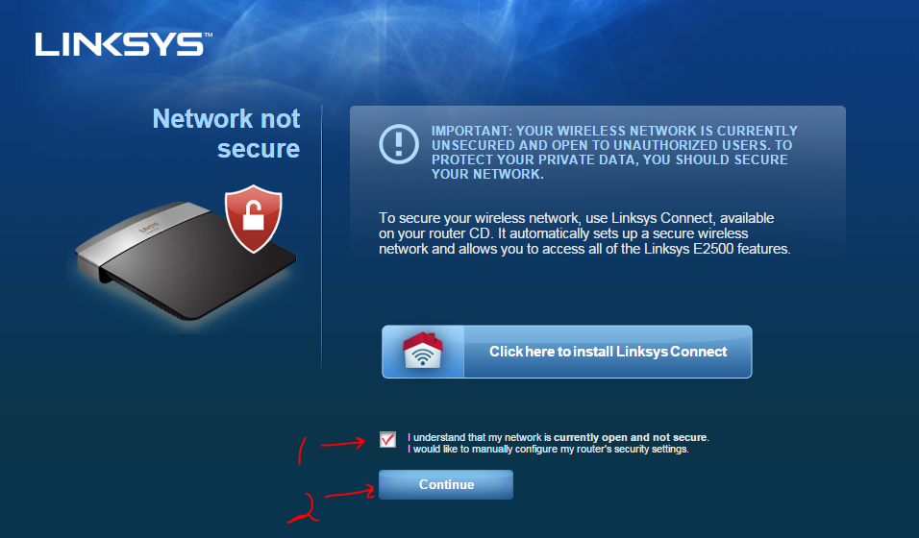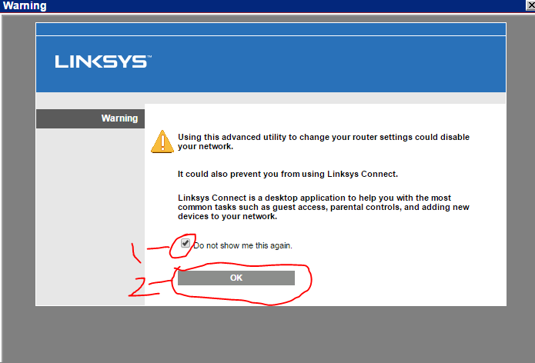

## Login to the router’s management interface:

Username: admin

Password: admin

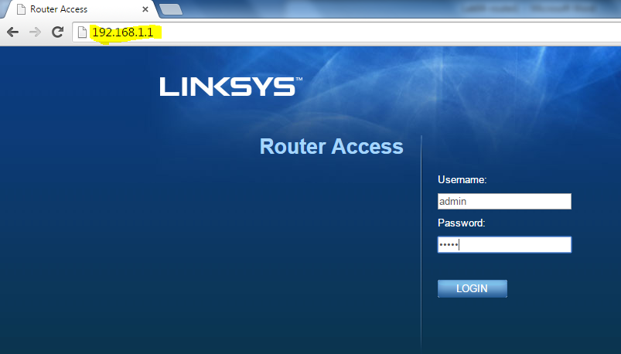

## Configure Router IP Addresses

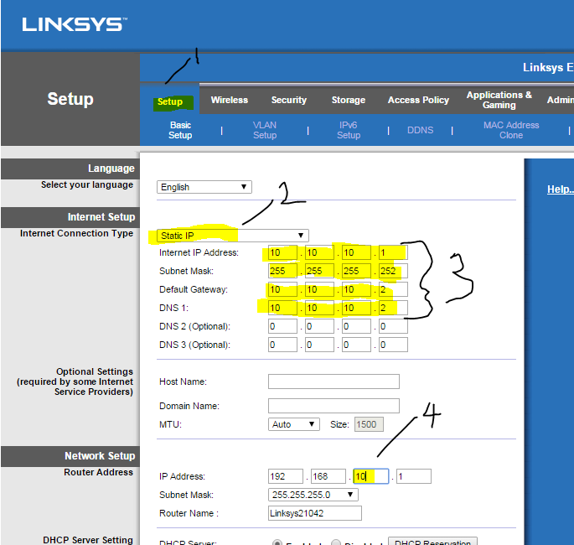

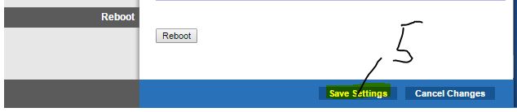

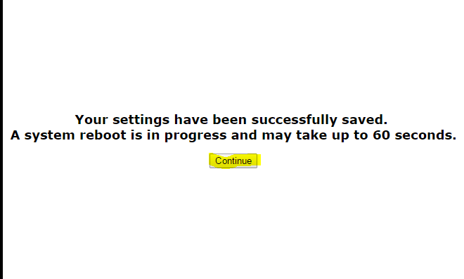

Wait for the router to reboot, and then reconnect to the router’s **new** IP address @192.168.10.1

## Disable NAT

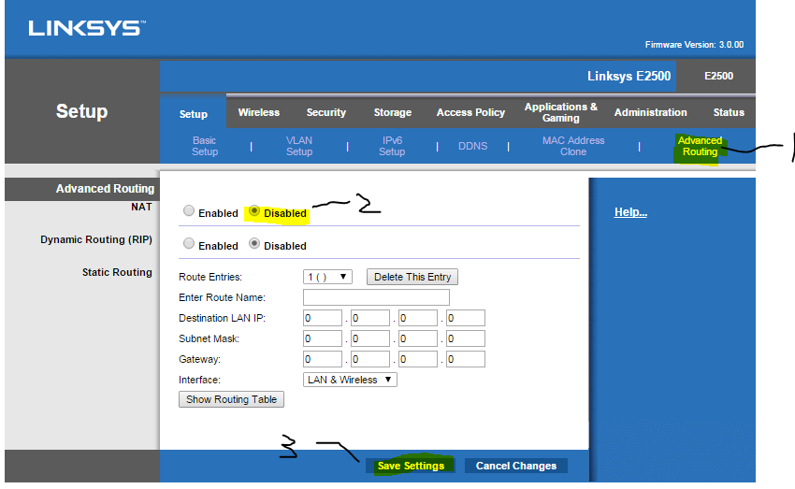

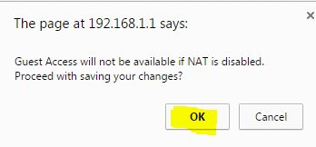

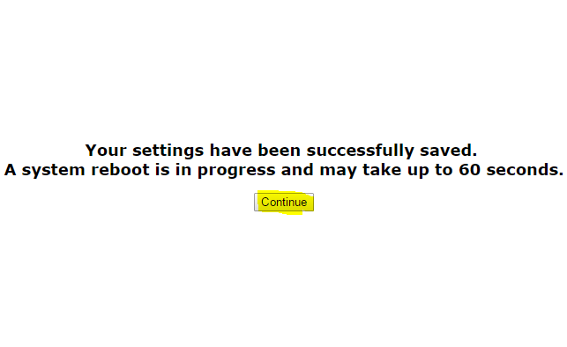

Wait for the router to reboot, and then reconnect to the router’s **new** IP address @192.168.10.1

## Allow anonymous internet request

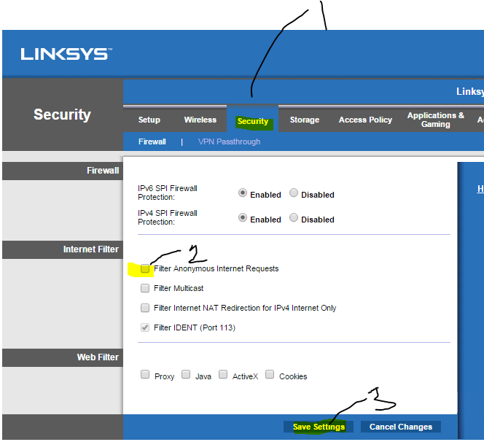



## Network Connectivity Tests

* Local Connectivity Tests
  + ping 192.168.10.1
  + ping 10.10.10.1

Wait for your partner to complete her/his router configuration before performing remote connectivity tests.

* Remote Connectivity Tests
  + ping 10.10.10.2
  + ping 192.168.20.1

You cannot proceed until both local and remote connectivity tests have succeeded.

Record your laptop’s IP and MAC addresses on the network topology diagram.

Record your router’s MAC address on your network topology diagram.

Record your partner’s laptop IP and MAC addresses on your network topology diagram.

Record your partner’s router MAC address on your network topology diagram.

Identify each laptop’s role – one is a webserver and the other a web client.

Return to the Task1 step 8 of the “Lab04 – InLab Activities” document.