Simulation of bin : https://mockbin.io/

19/09/2024

* Remote for the rest Sarangapani was present in L422
* MaurrasTOGBE send the specifications of the project
* Students have to do an example of application so I can see what they are able to do in web application development

SCRUD of Person (id, lastname, firstname, age, IDCARD, email, pwd)

Back-end : API SCRUD

Front-end : MyProfil page

Back-office : ListOfAllThePersons page, Delete a person, add person

SpringBoot

Database : Postgres

primeVue

Java

Hibernate as ORM

IDCARD is an image

26/09/2024

* Remote for the rest Jintao was present in L422
* Nithyalakshmi presents the backend and the database
* Jintao presents a proposition of structure to the project

03/10/2024

* Jintao and Nithyalakshmi are present
* Jintao presents its work (backend, FrontEnd and BackOffice)
  + SpringBoot, Postgres, Hibernate, VueJS
* Nithyalakshmi presents its work (Backend)
  + SpringBoot, Postgres, Hibernate
* Define the user story (<https://draft.io/zy2rvcddywzvedmzntze5c49cuyhb62zzb5n8e6pqszz> )
* ToDo
  + Students
    - Update the specification document according to the user story
    - Do the use case diagram (<https://app.diagrams.net/>)
  + Teacher
    - Create a table on Trello to manage the tasks
    - Create a GitHub repository for all the 3 projects
      * BO : <https://github.com/Maurras/PFP_2425_FFAPlatform_BO.git>
      * BE : <https://github.com/Maurras/PFP_2425_FFAPlatform_BE.git>
      * FE : <https://github.com/Maurras/PFP_2425_FFAPlatform_FE.git>

10/10/24

* Presentation of the use case diagram and the functionals specifications document
* ~~Activity diagram of some use case~~
* Structure of the web application Front End for user (Jintao) (Just the navigation diagram)
* Structure of the web application back office (Intervener) (Minghui) (Just the navigation diagram)
* Structure of the web application back office (Administrator or support Team) (BABU) (Just the navigation diagram)
* Back-end
  + List all of the web services in the Back-end (Nithya)
  + (ToDo on 17/10/2024) Sequence diagram (Important to back-end)
    - Registration of user
    - Active user’s account
    - Registration of Intervener
    - Validate the intervener account
    - Registration of administrator
  + (ToDo on 17/10/2024) Faire le workflow d’un use case et définir les tâches liées à chaque développeur. A chaque étape, préciser les besoins (DB, WS, Front end, Back Office intervener, Back-office Admin)
  + (ToDo on 17/10/2024) Redéfinir ensemble les technologies à utiliser pour chaque partie
    - Front-End
      * VueJs
    - Back office
      * VueJS
    - Back-end
      * SpringBoot
      * REST API
      * Java
    - Database
      * Postgres
* 17/10/2024
  + Front End : Wireframes with figma
    - List Of Projects
    - Detail about a Project
    - Apply to a Project
  + BO Intervener : Wireframes with figma
    - List of my projects
    - Submit a project
    - List of candidates on a particular project
  + BO Admin : Wireframes with figma
    - List of all the projects with the possibility to filter (department, etc...) with search
    - Detail about a project
    - Manage a project (delete, update)
  + Sequence diagram
    - Submit a project
    - Apply to a project

Presentation (power point) (All of you)

- Functionalities per profile

- Structure of the web applications

- Wireframes

07/11/2024

* ToDo Today : Download all the figma wireframes and put them in the right folder on Teams (Back Office Intervener, Back Office Administrator, Front End and Back-End)
* ToDo for next meeting
  + Next meeting 14/11/2024 at Isep 10AM in presential
  + Back-end (Nythia, Minghui)
    - Create a database in postgresql
    - Create a project Named “PFP_2425_FFAPlatform_BE” with at least
      * Hibernate
      * SpringBoot
    - produce web services concerning the tables Country and Embassy

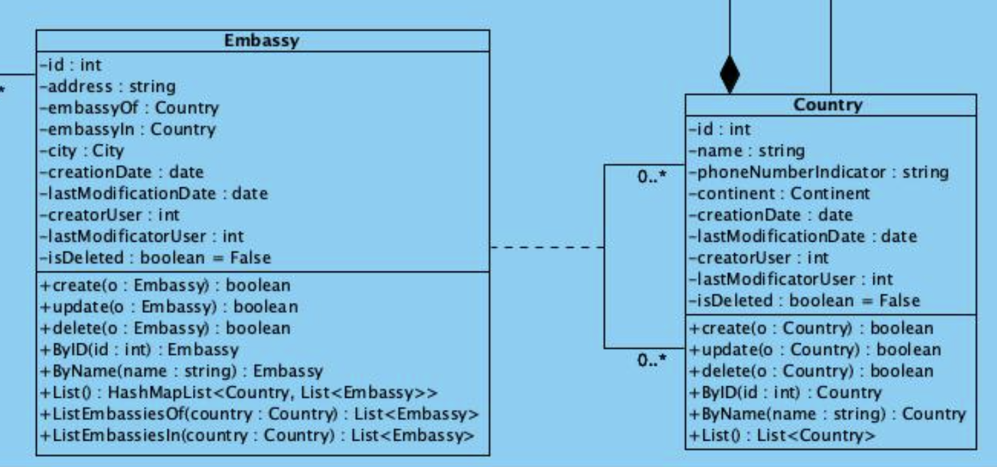

* + - * One access point for each method for each class
      * Follow the nomenclature defined in the file : [Development_Instructions.docx](https://iseparis.sharepoint.com/:w:/s/PlateformeFFA/EUOA_BAiGChNoJlU9Nl05K0BOuwP8wlDViFOdz5Igosyjg?e=EddnUI)
      * For next week: finish at least
        + For country

create, update, delete, ByName, List()

* + - * + For Embassy

create, update, delete, listEmbassiesOf, listEmbassiesIn

* + - Push the code in the github : <https://github.com/Maurras/PFP_2425_FFAPlatform_BE.git>
  + Back office:
    - Administrator (BABU)
      * Create a project Named “PFP_2425_FFAPlatform_BO”
      * Create HMI to:
        + Create, update, delete, list the countries
        + Create, Update, Delete, list embassies
      * Have to consume the webservices in the API created by Nithya
    - Intervner (Minghui)
      * Use the project Named “PFP_2425_FFAPlatform_BO”
      * Create HMI to:
        + list the countries
        + list embassies
      * Have to consume the webservices in the API created by Nithya and Minghui
    - ~~Push the code in the github~~ [~~https://github.com/Maurras/PFP_2425_FFAPlatform_BO.git~~](https://github.com/Maurras/PFP_2425_FFAPlatform_BO.git)
  + Front end (Jintao)
    - Create a project named “PFP_2425_FFAPlatform_FE”
    - Create HMI to:
      * Login
      * Register
      * List the countries
      * List embassies
      * Have to consume the webservices in the API created by Nithya and Minghui
    - Create Header and Footer with a specific css file wich will be used by everybody in their project.
    - ~~Push the code in the github~~ [~~https://github.com/Maurras/PFP_2425_FFAPlatform_FE.git~~](https://github.com/Maurras/PFP_2425_FFAPlatform_FE.git)
  + Everybody
    - Search and find many free templates to use for back office and front end using primeVue.
    - The final choice between them will be made next week
* The meeting on 05/12/2024 is canceled.
* We will meet on 12/12/2024 at 10 AM at Isep NDL.
* The 12/12/2024 you will do a presentation on :
* Front-end (Jintao FU):
  + View the list of the projects
  + View details about a specific project
  + Apply to a project by filling the form and submitting all the mandatories documents
  + See the list of the projects he already submit on
* Back-Office (Sarangapani BABU):
  + Intervener (Sarangapani BABU):
    - Create a project
    - See the list of all the projects
    - See the list of its own projects
    - See the submission list on its projects
    - Attribute a specific project to a specific candidate
  + Admin (Sarangapani BABU):
    - Validate the creation of a project
    - See the list of all the projects
* Back-end (Nithyalakshmi PADMANABAN & Minghui NIE)
  + Web service to create a project
  + Web service to display the list of all the projects
  + Web service to display the list of the projects according to some criteria (examples : by intervener, by country, by city, by date, etc.)
  + Web service to validate a specific project
  + Web service to attribute a specific project to a specific candidate
  + Web service to Apply to a project by filling the form and submitting all the mandatories documents
  + Web service to see the list of the projects a user already submit on
  + Check how to integrate Spring Authentication on the backend