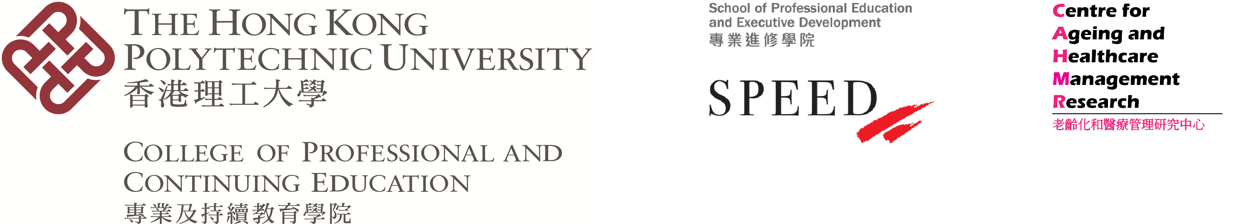

**CPCE Health Conference 2021**

**20 September 2021**

**Post-pandemic health and long-term care: A new paradigm**

**Call for Papers**

The COVID-19 pandemic is changing the world for more than a year and a half. All people are adapting to the “new normal” practices and behaviour, in addition to wearing facial mask, hand hygiene and social distancing which are predominantly mandatory particularly in public venues. Health care has undergone drastic reform in terms of precautious measures, especially in hospitals and during high-risk procedures. Human traffic and visits to health and residential care facilities have put on a nearly total halt, “neglecting” the usual pattern and empathy in patient care. Policy makers, public health officials and health professionals are encountering a very difficult time in human history from the COVID-19, the clinical and epidemiological nature of which are still not fully understood by the experts.

The objective of the 6th Annual CPCE Health Conference 2021 is to explore the emerging policy, practices and management of health care, including long-term care in the post-pandemic era. Against this background, the Conference Organiser invites submissions on (but not limited to) the following sub-themes:

* Application of technology in health and long-term care
* Community-based programmes
* District health and its effectiveness
* Healthy ageing and public/social policy
* Innovative healthcare management strategies in health institutions and the community
* Manpower of health and long-term care
* Monitoring psychological health for older adults
* Patient and staff safety during the pandemic
* Quality assurance in health services for older adults
* Social responsibility of health care service organisations

**Notes to Authors**

Please submit an abstract of 350 to 500 words, and/or a full paper, in English, by 31 July 2021 to [callforpaper-healthconf2021@cpce-polyu.edu.hk](mailto:callforpaper-healthconf2021@cpce-polyu.edu.hk). Abstracts and/or full papers submitted to this Conference should not have been previously published or under review in any journals. The Conference Organiser will select papers for presentation on a competitive basis. Notification of abstracts and/or full papers acceptance for presentation will be provided within four weeks after the submission deadline. The accepted author(s) should prepare a 15-minute PowerPoint presentation in English. The oral presentation should be in English. Full papers, subject to a double-blind review process, will be considered for potential publication in a special issue or a regular issue with the [Public Administration and Policy: an Asia-Pacific Journal](http://www.emeraldgrouppublishing.com/services/publishing/pap/index.htm) and [Asia-Pacific Journal of Health Management](https://journal.achsm.org.au/index.php/achsm/index).

In addition, there will be a parallel session for presentation of papers in English by students of tertiary institutions. Students from local and overseas institutions are welcome.

You are reminded to register for the Conference via the official website: <http://healthconf2021.cpce-polyu.edu.hk/>

Enquiries on submission of papers, including full papers intended for the two Journals, can be directed to: [callforpaper-healthconf2021@cpce-polyu.edu.hk](mailto:callforpaper-healthconf2021@cpce-polyu.edu.hk)

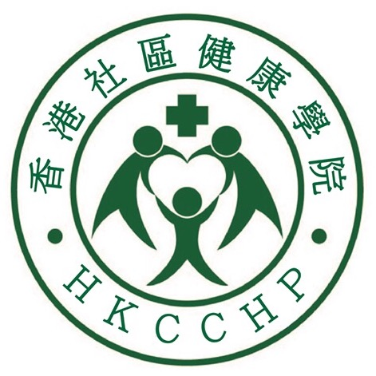 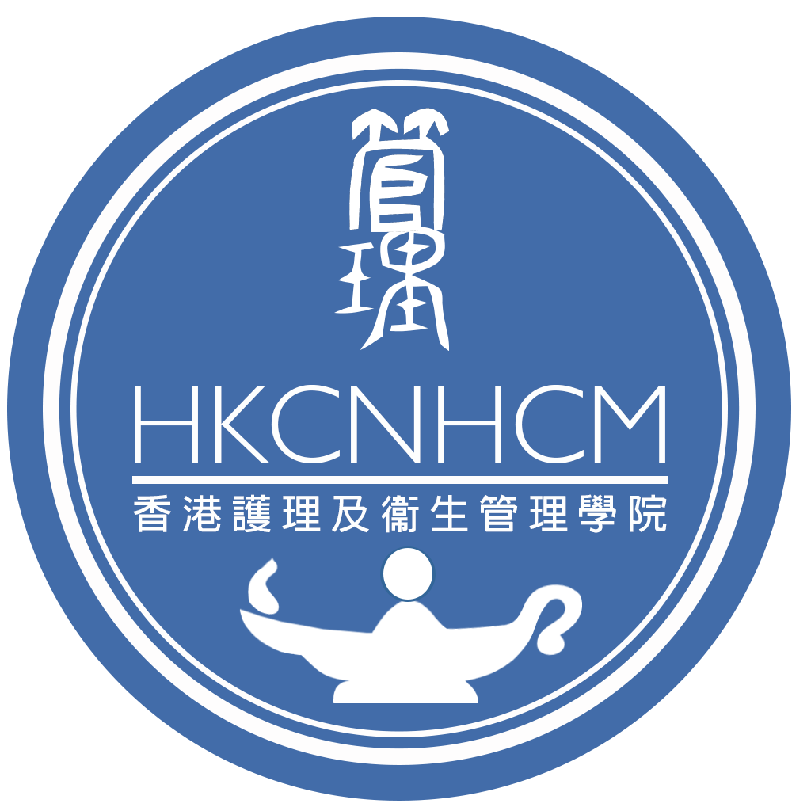

**Abstract (template)**

**[Title of the Paper]**

John T. M. Chan*a*\*, Sam M. Writer*b*

*a School of Professional Education and Executive Development, The Hong Kong Polytechnic University, Hong Kong*

*b College of Professional and Continuing Education, The Hong Kong Polytechnic University, Hong Kong*

*Corresponding author: Dr. John T. M. Chan ([chantaiman@speed-polyu.edu.hk](mailto:chantaiman@speed-polyu.edu.hk))

**Abstract**