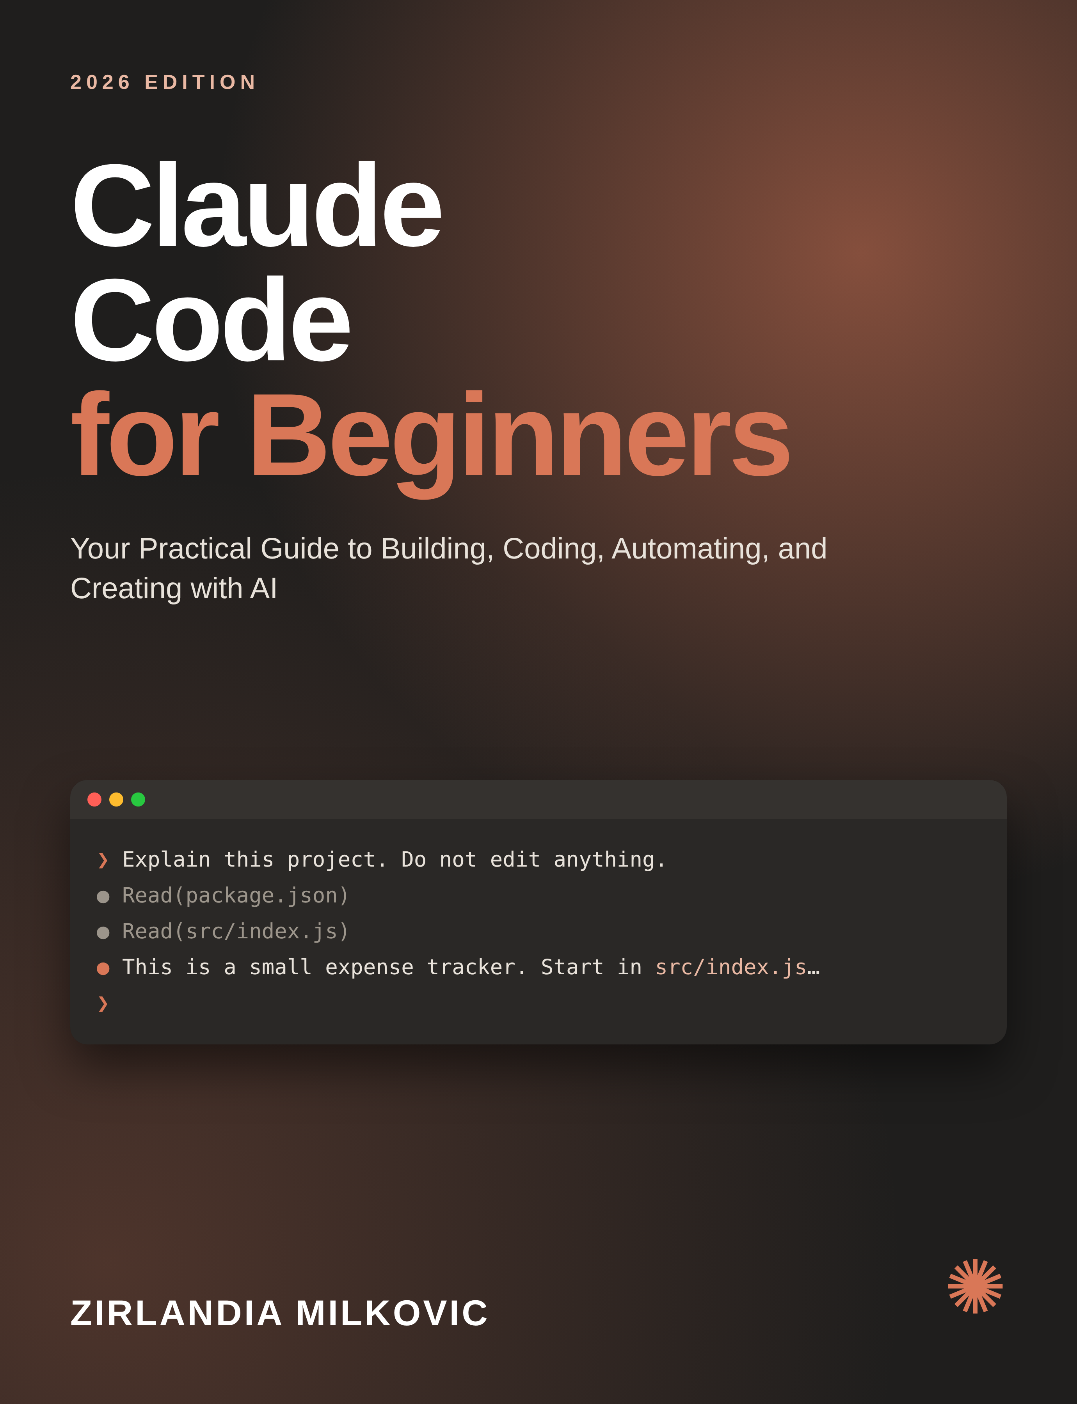

Copyright & Disclaimer
© 2026 Zirlandia Milkovic. All rights reserved.
Claude Code and Claude are products and trademarks of Anthropic. This independent book is not affiliated with, sponsored by, or endorsed by Anthropic. Product names are used for identification and educational purposes.
Technology changes quickly. Commands, pricing, availability, interfaces, models, policies, and features may change after publication. Always verify current information in official documentation before using a command or applying a configuration to a production environment.
Examples in this book are educational. Software generated with AI should be reviewed, tested, and secured before production use.

Table of Contents
Introduction — Welcome to AI-Powered Building
Chapter 1 — What Is Claude Code?
Chapter 2 — Setting Up Your Environment
Chapter 3 — The Art of Giving Claude Instructions
Chapter 4 — Understanding an Existing Project
Chapter 5 — Build Your First Mini Project
Chapter 6 — Turning Ideas Into Applications
Chapter 7 — Debugging With Claude Code
Chapter 8 — Working With Existing Code
Chapter 9 — Git and Version Control for Beginners
Chapter 10 — Safety, Privacy and Security
Chapter 11 — Claude Code for Work and Business
Chapter 12 — Building Your AI-Assisted Workflow
Chapter 13 — From Beginner to AI-Powered Builder
Chapter 14 — Ten Projects to Build Next
Bonus — 50 Claude Code Prompt Templates
Bonus — Beginner Cheat Sheet
Bonus — Your First 7 Days
Conclusion — You Are the Builder
Sources & Further Learning

Introduction — Welcome to AI-Powered Building
Software creation is entering a new phase. The important change is not simply that an AI can write a function or explain an error. The deeper change is that modern coding agents can work with a project as a system: they can inspect files, reason about a task, use development tools, make changes, and help you test and refine the result.
Claude Code is designed around this agentic style of work. Instead of copying a question into a chat window and manually moving code into a project, you can give Claude a goal inside a development environment and then review the work it proposes or performs. That changes the skill you need most: from memorizing syntax toward describing outcomes clearly, understanding your project, checking assumptions, and validating results.
This book is for the curious beginner. You may be a developer, but you may also be an entrepreneur, student, freelancer, designer, creator, analyst, or professional who has never considered yourself a programmer. You do not need to become an expert overnight. You need a safe workflow, a willingness to experiment, and enough understanding to know what you are asking the machine to do.
One principle will appear throughout this book: AI assistance does not remove responsibility. Generated code can be incomplete, insecure, inefficient, or simply wrong. Your job is not to trust the AI blindly. Your job is to collaborate with it, inspect the result, test it, and decide what belongs in your project.
By the end, you will understand the Claude Code workflow, write better instructions, explore an unfamiliar codebase, build a small project, debug errors, use Git more confidently, protect secrets, and develop a repeatable AI-assisted building process.

Chapter 1 — What Is Claude Code?
Claude Code is Anthropic's AI coding agent. The useful mental model is not “a chatbot that writes code,” but “an AI collaborator that can work with a software project through development tools.” Current Anthropic materials describe it as usable from the terminal and across several development environments, including VS Code and JetBrains, as well as web, mobile, Slack, and GitHub workflows.
A normal chat interaction often looks like this: you ask a question, receive text, and manually decide what to do next. With an agentic coding workflow, the AI can inspect the project context, reason about files and commands, propose or make changes according to permissions, and iterate based on test results. The difference is workflow, not magic.
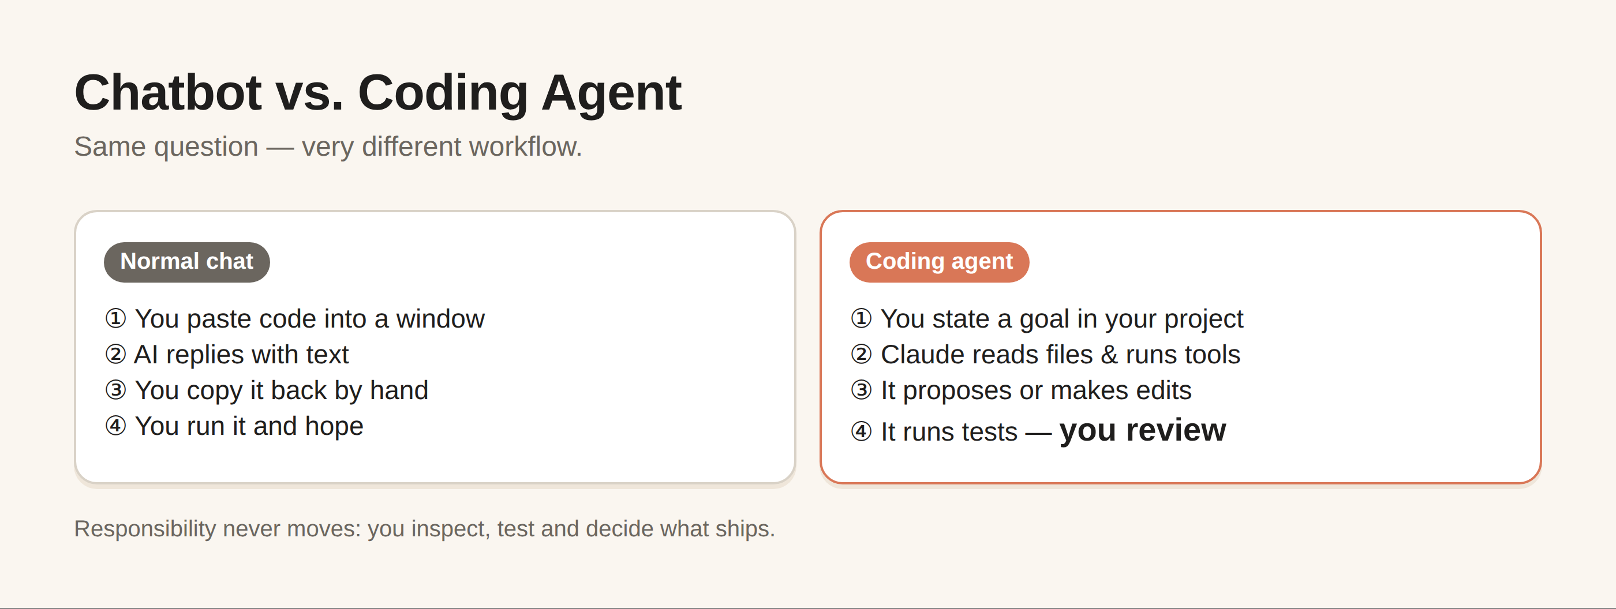
Figure 1. Chatbot versus coding agent
Imagine that you say: “Find why the checkout page crashes when a customer has an empty address, fix it, add a regression test, and explain the change.” A useful coding agent can investigate the relevant files, identify a likely failure path, modify the implementation, create a test, run appropriate checks, and report what happened. You should still review the diff and the tests.
Claude Code does not mean that every task becomes one prompt. Complex software work is usually iterative. A strong pattern is: understand → plan → change → test → inspect → improve. Beginners who learn this loop tend to get more reliable results than beginners who ask for an entire application in one enormous instruction.
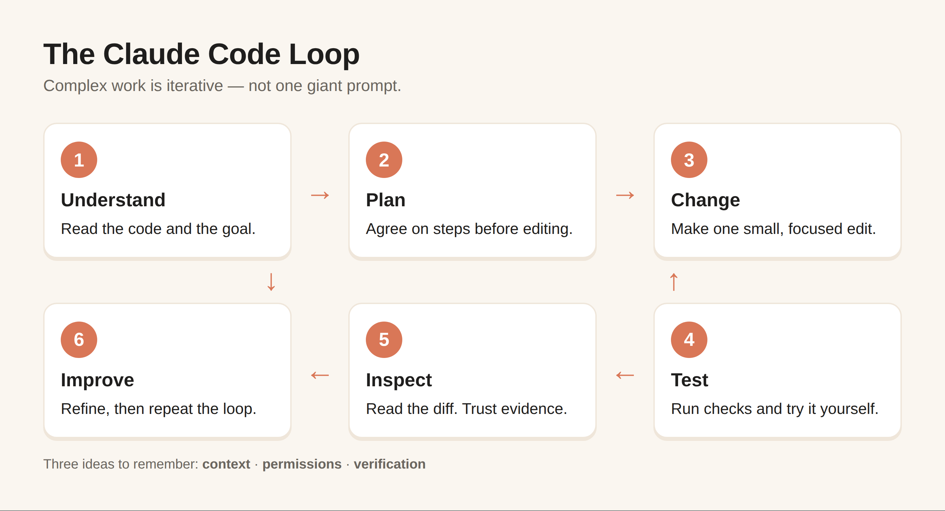
Figure 2. The understand-plan-change-test-inspect-improve loop
There are three concepts to remember. First, context: the AI needs to know what matters. Second, permissions: tools that can read files, edit files, or run commands should be treated deliberately. Third, verification: a successful-looking response is not proof that the software is correct.
Think of Claude Code as a junior-to-senior range of assistance depending on the task, but never as an infallible authority. It can explain unfamiliar code, accelerate routine work, explore possibilities, and help you reason about implementation. Your responsibility increases with the impact of the change.

Chapter 2 — Setting Up Your Environment
Because installation methods and supported environments evolve, always check the current official Claude Code documentation before installing. At the time of this edition, Anthropic's setup documentation lists macOS, Linux, and Windows options, with Windows workflows including WSL or Git for Windows. The documentation also describes several installation and authentication routes and recommends checking the installation with `claude doctor`.
For a beginner, the safest setup mindset is simple: use an up-to-date operating system, a supported shell/environment, a stable internet connection, and an account or subscription method appropriate to your use case. Do not copy installation commands from an old tutorial simply because the screenshots look familiar.
A typical project session begins by opening a terminal, moving into your project directory, and starting Claude Code. The important part is not memorizing the command; it is understanding that the current working directory establishes the context in which you are asking Claude to work.
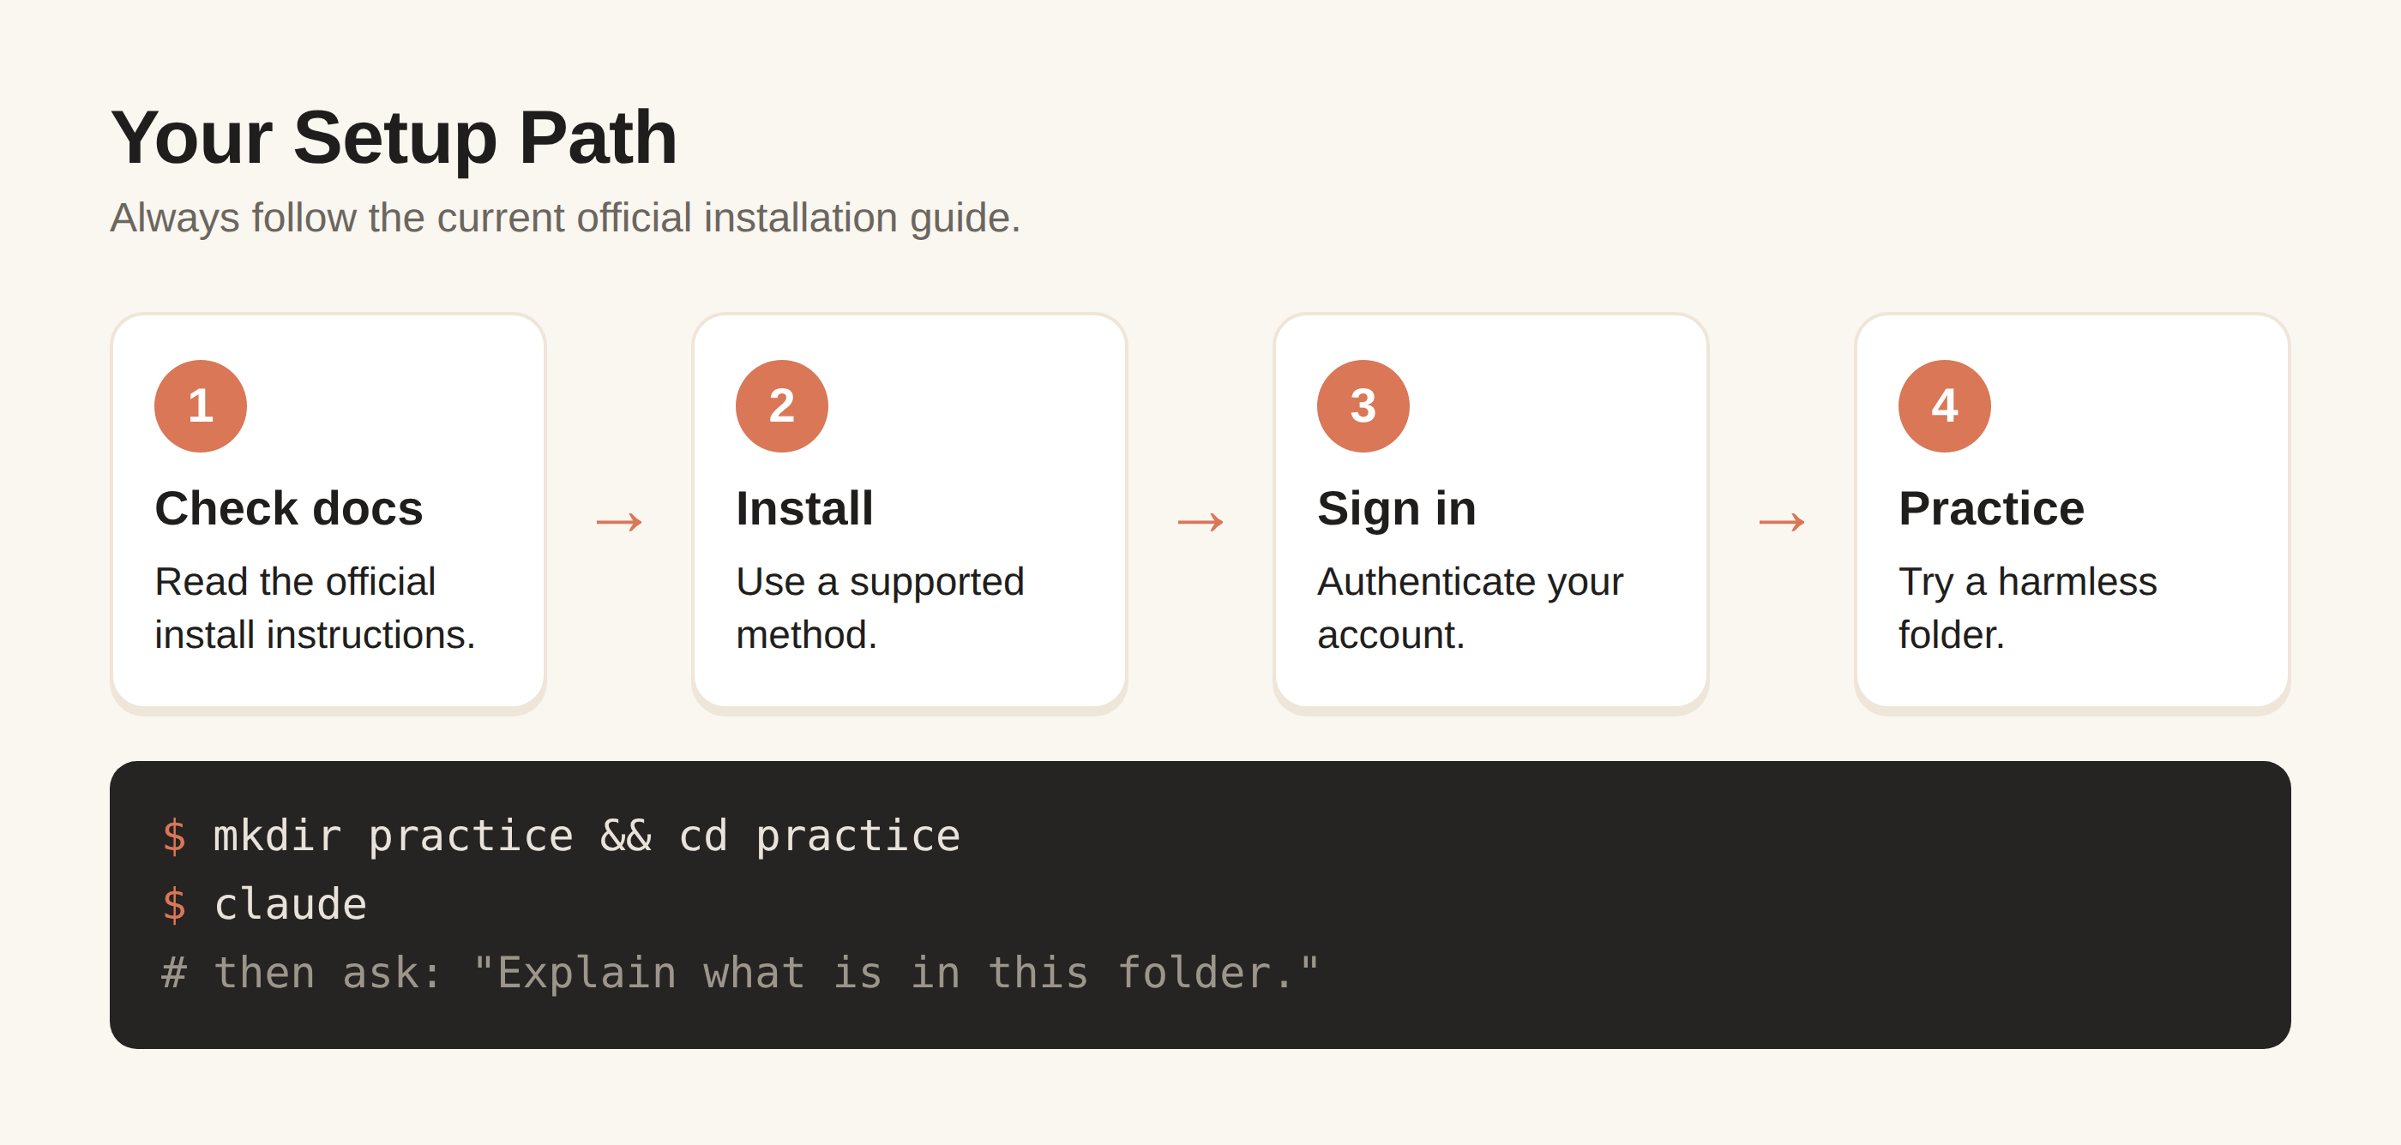
Figure 3. Your setup path
After installation, verify that Claude Code starts correctly and that authentication succeeds. If something fails, stop and diagnose the environment rather than repeatedly reinstalling packages. Useful troubleshooting questions include: What operating system am I using? What installation method did I use? What version is installed? What does the diagnostic command report?
Beginner exercise: create a harmless practice folder containing a small text file. Start Claude Code from that folder and ask it to explain the folder contents without changing anything. This teaches the most important first lesson: observation before modification.
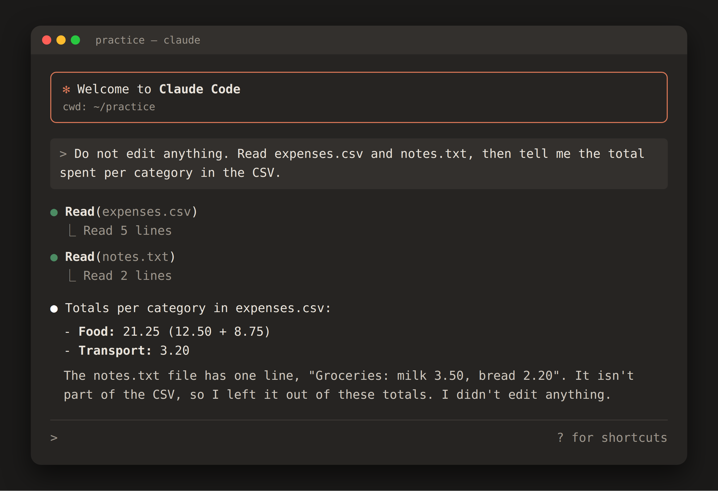
Figure 4. A real Claude Code run: reading two files and answering without editing anything
Setup checklist: verify the official installation instructions; install using a supported method; authenticate; check the installation; create a practice project; start Claude Code from the project directory; confirm that you understand which files and directories are in scope.

Chapter 3 — The Art of Giving Claude Instructions
The quality of an AI coding session often depends on the quality of the problem statement. “Build me an app” leaves hundreds of important decisions undefined. A better instruction establishes context, objective, constraints, expected behavior, and a definition of done.
Use this reusable structure: CONTEXT + GOAL + CONSTRAINTS + TASK + SUCCESS CRITERIA. Context tells Claude what it is looking at. Goal explains why. Constraints protect decisions you do not want changed. Task describes the work. Success criteria tell the agent how you will judge the result.
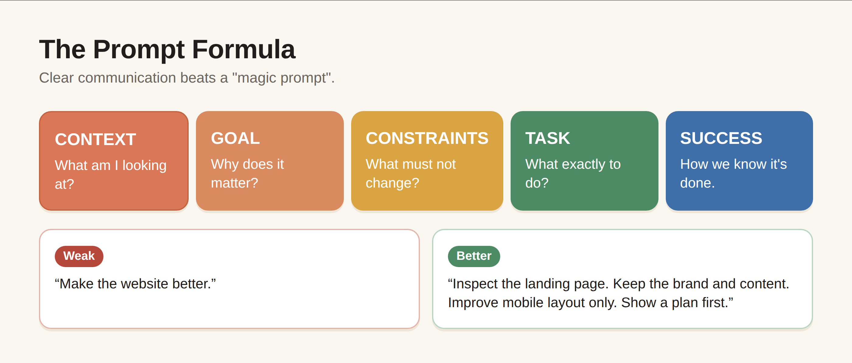
Figure 5. The prompt formula, with a weak and a better example
Weak instruction: “Make the website better.” Better instruction: “Inspect the existing landing page. Keep the current brand identity and content. Improve mobile spacing, hierarchy, and accessibility without changing the product claims. First propose a plan; then make the changes and run the existing checks.” The second request reduces ambiguity and protects the existing work.
When a task is large, ask for a plan before implementation. Planning gives you a chance to catch a misunderstanding before many files are changed. You can say: “Before editing, inspect the relevant files and give me a concise implementation plan, including files you expect to change, risks, and how you will test the result. Do not modify anything yet.”
Prompt pattern for debugging: “I expected X. Instead I see Y. The problem occurs when Z. Here is the exact error. Please inspect the relevant code, identify the likely root cause, propose the smallest safe fix, and explain how you will verify it.”
Prompt pattern for learning: “Explain this file as if I am a beginner. Start with the purpose, then explain the main sections, then trace one realistic request through the code. Do not rewrite anything.” This is powerful because it uses the project itself as your textbook.
Prompt pattern for review: “Review the current diff for correctness, security, maintainability, and unintended behavior. Do not change files. Give me findings grouped by severity and cite the relevant files or sections.”
Your goal is not to find a magical prompt. Your goal is to communicate clearly enough that an intelligent collaborator can act on the same problem you have in your head.

Chapter 4 — Understanding an Existing Project
Before asking an AI agent to modify unfamiliar software, learn its map. A project can contain application code, configuration, tests, documentation, generated files, dependencies, build scripts, deployment settings, and secrets. Editing the wrong layer can create unnecessary problems.
Start with reconnaissance. Ask Claude to describe the project structure, identify the main entry points, explain how the application is started, identify the test commands, and point out important configuration files. Ask it to distinguish source files from generated or dependency-managed files.
A useful exploration request is: “Do not edit anything. Inspect this project and create a short map: purpose, main technologies, entry points, important directories, how to run it, how to test it, and any obvious areas that should not be modified manually.”
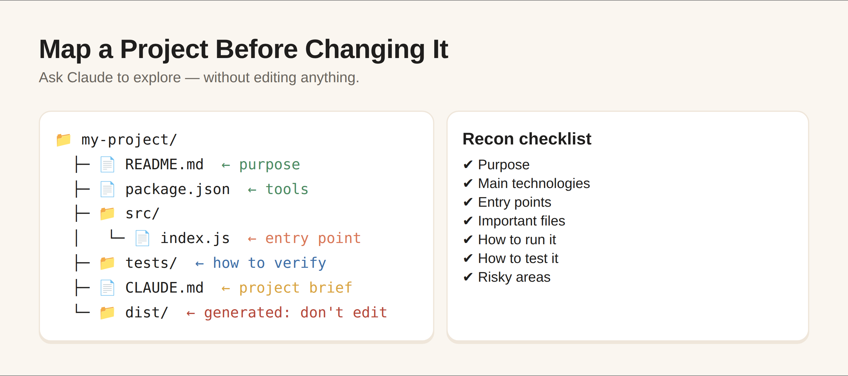
Figure 6. Mapping an unfamiliar project
Then investigate one feature. Ask Claude to trace the feature from user action to interface, business logic, data access, and tests. This teaches you architecture through a concrete example rather than a vocabulary list.
Create a project brief and keep it near the project when appropriate. Claude Code supports project-level instruction and memory mechanisms; current official documentation includes CLAUDE.md and related memory guidance. Treat such files as documentation and governance, not as a substitute for reviewing actual code.
Beginner rule: generated files are often not the right place to make a permanent change. If Claude suggests editing a generated artifact, ask where the source of truth lives. This single question can prevent a surprising amount of rework.

Chapter 5 — Build Your First Mini Project
Your first project should be small enough to finish and large enough to teach the workflow. In this book, we will build a simple personal expense tracker. The goal is not to create a production finance platform. The goal is to experience the complete AI-assisted development loop.
Start with requirements: add an expense, choose a category, enter an amount and date, view a list, calculate a total, and remove an entry. Keep the first version local and simple. Explicitly tell Claude that this is a learning project and that you want a minimal implementation rather than unnecessary infrastructure.
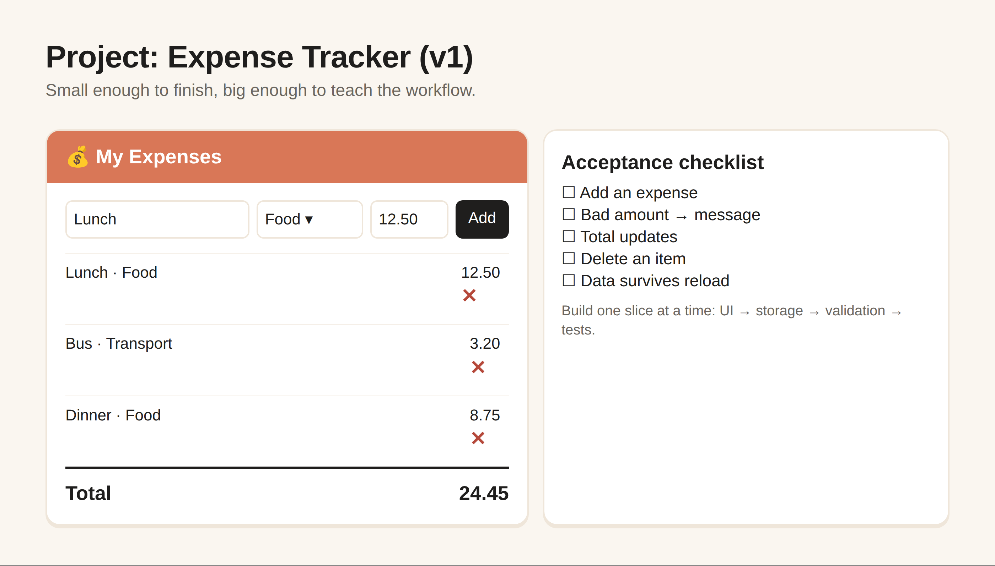
Figure 7. Wireframe and acceptance checklist for the expense tracker
First prompt: “I want to build a beginner expense tracker. Before coding, inspect the current folder and propose a minimal architecture. The first version must support adding, listing, totaling, and deleting expenses. Keep dependencies minimal. Explain the plan in beginner-friendly language and wait for approval.”
Once the plan is acceptable, implement one slice at a time. Ask Claude to create the basic interface first. Then add state or storage. Then add validation. Then add tests or checks. After each slice, run the project and inspect the behavior yourself.
A useful acceptance checklist is: Can I add an expense? Does an invalid amount produce a useful message? Does the total update? Can I delete an item? Does the page remain usable on a small screen? Do the relevant checks pass? Does the code remain understandable?
The project becomes a lesson in iteration. If the first design is ugly, ask for a focused design improvement. If the data model is awkward, ask for an explanation and a migration plan before changing it. If a bug appears, report the exact behavior rather than saying only “it doesn't work.”
The biggest beginner mistake is expanding scope too early. Once the first version works, resist immediately adding accounts, payments, cloud synchronization, analytics, AI categorization, and ten integrations. Finish the small thing first. A completed small project teaches more than an abandoned ambitious one.

Chapter 6 — Turning Ideas Into Applications
An idea is not yet a specification. “I want a business dashboard” describes a destination, not the road. Claude can help turn the idea into requirements, user stories, a technical plan, and implementation tasks.
Begin with the user. Who uses the product? What problem are they solving? What information do they need? What action should be easy? What must not happen? These questions prevent you from building features that sound impressive but do not solve the real problem.
A practical planning sequence is: problem statement → users → core workflow → data → screens or interfaces → integrations → security → testing → deployment. Ask Claude to challenge assumptions before writing code.
Use a feature boundary. Label features as MUST HAVE, SHOULD HAVE, and LATER. Then ask Claude to design the smallest useful version. This keeps the first release manageable and makes AI sessions more focused.
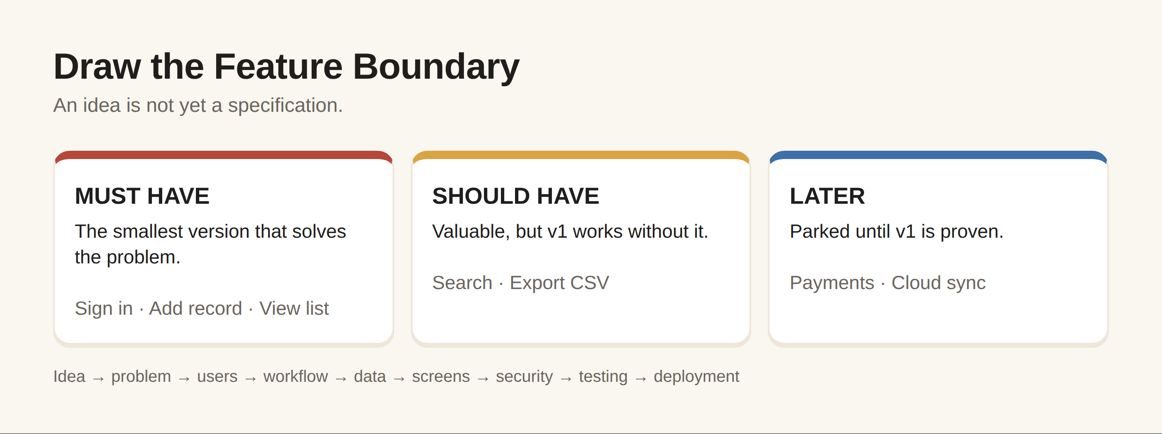
Figure 8. Must have, should have, later
For each feature, define acceptance criteria. Instead of “add login,” say what a successful login means: valid credentials are accepted, invalid credentials receive an appropriate message, protected content remains inaccessible without authorization, and relevant tests cover the behavior.
AI is especially useful for converting vague ideas into questions. Ask: “What information is missing from my specification? List ambiguities that could cause implementation mistakes.” Then answer those questions yourself.
This is an important shift in mindset: the AI should not be the owner of product decisions. It can generate options and expose trade-offs, but you decide what the product should do and what constraints matter.

Chapter 7 — Debugging With Claude Code
Debugging is not a sign that you failed. Software is a system of assumptions, and bugs are mismatches between expected and actual behavior. AI can accelerate debugging when you give it evidence instead of frustration.
Use the debugging formula: EXPECTED → ACTUAL → REPRODUCTION → ERROR → RECENT CHANGES → RELEVANT CONTEXT. If possible, include the exact error message and the smallest sequence of steps that reproduces the problem.
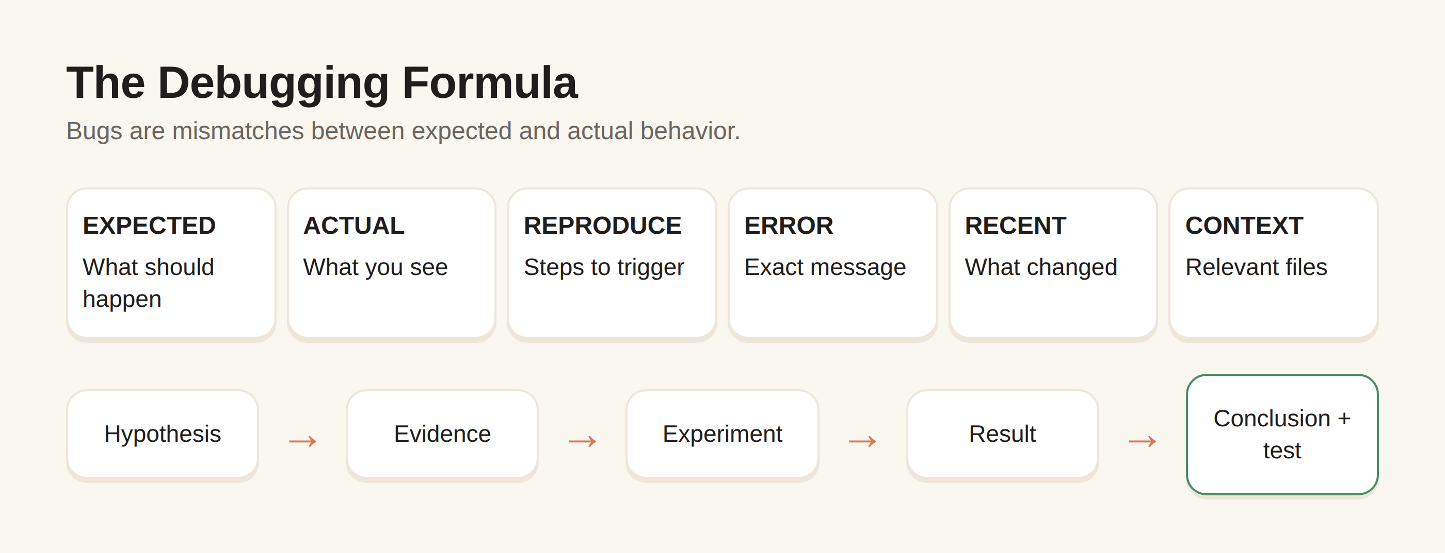
Figure 9. The debugging formula and reasoning log
Bad report: “The button is broken.” Better report: “On the checkout page, clicking Pay with an empty postal-code field causes the browser console to show this error. It started after the validation change in the last commit. Please inspect the validation path and identify the root cause before changing anything.”
Ask Claude to reproduce or reason about the failure, identify likely causes, rank them, and then test the hypothesis. Avoid asking it to make five unrelated changes at once. A small change with a clear verification step is easier to trust.
When a fix works, ask why it worked. Otherwise you may solve the symptom without learning the system. Also ask Claude to add or update a regression test when appropriate so the same bug is less likely to return.
For difficult bugs, ask for a debugging log: hypothesis, evidence, experiment, result, conclusion. This turns an opaque AI interaction into a reasoning trail you can inspect.
Remember that passing tests does not prove the entire application is correct. Tests cover what they cover. Combine automated checks with human review and realistic use of the feature.

Chapter 8 — Working With Existing Code
AI-assisted development becomes particularly valuable when the code is unfamiliar. Instead of asking Claude to rewrite everything, use it as a guided reader and reviewer.
Start with explanation. Ask Claude to identify responsibilities, dependencies, inputs, outputs, and side effects. Then ask it to identify duplicated logic, confusing names, fragile assumptions, or missing tests. Only after understanding the findings should you choose a refactor.
Refactoring means improving internal structure without intentionally changing external behavior. Ask Claude to state the behavior that must remain unchanged and the checks that will prove it. This is especially important when working in business-critical code.
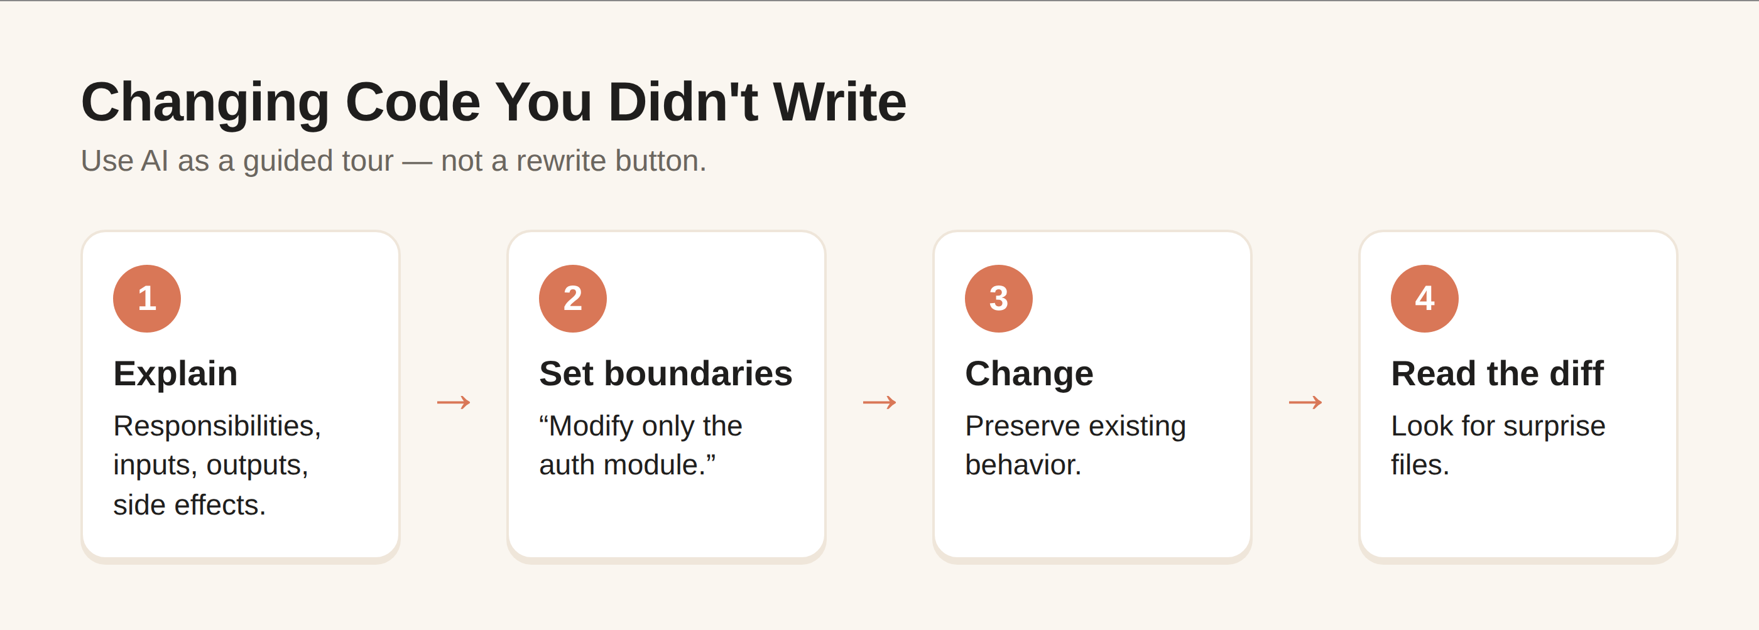
Figure 10. A safe way to change unfamiliar code
When requesting a change, define boundaries: “Modify only the authentication module. Do not change database schema, API responses, or unrelated formatting. Preserve current behavior except for the described bug.” Boundaries reduce accidental scope creep.
Use diffs as a learning tool. A diff shows what changed, not just what the AI says changed. Read it. Look for unexpected files, broad formatting changes, removed checks, altered dependencies, and changes to security-sensitive logic.
Ask for documentation when it creates lasting value: setup instructions, architecture notes, API examples, or a short explanation of a non-obvious decision. Documentation should explain the system, not narrate every line of code.
A mature workflow alternates between AI speed and human attention. Let AI handle exploration and mechanical work quickly; spend your attention on requirements, risk, architecture, security, and final decisions.

Chapter 9 — Git and Version Control for Beginners
Git is a history and collaboration system for software. For AI-assisted development, it becomes especially useful because it gives you a clear record of what changed and a way to recover when an experiment goes wrong.
Think of a commit as a meaningful checkpoint. Before asking an agent to make a risky change, having a clean checkpoint can make experimentation safer. This is not a reason to commit every tiny edit; it is a reason to create understandable history.
Learn four beginner concepts first: repository, working tree, commit, and branch. A repository contains the project history. The working tree is your current files. A commit records a snapshot of changes. A branch provides a separate line of work.
Before accepting AI-generated changes, inspect the diff. Ask Claude to summarize the diff, but do not rely on its summary alone. Use Git's own tools to see the actual changes.
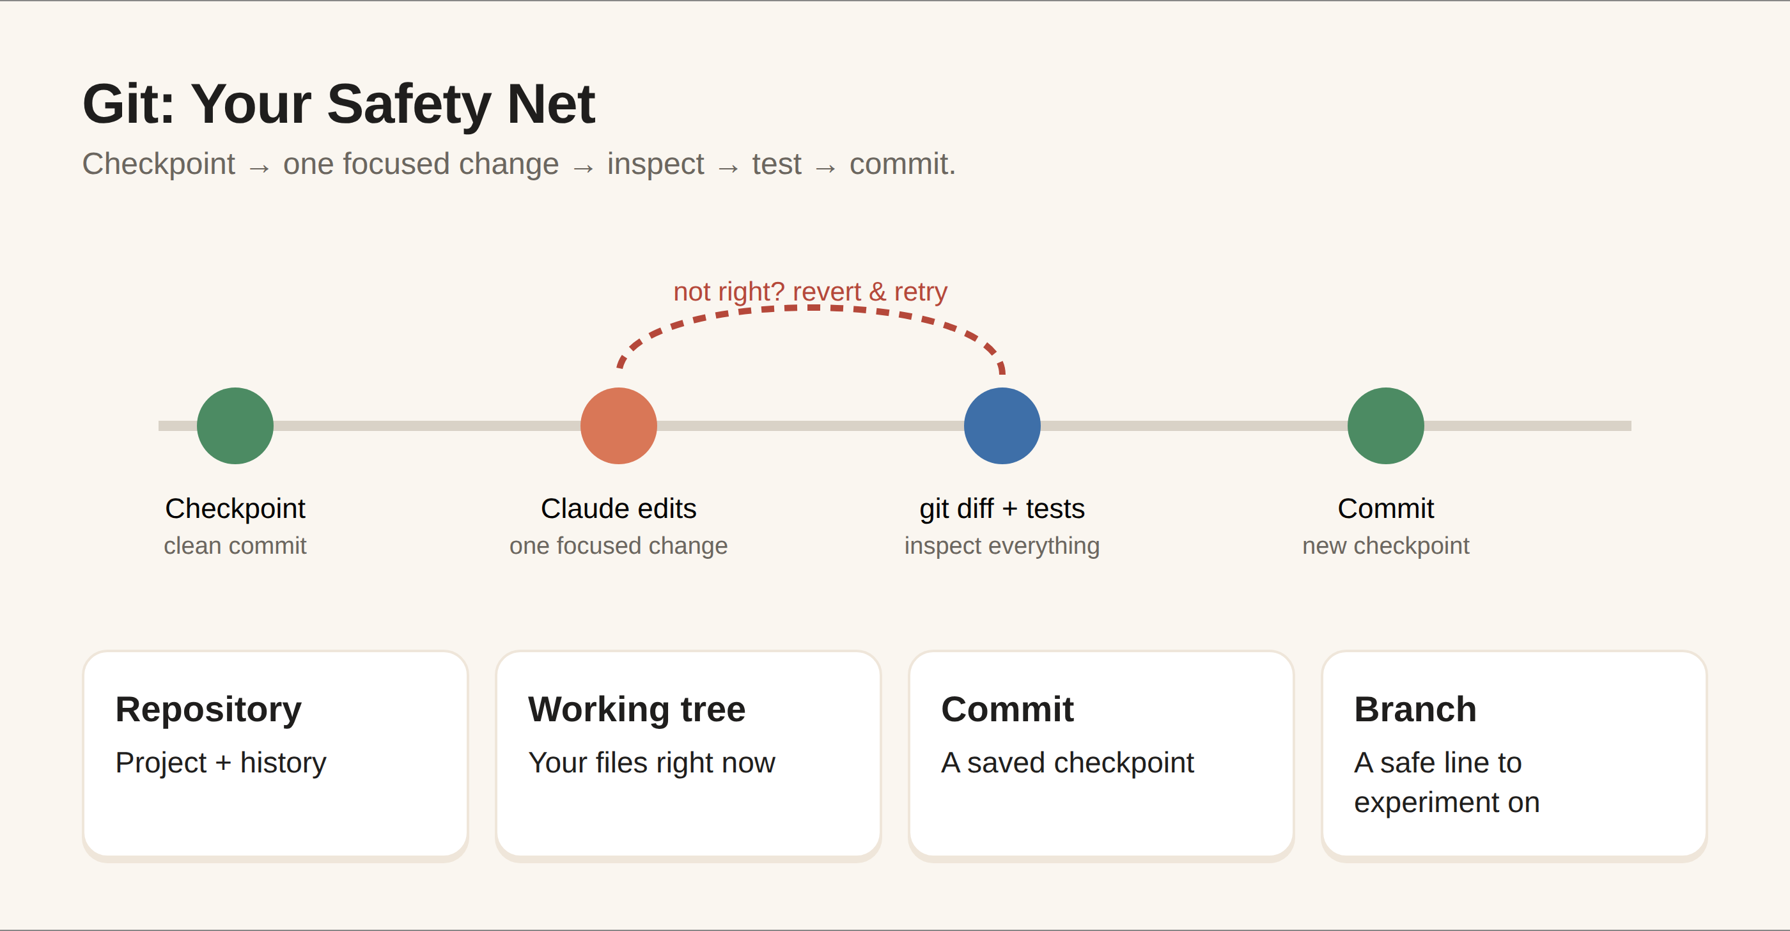
Figure 11. The Git checkpoint cycle
A safe pattern is: create a checkpoint → ask Claude to make one focused change → inspect diff → run tests → manually inspect important behavior → commit when the change is coherent. If the result is wrong, revert or restore using a deliberate Git workflow.
Never store secrets in Git. API keys, passwords, private certificates, and sensitive configuration should be handled using appropriate secret-management practices. An AI assistant can help detect obvious exposures, but prevention is better than cleanup.
You do not need to master every Git feature before using Claude Code. Learn enough to inspect, checkpoint, compare, branch, and recover. Then deepen your Git knowledge as your projects grow.

Chapter 10 — Safety, Privacy and Security
AI coding agents can be powerful because they can interact with real development environments. That same capability creates risk. The right question is not “Is AI safe?” in the abstract. The right questions are: What can this session access? What actions can it take? What information is present? What happens if an instruction is misunderstood or malicious input influences the agent?
Anthropic's current Claude Code materials emphasize permission controls and security guidance. In normal workflows, Claude Code can ask for approval before actions such as running commands or modifying files. Permission modes and tool restrictions can change the balance between convenience and control, so beginners should understand them before enabling broad automation.
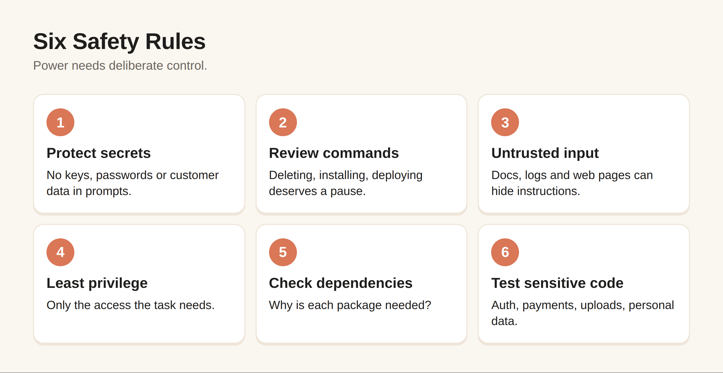
Figure 12. Six safety rules
Rule one: protect secrets. Never paste passwords, private keys, production tokens, or confidential customer information into a prompt merely because it is convenient. Review project files and environment configuration before giving an AI agent access to sensitive work.
Rule two: review commands. A command that deletes files, changes permissions, installs software, modifies infrastructure, or moves data deserves attention. Do not approve a command simply because Claude explains it confidently.
Rule three: treat external content as untrusted input. Documentation, issue descriptions, copied logs, websites, and repository files can contain instructions that are irrelevant or malicious. A coding agent should not automatically obey every instruction it encounters.
Rule four: minimize privileges. Give the agent only the access and permissions needed for the task. Broad access may be convenient, but narrow access limits the impact of mistakes.
Rule five: review dependencies. Generated code may introduce packages or configuration that you did not request. Ask why each dependency is needed, whether it is maintained, and whether the project can avoid it.
Rule six: test security-sensitive changes. Authentication, authorization, payments, personal data, encryption, file uploads, and external integrations deserve stronger review than cosmetic changes.
For business use, create a lightweight AI development policy covering approved tools, sensitive data, secrets, code review, testing, logging, and human approval. AI should strengthen governance, not bypass it.

Chapter 11 — Claude Code for Work and Business
Claude Code can be useful beyond traditional software companies. A small business may need an internal tool, a data transformation script, a reporting dashboard, a website change, or an automation prototype. A freelancer may need to understand a client's existing application quickly. A creator may want to build a simple utility rather than purchase a specialized service.
Start with low-risk, high-learning tasks. Documentation, code explanation, test generation, small UI improvements, data-format conversion, and prototype work can be good learning environments. As the consequences of an error increase, increase human review and testing.
For a business workflow, define the outcome in business terms first. Example: “Every Monday we spend two hours combining three CSV exports into one report.” Then ask Claude to help map the current process, identify repeatable steps, propose automation options, and estimate what information would be needed. Do not start by asking for code.
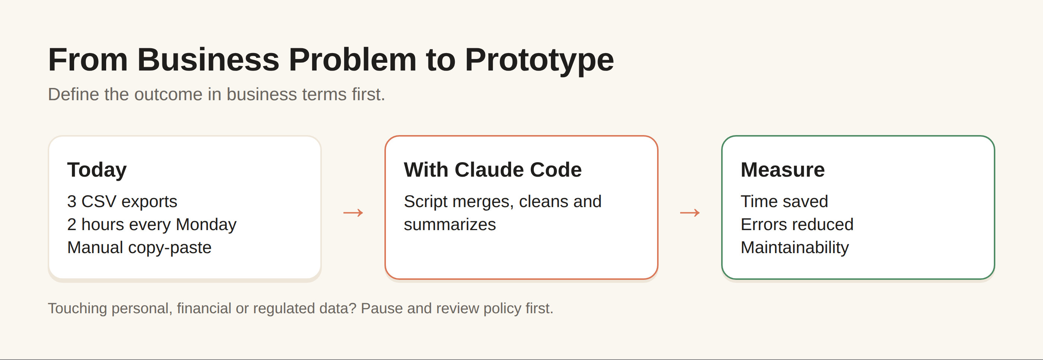
Figure 13. From business problem to prototype
A good business prompt contains: current process, inputs, desired output, constraints, privacy considerations, failure handling, and acceptance criteria. This lets the AI help with process design rather than merely producing scripts.
Do not measure AI success only by lines of code produced. Measure time saved, errors reduced, maintainability, user experience, and whether the resulting system can be understood and supported by humans.
If a prototype touches personal data, financial information, employee information, health information, or other regulated data, pause and evaluate the legal, privacy, security, and organizational requirements before connecting an AI agent to that environment.

Chapter 12 — Building Your AI-Assisted Workflow
A repeatable workflow is more valuable than a collection of clever prompts. Use this ten-step loop: define the goal; inspect the environment; create a plan; divide the work; implement one slice; test; review; fix; document; repeat.
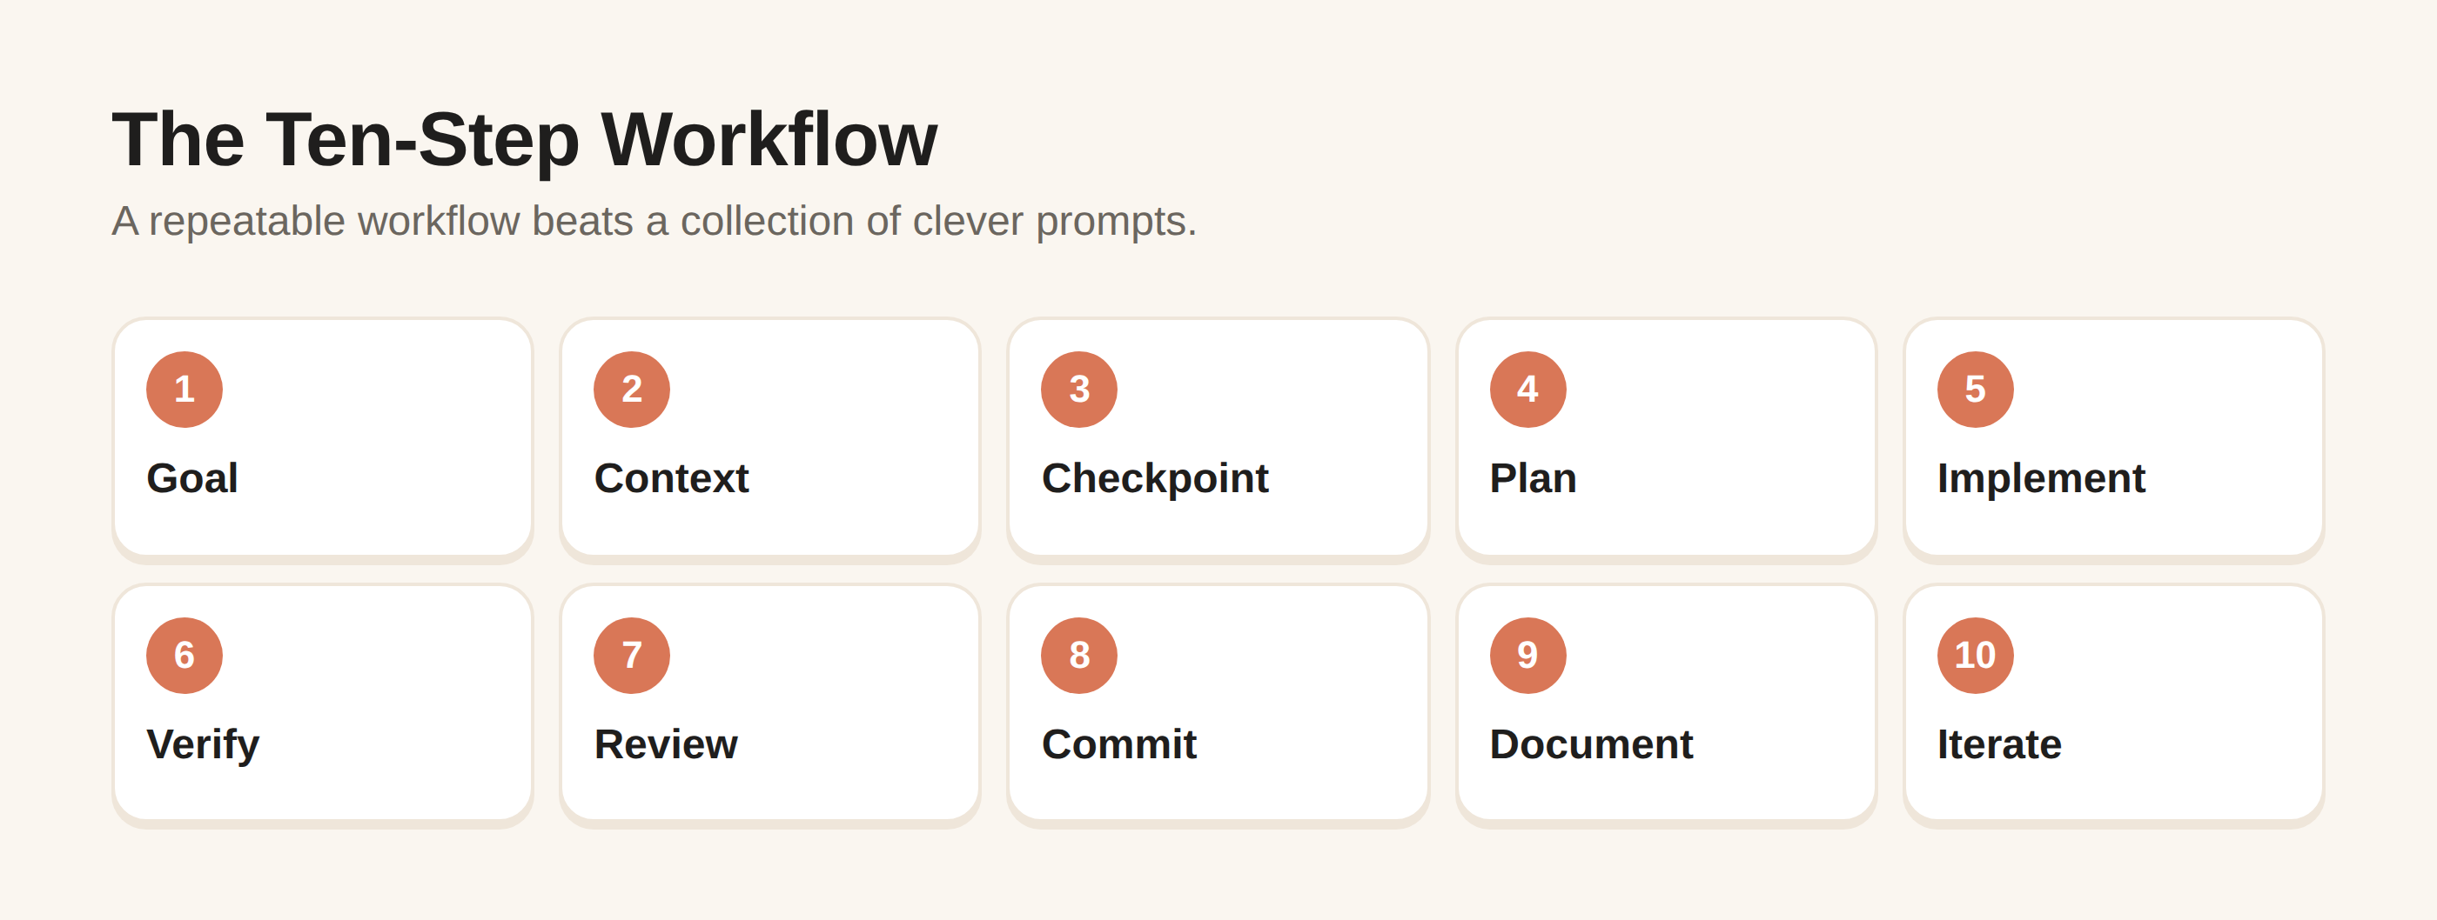
Figure 14. The ten-step AI-assisted workflow
Step one is intention. Write the desired outcome in plain language. Step two is context. Give the agent the project and constraints it needs. Step three is planning. Ask for a plan and risks before large changes. Step four is decomposition. Turn the plan into small tasks with clear completion criteria.
Step five is implementation. Work in small slices. Step six is verification. Run the relevant tests, checks, or manual scenarios. Step seven is review. Inspect the diff and important behavior. Step eight is correction. Fix specific findings rather than restarting the entire project.
Step nine is documentation. Record decisions that future contributors need. Step ten is iteration. Only after the current slice is stable should you move to the next one.
Create a personal session template: Objective; Context; Constraints; Files or components in scope; Plan requested; Definition of done; Tests; Review requirements. Reusing this structure reduces the cognitive load of starting every session from scratch.
As you become more experienced, you can explore advanced capabilities such as MCP integrations, skills, hooks, subagents, and automation. These are powerful precisely because they expand what the agent can do, so learn them after mastering the basic permission-and-verification loop.
The mature AI-assisted builder is not the person who gives the biggest prompt. It is the person who can frame a problem, constrain the work, inspect the result, and make good decisions quickly.

Chapter 13 — From Beginner to AI-Powered Builder
Your first goal is not to become an expert in every programming language. It is to become comfortable moving through a software problem. You should gradually learn how applications are structured, how data moves, how interfaces call logic, how tests work, how Git records change, and how deployment works.
At the beginner stage, focus on reading, prompting, small changes, and testing. At the confident-user stage, build complete small projects. At the builder stage, integrate APIs, databases, authentication, and deployment carefully. At the advanced stage, focus on architecture, reliability, security, performance, and team workflows.
A 30-day progression can look like this: Week 1 — setup, terminology, exploration, and prompting. Week 2 — build a small application and debug it. Week 3 — add persistence, tests, Git discipline, and documentation. Week 4 — build a second project and improve the workflow based on what you learned.
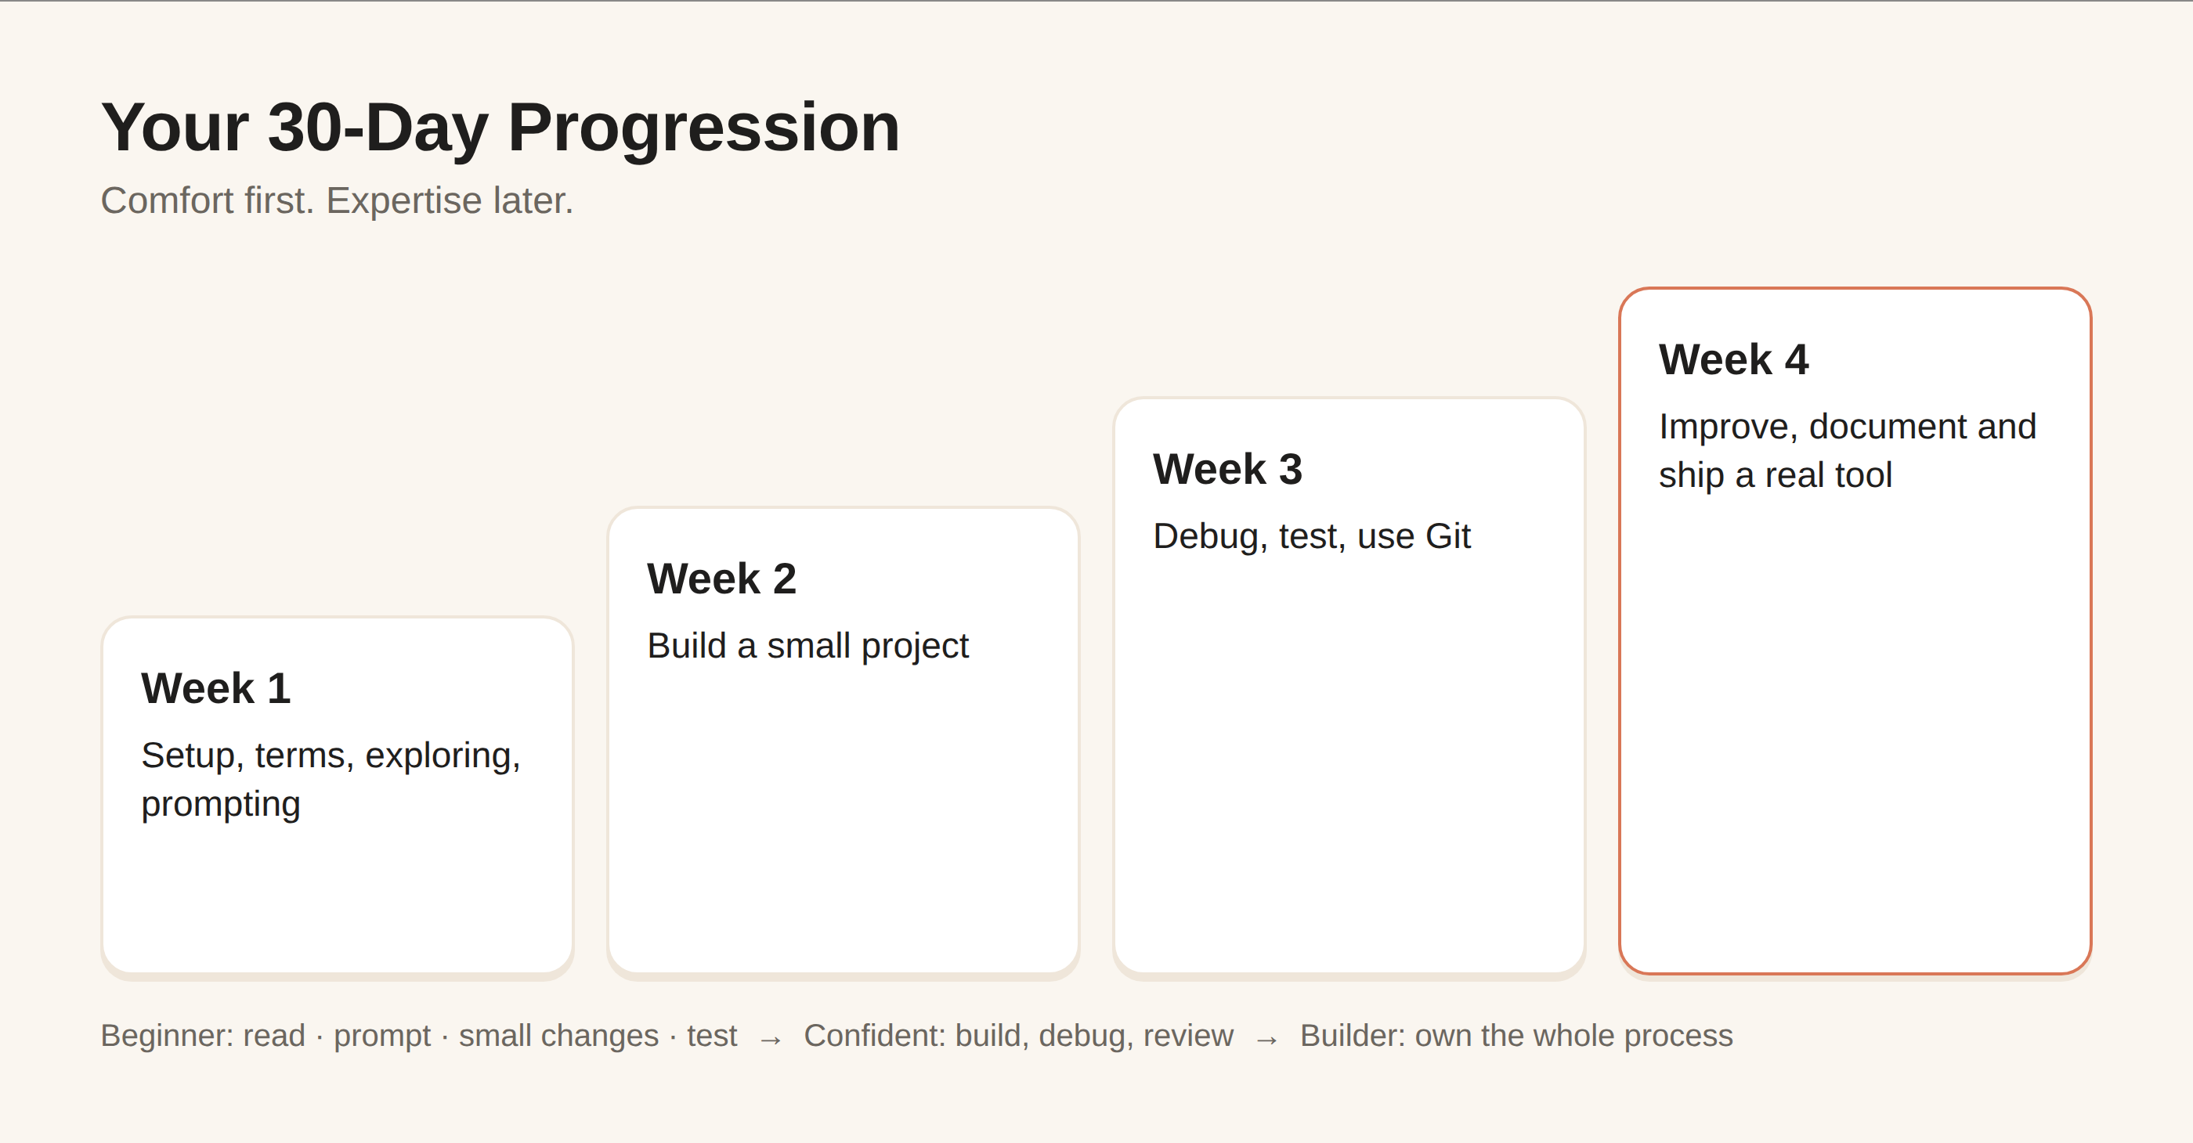
Figure 15. A 30-day progression
Do not measure learning by how many prompts you have copied. Measure it by whether you can explain what the software does, identify where a change belongs, recognize risky changes, and verify whether a result is correct.
The strongest long-term advantage is understanding. AI can generate implementation details quickly, but people who understand requirements, architecture, security, and users remain better positioned to direct and evaluate the work.

Chapter 14 — Ten Projects to Build Next
Project 1 — Personal website. Learn project structure, styling, assets, responsive design, and deployment concepts.
Project 2 — To-do application. Learn state, forms, validation, filtering, and basic persistence.
Project 3 — Expense tracker. Learn data modeling, totals, categories, validation, and testing.
Project 4 — Markdown notes app. Learn files, parsing, search, and a simple content workflow.
Project 5 — Portfolio dashboard. Learn reusable components, navigation, and presentation of structured data.
Project 6 — API-powered application. Learn HTTP requests, error handling, configuration, and API keys.
Project 7 — Business reporting tool. Learn CSV processing, transformation, summaries, and export.
Project 8 — Customer-support knowledge prototype. Learn search, structured content, permissions, and human review.
Project 9 — Small SaaS prototype. Learn authentication concepts, data persistence, billing concepts, deployment, and product boundaries.
Project 10 — Personal AI productivity tool. Learn how to combine an AI API with a useful workflow while applying cost, privacy, security, and reliability controls.
For every project, use the same discipline: define the problem; write acceptance criteria; ask Claude for a plan; build the smallest version; test it; inspect the diff; document it; then expand. Difficulty should increase gradually.
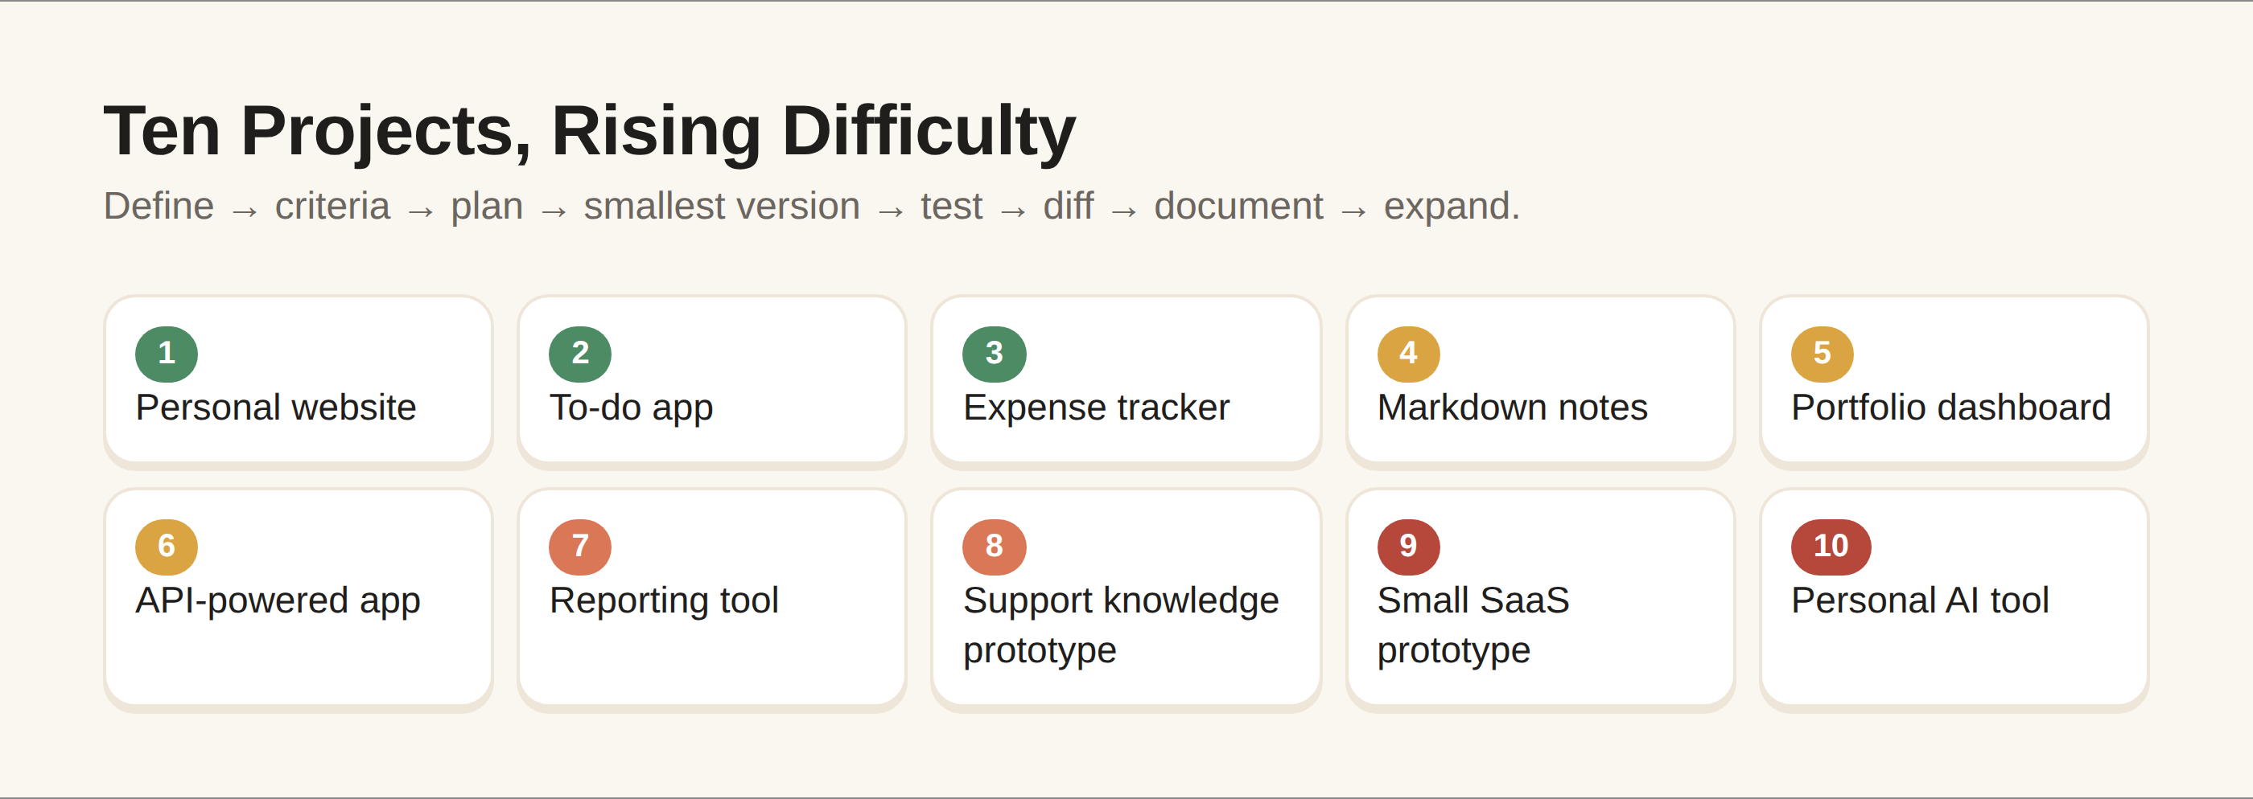
Figure 16. Ten projects with rising difficulty

Bonus — 50 Claude Code Prompt Templates
1. Explain this project to me as a beginner. 2. Map the folder structure without editing. 3. Identify the application entry point. 4. Explain how the app starts. 5. Identify the test commands. 6. Find where this feature is implemented. 7. Trace this user action through the code. 8. Identify the source of truth for this generated file. 9. Summarize the architecture. 10. List important configuration files.
11. Turn this idea into requirements. 12. List ambiguities in my specification. 13. Propose the smallest useful version. 14. Create acceptance criteria. 15. Propose an implementation plan. 16. Identify risks before coding. 17. Break this feature into small tasks. 18. Estimate which files are likely to change. 19. Suggest a testing strategy. 20. Challenge my assumptions.
21. Implement only the first task. 22. Keep changes limited to these files. 23. Preserve existing behavior except for this bug. 24. Add validation for this input. 25. Add a regression test. 26. Refactor this function without changing behavior. 27. Improve accessibility without changing content. 28. Reduce duplicated logic. 29. Add documentation for this workflow. 30. Explain every dependency you propose adding.
31. Here is the exact error; identify likely causes. 32. Reproduce this failure if possible. 33. Compare expected and actual behavior. 34. Find the smallest safe fix. 35. Explain why the fix works. 36. Add a test that would catch this bug. 37. Review the recent diff for regressions. 38. Check for error-handling gaps. 39. Check for insecure assumptions. 40. Check whether this change affects unrelated features.
41. Review this diff without editing. 42. Review this feature for security risks. 43. Review this feature for maintainability. 44. Review this API integration for error handling. 45. Review this authentication change carefully. 46. Summarize what changed in plain language. 47. Identify unexpected files changed. 48. Tell me what I should manually test. 49. Create a release checklist. 50. After reviewing everything, list unresolved risks.

Bonus — Beginner Cheat Sheet
Core loop: UNDERSTAND → PLAN → BUILD → TEST → REVIEW → IMPROVE. If you skip understanding, you may solve the wrong problem. If you skip planning, you may create unnecessary changes. If you skip testing, you may not know whether the change works. If you skip review, you may miss unintended consequences.
Prompt formula: CONTEXT + GOAL + CONSTRAINTS + TASK + SUCCESS CRITERIA. For debugging add EXPECTED + ACTUAL + REPRODUCTION + ERROR. For review add SCOPE + RISK AREAS + NO-EDIT INSTRUCTION.
Safety checklist: protect secrets; review commands; minimize permissions; inspect diffs; verify dependencies; test security-sensitive behavior; treat external instructions as untrusted; do not expose confidential data unnecessarily; keep recoverable version history.
Remember: a fluent AI response is not evidence of correctness. Evidence comes from the project, tests, documentation, observed behavior, and your review.
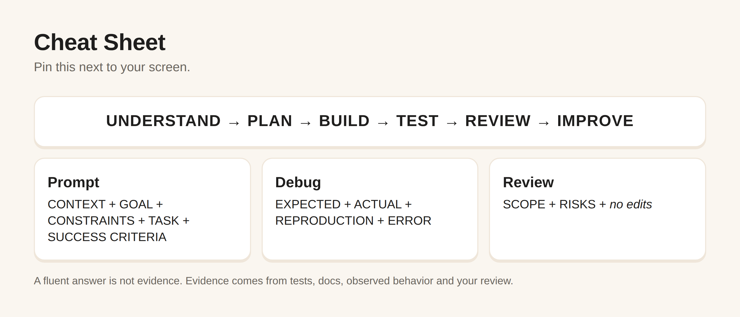
Figure 17. Beginner cheat sheet

Bonus — Your First 7 Days
Day 1 — Set up and explore. Install Claude Code using current official instructions. Open a practice project. Ask Claude to explain the project without changing anything.
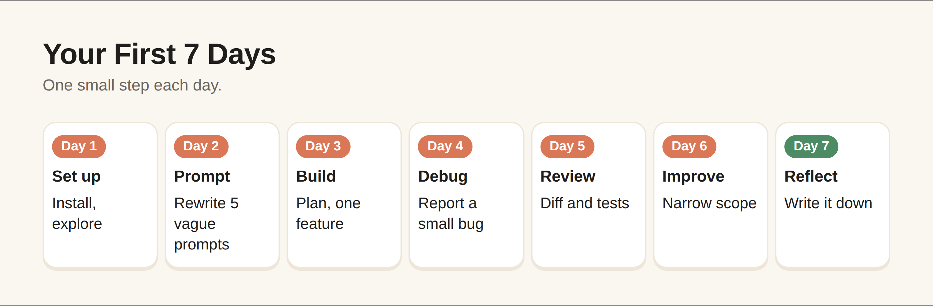
Figure 18. Your first 7 days
Day 2 — Learn prompting. Practice context, goals, constraints, and success criteria. Rewrite five vague prompts into precise requests.
Day 3 — Build. Start a tiny project and ask Claude to plan before implementing. Complete one small feature.
Day 4 — Debug. Introduce or encounter a small bug. Practice reporting expected behavior, actual behavior, error, reproduction, and recent changes.
Day 5 — Review. Inspect a diff, ask for a review, run tests, and manually check the feature.
Day 6 — Improve. Add one meaningful feature, keeping the scope narrow. Document the decision and update tests.
Day 7 — Reflect. Write what Claude did well, where it made mistakes, what you had to correct, and which technical concept you need to learn next. Then choose your second project.

Conclusion — You Are the Builder
Claude Code can lower the barrier between an idea and a working software experiment. But the most important capability is not the tool itself. It is your ability to turn an intention into a clear problem, guide an AI through the work, and judge whether the result is actually good.
You do not need to know everything before you start. You need a safe environment, a small project, a willingness to read what the system is doing, and a habit of verification. Every error becomes a lesson about how software works.
The future of software will likely involve more collaboration between people and increasingly capable AI systems. That makes human judgment more important, not less. Requirements, ethics, security, product sense, user empathy, and accountability cannot be delegated simply because an AI can write code.
Start small. Ask clearly. Review carefully. Test honestly. Keep learning. Then build the next thing.

Sources & Further Learning
This edition uses current official Anthropic material for Claude Code setup, CLI usage, security and product capabilities. Because Claude Code ships frequently, readers should verify version-specific details before following commands or configuring production systems.
Primary reference: Anthropic Claude Code documentation and official Claude Code resources. Current documentation includes setup, CLI reference, interactive mode, memory/CLAUDE.md, permission modes, MCP, skills, hooks, subagents, plugins, checkpointing, model configuration, common workflows, security, data usage, and best practices.
Additional references: official Anthropic announcements and engineering material concerning Claude Code and agentic coding workflows; official Git and GitHub documentation for version control; relevant documentation for the frameworks, languages, package managers, and cloud services used in a specific project.

About the Author
Zirlandia Milkovic is a guest relations manager and technology-focused entrepreneur interested in GDPR, cybersecurity, artificial intelligence, and practical digital tools. Her work combines a people-first perspective with a growing focus on responsible technology and AI-assisted productivity.
Her goal with this book is simple: make powerful technology understandable enough that ordinary people can begin experimenting, learning, and building with confidence.

