Mathpaqs

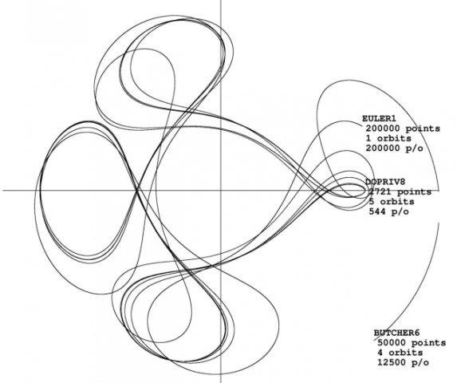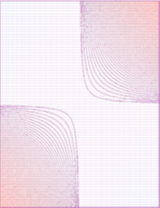

Mathpaqs is a collection of mathematical, 100% portable, packages in Ada.
Download:
 | Download Mathpaqs from the SourceForge project page. | 

Mathpaqs topics

The list of packages below is sorted by topics.
In the Mathpaqs archive, each topic has a subdirectory.
Of course there are many possible interactions, like between Multi-precision numbers and Algebra (see Euclidean_Ring_Tools) - it is like combining mathematics fields...

Algebra

Euclidean_Ring_Tools: Generic package: given a type with the properties of an Euclidean ring (like integers or polynomials, with 0,1,+,* and integral division), it gives the Greatest Common Divisor and the Bezout factors.

Frac: Generic package: given a type with the properties of a ring, it gives the fractions of it, with operators.

Frac.Order: Supplement of generic package 'Frac': provides an order relation from one of the ring.

Frac_Euclid: Generic package: given a type with the properties of an Euclidean ring (with division), it gives the fractions field of it, with operators and reduction.

Frac_Euclid.Order: Supplement of generic package 'Frac_Euclid': provides an order relation from one of the ring.

Polynomials: Generic package, creates polynomials on a field.

Examples of instantiation:
- Float_Polynomials: = Polynomials( float, 0.0,1.0, "-",... );
- Rationals.Polynomials: = Polynomials( rational, frac_0, frac_1, "-",... );

Rationals: Package for manipulation of rational numbers. One-liner package: Frac_Euclid( integer, 0,1, "-","+","-","*","/"); !
- Rationals_Order: = Rationals.Order("<");

Linear algebra

G_Matrices: Generic simple matrix package, with matrix-matrix, matrix-vector, vector operations.
NB: For Ada 2005+ and real numbers implemented as floating-point numbers, it is better to use Ada.Numerics.Generic_Real_Arrays instead.

Generic_Real_Linear_Equations: by Jon Squire. Inversion, Cholesky decomposition, LU decomposition, QR decomposition, SV decomposition.

ConjGrad: Fast (Bi)Conjugate Gradient iterative methods for solving Ax=b. Generic -> applies to the matrix storage of your choice (e.g. sparse) !

Numerics

G_FEK: Parts of the Finite Element Kernel from M. Bercovier (original in FORTRAN);
Computes values and derivatives of elementary functions given the element's geometry.
Available so far:
1D: L2 (linear)
2D: Q4 (linear), Q9 (quadratic)
3D: B27 (quadratic)
Generic -> can be instantiated for any precision!

Beta_Function : The Beta function: B(a,b), B(x,a,b), I_x(a,b).
Gamma_Function: The Gamma function: Γ(x) and Log(Γ(x)).
Phi_Function : Gauss' Phi function: Φ(x) and inverse.
Error_Function : error function: Erf(x) and complementary, ErfC(x).

Multi-precision integers

Multi_precision_integers: Multiple-precision integers package.

Multi_precision_integers_IO: Text_IO, for multi-precision integers.

(Pseudo-) Random number generation, probability models, statistics

Generic_Random_Functions: Functions facilitating computations with various standard random distributions, discrete and continuous: Beta, Normal, Poisson, Pareto.

Discrete_Random_Simulation: Random generation on any empirical discrete distribution.

Finite_distributed_random: Random generation on any enumerated type.

U_Rand: Standalone random generator (Pure Ada 95, replaces seamlessly the generator of an Ada implementation (Ada.Numerics.Float_Random) if the latter seems too slow).

Copulas: An object-oriented multivariate uniform random generator with dependency model of any kind. A few basic copulas are provided.

Samples: A package for building samples of random values, then computing statistics from these samples.

Estimators: Various statistical estimators.

Sparse matrices

Sparse: Sparse matrix package (Pure Ada 83); uses SparseB
SparseB: Low-level vector operations for Sparse package
- Pure Ada 83 [.adb] body, and
- DEC/Compaq/HP [.dec] body mapped to BLAS

Miscellaneous

Formulas : A generic symbolic computation package (expression parser, fast evaluation, formula simplification).
Contours : A generic contour plot package.

Contact:

