Thalassa
Mythical Age Adventure Game
CC BY-SA 4.0 Roberto Bisceglie

For Cristina and Elettra
Thálassa is based on Cairn SRD and is licensed under CC-BY-SA 4.0.
Thálassa is an adventure game for one facilitator (the odigós) and at least one other player. Players act as fearless explorers of the Mediterranean of the Mythical Age, studded with mysterious islands, thick forests, legendary creatures, labyrinths and dangers.

Overview
Thálassa was written with the following design philosophies in mind:

Neutrality
The odigós’s role is to portray the rules, situations, NPCs, and narrative clearly, while acting as a neutral arbiter.

Classless
A character’s role or skills are not limited by a single class. Instead, the equipment they carry and their experiences defines their specialty.

Death
Characters may be powerful, but they are also vulnerable to harm in its many forms. Death is always around the corner, but it is never random or without warning.

Fiction First
Dice do not always reflect an obstacle’s difficulty or its outcome. Instead, success and failure are arbitrated by the odigós in dialogue with the players, based on in-world elements.

Growth
Characters are changed through in-world advancement, gaining new skills and abilities by surviving dangerous events and overcoming obstacles.

Player Choice
Players should always understand the reasons behind the choices they’ve made, and information about potential risks should be provided freely and frequently.

Principles
The odigós and the players each have guidelines that help foster a specific play experience defined by critical thinking, exploration, and an emergent narrative.

Shared Objectives
Players trust one another to engage with the shared setting, character goals, and party challenges. Therefore, the party is typically working together towards a common goal, as a team.

Principles for odigoí

Information
- Provide useful information about the game world as the characters explore it.
- Players do not need to roll dice to learn about their circumstances.
- Be helpful and direct with your answers to their questions.
- Respond honestly, describe consistently, and always let them know they can keep asking questions.

Difficulty
- Default to context and realism rather than numbers and mechanics.
- If something the players want to do is sincerely impossible, no roll will allow them to do it.
- Is what the player describes and how they leverage the situation sensible? Let it happen.
- Saves cover a great deal of uncertain situations and are often all that is necessary for risky actions.

Preparation
- The game world is organic, malleable and random. It intuits and makes sharp turns.
- Use random tables and generators to develop situations, not stories or plots.
- NPCs remember what the PCs say and do,and how they affect the world.
- NPCs don’t want to die. Infuse their own self-interest and will to live into every personality.

Narrative Focus
- Emergent experience of play is what matters, not math or character abilities. Give the players weapon trainers and personal quests to facilitate improvement and specialization.
- Pay attention to the needs and wants of the players,then put realistic opportunities in their path.
- A dagger to your throat will kill you, regardless of your expensive armor and impressive training.

Danger
- The game world produces real risk of pain and death for the player characters.
- Telegraph serious danger to players when it is present. The more dangerous, the more obvious.
- Put traps in plain sight and let the players take time to figure out a solution.
- Give players opportunities to solve problems and interact with the world.

Prize
- A Prize is specific to the environment from where it is recovered. It suggests a story.
- A Prize is something valuable, but non necessarily a treasure or materially valuable.
- A Prize can be anything that calls to action the players.
- Use the Prize as a lure to exotic locations under the protection of intimidating foes.

Choice
- Give players a solid choice to force outcomes when the situation lulls.
- Use binary “so, A or B?” responses when their intentions are vague.
- Work together with this conversational progress to keep the game moving.
- Ensure that the player character’s actions leave their mark on the game world.

Die of Fate
- Gods are capricious: sometimes they favour the characters, other times they will play against them.
- In these situations, roll 1d6. A roll of 4 or more generally favors the players.
- A roll of 3 or under tends to mean bad luck for the PCs or their allies.

Principles for Players

Agency
- Attributes and related saves do not define your character. They are tools.
- Don’t ask only what your character would do, ask what you would do, too.
- Be creative with your intuition, items, and connections.

Teamwork
- Seek consensus from the other players before barreling forward.
- Stay on the same page about goals and limits, respecting each other and accomplishing more as a group than alone.

Exploration
- Asking questions and listening to detail is more useful than any stats, items, or skills you have.
- Take the odigós’s description without suspicion, but don’t shy away from seeking more information.
- There is no single correct way forward.

Talking
- Treat NPCs as if they were real people, and rely on your curiosity to safely gain information and solve problems.
- You’ll find that most people are interesting and will want to talk things through before getting violent.

Caution
- Fighting is a choice and rarely a wise one; consider whether violence is the best way to achieve your goals.
- Try to stack the odds in your favor and retreat when things seem unfavorable.

Planning
- Think of ways to avoid your obstacles through reconnaissance, subtlety, and fact-finding.
- Do some research and ask around about your objectives.

Ambition
- Set goals and use your meager means to take steps forward.
- Expect nothing. Earn your reputation.
- Keep things moving forward and play to see what happens.

Principles of the World

The Sea (hē thálassa)
- The Know World mostly faces the Sea. It is a vast basin on which peoples of different cultures live and where the creatures of myth roam free.
- The daring and the brave venture into its waters. In distant lands they go in search of the Prize and fortune and glory.
- The Sea is dotted with wild and unknown islands, ready to be explored and despoiled. The mainland is for the most part unexplored and mysterious.

Gods
- Gods are real, they walk among humans. Sometimes they fall in love with them, sometimes they are envious.
- They are powerful and capricious, but not almighty. They are immortal, but they can be injured.
- One can appeal to the deities to request their intervention. Often they will not listen, sometimes they will respond unpredictably.

Demigods & Heroes
- The Demigods are not necessarily the result of the union of a god and a mortal but some are, like Heracles.
- Those who demonstrate strength, power, good family, and good behavior are termed heroes.
- After death Gods may grant the apotheosis. When this happens the hero assumes the title of Demigod.

Deeds & Labours
- Characters are called to action out of obligation (labours) or to seek glory (deeds). They will often cross The Sea to accomplish their duties.
- Whether they are demigods, heroes or ordinary people, they all have something in common: Fate is inescapable. The Moirai have already established the length of their thread. They accept it and face creatures and oddities with courage.
- Characters prefer cunning to brute force. War is not a sport, after all. However, some times they will be arrogant and overconfident. This is called hubris and is punished by circumstances and the gods.

Aoidos & Myths
- Myths passed down in literature are real history in this world.
- Being passed down orally by the aoidos, there are conflicting versions of the same story.
- It is possible to meet the heroes of myth. The odigoí is free to choose which mythical era to set the adventure in.

Eukhé & Goïteia
- When one appeals to a god, they are a eukhé (prayer). Eukhé is the high and noble form of magic.
- In Egypt, west of Lybia, the high priests practice heka (magic) that draws on primordial power through rituals and incantations.
- Importing some incantations, which are passed down without fully understanding their function and power, some practice goïteia, a low and limited form of magic that has lesser effects than either eukhé or heka. Practitioners of goïteia are frowned upon and considered by most to be charlatans.

Labyriths
- Around the vast Sea on mysterious islands or impenetrable forests are located labyrinths.
- There are different types of labyrinths. Some are physically mazes built to imprison and protect. Others are networks of caves or palaces with complex geometry.
- Those who face the dangers of the labyrinths will be rewarded with Prizes and other riches.

The Underworld
- The Underworld is a real (but hidden to the living) physical place where the souls of the dead dwell. These are only shadows of the mortal that they were, with no sense of purpose. The Underworld has a complex geography it is crossed by rivers and inhabited and defended by creatures.
- It is possible to descend into the Underworld with the rite of katabasis. The ability to enter the realm of the dead while still alive, and to return, is a proof of being a hero. The purpose of the descent is to recover a quest-object or a loved one, or with heightened knowledge.
- It is also possible to summon the souls of the dead with the rite of nekyia. In this case the descent into the Underworld will not be physical and will have the purpose of obtaining knowledge or prophecies from the dead.

Character Creation

Name, Origin & Traits
First, choose or roll a name for your character from the Background tables, and their origin, indicating where they come from.
Next, roll for the rest of your character’s traits (appearance, speech, mannerisms, beliefs, reputation, etc.) on the Character Traits tables.
Finally, roll for their age (2d20+10).

Ability Scores
Player Characters (PCs) have just three attributes:
- kratos (KRA) (strength)
- tekhne (TEK) (nimbleness)
- thumos (THU) (control).
When creating a PC, the player should roll 3d6 for each of their character’s ability scores, in order. They may then swap any two of the results.
Example:
Ines rolls for her character’s KRA, resulting in a 2, a 4, and a 6, totaling 12. The next two ability rolls result in a 9 for TEK and a 13 for THU. She decides to swap the 12 and the 9, for a character with 9 KRA, 12 TEK and 13 THU.

Stamina
Roll 1d6 to determine your PC’s starting Stamina (STA), which reflects their ability to avoid damage in combat. STA does not indicate a character’s health or fortitude; nor do they lose it for very long (see Healing). If an attack takes a PC’s STA exactly to 0, the player must roll on the Scars table.

Inventory
Characters have a total of inventory slots equal to their KRA: this represents the character’s ability to to bear the weight and fatigue of carrying the equipment without being adversely affected.
Most items take up one slot, and small items can be bundled together. Slots are abstract and can be rearranged per the odigós’ discretion.
Bulky items take up two slots and are typically two-handed or awkward to carry. Anyone carrying a full inventory (e.g. filling all 10 slots) is reduced to 0 STA.
A PC cannot carry more items than their inventory allows. Carts (which must be pulled with both hands), horses, or mules can increase inventory. Companions can also be paid to carry equipment.

Starting Gear
All PCs begin with:
- Three days’ rations (one slot)
- A weapon (roll on the related table)
- 3d6 electron coins
Roll on the Starting Gear tables to determine your PC’s armor, tools, and equipment.
See the Equipment List for related armor, damage, and slot values. Smaller items can sometimes be bundled together into one slot.

Background (d20)

Female Names
1 | Althea | 6 | Deipyle | 11 | Lede | 16 | Phylia
2 | Berenike | 7 | Electra | 12 | Lyra | 17 | Themis
3 | Chloris | 8 | Eunice | 13 | Metis | 18 | Thyia
4 | Corythia | 9 | Galatea | 14 | Mykale | 19 | Xanthe
5 | Deineira | 10 | Helike | 15 | Niobe | 20 | Zoe

Male Names
1 | Agelaus | 6 | Croesus | 11 | Epistor | 16 | Lycoris
2 | Audax | 7 | Damastor | 12 | Glycon | 17 | Mydon
3 | Brygos | 8 | Demokrates | 13 | Hyllus | 18 | Pheidias
4 | Chrysippos | 9 | Dryas | 14 | Icarion | 19 | Skiron
5 | Cleonicus | 10 | Eleon | 15 | Kasos | 20 | Timonax

Child of
1 | Alcman | 6 | Geleon | 11 | Menexinos | 16 | Sosimenes
2 | Bacis | 7 | Gnipho | 12 | Peirithous | 17 | Sostias
3 | Diactorides | 8 | Hagias | 13 | Phaenippos | 18 | Teukros
4 | Eumaeus | 9 | Melanippos | 14 | Philokles | 19 | Thaumastus
5 | Eutuches | 10 | Menandros | 15 | Priam | 20 | Thettalos

Origin
1 | Amazon | 6 | Child of king | 11 | Egyptian | 16 | Phoenician
2 | Argive | 7 | Ciconian | 12 | Ethyopian | 17 | Rhodian
3 | Athenian | 8 | Cimmerian | 13 | Lydian | 18 | Spartan
4 | Child of deity | 9 | Cretese | 14 | Mycenaean | 19 | Thracian
5 | Child of hero | 10 | Cypriot | 15 | Mysian | 20 | Trojan

Character Traits (d10)

Physique
1 | Athletic | 6 | Scrawny
2 | Brawny | 7 | Short
3 | Flabby | 8 | Statuesque
4 | Lanky | 9 | Stout
5 | Rugged | 10 | Towering

Skin
1 | Birthmark | 6 | Round
2 | Dark | 7 | Soft
3 | Elongated | 8 | Tanned
4 | Pockmarked | 9 | Tattooed
5 | Rosy | 10 | Weathered

Hair
1 | Bald | 6 | Long
2 | Braided | 7 | Luxurious
3 | Curly | 8 | Oily
4 | Filthy | 9 | Wavy
5 | Frizzy | 10 | Wispy

Face
1 | Bony | 6 | Perfect
2 | Broken | 7 | Rat-like
3 | Chiseled | 8 | Sharp
4 | Elongated | 9 | Square
5 | Pale | 10 | Sunken

Speech
1 | Blunt | 6 | Gravelly
2 | Booming | 7 | Precise
3 | Cryptic | 8 | Squeaky
4 | Droning | 9 | Stuttering
5 | Formal | 10 | Whispery

Clothing
1 | Antique | 6 | Frayed
2 | Bloody | 7 | Frumpy
3 | Elegant | 8 | Livery
4 | Filthy | 9 | Rancid
5 | Foreign | 10 | Soiled

Virtue
1 | Ambitious | 6 | Honorable
2 | Cautious | 7 | Humble
3 | Courageous | 8 | Merciful
4 | Disciplined | 9 | Serene
5 | Gregarious | 10 | Tolerant

Vice
1 | Aggressive | 6 | Lazy
2 | Bitter | 7 | Nervous
3 | Craven | 8 | Rude
4 | Deceitful | 9 | Vain
5 | Greedy | 10 | Vengeful

Reputation
1 | Ambitious | 6 | Loafer
2 | Boor | 7 | Oddball
3 | Dangerous | 8 | Repulsive
4 | Entertainer | 9 | Respected
5 | Honest | 10 | Wise

Misfortunes
1 | Abandoned | 6 | Defrauded
2 | Addicted | 7 | Demoted
3 | Blackmailed | 8 | Discredited
4 | Condemned | 9 | Disowned
5 | Cursed | 10 | Exiled

Starting Gear

Armor (d20)
1-3 | 4-14 | 15-19 | 20
None | Fur Coat | Linothorax | Breastplate

Helmets & Shields (d20)
1-13 | 14-16 | 17-19 | 20
None | Krános (Helmet) | Aspis (Shield) | Krános & Aspis

Weapons (d20)
1-5 | 6-14 | 15-19 | 20
Kopis (curved knife) | Doru (spear), Xiphos (sword) | Akontia (javelin), Sfendonai (sling) | Xyston (long lance), Toxa (bow)

Expeditionary Gear (d12)
1 | Cart (+4 slots, bulky) | 7 | Lockpicks
2 | Chain (10ft) | 8 | Pick
3 | Dowsing Rod | 9 | Pole (10ft)
4 | Fire Oil | 10 | Rope (25ft)
5 | Large Sack | 11 | Torch
6 | Large Trap | 12 | Waterskin

Tools (d10)
1 | Bellows | 6 | Drill (Manual)
2 | Bucket | 7 | Fishing Rod
3 | Chalk | 8 | Flint & Steel
4 | Chisel | 9 | Grease
5 | Cook Pots | 10 | Staff

Trinkets (d10)
1 | Amulet | 6 | Lyre
2 | Bottle | 7 | Necklace
3 | Copper | 8 | Silver Mirror
4 | Horn | 9 | Talisman
5 | Incense | 10 | Tunic

Bonus Item (d20, roll on table indicated)
1-5 | 6-13 | 14-17 | 18-20
Tool or Trinket | Expeditionary Gear | Armor or Weapon | Incantation

Equipment List (Prices in Electrum)

Armor
Aspis (+1 Armor) | 10
Krános (+1 Armor) | 10
Fur Coat (+1 Armor) | 15
Linothorax (2 Armor, bulky) | 40
Breastplate (3 Armor, bulky) | 60

Weapons
Kopis (d6 damage) | 5
Doru, Xiphos (d8 damage) | 10
Akontia, Xyston (d10 damage, bulky) | 20
Sfendonai | 5
Toxa (d6 damage, bulky) | 20

Gear & Tools
Bucket | 5 | Mirror | 5
Cart (+4 slots, bulky) | 30 | Mule (+6 slots, slow) | 30
Chain (10ft) | 10 | Net | 10
Chisel | 5 | Oilskin Bag | 5
Cook Pots | 10 | Pick | 10
Drill (Manual) | 10 | Pole (10ft) | 5
Fire Oil | 10 | Stylus & Tablet | 10
Fishing Rod | 10 | Rations (three day’s worth) | 10
Grease | 10 | Rope (25ft) | 5
Horn | 10 | Saw | 5
Horse (+4 slots) | 75 | Sack | 5
Incense | 10 | Shovel | 5
Lantern & Oil | 10 | Soap | 1
Large Trap | 20 | Spike | 1
Large Sponge | 5 | Spiked Boots | 5
Lens | 10 | Tar | 10
Lockpicks | 25 | Tent (fits 2 people, bulky) | 20
Metal File | 5 | Torch | 1

Rules

Abilities
Each of the three abilities are used in different circumstances (see saves, below).
- Kratos (KRA): Used for saves requiring physical power, like lifting gates, bending bars, resisting poison, etc.
- Tekhne (TEK): Used for saves requiring poise, speed, and reflexes like dodging, climbing, sneaking, balancing, etc.
- Thumos (THU): Used for saves to persuade, deceive, interrogate, intimidate, charm, provoke, recite incantations, etc.

Saves
A save is a roll to avoid bad outcomes from risky choices and circumstances. PCs roll a d20 for an appropriate ability score. If they roll equal to or under that ability score, they pass. Otherwise, they fail. A 1 is always a success, and a 20 is always a failure.
Example:
Althea encounters a group of wild harpies standing guard before a tunnel entrance. Her player carefully plots a course, recognizing that her 13 TEK makes sneaking past the guards the best option. She rolls a d20, and resulting in a 10 – a success!

Deprivation & Fatigue
A PC deprived of a crucial need (such as food or rest) is unable to recover STA or ability scores. Anyone deprived for more than a day adds Fatigue to their inventory, one for each day. Each Fatigue occupies one slot and lasts until they are able to recuperate (such as a full night’s rest in a safe spot).

Healing
Resting for a few moments and having a drink of water restores lost STA but leaves the party exposed. Ability loss can usually be restored with a week’s rest facilitated by a healer or other appropriate source of expertise. Some of these services may be free, while more expedient or magical means of recovery may come at a cost.

Armor
Before calculating damage to STA, subtract the target’s Armor value from the result of damage rolls. Shields and similar armor provides a bonus defense (e.g. +1 Armor), but only while the item is held or worn.
No one can have more than 3 Armor.
Shields, gauntlets, and helms may provide additional benefits according to their use.

Reactions
When the PCs encounter an NPC whose reaction to the party is not obvious, the odigós may roll 2d6 and consult the following table:
2 | 3-5 | 6-8 | 9-11 | 12
Hostile | Wary | Curious | Kind | Helpful

Morale
Enemies must pass a THU save to avoid fleeing when they take their first casualty and again when they lose half their number. Some groups may use their leader’s THU in place of their own. Lone foes must save when they’re reduced to 0 STA. Morale does not affect PCs.

Companions
PCs can hire companions to aid them in their expeditions. To create a companion, roll 3d6 for each ability score, then give them 1d6 STA and a simple weapon (d6), then roll on the Character Creation tables to further flesh them out. Companions cost between 1-3ec per day, or a share of whatever treasure the party obtains.

Wealth & Treasure
The most common coin is the electrum (e), which is equal to 10 silver (s) and 100 copper (c).
Treasure is highly valuable, usually bulky, and rarely useful beyond its value. It can be a lure, taking PCs to exotic and even dangerous locations, and is often under the protection of intimidating foes.
Villages,strongholds, and ports of call barter and trade based on the local rarity and value of an item or commodity.

Magic
In the world of Thálassa there are two kinds of magic: Eukhé is the invocation of divine powers and Goïteia is reciting incantations.
Everyone may use magic and Thumos is the power source. Each time an incantation, invocation, curse or divination is casted, the magic-user consumes THU equal to 1d6 points. This determines the current level of THU until recovered (the same rule for STA in Healing do apply).

Eukhé
Eukhé is the highest form of magic. It consists of a set of magical practices performed to evoke Gods in order to see them or know them or in order to influence them or ask them a blessing. It is a power higher than all human wisdom embracing the blessings of divination, the purifying powers of initiation and all the operations of divine possession.
The practitioner evokes the God competent for a specific domain on which he wants to have effect:
- Apollo: divination and healing.
- Ares: might in battle.
- Artemis: protection in the night and charms in the hunt.
- Aphrodite: love charms and potions.
- Athena: insights and strategy.
- Hermes: thievery and trickery.
- Hephaestus: blessing weapons and armors.
- Hera: blessing marital unions.
- Persephone: calling upon the souls of the dead.
- Poseidon: control over sea and weather
A time of recollection and concentration is required to appeal to the deity, equal to 1d6 turns. Then roll 1d20: if the result is 16+, the deity hears and grants the request. In any case the practice will consume THU like any other magic.

Goïteia
Goïteia is the lowest form of magic, including astrology, alchemy and other forms of esoteric knowledge and not well regarded in Ellas. It originated in Egypt where the high priests drew on primal power with heka. Over the centuries they have written precise forms, in the form of incantations, to evoke this form of energy. This knowledge was taken away and vulgarized by some outcast priests and then exported to foreign peoples. The incantations thus handed down are limited in number and power and their effects constrained by the precise wording.
A scroll contain a single incantations and take up one slot. They cannot be created nor transcribed, but can be recovered from places like labyrinths. If the PC is deprived or in danger, the odigós may require a PC to make a save against THU to avoid any ill-effects from reciting the incantation. Consequences of failure are on par with the intended effect, and may result in added Fatigue, the destruction of the Spellbook, injury, and even death.
Alternatively, it is possible to memorize the content of the scroll to avoid slots consumption. In this case, the practitioner takes 1 day to memorize the incantation and then they burn the scroll. Save against THU, failing results in the loss of the spell and the need to find another copy.

30 Incantations
1. Assistant Daimon: A guardian spirit stays with the target for one day. +3 to each save against THU.
2. Attraction: The target is incredibly attracted to the person reciting the spell. The reaction is automatically helpful.
3. Bind Lover: This spell permanently binds the target to the practitioner. But beware: love can also bring jealousy.
4. Bonds Release: It nullifies any bond (of loyalty, love, friendship, etc) between two people. The effect is permanent.
5. Break Enchantment: It breaks the effects of a charm, whether it be the result of eukhé or goïteia.
6. Causing Separation: A permanent curse that allows to physically divide two objects.
7. Charm Beasts: It enslaves beasts and non-rational creatures to the practitioner for 2d6 turns.
8. Coerce: Forces a sentient creature or human to respond to the practitioner’s command. Lasts 3 turns.
9. Consecration: Gives a temporary boost to KRA or TEK of +3 for 1d6 turns.
10. Direct Vision: It allows clairvoyance on a specific object, person or place for only one time per cast.
11. Dissolve Incantations: It breaks the effects of any incantation casted with goïteia.
12. Dream Revelations: It should be performed before bedtime, focusing the request on a specific subject. During the night a dream will reveal details on it. There is a 1-in-6 chance that the dream will be forgotten upon awakening.
13. Foreknowledge: The practitioner will be able to predict the future on a specific event he focuses on while reciting the incantation. It can only be attempted once per event.
14. Gain Friendship: It automatically makes friends of the target permanently.
15. Gaining Favor: The target becomes well disposed towards the practitioner. The effect lasts 1d6 days, after which his disposition may change (reaction roll).
16. Healing: It allows immediate and total recovery of stamina.
17. Induce Insomnia : This curse causes a state of insomnia to the victim, which prevents him from resting and healing properly. For the effect roll 1d6: 1-2: 3 days 3-4: 1 week, 5: 2 weeks, 6: permanent.
18. Inflict Harm: It deals 1d6 direct damage to the target.
19. Invisibility: The target becomes completely invisible for 1d6 turns. The effect does not extend to weapons and equipment.
20. Protection: Subtract 1d6 damage for the next 3 turns.
21. Questioning Corpses: Makes it possible to interrogate a human or creature corpse if it has been dead for less than a week. The target will respond as if it were alive (not bound to the truth).
22. Restrain Anger: It instantly appeases any target blinded by anger.
23. Revelation: The practitioner receives an insight into something that was not previously clear or known.
24. Separate People: A permanent curse that allows to physically divide two people forever.
25. Shadow Control: The practitioner gains control of the target’s shadow (e.g., to spy on it). It can only be cast once per target and the duration is at the practitioner’s discretion.
26. Silence: This curse deprives you of the ability to speak or make sounds of any kind for 1d6 turns.
27. Slander: This curse causes a slander to be believed to be true by anyone. The effect is permanent.
28. Sleep Talk: It can only be cast on a person who is already asleep and will force them to talk in their sleep. The person can be questioned and will have to tell the truth.
29. Subjugate: The target is completely enslaved to the practitioner’s will until released. It only works with humans.
30. Victory: It guarantees automatic victory in a fight. It is valid only once per fight against one opponent.

Amulets & Talisman
An amulet is an object believed to confer protection upon its possessor. Also a talisman is any object intended to protect, heal, or harm individuals for whom they are made, but a key difference is in their form and materiality, with talismans often taking the form of objects like clothing, weaponry, or parchment inscribed with magic texts. Some examples of function are: - Demon Protection - Restraining Seal - Phylactery - Ring for success and favor and victory.

Gifts
Gifts are items imbued with a divine power. Gifts, usually granted by Gods, are powerful but have a limited and precise use. A few examples:
Achilleus’ Armor created by Hephaestus, it is impenetrable.
Aegis, the shield of Zeus which was often guarded by Athena along with his magical armour, Perseus used this when decapitating Medusa, it bore the head of Medusa to scare the enemy.
Apollon’s Bow: inducing health or death.
Caduceus: a staff used by Hermes, entwined by two serpents. Also known as the staff of healing.
Cornucopia: the horn of the river god Achelous overflowing with food.
Eros’s Bow: it generates arrows which caused the target to hate or love the first person in sight.
Harpe: a combination of a sword and sickle, and a term used to refer to the sword used by Perseus to kill Medusa, and to the sickle used by Cronus to castrate Ouranus.
The Helmet of Darkness: also known as helmet or Cap of Invisibility, was a headgear created by the Cyclopes for Hades (Pluto).
Heracles’s Bow: it belonged to the demi-god Heracles, with arrows tipped with the Hydra’s poison.
Hide of the Nemean Lion: earned by Heracles, it was impenetrable, at least by conventional weapons.
Poseidon’s Trident: Poseidon’s trademark weapon and symbol of power. The trident is imbued with the power to control and command the sea, it can also create huge tidal waves and make hurricanes.
Shield of Achilleus: used during Achille’s fight with Hector.
Shirt of Nessus: shirt poisoned with Nessus tainted/poisoned blood, used to poison and kill Heracles.
Spear of Achilleus: forged by Hephaestus and given to Peleus.
Sword of Peleus: magic sword which makes the wielder emerge victorious in battle.
Winged Helmet: winged helmet wore by Hermes.
Winged Sandals: wore by Hermes, allowing the god to fly.

Combat

Rounds
The game typically plays without strict time accounting. In a fight or circumstance where timing is helpful, use rounds to keep track of when something occurs. A round is roughly ten seconds of in-game time and is comprised of turns.

Actions
On their turn, a character may move up to 40ft and take up to one action. This may be casting an incantation, attacking, making a second move, or some other reasonable action.
Each round, the PCs declare what they are doing before dice are rolled. If a character attempts something risky, the odigós calls for a save for appropriate players or NPCs. All actions, attacks, and movements take place simultaneously.

Turns
The odigós will telegraph the most likely actions taken by NPCs or monsters. At the start of combat, each PC must make a TEK save to act before their opponents.
Example: Althea has accidentally stumbled onto the stomping grounds of a massive Cyclop. In order to make a move before the Cyclop, she makes a TEK save. She fails, and the Cyclop gets to attack first.

Attacking & Damage
The attacker rolls their weapon die and subtracts the target’s armor, then deals the remaining total to their opponent’s STA. Unarmed attacks always do 1d4 damage.
Example:
The Cyclop roars, swinging its club at Althea, who has 5 STA. The club does 1d10 damage and the odigós rolls a 4. They subtract 1 to account for Althea’s leather armor, leaving Althea with 2 STA remaining.

Multiple Attackers
If multiple attackers target the same foe, roll all damage dice and keep the single highest result.

Attack Modifiers
If fighting from a position of weakness (such as through cover or with bound hands), the attack is impaired and the attacker must roll 1d4 damage regardless of the attacks damage die.
If fighting from a position of advantage (such as against a helpless foe or through a daring maneuver), the attack is enhanced , allowing the attacker to roll 1d12 damage instead of their normal die.

Dual Weapons
If attacking with two weapons at the same time, roll both damage dice and keep the single highest result.

Blast
Attacks with the blast quality affect all targets in the noted area, rolling separately for each affected character. Blast refers to anything from explosions to huge cleaving onslaughts to the impact of a meteorite. If unsure how many targets can be affected, roll the related damage die for a result.

Critical Damage
Damage that reduces a target’s STA below zero decreases a target’s KRA by the amount remaining. They must then make a KRA save to avoid critical damage. Additionally, some enemies will have special abilities or effects that are triggered when their target fails a critical damage save.
Any PC that suffers critical damage cannot do anything but crawl weakly, grasping for life. If given aid and rest, they will stabilize. If left untreated, they die within the hour.

Ability Score Loss
If a PC’s KRA is reduced to 0, they die. If their TEK is reduced to 0, they are paralyzed. If their THU is reduced to 0, they are delirious. Complete TEK and THU loss renders the character unable to act until they are restored through extended rest or by extraordinary means.

Unconsciousness & Death
When a character dies, the player is free to create a new character or take control of a companion. They immediately join the party in order to reduce downtime.

Detachments
Large groups of similar combatants fighting together are treated as a single detachment. When a detachment takes critical damage, it is routed or significantly weakened. When it reaches 0 KRA, it is destroyed.
Attacks against detachments by individuals are impaired (excluding blast damage).
Attacks against individuals by detachments are enhanced and deal blast damage.

Retreat
Running away from a dire situation always requires a successful TEK save, as well as a safe destination to run to.

Scars
When an attack reduces a PC’s STA to exactly 0, they are uniquely impacted. Look up the result on the table below based on the total damage taken:
1 | Lasting Scar: Roll 1d6 | 1: Neck, 2: Hands, 3: Eye, 4: Chest, 5: Legs, 6: Ear. Roll 1d6. If the total is higher than your max STA, take the new result.
2 | Rattling Blow: You’re disoriented and shaken. Describe how you refocus. Roll 1d6. If the total is higher than your max STA, take the new result.
3 | Walloped: You’re sent flying and land flat on your face, winded. You are deprived until you rest for a few hours. Then, roll 1d6. Add that amount to your max STA.
4 | Broken Limb: Roll 1d6 | 1-2: Leg, 3-4: Arm, 5: Rib, 6: Skull. Once mended, roll 2d6. If the total is higher than your max STA, take the new result.
5 | Diseased: You’re afflicted with a gross, uncomfortable infection. When you get over it, roll 2d6. If the total is higher than your max STA, take the new result.
6 | Reorienting Head Wound: Roll 1d6 | 1-2: KRA, 3-4: TEK, 5-6: THU. Roll 3d6. If the total is higher than your current ability score, take the new result.
7 | Hamstrung: You can barely move until you get serious help and rest. After recovery, roll 3d6. If the total is higher than your max TEK, take the new result.
8 | Deafened: You cannot hear anything until you find extraordinary aid. Regardless, make a THU save. If you pass, increase your max THU by 1d4.
9 | Re-brained: Some hidden part of your psyche is knocked loose. Roll 3d6. If the total is higher than your max THU, take the new result.
10 | Sundered: An appendage is torn off, crippled or useless. The odigós will tell you which. Then, make a THU save. If you pass, increase your max THU by 1d6.
11 | Mortal Wound: You are deprived and out of action. You die in one hour unless healed. Upon recovery, roll 2d6. Take the new result as your max STA.
12 | Doomed: Death seemed ever so close, but somehow you survived. If your next save against critical damage is a fail, you die horribly. If you pass, roll 3d6. If the total is higher than your max STA, take the new result.

Bestiary

Cetus
10 STA, 3 Armor, 18 KRA, 4 TEK, 18 THU, spikey ail (d20, automatic fail against Critical Damage)
- Monstrous colossal sea-dragon, the size of a ship
- Attacks ships by smashing them with its fan-like tail
- Its spines, a cubit thick, can pierce a man (instant critical)

Chimera
7 STA, 18 KRA, 4 TEK, claws (d6), 2x bite (d8), fire-breath (d12)
- Lion’s body, three-heads: of a lion, goat on its back and serpent as tail
- Uses claws ad bites as natural weapons
- Fire-breathing creature, it can melt metal. Invulnerable to external attacks

Centaur
6 STA, 1 Armor, 15 TEK, rocks and branches (d6)
- Primitive half-man, half-horse savages who inhabit mountains and forests.
- Armed with rocks and tree branches.
- Galloping can crush the enemies.

Cerberus
7 STA, 14 KRA, 12 THU, claws (d6), poisonous bites (d8)
- The gigantic, three-headed hound of Hades which guards the gates of the underworld
- Serpent’s tail, mane of snakes, and a lion’s claws. It uses them asnatural weapons
- Save vs KRA if the PC is bitten by a snake of the mane. Failure is death.

Dragon of Colchis
10 STA, 2 Armor, bite (d8), tailblow (d10)
- Giant, watchful serpent which guards the Golden Fleece in Colchis
- Each turn it attacks with bites and a tailblow
- Its teeth have magical prorties: if seeded they spring Spartoi

Gígas
10 STA, 18 KRA, 8 TEK, 12 THU, spear (d8)
- Giant son of Gaia with the tails of serpents in place of legs.
- Spear-wielding hoplite warriors in armour.
- It has a close connection with its mother.

Gorgon
3 STA, 14 THU, petrifying gaze
- Winged women with broad, round heads, serpentine locks of hair, large staring eyes, wide mouths, and lolling tongues.
- They are three sisters named Medusa, Sthenno and Euryale. Only the former is mortal
- Their gaze petrifies if sustained directly. Save vs TEK to avoid.

Gryps
4 STA, 12 TEK, claws (d6)
- Beast with the head and wings of an eagle and the body of a lion.
- Fabulous animals which guarded the gold of sia.
- They are particularly nimble in air while flying.

Harpyia
5 STA, 14 TEK, claws (d6)
- Winged women with ugly faces and the lower bodies of birds.
- They are the hounds of Zeus, despatched to snatch away people and things.
- They are hidden in sudden, sharp gusts of wind.

Hesperian Dragon
9 STA, 15 KRA, 18 TEK, 15 THU, burst of bites (d10, automatic fail on saves against Critical Damage)
- Hundred-headed serpent, named Ladon, guarding the golden apples of the Hesperides
- Ladon attacks only if provoked or if stealing apples is attempted
- Critical Damage: the target loses a limb, which fuses with the dragon and becomes an additional head.

Hippokampos
3 STA, 12 TEK, hoof (d6)
- Fish-tailed horses of the sea, adult-form of the “sea-horse”
- Mounts of Nereid nymphs. Poseidon’s chariot is drawn by them.
- Very nimble in water and hard to hit while swimming.

Kyklôps
8 STA, 18 KRA, 8 TEK, 12 THU, club (d10)
- Primitive, one-eyed giants who dwelt in caves and herded flocks of sheep on the island of Hypereia.
- Born from the blood of the castrated Uranus spilt upon the earth.
- The biggest threat is their large size and strength.

Lernaean Hydra
10 STA, 2 Armor, 1 bite x head (or Blast Damage) (d8), Tailblow (d10)
- Gigantic, nine-headed water-serpent, which haunts the swamps of Lerna
- If 3 or more heads survives it attacks with a single d8 Blast Damage
- For every decapitated head, two grow if not cauterized

Minôtauros
8 STA, 14 KRA, 12 TEK, 12 THU, horns (d8)
- Bull-headed man born to Queen Pasiphae of Krete.
- Cannibal resident of the Crete Labyrinth.
- It will charge the opponent with its horns trying to impale it.

Pêgasos
4 STA, 14 TEK, hoof (d6)
- Immortal, winged horse
- Makes the rider fast and uncatchable
- Impossible to engage in melee if in air.

Python
10 STA, 18 TEK, 8 THU, poisonous bites (d8)
- Monstrous dragon-serpent set by Gaia to guard the sacred oracle of Delphi
- Immune to melee attacks
- Poison will cause excruciating pain, as live fire through the veins.

Satyros
3 STA, 12 THU
- Rustic fertility spirits of the countryside and wilds.
- Animalistic men with asinine ears, pug noses, reclining hair-lines, the tails of horses.
- Their partners are Nymphs and they are companions of the gods Dionysus, Hermes and Pan.

Seirên
4 STA, 18 THU, bewitching song (see below)
- Monstrous sea-nymphs with lower body of birds and the upper bodies of women
- They lure sailors to their death with a bewitching song.
- The lyre song can stop them

Skylla
10 STA, 2 Armor, 14 KRA, 8 TEK, 12 THU, jaws (d10)
- Sea-monster who haunts the rocks of a narrow strait opposite the whirlpool of Kharybdis
- She has twelve dangling feet, six long necks and grisly heads lined with a triple row of sharp teeth.
- Ships who sail too close to her rocks will lose men to her ravenous, darting heads.

Sphinx
6 STA, 14 TEK, claws (d6)
- Female monster with the body of a lion, the head and breast of a woman, and eagle’s wings.
- Sent by the gods to plague the town of Thebes as punishment for some ancient crime.
- She preying on the youths and devouring all who failed to solve her riddle.

Tritôn
3 STA, 12 TEK
- Fish-tailed man, sea equivalent of Satyros
- Plurification of the god Triton.
- Generally peaceful, invulnerable in water

Creating Monsters
Use the following template to model any more sophisticated Monster or NPC:
Name
X STA, X Armor, X KRA, X TEK, X THU, Weapon (dX, special items, qualities)
- Engaging descriptor of appearance or demeanor
- Quirk, tactic, or peculiarity making this NPC unique
- Special effect or critical damage consequence
General Principles
Ability Scores: 3 is deficient, 6 is weak, 10 is average, 14 is noteworthy, and 18 is legendary. Adjust as necessary.
- Give average creatures 3 STA, give hardy ones 6 STA, and serious threats get 10+ STA.
- Use flavor and style to help them stand out. Players will remember a pig-faced humanoid looking for his missing sheep more easily than a generic goblin archer.
- Use critical damage to lean into the threat or strangeness of any aggressive NPC.
- Remember that STA is Hit Protection , not Hit Points. It’s a measure of resilience, luck, and gumption not health.
Converting from OSR Games
- Give 1 STA per HD for most creatures.
- Most humanoids have at least 4HP.
- Morale can also be used as a baseline.
Some pointers:
- Is it good at avoiding a hit? Give it STA.
- Does it soak up damage? Give it Armor.
- Is it strong? Give it a high KRA.
- Is it nimble? Give it high TEK.
- Is it charismatic? Give it high THU.
Damage die are roughly the same, though armed attacks do at least 1d6 damage.

The World of Thálassa
Earth is a plane in the shape of a shield surrounded by the Ocean River. Heavens are a solid vault which encapsulate the Earth, beneath which Hades extends, the realm of the souls of the dead.
Under Hades is the prison Tartarus a pit deep and dark, made fast by strong gates of brass and iron.
The sun is an archer god, carried in a fiery chariot up and down the steep path of the heavens. The regions to the extreme east and west, which are bathed in the nearby splendors of dawn and dusk, are lands of delight and plenty. The east is the favorite country of the Ethiopians, a land that even Zeus himself loves to visit, so much so that he is often found absent from Olympus when sought by supplicants.

The Olympians
There are twelve members of the celestial council, six gods and as many goddesses.
The male deities are:
- Zeus, the father of gods and men;
- Poseidon, ruler of the sea;
- Apollo, or Phoebus, the god of light, of music, and of prophecy;
- Ares, the god of war;
- Hephaestus, the deformed god of fire, and the forger of the thunderbolts of Zeus;
- Hermes, the winged herald of the celestials, the god of invention and commerce, himself a thief and patron of thieves.
The female divinities are:
- Hera, the proud and jealous queen of Zeus;
- Athena, or Pallas (who was born all grown-up from the forehead of Zeus), the goddess of wisdom and the patroness of the domestic arts;
- Artemis, the goddess of hunting;
- Aphrodite, the goddess of love and beauty, born of the sea-foam;
- Hestia, the goddess of the hearth;
- Demeter, the earth-mother, the goddess of grains and harvests.
These great deities possess all the human virtues, and often their weaknesses. They yield to attacks of anger and jealousy. They surpass mortals more in power than in bodily size. They can make themselves visible or invisible to human eyes. Their food is ambrosia and nectar; their movements are as swift as light. They can suffer pain, but death can never come to them, for they are immortal. Their abode is Mount Olympus and the aerial regions above the earth.

Lesser Deities
Besides the great gods and goddesses that constituted the Olympian council, there is an almost infinite number of other gods, celestial characters and monsters neither human nor divine.
- Hades (Pluto) rules over the lower realms;
- Dionysus (Bacchus) is the god of wine;
- the goddess Nemesis is the punisher of crime, and particularly the queller of the proud and arrogant;
- Aeolus is the ruler of the winds, which he confined in a cave secured by mighty gates;
- There are nine Muses, inspirers of art and song;
- The Nymphs are beautiful maidens, who peopled the woods, the fields, the rivers, the lakes, and the ocean;
- Three Fates allott life and death;
- Three Furies (Eumenides or Erinnyes) avenge crime, especially murder and unnatural crimes;
- The Gorgons are three sisters, with hair entwined with serpents. A single gaze upon them chills the beholder to stone.
Besides these there are Scylla and Charybdis, sea-monsters that make perilous the passage of the Sicilian Straits, the Centaurs, the Cyclops, Cerberus, the watch-dog of Hades, and a thousand others.

The Heroic Age
Thálassa is set in the Heroic Age, according to Hesiod the penultimate of the Five Ages, in which the Homeric poems take place.
The Argonauts sail the seas guided by Jason in search of the Golden Fleece. Among them Heracles, son of Zeus, who may or may not have already faced the Twelve Labors.
Theseus confronts the Minotaur in the Labyrinth of Crete to snatch the young Athenians sent in tribute by a cruel fate imposed by Minos, king of Crete and mythical legislator.
Agamemnon gathers the Achaean princes to right the wrong suffered by Paris when he kidnapped Helen, wife of Menelaus.
Odysseus faces the long journey home hated by Poseidon, confronting various dangers, seductive but capricious goddesses and even a trip to the underworld.
All of these events may be contemporaneous with your adventures or cared for in the near past. It is up to you to decide how they fit into the sequence of events. Or get inspired by them for your own sessions.

Seafaring Adventures
The World of Thálassa has the Sea at its core and it is surrounded by The Ocean. Travel by sea is a common, yet dangerous, mean of transportation.
Peoples and communities communicate and trade through routes, even if they cannot rely on equipment such as a sextant or compass. Navigation is preferably done by keeping the coast in sight, stopping at night, and orienting with the sun, stars, and coastal features (if known).
Venturing out on a quest is a risky endeavor that involves facing unknown seas and the vagaries of climate, landing on mysterious islands to obtain supplies and meeting enigmatic peoples and legendary creatures.

Route for the Adventure
Characters establish a route to their destination.
The odigós rolls 1d6 to determine the number of waypoints required. These may increase due to bad weather or unforeseen events (see below). The journey will last 1d10 per waypoint. Each night the crew must rest. If they are in open sea, shifts will be arranged.
Whenever there will be coast in sight (every 1d4 days between waypoints), the crew should land for repairs and look for food.

Contingencies and Get Lost
At each waypoint or landing a d6 will be rolled to determine an event that will affect the next moves of the adventure. This system is intended as a guideline. The odigós will interpret the result in a way that best suits the fiction.
D6 | Event
1 | Encounter
2 | Clue to next waypoint
3 | Change of sea condition
4 | Shift weather
5 | Unexpected hindrance
6 | Getting lost
Weather conditions should be interpreted according to the fiction. Events such as storms or calms can have equally important effects on the course of the adventure (e.g., a storm rips the sails, calms add 1d6 days to the journey and decreases water and food supplies, etc).

Unexplored Lands
Should it be necessary to determine the nature of the waypoint or stop, you can use the tables below (only roll on necessary columns).
D6 | Location | Landing
1 | Inhabited Island | Reefs
2 | Wild Island | Sandy Beaches
3 | Wild Coast | High Cliffs
4 | Village | Cove
5 | Large Settlement | Pier
6 | Legendary Creature Lair | Mixed
D6 | Inhabitants | Landmark
1 | Humans | Large Caves
2 | Centaurs | Abandoned Mines
3 | Cyclopes | Ruined Fortress
4 | Gigantes | Remote Temple
5 | Nymphs | Dark Swamps
6 | Legendary Creatures | Lush Forest

The Quest
If you need to build a Quest on the fly or you are looking for inspiration you can pull on the following tables to build the outline.

Who
- A deity (roll on the list if you see fit)
- A local authority (king, nobles, council, etc)
- An old friend or relative
- A dear master or old mentor
- A local population in need
- Someone malicious who can blackmail the party

What
- Recover a Gift
- Stop a Legendary Creature
- Find a Legendary Place
- Appease the wrath of a deity (to stop famine, diseases,earthquakes,etc)
- Escort or delivering something
- Rescue someone

Why
- To help the inquirer
- To get your hands on the Prize
- An oracle has foreseen it
- Your daimon urges you to do so
- To seek fortune and glory
- To avenge a wrong (to you or someone else)

Where (1d6 days distant)
- Caverns
- Ruins
- Faraway Land (see Seafaring Adventures)
- Labyrinth
- Palace
- Abode of a deity

How
- During a quiet moment someone comes looking for you
- An old acquaintance asks you
- Have you heard any rumors where you are now
- You have been arrested or imprisoned and this is the condition of release
- It wasn’t planned, but it happened
- You have found an object that pushes you towards the Quest

Obstacle
- Someone wants to stop you (1-2: a deity 3-4: another party 5-6: a hero)
- You have been deceived, the mission is not what it seems
- The target is different from what was planned
- Someone in your party is not who they seem
- You arrived too late/early
- The target is somewhere else

Location Names

Real Locations
D20 | 1-5 | 6-10 | 11-15 | 16-20
1 | Abdera | Ephyra | Memphis | Phthia
2 | Achaia | Epidauros | Messene | Phylace
3 | Aegira | Eryx | Messenia | Plataea
4 | Aetolia | Euboea | Midea | Pleuron
5 | Aphetae | Haemus | Miletus | Psophis
6 | Argive | Hermione | Mycenae | Pytho
7 | Argolis | Hymettus | Mysia | Rhodes
8 | Argos | Hyria | Naupactus | Sardes
9 | Aricia | Icaria | Naxos | Sicyon
10 | Athens | Joppa | Nemea | Sicyon
11 | Attica | Lemnos | Nysa | Sparta
12 | Cilicia | Lerna | Oechalia | Tegea
13 | Colchis | Leros | Olenus | Tenos
14 | Colonus | Lindus | Pallene | Thasos
15 | Corinth | Locris | Paphos | Thebes
16 | Crete | Lycia | Parnassus | Tiryns
17 | Delos | Lydia | Paros | Trachis
18 | Delphi | Mantinea | Pelion | Trapezus
19 | Eleusis | Megara | Phocis | Troezen
20 | Elis | Melas | Phoenicia | Troy

Fictional Locations
D20 | 1-5 | 6-10 | 11-15 | 16-20
1 | Achalia | Eleuron | Messenicia | Pelis
2 | Achis | Eleuros | Oechaia | Phoenia
3 | Aetolis | Elion | Olene | Phyra
4 | Aphetaea | Elione | Pallenus | Platae
5 | Aphocis | Ephylace | Paphetaea | Pleuros
6 | Aphoenia | Ephyria | Paphocis | Pleusis
7 | Aphos | Epidauron | Paphoenia | Psophi
8 | Argolia | Hermion | Parna | Sparna
9 | Athebes | Icaricia | Parta | Sparos
10 | Atticaria | Lernassus | Pelione | Thens

Spark Tables
Spark Tables are used to prompt ideas. Roll 2d20 and combine the result. The entries are general enough that they can be used as the inspiration for a person, place, event, or object.
d20 | Spark One | Spark Two
1 | Begat | Kine
2 | Immortal | Island
3 | Antinous | Boar
4 | Alcinous | Ship
5 | Cunning | Cattle
6 | Insolent | Altar
7 | Furious | Beast
8 | Valiant | Chariot
9 | Maiden | Abode
10 | Sheer | Robe
11 | Phrygian | Precinct
12 | Achaean | Cave
13 | Skilled | Seer
14 | Displeased | Mare
15 | Everlasting | Sandal
16 | Inward | Sword
17 | Handed | Shield
18 | Foremost | Herdsman
19 | Thigh | Quoit
20 | Fain | Sickle
d20 | Spark One | Spark Two
1 | Livelong | Brute
2 | Shabby | Shepherd
3 | Ionian | Diviner
4 | Grievous | Vine
5 | Spacious | Cowherd
6 | Mixed | Wooer
7 | Cimmerian | Suppliant
8 | Brawny | Lyre
9 | Tight | Vulture
10 | Fertile | Labyrinth
11 | Tattered | Bullock
12 | Raiment | Suitor
13 | Unjust | Spouse
14 | Uncivilized | Hind
15 | Hospitable | Helmet
16 | Humane | Herb
17 | Prodigious | Axe
18 | Disgraceful | Torch
19 | Rugged | Oceanid
20 | Astounded | Trident
d20 | Spark One | Spark Two
1 | Redoubtable | Centaur
2 | Woollen | Expedition
3 | Twisted | Prize
4 | Tenth | Oath
5 | Thankful | Stead
6 | Savage | Intrigue
7 | Thrinacian | Pyre
8 | Ogygian | Cubit
9 | Inasmuch | Barbarian
10 | Comely | Voyage
11 | Fragrant | Instigation
12 | Luscious | Divination
13 | Imperishable | Pestilence
14 | Clamorous | Heed
15 | Blessed | Thicket
16 | Monstrous | Proclamation
17 | Pontonous | Rite
18 | Sicel | Disease
19 | Sorrowful | Secret
20 | Wooed | Jealousy
d20 | Spark One | Spark Two
1 | Melantian | Tribute
2 | Stubborn | Slaughter
3 | Ajax | Prophecy
4 | Murderous | Melody
5 | Consummate | Ambush
6 | Scaean | Prowess
7 | Cowardly | Outrage
8 | Dense | Tithe
9 | Patient | Arbitration
10 | Slain | Impiety
11 | Paeonian | Treachery
12 | Shrill | Archery
13 | Ashen | Famine
14 | Bridal | Thalia
15 | Radiant | Winnowing
16 | Thundering | Priesthood
17 | Pitiable | Pretext
18 | Stalwart | Tirrany
19 | Fraught | Charioteer
20 | Lycian | Burial

Examples
- Handed Mare
- Bridal Slaughter
- Shrill Oath
- Inward Jealousy
- Maiden Sickle
- Melantian Stead
- Thundering Lyre
- Furious Trident
- Fraught Melody
- Imperishable Vine
- Sorrowful Outrage
- Paeonian Ambush

Rules Summary

ACTIONS
On their turn, a character may move up to 40ft and take up to one action. Actions may include casting an incantation, attacking, making a second move, or other reasonable activities. Actions, attacks, and movements take place simultaneously. Whenever turn order is uncertain, the PCs should make a TEK save to see if they go before their enemies.
Retreating from a dangerous situation always requires a successful TEK save, as well as a safe destination to run to.

ABILITIES
- KRA: Brawn, prowess & resistance.
- TEK: Dodging, sneaking & reflexes.
- THU: Persuasion, intimidation & magic.

SAVES
- Roll a d20 equal to or under an ability.
- 1 is always a success, 20 is always a failure.

STAMINA
STA indicates a PC’s ability to avoid getting hurt. It is lost during combat & recovered after a few moment’s rest.

INVENTORY
PCs have a total of inventory slots equal to their KRA. Most items take up a one slot, but smaller items can be bundled. Bulky items take up two slots and are awkward or difficult to carry.
Filling all ten item slots reduces a PC to 0 STA. PCs cannot carry more than their inventory allows, though carts & horses may provide an increase in slots.

DEPRIVATION
Deprived PCs cannot recover STA. If deprived for more than a day,they add a Fatigue to inventory. Fatigue occupies one slot and lasts until they can recover in safety. This effect is cumulative.

HEALING
A moment’s rest and a swig of water will restore lost STA, but may leave the party vulnerable. Ability loss requires a week’s rest and the aid of a skilled healer.

MAGIC
In the world of Thálassa there are two kinds of magic: Eukhé is the invocation of divine powers and Goïteia is reciting incantations.
Everyone may use magic and Thumos is the power source. Each time an incantation, invocation, curse or divination is casted, the magic-user consumes THU equal to 1d6 points. This determines the current level of THU until recovered (the same rule for STA in Healing do apply).

COMBAT
The attacker rolls their weapon die and subtracts the target’s Armor, then deals the remaining total to their opponent’s STA.
Before calculating damage to STA, subtract the target’s Armor value from the result of damage rolls. Shields and similar armor provides a bonus defense (e.g. +1 Armor), but only while the item is held or worn.
No one can have more than 3 Armor.
Unarmed attacks always do 1d4 damage. If multiple attackers target the same foe, roll all damaged ice and keep the single highest result. If attacking with two weapons at the same time, roll both damage dice and keep the highest.
If an attack is impaired , the damage die is reduced to 1d4, regardless of weapon. If the attack is enhanced , the attacker rolls 1d12. Attacks with the blast quality affect all area targets, rolling separately for each.

DAMAGE
If an attack takes a PC’s STA exactly to 0, the player rolls on the Scars table.
Damage that reduces a target’s STA below 0 decreases their KRA by the remainder. They must then make a KRA save to avoid critical damage. Failure takes them out of combat, dying if left untreated.
Having KRA 0 means death; having TEK 0 is paralysis; having THU 0 is delirium.

Maps
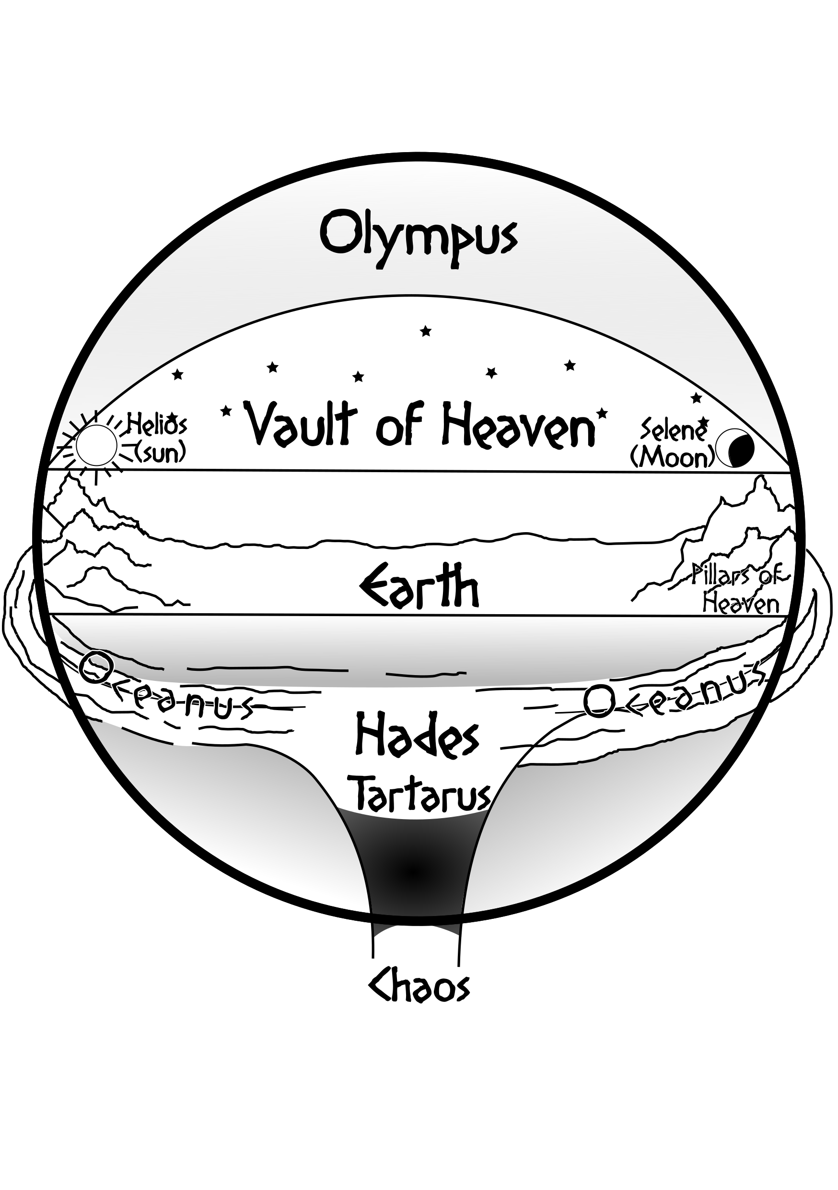
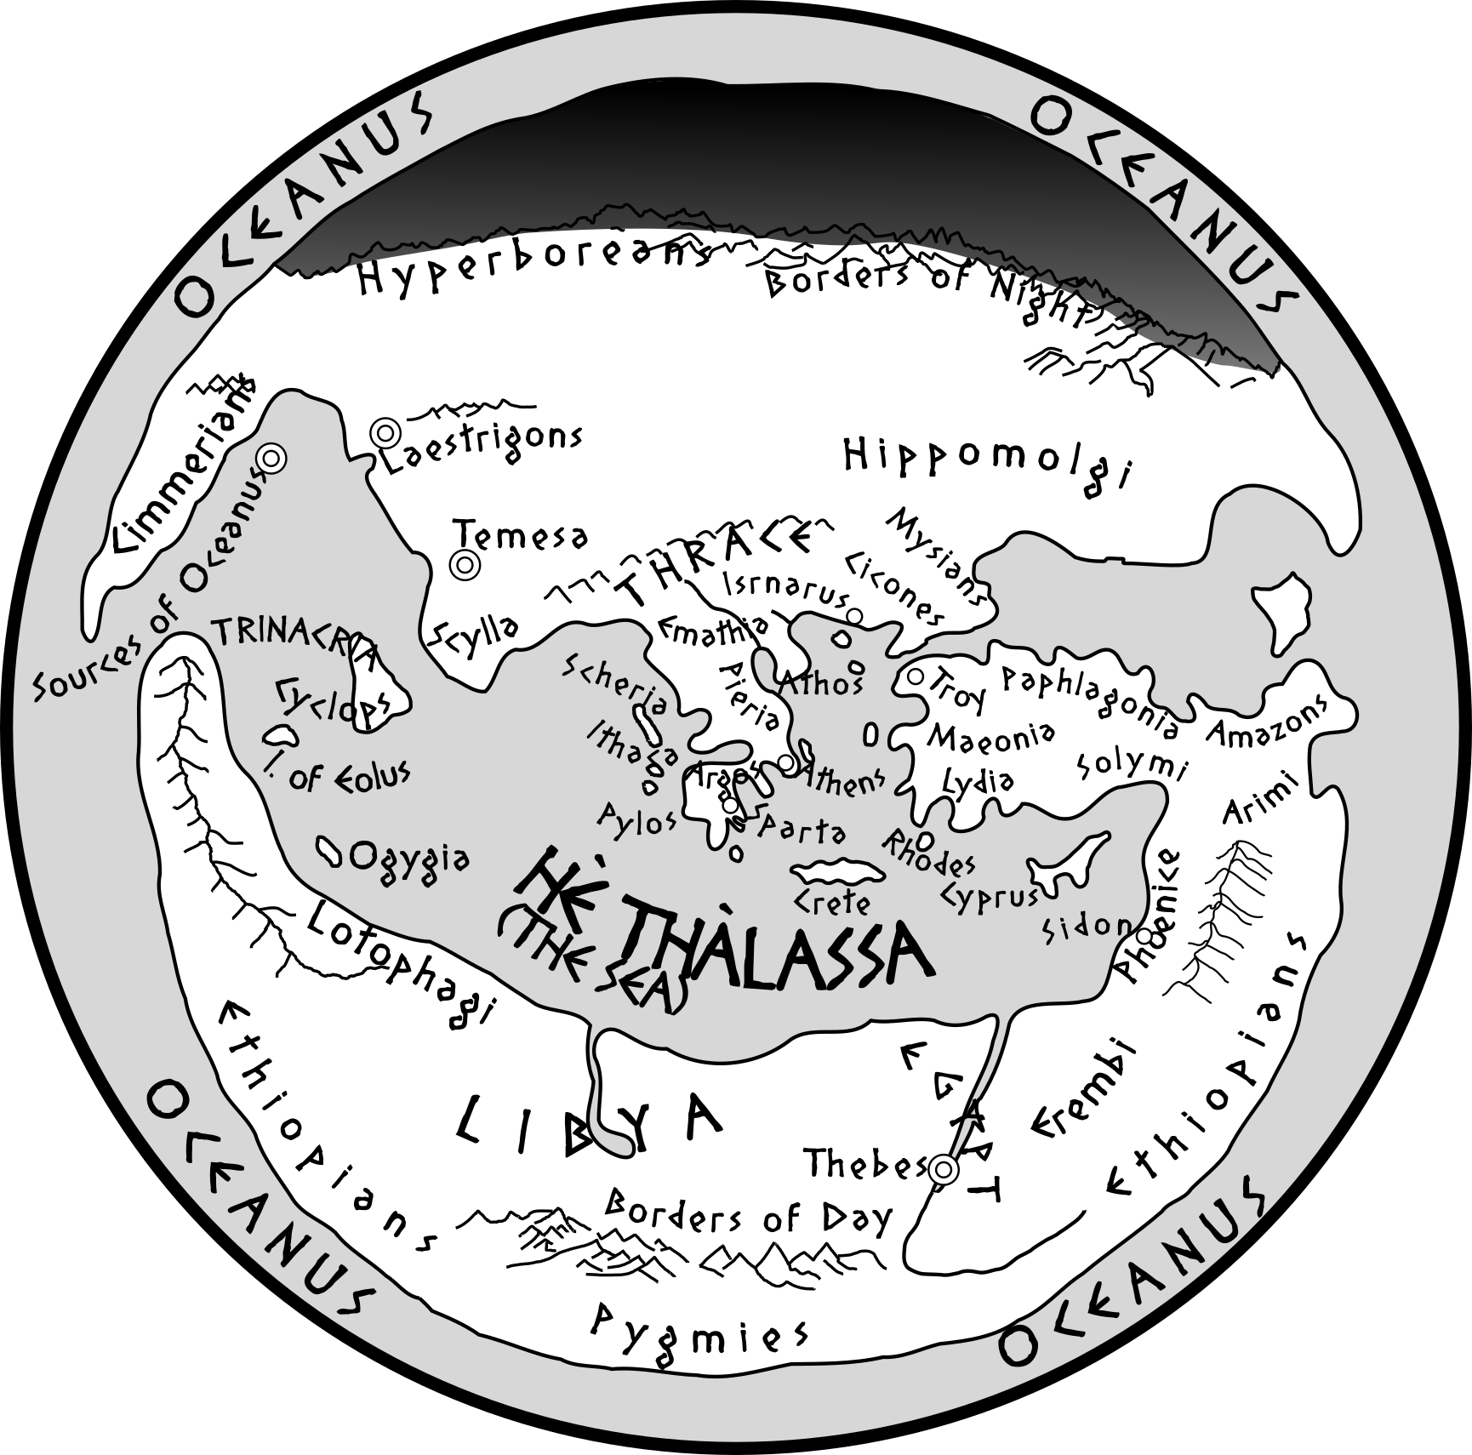
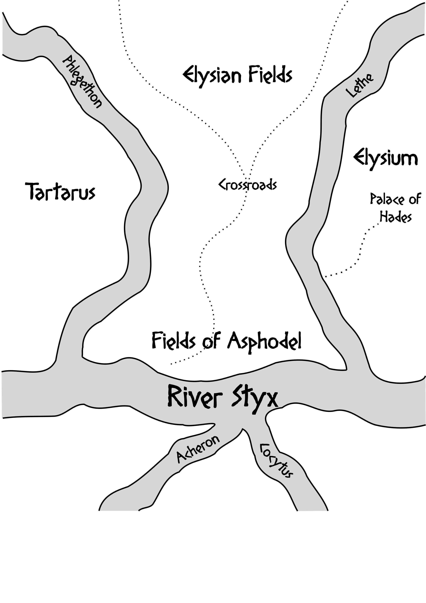

Appendix Ω
The inspiration for this game is drawn primarily from the literary works of Ancient Greece, but to find other ideas you can take a look at other sources. Here I suggest some of them, but surely you can find many others.

Primary Sources
- Aeschylus. The Persians and Prometheus Bound
- Apollodorus. Library and Epitome
- Apollonius of Rhodes. Argonautica
- Hesiod. Theogony and Works and Days
- Homer. The Iliad and The Odyssey. Hymns to Aphrodite, Demeter and Hermes

Modern Novels and Retellings
- Atwood, Margaret. The Penelopiad
- Barker, Pat. The Silence of the Girls and The Women of Troy
- Graves, Robert. The Greek Myths, Homer’s Daughter, The Golden Fleece
- Haynes, Natalie. A Thousand Ships
- Heywood, Claire. Daughters of Sparta
- Le Guin, Ursula K. Lavinia
- Lynn, Hannah. Athena’s Child, A Spartan’s Sorrow, Queens of Themiscyra
- Miller, Madeline. Circe and The Song of Achilles
- Renault, Mary. The Bull from the Sea and The King Must Die

Films
- 300 (2007)
- 300: Rise of an Empire (2014)
- 300 Spartans, The (1962)
- Alexander (2004)
- Alexander the Great (1956)
- Antigone (1961)
- Clash of the Titans (1981)
- Clash of the Titans (2010)
- Colossus of Rhodes, The (1961)
- Helen of Troy (1956)
- Helen of Troy (2003)
- Hercules (1983)
- Hercules (1997), A Disney film.
- Immortals (2011 film)
- Jason and the Argonauts (1963/2000)
- Minotaur (2006)
- Socrates (1971)
- Ulysses (1955)
- Troy (2004)
- Wrath of the Titans (2012)

Comics
- 300 by Frank Miller
- Age of Bronze by Eric Shanower
- The Iliad by Marvel Illustrated
- The Odyssey by Marvel Illustrated
- The Trojan War by Marvel Illustrated

Videogames
- Age of Mythology
- Apotheon
- Assassin’s Creed Odyssey
- Battle of Olympus
- God of War
- Fate of Hellas
- Phelios
- Rampage Through Time
- Rise of the Argonauts
- Rygar: The Legendary Adventure
- Titan Quest
- Warriors: Legends of Troy
- Zeus: Master of Olympus

Credits
Thálassa is based on the Cairn SRD by Yochai Gal (release under CC BY-SA 4.0 license) which derived from Weird North by Jim Parkin, Into the Odd by Chris McDowall, and Knave by Ben Milton.
Spark Tables above were created using Bibliomancer, a free-to-use Discord Bot created by Temmon and Colin Kloecker.
The full text of Pseudo-Apollodorus’ Bibliotheca and Homer’s Iliad and Odyssey were processed in search of the most unusual nouns and adjectives.
A huge thanks to:
- Yochai Gal: for Cairn, the NSR Discord server, and the kind support.
- Tom Van Winkle: for correcting all the Greek words and addressing me on magic in the ancient world.
- Alessio Persichetti: for all the valuable advice and for tolerating my lucubrations.
- Giovanni Tamba: for directing me on monster stats with his advice.
- The NSR and The Cauldron communities: for advice and support on this project.

Changelog
- v 1.0: Final version
- v 0.6: Bestiary is complete
- v 0.5.1: Bestiary entries revision
- v 0.5: first Bestiary entries
- v 0.4.2: Credits added
- v 0.4.1: fixed index
- v 0.4: first public release, completed Magic with Goïteia and Incantations
- v 0.3: Principles of the World added, backgrounds completed, magic terminology changed , Eukhé completed
- v 0.2: Magic drafted, equipment completed, attributes terminology changed, Gifts added
- v 0.1: Cairn forked, encumbrance rules modified, replaced Treasure with Prize

