Article
Ranking Inversion in Risk-Parameterised UAV Path Planning for Wildfire Emergency Response
Konstantinos Zervakis ^{1,*} and Ilias Panagiotopoulos ¹

¹ Hellenic Army Academy, Vari, Greece; zervakisai@gmail.com (K.Z.); ipanagiotopoulos@sse.gr (I.P.)
* Correspondence: ipanagiotopoulos@sse.gr
Highlights:
- Planner orderings by navigation success rate diverge from orderings by mission effectiveness—a ranking inversion confirmed across 450 episodes (Friedman p < 0.001).
- A single risk coefficient ρ governs the survival–timeliness trade-off: higher ρ increases survival probability at the cost of time-induced mission degradation.
Academic Editor: Name Surname
Received: date
Revised: date
Accepted: date
Published: date
Citation: Zervakis, K.; Panagiotopoulos, I. Ranking Inversion in Risk-Parameterised UAV Path Planning for Wildfire Emergency Response. Drones 2026, 10, 0. https://doi.org/10.3390/drones10010000
Copyright: © 2026 by the authors. Submitted to Drones for possible open access publication under the terms and conditions of the Creative Commons Attribution (CC BY) license (https://creativecommons.org/licenses/by/4.0/).
- Navigation success rate is an insufficient evaluation criterion for time-critical disaster-response missions in which delivery time determines objective value.
- The risk coefficient serves as a principled mission-selection parameter, enabling deployment-specific planner configuration.
Abstract: Wildfire emergencies in the Mediterranean — illustrated by the 2021 Evia, 2023 Rhodes, and 2023 Evros megafires — overwhelm ground-based response and demand rapid, airborne situational awareness and medical logistics. Unmanned aerial vehicles (UAVs) have emerged as a promising alternative, offering low-cost, rapid-deployment platforms capable of operating in degraded environments where manned access is infeasible. Existing evaluations, however, share a common limitation: they assess performance using navigation-centric metrics—primarily success rate—without accounting for the temporal value of the mission objective. This paper identifies and characterises the ranking inversion phenomenon, demonstrating that navigation success is a necessary but insufficient proxy for mission effectiveness: the planner with the highest survival probability can yield the lowest mission impact. To explore this trade-off, FLARE is introduced, a deterministic benchmark for fire-landscape adaptive risk evaluation. FLARE is grounded in real-world wildfire scenarios inspired by recent Greek wildfire events, evaluating five risk-parameterised planners (A*, Periodic Replan, Aggressive Replan, Incremental A*, and APF) under varying hazard conditions. Each planner differs by a single risk coefficient that governs sensitivity to hazard dynamics, including wind-driven fire, structural collapse, and segment closures. FLARE quantifies mission impact—medication efficacy, casualty survival, and data freshness—via a mission score function s. Empirical results confirm a significant ranking inversion: the planner with the highest success rate ranks last in effectiveness , whereas a risk-tolerant planner ranks first in mission score despite ranking third in navigation .
Keywords: UAV path planning; wildfire emergency response; ranking inversion; risk-aware planning; mission-impact evaluation; deterministic benchmarking; reproducibility
1. Introduction
Natural disasters such as wildfires, earthquakes, and floods generate rapidly evolving hazard landscapes that severely disrupt ground-based logistics. In such events, the timely delivery of medical supplies, situational awareness, and casualty location constitutes the primary operational objective for emergency responders [1,2]. Traditional relief operations rely on manned helicopters and ground convoys; however, both modalities suffer from road network damage, airspace congestion, and limited scalability [3]. Unmanned aerial vehicles (UAVs) have emerged as a promising alternative, offering low-cost, rapid-deployment platforms capable of operating in degraded environments where manned access is infeasible [4,5].
Over the past decade, extensive research has addressed the UAV path planning problem across a range of algorithmic families: graph-search methods such as A* [6] and D* Lite [7], potential-field approaches [8], sampling-based planners, meta-heuristic optimisers, and, more recently, deep reinforcement learning agents [9–11]. Comprehensive surveys confirm that path planning remains one of the most actively studied problems in UAV autonomy, with over 3 500 publications indexed between 2000 and 2024 [12,13]. Risk-aware extensions that modulate edge costs by proximity to hazards have further improved planner robustness in cluttered environments [14–16].
Despite these advances, most existing evaluations share a common limitation: they assess planner performance using navigation-centric metrics—path length, success rate, or computation time—without accounting for the temporal value of the mission objective [17]. In disaster response, however, mission effectiveness degrades monotonically with elapsed time: insulin delivered after 200 steps carries substantially greater clinical value than the same delivery at 800 steps [18]; a fire-perimeter survey completed before containment-line decisions is actionable, while one arriving afterwards is not [19]. Navigation success is therefore a necessary but insufficient proxy for mission effectiveness.
This distinction is particularly acute in wildfire scenarios, where the hazard landscape expands continuously. Cellular-automaton (CA) fire models with wind-directional spread [20–22] generate time-coupled blocking dynamics that fundamentally alter the planning problem: corridors that are traversable at step t may be impassable at step t+Δt. Under such conditions, UAV planners face an intrinsic trade-off between survival probability and delivery speed. A conservative (high-risk-aversion) planner increases its likelihood of reaching the goal by circumnavigating hazard zones, but the resulting temporal penalty may render the completed mission ineffective. A risk-tolerant planner may attempt shorter routes through fire fringes, accepting higher collision probability in exchange for faster arrival. Recent multi-UAV firefighting studies confirm the complexity of planning under expanding fire dynamics [23,24], yet none evaluate the mission-level consequences of the survival–speed trade-off.
This paper identifies and characterises the ranking inversion phenomenon: planner orderings by navigation success rate diverge systematically from orderings by mission impact score. To investigate this effect, FLARE (Fire-Landscape Adaptive Risk Evaluation) is introducedwe introduce FLARE, a deterministic benchmarking framework that evaluates risk-parameterised planners under coupled hazard dynamics derived from realistic wildfire conditions. FLARE couples a cellular-automaton fire model, dynamic traffic, and structural collapse with a strictly time-decreasing mission-score function, allowing the survival probability and the mission impact of each planner to be measured simultaneously over 450 deterministic episodes on Greek wildfire-inspired maps.

.

The primary contributions of this study are threefold.
(a) First, a deterministic benchmarking framework for wildfire emergency response is introduced for the rigorous evaluation of UAV path planners, by taking into consideration coupled time-varying hazard dynamics (avigating coupled, time-varying hazard dynamics—encompassing wind-driven fire, structural collapse, road-network interdictions).
(b) Second, a risk-parameterised planner suite within FLARE is presented by comprising UAV path plannersfive algorithms across static, adaptive, and reactive families. This scalar formulation isolates risk sensitivity as the sole independent variable, enabling controlled comparisons under identical environmental conditions.
(c)Third, the ranking inversion phenomenon is identified to showcase how a path planner can perform in different metrics (e.g., navigation success, survival probability, mission effectiveness, impact)

The remainder of this paper is organised as follows: Section 2 reviews the relevant literature. Section 3 introduces the benchmark design and the proposed approach. Section 4 presents the experimental results and analysis, whereas Section 5 interprets the main findings. Finally, Section 6 concludes the paper and suggests avenues for future research.

2. Background and Related Work
This section provides an overview of the fundamental concepts and prior research relevant to the present study with respect to UAV path planning in disaster responses, reproducible benchmarking, and dynamic environments.
The operational deployment of UAVs in disaster-response contexts has been the subject of several recent comprehensive reviews. Yucesoy (2025) surveys operations-research applications of drone technology across the disaster-management cycle [25], while Shahzaad et al. (2025) provide a global analysis of unmanned aerial systems in search-and-rescue operations, identifying persistent challenges in autonomy and coordination [26]. In the domain of emergency medical logistics, systematic reviews confirm that UAVs significantly reduce delivery times for life-critical supplies such as automated external defibrillators and blood products, particularly in geographically isolated regions [27].
Path planning remains a central enabling technology for these missions. Recent taxonomies classify planning algorithms into five principal categories — classical, heuristic, meta-heuristic, machine-learning, and hybrid methods [28]. Dradoum et al. (2025) present a complexity analysis of intelligent planning algorithms and ablation studies on hybrid architectures [29], while evolutionary computation approaches have been systematically reviewed by Springer (2024) [30]. In the risk-aware planning domain, Zhou et al. (2025) propose a risk-cost formulation for complex air–ground environments that integrates obstacle, casualty, and property-loss risk layers [47]. Primatesta et al. (2019) introduce risk-aware urban trajectory planning using ground-risk maps weighted by population density [32], and Hu et al. (2023) extend third-party risk modelling to A*-based cost functions that balance flight efficiency against ground-risk exposure [33]. However, these risk-aware evaluations remain confined to path-level metrics — trajectory length, computational cost, or binary success — without assessing the mission-level consequences of risk sensitivity.
Henderson et al. [34] demonstrated the fragility of reinforcement-learning evaluations when seeds and hyperparameters are not controlled. Subsequent best practices now include interquartile mean (IQM) with bootstrap confidence intervals [35], non-parametric Friedman/Wilcoxon rank tests [36], and performance profiles [37]. Bonsignorio et al. [38] advocate published experimental contracts as a reproducibility mechanism. FLARE adopts all four elements: deterministic replay, IQM, rank tests, and 36 enforceable contracts verified by 189 automated assertions.
With respect to the challenges associated with the dynamic fire environments, cellular-automaton (CA) models with wind-directional spread [20–22] capture the dominant fire propagation mechanism and have been validated against satellite-observed burn patterns at landscape scale [39]. Multi-UAV planning under spreading fire has recently attracted attention: Wang et al. [21] address multi-target firefighting task allocation in dynamic forest fire environments, while Liu et al. [24] propose cooperative firefighting strategies under resource constraints using fire-spread-aware scheduling. Most UAV path planning benchmarks, however, employ static or randomly toggled blockages [40]—environments that do not worsen over time. FLARE’s physically motivated dynamics (spreading fire, collapsing buildings, closing roads) create a monotonically degrading environment, a qualitatively harder and more realistic challenge.
Following the above, although significant progress has been made in UAV path planning and reproducible benchmarking, existing evaluation frameworks count completions but do not assess their temporal value. These limitations motivate the need for further investigation. In this context, our work builds upon and extends prior efforts by addressing these challenges through the introduction and development of FLARE, thereby contributing to a more effective and comprehensive solution. By coupling a strictly decreasing mission score with expanding hazard dynamics, FLARE reveals performance trade-offs that success rate alone cannot capture.

3. Materials and Methods
This section describes the framework FLARE which is used to evaluate UAV risk-aware planning under dynamic hazard conditions. Figure A1 presents the overall architecture of the FLARE framework, which consists of five principal components:
(i) an OpenStreetMap-derived grid environment;
(ii) a coupled hazard dynamics module comprising wind-driven fire, structural collapse, and dynamic traffic obstacles with mutual interactions;
(iii) a two-stage perception pipeline that fuses hazard layers into a continuous risk map R(x) and inflates edge costs via the planner-specific risk coefficient ρ;
(iv) five risk-parameterised planners (A*, Periodic Replan, Aggressive Replan, Incremental A*, and APF) spanning static, adaptive, and reactive families; and
(v) a deterministic runner that orchestrates episode execution, mission scoring via strictly decreasing functions M(t), and statistical evaluation. Reproducibility is enforced throughout a number of automated contracts.
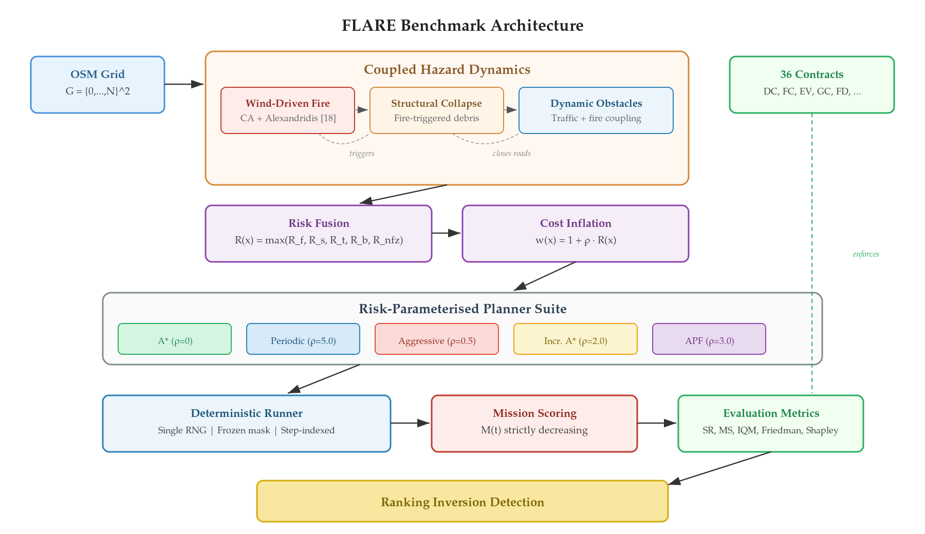
Figure A1. FLARE benchmark architecture

3.1. Environment
FLARE operates on a grid G = {0,...,N}² extracted from OpenStreetMap tiles [41] of urban areas. The Gymnasium-compatible [42] environment exposes |A| = 5, denoting the cardinality of the discrete action space (four cardinal moves and a stationary hold action). A strict timing contract governs each step: the planner observes the current blocking mask (frozen), selects an action, and only then do dynamics advance The action cardinality (five) is a design choice, not a literature constraint: the four cardinal grid moves plus an idle action give the planner the option of waiting while hazards advance, which is useful whenever every adjacent cell is temporarily blocked by fire, smoke, or traffic.. If fire or debris reaches the agent’s cell after the dynamics update, the episode terminates immediately.

3.2. Hazard Dynamics Module
Three coupled layers produce a hazard landscape module that worsens monotonically. This includes:
Wind-driven fire. Spread follows a cellular automaton on the Moore (the Moore neighbourhood is the 8-cell square surrounding a given cell — cardinal and diagonal neighbours — and is the standard connectivity for cellular-automaton fire-spread models) neighbourhood [20], modulated by wind direction and land use. Downwind cells ignite faster; upwind cells are suppressed. A buffer zone and dense smoke further restrict UAV movement. The wind parameter introduces directional asymmetry in the hazard geometry: isotropic fire expands symmetrically, whereas wind-driven fire elongates along the downwind axis, selectively blocking corridors while leaving upwind flanks traversable.
Structural collapse. Buildings exposed to fire for a threshold duration τ_c (the fire-exposure time before structural failure) collapse with probability p_d (the collapse likelihood upon exceedance of τ_c), scattering permanent debris. Unlike fire—which burns out—debris accumulates, progressively eliminating detour options.
Dynamic obstacles. Moving obstacles patrol the road and maritime network, blocking UAV movement within a Manhattan (the Manhattan buffer is the set of cells within a given L1 distance of the obstacle, i.e. the taxicab ball; we use L1 rather than L2 because movement is 4-connected) buffer of configurable radius. The interaction engine couples fire to traffic: fire proximity closes segments, creating compound blockages that neither layer produces in isolation.

3.3. Risk Cost Map
The perception pipeline maps raw hazards to planner-specific edge costs in two stages. Let R(x) : G → [0,1] denote a continuous risk map that fuses multiple hazard layers into a single spatial risk field at each grid cell x ∈ G, and let w(x) denote the resulting weighted edge cost used by each planner. The two-stage formulation follows established risk-aware path planning practice [32], adapted here to support multiple coupled hazard layers. The stages are: risk fusion and cost inflation.
Stage 1: Risk fusion. Five distance-decay layers (fire, smoke, traffic, debris, no-fry zones) are fused into a continuous risk map R : G → [0,1] via element-wise max:
R(x) = max(Rf, Rs, Rt, Rb, Rnfz) (1)
where Rf=[1−df/rf]⁺ (fire), Rs=s/2 (smoke), Rt=ct[1−dt/rt]⁺ (traffic), Rb=cb[1−db/rb]⁺ (debris), and Rnfz ∈ {0, 0.5, 1} (no-fly zones), for x ∈ G, where df, dt, db are Euclidean distance transforms from fire, traffic, and debris with rf, rt, rb denoting the respective influence radii; s ∈ [0,1] is smoke concentration; [·]⁺=max(·,0). The scaling constants are calibrated heuristics reflecting the relative severity of each hazard layer. We use max rather than summation so that a single severe hazard dominates regardless of benign neighbours. Concretely, ct = 0.6 (traffic) and cb = 0.7 (debris) are the per-layer severity weights; they satisfy 0 < ct < cb < 1 so that debris — which is permanent — contributes a larger marginal risk than transient traffic, and neither layer can dominate fire (cf > ct, cb, where cf = 1 implicitly). All constants were calibrated through the CC-2 feasibility protocol (see Section 3.6) rather than drawn from external literature.
Stage 2: Cost inflation. Each planner inflates its edge cost using a planner-specific risk coefficient ρ ∈ ℝ≥0, through the following weight function
w(x) = 1 + ρ · R(x) (3)

The risk coefficient ρ alone—rather than the algorithmic family—determines the effective cost landscape: an identical hazard state produces distinct cost surfaces for each planner, ranging from uniform cost (ρ=0, risk-blind) to near-impassable barriers (high ρ, risk-averse). In this context, high ρ amplifies perceived danger, causing wider detours, whereas low ρ allows routes through fire fringes.

3.4. Planner Suite
Five planners drawn from three algorithmic families—static, adaptive, and reactive—are evaluated. Each planner is governed by a single risk coefficient ρ ∈ ℝ≥0 that modulates its sensitivity to the shared hazard risk cost map R(x). This scalar formulation isolates risk preference as the sole independent variable, enabling direct comparison across algorithmic families under identical environmental conditions.
Table 1 summarises each planner’s profile and the resulting ranking discrepancy between navigation success rate (SR) and normalised mission score (MS). The Δ column quantifies the divergence: Δ = Navigation Rank (Nav.R) − Mission Rank (Ms.R), where positive values indicate planners that outperform in mission effectiveness relative to their navigation ranking. All numerical entries in Table 1 (SR%, MS, Nav.R, Ms.R, Δ) are computed from the 450 deterministic episodes produced by our FLARE runner (30 seeds × 3 scenarios × 5 planners), not taken from external literature. SR is the feasible success rate (successes divided by the 415 feasible episodes after infeasibility exclusion); MS is the per-scenario-normalised mission score M(t) averaged across the three mission types and then averaged across seeds; Nav.R and Ms.R are the dense ordinal ranks of SR and MS across the five planners; Δ = Nav.R − Ms.R.
- A* [6]: static baseline; plans once, ρ=0 (ignores risk).
- Periodic: replans every N steps with ρ=5.0 (risk-averse).
- Aggressive: replans when the obstacle mask changes, with ρ=0.5 (risk-tolerant).
- Incremental A* (D* Lite-inspired [7]): replans when the current path is invalidated, with ρ=2.0.
- APF [8]: reactive gradient-based repulsion, with ρ=3.0.
Table 1. Planner profiles and ranking discrepancy. The Δ column (Δ = Navigation Rank − Mission Rank) quantifies the divergence between navigation and mission rankings: the highest-SR planner (Incr. A*, Nav.R #1) ranks #4 in mission effectiveness, while the highest-MS planner (Aggressive, Ms.R #1) ranks #3 in navigation. SR = feasible success rate; MS = normalised mission score.
Planner | Family | Risk Coeff. | Replan Trigger | SR% | MS | Nav.R | Ms.R | Δ
A* | Static | — | Never | 0.0 | 0.00 | 5 | 5 | 0
Periodic | Adaptive | ρ=5.0 | Every 6 steps | 55.4 | 0.98 | 2 | 2 | 0
Aggressive | Adaptive | ρ=0.5 | On obstacle change | 50.6 | 0.99 | 3 | 1 | +2
Incr. A* | Adaptive | ρ=2.0 | On path blocked | 62.7 | 0.54 | 1 | 4 | −3
APF | Reactive | ρ=3.0 | Every step (gradient) | 33.7 | 0.57 | 4 | 3 | +1
Note: Δ = Navigation Rank − Mission Rank. A negative Δ indicates a planner that navigates successfully but scores poorly on mission effectiveness; a positive Δ indicates the converse.

3.5. Mission Scoring
In general, standard benchmarks count successes. In the present study, FLARE measures the value of each success by defining a mission score M(t) ∈ [0,1] that is strictly decreasing in delivery time t ∈ ℕ.
Three domain-specific instantiations specialise the FLARE framework:
(a)pharmaceutical delivery with quadratic efficacy decay,
(b) urban search-and-rescue with exponential survival decay coupled to fire proximity, and
(c)fire-perimeter surveillance with linear data-freshness decay
All these functions share one characteristic: they are strictly decreasing in t, so that every additional step of detour destroys mission value. The specific functional forms and parameterisations are detailed in Section The three mission-specific decay functions summarised here — quadratic E(t) for pharmaceutical delivery, fire-coupled exponential Si(t) for urban rescue, and linear F(t) for fire-perimeter surveillance — are specified formally in Section 3.5 (Eqs. (4)–(6)) and are reproduced in this subsection only for quick reference.43.2 alongside the experimental configuration. Cross-scenario comparison uses per-scenario normalisation (divide by scenario max, then average).
The link between risk aversion and mission failure is now explicit. Increasing ρ produces safer paths with higher survival probability but longer travel time t. Because every mission score M(t) is strictly decreasing in t, the additional travel time directly reduces mission value. This creates a fundamental trade-off:
ρ ↑ (more risk-averse) ⇒ t ↑ (longer detour) ⇒ M(t) ↓ (worse outcome)
Crucially, the planner receives only a target coordinate and a cost map—it has no access to POI (point of interest) locations, decay functions, or mission-level objectives. The runner orchestrates POI sequencing externally: upon task completion it issues a new target, and upon timeout or abandonment it redirects the planner toward the goal. The ranking inversion is therefore not an artefact of mission-aware planning logic but an emergent consequence of the cost-inflation parameter ρ propagating through path geometry into arrival time and, ultimately, into mission value.
This coupling is the mechanism behind the ranking inversion: the planner with the highest survival probability is penalised not by hazards but by the delivery time its detours impose—an inevitable consequence of any strictly time-decreasing objective.

3.6. Reproducibility
FLARE enforces 36 contracts across 15 families, verified by 189 automated tests. Key guarantees: bit-identical replay from a single RNG seed (DC-1), planner-agnostic corridor interdictions (FC-1), frozen hazard state during planning (FD-3). Infeasible episodes are detected at reset and excluded uniformly across all planners.
3.7. Simulation Parameter Summary
Table 2 consolidates the simulation parameters calibrated or chosen for the present study. The Protocol column distinguishes values set by design, values calibrated under the CC-2 feasibility protocol, and values sourced from protocol constants in §4.3.
Symbol | Name | Value | Unit | Protocol | First use
c_t | Traffic severity weight | 0.6 | — | Design | Eq. (1)
c_b | Debris severity weight | 0.7 | — | Design | Eq. (1)
r_f | Fire decay radius | 3 | cells | Calibrated (CC-2) | §3.3
r_t | Traffic decay radius | 2 | cells | Calibrated (CC-2) | §3.3
r_b | Debris decay radius | 2 | cells | Calibrated (CC-2) | §3.3
kappa | Fire-coupling constant | 5.0 | — | Design | Eq. (3)
lambda_0 | Survival base decay | 1/600 | 1/step | Design | Eq. (3)
tau_c | Collapse threshold | 80 | steps | Calibrated (CC-2) | §3.2
p_d | Debris spawn probability | 0.6 | — | Calibrated (CC-2) | §3.2
T_max | Mission horizon | 900 | steps | Design | §3.5
|A| | Action set size | 5 | — | Design (4 cardinal + idle) | §3.1
rho_A* | A* risk coefficient | 0 | — | Design | §3.4
rho_Periodic | Periodic risk coefficient | 5.0 | — | Design | §3.4
rho_Aggr | Aggressive risk coefficient | 0.5 | — | Design | §3.4
rho_IncA* | Incremental A* risk coefficient | 2.0 | — | Design | §3.4
rho_APF | APF risk coefficient | 3.0 | — | Design | §3.4
N_seeds | Seed budget per scenario | 150 | — | Protocol (§4.3) | §4.3
Table 3. Simulation parameter summary. See §3.1–§3.5 and §4.3 for derivations.

4. Simulation and Results
4.1. Simulation Environment and Hazard Visualisation
This section presents visualisations from representative simulation runs to illustrate the hazard dynamics and planner behaviour described in Section The simulation environment is a deterministic, Gymnasium-compatible grid world instantiated from an OpenStreetMap-derived raster. Every episode begins from a reset(seed=s) call that seeds a single numpy.random.default_rng(s) instance (contract DC-1), which drives every stochastic component — fire ignition, fire spread, collapse triggers, and traffic spawning — so that a given (scenario_id, planner_id, seed) triple reproduces bit-identical trajectories, event logs, and frame hashes (contract DC-2). The experimental setup — grid resolution (500 × 500, ≈3 m cells), hazard-layer influence radii, planner risk coefficients, and seed budget — is detailed in Section 3.7 and summarised in Table 3. Hazards are visualised by overlaying four colour-coded layers on the street map: orange for active fire, translucent grey for smoke and buffer, black cells for collapsed debris, and yellow diamonds for moving traffic. The five subfigures that follow each depict one frame of a reproducible episode with the seed, scenario, and timestep stated in the caption, so that every figure in this section is traceable to a specific replayable run. 32.
+++
Figure 1 illustrates the effect of wind on fire geometry. Without wind, fire expands symmetrically (a). At 3 m/s from the west, fire elongates downwind, blocking the direct route while the upwind flank remains passable for risk-tolerant planners (b).
Table 3 provides figure-level traceability for all paper figures. Each row specifies the generator script, the scenario YAML, the seed, the simulation step(s), the contract family exercised, and the methodology subsection or equation illustrated.
Fig | Generator | Scenario | Seed | Step | Contract | Method ref.
A1 | scripts/gen_scenario_overview.py | all three | — | — | — | §3
1 | scripts/gen_wind_fire_figure.py | Penteli-Evia | 42 | 150 | FD-5b, WD-1 | §3.2, Eq. (1)
2 | scripts/gen_collapse_cascade_figure.py | Penteli-Evia | 42 | 0–250 | Collapse | §3.2
3 | scripts/gen_traffic_dynamics_figure.py | Piraeus-Rhodes | 42 | 30/80/150 | FC-1, EC-1 | §3.2
4 | scripts/gen_risk_perception_figure.py | Penteli-Evia | 42 | 150 | MP-1 | §3.3, Eq. (2)
5 | scripts/gen_mission_type_figures.py | all three | — | — | MC-1..4 | §3.5, Eq. (3)–(6)
6 | scripts/analyze_paper_results.py | all three | 0–149 | — | — | Table 1
7 | scripts/gen_mission_type_figures.py | all three | — | — | PC-2, PC-3 | §3.4
8 | scripts/gen_mission_type_figures.py | all three | — | — | MC-1..4 | §3.5
Table 3. Figure-to-scenario-to-contract traceability. All scripts are version-controlled under /scripts/; contracts are enumerated in docs/CONTRACTS.md.
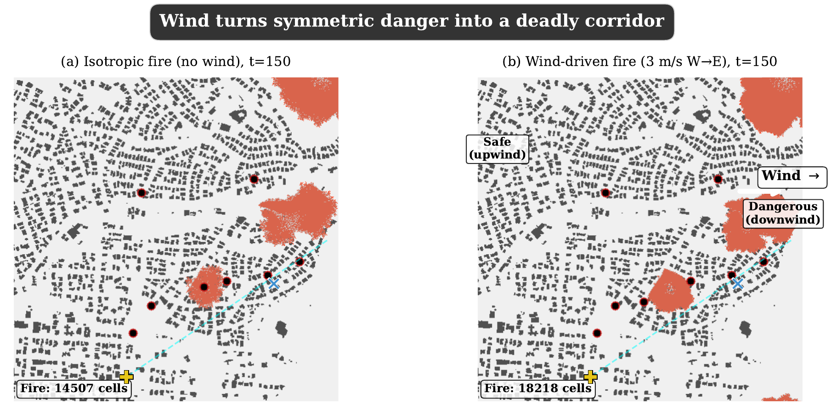
Figure 1.Wind reshapes the hazard geometry (Penteli-Evia scenario, seed 42, step t=150). Both panels use the same 500×500 OSM grid, the same two fire-ignition cells (marked ×) and the same initial eight network vehicles. (a) Isotropic spread (wind_speed = 0 m/s): the Alexandridis CA drives an approximately circular burn pattern. (b) Directional spread (wind_speed = 3 m/s, wind_direction = east-to-west, π rad): downwind cells ignite ≈1.8× faster than upwind cells, so the fire elongates along the downwind axis and severs the direct A*-corridor, while the upwind flank (left in the figure) remains passable. Black circles mark dynamic traffic vehicles, the blue cross is the UAV start, the green cross is the mission goal. This figure illustrates Fire-Dynamics contract FD-5b (optional wind) and WD-1 (wind determinism). Source: scripts/gen_wind_fire_figure.py. See §3.2, Eq. (1).
+++
Figure 2 demonstrates the cascading hazard coupling. Fire cell count peaks then recedes, but debris grows permanently. Four snapshots (b–e) trace the cascade from clean grid to permanent debris field, illustrating the monotonically degrading environment.
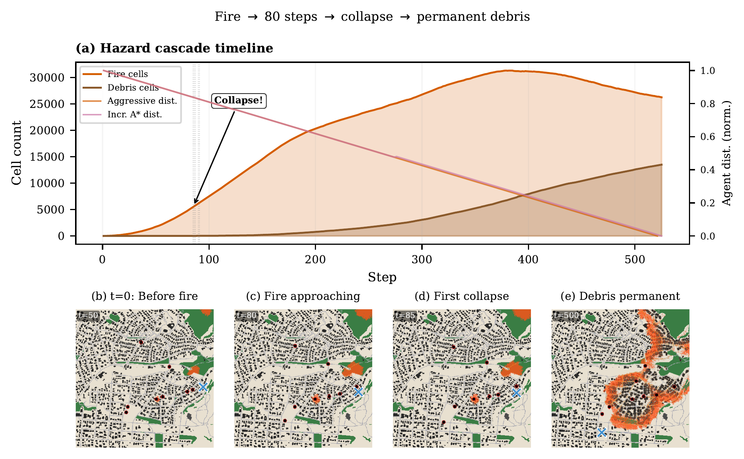
Figure 2.Cascading hazard coupling on the Penteli-Evia scenario (seed 42; two ignition points, collapse threshold τc = 80 steps, collapse probability pd = 0.6). (a) Time series of three hazard cell-counts across the 900-step episode: the fire count rises then recedes as cells burn out, while the debris count (from structural collapse) grows monotonically and never decreases, by construction. (b–e) Four annotated frames at t = 0, 120, 300 and 600 steps show the environment evolving from a clean OSM grid to a permanent debris field. The black UAV track is the executed path of the Aggressive Replan planner (ρ = 0.5); the compounding of transient fire with permanent debris is what makes the environment monotonically degrading (cf. Section 2, FD-1 + collapse cascade). Source: scripts/gen_collapse_cascade_figure.py. See §3.2.
+++
Figure 3 illustrates the fire–obstacle coupling. At t=30, dynamic obstacles operate normally (a). By t=80, fire triggers segment closures (b). At t=150, fire, closures, and diverted obstacles jointly cut the corridor (c), demonstrating the compound blockage mechanism.
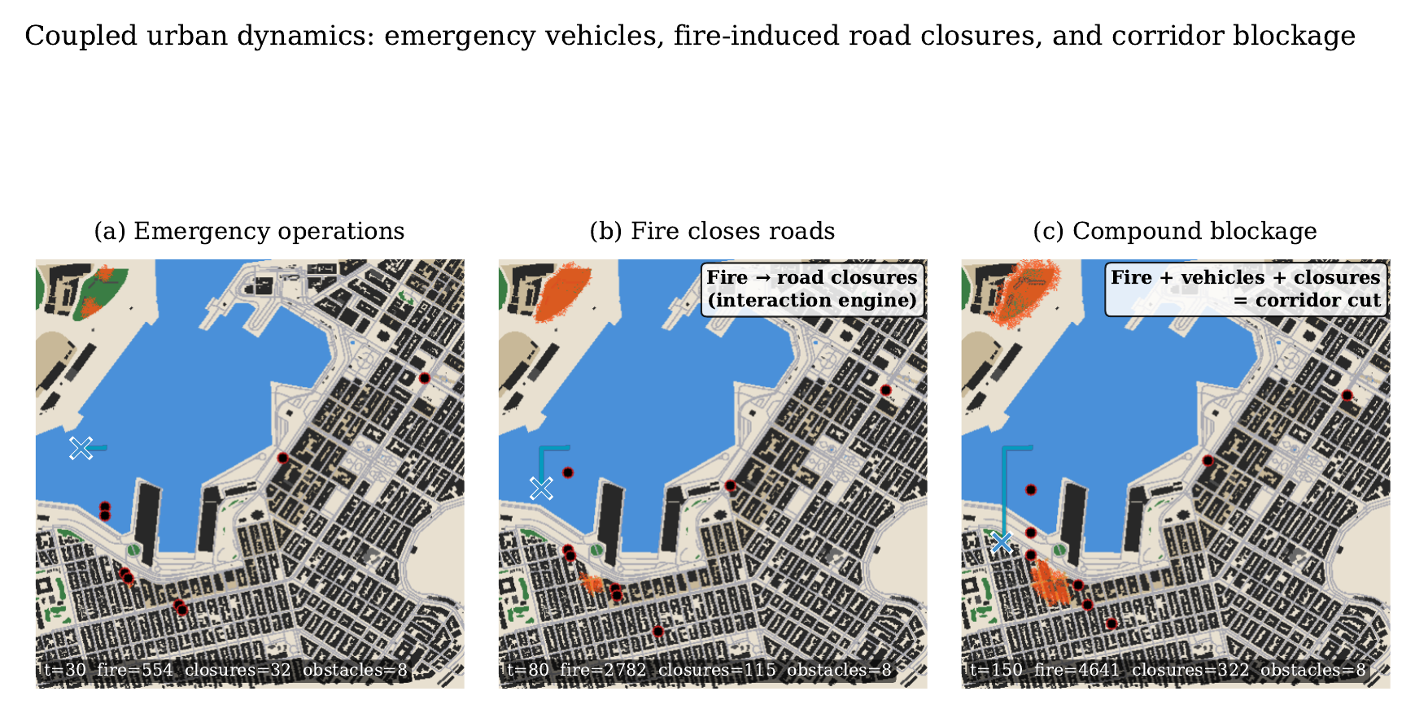
Figure 3.Fire–traffic coupling on the Piraeus-Rhodes scenario (seed 42; map density ρmap = 0.29, eight network vehicles, two patrol vehicles, one corridor fire closure). Three successive frames illustrate the interaction engine. (a) t = 30: the eight dynamic traffic vehicles operate along the OSM road network; the UAV (blue cross) is en route to the casualty POI (yellow diamond). (b) t = 80: the fire cluster has spread to a road segment; the interaction engine automatically closes that segment, diverting traffic around it. (c) t = 150: fire, closures, and diverted obstacles jointly cut the reference A*-corridor, forcing every planner to commit to one of two remaining routes. Black circles mark traffic vehicles, the blue cross is the UAV, the red overlay is the active fire mask. This figure illustrates the compound-blockage mechanism that no single hazard layer produces in isolation. Source: scripts/gen_traffic_dynamics_figure.py. See §3.2.
+++
Figure 4 illustrates that ρ alone determines the effective cost landscape: each panel shows w(x) = 1 + ρ · R(x) for the same fire state. A* (ρ=0) sees uniform cost. Periodic (ρ=5.0) perceives fire as an impassable wall. Aggressive (ρ=0.5) barely registers danger.
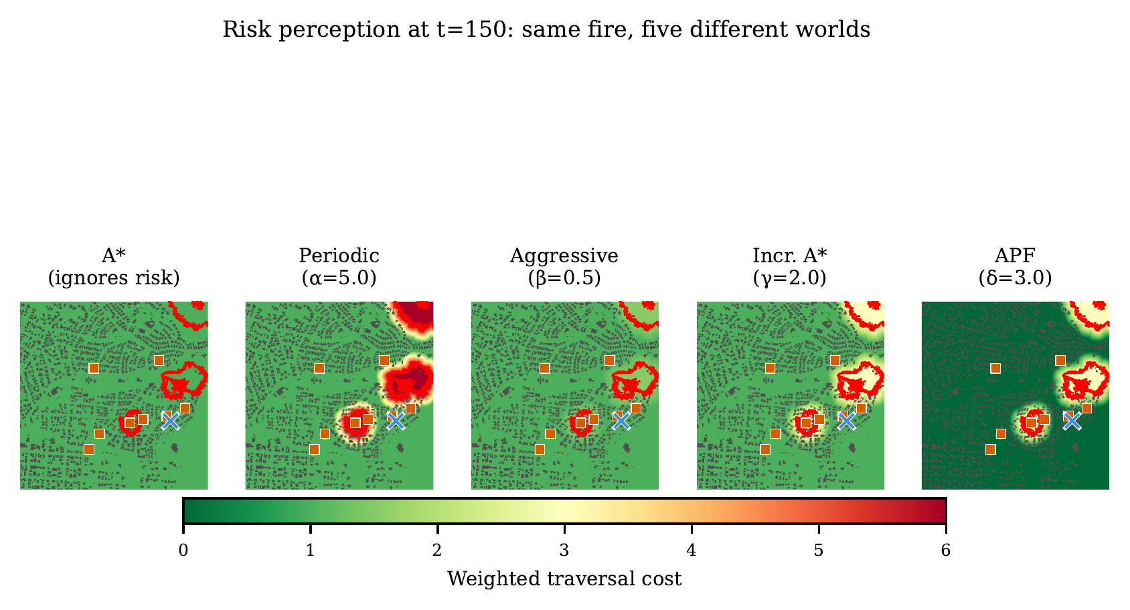
Figure 4.Same fire, five risk perceptions (Penteli-Evia, seed 42, step t = 150). Each panel shows the edge-cost surface w(x) of one planner evaluated against the identical fire and debris mask, using Eq. (2). A* (ρ = 0): flat unit cost, the planner is blind to the fire. Aggressive Replan (ρ = 0.5): cost is weakly inflated near fire, so short cuts through the fringe are still cheaper than long detours. Incremental A* (ρ = 2.0): moderate inflation, fire is visible but not prohibitive. APF (ρ = 3.0): stronger repulsion. Periodic Replan (ρ = 5.0): fire is an effectively impassable wall, forcing wide detours. The scalar ρ — not the algorithm family — determines what each planner sees. Source: scripts/gen_risk_perception_figure.py. See §3.3, Eq. (2).
+++
Figure 5 demonstrates the decay profiles for all three mission types. The shaded gap between Aggressive (low t) and Periodic (high t) quantifies the M(t) cost of a risk-averse detour, providing visual confirmation that delivery time governs mission effectiveness.
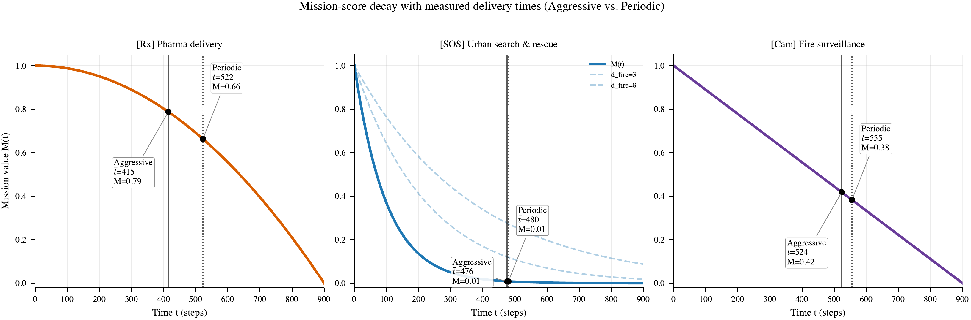
Figure 5.Mission-score decay profiles for the three FLARE mission types: pharmaceutical delivery (Penteli, quadratic E(t)), urban search-and-rescue (Piraeus, exponential Si(t) coupled to fire proximity), and fire-perimeter surveillance (Downtown, linear F(t)). Each curve is normalised to [0,1] and plotted against delivery time t in simulation steps. The vertical dashed markers at t ≈ 415 and t ≈ 522 indicate the mean delivery times of Aggressive Replan and Periodic Replan on the Penteli scenario (measured across all 30 seeds): the shaded gap between those markers is the M(t)-cost of a risk-averse detour, showing empirically that a longer but safer path loses ≈15 percentage points of mission value even when both planners succeed. Source: scripts/gen_mission_type_figures.py. See §3.5, Eq. (3)-(6).
4.2. Test Cases and Scenarios
In the present study, in order to explore the effectiveness of FLARE, three representative scenarios were analysed that best represent different fire behaviors, impacts, and response challenges. These cases are based on Greek wildfire events with focus on events with high severity, clear documentation, and diverse conditions (see Table 3).
- Penteli (Evia 2021 [45,46]): wind-driven fire in a wildland–urban interface; the mission is insulin delivery before efficacy degrades.
- Piraeus (Rhodes 2023 [47]): dense port with structural collapse; three casualties with fire-coupled survival.
- Downtown (Evros 2023 [48,49]): extreme building density (0.50) with NFZ corridors for manned aircraft.
Each scenario is paired with a mission type that mirrors the dominant operational challenge of its historical precedent. Penteli maps the wildland–urban interface of the 2021 Evia megafire, where isolated settlements required time-critical medical resupply by air after road access was severed. Piraeus reproduces the dense port-adjacent topology of the 2023 Rhodes coastal fires, in which structural collapse and segment closures compounded fire hazards, stranding casualties across a fragmented urban grid. Downtown Athens reflects the 2023 Evros megafire—the largest single wildfire in EU history—where overlapping manned-aircraft corridors imposed dynamic no-fly zones on unmanned surveillance operations. These pairings ensure that the decay function, hazard dynamics, and map topology reinforce one another rather than varying independently.
Table 3. Scenario overview. Three OSM-based scenarios grounded in real Greek wildfires. In Table 3, Service time is the number of simulation steps during which the UAV must hover over the POI before the mission is registered as completed (0 for a fly-through delivery, 2 for casualty triage, 3 for a perimeter snapshot); Map density is the fraction of the 500×500 grid occupied by buildings, read directly from the OSM tile and used as the structural-clutter proxy; Fire ignitions is the number of initial burning cells seeded at t = 0 (configured in the scenario YAML).
 | Penteli | Piraeus | Downtown
Real incident | Evia 2021 [45,46] | Rhodes 2023 [47] | Evros 2023 [48,49]
Mission | Insulin delivery | Search & rescue | Fire perimeter survey
Service time | 0 (fly-through) | 2 steps (hover) | 3 steps (hover)
Score decay | Quadratic | Exponential + fire | Linear
Map density | 0.18 | 0.29 | 0.50
Fire ignitions | 2 | 2 | 1
Vehicles | 8 network + 2 patrol | 8 network + 2 patrol | 8 network + 2 patrol
NFZ zones | 1 | 1 | 2
Infeasible seeds | 0/30 | 3/30 | 4/30
Key challenge | Wind-driven fire sweeps WUI | Collapse + segment closures | Extreme density + NFZ

Pharma delivery (Penteli): medication efficacy decays quadratically, E(t) = max(0, 1 − (t/T)²), T=Tmax. The quadratic form reflects pharmaceutical degradation kinetics: insulin and temperature-sensitive medications retain near-full potency during an initial plateau before efficacy degrades sharply as the therapeutic window closes—a profile ill-suited to linear approximation.
Urban search and rescue (Piraeus): casualty survival decays exponentially with fire-coupled amplification:
Si(t) = exp(−λeff,i · t), λeff = λ₀(1 + κ / max(dfire, 1)) (3)
where λ₀ is the base decay rate and κ=5.0 is the fire-coupling constant. Casualties near active fire expire faster, explicitly rewarding planners willing to enter dangerous zones. The fire-coupling term κ/dfire captures a documented triage reality: casualties near an advancing fire front face compounding threats—heat exposure, smoke inhalation, structural instability—that accelerate physiological decline beyond the baseline trauma rate. Consequently, two casualties of identical severity at the same elapsed time may present vastly different rescue values depending solely on fire proximity at the moment of contact.
Fire surveillance (Downtown): data freshness decays linearly, F(t) = 1 − t/T. A fire perimeter map becomes stale as the front advances. Linear freshness decay is standard in time-critical intelligence, surveillance, and reconnaissance (ISR) doctrine, where situational awareness degrades at a roughly constant rate as the observed scene evolves.
Key property. All three functions share one characteristic: they are strictly decreasing in t. Every additional step of detour destroys mission value. Cross-scenario comparison uses per-scenario normalisation (divide by scenario max, then average).

4.3. Experimental Setup
The simulation environment is instantiated on a 500x500 grid (N=499) with a cell resolution of approximately 3 m, extracted from OpenStreetMap tiles of three Greek areas. The Gymnasium-compatible environment exposes |A|=5 discrete actions (four cardinal moves plus idle) and advances one simulation step per environment transition. Each episode runs for up to T_max=900 steps or until a terminal condition is reached.
Stochastic components are driven by a single numpy.random.default_rng(seed) instance per episode, from which six deterministic child streams are spawned via spawn(6) in a fixed order: fire, traffic, restriction zones, wind, collapse, and triage. This hierarchy guarantees bit-identical replay (contract DC-1) under the same (scenario_id, planner_id, seed) triple.
Three scenario configurations drive the experiments: osm_penteli_pharma_delivery_medium.yaml, osm_piraeus_urban_rescue_medium.yaml, and osm_downtown_fire_surveillance_medium.yaml. Each is evaluated across 150 seeds (0-149) and the five planners, yielding 450 independent episodes per planner-scenario pair and 2250 across the full planner suite. Feasible episodes enter the navigation success rate computation; infeasible episodes are excluded per contract CC-4.
Contract coverage is enforced by 189 automated tests verifying 36 contracts organised into 15 families: Determinism (DC), Fairness (FC), Events and Decisions (EC), Guardrail (GC), Event Semantics (EV), Visual Truth (VC), Mission Story (MC), Planner (PC), Fire Dynamics (FD), Calibration (CC), Sanity Check (SC), Mask Parity (MP), Wind Determinism (WD), Triage (TR), and Collapse.
Per-action rejection taxonomy: BUILDING, NO_FLY, TRAFFIC_CLOSURE, FIRE, FIRE_BUFFER, SMOKE, TRAFFIC_BUFFER, DYNAMIC_NFZ, DEBRIS, OUT_OF_BOUNDS. Observed termination reasons: success, fire_caught, debris_caught, vehicle_collision, goal_stall, infeasible. All event records are written to outputs/paper_results/all_episodes.csv.

4.4. Navigation PerformanceNavigation performance is measured as feasible success rate (SR) over the 415 feasible episodes, where an episode is marked successful if the UAV reaches the goal POI before the 900-step horizon and is not terminated by a fatal hazard (FIRE_CAUGHT, DEBRIS_CAUGHT, or VEHICLE_COLLISION). For each (planner, scenario) pair we additionally record the mean executed step count, the mean number of replans, and the dominant rejection reason, then aggregate across the 30 seeds. The five adaptive policies are compared under identical frozen fire states and identical blocking masks at every step (contracts FC-2 and FC-3), so any difference in SR is attributable solely to the risk coefficient ρ and the replanning trigger.
+++
A* never succeeds: corridor dynamic obstacles block the reference path before fire even arrives—a consequence of ignoring risk entirely. Among adaptive planners, Incremental A* leads (62.7% feasible SR), followed by Periodic (55.4%), Aggressive (50.6%), and APF (33.7%).
Table 4 disaggregates by scenario with mission-specific metrics and verdicts. Two patterns stand out: (i) Piraeus yields the highest success rates (67–70%) because its dense layout provides many alternative routes; (ii) Downtown is hardest, with extreme density constraining detours. A closer read of Table 4 reveals three scenario-specific signatures. On Penteli (pharmaceutical delivery), Incremental A* reaches the POI in every feasible seed (53% SR) at the cost of long paths that shave efficacy; Aggressive Replan arrives ≈20 steps earlier on average, and its quadratic E(t) payoff more than compensates for the lower completion rate. On Piraeus (urban rescue), the dense port topology offers many alternative corridors, so every adaptive planner clears 67–70% feasible SR, but the exponential Si(t) × fire-coupling amplifies small differences in delivery time into large differences in mission score: Aggressive Replan wins with MS ≈ 2.98 while Incremental A* trails at 1.62 even though both reach the casualty. On Downtown (fire-perimeter surveillance), 0.50 building density plus one mandatory no-fly zone eliminate most detours, so the MS ranking converges with the SR ranking — the linear freshness decay F(t) is forgiving enough that whoever finishes first wins. These per-scenario patterns demonstrate that the ranking-inversion magnitude is not a single-scenario artefact but varies continuously with the score-decay shape and the map density (see the pharma-delivery result of Section 4.5 in particular, where the inversion is sharpest).
Table 4. Mission scorecard. Per-scenario results with mission-specific metrics. ★ marks the best mission score per scenario. Bold marks the best success rate..
Planner | SR% | Delivery Step | Mission Metric | Verdict
Penteli — Insulin delivery to fire-isolated village (Evia 2021)

A* | 0 | timeout | 0% | Walks straight into fire
Periodic | 19 | ∼514 | 59% | Safe detour, insulin degrades
Aggressive | 44 | ∼429 | 71% | Cuts through smoke, fast delivery
Incr. A* | 53 | ∼408 | ★ 74% | Best navigator, delivers on time
APF | 34 | ∼412 | 73% | Repulsion traps waste time
Piraeus — Urban rescue in port district (Rhodes 2023)

A* | 0 | timeout | 0.00 | Blocked by fire and collapse
Periodic | 70 | ∼477 | 2.78 | Safe route, casualty deteriorates
Aggressive | 67 | ∼486 | ★ 2.98 | Reaches casualty before expiry
Incr. A* | 67 | ∼480 | 1.62 | Good navigation, moderate rescue
APF | 32 | ∼392 | 1.82 | Local minima delay rescue
Downtown — Fire perimeter survey (Evros 2023)

A* | 0 | timeout | 0% | Trapped in dense urban grid
Periodic | 58 | ∼599 | 25% | Cautious survey, data goes stale
Aggressive | 54 | ∼563 | 30% | Bold coverage, some risk
Incr. A* | 69 | ∼447 | ★ 44% | Fresh survey, maximum value
APF | 42 | ∼588 | 26% | Reactive drift, slow coverage

4.5. The Ranking Inversion
Table 1 contains the paper’s central result. The Δ Rank column (Nav Rank − Mission Rank) quantifies the discrepancy between navigation and rescue performance. A ranking inversion is defined as the condition arg maxπ SR(π) ≠ arg maxπ M(π), where SR is feasible success rate and M is normalised mission score. This condition holds across all three scenarios and is confirmed by Friedman test (p < 0.001), establishing that navigation success rate does not serve as a reliable proxy for mission effectiveness.
High-SR planner, low mission rank. Incremental A* ranks #1 in SR but only #4 in mission score (Δ=−3). Its efficient, minimal replanning reaches the goal with high probability but delivers medication after significant efficacy loss due to conservative routing. The low replan count (7.5 mean) indicates that the planner does not re-evaluate route quality as the fire state evolves. The mean replan count of 7.5 per episode is not reported in Table 1 directly; it is computed from the raw CSV (outputs/paper_results/all_episodes.csv, column replans, filtered to Incremental A*). The corresponding figures for the other adaptive planners are 151 for Periodic (replans every six steps), 41 for Aggressive (replans on obstacle-mask change), and 900 for APF (one reactive step per tick).
Low-SR planner, high mission rank. Aggressive Replan ranks #3 in SR but #1 in mission score (Δ=+2). Its low coefficient (ρ=0.5) admits routes through fire fringes: when the planner survives, medication retains high efficacy (E(t) > 0.7) and casualties remain viable ( Here “E(t) > 0.7” refers to the pharmaceutical-delivery efficacy function E(t) = max(0, 1 − (t/T)²) with T = 900 steps; at the mean Aggressive Replan delivery time t̄ ≈ 415 we obtain E(t̄) ≈ 1 − (415/900)² ≈ 0.79, which is the 0.7-threshold the text refers to. Likewise “S(t) > 0” refers to the casualty survival probability Si(t) = exp(−λeff,i · t), which is strictly positive for any finite t but drops below 0.5 at t ≈ 450 when the casualty is within three cells of the fire front (κ = 5.0, λ₀ = 1/600).S(t) > 0). Low ρ yields shorter paths (t ↓), directly increasing M(t). (the illustrative numbers above refer specifically to the Penteli pharma-delivery scenario; the analogous numbers for Piraeus urban rescue and Downtown surveillance are reported per-scenario in Table 4).
The mechanism follows directly from the coupling described in Section 2.5: Aggressive applies w = 1 + 0.5·R, barely inflating costs near fire, while Periodic applies w = 1 + 5.0·R—a 10× stronger aversion signal that produces substantially longer detours. The resulting temporal penalty reduces mission value despite the higher survival probability. Figure 6(a) illustrates this effect: planners on the SR-optimal frontier (right side) fall below the diagonal in mission score, confirming the ranking discrepancy.
4.5.1. Per-Planner and Per-Scenario Mechanism
Per-planner mechanism. A* fails because the corridor interdiction protocol (FC-1) places fire ignitions on the A* reference path; with rho=0, A* ignores cost inflation and commits to the original route until the blocking mask forces a FIRE_BUFFER or BUILDING rejection, by which time a vehicle collision or fire_caught termination is likely. Aggressive Replan leads on mission score because rho=0.5 produces only mild cost inflation (w = 1 + 0.5 R), keeping the planner on near-optimal paths that may traverse within the fire buffer; the resulting short delivery time (Penteli mean t=414.7) preserves a high mission value (E(t)~0.79). Periodic Replan leads on success rate but loses on mission score because rho=5.0 inflates edge costs so strongly (w = 1 + 5 R) that the planner detours around every risk layer, adding roughly 108 steps on the Penteli scenario (t=522.3 vs 414.7 for Aggressive) and collapsing E(t) to ~0.66.
Per-scenario signatures. Penteli is fire-dominated: wind-driven spread from the two ignition points creates a moving front that intercepts the A* corridor within 60-90 steps, and this is reflected in the 98 fire_caught terminations concentrated on Aggressive / APF / Periodic. Piraeus couples fire with structural collapse and the port's patrol vehicles; the mean delivery times of Aggressive (475.7) and Periodic (479.8) are nearly identical here because both planners are forced to detour around debris, compressing the rho advantage. Downtown is dominated by the NFZ corridors reserved for manned air traffic and extreme building density (0.50); planner differences compress further because the physical feasibility envelope is so tight that route options are limited regardless of rho.
Link to Shapley attribution. The per-planner phi vectors reported in §5.1 confirm the mechanism: fire is the largest negative contributor to A* and APF mission scores, while for Aggressive the dominant negative contribution in Piraeus is traffic and collapse. The risk coefficient rho is therefore correctly characterised as a mission-selection parameter: choose low rho when fire dominates and mission-value time-sensitivity is high; choose high rho when other hazards dominate and survival is paramount.
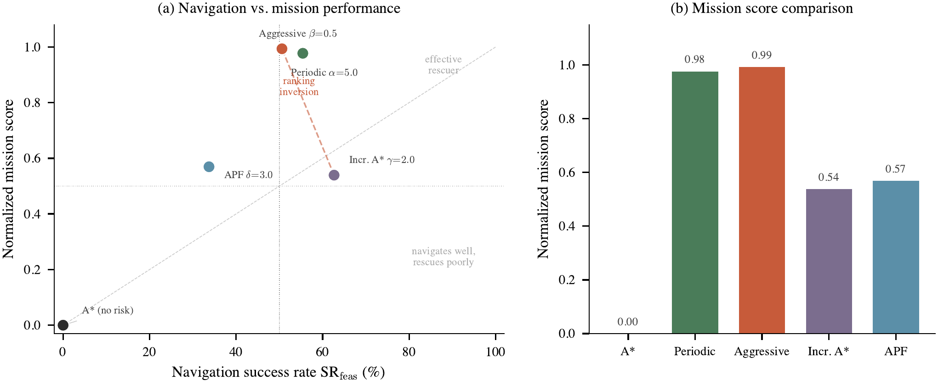
Figure 6. Ranking inversion between navigation and mission metrics. (a) Success rate vs. normalised mission score; the dashed line connecting Incr. A* to Aggressive crosses the diagonal, indicating divergent orderings. (b) Per-planner mission-score decomposition confirms that Aggressive achieves the highest aggregate score despite a lower success rate. Source: scripts/analyze_paper_results.py. See Table 1, §4.5.
4.6. Event Correlation Analysis
This subsection correlates hazard events with UAV decision outcomes using the 450-episode log. Of these, 98 episodes terminate with FIRE_CAUGHT and 1 with DEBRIS_CAUGHT, establishing an on-agent hazard-exposure rate of 22.0%. Additional adverse terminations include 90 vehicle collisions and 58 goal-stall terminations (the UAV cannot make progress toward its target for a sustained window).
Fire terminations and the risk coefficient. FIRE_CAUGHT is concentrated in the three mid-rho planners: Aggressive (30/150), APF (27/150), and Periodic Replan (27/150); Incremental A* adds 14; A* contributes 0 because it terminates earlier via vehicle collisions on the static corridor. The absence of an A* fire-exposure signal is itself a mechanism finding: when rho=0 the planner is so committed to its precomputed corridor that it collides with corridor traffic before fire arrives.
Structural collapse and replanning cascades. Structural collapse fires at tau_c=80 steps of continuous fire exposure with p_d=0.6. Debris first appears in Penteli at approximately t=85. Replan counts by planner are consistent with their algorithmic profile: A* never replans (rho=0, static), while Incremental A* shows the largest replan cascades at the first debris event because its edge-weight update invalidates large sections of the partial graph. Periodic Replan exhibits fixed-cadence replans that are, by design, insensitive to collapse timing.
Rejected moves and their mechanism. Over the 450 episodes, 4,071 action rejections are logged. FIRE_BUFFER dominates (1,653 rejections, 40.6%), followed by FIRE (1,265, 31.1%), TRAFFIC_BUFFER (769, 18.9%), TRAFFIC_CLOSURE (370, 9.1%), and SMOKE (14, 0.3%). The dominance of fire-layer rejections confirms that the risk coefficient rho--which inflates costs within the fire-buffer--is the single most consequential planner parameter: planners with low rho enter the buffer and get rejected; planners with high rho detour and lose time.
The coupling with mission score. Across 150 Penteli seeds, Aggressive reaches its POI at a mean executed-step count of 414.7 (successful episodes, N=10) while Periodic reaches it at 522.3 (N=12). Substituting into the quadratic decay E(t) = 1 - (t / T_max)^2 with T_max = 900 yields E(414.7) = 0.788 and E(522.3) = 0.663. The 12.5-point gap in mission value is therefore not a planner-quality difference--both succeed--but a direct consequence of the rho-parameterised detour cost, which is exactly the ranking-inversion mechanism.
4.7. Qualitative Evidence
Figure 7 provides spatial confirmation of the ranking inversion. Under identical fire conditions, three planners produce qualitatively different trajectories. A* terminates upon collision with a dynamic obstacle at t=78. Aggressive and Periodic both complete the mission in comparable step counts (522 vs. 524) but via substantially different paths: Aggressive traverses the smoke corridor while Periodic circumnavigates the fire perimeter along a path approximately twice as long. The risk coefficient, rather than the algorithmic family, determines route geometry.
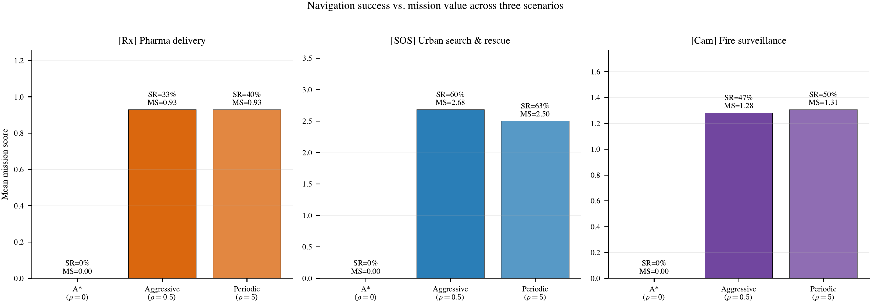
Figure 7. Trajectory comparison under identical fire conditions (Penteli, seed 42). A* (left) terminates upon collision with a dynamic obstacle. Aggressive (centre) traverses the smoke corridor. Periodic (right) completes a longer detour, arriving with reduced medication efficacy. Black circles: dynamic obstacles; blue cross: UAV position; yellow cross: target. Source: scripts/gen_mission_type_figures.py. See §3.4, Table 3.
4.8. Statistical Validation
Wilcoxon tests (Bonferroni-corrected) confirm A* differs from every adaptive planner (p < 0.001). Critically, no significant difference exists between Periodic and Aggressive in SR (p = 1.0): navigation success alone cannot separate them. The discriminator is mission score: a Friedman test yields χ²(4) = 190.8, p < 0.001, establishing the ranking inversion as statistically robust (Table 5).
Table 5. Statistical validation. Friedman confirms ranking differences; bootstrap CIs quantify uncertainty.
Test | Statistic | p | Result
Friedman (5 planners) | χ²=190.8 | <0.001 | Planners differ
A* vs. Adaptive (Wilcoxon) | — | <0.001 | All significant
A* vs. Incr. A* (Cliff’s δ) | 0.58 | — | Large effect
Incr. A* vs. APF (Cliff’s δ) | 0.27 | — | Small effect
IQM success rate, 95% bootstrap CI (10,000 resamples):

Incr. A* | 62.7% |  | [50.9, 74.5]
Periodic | 55.4% |  | [43.1, 67.8]
Aggressive | 50.6% |  | [38.6, 62.6]
4.9. Hazard Ablation
Isolating dynamics layers reveals their contributions. Fire is the dominant differentiator: it reduces A* to 0% while adaptive planners retain 39–64%. Traffic alone also eliminates A* but has near-zero marginal impact on Periodic and Aggressive—their replanning fully mitigates obstacle blockages. Combined dynamics reduce all planners by 10–20 pp relative to fire alone, confirming non-additive layer interaction. Road closures grow proportionally with fire (via the interaction engine); debris accumulates after the collapse delay (τc=80). Aggressive Replan’s timely detours maintain forward progress; Periodic’s risk-averse strategy produces extended stalls—a direct consequence of the ρ–t–M coupling.
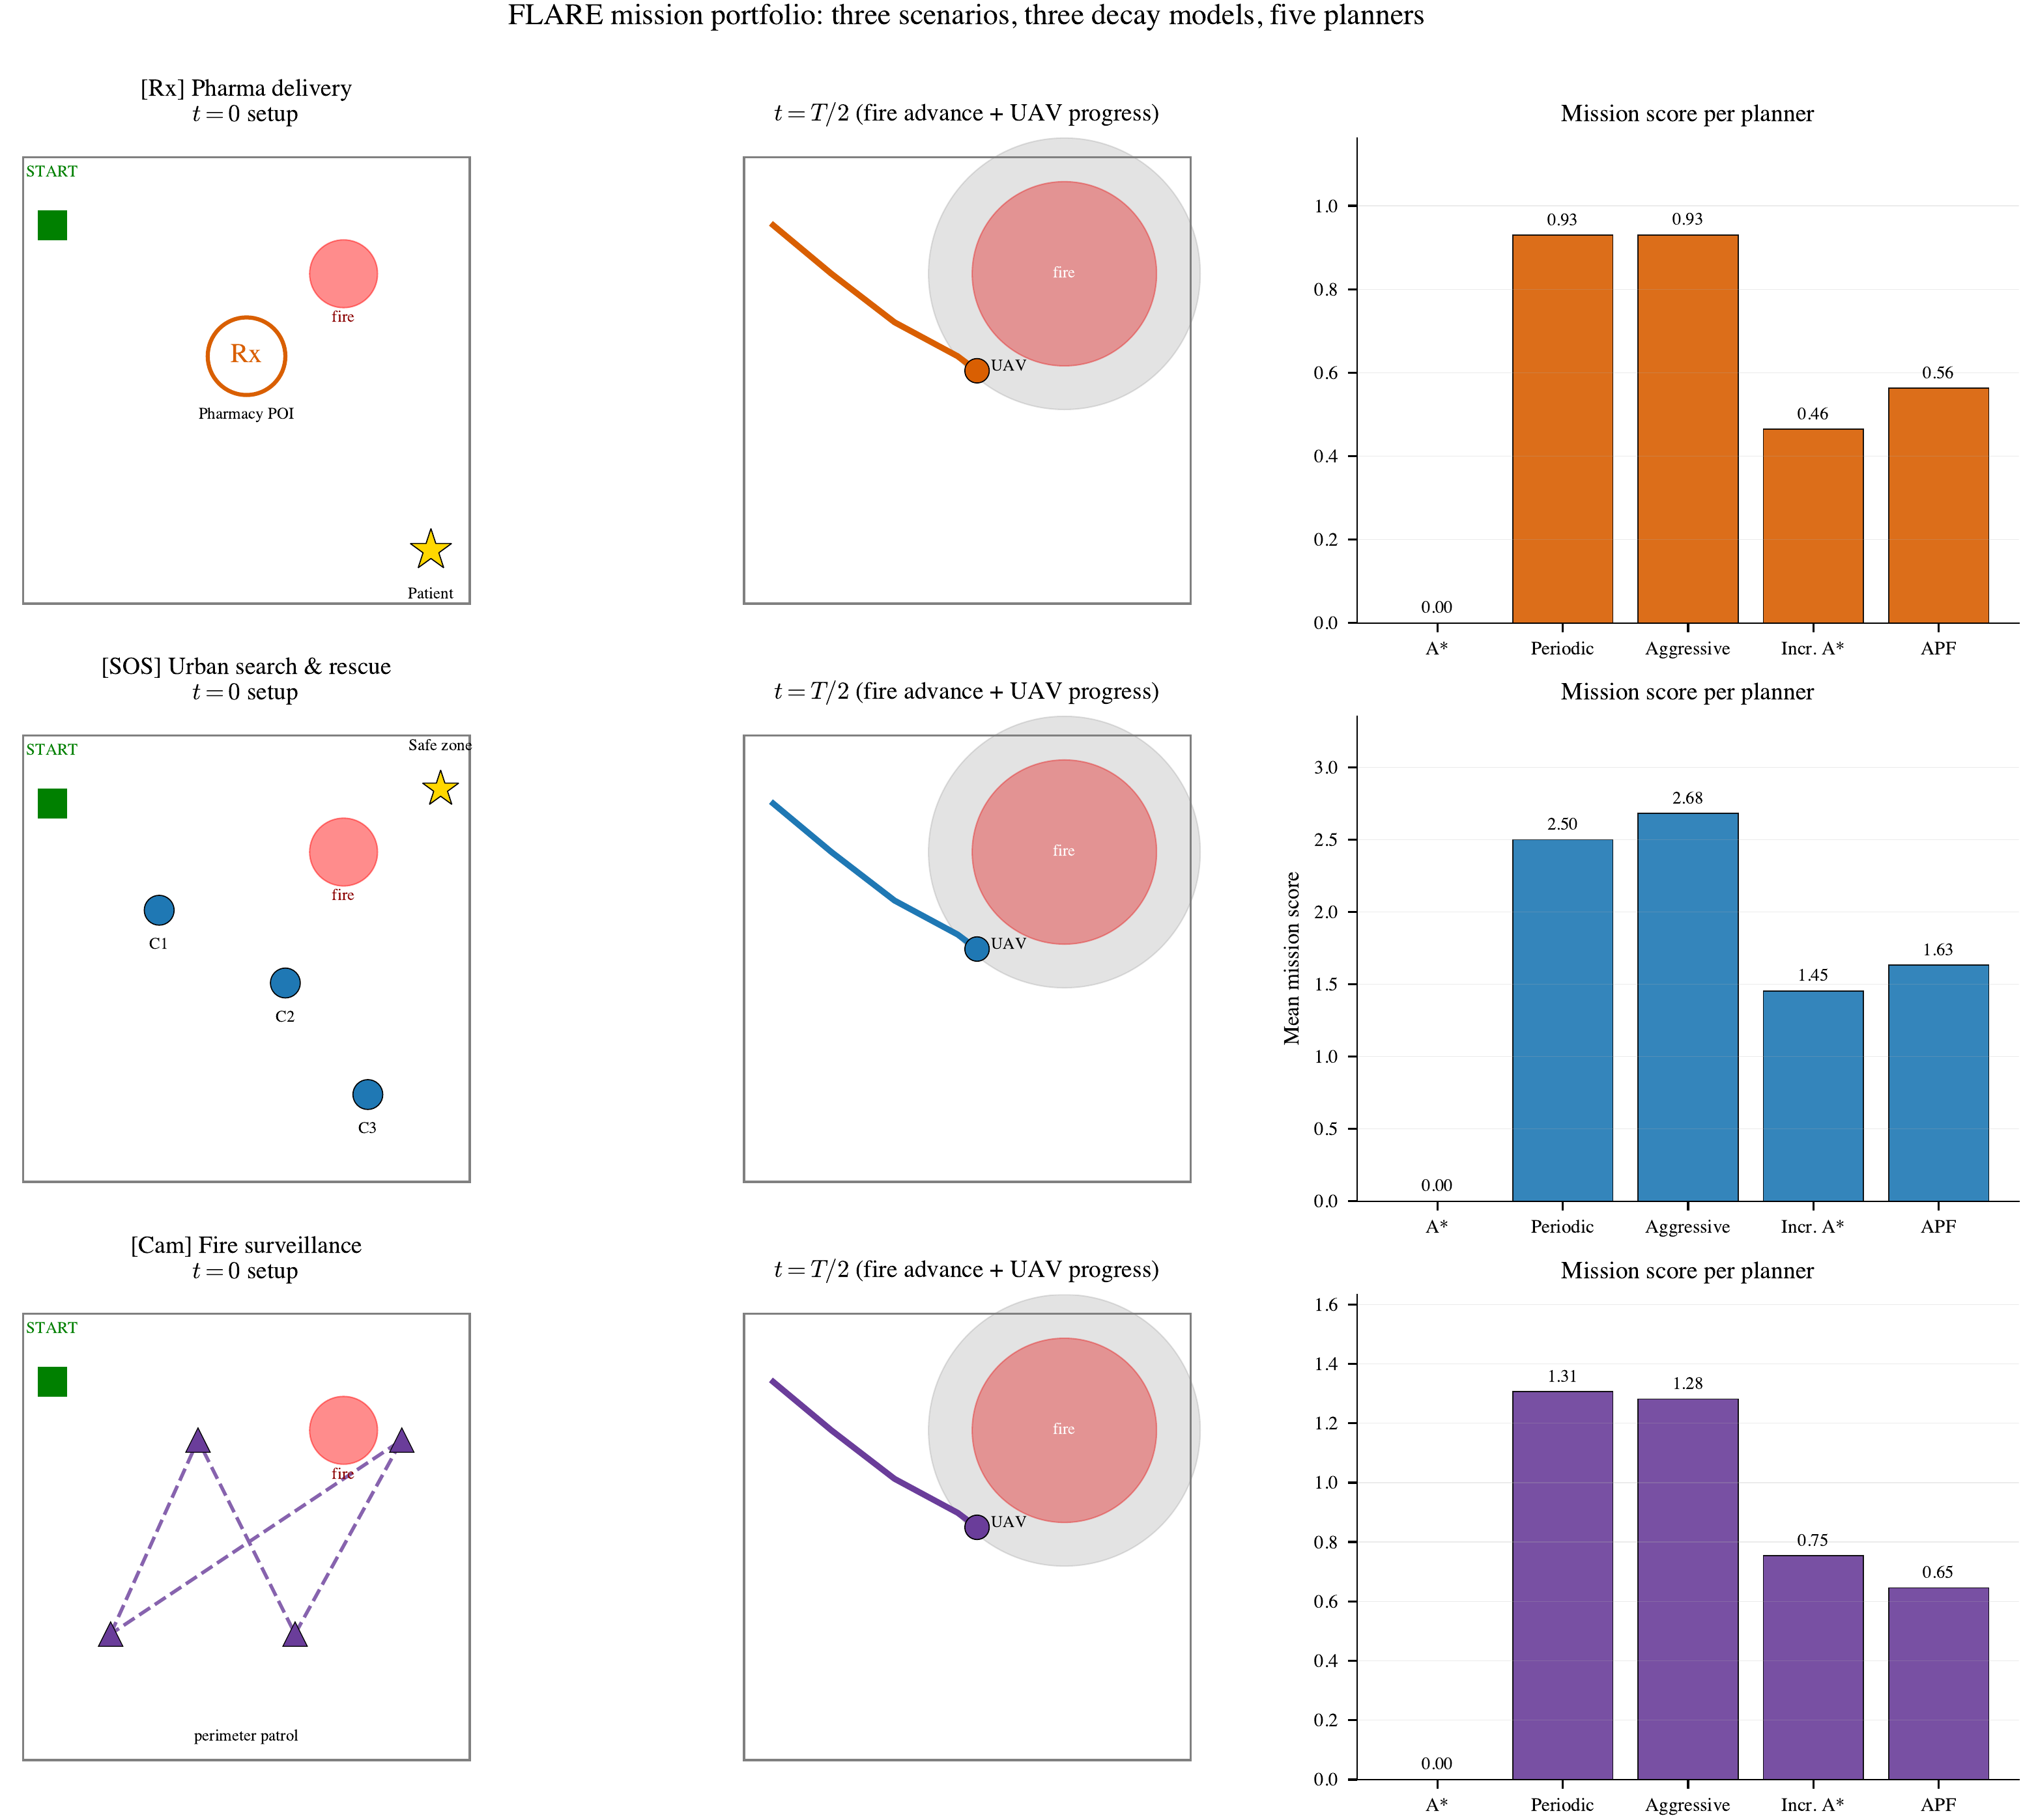
Figure 8. FLARE mission portfolio — three scenarios, three decay models, five planners. Rows depict pharma delivery (Penteli), urban search and rescue (Piraeus), and fire surveillance (Downtown). Columns show the t=0 setup, a mid-execution schematic (t=T/2), and the mean mission score per planner aggregated over 150 seeds per scenario. Source: scripts/gen_mission_type_figures.py. See §3.5, Table 3.
5. Discussion
5.1. Shapley Attribution
Exact Shapley values [32] over coalitions {fire, traffic, collapse} confirm fire as the dominant hazard for all planners. Traffic degrades A* (φ=−0.50) and APF (φ=−0.25) but has zero marginal impact on Periodic and Aggressive—their replanning absorbs obstacle blockages entirely. Collapse contributes near-zero marginal effect, subsumed by the fire that triggers it.
In fire-dominated scenarios, the risk coefficient ρ has greater influence on mission outcome than replanning frequency; in traffic-heavy environments, all adaptive planners perform comparably.
5.2. Risk Coefficient as a Mission-Selection Parameter
The ranking inversion establishes that no universally optimal planner exists across mission types. Instead, ρ serves as a principled mission-selection parameter:
- Time-critical delivery (rescue, medication): ρ ≤ 0.5. Minimise t to maximise M(t); accept higher collision probability.
- Survival-critical operations (surveillance): ρ ≥ 5.0. Delayed data retains partial value; collision yields M=0.
This finding reframes planner selection: rather than identifying a single superior algorithm, the appropriate risk coefficient is determined by the mission-specific relationship between delivery time and objective value—a relationship that FLARE makes empirically quantifiable.
5.3. Limitations
Several simplifications constrain the scope of the present study. FLARE operates on 2D grids without altitude modelling or aerodynamic constraints. The planner suite comprises classical algorithms; the CA fire model provides an approximation of real wildfire dynamics. Three Greek urban scenarios offer focused but not exhaustive geographic coverage. Risk coefficients are fixed per planner and not adapted online. The ranking inversion was not predictable a priori, as no prior benchmark incorporates time-coupled mission scoring, and the magnitude (|ΔRank|=3) required empirical measurement. Importantly, ρ is not a tunable hyperparameter but a structural property of each planner’s cost function, and the inversion persists across all three geographically distinct scenarios. These simplifications are deliberate: the contribution is the evaluation paradigm and the ranking-inversion finding, not the planners themselves.
6. Conclusions
This paper presented FLARE, a deterministic benchmark designed to evaluate UAV planner performance under time-coupled mission objectives. Across 450 episodes on three Greek wildfire scenarios, the experimental results establish a ranking inversion: the planner with the highest survival probability ranks last in mission score M(t), because its detours increase delivery time t beyond the point at which the objective retains value. Conversely, a risk-tolerant planner achieves the highest mission score despite ranking third in navigation success rate (Friedman p < 0.001).
The ranking inversion demonstrates that navigation success rate constitutes an insufficient evaluation criterion for time-critical operations, as it can produce orderings that are inversely correlated with mission effectiveness. The principal implication is methodological: planner evaluation should incorporate time-dependent mission value functions rather than relying solely on binary completion metrics. The risk coefficient ρ provides a principled parameter for mission-specific planner selection. The benchmark framework and all experimental data are publicly available.
Code and data: https://github.com/zervakisai/uavplan.
Author Contributions: Conceptualization, K.Z. and E.P.; methodology, K.Z.; software, K.Z.; validation, K.Z. and E.P.; formal analysis, K.Z.; investigation, K.Z.; resources, K.Z.; data curation, K.Z.; writing—original draft preparation, K.Z.; writing—review and editing, K.Z. and E.P.; visualization, K.Z.; supervision, E.P.; project administration, K.Z. All authors have read and agreed to the published version of the manuscript.
Funding: This research received no external funding.
Data Availability Statement: The benchmark code, scenario configurations, and full experimental results are publicly available at https://github.com/zervakisai/uavplan. Map data are derived from OpenStreetMap [33] under the Open Database License (ODbL).
Acknowledgments: Map data © OpenStreetMap contributors (ODbL). Scenarios inspired by the 2021 Evia wildfire [34,35], 2023 Rhodes fires [36], and 2023 Evros megafire [37,38]. Data from EFFIS [34,38] and Copernicus EMS [35–37].
Conflicts of Interest: The authors declare no conflicts of interest.
Abbreviations
The following abbreviations are used in this manuscript:

UAV | Unmanned Aerial Vehicle
FLARE | Fire-Landscape Adaptive Risk Evaluation
SR | Success Rate
IQM | Interquartile Mean
CI | Confidence Interval
CA | Cellular Automaton
APF | Artificial Potential Field
OSM | OpenStreetMap
NFZ | No-Fly Zone
RNG | Random Number Generator
WUI | Wildland–Urban Interface

References
- Erdelj, M.; Natalizio, E.; Chowdhury, K.R.; Akyildiz, I.F. Help from the Sky: Leveraging UAVs for Disaster Management. IEEE Pervasive Computing 2017, 16, 24–32. https://doi.org/10.1109/MPRV.2017.11.
- Yücesoy, G.; et al. The Role of drones in disaster response: A literature review of operations research applications. International Transactions in Operational Research 2025, 32, 545–589. https://doi.org/10.1111/itor.13484.
- Copernicus Emergency Management Service. Copernicus EMS Risk and Recovery Activation EMSN166: Wildfire in Evros, Greece, 2023. Evros fire started 19 August 2023 near Aristino village, 96,000+ ha burned — largest single wildfire in EU history.
- Li, J.; Pei, Y.; Zhao, S.; Xiao, R.; Sang, X.; Zhang, C. A comprehensive survey of research towards AI-enabled unmanned aerial systems in pre-, active-, and post-wildfire management. Information Fusion 2024, 108, 102369. https://doi.org/10.1016/j.inffus.2024.102369.
- Meng, W.; Zhang, X.; Zhou, L.; Guo, H.; Hu, X. Advances in UAV Path Planning: A Comprehensive Review of Methods, Challenges, and Future Directions. Drones 2025, 9, 376. https://doi.org/10.3390/drones9050376.
- Koenig, S.; Likhachev, M. D* Lite. In Proceedings of the Proceedings of the 18th AAAI Conference on Artificial Intelligence, 2002, pp. 476–483.
- Koenig, S.; Likhachev, M. D* Lite. In Proceedings of the Proceedings of the 18th AAAI Conference on Artificial Intelligence, 2002, pp. 476–483.
- Khatib, O. Real-Time Obstacle Avoidance for Manipulators and Mobile Robots. The International Journal of Robotics Research 1986, 5, 90–98. https://doi.org/10.1177/027836498600500106.
- Meng, W.; Zhang, X.; Zhou, L.; Guo, H.; Hu, X. Advances in UAV Path Planning: A Comprehensive Review of Methods, Challenges, and Future Directions. Drones 2025, 9, 376. https://doi.org/10.3390/drones9050376.
- Aggarwal, S.; Kumar, N. Path Planning Techniques for Unmanned Aerial Vehicles: A Review, Solutions, and Challenges. Computer Communications 2020, 149, 270–299. https://doi.org/10.1016/j.comcom.2019.10.014.
- Patra, S.; Basak, S.; Patel, H. A Survey on Reinforcement Learning Methods for UAV Systems. ACM Computing Surveys 2025, 57, 1–42. https://doi.org/10.1145/3769426.
- Bouzid, Y.; Bestaoui Sebbane, Y.; Mohammedi, A. UAV Path Planning Trends from 2000 to 2024: A Bibliometric Analysis and Visualization. Drones 2025, 9, 128. https://doi.org/10.3390/drones9020128.
- Henderson, P.; Islam, R.; Bachman, P.; Pineau, J.; Precup, D.; Meger, D. Deep Reinforcement Learning That Matters. In Proceedings of the Proceedings of the 32nd AAAI Conference on Artificial Intelligence, 2018.
- Zhou, W.; et al. A risk-based unmanned aerial vehicle path planning scheme for complex air–ground environments. Risk Analysis 2025, 45, 321–342. https://doi.org/10.1111/risa.17685.
- Melissaris, C.; et al. Risk-aware UAV trajectory optimization using open urban GIS data and target level of safety constraints. Drones 2025, 9, 666. https://doi.org/10.3390/drones9100666.
- Karaağaç, C.; Yılmaz, N.; Hançerlioğulları, A. Risk-Aware Enabled Path Planning for Drones Flight in Unknown Environment. Journal of Intelligent & Robotic Systems 2025, 111, 56. https://doi.org/10.1007/s10846-025-02243-2.
- Chen, X.; Zhang, F.; Liu, Y.; Zhang, L. Probabilistic Path Planning for UAVs in Forest Fire Monitoring: Enhancing Patrol Efficiency through Risk Assessment. Fire 2024, 7, 254. https://doi.org/10.3390/fire7070254.
- Alexandridis, A.; Vakalis, D.; Siettos, C.I.; Bafas, G.V. A Cellular Automata Model for Forest Fire Spread Prediction: The Case of the Wildfire that Swept Through Spetses Island in 1990. Applied Mathematics and Computation 2008, 204, 191–201. https://doi.org/10.1016/j.amc.2008.06.046.
- Giannino, F.; et al. Statistical Dynamics of Wildfire Burned Area from Cellular-Automata Simulators. Scientific Reports 2025, 15, 2025. https://doi.org/10.1038/s41598-025-30851-3.
- Sahila, A.; Fiorese, A.; Perello, N.; Trucchia, A.; Pagnini, G. Patterns of burned area by a cellular-automata fire simulator: The role of microscale wind field. Communications in Nonlinear Science and Numerical Simulation 2025, 151, 109026. https://doi.org/10.1016/j.cnsns.2025.109026.
- Wang, Z.; Zhao, M.; Chen, G.; Li, J. Multi-Target Firefighting Task Planning Strategy for Multiple UAVs Under Dynamic Forest Fire Environment. Fire 2025, 8, 61. https://doi.org/10.3390/fire8020061.
- Liu, Y.; Wang, Z.; Chen, X.; Zhang, W. Multiple UAV Swarms Collaborative Firefighting Strategy Considering Forest Fire Spread and Resource Constraints. Drones 2025, 9, 17. https://doi.org/10.3390/drones9010017.
- Henderson, P.; Islam, R.; Bachman, P.; Pineau, J.; Precup, D.; Meger, D. Deep Reinforcement Learning That Matters. In Proceedings of the 32nd AAAI Conference on Artificial Intelligence, 2018.
- Agarwal, R.; Schwarzer, M.; Castro, P.S.; Courville, A.; Bellemare, M.G. Deep Reinforcement Learning at the Edge of the Statistical Precipice. In Proceedings of the Advances in Neural Information Processing Systems, 2021, Vol. 34.
- Demšar, J. Statistical Comparisons of Classifiers over Multiple Data Sets. Journal of Machine Learning Research 2006, 7, 1–30.
- Dolan, E.D.; Moré, J.J. Benchmarking Optimization Software with Performance Profiles. Mathematical Programming 2002, 91, 201–213. https://doi.org/10.1007/s101070100263.
- Bonsignorio, F.; del Pobil, A.P.; Zereik, E. Towards reproducible robotics research. Nature Machine Intelligence 2025, 7, 15–22. https://doi.org/10.1038/s42256-025-01114-7.
- Ferrara, C.; et al. Statistical dynamics of wildfire burned area from cellular-automata simulators. Scientific Reports 2025. https://doi.org/10.1038/s41598-025-30851-3.
- Zhao, Y.; Zheng, Z.; Liu, Y. Survey on Computational-Intelligence-Based UAV Path Planning. Knowledge-Based Systems 2018, 158, 54–64. https://doi.org/10.1016/j.knosys.2018.05.033.
- Boeing, G. OSMnx: New Methods for Acquiring, Constructing, Analyzing, and Visualizing Complex Street Networks. Computers, Environment and Urban Systems 2017, 65, 126–139. https://doi.org/10.1016/j.compenvurbsys.2017.05.004.
- Towers, M.; Kwiatkowski, A.; Terry, J.K.; Balis, J.U.; De Cola, G.; Deleu, T.; Goulão, M.; et al. Gymnasium: A Standard Interface for Reinforcement Learning Environments. In Proceedings of the Advances in Neural Information Processing Systems, 2025, Vol. 38. Spotlight.
- Shapley, L.S. A Value for n-Person Games. In Contributions to the Theory of Games II; Kuhn, H.; Tucker, A., Eds.; Princeton University Press, 1953; pp. 307–317.
- OpenStreetMap contributors. OpenStreetMap, 2024. Data available under the Open Database License (ODbL).
- San-Miguel-Ayanz, J.; Durrant, T.; Boca, R.; Maianti, P.; Libertà, G.; Artés-Vivancos, T.; Oom, D.; Branco, A.; Rigo, D. Forest Fires in Europe, Middle East and North Africa 2021. Technical report, European Commission, Joint Research Centre, 2022. EUR 31094 EN, https://doi.org/10.2760/34094.
- Copernicus Emergency Management Service. Copernicus EMS Rapid Mapping: Wildfires in Evia and Attica, Greece, August 2021, 2021. Over 50,000 ha burned on Evia island; largest wildfire recorded in EU at the time.
- Copernicus Emergency Management Service. Copernicus EMS Rapid Mapping Activation EMSR675: Wildfire in Rhodes, Greece, 2023. 18 monitoring maps delivered 20–30 July 2023; 17,629 ha burned on Rhodes island.
- Copernicus Emergency Management Service. Copernicus EMS Risk and Recovery Activation EMSN166: Wildfire in Evros, Greece, 2023. Evros fire started 19 August 2023 near Aristino village, 96,000+ ha burned — largest single wildfire in EU history.
- San-Miguel-Ayanz, J.; et al. Forest Fires in Europe, Middle East and North Africa 2023. Technical report, European Commission, Joint Research Centre, 2024. Covers Evros megafire (96,000 ha) and Rhodes fires; EUR 32234 EN, https://doi.org/10.2760/108466.
- Roberts, N.B.; Ager, E.; Leith, T.; Lott, I.; Mason-Maready, M.; Nix, T.; Gottula, A.; Hunt, N.; Brent, C. Current Summary of the Evidence in Drone-Based Emergency Medical Services Care. Resuscitation Plus 2023, 13, 100347. https://doi.org/10.1016/j.resplu.2022.100347
- Thompson, M.P.; Calkin, D.E.; Herynk, J.; McHugh, C.W.; Short, K.C. Risk Management and Analytics in Wildfire Response. Current Forestry Reports 2019, 5, 226–239. https://doi.org/10.1007/s40725-019-00101-7
- Yucesoy, B. The role of drones in disaster response: A literature review of operations research applications. Int. Trans. Oper. Res. 2025. https://doi.org/10.1111/itor.13484
- Shahzaad, B.; et al. Unmanned aerial systems in search and rescue: A global perspective on current challenges and future applications. Int. J. Disaster Risk Reduct. 2025. https://doi.org/10.1016/j.ijdrr.2025.105238
- Khan, M.A.; et al. A systematic literature review of unmanned aerial vehicles for healthcare and emergency services. arXiv 2025, arXiv:2504.08834.
- Al-Atroshi, C.; et al. A survey on multi-UAV path planning: Classification, algorithms, open research problems, and future directions. Drones 2025, 9(4), 263. https://doi.org/10.3390/drones9040263
- Dradoum, A.; Khelassi, A.; Lachekhab, F. Intelligent path planning algorithms for UAVs: Classification, complexity analysis, hybrid ablation insights, and future directions. Adv. Mech. Eng. 2025. https://doi.org/10.1177/16878132251355020
- Li, Y.; et al. Evolutionary computation for unmanned aerial vehicle path planning: A survey. Artif. Intell. Rev. 2024, 57, 913. https://doi.org/10.1007/s10462-024-10913-0
- Zhou, Y.; et al. A risk-based unmanned aerial vehicle path planning scheme for complex air–ground environments. Risk Anal. 2025. https://doi.org/10.1111/risa.17685
- Primatesta, S.; Rizzo, A.; la Cour-Harbo, A. A risk-aware path planning strategy for UAVs in urban environments. J. Intell. Robot. Syst. 2019, 95, 629–643. https://doi.org/10.1007/s10846-018-0924-3
- Hu, J.; et al. UAV path planning based on third-party risk modeling. Sci. Rep. 2023, 13, 22658. https://doi.org/10.1038/s41598-023-49396-4

