**Design and Realization of a Mobile Robot to train Football Goalkeepers**

**Realized by: Maha Stihi**

**Abstract**  
The project consists on the modeling and the realization of an autonomous robot that shoots  
and evaluates the performances of a soccer goalkeeper based on his reactions.  
Using a camera and a 3D human pose estimator, the system can detect and modelize the  
goalkeeper’s physical gestures.  
Finally, it proposes using artificial intelligence the suitable decision for the future exercises,  
which maximizes the player’s performances.  
**Key words**: Soccer goalkeeper, Training, Robot, 3D human pose estimation, Artificial  
intelligence.

1. **Introduction**

Robotics has many areas of application. Originally, the robots been established in industries (as early as 1961) to perform repetitive tasks with a constant precision. Now, after the development of technology and especially after the introduction of artificial intelligence, we find robots implanted in almost all fields and used for all purposes, even in an environment close to humans. The artificial intelligence algorithms and robots are known to be introduced to automate tasks and replace human work. For example, "LawGeex" uses the latest technologies in intelligence, machine learning, analysis text and natural language processing to review and understand documents legal [1]. This smart system can replace hundreds of legal advisers who are often overworked to review daily contracts, which was very expensive in time, money and human resources. In robotics and more specifically in sports field, athletes are also among the recipients of technological assistance. We can cite:

- Mobile robots developed by the "Japanese Volleyball Association" with the help of researchers from Tsukuba University to help the team's attackers National Women's Training [2] (Figure 1.a);

- The tennis ball shooter robot that gives precise and intensive training to players [3] (Figure 1.b);

- And also the mobile robot "MVP" that simulates the veneer of football players American [4] (Figure 1.c).

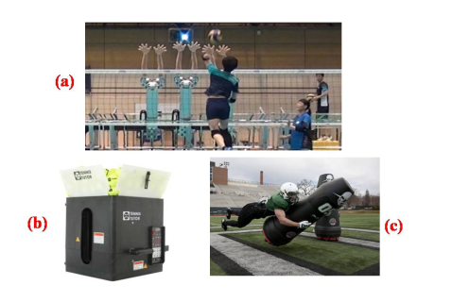

Figure 1 - Examples of sports robots

1. **Problematic**

In the field of sport, some techniques need a lot of training to master them. Even in the best teams in the world, the number of coaches is very limited, especially in football, for 4 goalkeepers only one coach is available. Therefore, players from different positions will help each other to ensure their training. What makes some players spend part of their workouts helping goalkeepers practicing.

Decision making has always been a difficult task; choose which player to introduce in a match is made by coaches based on several criteria like the physical and tactical performances of the player in the training. This decision is related to the skills and experiences of coaches, so it can be biased.

Injuries are the biggest enemies of athletes. Once the injury is treated medially, the player goes through special programs to return to his former performance. The follow-up of the players after a stoppage of play is a very important part; given that it determines the time it takes to get back to competition, so it can affect the whole team if he is an important player. The choices of the type and intensity of exercises are usually set by both medical and technical parties. By consequence, having a compromise between the medical team that wants to ensure that the player can play in security and the technical team that wants the player to return to the pitch as soon as possible is very difficult to ensure, so a neutral third opinion is highly recommended.

With this project, we want to contribute to a part of the sport field, which is the training of football goalkeepers to minimize the problems illustrated above.

We propose a mobile robot, to help the goalkeeper’s coach during the trainings and also to test the players’ performances with the help of the analysis of the goalkeeper's gestures based on well-studied exercises. Subsequently, the robot provides detailed technical reports to help the coach take the right decisions. It will also have an artificial intelligence that will help to propose the future exercises to work on to keep track of injuries and maximize players’ performances.

1. **Specifications**

In order to achieve our strategy, the robot must be able to:

- Move on a flat surface to position the coordinates (x, y) on the pitch;

- Turn it in a flexible way to orient the part of the shot at an angle θ with a good precision;

- Locate on the ground using odometers;

- Store the balls in the robot using the available height;

- Shoot the balls with a speed and a predefined trajectory;

- Estimate the pose of the goalkeeper;

- Analyze and study the goalkeeper's reaction to the shot.

1. **System Architecture**

The modeling of the system allows us to establish a work plan of the project, by identifying the essential parts of the project and the relationships between them. This modeling allows us to have the architecture overall system.

The architecture of mobile robots consists of four essential parts:

• Mechanical structure and motorization;

• Location system;

• Security organs;

• Information processing system and task management.

This architecture is usually presented as a block diagram, each block represents a feature of the system, and the blocks are then linked together based on the logic of system operation.

Our project is more complex than a simple mobile robot because we have a ball shooting functionality as well as another external data processing feature of the goalkeeper. So, more blocks are presented in the architecture of our system.

Security organs are not taken into account in our work. Only basic security components are set up in our system.

To represent the system parts and its logic process, we use the Moore state diagram as followed:

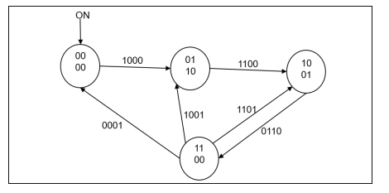

Outputs:

Motors moving & motors shooting

**Position arrived**

**Shoot**

**Analysis**

**done**

**Exercise**

State :

00 : initialization

01 : Move

10 : Shoot

11 : Analysis

Transition :

|  |  |  |  |
| --- | --- | --- | --- |
| x | x | x | X |

Fig 2– Moore diagram (state diagram)

In order to program this state machine in the future, we prefer to represent the state machine as known for the programmers:

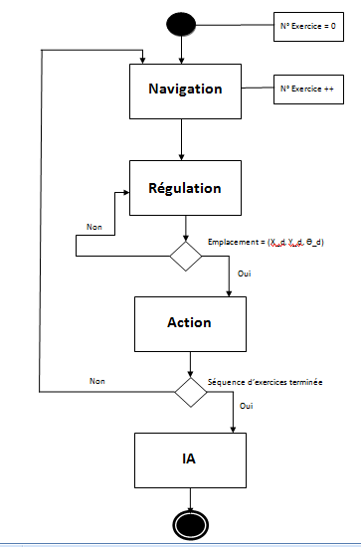

Fig 3 – State machine

1. **Mechanical Conception**

The mechanical design was done by SolidWorks, version 2016.

**V.1. Mobile Robot Base**

The top of the robot is dedicated to the shooting so, it’s bulky and heavy therefore, the upper surface must be spacious and solid. At the same time, robot must stay in balance to ensure a good trip on the pitch. So, we opted for a four-wheeled mobile base model "Rover" (Figure 4).

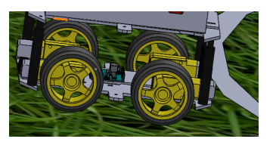

Figure 4 – Rover

**V.2. Ball Shooting System**

In order to ensure a variety of training exercises by our robot, it is necessary that the shooting system has the ability to generate different types of trajectories for the ball.

For this, this part of the robot must not be totally fixed. With two engines (Figure 5), a shooting angle of 30◦maximum can be achieved to aim at any point on the height of the goals.

On the other hand, the shooting is done using two motorized wheels with separate speeds, which makes it possible to vary the exit trajectory while varying the speeds of the two motors separately (Figure 5).

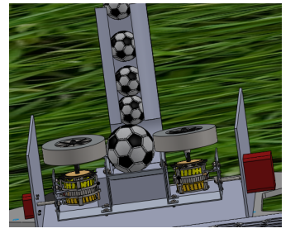

Figure 5 – Upper part of shooting balls

**V.3. Storage System**

To achieve several shots fast, automated, and also to avoid the human being assistance, a balloon storage system is necessary. We designed a cylindrical device with a diameter of 28 cm, which allows stacking footballs (diameter 22 cm) vertically.

Only one ball must pass at a time and on demand to the shooting part, for this a motorized controllable blocking system is implemented (Figure 6).

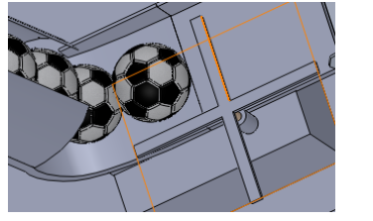

Figure 6 – Ball blocking system

**V.4. Robot Assembly**

The previous three parts are assembled to form our robot balls shooter (Figures 7 and 8).

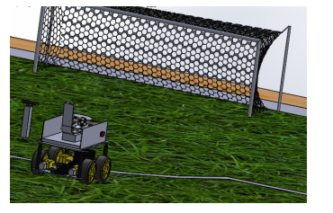

Figure 7 – Back view of the robot.

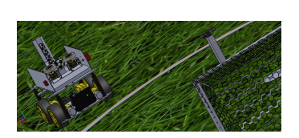

Figure 8 – Front view of the robot.

1. **Rover Simulation**

Before jumping into the realization of the real robot and test the navigation system, it’s preferable to test the programs and functionalities with a simulation.

Ardupilot is an [open source](https://en.wikipedia.org/wiki/Open-source_software), [unmanned vehicle](https://en.wikipedia.org/wiki/Uncrewed_vehicle) Autopilot navigation software capable of controlling autonomously different types of vehicles:

* [Multirotor](https://en.wikipedia.org/wiki/Multirotor) drones
* Fixed-wing and [VTOL](https://en.wikipedia.org/wiki/VTOL) [aircraft](https://en.wikipedia.org/wiki/Model_aircraft)
* [Helicopters](https://en.wikipedia.org/wiki/Radio-controlled_helicopter)
* Ground [rovers](https://en.wikipedia.org/wiki/Radio-controlled_car)
* Boats
* [Submarines](https://en.wikipedia.org/wiki/Radio-controlled_submarine)
* Antenna trackers

Ardupilot proposes also simulation functionality, using many knows simulators.

Rover is an advanced [open source](http://ardupilot.org/dev/docs/license-gplv3.html#license-gplv3) autopilot for guiding ground vehicles and boats. It can run fully autonomous missions that are defined using mission planning software or pre-recorded by the driver during a manual run.

Rover runs on the [Pixhawk](http://ardupilot.org/rover/docs/common-pixhawk-overview.html#common-pixhawk-overview) and a number of other [supported autopilot boards](http://ardupilot.org/rover/docs/common-autopilots.html#common-autopilots).

For our project we used:

* Simulator : Software In The Loop (SITL)
* Operating system: Linux
* Vehicle: Rover2
* Parameters: wind, speed, environment...

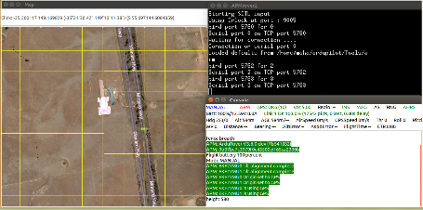

Fig 9 – Realized simulation using Ardupilot

1. **Prototype**

Once the robot modelization and the simulation done, we pass to the prototyping.

The prototype does not contain all the functionalities of the real robot for complexity reasons.

The steps of the realization are represented below:

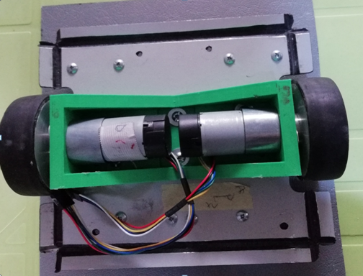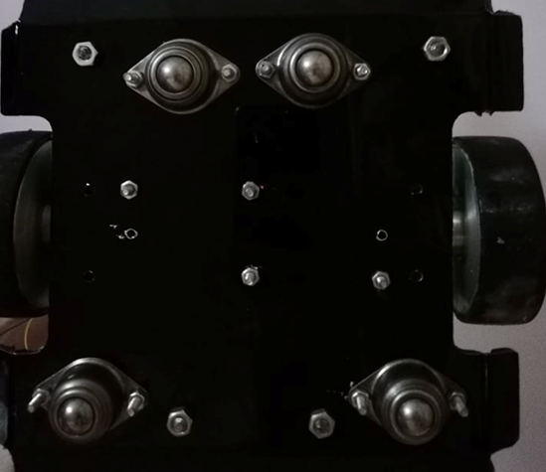

Fig 10 – Mobile base with 2 motorized DC motors and 4 free wheels

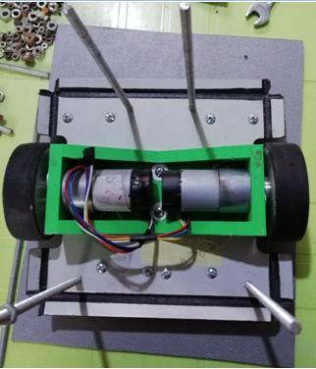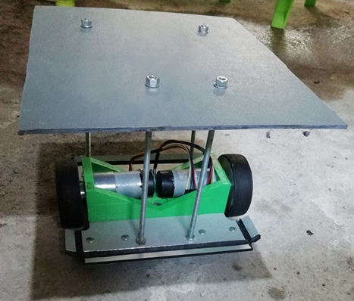

Fig 11 – Second level for the shooting dispositive

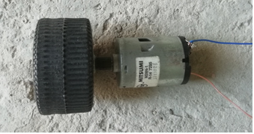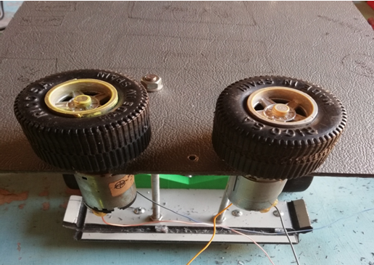

Fig 12 – Shooting system

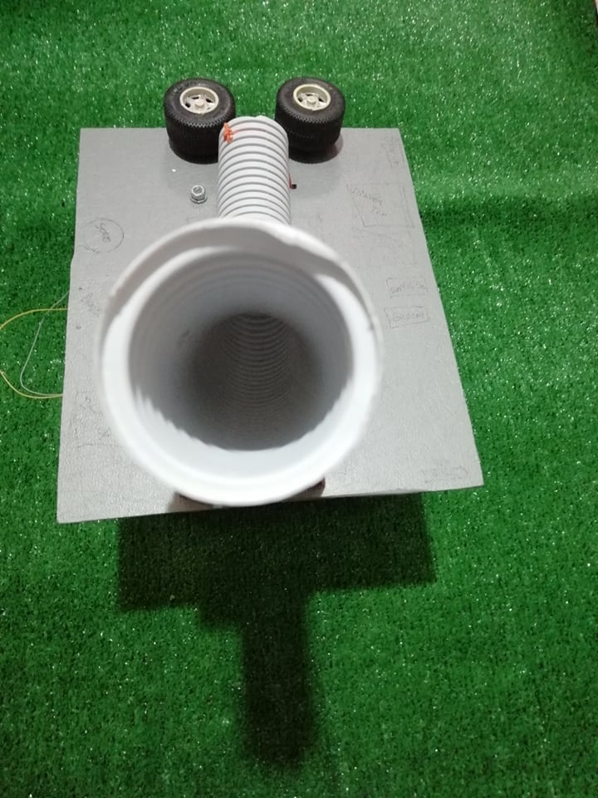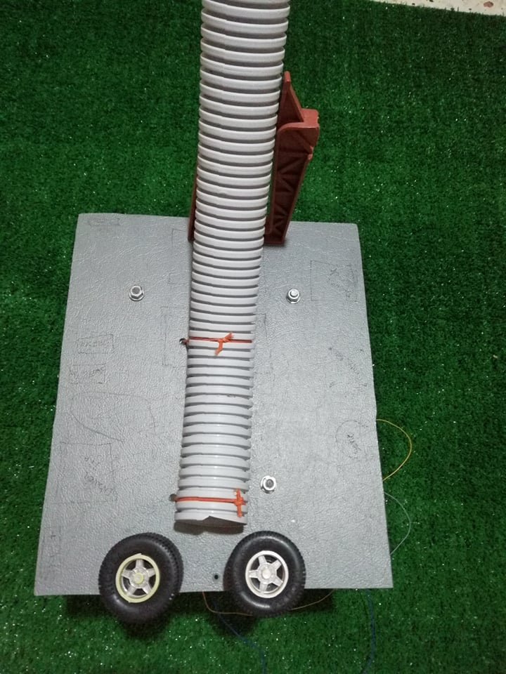

Fig 13 - Storage system

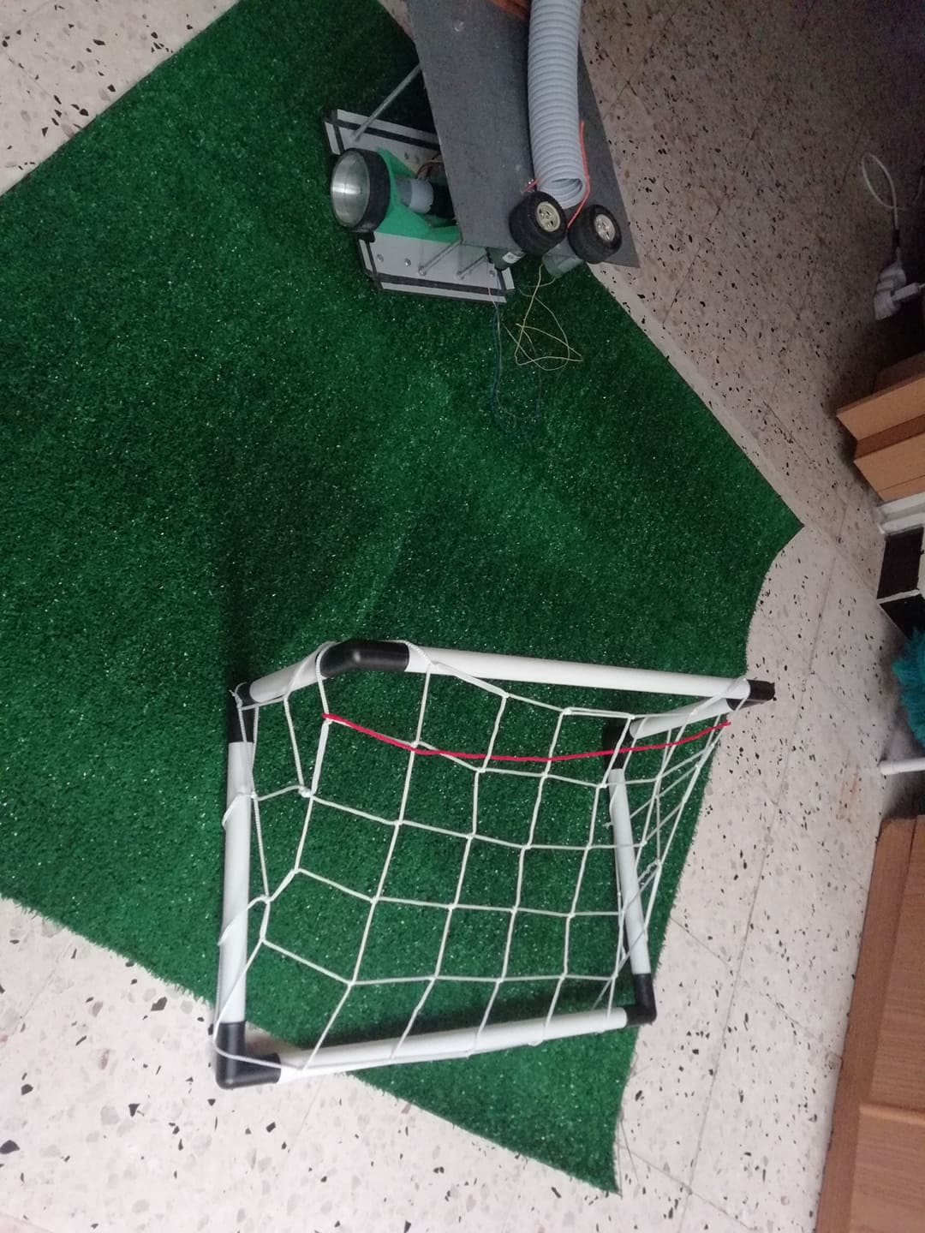

Fig 14 – Assembled robot

1. **Human Pose Estimation**

A video is collected after the shooting to evaluate the goalkeeper’s reactions. For this, we need to apply a human pose estimator on it to have exploitable (numerical) information. This numerical information will be used in the data analysis part.

Although many pose detection/estimation systems exist and in addition are in open source, many of them require specialized hardware and / or cameras, as well as many system configurations. The most flexible and accessible pose estimator we have chosen is "PoseNet" which functions on "TensorFlow.js". For our prototype, we use a RGB camera.

[**PoseNet**](https://github.com/tensorflow/tfjs-models/tree/master/posenet?source=post_page---------------------------) can be used to estimate either a single pose or multiple poses, meaning there is a version of the algorithm that can detect only one person in an image/video and one version that can detect multiple persons in an image/video.

At a high level pose estimation happens in two phases:

1. An input RGB image is fed through a convolutional neural network.
2. Either a single-pose or multi-pose decoding algorithm is used to decode poses, pose confidence scores, keypoint positions, and keypoint confidence scores from the model outputs.

**Pose** — at the highest level, PoseNet will return a pose object that contains a list of keypoints and an instance-level confidence score for each detected person.

* **Pose confidence score** — this determines the overall confidence in the estimation of a pose. It ranges between 0.0 and 1.0. It can be used to hide poses that are not deemed strong enough.
* **Keypoint** — a part of a person’s pose that is estimated, such as the nose, right ear, left knee, right foot, etc.It contains both a position and a keypoint confidence score. PoseNet currently detects 17 keypoints illustrated in the following Figure :

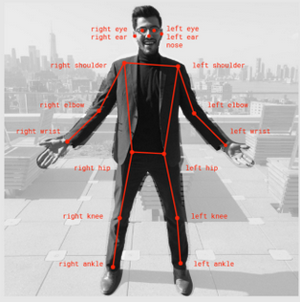

Fig 15 – 17 keypoints returned by PoseNet

* **Keypoint Confidence Score** — this determines the confidence that an estimated keypoint position is accurate. It ranges between 0.0 and 1.0. It can be used to hide keypoints that are not deemed strong enough.
* **Keypoint Position** — 2D x and y coordinates in the original input image where a keypoint has been detected.

The html program provided by PoseNet was used to test our project situations (Figure 16) [5].

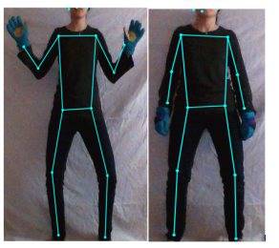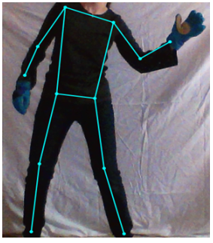

Fig 16 – Real time human pose estimation using PoseNet

The pose estimator reacted well to the movements, but the precision and the speed need to be improved to apply it for real time goalkeeper’s reactions analysis.

1. **Data Analysis**

The acquired data from the pose estimation of the goalkeeper will be used to analyze his reactions and determine either he made the good gestures or not.

After many exercises the strength and weakness of the goalkeeper can be determined.

For the technique of analysis, two methods were studied and compared:

* 1. Machine learning
  2. Fuzzy logic

The comparison between the two methods is as follow:

1. **Machine learning**

• Chosen technique: supervised learning "supervised learning"

• Estimated data collection time: 40h

• Estimated training time: 10h

• Estimated time of tests and implementation: 20h

• Method of data collection: manual (video games)

1. **Fuzzy logic**

• Chosen technique: fuzzy logic type 1

• Estimated data collection time: 8h

• Estimated time of system understanding: 12h

• Estimated time of tests and implementation: 10h

• Method of data collection: manual (with an expert)

1. **Conclusion and perspectives**

We managed to model the system’s parts: Mechanics, Automation and Computer Science as well as the construction of a small prototype of the robot balls shooter.

Regarding the analysis part, we worked on a human pose estimator that provides the data needed to interpret the goalkeeper's reactions.

Note that with the limited time available and taking into account the diversity and complexity of each part of the project, we have achieved a proof of concept and not a finished product. In order to present a product with high precision, finished and robust we propose that each part of the system be treated separately so, the performances of the different constituents of the training system will be strengthened.

Improving the accuracy of the human pose estimation requires the use of a more powerful camera, for example the kinect. The algorithm used for estimation can be improved too using one of the state-of-the-art methods.

The implementation of artificial intelligence, whose role is to interpret the reactions  
the goalkeeper and propose new exercises, can be done in two ways:

Machine Learning or fuzzy logic. It is better to dedicate a project dedicated to this part  
data analysis in order to have usable results.

**Bibliography**

[1] LAWGEEX . About us, [Online]. https://www.lawgeex.com/aboutus. [Page consulted: 01/20/2019].

[2]NUMERAMA. L’équipe Féminine Japonaise de Volley-ball s’Entraine avec un Robot  
[Online]. <https://www.numerama.com/tech/249453-lequipe-feminine-japonaise>.

[3] DOCPLAYER. Lancer Balles de Tennis Tutor 4 Plus Player [Online]. <https://docplayer.fr/29115688-Lance-balles-tennis-tutor-4-plus-player.html> . [Page consulted : 01/22/2019].

[4] LE TEMPS. Un Robot Sécurise le Placage d’un Terrains de Football Américan, [Online]. <https://www.letemps.ch/sciences/terrains-football-americain-un-robotsecurise> placages. [Page consulted: 01/22/2019].

[5] MEDIUM.Real_Time-Human-Pose-Estimation-in-the-Browser-with-TensorFlow.js.[Online] https://medium.com/tensorflow/real-time-human-pose-estimation-in-the-browser-with-tensorflow-js-7dd0bc881cd5. [Page consulted: 06/15/2019].