EMBEDDED SYSTEMS / PROJECT CONCEPT

SMARTPARK
An automated miniature parking management system
A modular Arduino Mega 2560 prototype that combines automated vehicle access, parking-space monitoring, local event logging and connected reporting.
04  monitored parking bays | 02  automatic barriers | 08  week development plan

01 Project overview
SmartPark is a working scale model of a parking facility. A vehicle approaches the entrance, is identified with an RFID card, and receives access only when the parking lot has available capacity. Once it crosses the barrier, the system tracks occupancy, entry time and session status. At the exit, it calculates the elapsed parking time and a demonstration fee.
The prototype combines physical hardware with a clear software architecture. It will be developed in successive stages so that the core parking system remains functional even if optional connectivity features are not completed.

02 Project objectives
- Automate separate entrance and exit barriers with vehicle-presence detection and obstruction handling.
- Monitor four individual parking bays and show their free/occupied status.
- Use RFID identification, an on-site LCD and a keypad for basic user/admin interaction.
- Record parking sessions and calculate simulated fees from accurate timestamps.
- Publish parking occupancy and events to a simple web dashboard via ESP32 Wi-Fi.
- Build a professional, 3D-printed physical demonstrator with concealed electronics.
Scope note The system will demonstrate fee calculation; it does not include real payment collection or production-grade RFID security.

SYSTEM CONCEPT

03 How the system works
01 Vehicle approach An HC-SR04 at the entrance detects an approaching model car and wakes the access workflow.
02 Access decision The entrance RFID reader identifies a registered card; the controller also checks available capacity.
03 Barrier passage The entrance servo lifts its arm. A break-beam pair detects interruption and restoration of the vehicle crossing path.
04 Space monitoring Four reflective IR sensors measure occupancy in bays P1–P4. LEDs and the LCD report parking availability.
05 Exit and fee The exit RFID reader matches an active session; the RTC supplies timestamps for calculating an illustrative charge.
06 Reporting The microSD module records local events. The ESP32 forwards current status to a simple web dashboard.

04 Functional architecture
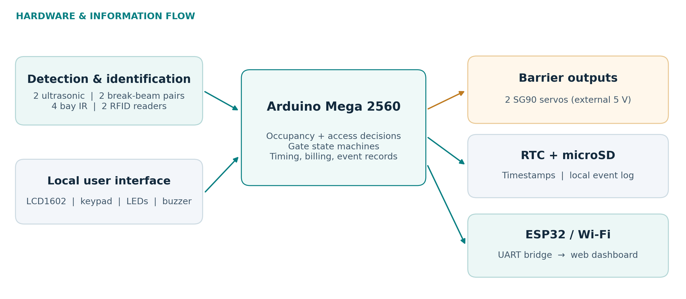
Figure 1. Proposed subsystem relationships (logical architecture; not a wiring diagram).

Planned physical prototype
A roughly 60 × 45 cm parking-lot base will contain four marked bays, separate entry/exit lanes, two servo-driven boom barriers, sensor pillars, small RFID terminals, LED indicators and an LCD housing. Critical holders and enclosures will be 3D printed in PLA; final dimensions will be adapted to the selected model cars.

BILL OF MATERIALS / 1 OF 2

05 Main control, sensing and actuation
Quantities below describe the planned finished prototype. “In cart” means selected for purchase, not yet confirmed as purchased.
Component | Qty. | Role in the system | Source / status
Arduino Mega 2560 | 1 | Main controller for sensors, gate logic, display and peripheral interfaces. | Starter kit
IR reflective obstacle sensors | 4 | One per parking bay; detects whether a miniature car occupies the space. | In cart
IR break-beam sensor pairs | 2 pairs | One pair across each gate lane; detects car passage/obstruction. | Ordered separately*
HC-SR04 ultrasonic sensors | 2 | Detect approaching vehicles at entrance and exit. | 1 kit + 1 cart
SG90 servo motors | 2 | Physically raise/lower the two lightweight barrier arms. | 1 kit + 1 cart
RC522 RFID readers + cards | 2 + tags | Identify cards at entry and exit; link scans to parking sessions. | 1 kit + 1 cart
ESP32 development board | 1 | Wi-Fi communication with a monitoring dashboard. | In cart
LCD1602 display | 1 | On-site capacity, instructions, entry and fee messages. | Starter kit
4×4 matrix keypad | 1 | Administrator PIN, manual commands and demo interaction. | Starter kit
DS3231 real-time clock (RTC) | 1 | Calendar date/time for records and duration calculations. | Starter kit
Red and green LEDs | 4 of each | Show individual bay occupancy (green = free, red = occupied). | Starter kit
Buzzer | 1 | Feedback for accepted cards, rejected access and alarms. | Starter kit

* The number of break-beam pairs in the separate order should be confirmed: the design requires two complete transmitter/receiver pairs.
Sensor design Reflective IR modules and break-beam pairs serve different purposes: bay occupancy versus reliable gate-path interruption. Calibration and placement are essential for model cars.

BILL OF MATERIALS / 2 OF 2

06 Data, electrical integration and construction
Component | Qty. | Why it is included | Source / status
MicroSD reader module | 1 | Local log storage for entry, exit, faults and fees; verify module SPI voltage support. | In cart
MicroSD card (FAT32) | 1 | Physical storage medium for CSV/text event logs. | Still needed
Regulated 5 V / 3 A adapter | 1 | Dedicated power for both servos and permitted 5 V peripherals. | In cart
DC barrel socket, 5.5 × 2.1 mm | 1 | Secure connection between adapter and power distribution. | Still needed
3.3 V regulator module | 1 | Clean external 3.3 V supply for both RC522 readers. | Still needed
SPI-compatible level shifting | 1 set | Protects 3.3 V reader inputs from 5 V Mega SPI/control outputs. | Still needed
UART voltage adaptation | 1 set | Reduces Mega TX 5 V to safe ESP32 RX level (e.g., divider). | Still needed
1000 µF capacitor (≥10 V) | 1–2 | Local bulk decoupling near the servo supply rails. | Still needed
Resistors, jumper wires, cable | Assortment | LED current limiting; signal and ground/power connections. | Kit + additional
Terminal block, perfboard, headers | Assortment | Robust, serviceable power and signal distribution. | Still needed
3D-printed PLA parts | As designed | Barrier bodies/arms, sensor pillars, RFID and LCD enclosures. | 3D printer access
Base, fasteners, model cars | 1 set | Parking layout, mounting, road markings and physical test vehicles. | Still needed

Practical purchase check The inexpensive microSD module and break-beam receivers may use different electrical interfaces depending on the exact seller. Verify their pinout, output type and logic voltage before wiring.

The prototype may also use adhesive road markings, additional plastic brackets, cable ties and short extension leads. These are construction consumables rather than functional electronic modules.

DESIGN RATIONALE AND SAFEGUARDS

07 Why the less-obvious parts matter
IR break-beam pairs — An approach sensor only notices a car near the gate; it does not indicate whether the car is still in the barrier opening. Interrupting the beam provides an explicit “vehicle in passage” condition and helps avoid premature closing. One pair alone cannot prove travel direction; the software must also track the expected gate sequence.
DS3231 real-time clock — The Arduino millis() timer measures uptime, not an accurate date and clock time across resets. The RTC provides dated arrival/departure timestamps for parking duration, event history and fee calculations.
microSD module and card — RAM is volatile and too limited for a useful history. MicroSD allows a simple CSV event log that survives a restart, helps debug unexpected behavior and supports later data export to the dashboard.
ESP32 in addition to Arduino Mega — The Mega handles time-sensitive hardware control using its many pins; the ESP32 handles Wi-Fi and network communication. Keeping responsibilities separate simplifies troubleshooting, and the parking system can still work locally if Wi-Fi is unavailable.
External 5 V power and 1000 µF capacitor — Servo motors draw short current peaks that can cause supply voltage drops or controller resets. A separate regulated supply and nearby bulk capacitor improve reliability; a capacitor cannot replace a correctly sized supply.
3.3 V regulator and logic conversion — RC522 readers and ESP32 inputs use 3.3 V logic, unlike the 5 V Mega. The regulator creates a suitable supply for the RFID modules; level shifting protects communication pins. These are different jobs and both may be necessary.

Electrical integration rules
- During development, power the Mega and ESP32 from USB; power servo motors directly from the external regulated 5 V supply. Connect signal grounds together.
- Never connect the external 5 V adapter to the Mega barrel jack. Never feed a bare ESP32 or RC522 pin with a 5 V logic signal.
- Confirm power-module current rating, regulator heat dissipation, SPI compatibility and microSD level shifting from each purchased module’s actual documentation.
- Use sensor filtering, timeouts and a safe default (barrier held open on detected obstruction) rather than relying on fixed delays.

EXECUTION AND VALIDATION

08 Eight-week development plan
Week | Work package | Expected result
1 | Basic HC-SR04 + SG90 test | Demonstrate an automatically opening/closing barrier.
2 | RFID and event-driven gate controller | Authorize cards and handle unknown cards and timeouts.
3 | Four-space occupancy detection | Display consistent free/occupied states using IR sensors and LEDs.
4 | Second gate, break-beam integration, RTC | Track entry and exit sessions and timestamp events.
5 | 3D-printed assembly and wiring | Install gates, housings and sensor mounts on the model.
6 | LCD, keypad, pricing, microSD log | Deliver a stand-alone end-to-end parking workflow.
7 | ESP32 connection and web dashboard | View live occupancy, active sessions and event summaries.
8 | Robustness tests and documentation | Demonstrate scenarios and prepare presentation.

09 Demonstration and test scenarios
- Authorized RFID card + free space → open entrance barrier, detect crossing, start session.
- Unknown RFID card or full capacity → deny access and show a clear message.
- Vehicle remains in the entrance beam → do not close the barrier on the vehicle.
- Parking bay occupied/cleared → LEDs, LCD and dashboard update consistently.
- Same card checked out at exit → compute duration/illustrative fee and close the session.
- Restart or Wi-Fi outage → local barrier safety and stored log remain usable.

Expected deliverables
Working 3D-printed demonstrator; documented wiring and power scheme; modular Arduino C++ code; ESP32 serial/Wi-Fi bridge; basic monitoring dashboard; test results and a concise final presentation.

Technical references
Arduino Mega 2560 Rev3 — technical specifications: https://docs.arduino.cc/hardware/mega-2560/
NXP MFRC522 — product data sheet: https://www.nxp.com/docs/en/data-sheet/MFRC522.pdf
Espressif ESP32-WROOM-32 — data sheet: https://documentation.espressif.com/esp32-wroom-32_datasheet_en.html

