- memo
rotate about roll axis

Heating by Air Conditioner (heat pump).
Heating by heater.
Stop heating operation when temperature reaches target.
Room. Assumed heat insulated closed volume.
Heater: just add heat into room..
Heat pump: ideal Carnot heat pumping cycle machine..
Heat taken from outside air and carried into room, instead of burning fuel/electrical heating...
Pumping heat requires some work. (driving power)

Heat pump, =エアコン, の方が圧倒的に少ない投入エネルギで室温を上昇させられる．
副次的な作用として，Heat pumpは外気をより低温にする．
ただし，地球全体で見ると，heat pumpに投入した仕事が熱に変わった分，より”熱く”なっている．

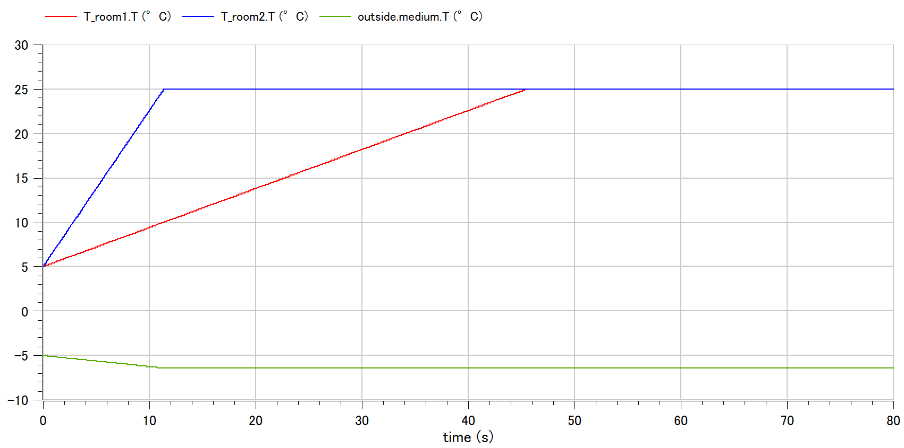
Heater: just add heat into room..

