- memo

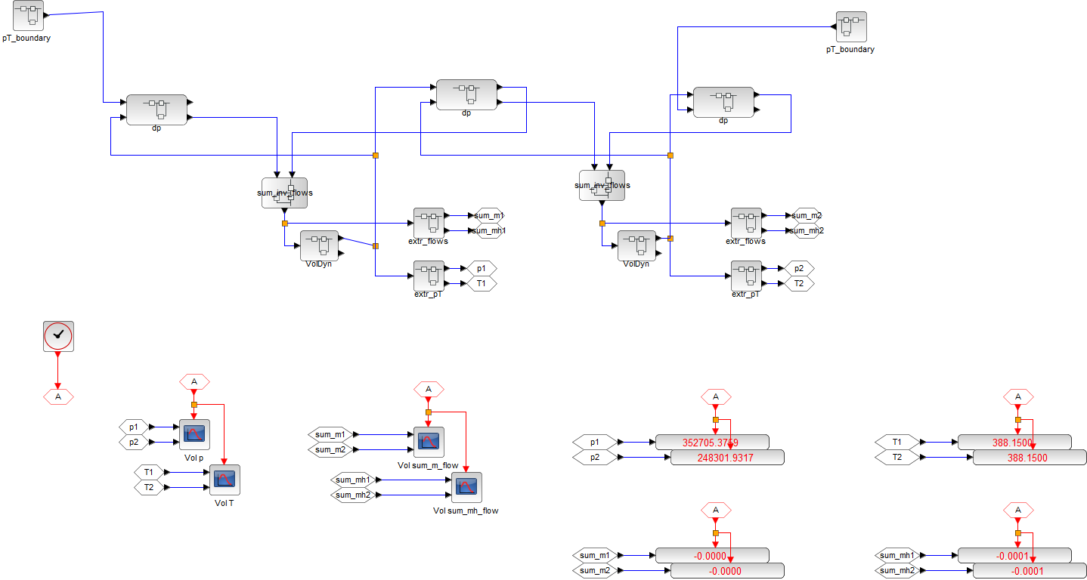
p&T boundary Condition
p&T boundary Condition
Volume Dynamics: differential equation and integrator
Volume Dynamics: differential equation and integrator
Sum-up mass and energy flows
Sum-up mass and energy flows
Flow Resistance:
State of 2 sides → flow
Flow Resistance:
State of 2 sides → flow
Flow Resistance:
State of 2 sides → flow
Extract p and T, then send them to visualization blocks
Extract p and T, then send them to visualization blocks
Time history plots of p, T
Display values of p, T
Time history plots of mass and energy flows
Display values of mass and energy flows

Differential equations:
[dp/dt, dT/dt]
= f( mass flow, energy flow, p, T)
Time integrator
dp/dt, dT/dt → p, T
Port:
Mass flow, energy flow
Port:
p, T
Port:
dp/dt, dT/dt

parameters / constants

variables

equations

Memo:
- 計算式のmmlファイルへの保存：計算式ボックスを左クリックで選択 → 右クリック → 「名前を付けてコピーを保存」 → 「MathML 2.0」を選択

