- memo

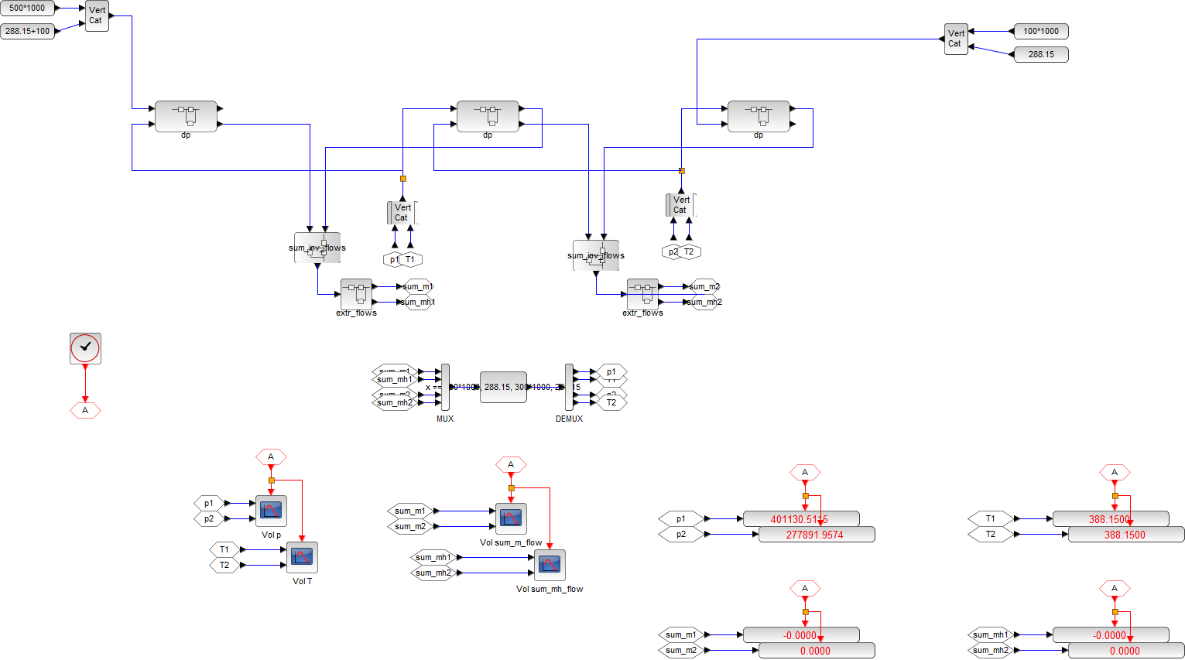
p&T boundary Condition
p&T boundary Condition
Extract mass and energy flow, then send them to solver block and visualization blocks
Volume Dynamics: differential equation and integrator
Sum-up mass and energy flows
Sum-up mass and energy flows
Flow Resistance:
State of 2 sides → flow
Flow Resistance:
State of 2 sides → flow
Flow Resistance:
State of 2 sides → flow
Algebraic solver
Time history plots of p, T
Display values of p, T
Time history plots of mass and energy flows
Display values of mass and energy flows

parameters / constants

variables

equations

Memo:
- 計算式のmmlファイルへの保存：計算式ボックスを左クリックで選択 → 右クリック → 「名前を付けてコピーを保存」 → 「MathML 2.0」を選択

