- Description

The component in which derivative of state is determined by sum of flow.
This behaves as “capacitance” or “delay/inertance” in system.

Flow: force
state: position of mass point.

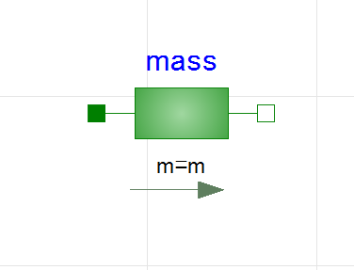
Flow: force
(*into: positive)
Flow: force
(*into: positive)
state: position
state: position
Direction of positive position
- Governing equations

Memo:
- 計算式のmmlファイルへの保存：計算式ボックスを左クリックで選択 → 右クリック → 「名前を付けてコピーを保存」 → 「MathML 2.0」を選択

