About physical systems

Model description

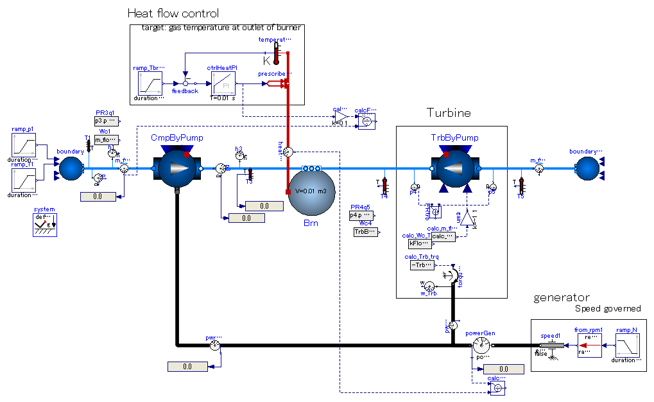
Pump component of MSL which has rotational mechanical connector.
The relation between flow and pressure rise is given by redeclared function.
Pump component of MSL in which mass flow rate is controlled by input signal.
The controlled pump is used to reproduce ‘choke’ characteristics of flow vs. pressure ratio..
Flow rate is calculated by RealExpression component outside of pump.
Torque is calculated and output for calculation of energy conservation in rotational mechanics system (or “shaft network”)..
Determine amount of heat input by PI control with targeting temperature of burner.
Calculate thermal efficiency.
Generator shaft speed is constrained.
Torque flowing into this speed boundary condition is power generated by this engine.

https://github.com/zeta-plusplus/WalkingInWorldOfThermoFluid/blob/master/docs/Trivial/GasTurbineEngine_1sp_ByCtrldPump_ex01/diagram_00.jpg?raw=true

Input

Time-varying:

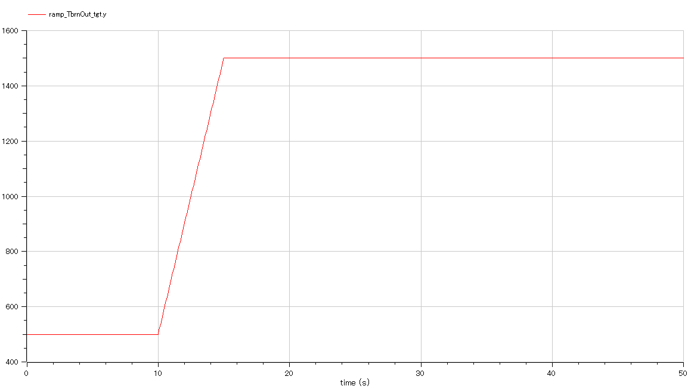

Output

Time-varying:

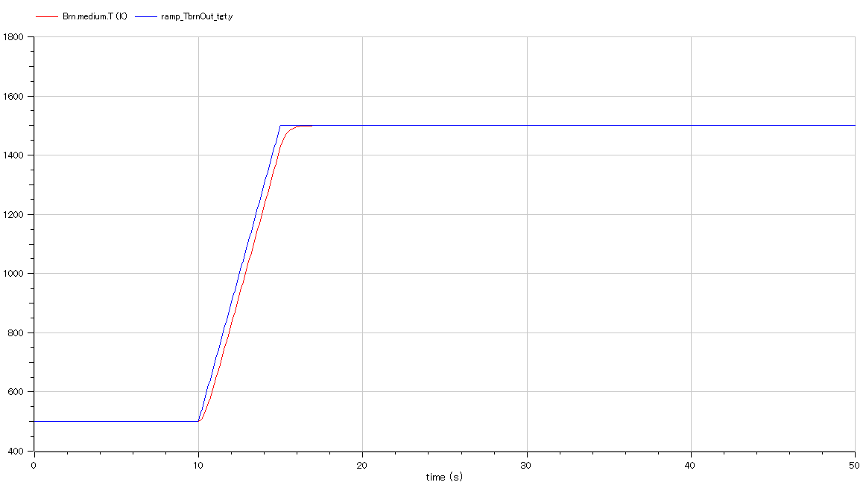

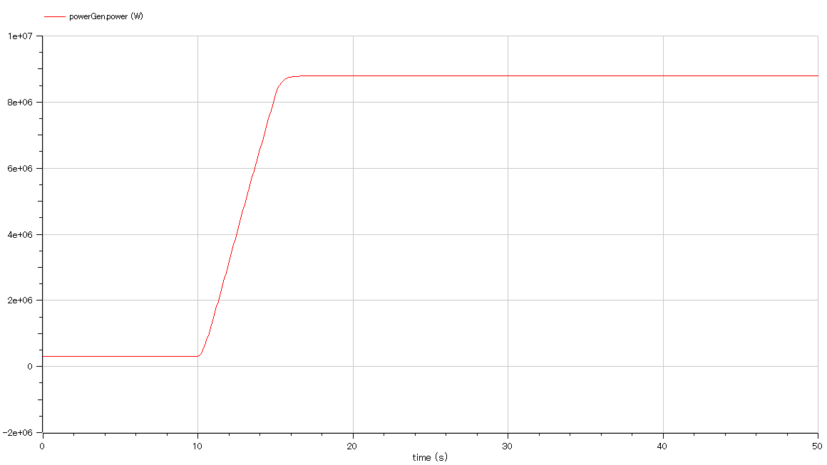

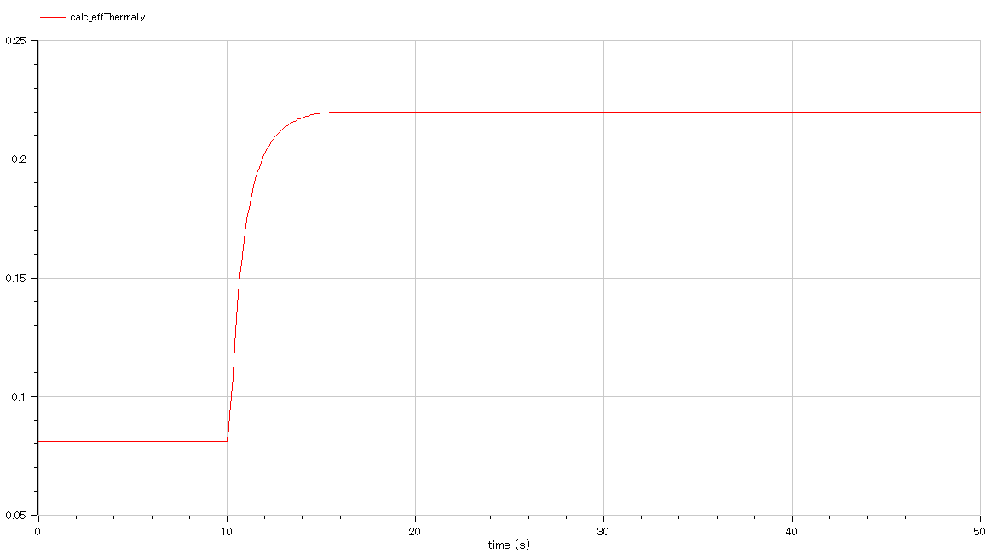

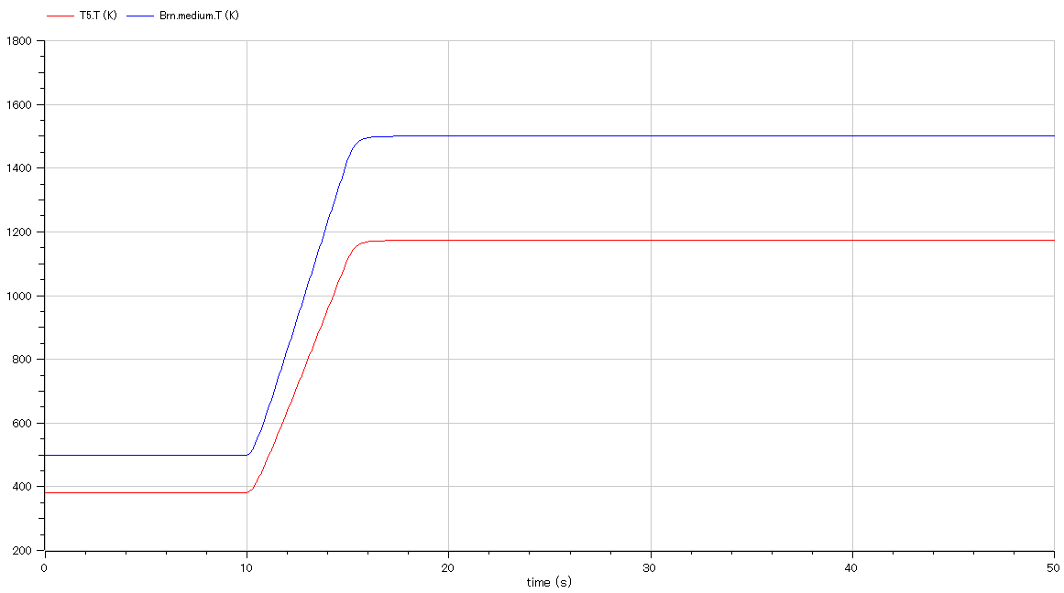

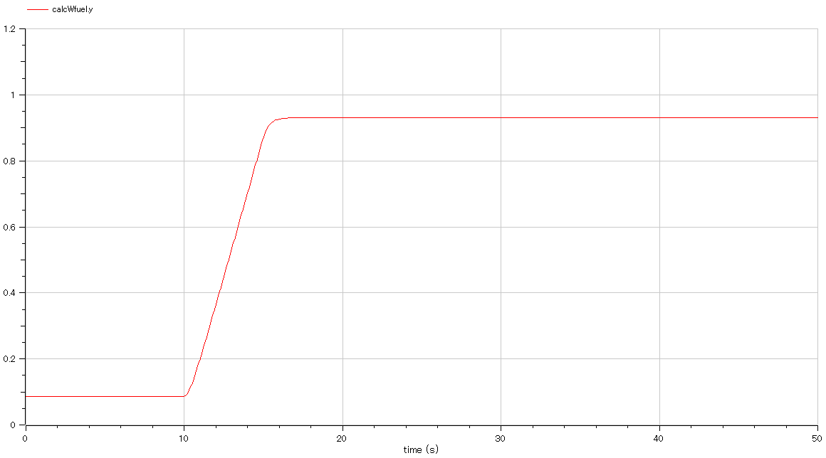

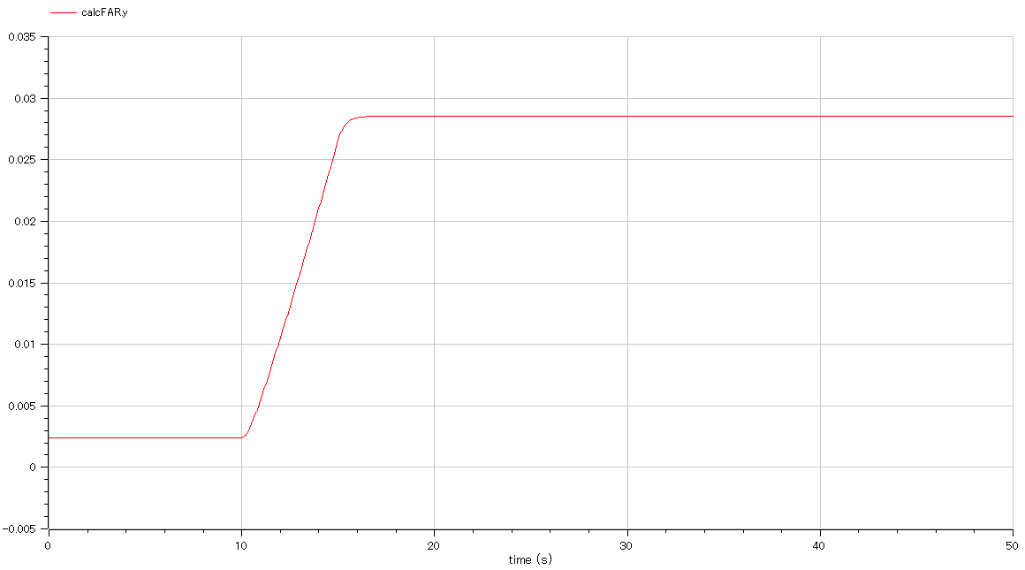

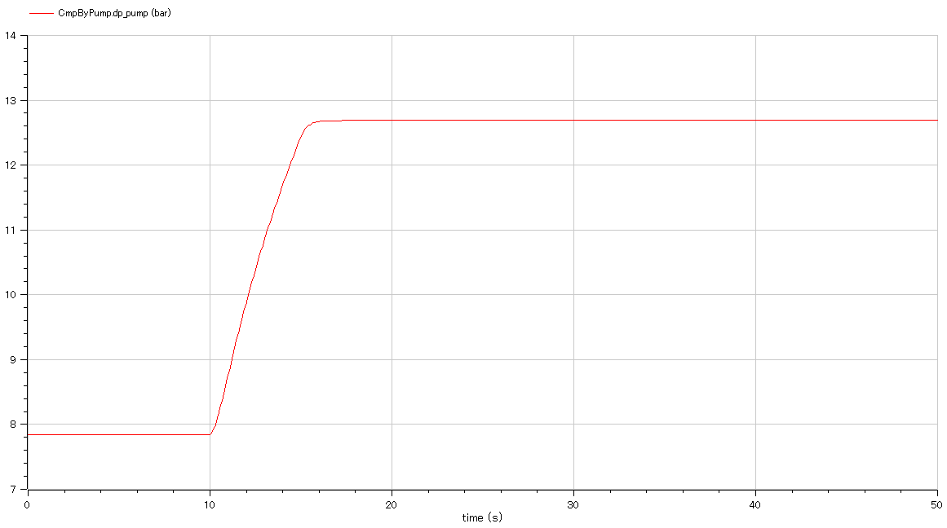

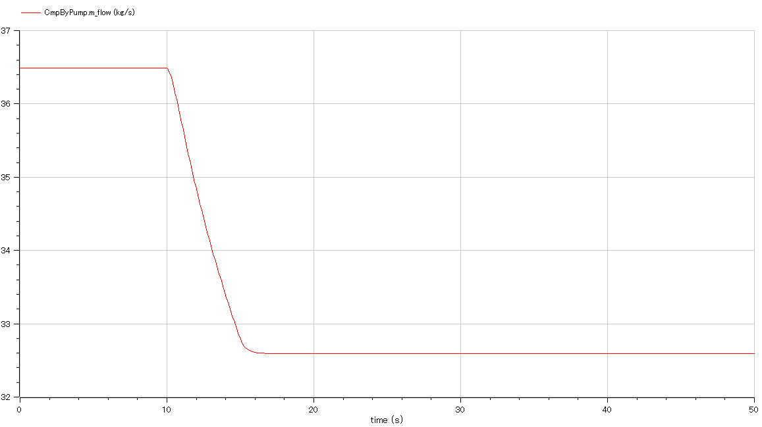

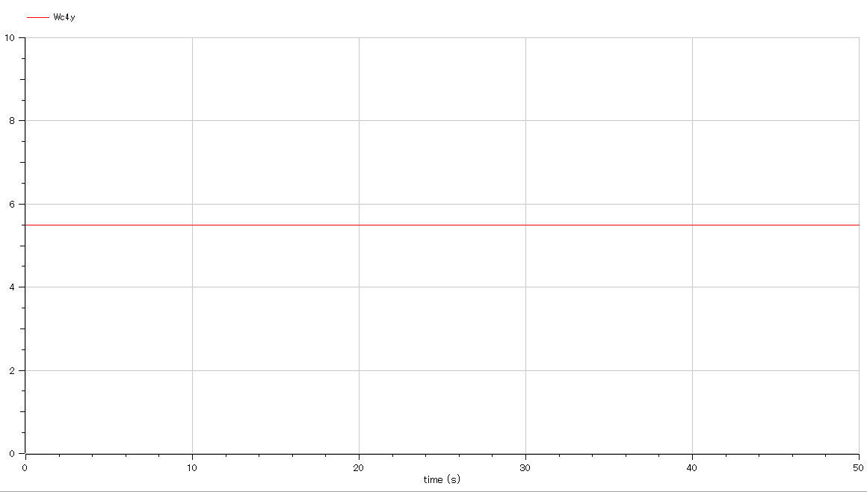

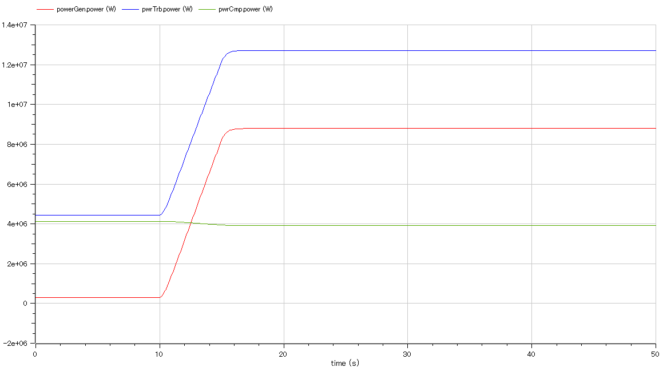

Parametric

