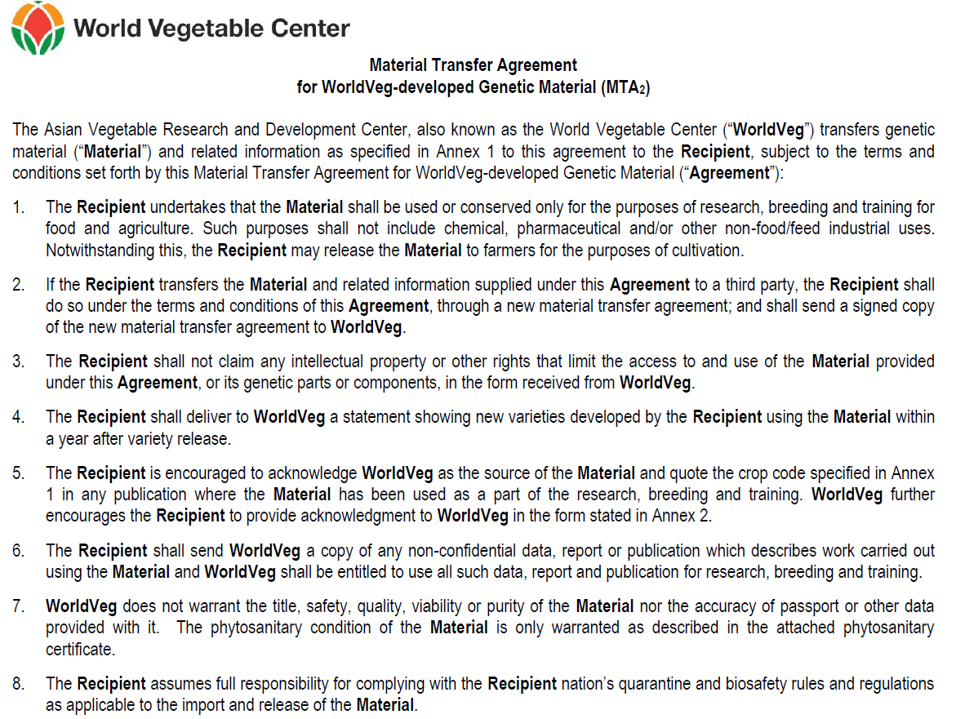
MTA₂ No.____________________________

Name of Recipient:
Title:
Institution:
Mailing Address:
Tel:
Fax:
Email:
Date:
Signature:

Please return the signed MTA promptly to the following address:

Genetic Resources and Seed Unit GRSU No. ___________________________
World Vegetable Center
P.O. Box 42 QI No. ___________________________
Shanhua, Tainan 74199
TAIWAN Date ___________________________
E-mail: seedrequest@worldveg.org
Fax: (+886-6) 583-0009
Annex 1
List of Material Provided

WorldVeg International Seed Distribution –
8 tomato and pepper breeding lines included

Tomato (Solanum lycopersicum)
No. | WorldVeg no. | Internal code | Seed Qty (g)
1 | AVTO0102 | CLN2366B | 1
2 | AVTO0922 | CLN3024A | 1
3 | AVTO1219 | CLN3241H-27 | 1
4 | AVTO1422 | CLN3670F | 1
5 | AVTO9304 | CL5915-93D4-1-0-3 | 1
6 | AVTO1350 | CLN3284G-1 | 1
7 | AVTO1424 | CLN3682C | 1
8 | AVTO1429 | FMTT1733D | 1
9 | AVTO1420 | CLN3670B | 1
10 | AVTO1418 | CLN3669A | 1
11 | AVTO1314 | CLN3212C | 1
12 | AVTO9801 | CLN1621L | 1
13 | AVTO9802 | CLN2026D | 1
14 | AVTO0301 | CLN2498D | 1
15 | AVTO1003 | CLN3125L | 1
16 | AVTO1008 | CLN3078C | 1
17 | AVTO1009 | CLN3078G | 1
18 | AVTO1288 | CLN3552B | 1
19 | AVTO1314 | CLN3212C | 1
20 | AVTO1315 | CLN3241Q | 1
21 | AVTO1464 | FMTT1733E | 1
22 | AVTO1701 | CLN3736D | 1
23 | AVTO1702 | CLN3853C | 1
24 | AVTO1703 | CLN3900C-23 | 1
25 | AVTO1704 | CLN3900D | 1
26 | AVTO1705 | CLN3902C | 1
TOTAL |  |  | 26

Pepper
No. | WorldVeg no. | Internal code | Seed lot code no. | Species name | Seed Qty (g)
1 | AVPP1113 | PP1037-7134 | 1342-36BK | SD161103-P1 | 1
2 | AVPP1114 | PP1137-7006 | 1342-37BK | SD161103-P2a | 0.5
3 | AVPP0701 | PP0737-7016 | 1342-98BK;  1142-86BK | SD161103-P2b | 1
4 | AVPP9814 | PP9852-174 | 1342-145-BK | SD161103-P2c | 1
5 | AVPP0121 | PP0142-023 | 1242-027BK | SD161103-P2d | 1
6
7
8
9
10
11
12
13
14
15
16
17
18
19
20

Onion (Allium cepa L.) – 3 g each
No. | WorldVeg no. | seedlot | Cross no. |  | Bulb* |  | Characters**
 |  |  |  | Color | Size | Shape | Characters**
1 | AVON1016 | 25657 | OC157-3-B-A-A-I | R | M-L | G | HY
2 | AVON1027 | 25783 | OC217-3-A-B-C-I | Y | L | G | HY,ER
3 | AVON1028 | 25658 | OC226ST-17ST-AST-A-N | Y | M-L | FG | ST
4 | AVON1052 | 25166 | OC400(B)ST-CST-BST-A-C | Y | L | FG | HY,ER
5 | AVON1074 |  | AC980 | R | S-M | FG | Africa selection
6 | AVON1103 | 23892 | OC233-C-AST-DST-A-C | R | S-M | FG | HY
**Characters: HY= high yield, ST= good storability
*Color: R=red, Y=yellow. Size: S=small, M=medium, L=large. Shape: G=globe; FG=flat globe.

Shallot (Allium cepa var. aggregatum) – 3 g
No. | WorldVeg no. | seedlot | Cross no. |  | Bulb* |  | Characters**
 |  |  |  | Color | Size | Shape | Characters**
1 | AVON1209 | 12249 | VFTA169-I | R | M | 2 | ST
2 | AVON1103 | 23892 | OC233-C-AST-DST-A-C | R | S-M | FG | HY
*Color: R=red, O=orange. Size: S=small, M=medium, L=large. Shape: 1=Spindle; 2=semi globe.
**Characters: HY= high yield, ER=early mature, ST= good storability, SLB=moderate resistant to stemphillium leaf blight

Cucumber (Cucumis sativus)
No | WorldVeg no. | Seed lot | Pedigree | Fruit type | Sex | Seed Qty (seeds)
1 | AVCU1202 | 12TWFC 2 | 00WGH22-1GrSA x Amata 765 | BISG | G/P | 20
2 | AVCU1203 | 12TWFC 3 | 00WGH22-1GrSA x Amata 765 | BISG | G/P | 20
3 | AVCU1205 | 12TWFC 6 | Picolino x Keisha | BISW | G/P | 20
4 | AVCU1206 | 12TWFC 7 | Picolino x Keisha | BISW | G | 20
5 | AVCU1302 | 12TWFC 32 | Kiros | BISL | M | 20
6 | AVCU1303 | 12TWFC 33 | Kiros | BISL | G/P | 20
 | AVCU1701 | 17C1 | CU114-26-19-6-1 | JP | G/P | 30
 | AVCU1702 | 17C2 | CU128-192-54-8-3 | JP | G/P | 30
 | AVCU1703 | 17C3 | CU172-31-9-2-3 | JP | G/P | 30
 | AVCU1704 | 17C4 | CU172-31-9-8-4 | JP | G/P | 30
Fruit Type: BISG – Bi-color short green, BISW- -Bi-color short white, BSL – Bi-color light green, BISL – Bi-color short light green, JP – dark green smooth
Sex: | Plant sex type: G – gynoecious, M - monoecious, G/P – predominantly female

Pumpkin (Cucurbita moschata)
No. | WorldVeg no. | Seed lot | Pedigree | Fruit type¹ | Flesh color² | Seed Qty (seeds)
1 | AVPU1391 | 12TWFP3013 | Achao(EL)-2-6-14-1-7-1-C | EL | DO | 25
2 | AVPU1392 | 13TWFP3016 | AChao-2-50-6-10-8-5-C | RO | DO | 25
3 | AVPU1393 | 12TWFP3017 | PY(Se)-1-55-4A-4-4-4-C | OV | DO | 25
4 | AVPU1394 | 12TWFP3001 | Saint222-1-15-7-3-7-1-C | FS | DO | 25
5 | AVPU1395 | 12TWFP3003 | Bungkan021-2-39-4-9-4-5-C | FS | O | 25
6 | AVPU1396 | 12TWFP3008 | Arjuna-1-77-7-1-10-2-C | FS | O | 25
7 | AVPU1397 | 12TWFP3005 | Srimuang016-2-91-6-12-3-5-C | FS | DO | 25
^{1.} EL=oblong boucky, FS=Flattened, OV=oval, PY=pyriform, RO=globular
^{2.} DO=dark orange, O=orange

Pumpkin (Cucurbita moschata) 2018-2019AVBC

No | WorldVeg no. | Pedigree | Trait
 |  |  | Resistance to SLCuCNV | Fruit shape | Flesh color
1 | AVPU1414 | THCM-119-2-3-4-10-5-1-8 | Resistant | Flattened | Orange
2 | AVPU1421 | THCM-120-1-3-2-8-4-8-7 | Resistant | Flattened | Dark orange
3 | AVPU1426 | THCM-114-2-2-2-8-7-6-5 | Resistant | Flattened | Orange
4 | AVPU1502 | 13THCM13-14VII-3 | Resistant | Pyriform | Yellow
5 | AVPU1504 | PP-9-8-27-3 | Resistant | Pyriform | Yellow
6 | AVPU1507 | THCM-122-1-6-8-7-9-4-2 | Resistant | Globular | Yellow

Garlic (Allium sativum) – 2 bulbs each
No. | WorldVeg no. | Pedigree | Original |  | Bulb |  | No. of bulbs | Characters***
 | code |  | country | Color* | Size** | clove no./bulb
1 | AVGL1801 | VFG68-3m1 | Taiwan | WP | M | 6 | 2 | Large clove
2 | AVGL1802 | VFG87m1-3 | Taiwan | P | M-L | 14 | 2 | Bolting with topset
3 | AVGL1109 | VFG141m2 | Brazil | WP | M-L | 12 | 2 | HY
4 | AVGL1110 | VFG173S2 |  | P | M-L | 14 | 2 | HY, Bolting with topset
5 | AVGL1116 | VFTA158m5 | Jamaica | W | M-L | 23 | 2 | HY
6 | AVGL1106 | VFG76m2-2 | Taiwan | WP | L | 7 | 2 | HY
7 | AVGL1107 | VFG77-6m3 | Taiwan | WP | M-L | 4 | 2 | Large clove
8 | AVGL1803 | VFG76-3m4 | Taiwan | WP | M | 6 | 2 | ST, HT
9 | AVGL1115 | VFG180(3-1) | Taiwan | W | L | 6 | 2 | ST, Large clove
10 | AVGL1114 | VFG178HP2 | China | WP | L | 9 | 2 | HY
* Clove skin color: W=ehite; P=purple; WP= white with purple
** Bulb size: S=small; M=medium; L=large
***Characters: HY= high yield, ER=early mature, ST= good storability

Bitter Gourd (Momordica charantia L.)
No. | WorldVeg no. | Internal code | Seed Qt (seeds)
1 | AVBG1301 | 12THBG1-03A6-13-1 | 25
2 | AVBG1304 | 12THBG2-06A6-20-4 | 25
3 | AVBG1310 | 12THBG3-09A6-20-10 | 25
4 | AVBG1313 | 12THBG4-10A6-19-13 | 25
5 | AVBG1323 | 12THBG6-20A6-19-23 | 25
6 | AVBG1324 | 12THBG6-21A6-8-24 | 25
7 | AVBG1327 | 12THBG7-24A6-11-27 | 25

Leafy Brassica
No. | Crop | WorldVeg no. | Seed no./1g | Maturity  (DAS) | Remark | Seed Qty
1 | Chinese kale  (Brassica oleracea var. alboglabra) | AVLB1201 | 146 | 40-45 | HT, very thick stem | 1 g
2 | Chinese kale  (Brassica oleracea var. alboglabra) | AVLB1202 | 224 | 40-45 | HT, thick smooth stem | 1 g
3 | Pakchoi  (Brassica rapa L. ssp. chinensis) | AVLB1203 | 607 | 40-45 | CT, compact brilliant green petiole | 1 g
4 | Pakchoi鶴藪白菜  (Brassica rapa L. ssp. chinensis) | AVLB1204 | 453 | 35-40 | HT, broad thick bright white petiole | 1 g
5 | Choysum  (Brassica rapa var. campestris) | AVLB1205 | 369 | 30-35 | HT, thick dark green stem | 1 g
6 | Choysum  (Brassica rapa var. campestris) | AVLB1206 | 411 | 30-35 | HT, compact green leaves | 1 g
7 | Choysum  (Brassica rapa var. campestris) | AVLB1207 |  | 30-35 | HT, thick green stem | 1 g
8 | Choysum小油菜  (Brassica rapa var. campestris) | AVLB1208 |  | 35-40 | HT, compact green leaves | 1 g

Maturity:
DAS: days after sowing to commercial harvest stage
Temperature response:
HT: heat tolerant
CT: cold tolerant

AVRDC-improved Chinese Cabbage (Brassica rapa L. ssp.pekinensis) Lines
No. | Vegetable Introduction no. | Entry code | Traits |  |  | Origin | Seed Qty
1 | VI060641 | CCS1101 | Open-pollinated line. Cold tolerant, medium early-maturity, medium heat tolerant, good for long distance transportation. |  |  | Taiwan | 1 g
2 | VI060642 | CCS1102 | Open-pollinated line. Cold tolerant, medium maturity, medium heat tolerant, good for long distance transportation. |  |  | Taiwan | 1 g
3 | VI060643 | CCS1103 | Open-pollinated line. Medium early-maturity, medium cold and heat tolerant, good for long distance transportation. |  |  | Taiwan | 1 g
4 | VI060644 | CCS1104 | Open-pollinated line. Heat tolerant, early maturity, medium cold tolerant, good for long distance transportation. |  |  | Taiwan | 1 g
5 | VI060645 | CCS1105 | Open-pollinated line. Cold tolerant, medium maturity, medium heat tolerant. |  |  | Taiwan | 1 g
6 | VI060646 | CCS1106 | Open-pollinated line. Heat tolerant, early maturity, medium cold tolerant. |  |  | Taiwan | 1 g
7 | VI060647 | CCS1107 | Open-pollinated line. Heat tolerant, early maturity, medium cold tolerant. |  |  | Taiwan | 1 g

Amaranth (Amaranthus spp.)
WorldVeg no. | Scientific name | Pedigree | Seed Qty (g)
AVAM1601 | A. hypocondriacus | Simon Farm-Sel | 0.2
AVAM1602 | A. hypocondriacus | IP-5-Sel | 0.2
AVAM1603 | A. hypocondriacus | AH-NL-Sel | 0.2
AVAM1604 | A. hypocondriacus | TZSMN 102-Sel | 0.2
AVAM1605 | A. hypocondriacus | AH-TL-Sel | 0.2
AVAM1606 | A. cruentus | Paris (A)-Sel | 0.2
AVAM1607 | A. cruentus | Bresil-Sel | 0.2
AVAM1608 | A. dubius | UG-AM-9-ES13-2 | 0.2

Malabar spinach (Basella alba)
Vegetable Introduction no. | Other name | Seed Qty
VI047671-A1 | MS12 | 100 seeds
VI047914 | MS05 | 100 seeds
VI049472 | MS10 | 100 seeds
VI051016 | MS17 | 100 seeds

Mungbean (Vigna radiate) – 50 seeds each
No. | WorldVeg no. | Internal code | Parentage | Remarks
1 | AVMU1601 | VR2012-5-9-23-1-1 | V02802BG x NM94F7 | Bruchid resistant & MYMV resistant
2 | AVMU1607 | VR2012-5-30-22-1-1 | V02802BG x NM94F7 | Bruchid resistant
3 | AVMU1631 | VR2012-12-14-1-1 | NM94 X V04718 F7 | Powdery mildew resistant
4 | AVMU1636 | VR2012-12-45-1-2 | NM94 X V04718 F7 | MYMV and Powdery mildew resistance
5 | AVMU1640 | VR2012-12-80-1-1 | NM94 X V04718 F7 | Powdery mildew resistant
6 | AVMU1641 | VR2012-12-81-1-1 | NM94 X V04718 F7 | MYMV and Powdery mildew resistance
7 | AVMU1642 | VR2012-12-81-1-2 | NM94 X V04718 F7 | MYMV and Powdery mildew resistance
8 | AVMU1644 | VR2012-12-113-2-2 | NM94 X V04718 F7 | Powdery mildew resistant
9 | AVMU1645 | VR2012-12-140-1-2 | NM94 X V04718 F7 | MYMV and Powdery mildew resistance
10 | AVMU1647 | VR2013-2-2-1-1 | VR2013-1= VR2012-18 xVR2012-19 F5
11 | AVMU1648 | VR2013-2-3-1-9 | VR2013-1= VR2012-18 xVR2012-19 F5
12 | AVMU1650 | VR2013-2-3-1-13 | VR2013-1= VR2012-18 xVR2012-19 F5
13 | AVMU1651 | VR2013-2-3-1-14 | VR2013-1= VR2012-18 xVR2012-19 F5
14 | AVMU1655 | VR2013-5-3-1-2 | VR2013-1= VR2012-18 xVR2012-19 F5
15 | AVMU1657* | VR2013-6-3-1-4 | VR2013-1= VR2012-18 xVR2012-19 F5
*: 20 seeds for AVMU1657

No. | WorldVeg no. | Internal code | Parentage
1 | AVSB0805 | AGS464 | Dada Cha 2000 x (Taisho Shiroge x Neu Ta Pien 1)
2 | AVSB0801 | AGS465 | Dadacha2000x(Taisho Shiroge x Neu Ta Pien 1)
3 | AVSB0901 | AGS466 | Ryokkoh/// PI157424/KS8//Neu Ta Pien 2////Wuyehedou
4 | AVSB0902 | AGS469 | Dadacha2000/KS7
5 | AVSB0903 | AGS470 | {Ryokkoh x [(PI 157424 x KS 8) x Neu Ta Pien 2]} x Dada Cha 2000
6 | AVSB0802 | AGS471 | {Ryokkoh x [(PI 157424 x KS 8) x Neu Ta Pien 2]} x Dada Cha 2000
7 | AVSB0807 | AGS472 | [(PI 157424 x KS 8) x (Ryokkoh x Tzuzunoko)] x Wuye-Edou
Annex 2

Acknowledging the use of germplasm accessions and breeding materials
from the World Vegetable Center

The germplasm accessions and breeding materials made available to you come from the generous donation of our partners and collaborators from all around the world, the dedication of our breeders and scientists in continuously improving their traits and quality, and our donors that provide funding for our work in germplasm improvement and conservation of the world’s largest collection of publicly-available vegetable germplasm.

For these reasons, our visibility and your feedback to the use of our materials are critical to ensure that your requests for materials from our genebank and breeding programs will be met, now and in the future. We thank you in advance for acknowledging our contribution in seed catalogues* (printed/on-line), as follows:-

- Acknowledgment signage (preferred)



Our logo, full name and credit line as shown above should be included. Camera-ready and web-ready copies of the above signage in various formats are available for download at http://avrdc.org/?page_id=219.

The actual size of the above signage is 2.5 cm x 9.5 cm. It may be enlarged but should not be reduced. Please also leave 3 mm space around all sides of the logo.

- Acknowledgment statement

World Vegetable Center
Contribution of WorldVeg-developed genetic material and selected accessions

Font type: Helvetica or Arial

Font size:
- First line : 12 pt, bold
- Second line : 9 pt, italics

Please note the correct spelling of “Center”

* For displays in seed catalogues, we recommend that the above acknowledgment signage or acknowledgment statement be printed/displayed either:-

- next to all varieties developed using WorldVeg materials; or
- at the beginning of the catalogue with an asterisk, with all varieties using WorldVeg materials marked with an asterisk.

