Foot Design for a Quadruped Robot

Rose-Hulman Institute of Technology

2009

Ryan J Mendonça

Rose-Hulman Institute of Technology

Summer 2009

Table of Contents

Executive Summary 3

Introduction and Overview 4

Background 4

Problem Statement 4

Overview 4

Design Alternatives 5

Strain Gauges 5

Switches and Digital I/O 7

Conclusion and Recommendations 9

Appendices 10

Appendix I: List of Figures 10

Appendix II: Measured Drawings 11

# Executive Summary

A plastic foot has been designed for use with a four-legged robot. The foot is designed to sense when it has touched an object in its environment such as the ground or a stair located nearby. It then sends that information to the robot as a digital signal. The foot has been designed such that it will sense an object which contacts the foot from any of a multitude of directions.

# Introduction and Overview

## Background

A Rose-Hulman international senior design team has created a quadrupedal robot in conjunction with the Seoul National Institute of Technology. At present the robot has solid plastic legs with no sensors. The team designing the robot has solicited a design for a new leg/foot that will sense when one of the robot’s feet has hit the ground or an object in the environment.

## Problem Statement

The robot’s current legs do not have the capability to sense anything about the robot’s surroundings. The task of the current project was to design a new system which could sense when the robot’s foot is in contact with another object. The major challenge to this is that the foot can contact the ground or other objects, such as stairs or walls in front of the robot, from many different angles.

Although there was no explicit restriction on the number and type (analogue or digital) of I/O ports, effort has been made to keep the input/output scheme as simple as possible as to minimize the effect that the new sensors would have on an already short battery life. Also, an effort has been made, at the behest of the robot design group, to keep additional weight to a minimum, as the motors that move the robot’s legs are already somewhat strained under normal use.

## Overview

This report was written to inform the reader of the decisions made during the design process concering the robot’s new feet. The reader will learn how the foot design came to be. The foot was designed to meet the needs of the robot’s design team in the most accurate and efficient way possible.

# Design Alternatives

## Strain Gauges

The first alternative that was considered was to place an array of strain gauges on the leg of the robot between the last motor and the foot which would measure the deflections of the leg when forces were applied to the foot. The advantages to this type of design are that forces could potentially be measured from any direction and that since the output of a strain gauge is analogue, information could be derived about how much force is being applied to each leg, which could then be used for new applications, such as more accurately determining the location of the center of gravity of the robot. Initially, this design possibility was considered the best choice due to the advantages stated above.

During the course of investigation of the use of strain gauges, however, some possibly detrimental problems with this type of system arose. For this application, it was determined that the two significant types of deflection are bending and axial deflection. In order to measure different types of deflections, strain gauges are generally set up differently in a Wheatstone bridge circuit as shown in Figure 1. A controlled voltage, V­EX, is applied, and an output voltage, VO, is measured.

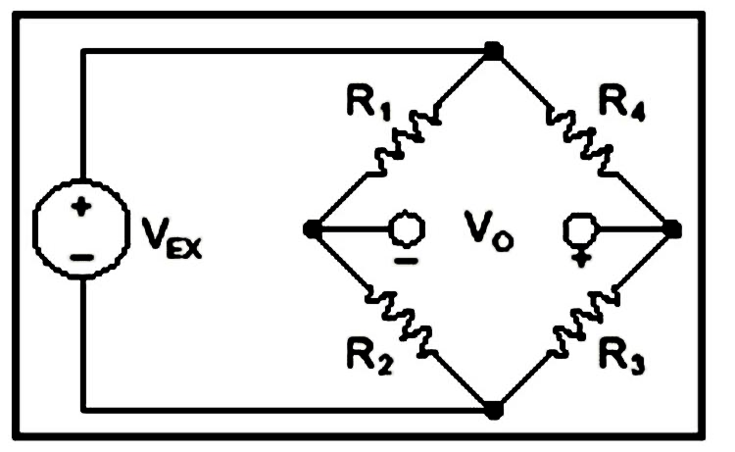

Figure : Wheatstone bridge

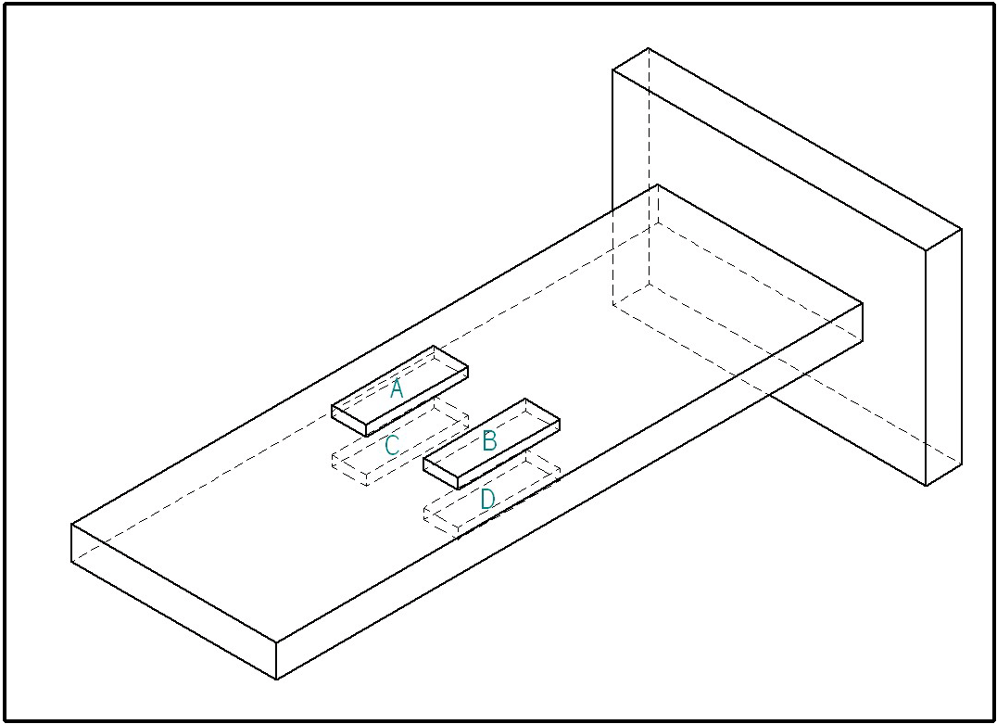

Figure : Beam with Strain Gauges

Using the beam in Figure 2 as an example, strain gauges could be used to measure an axial deflection if resistor R4 in Figure 1 were replaced with any one of the strain gauges in Figure 2. This is called a quarter bridge circuit because one quarter of the resistors in the Wheatstone bridge are strain gauges. As an axial force is applied to the beam, the resistance of R4 would either decrease (in the case of compression) causing the output voltage to increase, or R4 would increase (in the case of tension), which would cause the output voltage to decrease. The first problem arises due to the fact that the changes in resistance of the strain gauge tend to be very small, which allows for a low signal to noise ratio. This problem can be mitigated by using what is called a half bridge circuit, where both R4 and R2 are replaced by strain gauges in the circuit. In this case, a deflection due to tension causes both R4 and R2 to decrease, which will double the change in VO, in comparison to change in the quarter bridge circuit.

Another potential problem is that strain gauges can be sensitive to changes in temperature. As they heat up, their resistance increases. Since these strain gauges would be close to the motors and the entire robot uses quite a bit of electricity, there is a potential for a large variance in temperature. The effects of temperature can be lessened by using “dummy gauges.” A dummy gauge is a strain gauge that is mounted in such a way that it will not deflect when the beam deflects. The dummy gauges can be wired into the half bridge circuit in place of R1 and R3. Since the dummy gauges are subject to the same variance in temperature as the active gauges, the changes in R1 and R3 due to temperature will cancel out with the changes in R4 and R2 due to temperature.

To illustrate the next problem, one must understand how strain gauges can be used to measure deflection due to bending moments. Picture a force acting downward on the end of the beam in Figure 2. The top of the beam would be put into tension, and the bottom of the beam would be put into compression. To measure this deflection, a half bridge circuit could be used where gauge A from Figure 2 replaces R4 and gauge C replaces R3. When the force is applied, the resistance of R4 increases and R3 decreases, therefore VO also decreases. Again, the signal to noise ratio can be increased by using more strain gauges. If R2 and R4 are replaced by gauges A and B, and R1 and R3 by C and D, then the signal will be doubled. This is called a full bridge circuit.

Perhaps the most difficult problem to solve arises when both an axial force and a bending moment are applied to the beam simultaneously. Imagine two forces being applied to the beam, an axial force putting the beam in compression and the downward force used in the earlier example. In the case of an axial force being applied to a full-bridge set up to measure bending, the bridge stays balanced and VO does not change. However, if the bridge were set up to measure axial loads, the bending forces would interfere with that signal.

In order to deal with this, separate Wheatstone bridges would have to be set up for measuring axial loads and bending loads. This would mean possibly fitting as many as eight strain gauges on each leg and would result in there being two constant voltage inputs and two analogue outputs on each of the four legs. This would use quite a bit of processing power as well as electrical power from the robot.

Additionally, the signal to noise ratios could still possibly be too low depending on a multitude of factors. Vibrations from the motors, electromagnetic fields from the environment and other electronics on the robot, and the force due to the weight of the foot could all have adverse effects on the signal. This could partially be resolved through the use of amplification and filtering but the benefits of the system would quickly be overshadowed by the downfalls. For one, the additional circuitry would need to be placed either on the robot or on the leg. It would be difficult to find room for more PCBs on the robot, but on the leg, the circuitry is exposed to possible impacts both during use and during transportation of the robot. Lastly, even if such a system did work, it would require extensive knowledge of the material properties, as well as the geometry, of the legs to accurately model the relationship between forces and deflections. If these properties aren’t known, then the system would require extensive testing in order to create such a model.

## Switches and Digital I/O

The second alternative considered, and ultimately, the one that was chosen, is using some sort of digital sensing system that would simply be activated whenever the foot touches something. The primary shortcoming of this is that the information from the feet could not be used to determine actual forces or to locate the center of mass relative to the feet. The simplicity of such a system, however, was determined to outweigh this shortfall.

The system that has been designed uses three snap action switches in each foot. The switches sub-miniature snap action switches made by Cherry Corp. They are designated as being in the DG series of sub-miniature switches and they have a roller actuator designated as type RA. The primary advantage of using these switches is that they are extremely small and that they do not require a very great force to activate. These switches are placed in slots at 120° intervals along the perimeter of an internal section of the foot. The wires for the switches are fed up through the center of the foot where they are out of the way and can easily be accessed. The foot with the switches then gets covered by an external piece that is designed to activate the switches when a force is applied from almost any direction. Holding the external section to the internal section are some O-Rings (#17 x 2 and #18), which are available at any hardware store. A cutaway of the Assembled foot can be seen in Figure 3. The ramped section on the inside of the outer piece contacts the roller actuator of the switch, and when the foot contacts something from any direction, the switch gets pushed and activated. These switches have three terminals, a common terminal, a NO terminal, and a NC terminal so that the switch can be used either as a normal open switch or a normal closed switch using either rising or falling edge interrupts.

There are some possible problems with the manufacture of this design. The design has been made to be produced using a rapid prototyping machine. It is possible that the rapid prototyping machine may have problems creating the holes for the terminals and wires. If that is the case, additional part files have been made which exclude these holes. The holes are in standard drill sizes, so the part can be produced without the holes, which can then be drilled into the part after rapid prototyping.

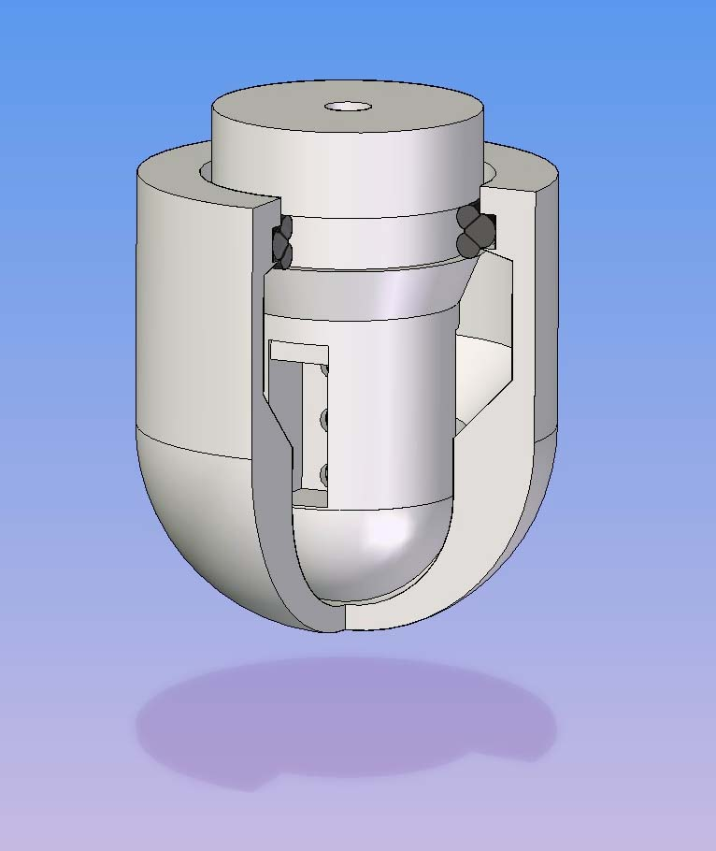

Figure : Cutaway of Assembled Foot

# Conclusion and Recommendations

Two possible alternative means of determining when the robot’s feet have touched the ground have been considered. It has been concluded that the more robust and practical of these two possibilities is to use a foot which employs a system of switches. It is recommended that first a single foot be prototyped and tested. If any adjustments to the design are necessary, they should be made before creating the final four feet.

# Appendices

## Appendix I: List of Figures

Figure 1: Wheatstone bridge…….……………………………………………………………………………………………………………3

Figure 2: Beam with Strain Gauges………………………………………………………………………………………………………..4

Figure 3: Cutaway of Assembled Foot…………………………………………………………………………………………………….8

## Appendix II: Measured Drawings

