RESEARCH ARTICLE | NOVEMBER 05 2024
Low-velocity impact response of lunar and Martian regolith simulants: Implications for lunar and Martian surface explorations 
Takuma Ishii (⽯井 琢真) H ; Arata Kioka (喜岡 新) H ; Jyh-Jaan Steven Huang (黃 致展) ; Yoshiki Tabuchi (⽥淵 芳樹); Yasuhiro Yamada (⼭⽥ 泰広)

Physics of Fluids 36, 113318 (2024) https://doi.org/10.1063/5.0233884


View
Online


Export
Citation







26 June 2025 22:17:12
Articles You May Be Interested In

Distinctive impact responses of extraterrestrial regolith simulants: Insights from crater morphology classification and granular dynamics through machine learning and x-ray computed tomography
Physics of Fluids (February 2025)
Impact craters reveal granular behavior of regoliths
Scilight (November 2024)
Tracking plume-regolith interactions in near-vacuum conditions
Physics of Fluids (January 2024)

Low-velocity impact response of lunar and Martian regolith simulants: Implications for lunar
and Martian surface explorations 

Cite as: Phys. Fluids 36, 113318 (2024); doi: 10.1063/5.0233884 Submitted: 18 August 2024 . Accepted: 3 October 2024 .



Published Online: 5 November 2024

Takuma Ishii (石井 琢真),^{1,2,a)}  Arata Kioka (喜岡新),^{1,3,4,a)}  Jyh-Jaan Steven Huang (黃致展),^{5,6,7}  Yoshiki Tabuchi (田淵 芳樹),³ and Yasuhiro Yamada (山田泰広)^{1,3}

AFFILIATIONS
¹Department of Earth Resources Engineering, Graduate School of Engineering, Kyushu University, Fukuoka, Japan
²Department of Mining Engineering, Faculty of Mining and Petroleum Engineering, Bandung Institute of Technology, Bandung, Indonesia
³Cooperative Program for Resources Engineering, Graduate School of Engineering, Kyushu University, Fukuoka, Japan ⁴Department of Systems Innovation, School of Engineering, The University of Tokyo, Tokyo, Japan ⁵Institute of Oceanography, National Taiwan University, Taipei, Taiwan ⁶Science and Technology Research Institute for DE-Carbonization (STRIDE-C), National Taiwan University, Taipei, Taiwan ⁷Research Center for Future Earth, National Taiwan University, Taipei, Taiwan
^{a)}Authors to whom correspondence should be addressed: ishii.takuma.948@s.kyushu-u.ac.jp. Tel.: +81-92-802-3345 and kioka@sys.t.u-tokyo.ac.jp. Tel.: +81-3-5841-8683

ABSTRACT
The granular mechanics of lunar and Martian regolith remain inadequately understood, impeding progress in successful exploration, landing, drilling, sampling, and construction activities on extraterrestrial surfaces. This study aims to bridge this knowledge gap by investigating the granular behavior of the lunar and Martian regolith under impact conditions. Impact cratering experiments were conducted for the lunar highlands, lunar mare, Martian regolith simulants (LHS-1, LMS-1, and MGS-1, respectively), and terrestrial silica sand with similar particle sizes as target granular materials, with a sphere projectile dropping at low velocities. A systematic analysis was undertaken to elucidate the influ-ence of parameters, including the fall height of the projectile, impact velocity, kinetic energy of the projectile, porosity, cohesion, and internal friction angle, on the resulting crater depths. Our findings demonstrate that the crater depths of regolith layers of the lunar highlands and Martian surfaces are greater than those of the lunar mare regolith and terrestrial silica sand layers. For example, the crater depth of the lunar highland regolith layer is about two times greater than that of the terrestrial silica sand layer at an impact velocity of 40–70 cm/s. Additionally, our power-law scaling highlights less resistance to crater impact in the lunar and Martian regolith layers than in the terrestrial sand layer. Our study highlights a significant difference in granular behavior between the Earth’s sand layer and the lunar and Martian regolith layers, providing valuable insights for future exploration, coring, drilling, and resource utilization endeavors on the lunar and Martian surfaces.
Published under an exclusive license by AIP Publishing. https://doi.org/10.1063/5.0233884

INTRODUCTION
26 June 2025 22:17:12
The physical and geomechanical properties of lunar and Martian surfaces remain an open and fundamentally interesting scientific issue. The lunar surface is covered by a layer of loose debris known as lunar regolith, with its average thickness varying from approximately 5 meters on the mare surfaces to around 10 meters on the highland sur-faces. This regolith layer is continually bombarded by micrometeorites, resulting in fragmentation and partial melting, which contributes to forming irregular clusters known as agglutinates, where melted
material mixes with lithic fragments.¹ On Mars, the regolith layer undergoes intricate geological processes alongside weaker impact and space weathering modifications. The regolith, composed of fragmental and unconsolidated rock material, forms the surface layer nearly every-where, overlaying or covering the bedrock.²
Various missions have conducted exploration, drilling, sampling, and coring projects on the lunar and Martian surfaces, including Luna, Apollo, Chang’E-5, and Curiosity missions. These missions and sam-ples hold immense scientific value, providing insights into the

composition and evolution of the lunar and Martian surfaces. However, the geological and geomechanical uncertainty significantly influences interpretations of exploration data, landing and drilling operations, and building infrastructure on the lunar and Martian sur-faces, emphasizing the necessity of a thorough understanding of rego-lith’s mechanical and physical properties.³ Understanding the geomechanical characteristics of regolith, including its strength, stiff-ness, and cohesion, is indispensable for designing successful landing and efficient drilling and coring tools on the lunar and Martian surfa-ces, optimizing the coring process, and enhancing sample collection methods.⁴ It is also essential for evaluating the feasibility and safety of drilling activities on these celestial bodies, aiding in assessing the land-ing and drilling site stability and associated risks. Moreover, the precise comprehension of physical and geomechanical properties, such as par-ticle size distribution, shear strength, and bearing strength, empowers scientists to refine landing, drilling, and sampling techniques, ensuring the successful retrieval of valuable samples from the lunar and Martian surfaces.⁵ Despite advancements, many challenges are still present, particularly in accurately modeling lunar drilling mechanics due to geological complexities and uncertainties.⁶ To facilitate the under-standing of regolith properties, various regolith simulants have been developed and synthesized to approximate the physical, mechanical, and chemical properties of the actual regolith, allowing us to open to study the regolith properties. For example, previous studies affirmed the suitability of Exolith Lab’s simulants lunar highlands simulants (LHS-1) and lunar mare simulants (LMS-1) as lunar regolith analogs, while the fidelity of Martian regolith simulants (MGS-1) simulant was highlighted as Martian basaltic regolith.^{7–9} These studies examined various properties, including mineralogy, particle size, density, and shear strength, indicating the importance of simulant fidelity in a broad area of extraterrestrial research.
Studies into the behavior of granular materials under impact conditions have been extensive, offering valuable insights into their response.^{10–14} Impact experiments, involving the launch of projec-tiles into target granular materials like regolith particles, provide cru-cial data on crater characteristics such as depth, diameter, and morphology. These features are closely tied to regolith properties like density, cohesion, porosity, and grain size distribution, signifi-cantly influencing the efficiencies of landing, drilling, and boring. Cook and Mortensen¹² conducted pioneering experiments on
projectile impact in dry sands, highlighting the dependence of crater size on projectile and target material properties. The study of low-velocity impacts in asteroid-level gravity conditions demonstrated that the speed of the eject scales with the projectile to target grain size ratio and the impact speed and that higher impact speeds result in more significant energy loss during collisions with regolith, lead-ing to lower rebound velocities.^{15,16} The scaling of crater size with grain-grain friction coefficient underscores the importance of granu-lar medium properties in crater formation. Higher friction coeffi-cients lead to reduced crater sizes due to increased energy dissipation, while lower coefficients result in larger craters due to lesser energy dissipation.¹⁷ These findings collectively enhance our understanding of regolith behavior under impact conditions and have practical implications for future space missions. However, most previous studies have conducted impact cratering experiments using terrestrial granular materials and glass beads, hampering a better understanding of the unique behavior of granular regolith.
In this study, we perform the low-velocity impact cratering experiments on the lunar highlands, lunar mare, and Martian regolith surfaces using high-fidelity regolith simulants LHS-1, LMS-1, and MGS-1, respectively, in the Earth’s environment. Our specific focus is on the depth of craters formed by projectile impact onto the granular regolith layers. We integrate experiments, high-resolution 3D topo-graphic mapping, and X-CT measurements. By comparing the results of the impact experiments on the regolith simulants with terrestrial sil-ica sand, we aim to gain insights that will contribute to advancing granular mechanics on the lunar and Martian surfaces. An analysis of shallow crater depths formed by low-velocity falls of spherical projec-tiles provides essential information about the geomechanical properties and mechanical responses of these granular materials to impact, espe-cially the influence of cohesion and porosity. Our study will extract indispensable insights to advance our understanding of granular mechanics in regolith for optimizing future lunar and Martian explorations.

MATERIAL AND METHODOLOGY
  - Preparation of target granular layer
In a series of laboratory experiments, we studied four granular materials with different physical properties (Table I). The studied gran-ular materials included terrestrial silica sand Tohoku Keisa No. 8 (T-8;

26 June 2025 22:17:12
TABLE I. Physical properties of studied granular materials.

Target material | Mean particle density qg (g/cm³) | Mean particle diameter (lm) | Internal friction angle (◦) | Mean porosity  / (-) | Cohesion (Pa)
LHS-1 | 3.23 | 90ª | 31.49^{b} | 0.586 6 0.006 | 311^{b}
LMS-1 | 3.34 | 91^{c} | 34.84^{b} | 0.511 6 0.004 | 393^{b}
MGS-1 | 3.40 | 90^{d} | 32.34e | 0.588 6 0.003 | 307e
T-8 | 2.78^{f,g} | 120f,g | 36.2^{f} | 0.579 6 0.004 | 0f
ªExolith Lab.¹⁹ ^{b}Millwater et al.²⁰ ^{c}Exolith Lab.²¹ ^{d}Exolith Lab.²² ^{e}Dotson et al.²³ ^{f}Ozaki et al.²⁴ ^{g}Tabuchi et al.²⁵

mean particle density of 2.78 g/cm³ and mean particle diameter of 120 lm) and three different Exolith Lab’s high-fidelity regolith simu-lants. This type of silica sand has well-documented and consistent geo-mechanical properties comparable to those of lunar and Martian regolith simulants (Table I). It is commonly used for granular studies and establishes a reliable baseline for interpreting the behavior of extra-terrestrial regolith simulants under controlled experimental condi-tions.^{15,16,18,24} The high-fidelity regolith simulants were the lunar highlands regolith simulant LHS-1 (mean particle density of 3.23 g/ cm³ and mean particle diameter of 90 lm), lunar mare regolith simu-lant LMS-1 (3.34 g/cm³, 91 lm), and Martian global regolith simulant MGS-1 (3.40 g/cm³ and 90 lm). Long-Fox et al.⁷ conducted a compre-hensive study on two prominent lunar regolith simulants, LHS-1 and LMS-1, highlighting their suitability as geomechanical analogs for lunar regolith. This study encompassed a thorough analysis of various properties, including mineralogical and chemical composition, particle size distribution, density, shear strength, angle of repose, mass flow rates, and abrasivity.⁷ Yin et al.⁸ further studied the shear properties of the lunar regolith simulants LHS-1 and LMS-1 through direct shear tests, revealing that their cohesion and internal friction angles closely resemble those of actual lunar regolith. Also, the temperature-programmed desorption experiments showed the simulants LHS-1 and LMS-1 efficiently replicate the water-binding behavior of actual lunar regolith.²⁶ The MGS-1 simulant was developed as a high-fidelity mineralogical analog to the global basaltic regolith on Mars. The high fidelity of the MGS-1 simulant is attributed to mineralogy-based syn-thesis, highlighting the superior fidelity of MGS-1 compared to previ-ous Martian simulants such as Johnson Space Center JSC Mars-1 and Mojave Mars Simulant.⁹
We filled the given studied granular material in acrylic containers for the impact crater experiments. The loading method of the target granular material significantly influences the depth-diameter ratios of the craters.¹⁸ Therefore, the target granular media for the respective experiment was prepared by meticulously pouring the given granular
material into the acrylic container with dimensions of 46 × 46
× 45 mm through a plastic funnel until the container was filled entirely (Fig. 1). The excess granular materials accumulated above the upper-most level of containers were carefully removed from the top of the container to form a flat surface using a metal scraper (Fig. 1). The mean porosity / of the given granular media filled in the container averaged over the height of container was estimated by
V — M/qg
/ = V , (1)
where V is the container volume, M is the mass of the given granular media within the container, and qg is the mean particle density of the given granular material.

  - Preparation of spherical projectiles into the studied granular media
A spherical alumina projectile HD-10 (Nikkato Corporation, Osaka, Japan), with a diameter of 10 mm, was subjected to penetration into the studied granular media, generating craters upon impact under the earth’s gravity in terrestrial atmospheric conditions at ~25 ◦C. We dropped the spherical projectile immediately after preparing the given target granular layer in the container. The ratio of the container width to the radius of the studied spherical projectile is 46/5 = 9.2, nearly negligible of the effect of finite container size that could influence the penetration depth.²⁷ The vertical falls of spherical projectiles toward the surface of the given granular media were made by varying heights above the surface of the given granular material. We used a height-adjustable clamp to hold and release the spherical projectile at the given height. The studied heights were 10.0, 15.0, 20.0, and 25.0 mm, and more than five impacts were conducted at the given condition to assess their uncertainties in generated crater depths. We conducted a total of 112 impact cratering experiments in this study.

26 June 2025 22:17:12
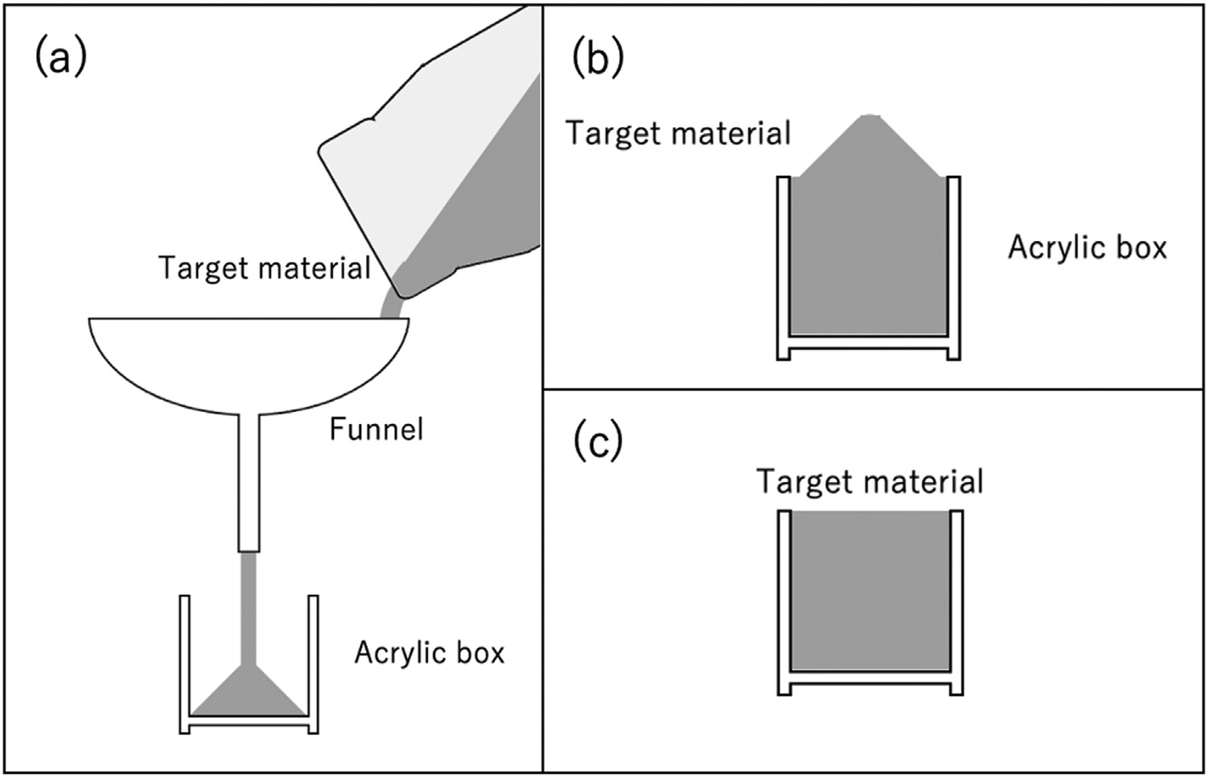
FIG. 1. Schematic diagram of prepara-
tion for the target layer (see the main text for the details). (a) Pouring the given target granular materials into the acrylic container using a plastic funnel.
(b) Excess granular materials accumu-lated above the uppermost level of the container. (c) Excess granular materials were removed from the container to form a flat surface.

The variation in drop heights is a crucial aspect of the impact experiment, as it leads to changes in the impact velocities normal to the surface of the granular media. This variation allows us to study penetration depths and kinetic energies with different granular media. Therefore, this study focuses on the depth of craters formed by projec-tile impact onto the granular media surfaces. The impact velocity nor-mal to the surface is the most significant parameter in determining the penetration depth and shape of the crater. The impact velocity on the surface can theoretically be obtained by
m dv = mg — 1 C_{d}(Re) q pR²v², (2)
a
dt 2
where m is the mass of the studied alumina spherical projectile, v is the impact velocity, t is time, g is the gravitational acceleration, C_{d} is the drag coefficient, Re is the Reynolds number, qa is the air density, and R is the radius of the spherical projectile. When the studied Reynolds number Re is below the critical Reynolds number (3 × 10⁵), the drag coefficient C_{d} was calculated by the C_{d}- Re relationship,^{28,29}
  - Measurement of crater depth
We obtained a total of 112 high-resolution 3D topographical images of the granular media with a dropped spherical projectile and a container using a 3D scanning device CR-Scan Lizard 3D Scanner (Shenzhen Creality 3D Technology Co., Ltd., China). Its accuracy and resolution of the device are 0.05 and 0.1 mm, respectively, allowing the acquisition of high-resolution 3D images (Fig. 2). The scanning was carried out carefully because the granular media with a dropped spher-ical projectile is susceptible to vibration. We performed the 3D scan-ning without removing the dropped spherical projectile from the surface of the granular media to avoid any surface disturbances. The given 3D scanning was done immediately after we dropped spherical projectile to the given granular media. We used the open-source soft-ware CloudCompare to convert acquired 3D scanning data into points cloud data. The crater depth was thus obtained from the difference between the exposed height of the spherical projectile above the granu-lar media’s surface (h) and the spherical projectile’s diameter (2R). The exposed height of the spherical projectile references the median of the

C (Re) = 24 (1 + 0.15Re^{0.687}) + 0.42
. (3)
surface of the granular media surrounding it as the standard level, with

^{d} Re
1 + 42500Re—1.16
its highest point as the top (Fig. 3). Our experiment studies only the
condition of shallow crater depth (d) of d < 2R.

Because the required time at which the given projectile contacts
the media surface is unknown, the given impact velocity was computed iteratively by using the free fall velocity v₀ = 2gh without considering the air resistance, where h is the drop height the spherical projectile. The resulting impact velocity v on the surface was low, ranging from 0.44 m/s (drop height of 10 mm) to 0.70 m/s (25 mm) in our experiment.
pﬃﬃﬃﬃﬃﬃﬃ
  - X-ray computed tomography (X-CT)
To better characterize the surface of the studied granular media and the contact interface between the spherical projectile and granular media, we performed X-ray computed tomography (X-CT) imaging

26 June 2025 22:17:12
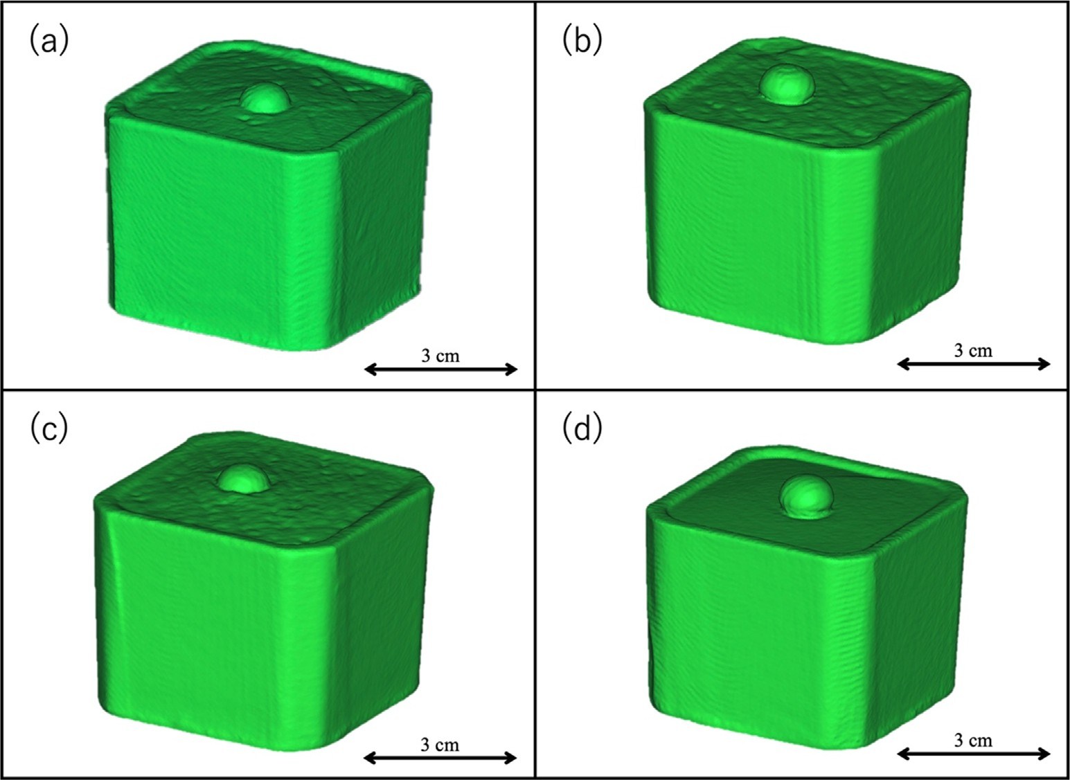
FIG. 2. 3D scanned images of (a) lunar highland regolith simulant LHS-1, (b) lunar mare regolith simulant LMS-1, (c) Martian global regolith simulant MGS-1, and (d) terrestrial
silica sand T-8 granular media filled in an acrylic container with the spherical projectile dropped from 15 mm above the surface.

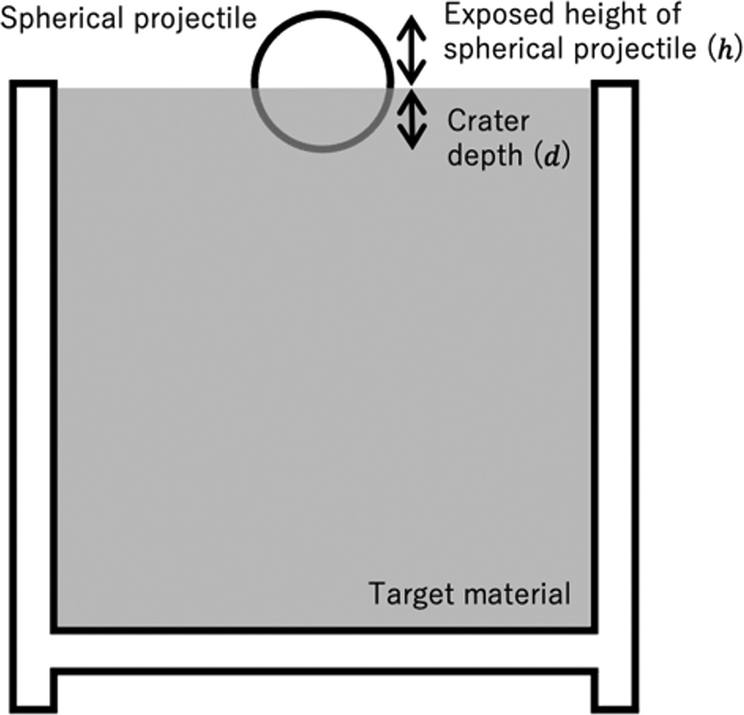
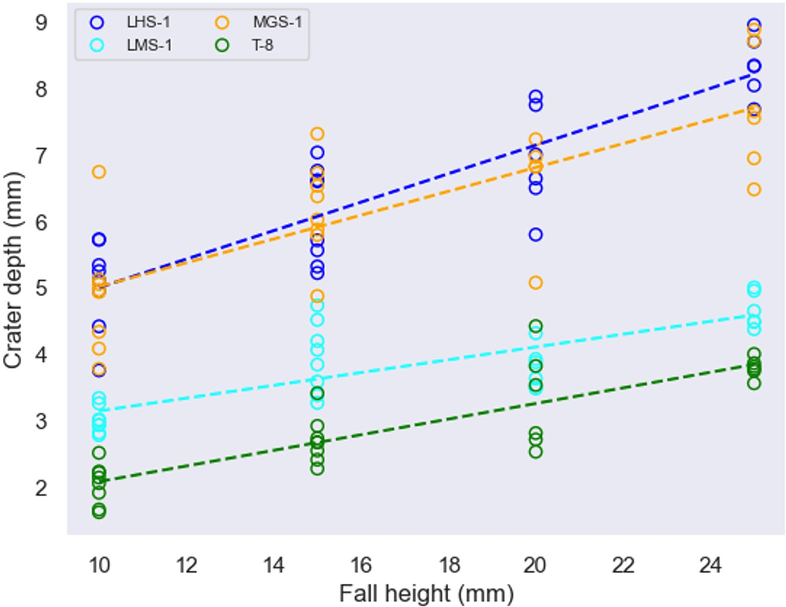
for selected granular media samples using a Geotek Rotating X-ray Computed Tomography (RXCT) at STRIDE-C of National Taiwan University. The RXCT system performs linear and rotational scans without moving the granular material, allowing the acquisition of high-resolution X-CT images of the studied granular media after pene-tration of the spherical projectile. The granular media with a dropped spherical projectile was scanned using RXCT, and X-CT reconstruc-tion was performed using Geotek reconstruction software. The result-ing resolution of all the acquired X-CT images was 57 lm.
FIG. 3. Schematic diagram of measurement of crater depth.

RESULTS AND DISCUSSION
  - Crater depths in the lunar and Martian regolith and terrestrial silica sand
We conducted a total of 112 spherical projectile impact experi-ments and their 3D scan imaging. The depths of generated craters of all the studied granular materials, including the lunar highland regolith simulant LHS-1, lunar mare regolith simulant LMS-1, Martian global regolith simulant MGS-1, and terrestrial silica sand T-8 layers, increased with the height of the fall (Fig. 4). For example, the crater

FIG. 4. Crater depths in target material of the lunar highland regolith simulant LHS-
1, lunar mare regolith simulant LMS-1, Martian global regolith simulant MGS-1, and terrestrial silica sand T-8 with different fall heights of spherical projectile.

depths with fall heights of 10 and 20 mm were 5.0 6 0.7 mm and
6.9 6 0.8 mm, 3.0 6 0.2 mm and 3.8 6 0.3 mm, 4.9 6 0.9 mm and
6.6 6 0.8 mm, and 2.0 6 0.3 mm and 3.3 6 0.7 mm in the LHS-1, LMS-1, MGS-1, and T-8 granular media, respectively. Notably, the cra-ter depths in LHS-1 and MGS-1 were nearly identical and exhibited the greatest depth among the studied granular media, whereas T-8 had the smallest depth (Fig. 4), indicating the most resistance to the spheri-cal projectile penetration. However, the crater depths at the given fall height in the regolith layers were more variable than those in the ter-restrial sand layers. This agrees with the potential non-uniformity and increased complexity associated with handling regolith simulants in contrast to silica sand. Also, the observed variations in crater depth among regolith simulants are ascribed to the heterogeneous nature of particle material. This heterogeneity is visually corroborated by our X-CT images of the regolith and terrestrial sand layers (Fig. 5). The X-CT

26 June 2025 22:17:12
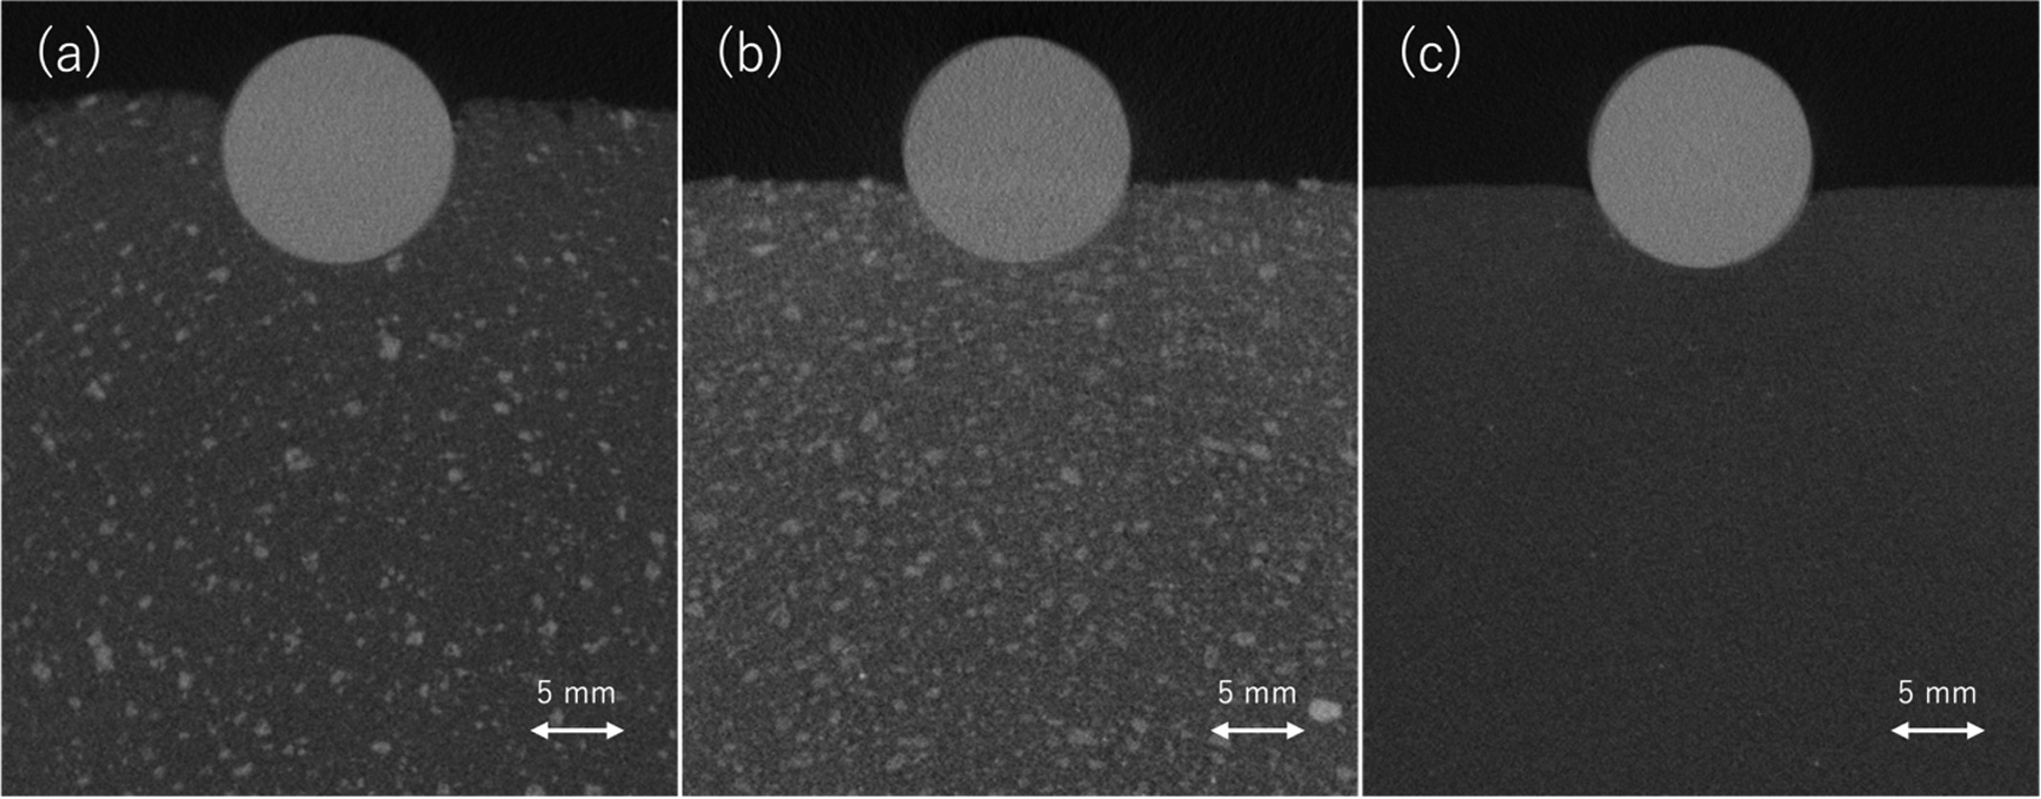
FIG. 5. Examples of X-CT image of the studied granular media of (a) lunar highland regolith simulant LHS-1 with a spherical projectile dropped from 15 mm, (b) lunar mare reg-
olith simulant LMS-1 with a spherical projectile dropped from 15 mm, and (c) terrestrial silica sand T-8 with a spherical projectile dropped from 25 mm. Dark and light colors indi-cate low and high densities, respectively. The light-colored circle shows the alumina spherical projectile.

images represent the scattered small whitish dots denoting high density within the layers composed of regolith simulant, contrasting with the uniformly gray appearance of the T-8 layer. This heterogeneous nature of regolith materials contributes to greater variability in crater depths compared to terrestrial silica sand materials (Fig. 4), suggesting the potential non-uniformity and complexity inherent in the behavior of regolith particles relative to silica sand particles.
The distinct environmental factors of the lunar and Martian sur-faces, such as atmospheric conditions, temperature fluctuations, and low gravitational accelerations, may significantly influence regolith behavior under impact, including ejecta production processes, as sug-gested by experiment campaigns in microgravity levels (on the order of below 1/100 of the gravity acceleration at the Earth’s surface) with vacuum levels of a few tens of mTorr.^{15,16} The experiments in this study were conducted under terrestrial conditions without accounting for these factors. However, our findings suggest the influence of granu-lar material properties on crater formation, with penetration depth scaling linearly with a low collision velocity on an order of 10^{—1} m/s, as suggested by previous studies.³⁰ Our results showed that the crater depth of the T-8 granular media increased almost linearly with an impact velocity. Although some deviation was present, the crater depths of the granular media of regolith simulants (LHS-1, LMS-1, and MGS-1) also demonstrated nearly linear scaling with an impact velocity of 0.44–0.70 m/s (Fig. 6). The depth of impact craters is signifi-cantly influenced by the kinetic energy of spherical projectiles. The kinetic energy E_{k} on the granular media surface, proportional to the square of the projectile’s velocity v on the surface, increases with higher velocities, leading to greater crater depths upon impact (Fig. 7). The released energy excavates and displaces target granular material, form-ing depressions on the surface. In experiments, varying projectile velocities made observations of the direct impact on crater formation available, highlighting the fundamental relationship between kinetic energy E_{k} and crater depth d. The relationship in the LHS-1, LMS-1, MGS-1, and T-8 layers at the kinetic energy E_{k} of 0.2 × 10^{—3}
— 0.5 × 10^{—3} J was expressed by power laws, with d ~ E^{0.553},
k
d ~ E^{0.417}, d ~ E^{0.473}, and d ~ E^{0.672}, respectively. The power laws

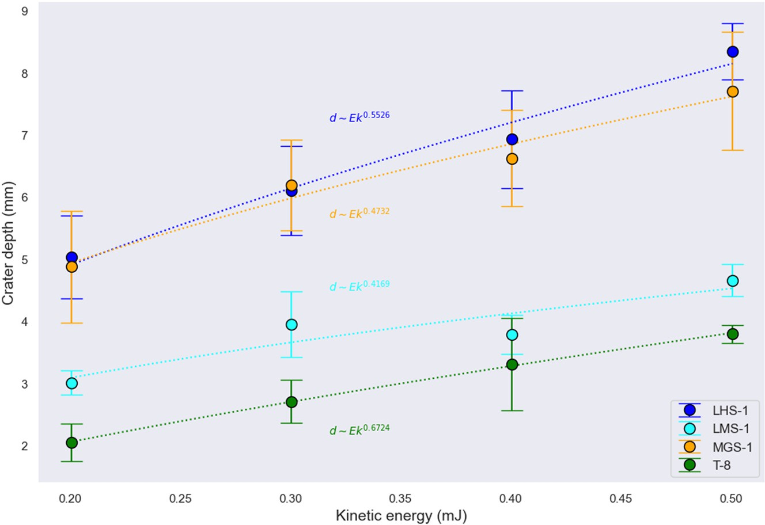
FIG. 7. Crater depth in target material of LHS-1, LMS-1, MGS-1, and T-8 at different kinetic energies at the surface contact. The dotted curves present power-law scaling
(d ~ Eª). Error bars represent 61r (one standard deviation) from the mean.
k

crater depth than the terrestrial sand surface with the similar particle size in the studied range of kinetic energy. Our findings can be utilized to refine sedimentary layer simulations and consider vacuum condi-tions and low gravity.

  - The effect of the physical and geotechnical properties of regolith
The observed variations in crater depths among the studied rego-lith and terrestrial sand materials highlight the complex interplay between various factors in determining the response of the granular media to impact events. The difference in the crater depth between the studied granular materials will be attributed to not only the projectile’s kinetic energy but also their physical and geotechnical properties. Below we discuss the effect of regolith’s physical and geotechnical
properties, including particle diameter, porosity, cohesion, and internal

k k k

indicate that the lunar and Martian regolith surfaces can form a greater
26 June 2025 22:17:12
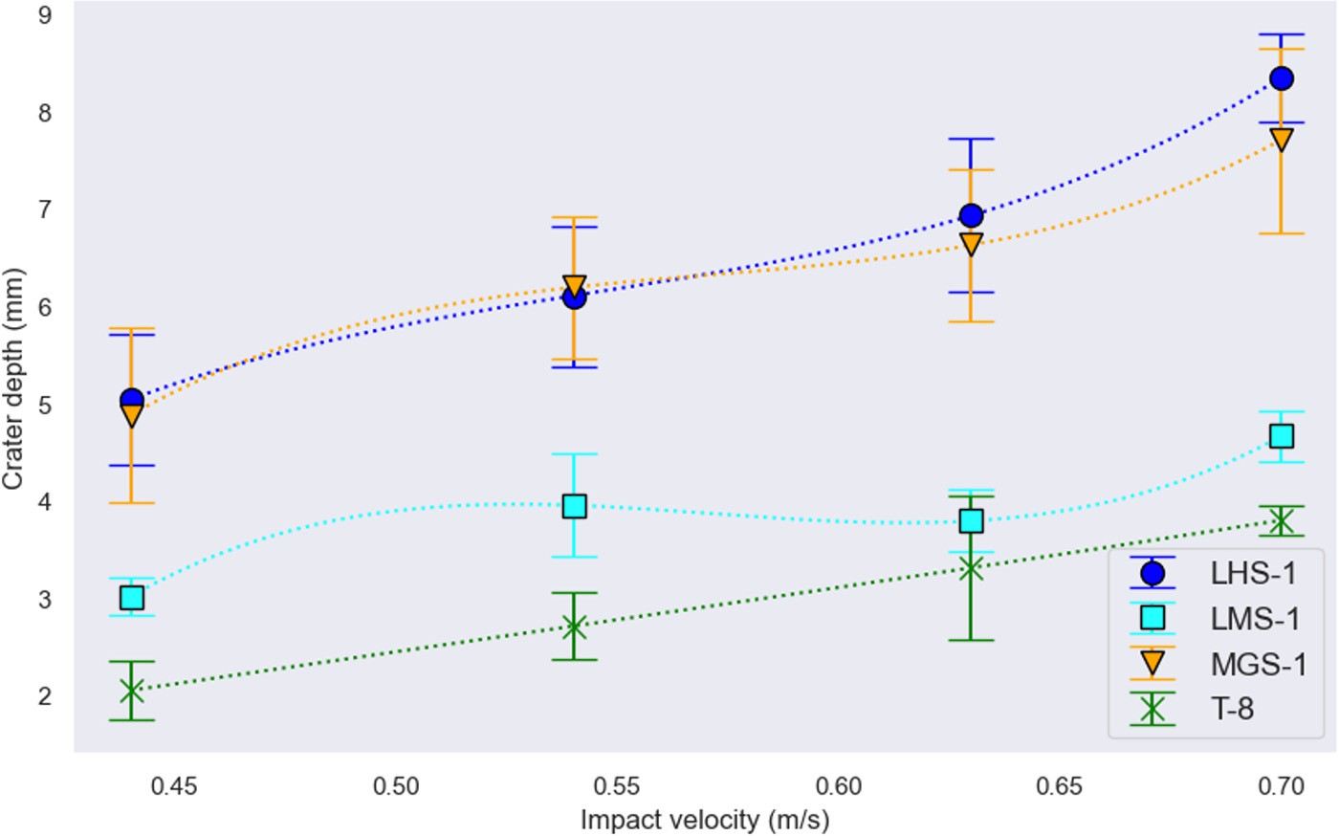
friction angle, which could influence the crater depths on the regolith
surfaces.
The mean particle diameters of the studied regolith simulants LHS-1, LMS-1, and MGS-1 are approximately 90 lm, while the stud-ied terrestrial silica sand T-8 has a slightly larger particle diameter of 120 lm (Table I). This difference could result in crater depths variable between regolith and terrestrial sand layers. However, earlier studies of impact experiments with sand bed revealed that the crater depth does
not correlate with the particle diameter of sand (<2.0 mm) and does not change in the mixtures of sand particles with various diameters.³¹
Therefore, we conclude that the particle diameter of granular material is not the primary factor that resulted in greater crater depths of the LHS-1 and MGS-1 layers than the depth of the terrestrial silica sand layer.
Previous studies have demonstrated that crater depth depends on the mean porosity of the target material.^{18,32} The porosities of the granular media of LHS-1, LMS-1, MGS-1, and T-8 in our experiment are 0.586, 0.511, 0.588, and 0.579, respectively (Table I). When com-pared among the regolith simulants, the craters in the LHS-1 and MGS-1 layers with high porosity are deeper than those in the LMS-1 layer with lower porosity, which may be consistent with the porosity
FIG. 6. Crater depth in target granular material of lunar highland regolith simulant LHS-1, lunar mare regolith simulant LMS-1, Martian global regolith simulant MGS-1, and terrestrial silica sand T-8 at different impact velocities. Error bars represent 61r (one standard deviation) from the mean.

difference. However, the T-8 layer, having a porosity similar to that of the LHS-1 and MGS-1 layers, generated the least crater depths. Additionally, our X-CT image of the LHS-1 layer [Fig. 5(a)] discerns airy and blurred outlines, agreeing well with its higher porosity and the actual lunar surface considered dusty.³⁰ This characteristic contributes to deeper craters, where the spherical projectile dropped from a height of 15 mm into LHS-1 produces a deeper crater compared to those formed by the spherical projectiles dropped from heights of 25 mm into LMS-1 [Fig. 5(b)] and T-8 [Fig. 5(c)]. Thus, the porosity differ-ences between the regolith and terrestrial sand layers alone cannot explain the observed crater depths.
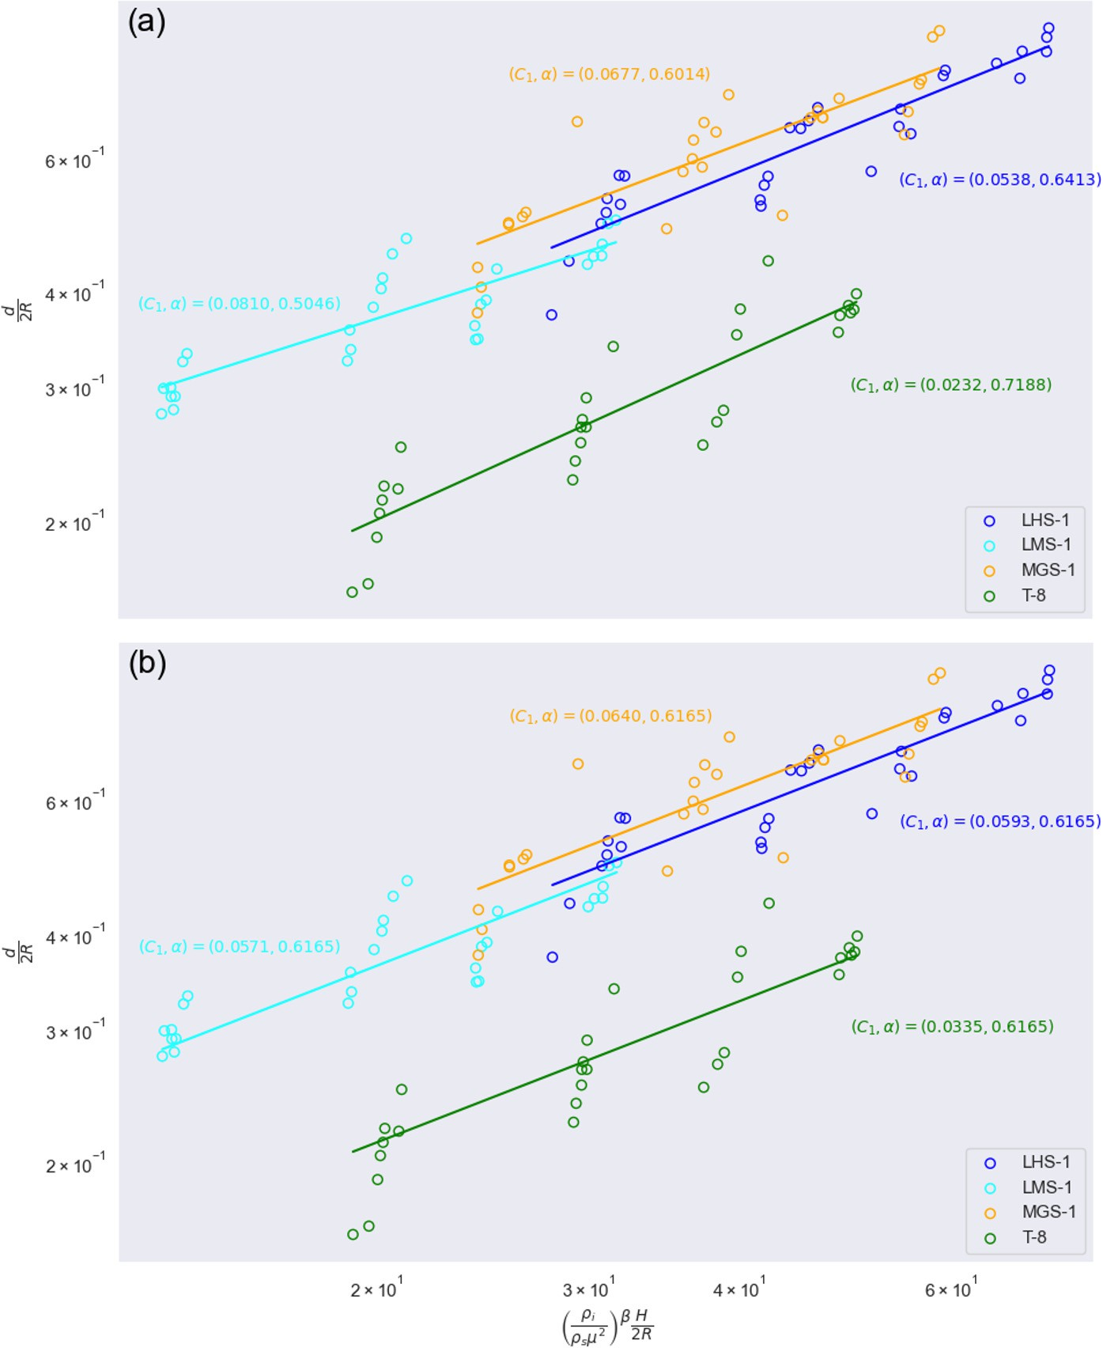
The cohesion of the studied regolith simulants is variable, with 311, 393, and 307 Pa, in the LHS-1, LMS-1, and MGS-1, respectively (Table I).^{20,23} The regolith is thus characterized by more significant adhesion and cohesion than the terrestrial silica sand. The difference is also visually evident; the granular materials of LHS-1, LMS-1, and MGS-1 in the vials readily solidify upon vibration, while it is unobserv-able in the T-8 material. Therefore, these properties can also influence crater formation in our experiments, with higher cohesion resulting in smaller crater sizes, as suggested by an earlier study.³³ Our impact cra-tering experiments showed that the crater depths in the LHS-1 and MGS-1 layers were greater than that of the LMS-1 layer, which is cor-roborated by the fact that the cohesion of the LHS-1 and MGS-1 mate-rials is well lower than the LMS-1 material. Also, Housen and Holsapple¹⁰ revealed that increasing a target’s internal friction reduces cratering efficiency and depth. The internal friction angles of LMS-1 and T-8 are lower than those of LHS-1 and MGS-1 (Table I),^{20,23} aligning our results of crater depths of the LMS-1 and T-8 layers are smaller than those of the LHS-1 and MGS-1 layers. Thus, we suggest that the cohesion and internal friction angle are the primary properties that make the crater depths on the lunar highlands and Martian rego-lith surfaces greater.

  - Scaling laws
Below, we consider how the observed crater depths scale with the experimental parameters to allow us to investigate in different condi-tions. Numerous empirical models have been developed to elucidate impacts on granular materials. The penetration depth is generally pro-portional to the 1/2 power of sphere density, the 2/3 power of sphere diameter, and the 1/3 power of total drop distance.³⁴ Similarly, Katsuragi and Blum³⁵ concluded that crater depth scales as the 1/3 power of the total drop distance, corresponding to the scaling by impact energy. We validated our data for the well-known power-law scaling³⁶ when the spheres do not completely submerge, while varying the constants C₁ and a,
Previous impact crater experiment in the wet granular media³⁶ revealed a fitting of their data for fine granular material (with major and minor axes of 0.28 6 0.07 mm and 0.19 6 0.04 mm) with C₁ = 0.056 when b = 3/2 and a = 1/3. Another impact crater experi-ment with a dry, noncohesive granular media³⁷ resulted in the fitting of C₁ = 0.14 when b = 3/2 and a = 1/3. The values of C₁ and a in our data were also determined to fit the scaling law [Eq. (4)] to the given granular material (Fig. 8). Our data indicate that the crater depth is scaled with the exponent a ranging from 0.50 to 0.72. The exponent a of the LMS-1 layer was the lowest, and those of the regolith simulant layers were lower than that of the terrestrial silica sand layer. When the exponent a was fixed with its average value from the fitting results (a = 0.6165), the C₁ values for the regolith simulants were around 0.06 [Fig. 8(b)], about two times higher than that for T-8 (C₁ = 0.034). This considerable difference in the C₁ value cannot be explained by the dif-ference in the mean particle diameters between the regolith simulants and terrestrial silica sands because the difference was small and the scaling [Eq. (4)] has no dependence on the particle diameter. Thus, we concluded that the observed difference between granular regolith and terrestrial silica sand materials is likely because regolith particles com-prise irregular and angular shapes with sharp edges due to the least weathering, unlike Earth’s soil particles. Our scale law highlights that

d " q
= C₁
i
, (4)
qsl2

2R
b H #_{a}

2R

where d is the crater depth, R is the sphere radius, H is the sum of the fall height and crater depth, C₁, a, and b denote empirical constants reliant on the packing fraction (b = 3/2; ref.37) with qi and qs repre-senting the projectile and substrate densities, respectively, and l is the tangent of the friction angle. Here, the tangent of the friction angle l plays a role as an approximation of the coefficient of friction between grains.¹⁷
FIG. 8. (a) Our data scaled by Eq. (4) using C₁ and a values of 0.0538 and 0.6413
for LHS-1, 0.0810 and 0.5046 for LMS-1, 0.0677 and 0.6014 for MGS-1, and 0.0232 and 0.7188 for T-8, respectively, with a common b value of 3/2 for all target materials. In (b), Eq. (4) is scaled with a common a value of 0.6165, calculated as the average of the four a values in (a), and C₁ values of 0.0593, 0.0571, 0.0640, and 0.0335 for LHS-1, LMS-1, MGS-1, and T-8, respectively.
26 June 2025 22:17:12

less resistance of the lunar and Martian regolith surfaces to impact attributes to the unique granular properties of the lunar and Martian regolith materials, with significant implications for our understanding of these granular materials.
26 June 2025 22:17:12
Birch et al.³⁶ investigated the penetration of spherical projectiles into a water-saturated granular medium, observing that the wet medium undergoes plastic deformation with an increased yield strength. Their findings revealed that this yield strength diminishes the mobility of individual grains, resulting in shallower penetration depths. Introducing water into a granular medium introduces a plastic yield stress dependent on grain size, where the strength of individual force chains within a small volume around the impacting sphere predomi-nates energy dissipation. Consequently, a pore fluid alters the scaling from a gravity-dominated regime to one where the material’s yield strength becomes significant.³⁶ Pore water, if it exists, cannot be disre-garded in lunar and Martian environments, where icy regolith is expected to be present.^{38,39} The pore water in the solid phase due to freezing encourages the rearrangement of regolith particles and alters the total contact area between them.²⁵ The freeze-thaw cycling induces decompaction in wet granular materials, resulting in a reduction in cohesion over cycles.⁴⁰ Therefore, the behavior of wet regolith in actual lunar and Martian environments during impacts is presumed to be more complex. Moreover, lunar regolith contains glassy agglutinates ¹ yielding complex morphologies, which could significantly influence the granular behavior of lunar soils. The agglutinates can be chemically reactive, especially in the presence of water or other solvents. The pres-ence of chemically reactive substances in the lunar and Martian soils, such as the formation of iron oxides, can increase soil cohesion.^{41,42} The variable abundance of the reactive substances can thus be the fac-tor influencing the scaling laws. The influence of moisture contents, freeze-thaw cycling, and chemically reactive substances as well as vac-uum degree^{30,43} on the impact crater depths should be further investi-gated in future studies.

  - Implications for future space exploration missions
Various drilling, sampling, and coring projects have been con-ducted on the lunar and Martian surfaces. Drilling on the lunar surface is not challenging in terms of the absence of abundant water, salts, clay minerals, and a dense atmosphere capable of sustaining liquid water because the lunar is predominantly composed of dry regolith inter-spersed with occasional rocks. Several missions, including Apollo Missions 11–17, Luna Missions 16 and 20, and Chang’e 5 mission, have been successful in drilling down to a couple of meters depth.^{44,45} The facts may be consistent with the results in our experiments reveal-ing that the crater depths in lunar regolith simulants are larger than those in terrestrial sand at the given energy upon impact (Fig. 7). Our results further showed the generated crater depths on the Martian regolith surface can be nearly identical to those on the lunar highlands regolith surface; however, Martian missions have faced more challeng-ing environment for drilling activities, limiting the successful deep dril-ling depths.^{46,47}
Our findings will a significant step toward designing stable land-ing and effective drilling systems and tools that can successfully extract valuable resources and conduct scientific investigations on the lunar and Martian surfaces. However, it should be noted that the findings in our work are limited to the uppermost a few centimeters of the surface. While the LMS-1 and MGS-1 layers exhibited low resistance against
impact in our experiments, the results might differ at great depths of the regolith layers. For example, high shear strengths have been dem-onstrated at a depth of 15 cm below the lunar surface.⁴⁸ Furthermore, the high cohesion and fine particle diameter of the regolith are expected to result in high compactability, potentially affecting drilling efficiency. More experiments are necessary to advance our understand-ing of granular mechanics in regolith for optimizing future lunar and Martian surface explorations. Nevertheless, our insights can aid in the design of lunar rovers and Martian landers by optimizing landing strategies to minimize damage and ensure stability on varying and compressible surfaces. The results also enhance sampling strategies by identifying areas where regolith is more compressible or cohesive, guiding the selection of regions for scientific study or resource extrac-tion. Moreover, these findings are crucial for future infrastructure development on extraterrestrial surfaces, such as constructing landing pads or bases. By understanding the compressibility and structural properties of regolith, engineers can better plan for foundation stability and address mechanical challenges during construction.

CONCLUSIONS
We conducted spherical projectile impact experiments into rego-lith layers under the earth’s gravity in terrestrial atmospheric condi-tions, along with their 3D scan imaging and X-CT measurements, using four different granular materials: lunar regolith simulant LHS-1, lunar mare regolith simulant LMS-1, Martian global regolith simulant MGS-1, and terrestrial silica sand T-8. Our results of the impact experiments revealed significant differences in the crater depths among the studied granular materials upon the impact of a 10-mm alumina ball at a low velocity of 44–70 cm/s. The crater depths for the lowest fall height of 10 mm and the highest fall height of 25 mm were
5.0 6 0.7 mm and 8.3 6 0.5 mm, 3.0 6 0.2 mm, and 4.7 6 0.3 mm,
4.9 6 0.9 mm, and 7.7 6 0.9 mm, and 2.0 6 0.3 mm and 3.8 6 0.1 mm in the LHS-1, LMS-1, MGS-1, and T-8 granular media, respectively. The crater depths in the LHS-1 and MGS-1 layers increased signifi-cantly with impact velocity. In contrast, the LMS-1 and T-8 layers exhibited a more gradual increase in crater depth with impact velocity. These results indicate variations in the response of different regolith and terrestrial sand surfaces to impact events. Our power-law scaling law also indicated that the resistance to crater impact in the lunar and Martian regolith layers is less than that in the terrestrial sand layer. Notably, the crater depth in the LHS-1 layer was greater than that in the LMS-1 layer, suggesting that the typical regolith layer in the lunar mare may present greater resistance to penetration compared to that in the lunar highlands. This highlights the importance of considering the unique granular mechanics of different regolith surfaces when assessing landing and sampling missions and potential challenges for drilling operations on the lunar and Martian surfaces. The lunar high-lands and Martian surface may exhibit reduced resistance to impact due to the higher porosity of the studied LHS-1 and MGS-1 layers, particularly evident in their uppermost surface layers. However, the substantial cohesion inhibiting the penetration into the lunar and Martian surfaces is expected to pose a significant challenge to effective drilling operations. Further investigation into the greater depths of reg-olith below the surface is essential, where the pronounced cohesive properties may exert a more pronounced influence. While the shallow cratering experiment revealed a gradual slope in the scaling law for the LMS-1, we suggest that the scaling law will need modification for larger crater sizes and higher impact velocities. Our findings have

important implications for future exploration missions, particularly in the context of landing, resource utilization, and construction activities on the lunar and Martian surfaces.
26 June 2025 22:17:12

ACKNOWLEDGMENTS
The authors are grateful to S.-A. Cheng for his assistance throughout our RXCT measurements. This work was supported by JSPS KAKENHI Grant-in-Aid for Early-Career Scientists JP23K13698.

AUTHOR DECLARATIONS
Conflict of Interest
The authors have no conflicts to disclose.

Author Contributions
Takuma Ishii: Data curation (lead), Formal analysis (lead), Investigation (equal), Methodology (equal), Software (equal), Validation (equal), Visualization (lead), Writing—original draft (equal), Writing—review and editing (supporting). Arata Kioka: Conceptualization (lead), Funding acquisition (lead), Investigation (equal), Methodology (lead), Project administration (lead), Resources (equal), Software (equal), Supervision (lead), Writing—original draft (equal), Writing—review and editing (lead). Jyh-Jaan Steven Huang: Data curation (supporting), Formal analysis (supporting), Methodology (equal), Resources (equal), Validation (equal), Visualization (supporting), Writing—review and edit (supporting). Yoshiki Tabuchi: Methodology (supporting); Writing—review and edit (supporting). Yasuhiro Yamada: Supervision (supporting).

DATA AVAILABILITY
The data that support the findings of this study are available from the corresponding author upon reasonable request.

REFERENCES
¹P. Lucey, R. L. Korotev, J. J. Gillis, L. A. Taylor, D. Lawrence, B. A. Campbell, R. Elphic, B. Feldman, L. L. Hood, D. Hunten, M. Mendillo, S. Noble, J. J. Papike,
R. C. Reedy, S. Lawson, T. Prettyman, O. Gasnault, and S. Maurice, “Understanding the lunar surface and space-moon interactions,” Rev Miner. Geochem. 60, 83–219 (2006).
²L. Zhang, Y. Xu, R. Liu, R. Chen, R. Bugiolacchi, and R. Gao, “The dielectric
properties of Martian regolith at the Tianwen-1 landing site,” Geophys. Res. Lett. 50, e2022GL102207, https://doi.org/10.1029/2022GL102207 (2023).
³V. Stamenkovi´c, L. W. Beegle, K. Zacny, D. D. Arumugam, P. Baglioni, N.
Barba, J. Baross, M. S. Bell, R. Bhartia, J. G. Blank, P. J. Boston, D. Breuer, W. Brinckerhoff, M. S. Burgin, I. Cooper, V. Cormarkovic, A. Davila, R. M. Davis,
C. Edwards, G. Etiope, W. W. Fischer, D. P. Glavin, R. E. Grimm, F. Inagaki, J.
L. Kirschvink, A. Kobayashi, T. Komarek, M. Malaska, J. Michalski, B. M´enez,
M. Mischna, D. Moser, J. Mustard, T. C. Onstott, V. J. Orphan, M. R. Osburn,
J. Plaut, A. C. Plesa, N. Putzig, K. L. Rogers, L. Rothschild, M. Russell, H. Sapers, B. S. Lollar, T. Spohn, J. D. Tarnas, M. Tuite, D. Viola, L. M. Ward, B. Wilcox, and R. Woolley, “The next frontier for planetary and human explora-tion,” Nat. Astron. 3(2), 116–120 (2019).
⁴J. Tang, T. Yang, X. Chen, Z. Zhang, Y. Tian, W. Zhang, and S. Jiang,
“Mechanical characteristics of lunar regolith drilling and coring and its crawl-ing phenomenon: Analysis and validation,” Aerospace 9(11), 709 (2022).
⁵D. Knez and M. A. M. Zamani, “A review of the geomechanics aspects in space
exploration,” Energies 14(22), 7522 (2021).
⁶Y. Pang, T. Zhang, H. Wei, T. Zeng, Y. Zhang, G. Mo, K. Xu, S. Yin, G. Wang, X. Zhang, X. Lai, and X. Ding, “Influence of lunar regolith compressibility on sampling performance of thick wall spiral drills,” Chin. J. Aeronaut. 36(2), 350–362 (2023).
⁷J. M. Long-Fox, Z. A. Landsman, P. B. Easter, C. A. Millwater, and D. T. Britt,
“Geomechanical properties of lunar regolith simulants LHS-1 and LMS-1,” Adv. Space Res. 71(12), 5400–5412 (2023).
⁸K. Yin, Z. Cheng, J. Liu, and A. Chen, “Shear properties of LHS-1 and LMS-1
Lunar regolith simulants,” Planet. Space Sci. 226, 105630 (2023).
⁹K. M. Cannon, D. T. Britt, T. M. Smith, R. F. Fritsche, and D. Batcheldor, “Mars global simulant MGS-1: A Rocknest-based open standard for basaltic martian regolith simulants,” Icarus 317, 470–478 (2019).
¹⁰K. R. Housen and K. A. Holsapple, “Ejecta from impact craters,” Icarus 211(1),
856–875 (2011).
¹¹M. Kiuchi, T. Okamoto, Y. Nagaashi, Y. Yamaguchi, S. Hasegawa, and A. M. Nakamura, “Impact experiments on granular materials under low gravity: Effects of cohesive strength, internal friction, and porosity of particle layers on crater size,” Icarus 404, 115685 (2023).
¹²M. A. Cook and K. S. Mortensen, “Impact cratering in granular materials,”
J. Appl. Phys. 38(13), 5125–5128 (1967).
¹³J. R. De Bruyn and A. M. Walsh, “Penetration of spheres into loose granular media,” Can. J. Phys. 82(6), 439–446 (2004).
¹⁴J. C. Ruiz-Su´arez, “Penetration of projectiles into granular targets,” Rep. Prog.
Phys. 76(6), 066601 (2013).
¹⁵J. Brisset, J. Colwell, A. Dove, S. Abukhalil, C. Cox, and N. Mohammed, “Regolith behavior under asteroid-level gravity conditions: Low-velocity impact experiments,” Prog. Earth Planet. Sci. 5(1), 73 (2018).
¹⁶J. Brisset, C. Cox, S. Anderson, J. Hatchitt, A. Madison, M. Mendonca, A.
Partida, and D. Remie, “Regolith behavior under asteroid-level gravity condi-tions: Low-velocity impacts into mm- and cm-sized grain targets,” Astron. Astrophys. 642, A198 (2020).
¹⁷J. S. Uehara, M. A. Ambroso, R. P. Ojha, and D. J. Durian, “Low-speed impact
craters in loose granular media,” Phys. Rev. Lett. 90(19), 194301 (2003).
¹⁸C. J. Cline and M. J. Cintala, “The effects of target density, porosity, and friction on impact crater morphometry: Exploratory experimentation using various granular materials,” Meteorit. Planet. Sci. 57(7), 1441–1459 (2022).
¹⁹LHS-1 Lunar Highlands Simulant j Fact Sheet (2022).
²⁰C. Millwater, J. Long-Fox, Z. Landsman, A. Metke, and D. Britt, “Direct shear measurements of lunar regolith simulants LHS-1, LHS-1D, LMS-1, and LMS-1D,” in 53rd Lunar and Planetary Science Conference (Universities Space Research Association (USRA)/Lunar and Planetary Institute (LPI), 2022), Vol. 53, p. 2038.
²¹LMS-1 Lunar Mare Simulant j Fact Sheet (2022).
²²MGS-1 Mars Global Simulant j Fact Sheet (2022).
²³B. Dotson, D. Sanchez Valencia, C. Millwater, P. Easter, J. Long-Fox, D. Britt, and P. Metzger, “Cohesion and shear strength of compacted lunar and Martian regolith simulants,” Icarus 411, 115943 (2024).
²⁴S. Ozaki, G. Ishigami, M. Otsuki, H. Miyamoto, K. Wada, Y. Watanabe, T.
Nishino, H. Kojima, K. Soda, Y. Nakao, M. Sutoh, T. Maeda, and T. Kobayashi, “Granular flow experiment using artificial gravity generator at International Space Station,” NPJ Microgravity 9, 61 (2023).
²⁵Y. Tabuchi, A. Kioka, and Y. Yamada, “Water permeability of sunlit lunar high-
lands regolith using LHS-1 simulant,” Acta Astronaut. 213, 344–354 (2023).
²⁶A. R. Clendensen, A. Aleksandrov, B. M. Jones, P. G. Loutzenhiser, D. T. Britt, and
T. M. Orlando, “Temperature programmed desorption comparison of lunar regolith to lunar regolith simulants LMS-1 and LHS-1,” Earth Planet Sci. Lett. 592, 117632 (2022). ²⁷D. I. Goldman and P. Umbanhowar, “Scaling and dynamics of sphere and disk
impact into granular media,” Phys. Rev. E 77, 021308 (2008).
²⁸N. S. Cheng, “Comparison of formulas for drag coefficient and settling velocity of spherical particles,” Powder Technol. 189(3), 395–398 (2009).
²⁹R. Clift and W. H. Gauvin, “Motion of entrained particles in gas streams,” Can.
J. Chem. Eng. 49(4), 439–448 (1971).
³⁰J. E. Colwell, S. Batiste, M. Hor´anyi, S. Robertson, and S. Sture, “Lunar surface: Dust dynamics and regolith mechanics,” Rev. Geophys. 45(2), RG2006, https:// doi.org/10.1029/2005RG000184 (2007).
³¹N. Murdoch, I. A. Martinez, C. Sunday, C. Sunday, E. Zenou, O. Cherrier, O.
Cherrier, A. Cadu, Y. Gourinat, and Y. Gourinat, “An experimental study of low-velocity impacts into granular material in reduced gravity,” Mon. Not. R Astron. Soc. 468(2), stw3391–1272 (2017).

³²R. Mazur, M. Beczek, J. Janiszewski, W. Koperski, C. Polakowski, B. Fikus, A. Sochan, R. Wozniak, D. Gozdzik, M. Ryzak, M. Banda, and A. Bieganowski, “Experimental investigations of crater formation as a result of high-velocity impacts on sand bed,” PLoS ONE 17, e0265546 (2022).
26 June 2025 22:17:12
³³D. Nowka, K. Wu€nnemann, G. S. Collins, and D. Elbeshausen, “Scaling of
impact crater formation on planetary surfaces,” in European Planetary Science Congress (2010), Vol. 5, EPSC2010-87.
³⁴M. A. Ambroso, C. R. Santore, A. R. Abate, and D. J. Durian, “Penetration
depth for shallow impact cratering,” Phys. Rev. E 71(5), 051305 (2005).
³⁵H. Katsuragi and J. Blum, “The physics of protoplanetesimal dust agglomerates.
IX. Mechanical properties of dust aggregates probed by a solid-projectile impact,” Astrophys. J. 851(1), 23 (2017).
³⁶S. P. D. Birch, M. Manga, B. Delbridge, and M. Chamberlain, “Penetration of spher-
ical projectiles into wet granular media,” Phys. Rev. E 90(3), 032208 (2014).
³⁷K. A. Newhall and D. J. Durian, “Projectile-shape dependence of impact craters in loose granular media,” Phys. Rev. E 68(6), 060301 (2003).
³⁸C. Pitcher, N. K€omle, O. Leibniz, O. Morales-Calderon, Y. Gao, and L. Richter,
“Investigation of the properties of icy lunar polar regolith simulants,” Adv. Space Res. 57(5), 1197–1208 (2016).
³⁹M. Siegler, O. Aharonson, E. Carey, M. Choukroun, T. Hudson, N.
Schorghofer, and S. Xu, “Measurements of thermal properties of icy Mars rego-lith analogs,” J. Geophys. Res. 117(3), E03001, https://doi.org/10.1029/ 2011JE003938 (2012).
⁴⁰M. Pakpour, N. Vandewalle, and G. Lumay, “Decompaction of wet granular
materials under freeze-thaw cycling,” Phys. Rev. E 99(1), 012901 (2019).
⁴¹M. T. Barral, M. Arias, and J. Gu´erif, “Effects of iron and organic matter on the porosity and structural stability of soil aggregates,” Soil Tillage Res. 46, 261–272 (1998).
⁴²L. Walter, Y. Estevez, G. Medjigbodo, J.-E. Aubert, L. Linguet, and O. Nait-Rabah, “Design of poured earth construction materials from the elementary characteristics of tropical soils,” Case Stud. Constr. Mater. 20, e02709 (2024).
⁴³S. Subramanian, A. Wilson, C. White, K. Kontis, D. Evans, and J. Van den
Eynde, “Tracking plume-regolith interactions in near-vacuum conditions,” Phys. Fluids 36(1), 013301 (2024).
⁴⁴K. Zacny, Y. Bar-Cohen, M. Brennan, G. Briggs, G. Cooper, K. Davis, B.
Dolgin, D. Glaser, B. Glass, S. Gorevan, J. Guerrero, C. McKay, G. Paulsen, S. Stanley, and C. Stoker, “Drilling systems for extraterrestrial subsurface explora-tion,” Astrobiology 8, 665–706 (2008).
⁴⁵M. Gao, X. Wang, G. Zhang, M. Li, T. Liu, H. Hao, C. Li, and H. Xie, “The
novel idea and technical progress of lunar in-situ condition preserved coring,” Geomech. Geophys. Geo-Energy Geo-Resour. 8(2), 46 (2022).
⁴⁶J. P. Grotzinger, J. Crisp, A. R. Vasavada, R. C. Anderson, C. J. Baker, R. Barry,
D. F. Blake, P. Conrad, K. S. Edgett, B. Ferdowski, R. Gellert, J. B. Gilbert, M. Golombek, J. G´omez-Elvira, D. M. Hassler, L. Jandura, M. Litvak, P. Mahaffy,
J. Maki, M. Meyer, M. C. Malin, I. Mitrofanov, J. J. Simmonds, D. Vaniman, R.
- Welch, and R. C. Wiens, “Mars Science Laboratory mission and science investigation,” Space Sci. Rev. 170, 5–56 (2012).
⁴⁷R. C. Moeller, L. Jandura, K. Rosette, M. Robinson, J. Samuels, M. Silverman,
K. Brown, E. Duffy, A. Yazzie, E. Jens, I. Brockie, L. White, Y. Goreva, T. Zorn,
A. Okon, J. Lin, M. Frost, C. Collins, J. B. Williams, A. Steltzner, F. Chen, and J. Biesiadecki, “The sampling and caching subsystem (SCS) for the scientific exploration of Jezero crater by the Mars 2020 perseverance rover,” Space Sci. Rev. 217, 5 (2021).
⁴⁸B. A. C. S. Jayathilake, I. M. S. K. Ilankoon, and M. N. P. Dushyantha,
“Assessment of significant geotechnical parameters for lunar regolith excava-tions,” Acta Astronaut. 196, 107–122 (2022).

