

Effect of Low-Temperature Fluctuations on Martian Steel Structures: Numerical and Analytical Studies
Yongtao Bai¹; Jing Li²; and Xuhong Zhou³

Abstract: To harness a variety of unique resources, humanity is progressively venturing deeper into space. This endeavor necessitates a comprehensive investigation into the formidable challenges presented by hostile environments, particularly the impact of extreme low-tem-perature fluctuations on extraterrestrial engineering and construction. This paper employs numerical simulation methodologies to scrutinize the displacement variations and stress distribution within a full-scale circular arch steel structure subjected to diverse thermal cycles, thereby assessing the influence of severe cryogenic temperature fluctuations on Martian steel infrastructure. The findings of this research contribute to understanding the resilience of such structures within fluctuating low-temperature conditions, thereby offering an empirical foundation for the architectural design and material selection pertinent to the establishment of a Martian base. DOI: 10.1061/JCRGEI.CRENG-875.
© 2025 American Society of Civil Engineers.
Author keywords: Mars; Low-temperature fluctuations; Steel structure; Displacement variations; Durability.

Introduction
Downloaded from ascelibrary.org by Xian Jiaotong Liverpool University on 06/23/25. Copyright ASCE. For personal use only; all rights reserved.
Amid the relentless expansion and development of human civiliza-tion on Earth, coupled with an escalating imperative for resource procurement, the quest for extraterrestrial domains, notably the Moon and Mars, has emerged as a pivotal objective within the aero-space sector. Although the Moon is much closer to Earth than Mars, scholarly discourse suggests that Mars harbors a surface milieu conducive to human habitation, attributable to its enhanced gravi-tational pull, atmospheric composition, and diminished radiation exposure (Lim et al. 2017). Mars, as the most similar planet to Earth in the solar system, is the first choice for human space migra-tion (Petrov 2004). Consequently, the inception of a Martian out-post constitutes a critical juncture in our celestial odyssey, underpinning the broader spectrum of extraterrestrial scientific in-quiry. Since 2014, NASA has launched various competitions to ex-plore how to build habitats on Mars.
In discussing the selection of materials for extraterrestrial con-
struction, Jarvstrat and Toklu (2004) outlined the evolution of hab-itat types and construction materials, highlighting the indispensable role of metals in this progression. However, selecting the appro-priate metal materials for extraterrestrial structures is critical. A comprehensive evaluation of each material’s advantages and disad-vantages—including mechanical properties, thermal performance, weight, construction feasibility, and workability—is essential, while also ensuring structural elasticity (Troemner et al. 2022). Furthermore, these materials must maintain stability under extreme extraterrestrial environmental conditions and effectively resist

¹Professor, Dept. of Civil Engineering, Chongqing Univ., Chongqing 400045, China (corresponding author). Email: bai.yongtao@cqu.edu.cn
²Doctoral Candidate, Dept. of Civil Engineering, Chongqing Univ., Chongqing 400045, China. ORCID: https://orcid.org/0000-0003-4551
-9810. Email: lijing2023@stu.cqu.edu.cn
³Chair Professor, Dept. of Civil Engineering, Chongqing Univ., Chong-qing 400045, China. Email: zhouxuhong@126.com
Note. This manuscript was submitted on April 2, 2024; approved on October 29, 2024; published online on January 27, 2025. Discussion period open until June 27, 2025; separate discussions must be submitted for indi-vidual papers. This paper is part of the Journal of Cold Regions Engineer-ing, © ASCE, ISSN 0887-381X.
specific environmental challenges such as radiation, temperature fluctuations, and chemical reactions. The recyclability of materials is also a critical consideration, because metals are generally easier to recycle than composites, which further supports their selection for extraterrestrial habitats (Ruess et al. 2006). Steel structures have gradually been used in spaceflight due to low cost, easy pro-cessing, and excellent low-temperature resistance compared with titanium, aluminum, magnesium, and carbon fiber, which have been widely used in spaceflight. Benaroya and Ettouney (1992a, b) pro-posed the use of steel to build extraterrestrial buildings. Hoffman (1997) created a conceptual design for a Martian mission of 458 sols using a steel cylindrical shape habitat (Landis 2009). Most importantly, the existence of easily available iron and nickel in a reduced, elemental form on the surface of Mars changes the think-ing on in situ resources for construction. The fact that Mars has re-sources of iron available without the energy-intensive process of reduction means that the production of steel on Mars will be easier and less energy-intensive than steel production on Earth, in signifi-cant contrast to most planetary resource production processes (Landis 2009).
However, Mars presents an array of environmental extremities, distinct from Earth’s, such as reduced gravity and extreme temper-ature fluctuations. On the one hand, due to the microgravity on the surface of Mars and the lack of atmospheric external pressure, the high internal pressure of the structure is dominant. On the other hand, due to the thin atmosphere of Mars, it is impossible to main-tain heat effectively, resulting in a great temperature difference be-tween day and night on the surface, which will pose profound scientific challenges for future engineering structures. Therefore, a well-engineered extraterrestrial structure needs to consider the correlation between temperature cycles and structural and material fatigue, the possibility of brittle fracture under the influence of ex-tremely low temperatures, and so on (Sartipi 2021).
It is imperative to acknowledge that while individual variables can be assessed on Earth, the synergistic impact of these variables on structural integrity remains elusive. Finding the experimental equipment required to simulate the special environment of extrater-restrial space is highly challenging (Sartipi 2021). Numerical sim-ulation is relatively economical and feasible in studying the coupling effects of extraterrestrial vacuum, temperature fluctuation,

and high radiation. Malla and Brown (2012) used ABAQUS (ver-sion 2008) software to simulate the influence of two extreme tem-peratures (−233°C and +134°C) on the frequency response of a rectangular lunar habitat concept. Dronadula and Benaroya (2021) also adopted the method of numerical simulation to apply
Downloaded from ascelibrary.org by Xian Jiaotong Liverpool University on 06/23/25. Copyright ASCE. For personal use only; all rights reserved.
the static analysis under the lunar simulated load (including gravity load and internal pressure) on the structure. Temperature is set at a constant −23°C/250 K based on surface temperature data from the Apollo 11 mission. Mottaghi (2013) and Mottaghi and Benaroya (2015) conducted a thermal analysis of the structure using numer-
ical simulation (ANSYS) and studied the resistance of the magne-sium alloy dome structure to the extreme temperature of the moon with or without regolith. The structural thermal behavior was stud-ied under two steady-state conditions, namely at night and noon on the moon, at 120 and 166.61 K (−243.7 and −168.8°F), respec-
tively. To sum up, there are many structural temperature analyses
for the lunar environment at present, and most of them take stable temperatures, which is different from the situation of the extrater-restrial temperature cycle. Therefore, it is necessary to study the performance of the structure under the Mars temperature cycle.
To avoid the complexity, this study prioritized gravity, internal air pressure and extreme temperature fluctuations as the main fac-tors. Numerical simulations were used to investigate the fatigue performance of steel structures under the effects of alternating low temperatures on Mars. The objective is to provide a scientific basis for the durability and stability of steel structures under ex-treme environmental conditions.

Overview of the Martian Environment
Mars, distinguished as the most Earth-analogous celestial body within our solar system, boasts an abundance of material resources, including water ice and a spectrum of minerals. The prospective presence of aqueous resources on Mars affords a unique opportu-nity for the generation of oxygen through solar-powered electroca-talytic oxygen evolution reactions, potentially fostering an oxygenated atmosphere conducive to human habitation. Presently, Mars is deemed the most viable candidate for interplanetary colo-nization (Zhu et al. 2024). Nonetheless, the environmental condi-tions, external loads, and material responses of extraterrestrial structures diverge radically from Earth-based counterparts. As such, caution is advised when extrapolating terrestrial design codes to Martian architecture.

Low-Temperature Alternating Environment
Temperature fluctuations are recognized as an important factor influ-encing structural performance. Although the Moon and Mars both present extreme temperature variations, their differing thermal cy-cling patterns result in distinct fatigue behaviors of materials and structures under extreme conditions. This paper will focus on analyz-ing the low-temperature cycling environment of Mars, which will be applied as a boundary condition to the structures, thereby allowing differentiation from the Moon and other planetary environments. This approach allows for a deeper investigation into the effects of ex-treme low-temperature cycling on structural fatigue on Mars.
Mars’ diurnal cycle closely mirrors that of Earth, with a Martian day—termed a sol—lasting 24 h, 39 min, and 35 s. The axial tilt of Mars is 25.19°, akin to Earth’s 23.44°, endowing Mars with a quar-tet of seasons analogous to those on Earth, although each season is approximately double the duration, given that a Martian year spans 687 Earth days (Table 1) (Petrov 2004). The Martian atmosphere is notably tenuous, with a density of merely 1% of Earth’s, which
Table 1. Comparison of seasonal time between Mars and Earth

Seasons | Mars | Earth
Spring | 171 | 93
Summer | 199 | 94
Fall | 171 | 89
Winter | 146 | 89

hampers the formation of a substantial greenhouse effect. Conse-quently, the ambient temperatures on Mars are exceedingly low, and the diurnal temperature variance is vast. This extreme thermal fluctuation induces significant stress on structures, potentially lead-ing to thermal cycling–induced cracks (Kuster and Delorit 2023), which will have a certain effect on structural durability and stabil-ity. Therefore, the effect of temperature change and thermal stress should be considered as a final control in the structural design procedure.
Drawing upon the publicly available seasonal weather report from NASA’s InSight Mission, to simplify the numerical simula-tion calculations and to simulate the most unfavorable case of Mars temperature, the temperature maximum value of the temper-ature alternating curve is taken as +20°C, and the temperature min-imum value is −110°C, with 24 h as a temperature cycle. Furthermore, in alignment with the observed diurnal temperature
variations on the Martian surface (Atri et al. 2023), the simulation adopts a cooling duration that is twice that of the warming phase, specifically 16 h for cooling juxtaposed with 8 h for warming, and the daily cycle of Mars temperature is shown in Fig. 1. Because of the huge amount of calculation, the temperature cycle simulation curve to be used in numerical simulation adopts the form of trian-gular wave.

Structure Form and Force of Martian Architecture
In the context of extraterrestrial construction, the replication of terrestrial verticalized urban architecture is impractical due to the resultant increased mass of structures and the necessity for deeper foundations. Moreover, the maintenance and replacement of structural components in such configurations could prove to be laborious and time-intensive, particularly within a Martian environment. Consequently, a preference emerges for simplistic, autonomous, single-level edifices characterized by elementary ge-ometries and junctures. On Earth, gravitational forces dictate archi-tectural design; therefore, parabolic arches are favored over semicircular ones due to their efficiency in minimizing internal stress and potential damage. Conversely, under conditions of re-duced gravitational influence, semicircular arches are advantageous for the effective transmission of loads to the foundation while mit-igating the development of internal moments (Benaroya 2006; Ruess et al. 2006). This discourse references the structural concep-tual module depicted in Fig. 2 (Benaroya 2006), which outlines the design of a rudimentary single-story habitat. This habitat comprises a semicircular arch steel member coupled with a flat floor member, possessing a structural radius of 5 m, a material thickness of 50 mm, and a longitudinal span of 10 m. The design fulfills NASA’s habitat specifications for supporting a quartet of astronauts over a terrestrial annum [93 m² (NASA and Bradley University 2019)], as illustrated in Fig. 3.
In terms of loading considerations, the most usual combination
was gravitational loads including the weight of the structural mem-bers and the regolith shielding, together with high internal pres-sures, which dominate on the Mars surface due to microgravity and the lack of atmospheric external pressures (about 700 Pa), as illustrated in Fig. 4. Other dead and live loads are very small

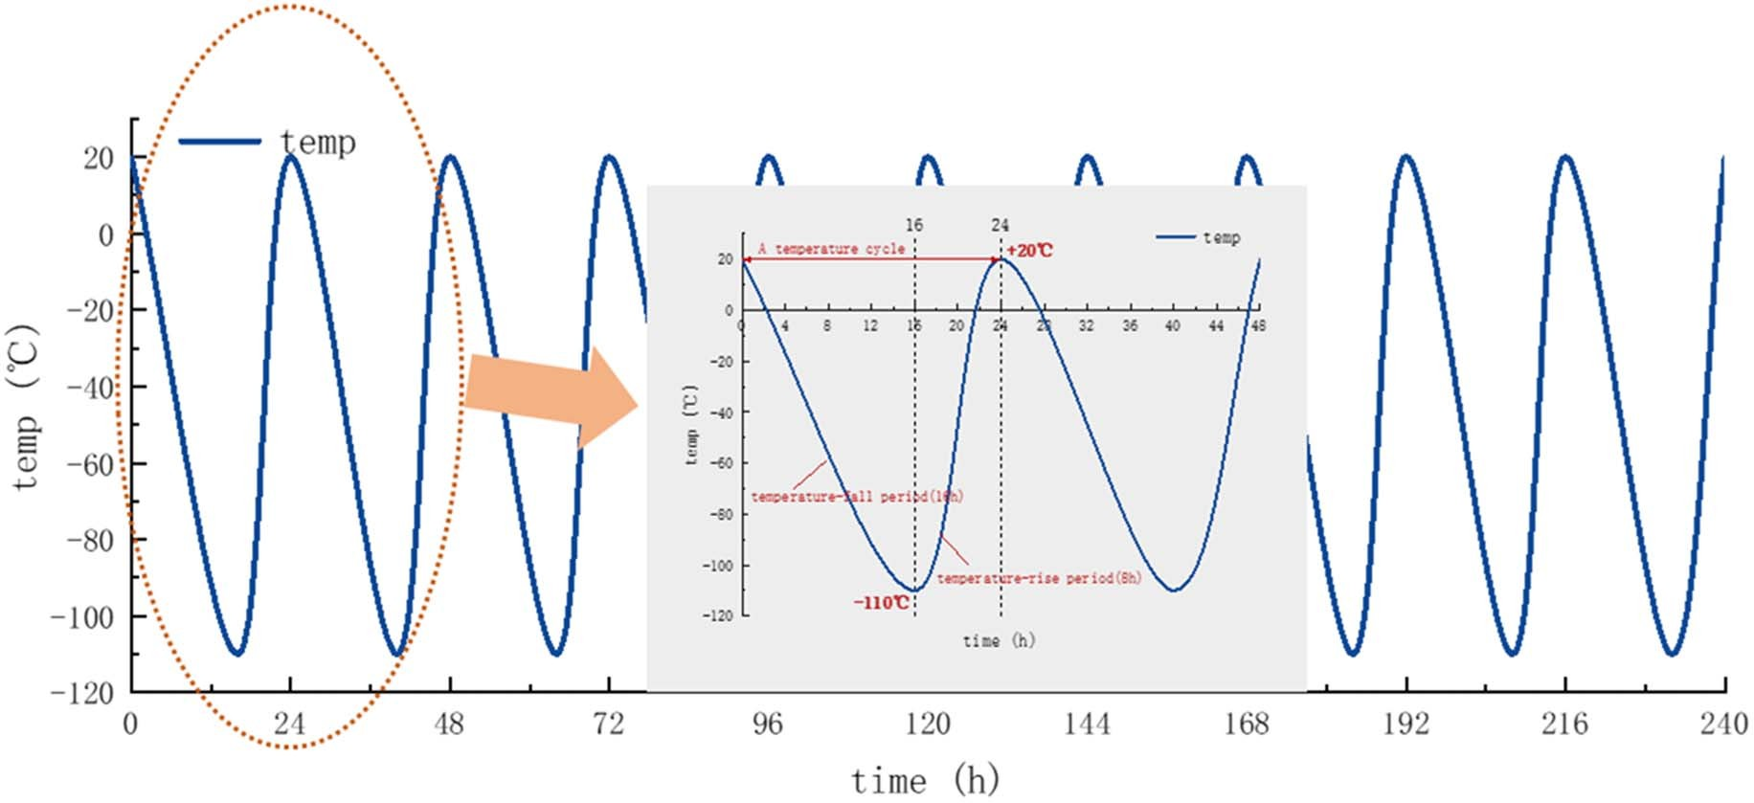
Fig. 1. Temperature curve of the Martian daily cycle.

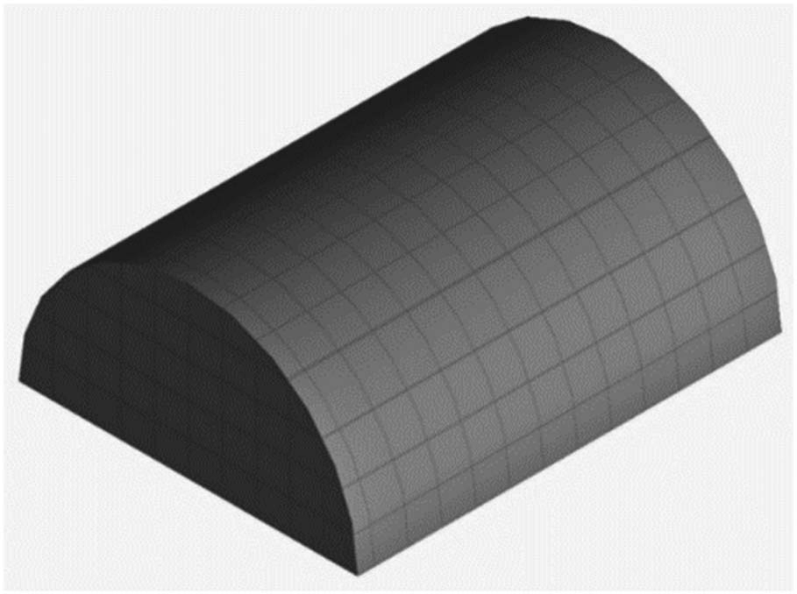
Fig. 2. Mars architecture concept module.

compared with the internal pressure and, therefore, considered negligible.
For example, the calculation of wind loads considers that on Mars, it is important to note that, despite frequent dust storms,
the resulting wind loads are nearly negligible due to the planet’s low atmospheric pressure. According to NASA data, even the strongest Martian storms produce winds of <60 mi/h (NASA 2015). Therefore, with a wind speed of 70 mi/h and an atmospheric density of 0.020 kg/m³, the estimated wind load is calculated to be
9.79 Pa. Even if the presence of dust particles increases the density, leading to a wind load of up to 60.0 Pa for analytical purposes, this value remains insignificant compared with the high internal pres-sure. Additionally, special loads such as Marsquakes, asteroid im-pacts, and meteoroid impacts can be disregarded due to the infrequent geological activity on Mars or other relevant factors, and therefore, will not be discussed further here (Soureshjani and Massumi 2022; Soureshjani et al. 2023).
To improve clarity and streamline calculations, this paper will focus on three key loads for Martian steel structures: gravitational load, internal pressure, and external pressure.

Gravity Load
The simplest structural loads that can be considered for Martian structures and structural design are gravity loads. Gravity load is one of the most important structural loads on which the primary stability of a structure depends. With Mars’ gravitational accelera-tion (g_{M}) being 3.73 m/s², the resultant weight and dead load of Martian structures are significantly reduced compared with their

Downloaded from ascelibrary.org by Xian Jiaotong Liverpool University on 06/23/25. Copyright ASCE. For personal use only; all rights reserved.
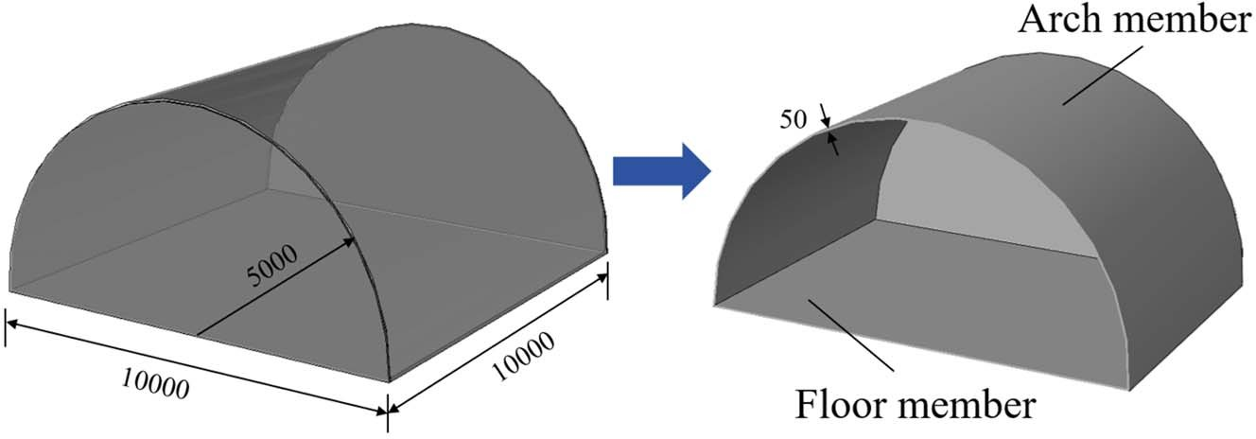
Fig. 3. Mars building structure composition (unit: mm).

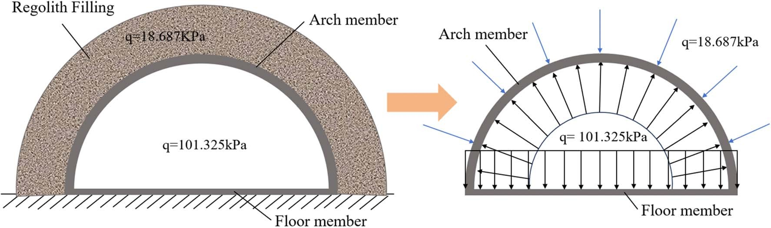
Fig. 4. Diagram of the structure subjected to internal and external pressures.

terrestrial counterparts. However, this reduction in gravity does not simplify the design process; rather, it necessitates a comprehensive consideration of the gravitational effects in conjunction with other environmental loads. Eq. (1) delineates the calculation of the struc-tural dead load for Martian residential edifices as follows:
Downloaded from ascelibrary.org by Xian Jiaotong Liverpool University on 06/23/25. Copyright ASCE. For personal use only; all rights reserved.
D_{M} = mg_{M} (1)
where D_{M} (N) = Martian dead load; g_{M} (m/s²) = gravitational accel-eration of Mars; and m (kg) = mass.

Internal Pressure
Internal pressure is the most challenging force in Martian structural design. To preserve the health of the crew members and provide a human-friendly space in Martian structures, the internal pressure should be equal to the atmospheric pressure on Earth (101.325 kPa) (Soureshjani et al. 2023). Similarly, the International Space Station (ISS) has an internal pressure of 101.3 kPa (14.7 psi) (Earth equivalent). It should be noted that the Martian structures proposed in this study were designed in accordance with 1 atm of internal pressure.

External Pressure
The internal pressure of the structures will create substantial tensile loads on the structure. The overlying regolith, utilized as a shield-ing material, is expected to mitigate the tensile loads at the apex of the structure. Additionally, this regolith layer offers resistance to the deleterious effects of space radiation and micrometeoroid im-pacts. However, due to the reduced Martian gravity, the pressure caused by its weight will not be greater than the internal pressure. Assume that the regolith shield is 3 m high, gravity is 3.73 m/s², and the density of regolith is 1.67 g/cm³ (Kalapodis et al. 2020). The pressure created by the regolith will be 18.687 kPa, which is much less than the minimum required internal pressure. To inves-tigate the thermal fatigue performance of the structure’s surface under the most extreme conditions and to simplify the calculations, this study treats the weight generated by the weathering layer as a uniform pressure applied to the exterior of the structure, without considering factors such as the conductivity of the weathering layer.

Materials and Methods for Numerical Simulation

General
ABAQUS finite-element analysis software is used to simulate the low-temperature alternating fatigue performance of steel structures in the Martian environment, and the numerical simulation is carried
out using sequential thermal coupling, which means that the tem-perature data obtained from the low-temperature alternating-temperature heat-transfer analysis of the structure are substituted into the model as an initial temperature boundary condition to per-form the thermal stress analysis.

Finite-Element Model and Mesh Generation
The 1:1 design dimensions are taken for modeling, and 1,000 mm in the longitudinal direction of the designed structure is taken for numerical simulation analysis, and the model dimensions are shown schematically in Fig. 5. Unlike Earth structures, on Mars, structural damage at any level could lead to disaster. On Mars, a
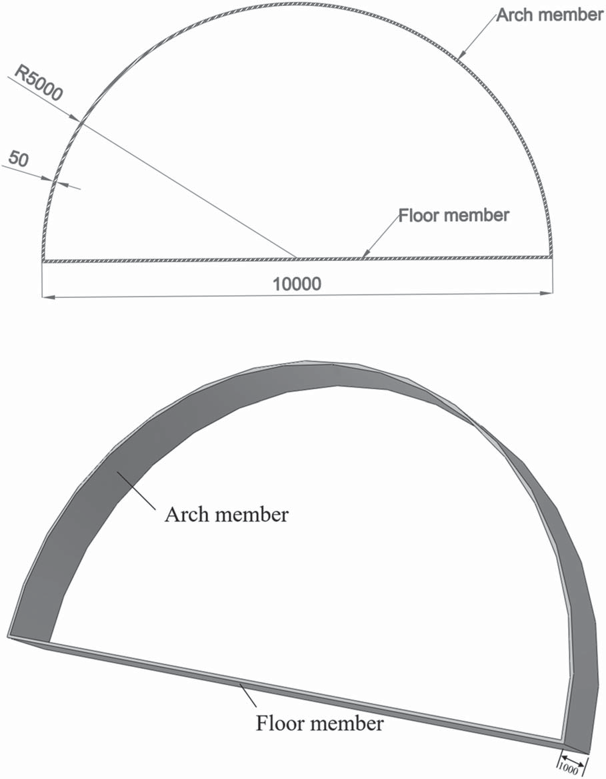
(a)
(b)
Fig. 5. Schematic diagram of structural components (unit: mm): (a) di-mensioning of structural members; and (b) structural component com-position diagram.

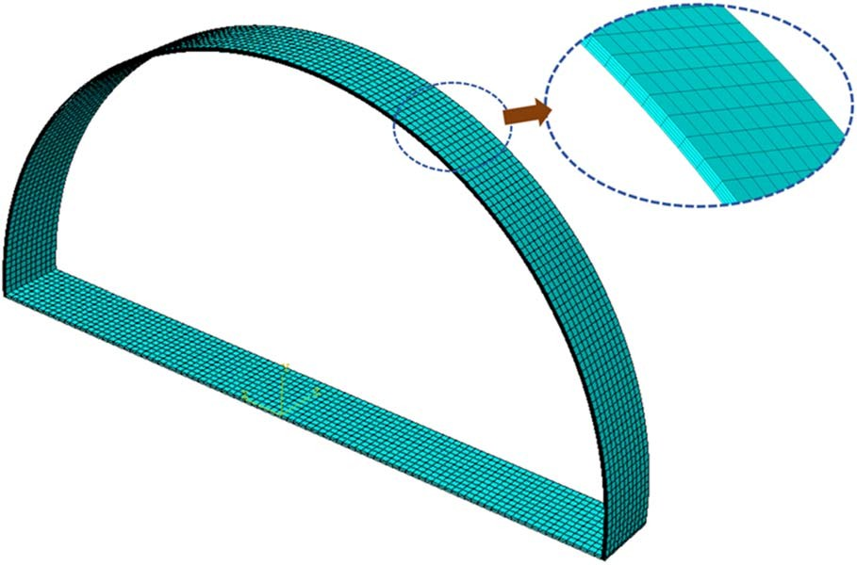
Fig. 6. Mesh generation.

small crack that allows air leakage can cause freezing, expansion, crack propagation, and finally, collapse (Kuster and Delorit 2023). The member adopted the 3D eight-node continuum element with reduced integration point (C3D8R). The element size and meshing are key parameters influencing the finite-element model simulation accuracy. Refine the mesh size of the structure along the thickness direction, as shown in Fig. 6. The final division
unit has a total of 10,080 elements.
In the ABAQUS isotropic material model, it is necessary to de-fine its density, expansion, specific heat, conductivity, as well as elastic and plastic behaviors. The thermal and mechanical parame-ters of the material are given in Table 2.

Boundary Conditions and Load Application
Robert P. Mueller (NASA) delivered a presentation titled “Space Environment & Planetary Civil Engineering Basics,” emphasizing
Table 2. Material parameter

Parameter Steel

Density (kg/m³) 7,850
Conductivity (W/m·°C) 54
Specific heat (J/kg·°C) 425
Expansion coefficient (1/°C) 1.36 × 10⁻⁵ Yield stress (MPa) 250
Young’s modulus (MPa) 2.06 × 10⁵
Poisson’s ratio 0.3
that for buildings in space, long life cycles (5–10 years) and high reliability are required. In this paper, the safety and reliability of the structure over a specified lifespan are studied and analyzed, using an upper limit of 10 Martian years. Temperature boundary conditions are based on the temperature cycle curve shown in Fig. 1 and the temperature distributions of the structure are calcu-lated for 1–10 Martian years (687, 1,374, 2,061, 2,748, 3,435,
4,122, 4,809, 5,496, 6,183, and 6,870 temperature cycles), respec-tively, which are then used as the initial conditions for the structural field. The heat transfer consideration on the outer surface of the structure is mainly thermal radiation and a gravity load of 0.38G is applied to the structure. The numerically calculated boundary conditions and loads applied are shown in Fig. 7 and Table 3.

Results and Discussion
After a series of temperature cycles extending over a period of 1–10 Martian years, the structural integrity was meticulously evaluated. There is no cracking or failure of the structure, indicating that the structural resilience is within the safety parameters. This observa-tion corroborates the structure’s compliance with the prescribed service life criteria of a minimum of 5–10 years for extraterrestrial edifices.

Downloaded from ascelibrary.org by Xian Jiaotong Liverpool University on 06/23/25. Copyright ASCE. For personal use only; all rights reserved.

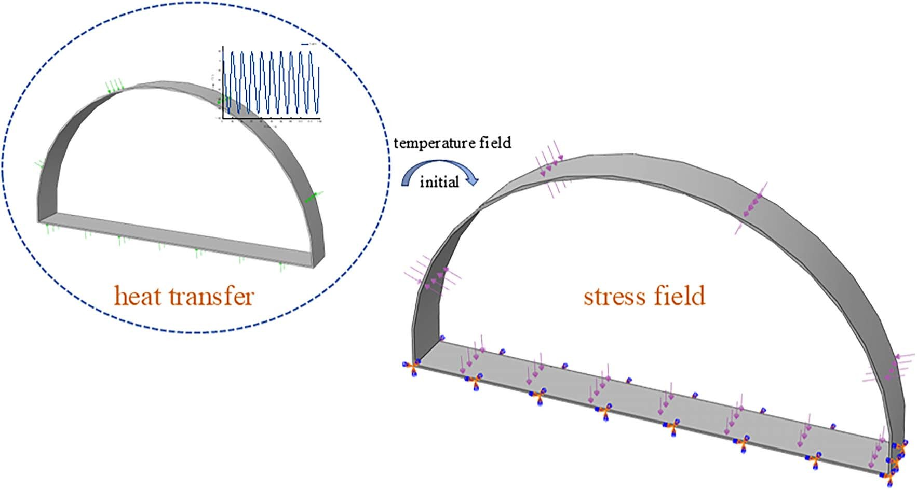
Fig. 7. Structural boundary conditions and load application.

Table 3. Numerical simulation of boundary conditions and load application
temperature cycle curve of the structure is shown in Fig. 8, in which the structure temperature cloud image of key time points

Applied position of the boundary and load application
The inner surface of the arch member and floor member
The exterior surface of the arch member
Boundary conditions and load application
Pressure (101.325 kPa)

Pressure (18.687 kPa)
is specially marked. The corresponding structure temperature cloud image is the same at the same temperature and is not limited to the three points marked in the figure.
Fig. 9 presents a schematic diagram of the heat flux cloud circu-lation of the structure, illustrating that the surface heat flux under thermal loading exceeds that of the interior, and the heat flux of

Floor member The displacement is equal to 0
the structure circulates in the following manner. The direction of

The initial temperature of the stress field
687, 1,374, 2,061, 2,748, 3,435, 4,122,
4,809, 5,496, 6,183, and 6,870
temperature cycle node data
heat flux is shown in Fig. 10. From the figure, it can be seen that the medium picture represents the stage when the ambient temper-ature drops from +20°C to −110°C. During this stage, heat flows from the structure to the external environment, causing the structure
to dissipate heat. In contrast, the picture on the far right shows the

Structural Temperature Field Analysis
In the sequential heat transfer process, the computational model does not account for structural deformations attributable to thermal stresses. Then, the pure heat transfer is first performed on the struc-ture. Owing to the high thermal conductivity of steel, and the tem-perature conduction is fast, there is no temperature delamination in the thickness direction of the steel structure cross section. The
opposite scenario, where the direction of heat flux influences the deformation direction of the structure.

Structural Analysis without a Temperature Cycle
Fig. 11 illustrates the displacement contour map of the structural element within a simplified stress field. An analysis of the figure

Downloaded from ascelibrary.org by Xian Jiaotong Liverpool University on 06/23/25. Copyright ASCE. For personal use only; all rights reserved.
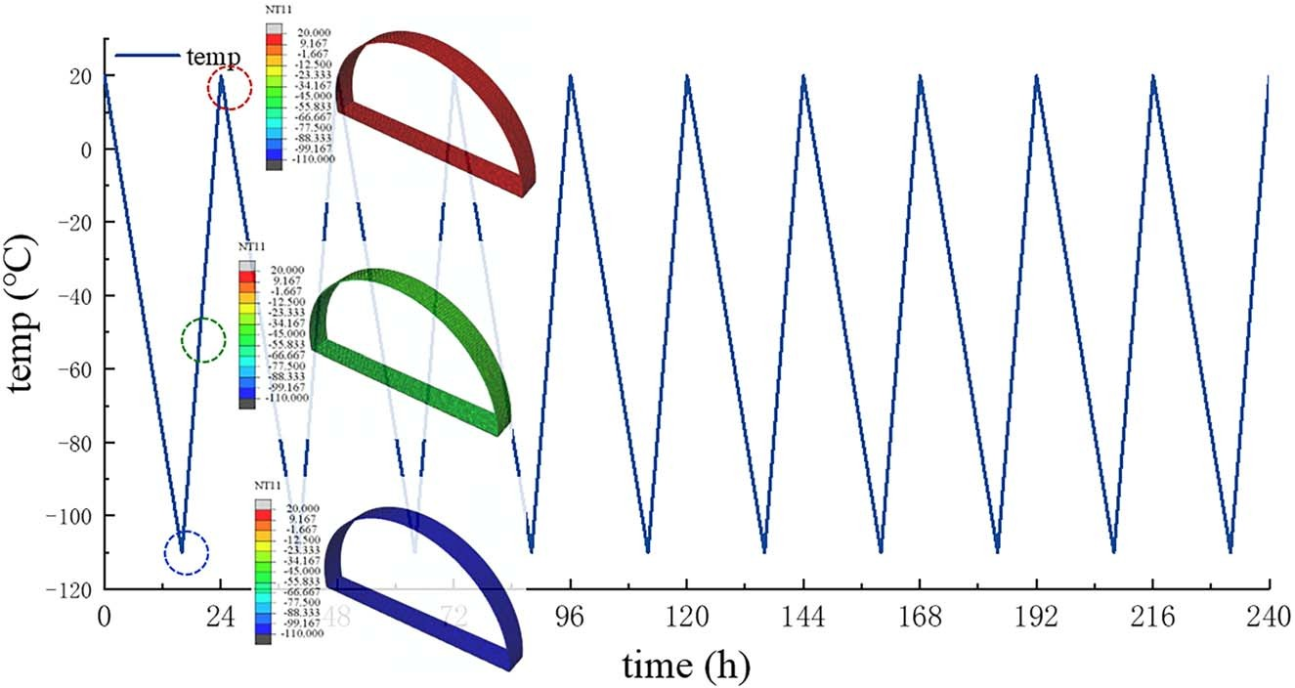
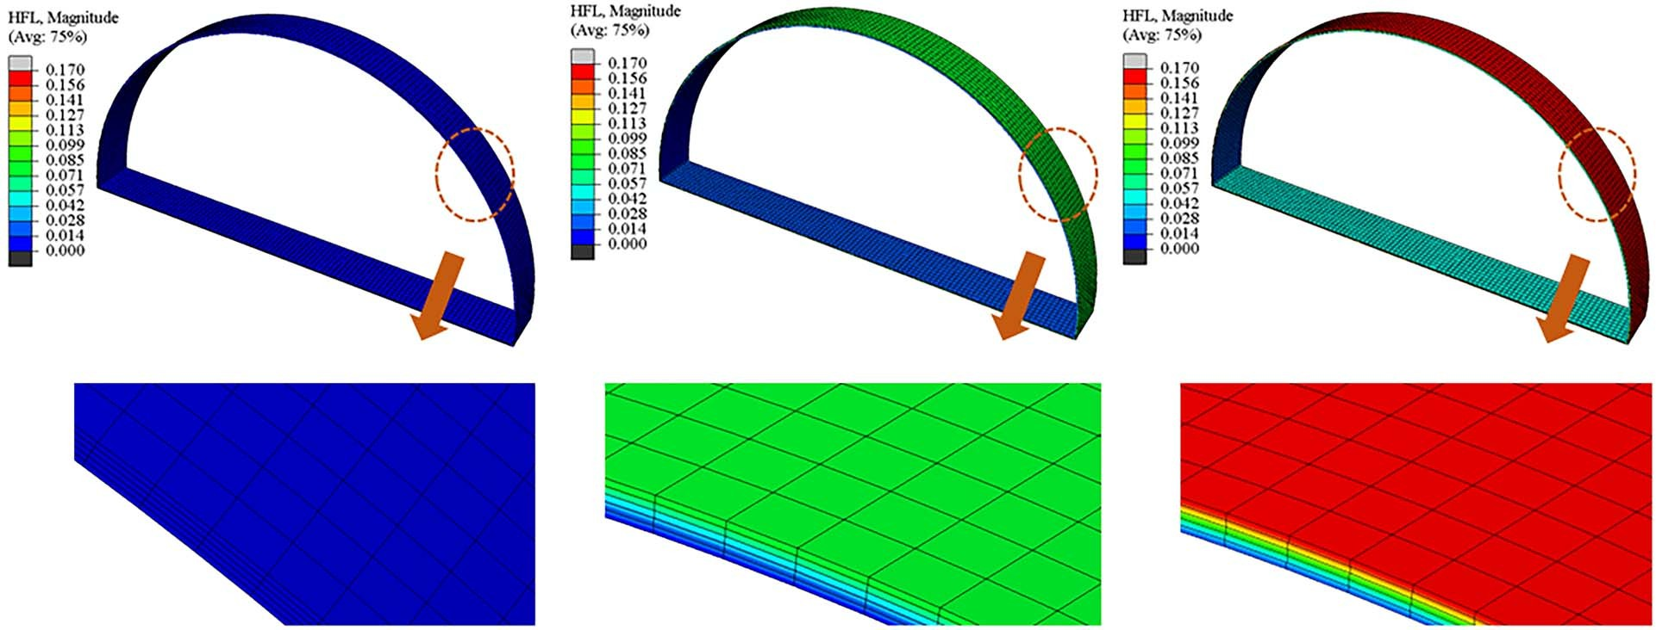
Fig. 8. Schematic diagram of structural temperature cycle curve and temperature cloud maps of critical time point.

Fig. 9. Schematic diagrams of structural heat flux.

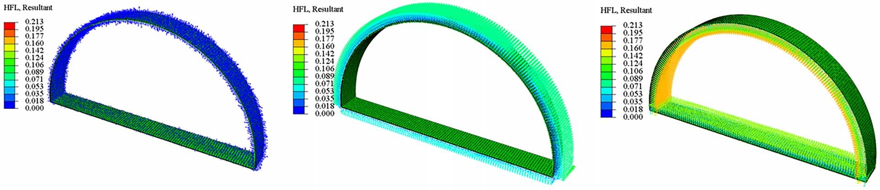
Fig. 10. Heat flux direction diagram.

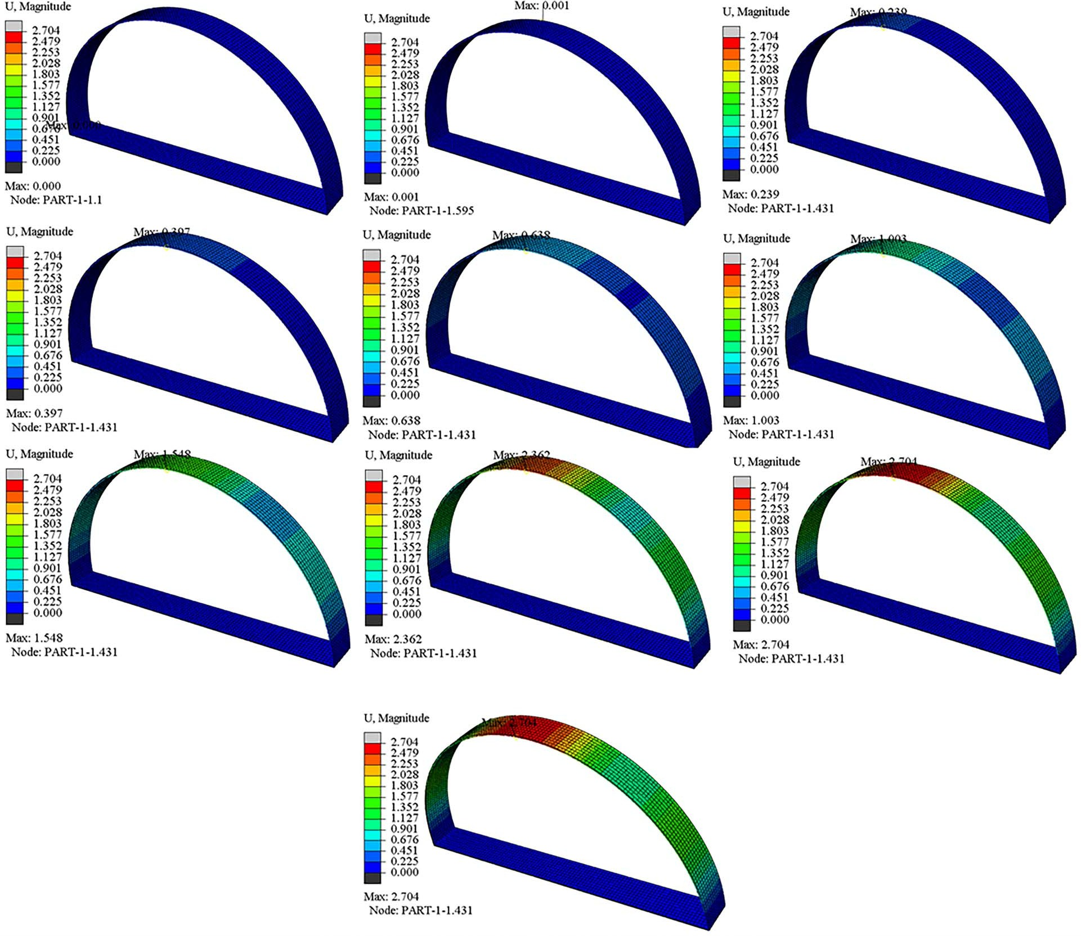
(a)
(b)
Fig. 11. Structure displacement contour map: (a) contour maps of the displacement process; and (b) contour map of the last substep displacement.

reveals a linear augmentation in both displacement and stress of the arch structure over time, and the curves of the displacement and stress of the structural vault with the time are shown in Fig. 12.
Downloaded from ascelibrary.org by Xian Jiaotong Liverpool University on 06/23/25. Copyright ASCE. For personal use only; all rights reserved.
Upon completion of the analysis, the apex displacement of the arch was recorded at 2.70406 mm, with this maximum displace-ment manifesting at the site of the vault. Notably, there was no

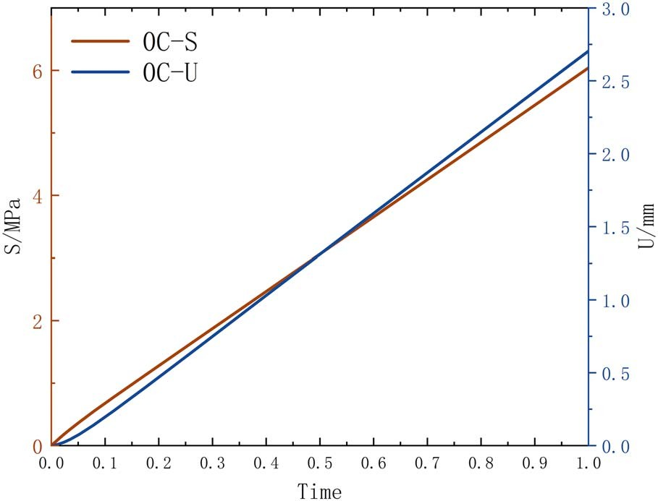
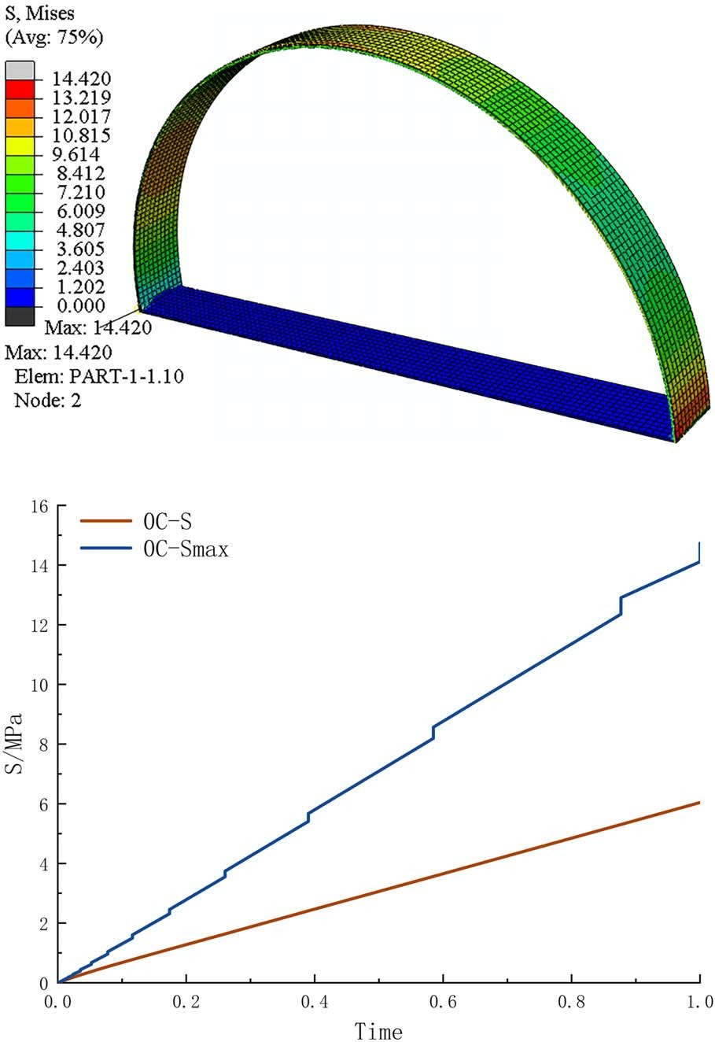
Fig. 12. Curve of displacement and stress of structural vault with time.
(a)
(b)

damage to the structure, affirming the structural integrity and safety.
Fig. 13(a) delineates the stress distribution within the struc-tural members situated in a rudimentary stress field. It is discern-ible from the figure that the stress apex is located at the juncture of the floor member and the arch member. Fig. 13(b) contrasts the stress-time profiles at the arch’s zenith and the locus of the maximal stress point (denoted as S_{max}). The stress evolution at S_{max} is characterized by a more pronounced rate of change and a higher peak value, signifying an amplified response to structural alterations at the interface of the floor member and the arch member.

Structural Stress Distribution under Low-Temperature Fluctuations
When the structure was subjected to 1,374 temperature cycles (a set of conditions was selected for specific analysis), it was observed that, unlike the stress distribution of the structure with a simple stress field [Fig. 14(a)], the stress distribution appeared to be dras-tically changed when the structure was subjected to temperature cy-cling [Fig. 14(b)]. Specifically, in the absence of temperature cycling and under the influence of merely the internal and external pressure differential, the stress was predominantly localized on the

Fig. 13. Stress distribution of structure and stress curves of different nodes under the background of no temperature cycle: (a) structural stress distribution; and (b) stress curves of the vault and point-S_{max.}

domed arch. Conversely, after the temperature cycling, stress con-centration was observed to shift to the floor member of the structure.
This shift in stress distribution can be attributed to several fac-tors. Primarily, the internal and external pressures engendered a substantial pressure gradient upon the application of stress,

Downloaded from ascelibrary.org by Xian Jiaotong Liverpool University on 06/23/25. Copyright ASCE. For personal use only; all rights reserved.

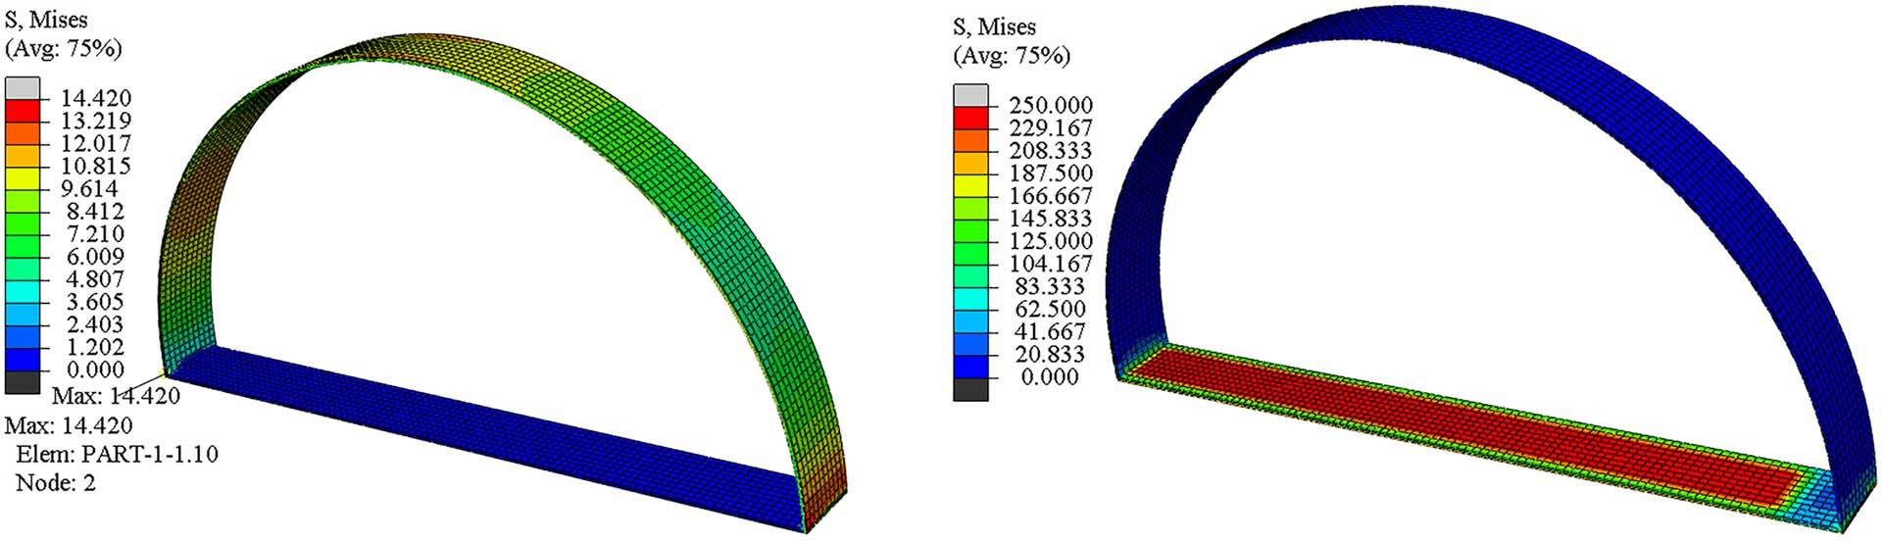
(a)
(b)
Fig. 14. Structure stress distribution: (a) structure is subject to internal and external pressure only; and (b) structure is subjected to internal and external pressure +1,374 low-temperature alternating cycles.

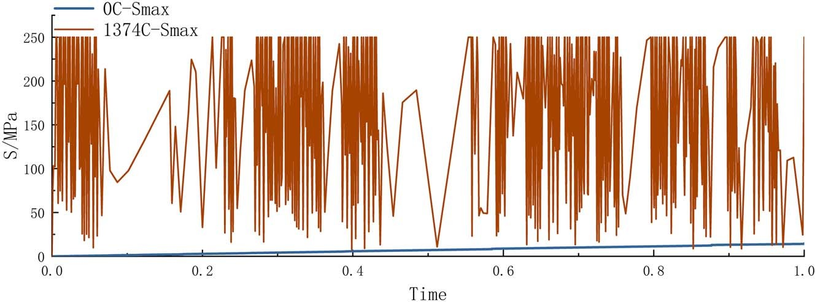
Fig. 15. Time history curve of stress change of S_{max} after 1,374 temperature cycles.

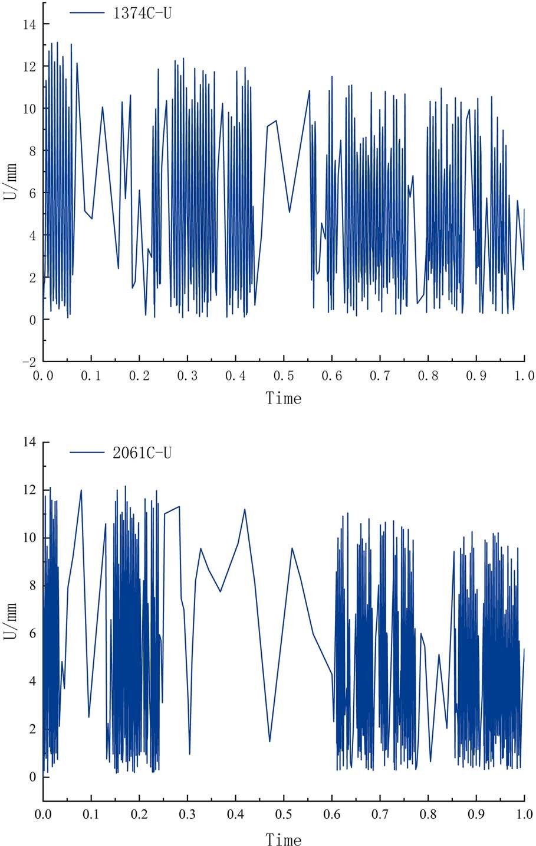
culminating in stress concentration on the arch. However, the in-troduction of 1,374 cryogenic cycles instigated material thermal expansion and contraction, thereby influencing the structural de-formation. Given that the floor member was solely subjected to internal pressure and served as the foundational support for the entire structure, they exhibited heightened sensitivity to tempera-ture fluctuations. The differences in geometry and local con-straints restricted thermal deformation in various regions, leading to stress concentration at the floor member. These obser-vations unequivocally demonstrate that temperature cycling exerts a profound impact on the stress distribution of domed steel struc-tures, thus changing the location of stress concentration within the structure.
(a)
(b)
However, both of them are the same in that the maximum stress
occurs at the connection between the arch member and the floor member. Fig. 15 delineates the temporal progression of the maxi-mum stress point (S_{max}) under two distinct scenarios: one where the structure endures solely the internal and external pressure dif-ferentials, and another after 1,374 temperature cycles. The graphi-cal representation elucidates that S_{max} exhibits a cyclical pattern posttemperature cycling, in stark contrast to its linear augmentation under the former condition. This phenomenon indicates that tem-perature cycling precipitates fatigue damage at the structural inter-connections, thereby engendering a deterioration of material characteristics and compromising the edifice’s overall stability. The accumulation of fatigue causes the stress distribution to change dynamically, and the gradual degradation of the material weakens its resistance to deformation, leading to fluctuations in the stress–time curve. In light of these findings, the architectural design of Martian habitats must incorporate augmented thickness of the floor member, thereby bolstering its load-bearing capacity. Further-more, the interface between the dome and the floor member war-rants refinement to mitigate stress concentration, ensuring the structural integrity of the construction.

Structural Vault Displacement under Low-Temperature Fluctuations
Downloaded from ascelibrary.org by Xian Jiaotong Liverpool University on 06/23/25. Copyright ASCE. For personal use only; all rights reserved.
As shown in Fig. 16, the displacement variation of the vault under different temperature cycles is illustrated. It is evident from the graph that as the number of temperature cycles increases, the vault displacement no longer follows the monotonous linear up-ward trend seen in the absence of temperature cycles [as shown in Fig. 13(b)]. Instead, thermal expansion and contraction in the low-temperature environment lead to cyclical displacement fluctu-ations. This pattern arises from the repeated thermal cycling, in which the alternating temperatures drive significant displacement

Fig. 16. Curves of vault displacement under different temperature cy-cles: (a) 1,374 temperature cycles; and (b) 2,061 temperature cycles.

changes. The extreme temperature variations on Mars further inten-sify the accumulation and release of thermal stress, amplifying the displacement fluctuations in the structure.
An examination of the structural displacement curves, following 687–6,870 low-temperature alternating cycles (encompassing 10 distinct sets of conditions), reveals that the maximum displacement

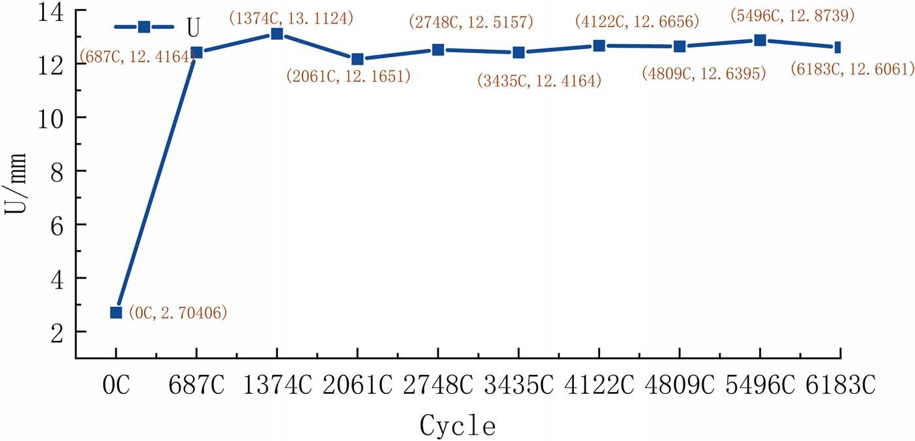
Fig. 17. Maximum displacement of vault point under different cycle periods.

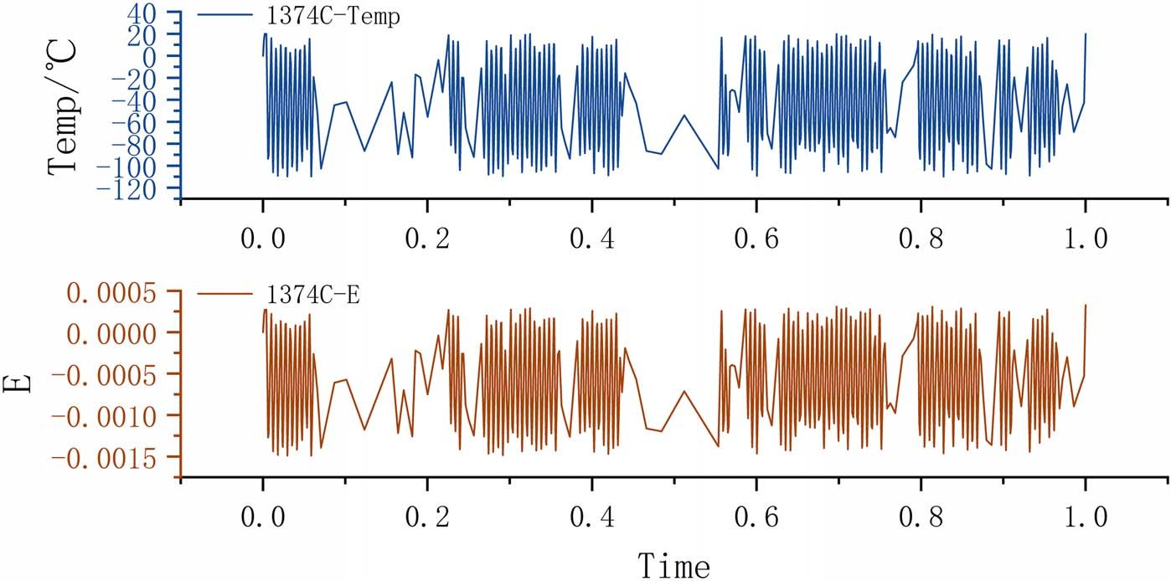
Fig. 18. Structural strain and temperature change under 1,374 cycles.

values of the vaults—12.4164, 13.1124, 12.1651, 12.5157,
Downloaded from ascelibrary.org by Xian Jiaotong Liverpool University on 06/23/25. Copyright ASCE. For personal use only; all rights reserved.
12.4164, 12.6656, 12.6395, 12.8739, and 12.6061 mm—are all
markedly greater than those recorded under nontemperature cy-cling conditions, as shown in Fig. 17. Research indicates that cycli-cal thermal stress loading accumulates effects on the material’s microstructure, gradually leading to fatigue damage, which reduces stiffness and strength. As a result, the deformation characteristics are altered, increasing vault displacement and compromising the structure’s overall stability and durability.
However, it is discernible that the maximum displacement of the vault does not exhibit a monotonic increase concomitant with the escalation in the number of temperature cycles. At 2,061 cycles, a noticeable decrease in maximum displacement is observed com-pared with 1,374 cycles. This suggests that the structure may have reached a critical point at 1,374 cycles, where material fatigue began, reducing its strength and stiffness. By 2,061 cycles, the maximum displacement had dropped significantly to 12.1651 mm, indicating material fatigue or stress redistribution, which diminished the structure’s deformation capacity under thermal cycling. In subsequent cycles, displacement remained relatively
stable with minor fluctuations, suggesting that after the initial im-pact of temperature cycling, the structure stabilized, with no signif-icant changes in displacement. This trend reflects the material’s fatigue characteristics under continuous thermal cycling, suggest-ing that an equilibrium between stress and deformation may have been reached in the previous cycle stages.

Analysis of Temperature and Strain Law
Fig. 18 delineates the strain–time history curve juxtaposed with the temperature–time history curve of the structure’s vault, after under-going 1,374 cycles of low-temperature fluctuations. During the temperature cycling, the structure incurs thermal stress due to tem-perature fluctuations, which induces strain. The structure did not experience significant plastic deformation under the temperature fluctuations, primarily exhibiting elastic deformation. The struc-tural strain maintained a linear relationship with the externally ap-plied low-temperature cyclic load, and the thermal expansion effect dominated the strain response of the structure, causing the structure to expand or contract directly in response to the temperature

fluctuations. This correlation is manifested in the strain–time curve, which exhibits notable congruence with the temperature–time curve.
Downloaded from ascelibrary.org by Xian Jiaotong Liverpool University on 06/23/25. Copyright ASCE. For personal use only; all rights reserved.

Conclusion and Discussion
Using ABAQUS finite-element numerical simulation software, a full-scale steel circular arch model suitable for Mars with high in-ternal pressure as the dominant environment was established. The temperature changes, stress distribution, and displacement changes of the structure under different Mars low-temperature alternating periods were simulated.
- The structure was subjected to 1–10 Martian years of tempera-ture cycling without structural damage or cracking, indicating that this 50-mm-thick steel structure consisting of a semicircular arch member and a flat floor member is capable of meeting the Martian environment dominated by high internal pressure plus subjected to temperature cycling.
- According to the stress distribution of the structure under low-temperature fluctuations, it was obtained that after the structure has experienced the low-temperature cycles, the stress is con-centrated in the floor member, and the maximum value of the stress occurs at the connection between the bottom of the arch member and the bottom floor member. It is recommended that the structural design of the Mars construction should thicken the thickness of the floor member to improve the bearing capac-ity of the floor member, and optimize the connection between the round arch member and the floor member, to reduce the stress concentration of the structure and improve the durability of the structure.
- Upon subjecting the structure to thermal cycling, the vault’s dis-placement exhibits a cyclical alteration pattern. The low-temperature fluctuation cycles unequivocally precipitate an in-cremental accrual of material fatigue damage. However, it is noteworthy that the vault’s maximal displacement did not ex-hibit a monotonic escalation with the proliferation of thermal cycles. Intriguingly, at the 2,061st cycle, the maximal displace-ment value conspicuously diminished in comparison with that observed at the 1,374th cycle.
Research on structural temperature fatigue in the extreme envi-ronment of Mars is currently limited. In this paper, numerical sim-ulations are employed to model the performance and displacement variations of steel structures under low-temperature fluctuations on Mars. The structural stress forms in the Martian environment, which differ from those on Earth (with structural internal pressure being predominant), were systematically analyzed. Low-temperature alternating loads were applied to the structures, and their stability and durability were characterized through metrics such as stress distribution and displacement variations. The boun-dary condition setting methods and numerical simulation results presented in this study aim to provide theoretical references for fu-ture numerical analyses and structural designs in the Martian envi-ronment. Looking ahead, experimental and numerical simulation studies on different structural forms under Martian conditions are planned. It is hoped that these findings will offer scientific insights for enhancing the safety and development of sustainable buildings on Mars.

Data Availability Statement
All data, models, and codes generated or used during the study appear in the published article.

Acknowledgments
This study was partially supported by the National Key R&D Pro-gram of China (No. 2022YFB2602700), the National Natural Sci-ence Foundation of China (No. 52378216), the National Natural Science Foundation of China for Excellent Young Scientists Fund (HW2021006), and the Fundamental Research Funds for the Central Universities (Grant No. 2022CDJKYJH052).

References
Atri, D., N. Abdelmoneim, D. B. Dhuri, and M. Simoni. 2023. “Diurnal variation of the surface temperature of Mars with the Emirates Mars mission: A comparison with curiosity and perseverance rover measure-ments.” Mon. Not. R. Astron. Soc.: Lett. 518 (1): L1–L6. https://doi.org
/10.1093/mnrasl/slac094.
Benaroya, H. 2006. “Structures for manned habitation.” In Earth & space 2006: Engineering, construction, and operations in challenging envi-ronment, edited by R. B. Malla, W. K. Binienda, and A. K. Maji, 1–8. Reston, VA: ASCE.
Benaroya, H., and M. Ettouney. 1992a. “Design and construction consider-ations for lunar outpost.” J. Aerosp. Eng. 5 (3): 261–273. https://doi.org
/10.1061/(asce)0893-1321(1992)5:3(261).
Benaroya, H., and M. Ettouney. 1992b. “Framework for evaluation of lunar base structural concepts.” J. Aerosp. Eng. 5 (2): 187–198. https://doi.org
/10.1061/(asce)0893-1321(1992)5:2(187).
Dronadula, R., and H. Benaroya. 2021. “Hybrid lunar inflatable structure.”
Acta Astronaut. 179: 42–55. https://doi.org/10.1016/j.actaastro.2020.10
.039.
Hoffman, S. J. 1997. “Human exploration of Mars: The reference mission of the NASA Mars exploration study team (Vol. 6107).Houston: National Aeronautics and Space Administration, Lyndon B. Johnson Space Center.
Jarvstrat, N., and C. Toklu. 2004. “Design and construction for self-sufficiency in a lunar colony.” ASEM2004. Accessed January 11, 2025. www.moonisru.com/information/ASEM2004.pdf.
Kalapodis, N., G. Kampas, and O.-J. Ktenidou. 2020. “A review towards the design of extraterrestrial structures: From regolith to human out-posts.” Acta Astronaut. 175: 540–569. https://doi.org/10.1016/j
.actaastro.2020.05.038.
Kuster, L. E., and J. D. Delorit. 2023. “Viability of construction material within an extraterrestrial environment.” Earth Space 2022: 602–615. https://doi.org/10.1061/9780784484470.053.
Landis, G. A. 2009. “Meteoritic steel as a construction resource on Mars.”
Acta Astronaut. 64 (2–3): 183–187. https://doi.org/10.1016/j.actaastro
.2008.07.011.
Lim, S., V. L. Prabhu, M. Anand, and L. A. Taylor. 2017. “Extra-terrestrial construction processes—Advancements, opportunities and challenges.” Adv. Space Res. 60 (7): 1413–1429. https://doi.org/10.1016/j.asr.2017
.06.038.
Malla, R. B., and K. M. Brown. 2012. “Frequency analysis of a frame-membrane lunar habitat considering extreme temperatures and internal pressure.” In Earth and space 2012: Engineering, science, construction, and operations in challenging environments, edited by
K. Zacny, R. B. Malla, and W. Binienda, 1400–1412. Reston, VA: ASCE.
Mottaghi, S. 2013. Design of a lunar surface structure. New Brunswick, NJ: Rutgers, State Univ. of New Jersey, School of Graduate Studies.
Mottaghi, S., and H. Benaroya. 2015. “Design of a lunar surface structure. I: Design configuration and thermal analysis.” J. Aerosp. Eng. 28 (1): 04014052. https://doi.org/10.1061/(asce)as.1943-5525.0000382.
NASA (National Aeronautics and Space Administration). 2015. “The fact and fiction of Martian dust storms.” Accessed February 4, 2024. https:/
/www.nasa.gov/content/the-fact-and-fiction-of-martian-dust-storms.
NASA and Bradley University. 2019. “On-site habitat competition rules.” Accessed March 30, 2024. www.bradley.edu/sites/challenge/assets
/documents/3DPHPhase3Rules-v3.pdf.

Petrov, G. I. 2004. “A permanent settlement on Mars: The first cut in the land of a new frontier.” Ph.D. thesis, Dept. of Architecture, Massachusetts Institute of Technology.
Downloaded from ascelibrary.org by Xian Jiaotong Liverpool University on 06/23/25. Copyright ASCE. For personal use only; all rights reserved.
Ruess, F., J. Schaenzlin, and H. Benaroya. 2006. “Structural design of a lunar habitat.” J. Aerosp. Eng. 19 (3): 133–157. https://doi.org/10
.1061/(asce)0893-1321(2006)19:3(133).
Sartipi, F. 2021. “Preliminary structural design for extraterrestrial build-ings.” J, Constr. Mater. 2: 2–3, https://doi.org/10.36756/jcm.v2.2.3.
Soureshjani, O. K., and A. Massumi. 2022. “Martian buildings: Structural forms using in-place sources.” Sci. Rep. 12 (1): 21992. https://doi.org
/10.1038/s41598-022-25507-5.
Soureshjani, O. K., A. Massumi, and G. Nouri. 2023. “Martian buildings: Design loading.” Adv. Space Res. 71 (5): 2186–2205. https://doi.org/10
.1016/j.asr.2022.10.066.
Troemner, M., E. Ramyar, J. Meehan, B. Johnson, N. Goudarzi, and
G. Cusatis. 2022. “A 3D-printing centered approach to Mars habitat ar-chitecture and fabrication.” J. Aerosp. Eng. 35 (1): 04021109. https:// doi.org/10.1061/(asce)as.1943-5525.0001359.
Zhu, Q., et al. 2024. “Automated synthesis of oxygen-producing catalysts from Martian meteorites by a robotic AI chemist.” Nat. Synth. 3 (3): 319–328. https://doi.org/10.1038/s44160-023
-00424-1.

