RESEARCH ARTICLE

www.small-journal.com

Balancing Strength and Extreme Thermal Resilience in Lunar Regolith Composites: The Role of Multi-Walled Carbon Nanotubes
Andrea J. Hoe, Amirreza Tarafdar, Wenhua Lin, Michael R. Fiske, Jennifer E. Edmunson, and Yeqing Wang*

A. J. Hoe, A. Tarafdar, W. Lin, Y. Wang
Department of Mechanical and Aerospace Engineering Syracuse University
Syracuse, NY 13244, USA E-mail: ywang261@syr.edu
M. R. Fiske
Amentum Space Exploration Division serving NASA MSFC Huntsville, Alabama 35806, USA
J. E. Edmunson
NASA Marshall Space Flight Center Huntsville, AL 35812, USA

The ORCID identification number(s) for the author(s) of this article can be found under https://doi.org/10.1002/smll.202502220
© 2025 The Author(s). Small published by Wiley-VCH GmbH. This is an open access article under the terms of the Creative Commons Attribution-NonCommercial-NoDerivs License, which permits use and distribution in any medium, provided the original work is properly cited, the use is non-commercial and no modifications or adaptations are made.
DOI: 10.1002/smll.202502220

Introduction
Establishing sustainable habitats on the Moon or other celestial bodies requires overcoming numerous challenges, particu- larly in terms of resource management and material sourcing. Extraterrestrial construc- tion faces significant resource constraints primarily due to the high cost of transport- ing materials. According to NASA, it costs
The National Aeronautics and Space Administration’s (NASA) Artemis program stands at the forefront of commercial space initiatives, aiming to establish sustainable lunar habitats, demanding resilient construction materials with minimal reliance on Earth-based resources. In response to these demands, this study explores the feasibility of reinforcing lunar regolith with multi-walled carbon nanotubes (MWCNTs) while relying on minimal water and additives for composite fabrication as a potential solution for building semi-permanent Moon bases. Composites incorporating 0.00, 0.25, 0.50, and 1.00 wt.% MWC- NTs are subjected to freeze-thaw cycles, vacuum pressures, ambient environ- ments, and oven-curing methods to emulate the Moon’s harsh environment. Results show that ambient-cured composites containing MWCNTs achieve compressive strengths exceeding 35 MPa, resulting in a 44.44% increase com- pared to the sample without MWCNTs, highlighting the reinforcing potential of carbon nanotubes (CNTs) for extraterrestrial applications. However, thermal cycling reveals performance limitations due to mismatched coefficients of thermal expansion between MWCNTs and the regolith matrix, causing micro- cracking. In contrast, vacuum-cured MWCNT-free samples surpass 45 MPa, indicating that curing protocols can significantly influence densification
and mechanical properties. These findings underscore the trade-offs between material composition, curing approaches, and thermal stability, offering
key insights into designing robust, resource-efficient lunar construction.
≈$10 000 to send one pound of material
into orbit,[1] making sourcing local materi-
als essential for lunar habitats. Due to this high cost, utilizing lunar regolith as a pri- mary construction material becomes an im- portant strategy as it can be excavated di- rectly from the surface of the Moon. Addi- tionally, the discovery of ice at the Moon’s south pole further enhances the potential for in situ resource utilization, as water serves multiple life-support[2] and various material applications. This has driven ef- forts to efficiently utilize limited water sup- plies, including combining regolith with acidic or alkaline solutions to create lu- nar concrete-like materials.[3] Another strat- egy to lower off-site material needs is to combine regolith with superplasticizers to lower water needs.[4] Urea, which serves as
an effective superplasticizer, can be locally sourced from a hu-
man’s urine, sweat, and tears.[5] Urea, disrupts hydrogen bonds, decreasing the viscosity of composite mixtures and improving their workability while minimizing water requirements. Simi- larly, attempts to 3D printing habitats using regolith mixtures[G] heavily depend on the workability of the materials used, as they must flow easily during the printing process while maintaining sufficient stability to form complex structures. Pilehvar et al.[7] found that the addition of urea in lunar regolith composites re- duced the water needed for workability by up to 32%. However, researchers also found a direct relationship between increasing urea content and decreasing compressive strength under both vacuum and ambient pressure conditions. The results showed promise to decrease the water needs but to advance further, it is essential to develop materials that have a higher compressive strength.
Beyond the water usage, the harsh environmental condition on the Moon introduces additional engineering challenges, such as


Small 2025, 2502220

2502220 (1 of 15)
© 2025 The Author(s). Small published by Wiley-VCH GmbH



extreme temperature fluctuations ranging from ≈114 to −171 °C, radiation exposure, and micrometeorite impacts.[8] Therefore,
materials must be capable of withstanding harsh conditions with extreme temperature fluctuations, by providing effective thermal insulation, while offering protection against physical and envi- ronmental hazards. A study by Zhang et al.[9] identified a 72-h curing scheme as suitable for lunar pavement construction, with compressive strengths reaching 31.2 MPa. However, representa- tive cycling tests caused notable deterioration, including flexural strength reductions of up to 70%, microcrack formation, and in- creased porosity. These findings emphasize the importance of ad- dressing not only vacuum conditions but also the repeated ther- mal stresses inherent to the lunar surface.
Identifying and implementing strategies to ensure mechanical properties while minimizing the detrimental effects of extreme environmental conditions is essential for space-based construc- tion. In designing composites for space applications, there is of- ten a balance between structural performance and payload mass.
A compressive strength of ≈G MPa is typically adequate for lu-
nar architecture due to lower gravity (one-sixth of Earth’s),[10] but
achieving higher strength, comparable to the 35 MPa needed for terrestrial structures,[11] is desirable to ensure safety in the ex- treme lunar condition. Existing literature reports lunar regolith composite compressive strengths ranging broadly from 12 to 120 MPa, highlighting significant variability of additives and po- tential for further optimization.[12] Polymers, for instance, are un- suitable for space due to the cost of transportation, low thermal stability, and radiation sensitivity.[ 13] However, magnesium[14] is beneficial for sintering but is less practical for near-room- temperature curing conditions. CNTs on the other hand, offer significant advantages compared to other additives with their ex- ceptional tensile/compressive strength,[15] superior stiffness, en- hanced structural integrity, and compatibility with 3D printing. CNTs have been widely used to augment various composite mate- rials’ mechanical properties and environmental resistance, such as aircraft components and concrete composites.[ 1G–20] Bodnarova et al.[21] found that adding CNTs into concrete can effectively im- prove its mechanical properties and durability. Enhanced CNT dispersion improved mechanical properties by filling internal pores, reducing porosity, and strengthening the interface tran- sition zone, resulting in greater compressive strength by 11.9% and 17.30% flexural strength, frost resistance, and impermeabil- ity, even after 100 freeze-thaw cycles. Since this study uses a very low concentration of CNTs (0.0015 and 0.012 wt.%), the im- pact on the matrix’s overall thermal expansion properties is min- imal, avoiding significant internal stresses during temperature changes. Several studies have highlighted the advantages of us- ing CNTs in space applications due to their exceptional strength- to-weight ratio.[22] Notably, Garcia et al.[23] fabricated highly dense lunar regolith composites by applying 250 MPa of pressure in a pellet die and using CNT additives. The resulting compres-
sion properties enhanced from ≈15 MPa using 0.G0 wt.% CNT
to 100 MPa using 7.00 wt.% CNT. However, since this study did
not include lunar cycle temperature cycling, which is crucial for space habitation, the true impact of CNT additives under these conditions remains uncertain. It is also anticipated that apply- ing a pressure of 250 MPa, similar to that used by Garcia et al., would result in a significant increase in the strength observed in this study which only uses a pressure of 8 MPa due to equipment
limitations. Despite the potential benefits, such high pressures are highly unfeasible for space applications.
Although prior research has demonstrated impressive com- pressive strengths using advanced matrices, many of these ap- proaches rely on high water content (up to 30 wt.%),[24] over- look temperature cycling tests,[25,2G] or provide limited chemi- cal analysis which are factors that limit their feasibility for lunar construction.[27] To address these gaps, the present study intro- duces a novel synthesis method that provides a more sustain- able and efficient approach for constructing future lunar habi- tats. This method integrates MWCNTs into lunar regolith com- posites while minimizing water usage to 12.48 wt.%. Addition- ally, it employs a particle size tuning strategy that combines an 80:20 ratio of fine-to-coarse regolith fractions to optimize the mi- crostructure. MWCNTs are also paired with urea, and the re- search uniquely adopts an acidic formulation. Central to this study is its emphasis on the lunar environment, where stabil- ity is assessed through the effects of thermal cycling, vacuum pressure curing, and varying MWCNT weight percentages. By examining these factors’ influence on microstructure and com- pressive strength, the study aims to develop regolith-based com- posites capable of achieving compressive strengths exceeding 35 MPa while retaining resilience under extreme lunar condi- tions. This work provides a comprehensive chemical, experimen- tal, and simulation-based analysis of the benefits of CNTs for re- golith composites, while also identifying areas for improvement. The proposed mechanisms offer valuable insights to guide future research directions and advance the development of optimized regolith-based materials for lunar habitats.

Results and Discussion

Mechanical Strength Enhancement with MWCNT Inclusion without Temperature Cycling

For the purpose of examining the lunar conditions’ influence on the regolith composites, this study follows three distinct pro- cessing routes that are evaluated with different preconditions (Figure 1a). Route 1 serves as the baseline for comparison consist- ing of ambient curing without temperature cycling. Route 2 com- bines ambient curing with four temperature cycles simulating extreme day-night fluctuations on the lunar surface (Figure 1b).
The temperature gradually increases from 80 °C to a peak of 117 °C, then decreases to a minimum of −80 °C before return- ing to 80 °C, completing one full cycle. Route 3 starts with vac-
uum curing, followed by the same thermal cycling as in Route 2,
thereby enabling an evaluation of how reduced atmospheric pres- sure and extreme temperature variations jointly influence com- posite performance. Unlike the Moon’s continuous thermal gra- dient, we cycled between an oven, refrigerator, and ultra-freezer, which may have caused inconsistencies in thermal exposure.
Real lunar temperatures at night were ≈−171 °C, but due to equipment limits, we were only able to reach −80 °C.
In exploring the different processing routes with varying
MWCNT concentrations, there is a focus on a more accessible
processing approach using room temperature pre-curing con- ditions and low curing conditions (≈100 °C), in contrast to the high-temperature sintering processes (>1000 °C) typically used
in existing research.[28–30] The composition of the composite is

Small 2025, 2502220
16136829, 0, Downloaded from https://onlinelibrary.wiley.com/doi/10.1002/smll.202502220 by Xi'An Jiaotong-Liverpool, Wiley Online Library on [24/06/2025]. See the Terms and Conditions (https://onlinelibrary.wiley.com/terms-and-conditions) on Wiley Online Library for rules of use; OA articles are governed by the applicable Creative Commons License

2502220 (2 of 15)
© 2025 The Author(s). Small published by Wiley-VCH GmbH



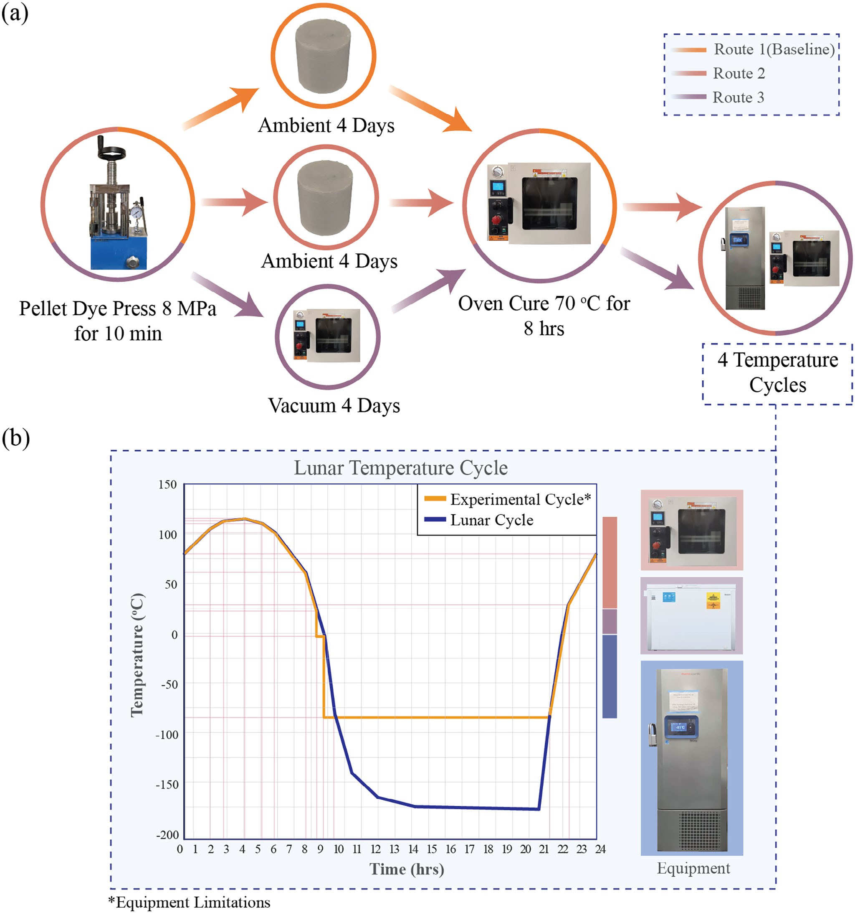
Figure 1. a) Schematic illustration of the three distinct curing routes developed for lunar regolith composites, tailored to address the feasibility of this material for off-Earth construction, b) Comparison of the experimental temperature cycle with the simulated lunar cycle.

illustrated in Figure 2a. A key aspect of the processing is the regolith method of mixing fine (<0.25 μm) and coarser (0.25– 250 μm) regolith particles (Figure 2b). Preliminary experiments
identified an optimal fine-to-coarse particle ratio of 80:20, which
achieved the highest compressive strength of 32.57 MPa. In this mixture, fine particles constituted 80% of the total mass, while coarse particles made up the remaining 20%. Alternative ratios
of 70:30 and 50:50 yielded lower compressive strengths of 24.07 and 22.G5 MPa, respectively. The enhanced performance of the 80:20 ratio is attributed to the fine particles effectively filling the voids between larger particles, thereby reducing porosity and promoting a denser packing structure. This denser matrix im- proves compressive strength by minimizing internal defects and enhancing load transfer. Simultaneously, the inclusion of larger

Small 2025, 2502220
16136829, 0, Downloaded from https://onlinelibrary.wiley.com/doi/10.1002/smll.202502220 by Xi'An Jiaotong-Liverpool, Wiley Online Library on [24/06/2025]. See the Terms and Conditions (https://onlinelibrary.wiley.com/terms-and-conditions) on Wiley Online Library for rules of use; OA articles are governed by the applicable Creative Commons License

2502220 (3 of 15)
© 2025 The Author(s). Small published by Wiley-VCH GmbH



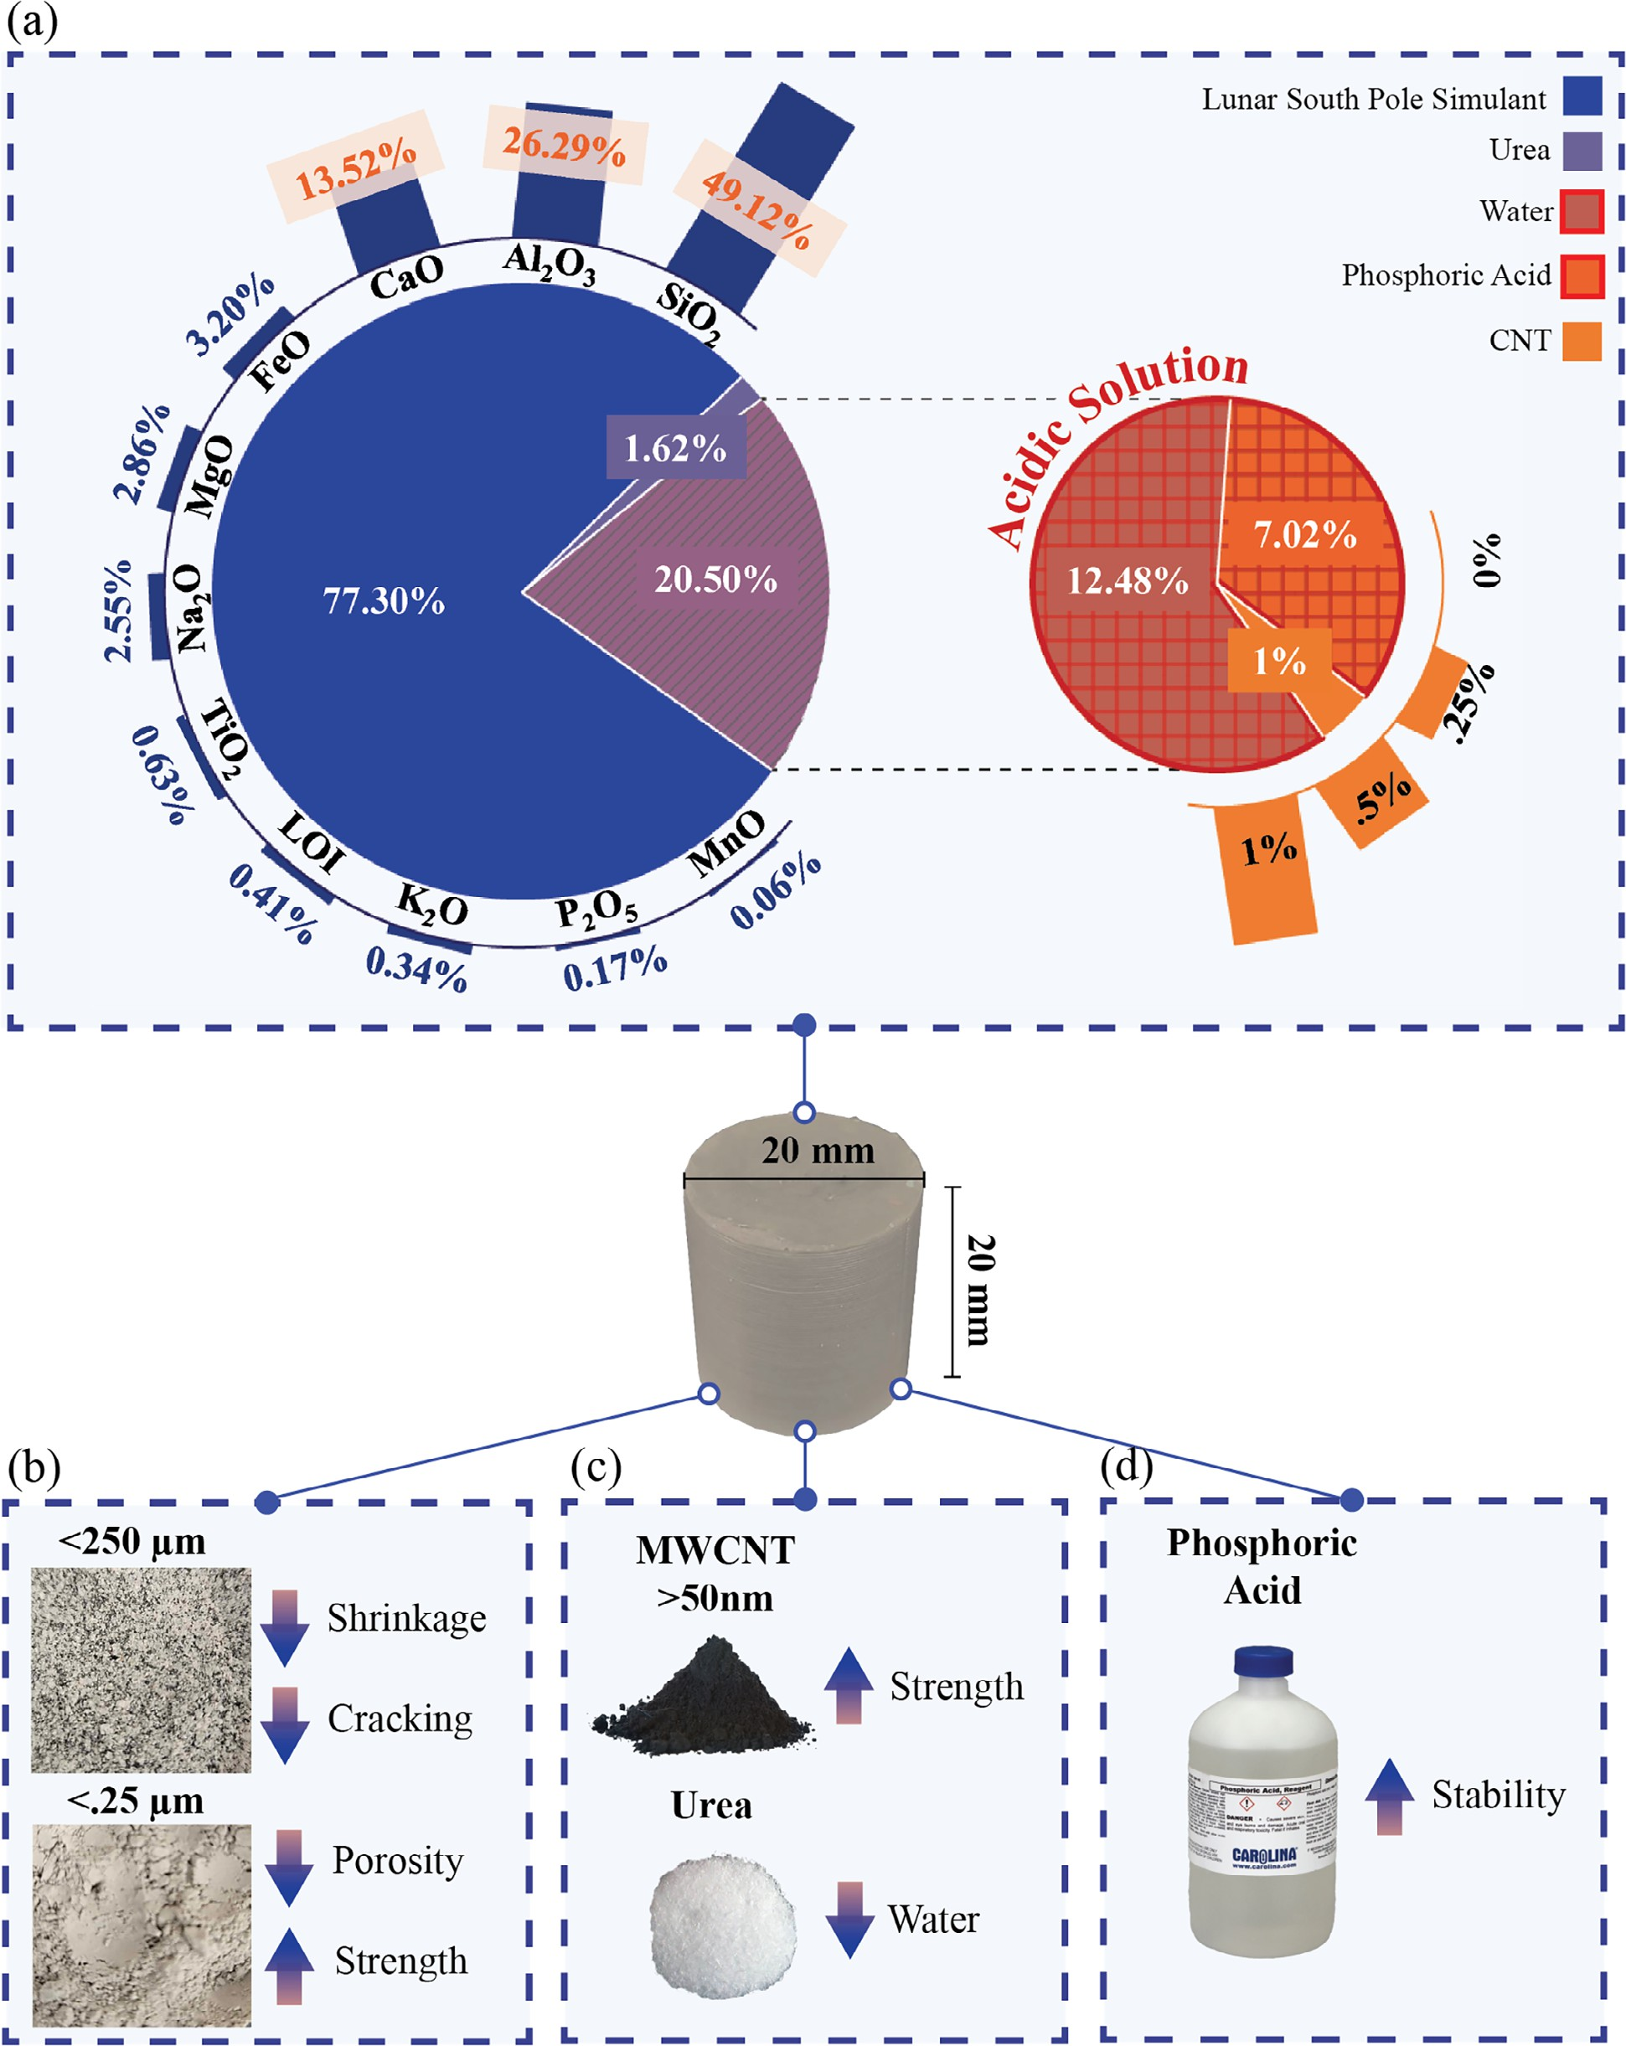
Figure 2. Overview of the 20 mm height and 20 mm diameter composite formulation: a) Chemical composition with weight percentages of each component, b) Particle size tuning strategy highlighting the complementary roles of fine (<25 μm) and coarse (<250 μm) particles in enhancing packing density and mechanical performance, c) Synergistic integration of urea and carbon nanotubes (CNTs) to simultaneously increase compressive strength
and reduce water requirements, and d) Use of phosphoric acid as an acidic solution to enhance the chemical stability of the composite.

Small 2025, 2502220
16136829, 0, Downloaded from https://onlinelibrary.wiley.com/doi/10.1002/smll.202502220 by Xi'An Jiaotong-Liverpool, Wiley Online Library on [24/06/2025]. See the Terms and Conditions (https://onlinelibrary.wiley.com/terms-and-conditions) on Wiley Online Library for rules of use; OA articles are governed by the applicable Creative Commons License

2502220 (4 of 15)
© 2025 The Author(s). Small published by Wiley-VCH GmbH



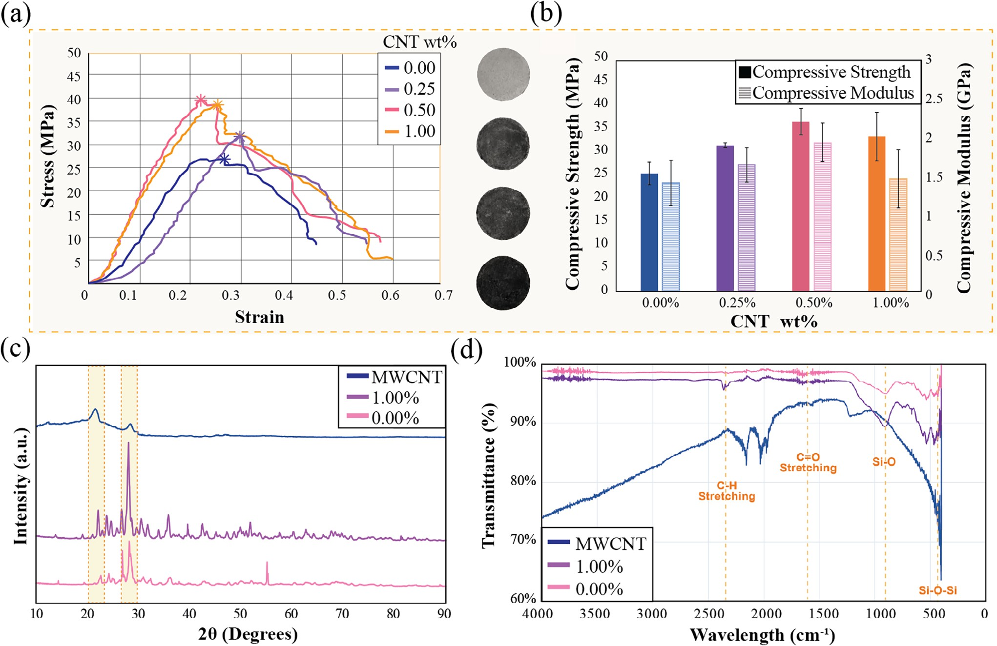
Figure 3. a) Maximum recorded compressive strength values. b) Average compressive strength and compressive modulus for ambient-cured composites (Route 1), with error bars representing the standard deviation c) XRD spectroscopy for pure MWCNT, 0.00, and 1.00 wt.% MWCNT composites fabricated under Route 1 d) FTIR spectra for pure MWCNT, 0.00, and 1.00 wt.% MWCNT composites fabricated under Route 1.

particles serves to mitigate shrinkage and cracking during curing by acting as a structural skeleton that resists the stresses induced during drying. This synergistic interaction not only minimizes voids and increases packing density but also reduces binder de- mand while improving strength, impermeability, and volumetric stability.[31,32] By leveraging natural particle gradation, this scal- able strategy offers a novel contribution to regolith-based com- posite research.
Beyond the particle size optimization, this research further in- tegrates urea and MWCNTs to reduce water requirements while enhancing the strength of lunar regolith composites (Figure 2c). Unlike prior studies focusing on urea[33] or CNTs[34] individu- ally, this approach leverages their synergistic effects. Urea acts as a superplasticizer reducing water content to 12.48 wt.%, lower than typical lunar concrete formulations (5–30 wt.%).[23,24] While urea reduces water usage, it causes a trade-off with strength, which was offset by adding MWCNTs to enhance compressive properties. Additionally, an acidic solution with phosphoric acid (H₃PO₄) was chosen as the pH modifier over the more commonly used sodium hydroxide due to its milder reactivity (Figure 2d). Phosphoric acid contributes hydrogen donor molecules that form strong chemical bonds with regolith compounds, stabilizing the composite structure.[35] While sodium hydroxide’s high pH fa- cilitates the breakdown of silicates and metal oxides to form sodium silicate, phosphoric acid exhibits milder reactivity, dis-
solving some minerals and forming phosphate salts without overly aggressive reactions. Its stability, particularly at low tem- peratures, ensures long-term durability and resistance to extreme lunar temperature fluctuations.
In order to validate the material modification and particle size optimization, the compressive strength, compressive modulus, and chemical characteristics of lunar regolith composites were evaluated under ambient curing conditions without thermal cy- cling (Route 1), as illustrated in Figure 3. These experiments establish a baseline understanding of the effects of MWCNT incorporation on the compressive performance of composites. The compressive strength (Figure 3a) and compressive mod- ulus (Figure 3b) results for Route 1 demonstrated a clear en- hancement with the inclusion of MWCNTs. The sample with
0.50 wt.% MWCNT exhibited the highest compressive strength, achieving 39 MPa (44.44% increase), and a compressive mod- ulus of 1.98 GPa (41.43% increase) compared to the 27 MPa compressive strength and 1.4 GPa compressive modulus of the
0.00 wt.% MWCNT sample. Additionally, the sample with
0.25 wt.% MWCNT showed a marked increase in compressive strength with 31 MPa (14.81% increase) and 1.8 GPa compres- sive modulus, indicating the effectiveness of MWCNT additives in reinforcing the composite in comparison with the MWCNT- free sample. However, when the MWCNT content was increased to 1.00 wt.%, even the best-performing sample showed a slight

Small 2025, 2502220
16136829, 0, Downloaded from https://onlinelibrary.wiley.com/doi/10.1002/smll.202502220 by Xi'An Jiaotong-Liverpool, Wiley Online Library on [24/06/2025]. See the Terms and Conditions (https://onlinelibrary.wiley.com/terms-and-conditions) on Wiley Online Library for rules of use; OA articles are governed by the applicable Creative Commons License

2502220 (5 of 15)
© 2025 The Author(s). Small published by Wiley-VCH GmbH



decrease in compressive strength to 38 MPa and a lower compres- sive modulus of 1.5 GPa. In contrast, the best-performing 0.50 wt.% MWCNT sample achieved a higher compressive strength of 39 MPa and a higher compressive modulus of 1.98 GPa. Ad- ditionally, the 1.00 wt.% specimens exhibited larger margins of error in both compressive strength and modulus, as shown in Figure 3b, indicating greater variability in performance. These re- sults suggest that increasing MWCNT content beyond 0.50 wt.% does not improve mechanical properties and may even reduce overall performance. This slight decrease indicates poor interfa- cial bonding between the CNTs and the matrix material.[3G] When an excessive amount of CNTs disrupts the balance of distribu- tion between CNTs and regolith particles, it negatively impacts and weakens the interfacial bonding between them, ultimately resulting in a decline in compressive strength.
To understand the compressive strength improvement achieved by incorporating MWCNTs into the composite under the ambient temperature curing method, an XRD technique
was used as illustrated in Figure 3c. The characteristic peaks of MWCNTs observed at 23° and 30° correspond to graphite diffraction,[37] confirming that the hexagonal graphite structure
of the MWCNTs remains intact across all samples.[38] The broad nature of these peaks at 23° and 30° reflects the layered arrange- ment of graphitic planes within the MWCNTs, highlighting the
absence of significant long-range crystalline order. When 1.00 wt.% MWCNT is incorporated into the composite, the XRD
patterns reveal a noticeable increase in the intensity of the peaks at 23° and 30° compared to the 0.00 wt.% MWCNT sample. This enhancement suggests that the MWCNTs influence the
microstructure of the lunar matrix by improving packing density and promoting structural alignment, due to their high surface area and ability to act as nucleation sites during the curing process. In contrast, the 0.00 wt.% MWCNT sample exhibits
broader and lower-intensity peaks in the same region (23°, 30°), indicative of a less ordered and predominantly amorphous structure, which may be due to the absence of the reinforcing
effects provided by the MWCNTs. The results show that the sharper, higher-intensity peaks observed at 23° and 30° in the XRD patterns correlate with improved compressive strength,
indicating that the presence of MWCNTs enhances the compos- ite’s structural order and compressive performance under the ambient curing method.
Beyond the microstructural alignment revealed by XRD, the chemical interactions between MWCNTs and the lunar matrix were examined using Fourier-Transform Infrared Spectroscopy (FTIR) (Figure 3d). This analysis highlights the bonding mech- anisms and changes in the chemical environment induced by MWCNT integration, further explaining their dual role in rein- forcing and modifying the matrix network. The FTIR spectra re- veal that incorporating MWCNTs into cementitious composites enhances the out-of-plane flexibility of silica tetrahedra, which can improve the material’s adaptability, mechanical performance,
and overall durability. This is evidenced by the sharper peak ob- served ≈500 cm−1 in the MWCNT-containing sample, indicating a structural modification that increases the mobility of silica tetra-
hedra. Additionally, the reduced intensity observed in samples containing MWCNTs, compared to the 0.00 wt.% MWCNT sam- ple, suggests that MWCNTs help mitigate carbonation within the composite material. Carbonation, a chemical reaction between
carbon dioxide and cement components, can degrade the ma- terial’s structure over time, and the presence of MWCNTs ap- pears to inhibit this process, enhancing the composite’s dura- bility. The presence of MWCNTs seems to interfere with this process, likely by altering the chemical environment, making it harder for carbonation to occur.[ 39] Peaks corresponding to spe- cific functional groups further elucidate the nature of these in- teractions and their impact on the composite properties. In the
1700 cm−1 wavelength, associated with C═O stretching,[40] slight
changes in intensity suggest that the MWCNTs interact with
carbonyl-containing groups through secondary bonding mecha- nisms, such as hydrogen bonding, given their conjugated struc- ture. These interactions improve the matrix cohesion by facili- tating additional bonding sites, which enhance load transfer and stability under compressive loading conditions. Furthermore, no- table changes in the Si-O and Si-O-Si peaks (1000–500 cm−1)[41] highlight the influence of MWCNTs on the siloxane network, due to physical and chemical interactions that disrupt the orig- inal network while facilitating new interfacial bonds which en- hance the structural integrity. MWCNTs not only act as reinforc- ing agents but also alter the chemical environment of the ma- trix, as evidenced by reduced transmittance and variations in peak intensities, highlighting their dual role in disrupting and enhancing the matrix network through both chemical and physi- cal mechanisms. These chemical modifications align closely with the observed improvements in mechanical properties, such as the compressive strength and modulus achieved with MWCNT incorporation. The enhanced bonding and structural alignment facilitated by MWCNTs provide a more robust matrix capable of withstanding greater mechanical loads, as evidenced by the 44.44% increase in compressive strength and 41.43% increase in modulus for samples containing 0.50 wt.% MWCNTs. This synergy between chemical and mechanical enhancements under- scores the effectiveness of MWCNTs in reinforcing the lunar re- golith composite.

Thermal Cycling Effects on Compressive Properties

To ensure the suitability of lunar regolith composites for space applications, subjecting them to simulated lunar environments is crucial. Thermal cycling, which mimics the extreme tem- perature fluctuations on the Moon, plays a crucial role in as- sessing material reliability. The results from mechanical test- ing demonstrated significant differences between the ambient- cured samples (Route 1) and those subjected to thermal cycling (Routes 2 and 3). While ambient-cured samples exhibited pre- dictable trends in compressive strength and modulus with vary- ing MWCNT concentrations, thermal cycling introduced incon- sistencies and revealed critical challenges associated with com- posite behavior under lunar-like conditions.
In Route 2, which involved thermal cycling after ambient pre-curing, the compressive strength (Figure 4a) and modulus (Figure 4b) were inconsistent and showed no clear correlation with MWCNT content. While the 1.00 wt.% MWCNT sample achieved the highest compressive strength (24 MPa) and mod- ulus (1 GPa), the overall performance of Route 2 samples was significantly lower than Route 1, with all samples falling below 20 MPa. For example, the 0.00 wt.% MWCNT sample in Route

Small 2025, 2502220
16136829, 0, Downloaded from https://onlinelibrary.wiley.com/doi/10.1002/smll.202502220 by Xi'An Jiaotong-Liverpool, Wiley Online Library on [24/06/2025]. See the Terms and Conditions (https://onlinelibrary.wiley.com/terms-and-conditions) on Wiley Online Library for rules of use; OA articles are governed by the applicable Creative Commons License

2502220 (6 of 15)
© 2025 The Author(s). Small published by Wiley-VCH GmbH



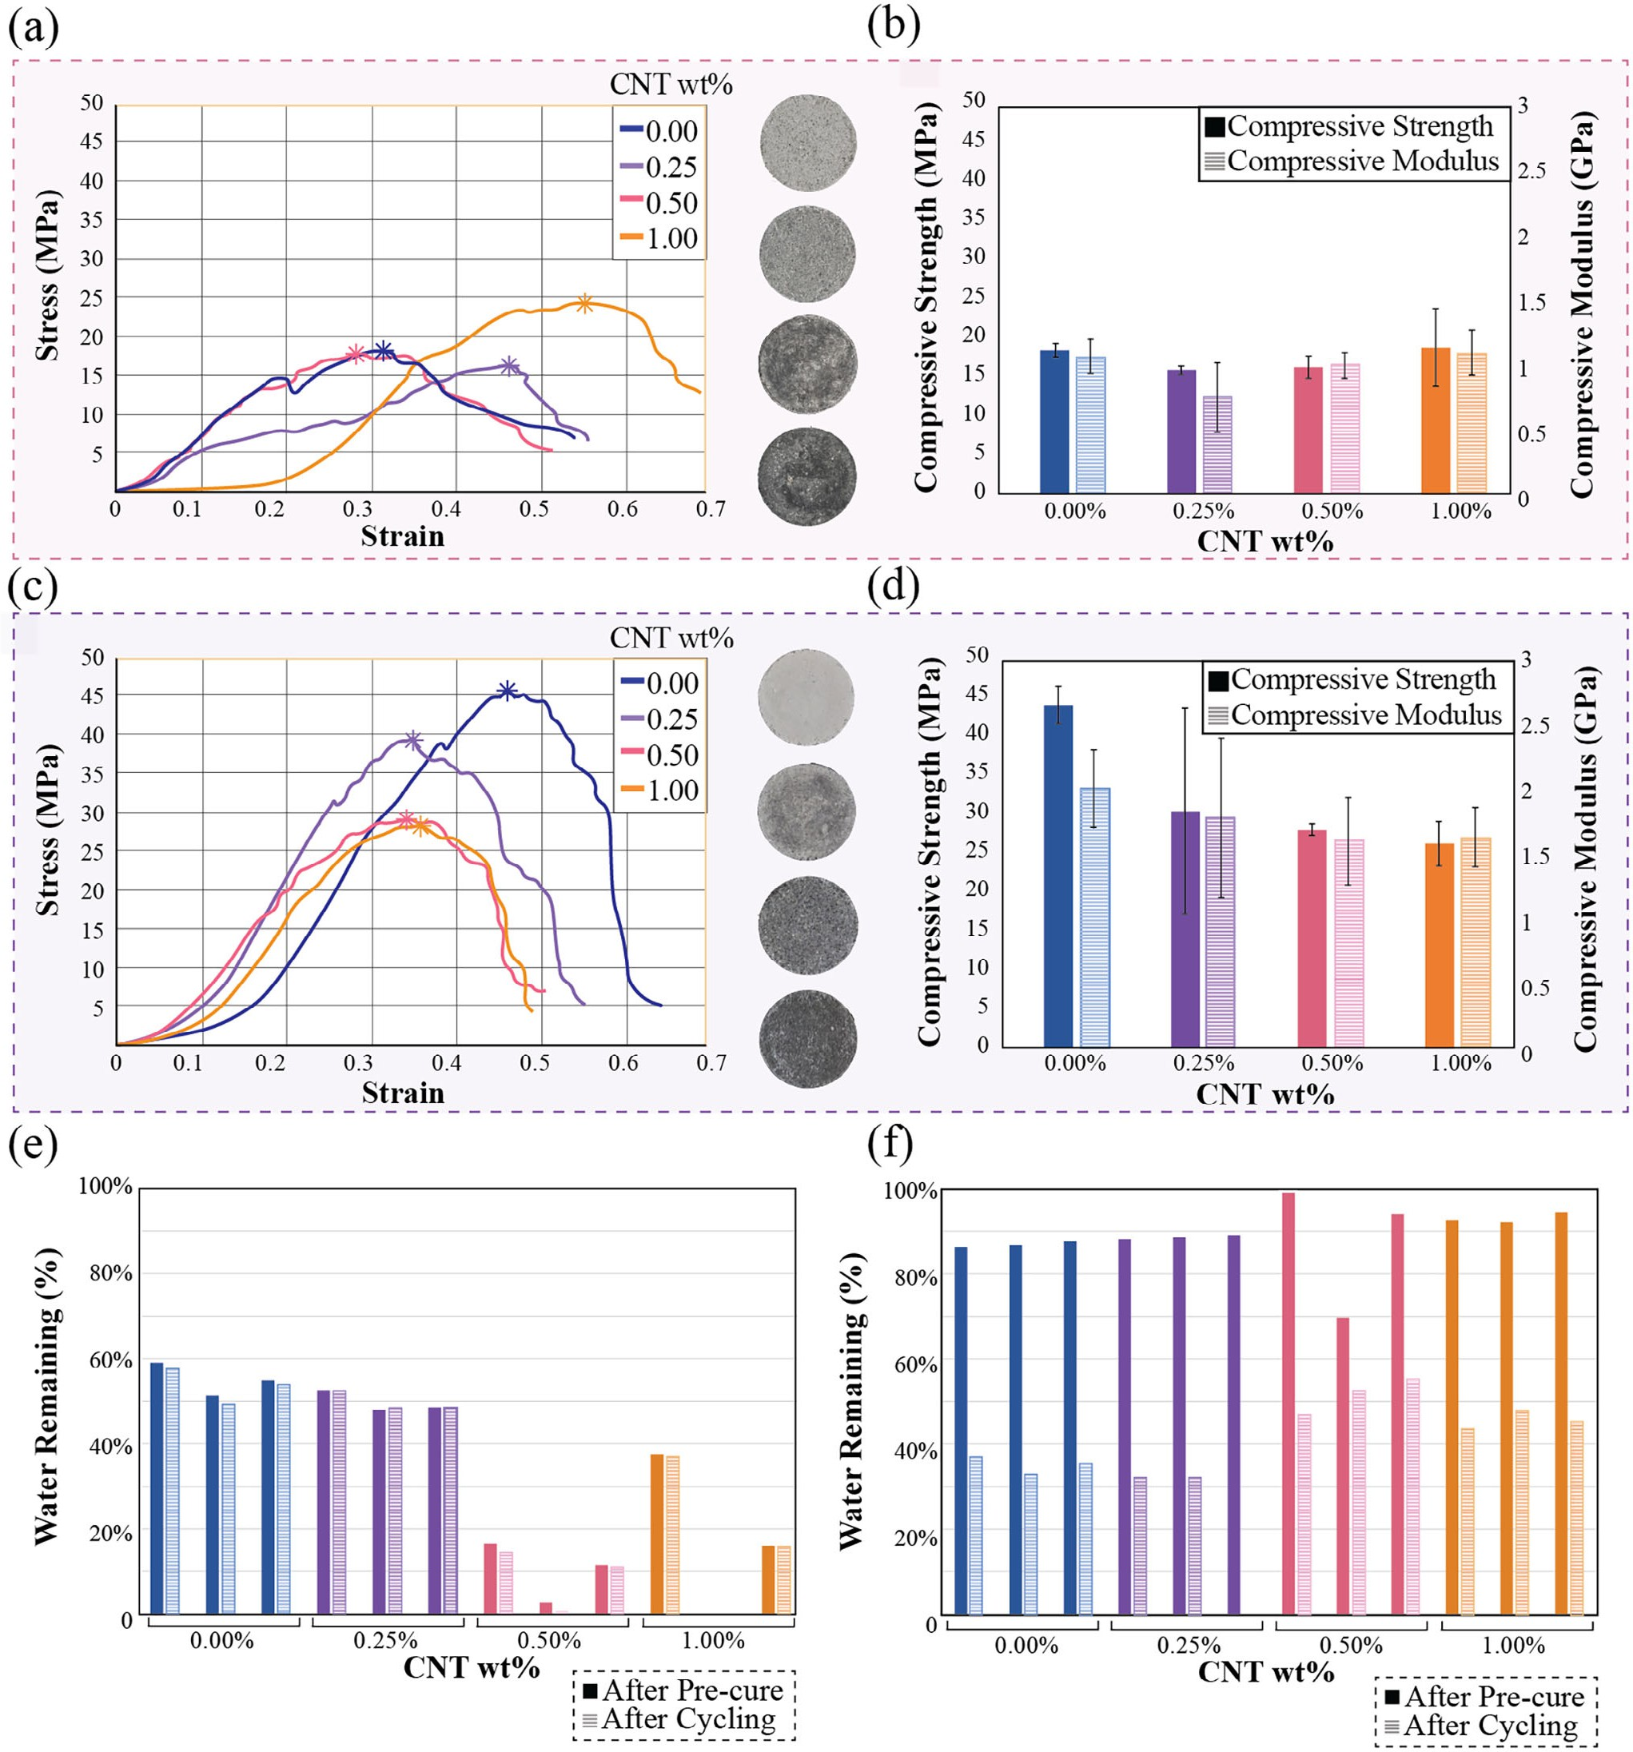
Figure 4. a–d) Compressive strength and compressive modulus of ambient-cured (Route 2) and vacuum-cured (Route 3) specimens subjected to temperature cycling, error bars representing the standard deviation of the average values e–f) remaining water content after pre-curing and post-cycling for samples fabricated under Routes 2 and 3, respectively.

2, despite its stability, achieved a compressive strength ≈18 MPa with a compressive modulus of 0.98 GPa, falling short of the recorded 27 MPa compressive strength and 1.40 GPa compres-
sive modulus of 0.00 wt.% MWCNT sample in Route 1. In con- trast, Route 3 which combined vacuum pre-curing with thermal cycling, demonstrated better mechanical performance, with the
0.00 wt.% MWCNT sample achieving a compressive strength of 47 MPa (Figure 4c) and modulus of 1.G7 GPa (Figure 4d). This improvement is unique, as vacuum pressure typically has a detrimental effect on compressive strength.[42] However, higher MWCNT content samples in Route 3 performed poorly, with the 1.00 wt.% MWCNT sample showing a compressive strength

Small 2025, 2502220
16136829, 0, Downloaded from https://onlinelibrary.wiley.com/doi/10.1002/smll.202502220 by Xi'An Jiaotong-Liverpool, Wiley Online Library on [24/06/2025]. See the Terms and Conditions (https://onlinelibrary.wiley.com/terms-and-conditions) on Wiley Online Library for rules of use; OA articles are governed by the applicable Creative Commons License

2502220 (7 of 15)
© 2025 The Author(s). Small published by Wiley-VCH GmbH



of only 28 MPa and modulus of 1.3G GPa. This trend suggests that the thermal cycling process interacts with fabrication condi- tions and MWCNT wt.% to significantly alter mechanical behav- ior compared to Route 1.
The inconsistencies in compressive strength and modulus be- tween Routes 1, 2, and 3 can be explained by the role of water retention during fabrication. In Route 2, samples experienced significant water loss during the ambient exposure phase, leav-
ing lower MWCNT wt.% samples with ≈50% water retention,
while higher MWCNT wt.% samples retained less than 20%
(Figure 4e). Excessive dryness in these levels of MWCNT wt.% samples contributed to brittleness and poor mechanical perfor- mance. Route 3, on the other hand, i.e., Vacuum pre-curing re- tains higher water content by creating a localized humid environ- ment that slows moisture loss. The absence of airflow reduces convective drying, while redistributed moisture remains trapped within the material’s microstructure. As a result, significant evap- oration occurs predominantly during thermal cycling when heat drives moisture out more effectively (Figure 4f). This controlled evaporation process promoted densification and reduced poros-
ity in low MWCNT content samples, resulting in optimal wa- ter retention of ≈35%, which correlated with superior compres- sive strength compared to Routes 1 and 2, respectively. However, higher MWCNT content in Route 3 samples retained ≈50% water after thermal cycling, leading to increased porosity and weaker
interfacial bonding, negatively impacting their strength. Under vacuum, the CNT network likely traps water by limiting its es- cape pathways, creating localized moisture pockets. Additionally, the prevention of rapid surface evaporation in a vacuum, allows the CNT network to retain more water than ambient conditions. While water retention plays a critical role in determin- ing microstructural integrity, the significant reduction in com- pressive strength during thermal cycling, particularly in high MWCNT content samples, is largely attributed to the mismatch in thermal expansion coefficients (CTE) between the regolith matrix and MWCNTs. MWCNT exhibited a negative CTE of
−1.2 × 10−5/ °C−1,[43] MWCNT shrinks when heated, whereas the regolith components, such as SiO2 (0.24 × 10−G/ °C−1),[44] Al2O3 (8.1 × 10−G/ °C−1),[45] and CaO (13.57 × 10−G/ °C−1)[4G]
expand under the same conditions (Figure S4, Supporting In-
formation). This opposing thermal behavior generates signifi- cant internal stresses at the CNT-matrix interfaces during tem- perature fluctuations. These stresses disrupt the structural co- hesion of the composite, leading to localized microcracking and delamination, which are more pronounced in samples with higher MWCNT concentrations. Consequently, while vacuum pre-curing improves strength by promoting densification, the ad- dition of MWCNTs aggravates the thermal mismatch issue, re- ducing mechanical performance during cycling.
To further investigate and quantify the effects of CTE mis- match, thermal cycling simulations were conducted to model the stress and strain distributions in MWCNT-reinforced com- posites under lunar-like temperature fluctuations. The simula- tions utilized a representative volume element (RVE) approach, with the RVE extracted from a larger computational model popu- lated with homogeneously distributed, randomly oriented MWC-
NTs (Figure 5a). The MWCNTs were modeled as solid cylinders with diameters of 20 nm and lengths between 1 and 15 μm, en- suring no intersections or overlaps to replicate a realistic mi-
crostructure. The chosen RVE size of 5 × 5 × 5 μm3 included a MWCNT volume fraction of 0.77%, closely matching the experi-
mental value of 0.71% (equivalent to 0.5 wt.%). The finite element model, implemented in general finite element analysis software, ABAQUS, with a coupled temperature-displacement solver, ap-
plied a heating-cooling-heating cycle ranging from 80 to 117 °C, cooling to −80 °C, and returning to 80 °C. This setup simulated the thermo-mechanical interactions arising from differences in
the CTEs of the MWCNTs and the matrix material. Incorporating temperature-dependent properties for both the
MWCNTs and the lunar regolith matrix revealed more pro-
nounced effects of thermal mismatch across the full extended cy- cle. At the highest temperature of 117 °C, the MWCNTs slightly contracted while the matrix expanded, creating localized stress
concentrations at their interfaces and increasing principal strain within the adjacent matrix (Figure 5b). As the temperature
dropped to −80 °C, the thermal expansion mismatch became
more pronounced, with interfacial stresses rising sharply from
33.42 MPa at 117 °C (Figure 5b) to 127.G0 MPa (Figure 5c), and the principal strain reaching 5.87 × 10−4 (Figure 5c). Upon fur- ther cooling to −171 °C, the mismatch effects intensified, which the matrix experienced contraction while the MWCNTs contin-
ued expanding, causing interfacial stress to exceed 207.20 MPa and principal strain to surpass 1.58 × 10−3 (Figure 5d). When reheated to + 80 °C (Figure 5e), the system exhibited partial
stress relief; however, residual stress and strain concentrations
remained along the interfaces. These persistent stress–strain fields indicate accumulated thermal mismatch and point to the potential for long-term damage mechanisms such as microcrack- ing and interfacial debonding between the MWCNTs and the re- golith matrix.

Comparative Evaluation of MWCNT-Incorporated Composites

Achieving consistent compressive strength in composites relies heavily on uniform particle dispersion. To evaluate the quality of dispersion, Scanning Electron Microscopy (SEM) and Energy Dispersive Spectroscopy (EDS) are employed to visualize and an- alyze the distribution of materials within the composite with 1.00 wt.% MWCNT across the three processing routes (Figure 6). The SEM images for all samples across the three synthesis routes reveal minimal porosity, a crucial characteristic for enhancing material strength. The microstructure includes a mix of small and large particles, reflecting a deliberate particle-size blending strategy designed to optimize packing density and mechanical properties. However, the significant differences in the distribu- tion of MWCNTs are visible among different routes, providing insight into their reinforcement efficiency under different fabri- cation conditions. In the Route 1 samples (ambient curing with- out temperature cycling), the MWCNTs appear to wrap around the regolith particles, creating a smoother overall morphology (Figure Ga). This wrapping behavior enhances interfacial bond- ing and contributes to improved load transfer within the com- posite, as evidenced by the smoother textures in the correspond- ing SEM images (detailed further in Figure S1, Supporting In- formation). The smoother morphology aligns with the minimal thermal stresses present in Route 1, as these samples were not

Small 2025, 2502220
16136829, 0, Downloaded from https://onlinelibrary.wiley.com/doi/10.1002/smll.202502220 by Xi'An Jiaotong-Liverpool, Wiley Online Library on [24/06/2025]. See the Terms and Conditions (https://onlinelibrary.wiley.com/terms-and-conditions) on Wiley Online Library for rules of use; OA articles are governed by the applicable Creative Commons License

2502220 (8 of 15)
© 2025 The Author(s). Small published by Wiley-VCH GmbH



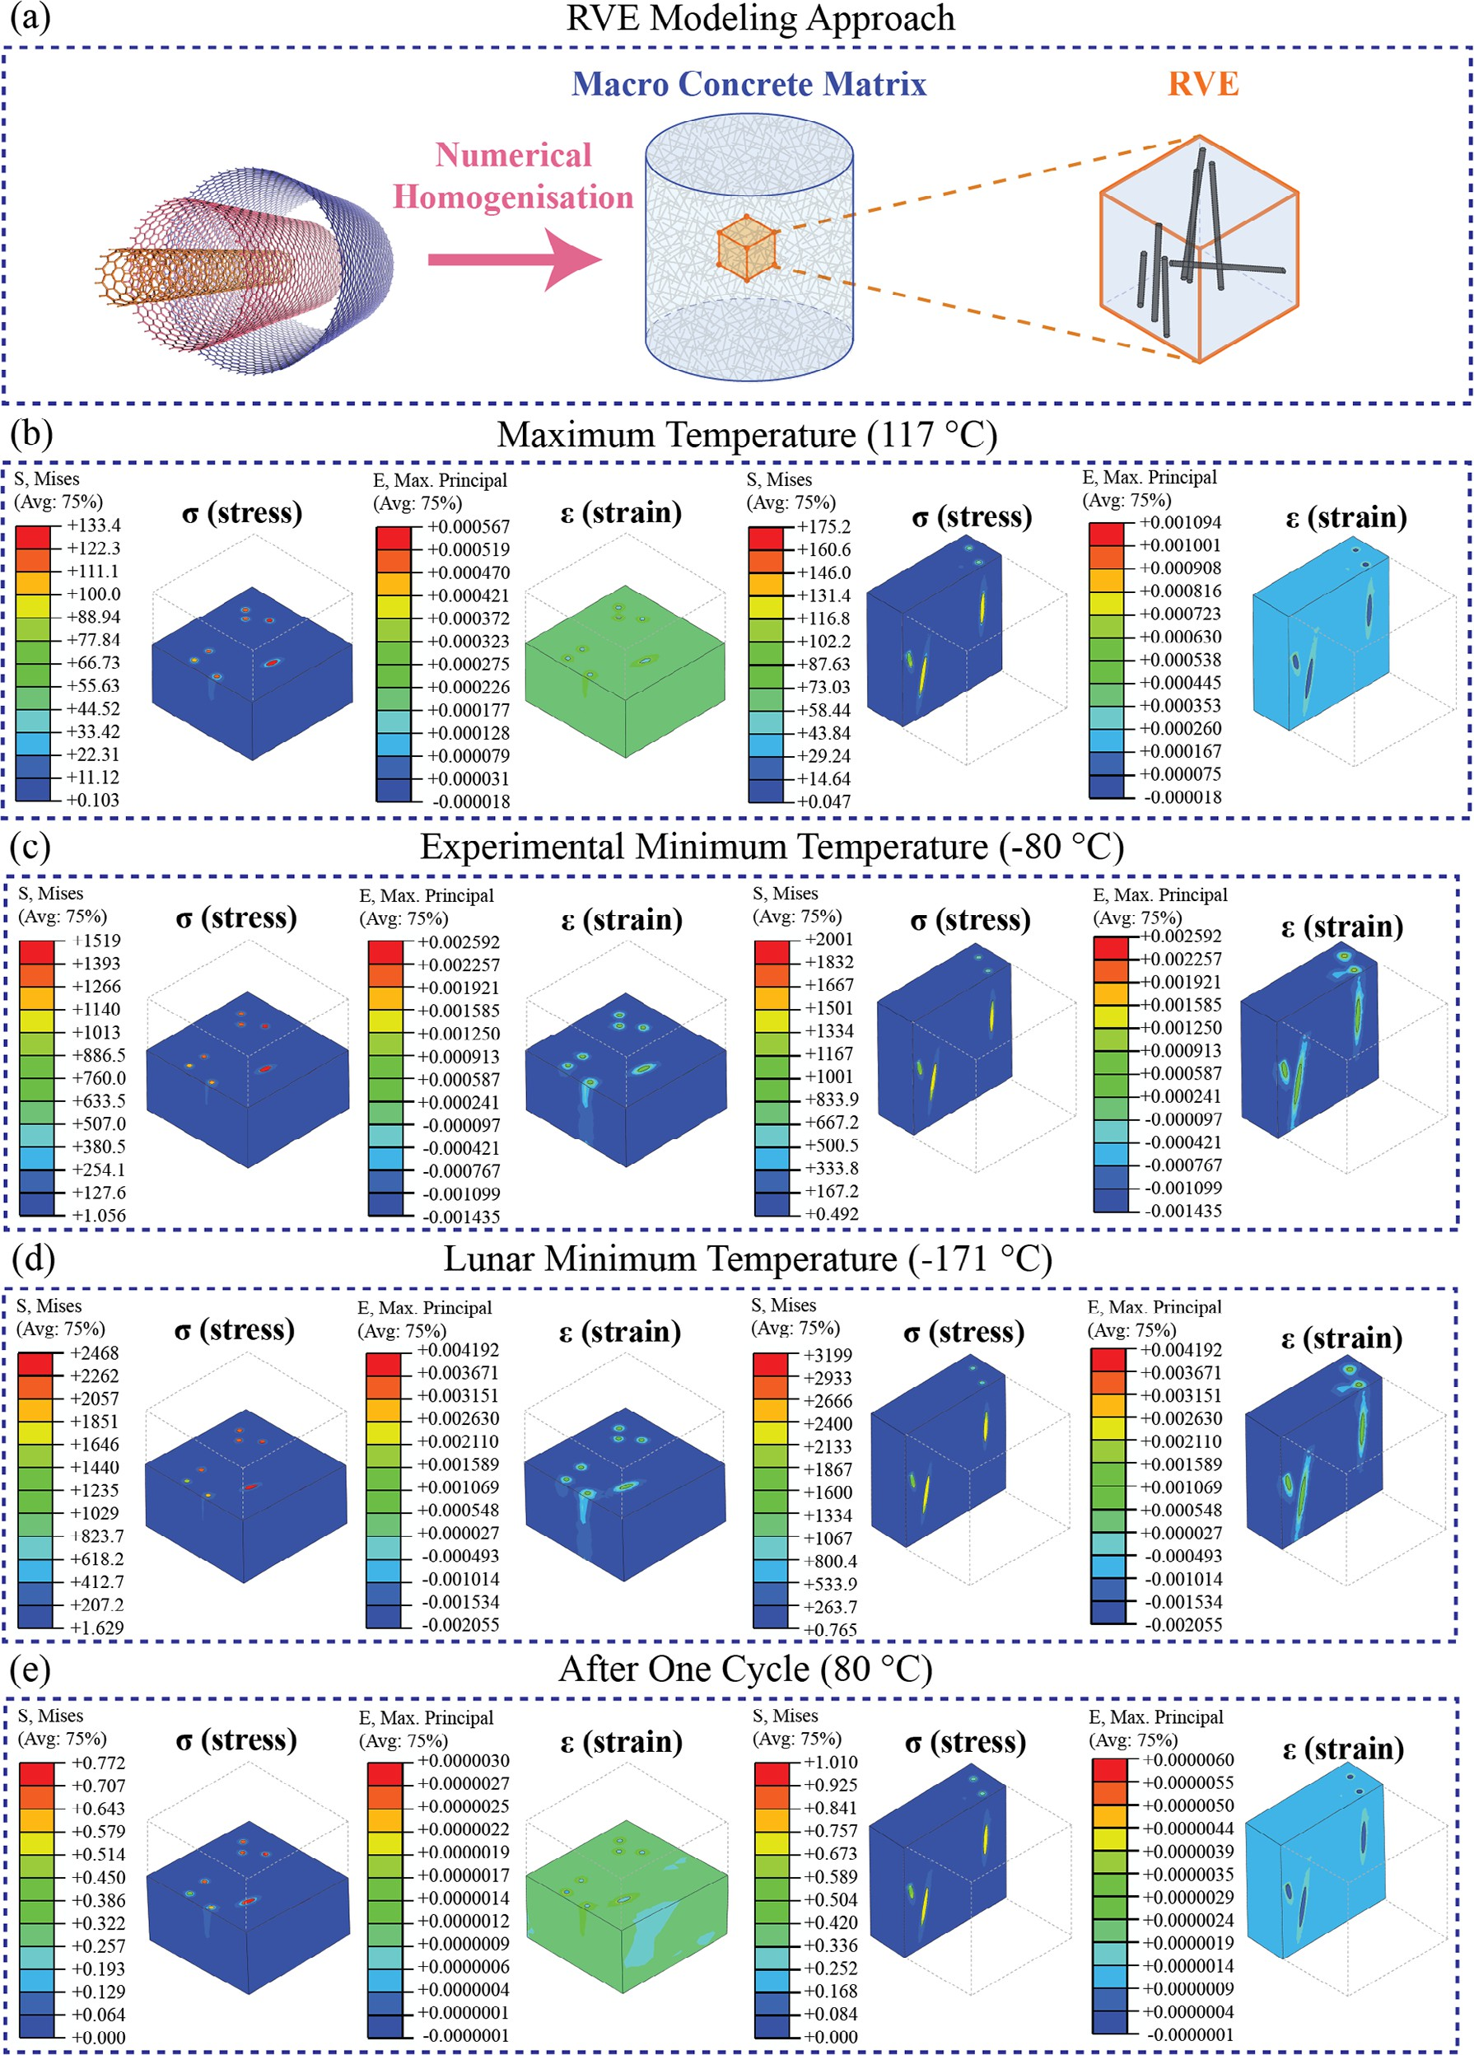
Figure 5. a) schematic of the RVE modeling approach incorporating MWCNT distribution. Stress (unit in MPa) and strain contours in the x and y
directions within a RVE of the lunar regolith composite reinforced with MWCNTs, evaluated through simulation at b) lunar maximum temperature of 117 °C, c) experimental minimum temperature of −80 °C, d) lunar minimum temperature of −171 °C, and e) after one complete thermal cycle ending at 80 °C.

Small 2025, 2502220
16136829, 0, Downloaded from https://onlinelibrary.wiley.com/doi/10.1002/smll.202502220 by Xi'An Jiaotong-Liverpool, Wiley Online Library on [24/06/2025]. See the Terms and Conditions (https://onlinelibrary.wiley.com/terms-and-conditions) on Wiley Online Library for rules of use; OA articles are governed by the applicable Creative Commons License

2502220 (9 of 15)
© 2025 The Author(s). Small published by Wiley-VCH GmbH



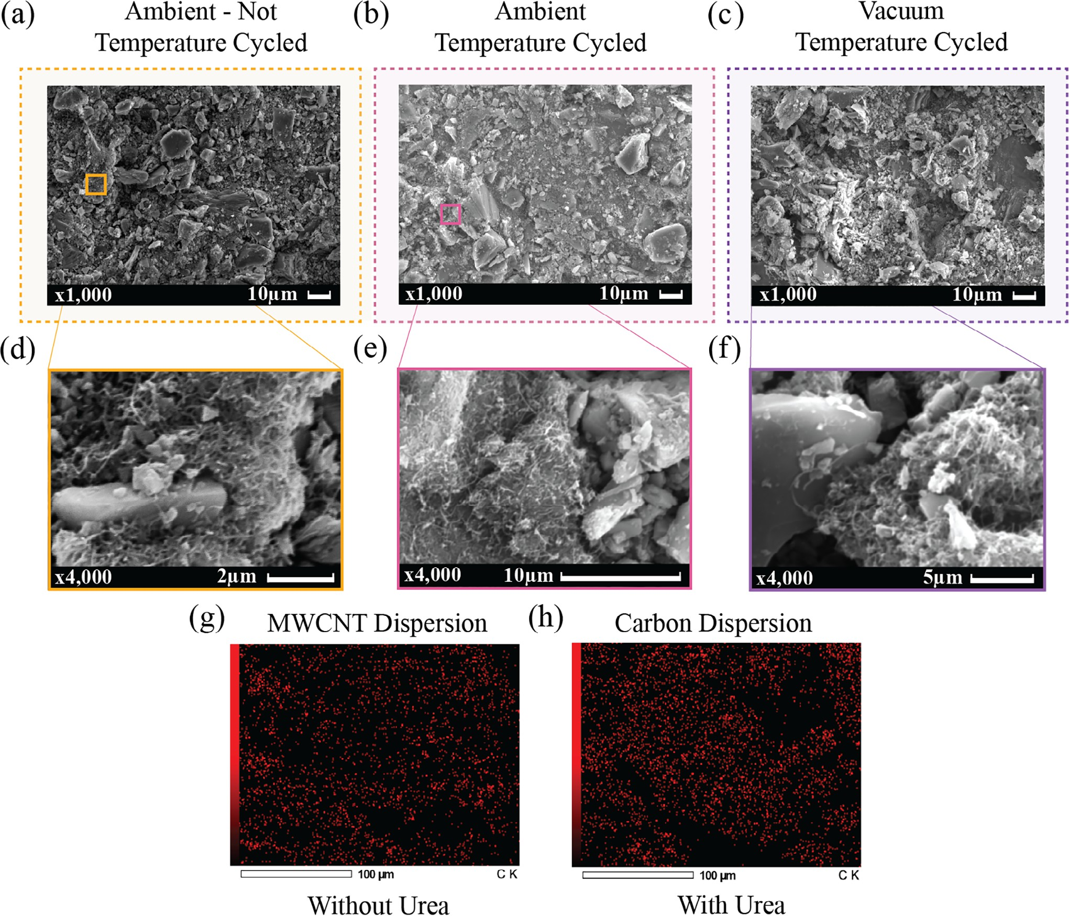
Figure 6. a–c) SEM images of 1.00 wt.% MWCNT samples with callouts d–f) highlighting visible MWCNTs fabricated under ambient-cured, non-cycled condition (Route 1), ambient-cured with temperature cycling condition (Route 2), and vacuum-cured with temperature cycling condition (Route 3), respectively, g) EDS image showing MWCNT distribution in the control sample without urea to show the quality of dispersion, h) EDS image showing carbon distribution in the Route 1 sample with urea.

subjected to temperature cycling. The uniformity of the matrix and the close interaction between MWCNTs and particles pro- vide evidence of a cohesive composite structure, reinforcing the mechanical stability, as illustrated in Figure 3a. Conversely, the temperature-cycled samples (Routes 2 and 3) display a distinct separation between the MWCNTs and the regolith particles, re- sulting in a rougher morphology (Figures Gb and 7c) (detailed further in Figures S2 and S3, Supporting Information). The sep- aration in the regolith-MWCNT composite after temperature cy- cling arises from the mismatch in their coefficients of thermal expansion (CTE). This discrepancy causes stress at the interface, leading to delamination and affecting the composite’s structural integrity. This separation was more pronounced in the vacuum- cured Route 3 samples, suggesting that thermal cycling intro- duces the CTE mismatch between the MWCNTs and the regolith
matrix. To verify the quality of MWCNT dispersion and ensure that the observed carbon distribution was not solely due to the presence of urea, EDS analysis was used to distinguish MWCNT dispersion from other carbon-containing components. EDS map- ping was conducted on a control sample without urea (Figure Gd) and a standard sample containing urea (Figure Ge). Since urea introduces additional carbon into the matrix, this comparative analysis was essential to isolate the contribution of MWCNTs. The results demonstrate a homogeneous distribution of MWC- NTs in both cases, confirming that the addition of urea did not adversely affect dispersion. This uniform dispersion, achieved by directly dispersing MWCNTs into the acidic solution, effectively prevented MWCNT conglomeration, which is critical for avoid- ing stress concentrations and maintaining composite integrity. However, the SEM images indicate that the primary issue lies

Small 2025, 2502220
16136829, 0, Downloaded from https://onlinelibrary.wiley.com/doi/10.1002/smll.202502220 by Xi'An Jiaotong-Liverpool, Wiley Online Library on [24/06/2025]. See the Terms and Conditions (https://onlinelibrary.wiley.com/terms-and-conditions) on Wiley Online Library for rules of use; OA articles are governed by the applicable Creative Commons License

2502220 (10 of 15)
© 2025 The Author(s). Small published by Wiley-VCH GmbH



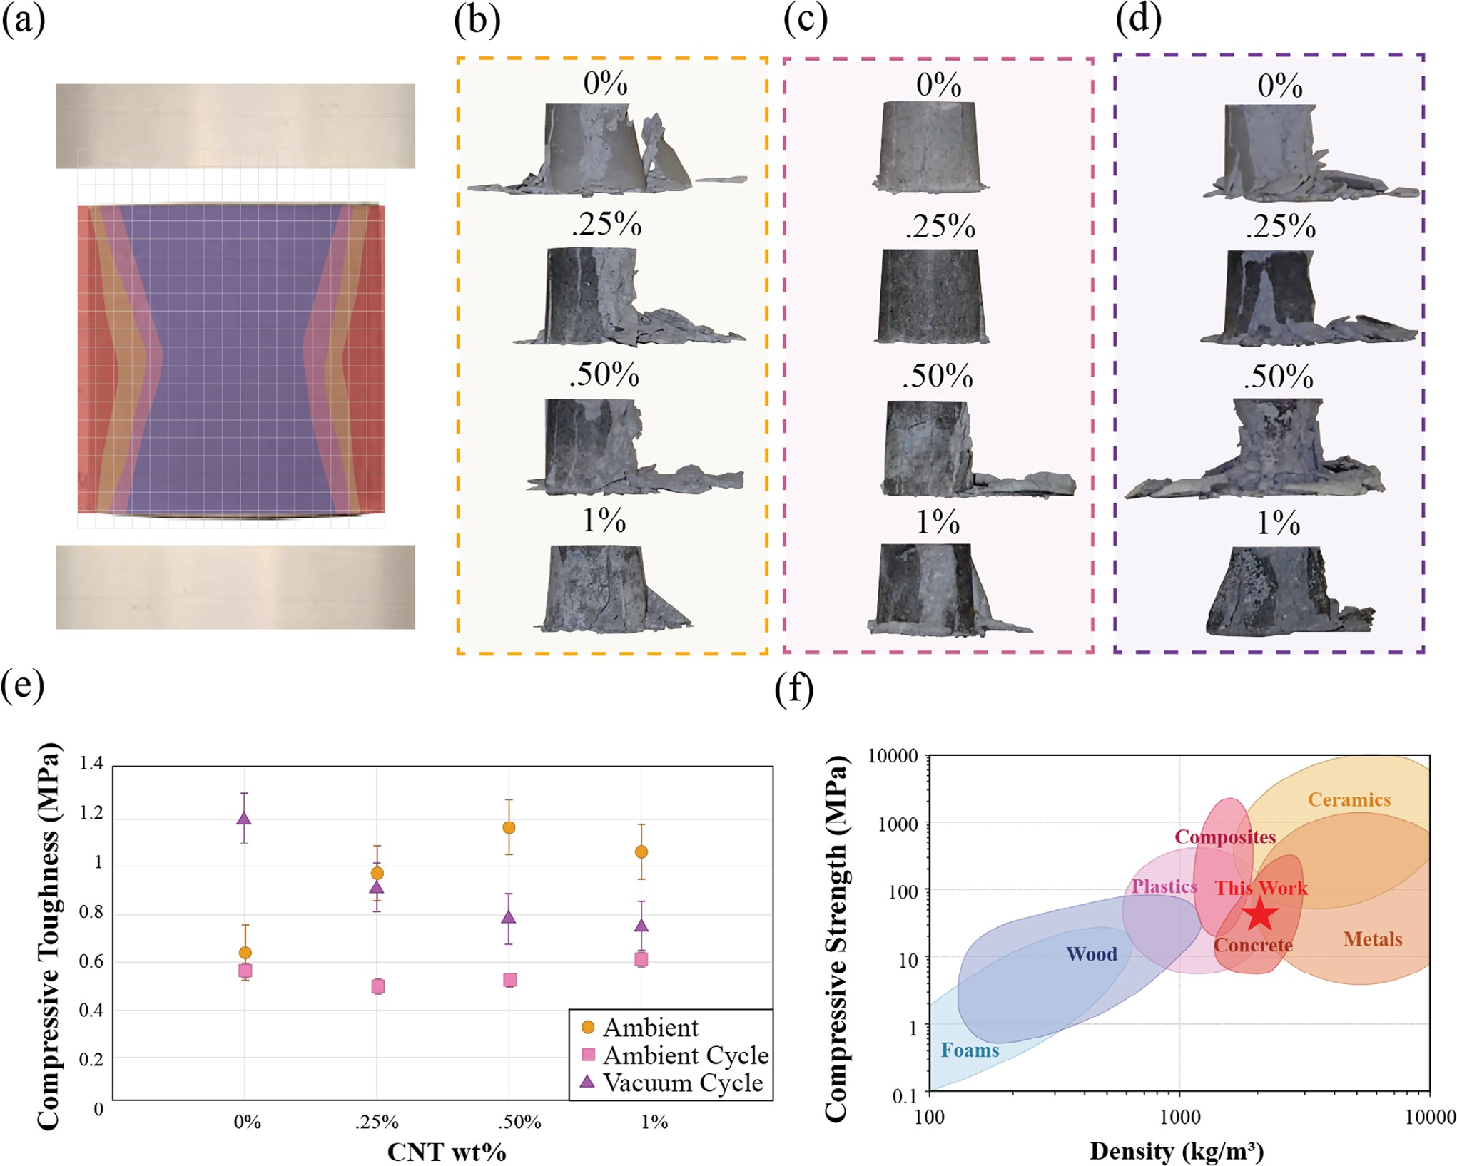
Figure 7. a) Schematic illustrating failure patterns observed during compressive test b–d) post-compression failure patterns for specimens with varying MWCNT wt.% fabricated under ambient non-cycled, ambient-cycled, and vacuum-cycled routes, respectively e) comparisons of compressive toughness of the specimens fabricated under three distinct routes. Visualization of compressed sample fabricated under f) Ashby plot comparing compressive strength versus density of this study against other literature.^{[49–52]}

not in MWCNT dispersion but in the weakened interfacial ad- hesion caused by temperature cycling. While the uniform distri- bution of MWCNTs should theoretically enhance load transfer and mechanical performance, the separation between MWCNTs and regolith particles observed in cycled samples undermines this potential. The rougher texture corresponds to reduced in- terfacial bonding, with MWCNTs failing to form an intercon- nected network with the surrounding particles. This weak adhe- sion likely limits the efficiency of load transfer and contributes to stress concentrations at the interfaces between the MWCNT and regolith particles, particularly under temperature cycling con- ditions. In addition to the adhesion challenges, the separation observed in temperature-cycled samples highlights the role of CTE mismatch. The contrasting CTEs of the MWCNTs (nega- tive) and the regolith matrix (positive) introduce internal stresses during heating and cooling cycles, further degrading the com- posite structure. These stresses amplify microcracking risks, par-
ticularly in high MWCNT content samples where the MWCNT concentration intensifies these effects. Therefore, while the fab- rication process ensures uniform MWCNT dispersion, thermal cycling disrupts interfacial adhesion and matrix cohesion, ulti- mately reducing the compressive strength of the composite.
The uniformity of both particle dispersion and degree of dry- ness is crucial for maintaining a well-supported composite struc- ture, as evaluated in the SEM and EDS analyses. Both forms of analyses supported that MWCNTs were uniformly dispersed throughout all routes with a good mixing strategy, avoiding con- glomerations that weaken the composite. However, the SEM im- ages further demonstrated that temperature cycling (Routes 2 and 3) introduced interfacial adhesion challenges due to the sep- aration of MWCNTs and regolith particles, which intensified the internal stress gradients generated during the curing process. These findings correlate directly with the failure patterns ob- served in the compressive tests, as illustrated in Figure 7.

Small 2025, 2502220
16136829, 0, Downloaded from https://onlinelibrary.wiley.com/doi/10.1002/smll.202502220 by Xi'An Jiaotong-Liverpool, Wiley Online Library on [24/06/2025]. See the Terms and Conditions (https://onlinelibrary.wiley.com/terms-and-conditions) on Wiley Online Library for rules of use; OA articles are governed by the applicable Creative Commons License

2502220 (11 of 15)
© 2025 The Author(s). Small published by Wiley-VCH GmbH



Following the compressive tests, failure in the samples consis- tently began with exterior damage, leading to slight hourglass- shaped deformation on the interior parts (Figure 7a). These fail- ure patterns were observed across all samples fabricated via dif- ferent processing methods including ambient curing with no cy- cling (Figure 7b), ambient curing with cycling (Figure 7c), and vacuum curing with cycling (Figure 7d). This suggests that the exterior parts of the sample cure more efficiently than the interior parts. Cylindrical samples are prone to fracture at any point along the sides or edges, with fractures occurring both in the middle and at the outer parts of the specimens.[47] This failure, referred to as “hourglass failure,” happens when the load is applied uni- formly at the center, resulting in symmetrical failure across all sides due to the absence of loading eccentricity.[ 48] Although the pattern of breakage was consistent across all routes, slight differ- ences were observed in the breakage process. Routes 1 and 3 ex- hibited more visible cracks and breakage, while Route 2 retained its shape without significant break-off damage. This suggests that the high compressive strength observed in Routes 1 and 3 is pri- marily due to their hard exterior, even though the interior was not fully dried. In contrast, Route 2 demonstrated lower performance with compressive strengths falling below 20 MPa. This indicates that the outer layer, which is the first to break off, was not as hard in Route 2 compared to the other routes, as evidenced by the lack of pronounced breakage.
The uneven drying process during curing plays a critical role
in creating internal stress gradients, which weakens the compos- ite structure. As the material cures, moisture migrates from the interior to the exterior, causing the outer layers to dry faster. This differential drying leads to greater shrinkage on the exterior, gen- erating tensile stresses that can initiate failure on the outer lay- ers. Although the interior is weaker due to these internal stress gradients, the exterior typically experiences higher surface ten- sion during drying, further contributing to localized damage and structural weakening. These stress gradients are less pronounced in Route 1 due to the absence of temperature cycling, resulting in smoother and more cohesive fracture surfaces. In contrast, temperature cycling in Routes 2 and 3 intensified the internal stresses, leading to brittle failure and rougher fracture surfaces due to weakened interfacial adhesion and separation between MWCNTs and regolith particles.
Building on the microstructure characteristics of samples fab- ricated through different routes, the toughness data provides a comparative measure of the material energy absorption un- der compressive load (Figure 7e). In Route 1, the toughness in- creased significantly from 0.G4 MPa for 0.00 wt.% specimen to
1.17 MPa for 0.5 wt.% with increasing the MWCNT wt.%, how- ever, a slight decrease to 1.0G MPa was observed at 1.00 wt.% MWCNT content. This increasing trend is attributed to the en- hanced strength and ductility imparted by MWCNT reinforce- ment. This improves the material’s capacity to resist deforma- tion and failure under compressive forces. However, the decline at 1.00 wt.% MWCNT is due to poor interfacial bonding, which compromises structural integrity. In contrast, Route 2 exhibits no clear or consistent trend in toughness with results ranging from 0.40 to 0.G0 MPa. The lack of a clear pattern suggests that temperature cycling disrupted the interaction between MWCNTs and the composite matrix, potentially due to thermal mismatch stresses or microstructural changes caused by repeated expan-
sion and contraction. These inconsistencies highlight the chal- lenges of maintaining uniform performance when the compos- ite is subjected to thermal fluctuations. For Route 3, the tough- ness gradually decreases from 1.20 to 0.7G MPa as MWCNT wt.% increases from 0.00 to 1.00 wt.% respectively. While the vacuum curing process positively influences the overall curing quality and minimizes porosity, the higher MWCNT concentrations are ad- versely affected by the temperature cycling. These results from the amplified CTE mismatch between the MWCNT and the re- golith, lead to microcracks and reduced energy absorption capac- ity. The decreasing trend in Route 3 closely aligns with the ob- served compressive strength data and the separation of MWCNT and regolith particles observed in SEM images. This also empha- sizes the interconnected roles of the MWCNT wt.%, curing con- ditions, and mechanical properties.
The performance trends observed across the three fabrication routes highlight the critical influence of processing conditions on mechanical properties. To contextualize these results, the Ashby plot of compressive strength versus density highlights the per- formance of various material systems in comparison with this study (Figure 7f).[49–52] This study occupies a unique position at the intersection of plastics, metals, composites, concrete, and ce- ramics. This unique placement underscores their versatility and suitability for a wide range of structural applications, offering an optimal balance of strength and lightweight properties tailored to diverse engineering demands. Our composite exhibits distinct advantages compared to existing lunar regolith-based materials, including high compressive strength under low-temperature cur- ing, enhanced performance under vacuum conditions, and a straightforward, energy-efficient fabrication process tailored for lunar applications. We demonstrated a practical synthesis route that achieved competitive mechanical performance without the need for high-temperature processing. While higher compaction pressures could potentially further improve strength, our use of relatively low pressure (8 MPa) was intentional, as it reflects the practical limitations of equipment likely to be available for in situ construction on the Moon. This balance between performance and feasibility makes our approach particularly relevant for ex- traterrestrial infrastructure development.

Conclusion
This study presents a detailed exploration of the complex inter- play between MWCNT reinforcement and lunar regolith com- posites under varied curing conditions, highlighting both the potential and limitations of using MWCNTs in extraterrestrial construction. The results of the different processing routes, in- cluding ambient cured with no cycling (Route 1), ambient cured with cycling (Route 2), and vacuum cured with cycling (Route 3), demonstrate that incorporating MWCNTs significantly en- hances composite strength under specific conditions. In ambi- ent curing without cycling, samples achieved a high compres- sive strength of 39 MPa at 0.50 wt.% MWCNT, representing a 44.44% improvement over the 0.00 wt.% MWCNT sample. How- ever, a thermal mismatch between the negative CTE of MWC- NTs and the positive CTE of the regolith matrix limited dura- bility during lunar temperature cycling, causing microcracking and reduced performance. Under vacuum curing and temper- ature cycling, the 0.00 wt.% MWCNT composite achieved the

Small 2025, 2502220
16136829, 0, Downloaded from https://onlinelibrary.wiley.com/doi/10.1002/smll.202502220 by Xi'An Jiaotong-Liverpool, Wiley Online Library on [24/06/2025]. See the Terms and Conditions (https://onlinelibrary.wiley.com/terms-and-conditions) on Wiley Online Library for rules of use; OA articles are governed by the applicable Creative Commons License

2502220 (12 of 15)
© 2025 The Author(s). Small published by Wiley-VCH GmbH



www.advancedsciencenews.com www.small-journal.com

highest strength of 47 MPa, attributed to enhanced densifica- tion from accelerated moisture evaporation and an optimal wa- ter retention level of 35%, while the 1.00 wt.% MWCNT sam- ple performed the worst at 28 MPa. Addressing thermal mis- match challenges requires optimizing CTE compatibility or de- veloping tailored CNT variants to enhance compressive strength and durability under lunar conditions. This study highlights the importance of testing composites under realistic condi- tions and reveals that the MWCNTs used in this study are incompatible with the regolith matrix during temperature cy- cling. Improving CTE compatibility is key to mitigating thermal stresses and enhancing material durability for extraterrestrial construction.

Experimental Section
Materials: The regolith used in this study was LSP-1 Lunar South Pole Simulant, sourced from Exolith Lab with a particle size range of <0.04– 1000 μm. For the particle size strategy, larger particles were screened out using a sifter, while smaller particles were generated through grinding and
further sieving (20 × 60 mesh). To reduce water requirements, urea gran- ules with a 99.0–100.5% assay (anhydrous basis) were from Lab Alley and utilized as a superplasticizer. An acidic solution composed of water and 85% ACS-grade phosphoric acid was prepared, with the acid sourced from Oakwood Chemical. Multi-walled carbon nanotubes with a diame-
ter greater than 50 nm and a length of 10–20 μm, purchased from Cheap
Tubes Inc., were incorporated to investigate their effects on the mechani-
cal compressive strength of the composite.
Fabrication: The composite system itself comprises five primary components: lunar regolith, urea, distilled water, phosphoric acid, and
MWCNT powder (>50 nm), with ≈77.36 wt.% derived from a simulated
South Pole regolith. An acidic solution of phosphoric acid mixed with distilled water constitutes ≈19.50 wt.% of the mixture. The MWCNTs were initially dispersed in the alkaline solution for ≈30 min to promote
a more uniform distribution, as the liquid medium helps prevent agglom-
eration and allows the nanotubes to spread more evenly before being in- troduced to the dry regolith. Other strategies to enhance additive distribu- tion in future work could include milling,^{[53]} water-assisted chemical vapor deposition,^{[54]} and sonication.^{[55]} After the preparation of all the materials, they were thoroughly mixed manually for 3 min to form a homogeneous slurry. To ensure consistent testing, three replicates of each MWCNT load- ing were prepared and subjected to uniaxial compression at 8 MPa for 10 min using a 20 mm diameter pellet die (Specac, USA). After compres-
sion, the specimens proceeded through one of the three curing pathways. Route 1 involved ambient air curing for four days, followed by 8 h at 70 °C in an oven. Route 2 followed the same ambient and oven curing but intro-
duced four temperature cycles to simulate lunar day-night extremes, while
Route 3 replaced ambient curing with four days in a vacuum chamber and then vacuum oven curing at 70 °C for 8 h, followed by the same thermal cycling. Temperature preconditioning was based on the lunar surface ex- tremes reported by Malla et al.^{[8]} which was ≈114 °C during daytime to
−171 °C at night. Due to equipment constraints, the minimum temper- ature in this study was adjusted to −80 °C, a maximum temperature of 117 °C was used due to variations in temperature reporting, and the typical
14-day lunar cycle was compressed into 24 h for practical implementation.
Although this work used a maximum achievable vacuum of −0.1 MPa, fu- ture studies may aim for conditions nearing 3.04 × 10⁻¹⁵ atm^{[56]} to repli- cate the near-total vacuum on the Moon more closely. Once curing and preconditioning were complete, all specimens underwent chemical analy- ses and mechanical testing to evaluate their performance under simulated lunar conditions.
Characterization: Chemical analysis was performed to confirm the composition quality of the samples and ensure uniform dispersion of the components in the composite samples. Residual water content was quan- tified to evaluate the impact of different curing routes on residual water
content. For each MWCNT weight percentage under Routes 2 and 3, three samples were weighed before and after thermal curing, and after cycling. Additionally, the density was calculated at these three stages, both with and without assuming complete water evaporation. From these values, the accurate assumption of water remaining was calculated to determine the percentage of residual water content.
The bonding structures of the composites with no cycling were further analyzed using FTIR. FTIR spectroscopy was conducted with a Thermo Nicolet 6700 FT-IR spectrometer (Thermo Fisher Scientific) in transmit- tance mode over a wavenumber range of 4000–400 cm⁻¹, focusing on the bottom surface area of each sectioned sample. The crystallographic struc- tures of the composites were analyzed using X-ray Diffraction (XRD). XRD
measurements were performed using a Bruker D2 Phaser with LYKXEYE 1D silicon strip detector, employing Cu K∝ radiation (𝜆 = 1.5406 Å). Data were collected over a 2𝜃 range of 10–90° at a scanning rate of 3°/min, with a step size of 0.05°. Powdered samples were prepared to ensure uniformity and minimize preferred orientation effects, allowing for accurate analysis
of the composite’s crystalline and amorphous phases. A batch of compos- ites in all routes were sectioned vertically for SEM and EDS analysis. SEM was utilized to examine porosity and surface texture across the 1.00 wt.% CNT concentration for the three curing routes and EDS was performed on the 1.00 wt.% CNT sample to map the distribution of MWCNTs.
Mechanical Analysis: The compressive strength of the lunar regolith composites was evaluated using a Materials Test System (MTS) machine with 80 kN load cell. Compressive strength tests were conducted on sam- ples containing 0, 0.25, 0.50, and 1.00 wt.% CNTs, with a controlled dis- placement rate of 1 mm min⁻¹. From the compressive strength, the com- pressive modulus was calculated. Additionally, the toughness factor was determined by calculating the area under the stress–strain curve through numerical integration. The fracture behavior of each sample was analyzed to provide further insight into the mechanical properties and failure mech- anisms of the composites.
Computational Analysis: An in-depth analysis of the CTE was con- ducted to elucidate the underlying mechanisms driving the results. No- tably, this represents the first such investigation for lunar regolith. A sim- ulation basis was developed to investigate thermal mismatch and the re- sultant thermal stresses in MWCNT-reinforced nanocomposite matrices based on lunar regolith. The computational approach was integrated with the experimental methodology to validate the behavior of MWCNTs within the composite under lunar temperature fluctuations. A model of the con- crete matrix was then created, beginning with generating a larger domain populated with homogeneously distributed, and randomly oriented MWC-
NTs using a Python script. The MWCNTs were modeled as solid cylinders with a diameter of 20 nm and lengths ranging from 1 to 15 μm, distributed without intersections or overlaps to replicate a realistic microstructure.
Subsequently, a smaller sub-domain rich in MWCNT density was extracted from the larger domain to serve as the 3D RVE for thermal stress analy-
sis. The chosen RVE size was 5 × 5 × 5 μm³, with a fiber volume frac-
tion of 0.77%, closely matching experimental samples (0.71%, equivalent
to 0.5 wt.%).
The finite element model for the selected RVE was implemented in Abaqus using a coupled temperature-displacement solver to analyze thermo-mechanical interactions. Both the MWCNTs and the lunar regolith matrix were modeled as linear elastic materials with isotropic coefficients of CTE to capture their thermal behavior (Table S1, Supporting Informa- tion). A temperature field was applied to all outer surfaces to simulate
thermal effects, following a heating-cooling-heating cycle replicating one cycle used for this study: the temperature rises from 80 to 117 °C, cooled to −80 °C, and then returned to 80 °C. This cycle was designed to eluci-
date thermal mismatch effects arising from differences in the CTEs of the
MWCNTs and the matrix material.
Boundary conditions of the temperature cycle and displacement were defined to ensure accurate simulation results. Since the sample rests on a surface, penetration was not possible. To account for this, one sur- face of the RVE was fixed to prevent rigid body motion, while the other surfaces were allowed to deform freely. The interface between the MWC- NTs and the lunar regolith was modeled using a “Tie” contact with the nodes-to-surface option, ensuring an accurate representation of contact

Small 2025, 2502220
16136829, 0, Downloaded from https://onlinelibrary.wiley.com/doi/10.1002/smll.202502220 by Xi'An Jiaotong-Liverpool, Wiley Online Library on [24/06/2025]. See the Terms and Conditions (https://onlinelibrary.wiley.com/terms-and-conditions) on Wiley Online Library for rules of use; OA articles are governed by the applicable Creative Commons License

2502220 (13 of 15)
© 2025 The Author(s). Small published by Wiley-VCH GmbH



www.advancedsciencenews.com www.small-journal.com

mechanics. A fine mesh with a size of 03 μm was used, employing lin- ear 4-node thermally coupled tetrahedral elements. This meshing strategy
achieves a balance between computational efficiency and the resolution required to capture significant thermal and mechanical stress gradients. Thermal stress evolution during the heating and cooling cycles was then analyzed to understand the impact of CTE mismatches between the MWC- NTs and the matrix material. The residual stresses following the cycle pro- vided insights into microstructural stress distributions and their potential effects on the mechanical integrity of the composite under cyclic thermal loading.
Statistical Analysis: All statistical analyses were performed using Mi- crosoft Excel. Figures 3a, 4a,c present the maximum recorded values for compressive strength, while Figures 3b, 4b,d display the average values for both compressive strength and compressive modulus, with error bars representing the standard deviation.
For the density calculations and water retention analysis, the initial weight of each sample was recorded immediately after removal from the pellet die. A theoretical dry weight was then calculated by assuming com- plete evaporation of all water content, serving as the reference dry value. Samples were subsequently weighed at two key stages: 1) after pre-curing (prior to oven placement) and 2) after the thermal cycling process. These recorded weights were compared to the reference dry weight to estimate the remaining water content. The percentage of water retention was cal- culated based on this comparison and plotted for comparative analysis across different conditions.

Supporting Information
Supporting Information is available from the Wiley Online Library or from the author.

Acknowledgements
The material was based upon work supported by the NASA under award No 80NSSC24K1347. The authors would also like to thank Seneca Ceram- ics for their assistance in grinding the regolith. The authors also thank many helpful discussions with Dr. Weiwei Zheng (Associate Professor of Chemistry at Syracuse University).

Conflict of Interest
The authors declare no conflict of interest.

Data Availability Statement
The data that support the findings of this study are available from the corresponding author upon reasonable request.

Keywords
carbon nanotubes, coefficient of thermal expansion, compressive strength, lunar regolith composite, lunar temperature cycling

Received: February 19, 2025
Revised: April 20, 2025 Published online:

- W. E. Hammond, Design Methodologies for Space Transportation Sys- tems, ARC, Reston, VI, USA 2001.
- A. Ellery, Life 2021, 11, 770.
- Y. Wang, L. Hao, Y. Li, Q. Sun, M. Sun, Y. Huang, Z. Li, D. Tang, Y. Wang, L. Xiao, Appl. Clay Sci. 2022, 222, 106673.
- P.-C. Aïtcin, High Performance Concrete, CRC Press, Boca Raton, FL, USA 2018, pp. 14–33.
- A. D. Roberts, D. Whittall, R. Breitling, E. Takano, J. J. Blaker, S. Hay,
N. S. Scrutton, Mater. Today Bio. 2021, 12, 100136.
- K. Korniejenko, K. Pławecka, B. Kozub, Energies 2022, 15, 9322.
- S. Pilehvar, M. Arnhof, A. Erichsen, L. Valentini, A. L. Kjøniksen, J. Mater. Res. Technol. 2021, 11, 1506.
- R. B. Malla, K. M. Brown, Acta Astronaut. 2015, 107, 196.
- R. Zhang, S. Zhou, F. Li, Constr. Build. Mater. 2015, 2022, 126033.
- M. Mathieu, P. Haji Abdulrazagh, A. M. Jablonski, P. Maghoul, Earth and Space: Engineering for Extreme Environments, ASCE, Reston, VI, USA 2024, pp. 858–867.
- NRMC Association, Concrete in Practice: What, Why and How, NRMC Association, Silver Spring, Maryland, USA 2003.
- C. Bao, D. Zhang, Q. Wang, Y. Cui, P. Feng, Engineering 2024, 32, 204.
- R. Pastore, A. Delfini, M. Albano, A. Vricella, M. Marchetti, F. Santoni,
F. Piergentili, Acta Astronaut. 2020, 170, 466.
- J. Osio-Norgaard, A. C. Hayes, G. L. Whiting, Acta Astronaut. 2021,
183, 227.
- A. Takakura, K. Beppu, T. Nishihara, A. Fukui, T. Kozeki, T. Namazu,
Y. Miyauchi, K. Itami, Nat. Commun. 2019, 10, 3040.
- A. J. Hoe, W. Lin, Y. Wang, in Proceedings of ASME 2023 Aerospace Structures, Structural Dynamics, and Materials Conference (SSDM 2023) (Paper No. SSDM2023-107092, V001T003A014), American So-
ciety of Mechanical Engineers, New York, NY, USA 2023.
- S. Ding, X. Wang, L. Qiu, Y. Q. Ni, X. Dong, Y. Cui, A. Ashour, B. Han,
J. Ou, Small 2023, 12, 2206258.
- Z. Wu, Y. Zhao, K. Yang, J. Guan, S. Wang, Y. Gu, M. Li, Y. Feng, W. Feng, R. O. Ritchie, Adv. Mater. Interfaces 2023, 10, 2201935.
- Y. Jing, J. C. Lee, W. C. Moon, J. L. Ng, M. K. Yew, Y. Jin, Sci. Rep. 2025,
15, 4352.
- X. Chen, P. Cheng, Z. Tang, X. Xu, H. Gao, G. Wang, Adv. Sci. 2021, 8, 2001274.
- L. Bodnarova, T. Jarolim, in IOP Conf. Series: Materials Science and Engineering, IOP Publishing, Bristol, England 2018, Vol. 385, p 012006.
- K. Ramachandran, V. Boopalan, J. C. Bear, R. Subramani, J. Mater. Sci.
2022, 57, 3923.
- J. Garcia, E. Caffrey, L. Doolan, D. V. Horvath, T. Carey, C. Gabbett, J.
N. Coleman, Small 2024, 20, 2310954.
- Z. Geng, L. Zhang, Z. Wu, J. Huang, X. Wang, M. J. Tan, W. She, H. Zhou, G. Geng, Constr. Build. Mater. 2024, 442, 138517.
- H. Liao, J. Zhu, S. Chang, G. Xue, J. Pang, H. Zhu, Vacuum 2021, 187, 110122.
- T. Tafsirojjaman, S. T. Smith, M. A. Hossain, Acta Astronaut. 2025,
228, 652.
- C. Bao, Y. Wang, R. T. Mushtaq, X. Chen, Z. Liu, X. Li, M. Liu, Constr. Build. Mater. 2023, 387, 131560.
- M. S. Suhaizan, P. Tran, A. Exner, B. G. Falzon, Prog. Addit. Manuf.
2024, 2, 1715.
- P. Warren, N. Raju, H. Ebrahimi, M. Krsmanovic, S. Raghavan, J. Kapat, R. Ghosh, Ceram. Int. 2022, 48, 35825.
- W. Han, Y. Zhou, L. Cai, C. Zhou, L. Ding, Int. J. Min. Sci. Technol.
2024, 34, 1243.
- W. J. Abushama, A. K. Tamimi, S. W. Tabsh, M. M. El-Emam, A. Ibrahim, T. K. Mohammed Ali, Sustainability 2023, 15, 14331.
- S. Fennis, J. C. Walraven, J. A. Den Uijl, Heron 2009, 54, 185.
- J. Shi, Z. Xiao, Y. Xiao, H. Liu, Biogeotechnics 2024, https://doi.org/ 10.1016/j.bgtech.2024.100159.
- J. Prater, Y. H. Kim, J. Compos. Sci. 2024, 8, 492.

Small 2025, 2502220
16136829, 0, Downloaded from https://onlinelibrary.wiley.com/doi/10.1002/smll.202502220 by Xi'An Jiaotong-Liverpool, Wiley Online Library on [24/06/2025]. See the Terms and Conditions (https://onlinelibrary.wiley.com/terms-and-conditions) on Wiley Online Library for rules of use; OA articles are governed by the applicable Creative Commons License

2502220 (14 of 15)
© 2025 The Author(s). Small published by Wiley-VCH GmbH



www.advancedsciencenews.com www.small-journal.com

- D. J. Mandell, I. Chorny, E. S. Groban, S. E. Wong, E. Levine, C. S. Rapp, M. P. Jacobson, J. Am. Chem. Soc. 2007, 122, 820.
- L. Wei, X. Liu, Y. Gao, X. Lv, N. Hu, M. Chen, Mater. Des. 2021, 127, 109261.
- A. Awadallah-f, S. Al-Muhtaseb, Sci. Rep. 2020, 10, 4878.
- A. Garzon-Roman, A. Ferreiro, C. Zúñiga-Islas, M. E. Rabanal, Mater. Charact. 2023, 203, 113105.
- Z. Li, D. J. Corr, B. Han, S. P. Shah, Cem. Concr. Compos. 2020, 107, 103513.
- X. Liu, IR Spectrum and Characteristic Absorption Bands Organic Chemistry I ed, https://chem.libretexts.org/ Bookshelves/Organic_Chemistry/Organic_Chemistry_I_(Liu)
/06%3A_Structural_Identification_of_Organic_Compounds-
_IR_and_NMR_Spectroscopy/6.03%3A_IR_Spectrum_and_ Characteristic_Absorption_Bands (accessed: May 2025).
- S. Voropaev, in Advances in Geochemistry, Analytical Chemistry, and Planetary Sciences: 75th Anniversary of the Vernadsky Institute of the Russian Academy of Sciences, Springer, Berlin, Germany 2023, pp.365– 374.
- P. J. Collins, J. Edmunson, M. Fiske, S. G. Bilén, A. Radlin´ska, in 73rd International Astronautical Congress, Paris, FR, September 2022.
- K. Shirasu, G. Yamamoto, I. Tamaki, T. Ogasawara, Y. Shimamura, Y. Inoue, T. Hashida, Carbon 2015, 25, 904.
- C. Tsou, Y.-S. Huang, H.-C. Li, T.-H. Lai, Sens. Mater. 2005, 17, 441.
- K. Bobzin, C. Kalscheuer, M. P. Möbius, P. H. Aghdam, Surf. Coat. Technol. 2024, 477, 130411.
- M. De Almeida, R. Brook, T. Carruthers, J. Mater. Sci. 1979, 14, 2191.
- U. Bezerra, S. Alves, N. Barbosa, S. Torres, Revista IBRACON de es- truturas e materiais 2016, 2, 510.
- H. Girish, N. Balaji, in Int. Conf. on Sustainable Infrastructure: In- novation, Opportunities and Challenges, Springer, Berlin, Germany, 2023, pp 151–162.
- H. Shercliff, M. Ashby, Encyclopedia of Materials: Science and Tech- nology, Astrophysics Data System, Cambridge, MA, USA 2001, 2429.
- D. L. Schodek, P. Ferreira, M. F. N. Ashby, Nanomaterials, Nan- otechnologies and Design: An Introduction for Engineers and Architects, Butterworth-Heinemann, Oxford, UK 2009.
- A. L. Gorkina, A. P. Tsapenko, E. P. Gilshteyn, T. S. Koltsova, T. V. Larionova, A. Talyzin, A. S. Anisimov, I. V. Anoshkin, E. I. Kauppinen,
O. V. Tolochko, Carbon 2016, 100, 501.
- D. U. Shah, Materials Science and Materials Engineering, Elsevier, Am- sterdam, NL 2020, 768.
- F. Deng, M. Ito, T. Noguchi, L. Wang, H. Ueki, K.-I. Niihara, Y. A. Kim,
M. Endo, Q.-S. Zheng, ACS Nano 2011, 5, 3858.
- S. Ata, K. Kobashi, M. Yumura, K. Hata, Nano Lett. 2012, 12, 2710.
- M. Zhang, W. Zhang, N. Jiang, D. N. Futaba, M. Xu, Carbon 2019, 154, 457.
- D. R. Williams, Moon Fact Sheet. NASA Goddard Space Flight Cen- ter, https://nssdc.gsfc.nasa.gov/planetary/factsheet/moonfact.html (accessed: May 2025).

Small 2025, 2502220
16136829, 0, Downloaded from https://onlinelibrary.wiley.com/doi/10.1002/smll.202502220 by Xi'An Jiaotong-Liverpool, Wiley Online Library on [24/06/2025]. See the Terms and Conditions (https://onlinelibrary.wiley.com/terms-and-conditions) on Wiley Online Library for rules of use; OA articles are governed by the applicable Creative Commons License

2502220 (15 of 15)
© 2025 The Author(s). Small published by Wiley-VCH GmbH

