

J. Mech. Phys. Solids 196 (2025) 105969
Contents lists available at ScienceDirect

Journal of the Mechanics and Physics of Solids

journal homepage: www.elsevier.com/locate/jmps

Multi-scale modeling of hydrogel-based concrete formed under the  ambient environment and the extremely harsh environment
of Mars
Ning Liu , Tianju Xue , Jishen Qiu *
Department of Civil and Environmental Engineering, Hong Kong University of Science and Technology, Clear Water Bay, Hong Kong, China

A R T I C L E I N F O

Keywords:
Hydrogel-based concrete Extraterrestrial construction Extreme curing environment Multi-scale microstructure Discrete element model
A B S T R A C T

Hydrogel-based concretes (HBCs) are an emerging class of load-bearing composite materials consisting of inert particles joined together by micro-hydrogel joints. As HBCs can harden via sol- gel process and H₂O phase changes under a freezing temperature and vacuum, they are suitable for future exterritorial constructions. Previous studies have demonstrated that the internal microstructure of the hydrogel joints in HBC varies significantly with curing temperature and air pressure, leading to variations in their mechanical properties. In this study, we present a new multi-scale model that quantitatively predicts the mechanical properties of HBC formed under different curing environments including Martian atmosphere. On the micro-scale, four repre- sentative joint microstructures are studied, including tubular, foamy, honeycomb, and tube- cased-foam joints. We experimentally studied and analytically derived the constitutive relation- ship between the joint force and displacement. Particularly, we determined the process of hydrogel skin peeling from the particle’s surface of tubular joints based on force and energy equilibrium. On the macro-scale, we simplified the constitutive joint relationships in a linear parallel bond model (LPM) and employed them to quantify interparticle relationships in a discrete element method (DEM)-based HBC model. The Weibull distribution is used to consider the variation of tensile and shear strengths of the hydrogel joints in the DEM. The modeling results are not only validated with the experimentally acquired compressive stress-strain curves of HBC, but also accurately predict the combined influence of mix design and curing conditions on the mechanical properties.

Introduction

Hydrogel-based concrete (HBC) is a new class of load-bearing composite material with potential for constructional applications. It is formed in two steps: first, mixing flowable hydrosol and inert aggregates; second, curing the fresh mixture for sol-to-gel transition and thus composite hardening. HBCs have two advantages over traditional cement-based concrete. First, the porous organic hydrogel matrix can provide a more sustainable environment for living microorganisms, which can be genetically engineered to engage desirable functionalities in the construction material (Qiu et al., 2021; Heveran et al., 2020). Second, unlike the cement mixture that would stop hydrating at sub-zero temperatures and reduced air pressure because of the H₂O freezing and vaporization (Reches, 2019;

* Corresponding author.
E-mail address: cejqiu@ust.hk (J. Qiu).

https://doi.org/10.1016/j.jmps.2024.105969
Received 18 May 2024; Received in revised form 8 November 2024; Accepted 17 November 2024
Available online 22 November 2024
0022-5096/© 2024 Elsevier Ltd. All rights are reserved, including those for text and data mining, AI training, and similar technologies.

length of peeled skin radius of particles
hydrosol-to-aggregate weight ratio normal, shear displacement of particles
normal, shear critical debonding displacement (foam, first stage of tube)
critical failure displacement of gel skin in normal, shear directions (second stage of tube, honeycomb)
Poisson’s ratio of gel material
shape coefficient that quantifies the effect of changing a curved wall from a straight wall of tubular joints coefficient of shear stiffness, fracture force in shear
free energy of the skin-to-particle interface elastic strain of peeled skin
angel of peeling frontier stretch ratio of peeled skin
normal, shear debonding strength(foam, first stage of tube) normal, shear equivalent joint failure strength
normal, shear failure strength of gel(second stage of tube, honeycomb)
material porosity of foamy joints
F

λ
σ_{b}, τ_{b} σeq , τeq σ_{f} , τ_{f} ϕfoam
β , β
k
Γ
ε
θ
ʹ
v
α
n s
uʹ , uʹ
n s
uʹ , uʹ
K_{n1}, K_{s1}; K_{n2}, K_{s2} first stage normal, shear stiffness; second stage normal, shear stiffness of tubular joints
K_{neq}, K_{seq} equivalent normal, shear stiffness of tubular joints
ΔL
r s/a
u_{n}, u_{s}
elastic modulus, shear modulus of gel material applied normal, shear force on particles
first stage normal, shear force function second stage normal, shear force function
normal, shear debonding critical force (foam, first stage of tube)
normal, shear critical failure force of gel skin (second stage of tube, honeycomb) energy release rate
normal, shear stiffness of foamy and honeycomb joints
J
K_{n}, K_{s}
n s
F ʹ, F ʹ
n s
Fʹ , Fʹ
Nomenclature

A_{j}, A_{p} area of cross section of joints, peeled skin
C₁, C₂ constant of foam in the calculation of Eʹ, Gʹ D₀ diameter of particles
d₀ diameter of fresh hydrogel
d_{max},d_{min}, h, t, tʹ maximum diameter, minimum diameter, height, gel wall thickness, gel skin thickness of post-curing joints
Eʹ, Gʹ elastic modulus, shear modulus of joint structures
E_{s}, G_{s} F_{n}, F_{s} Fn1, Fs1 Fn2, Fs2
Naser, 2019), the hydrosol can transform into frozen gel or aerogel under harsh environmental conditions.
HBC is a potential construction material for resource-starved and extremely harsh environments like the surface of the Moon or Mars because minimal non-local material and energy input are required for their production. Recently, the authors have demonstrated the feasibility of mixing and curing HBCs in an environment that mimics the temperature and air pressure of Mars (—55 ◦C, 0.01 %
3
atm) (Liu and Qiu, 2022). This HBC incorporated mostly inert sand particles and minimal polymer (20 kg/m ), achieving a
compressive strength of 5 MPa. Finite element simulation showed that a multi-story HBC building would be structurally adequate for typical Martian loadings (g = 3.7 m²/s). During the manufacturing of HBC, the hydrosol was mixed at a moderate temperature (< 80
- C), and no special machinery was required. Therefore, HBC structures could be built with significantly less energy input than the
previously proposed extraterrestrial construction technologies, which use high-power laser or microwave to heat and melt regolith in situ (> 500 ◦C) (Reches, 2019; Naser, 2019; Karl et al., 2022; Wan et al., 2016).
Our previous work found out that the mechanical properties of HBC varied under different mixing ratios and curing environments
because of their unique multi-scale microstructures, which were formed under the combined effect of aggregate particles (capillary action to the hydrosol) and curing paths (phase change of the hydrosol) (Liu and Qiu, 2022). The elastic modulus and compressive strength of HBCs increase with the increasing s/a ratio and was reduced by freeze-drying process (—55 ◦C, 10 Pa) compared to the
air-dried HBCs, which can be attributed to the evolution of inter-aggregate gel microstructure. As shown in Fig. 1, under ambient
curing (22 ◦C, 1 atm), the sol-gel transition was mainly driven by gentle water evaporation. Thus, the hydrogel featured larger cells with thicker cell walls–forming tubular interparticle joints when s/a is low or continuous micro-cellular structures when s/a is high. Under extreme conditioning (—55 ◦C, 0.01 % atm), the sol-gel transition was mainly driven by dramatic water freezing and/or sub- limation. Thus, the hydrogel featured smaller cells with significantly thinner walls–forming foamy interparticle joints when s/a is low
or continuous foam structure when s/a is high.
There is a need to maximize the mechanical efficiency of the hydrogel in HBC for potential extraterrestrial applications. Previous research has investigated the qualitative relationship between the mechanical properties of HBCs and microstructural evolution (Liu

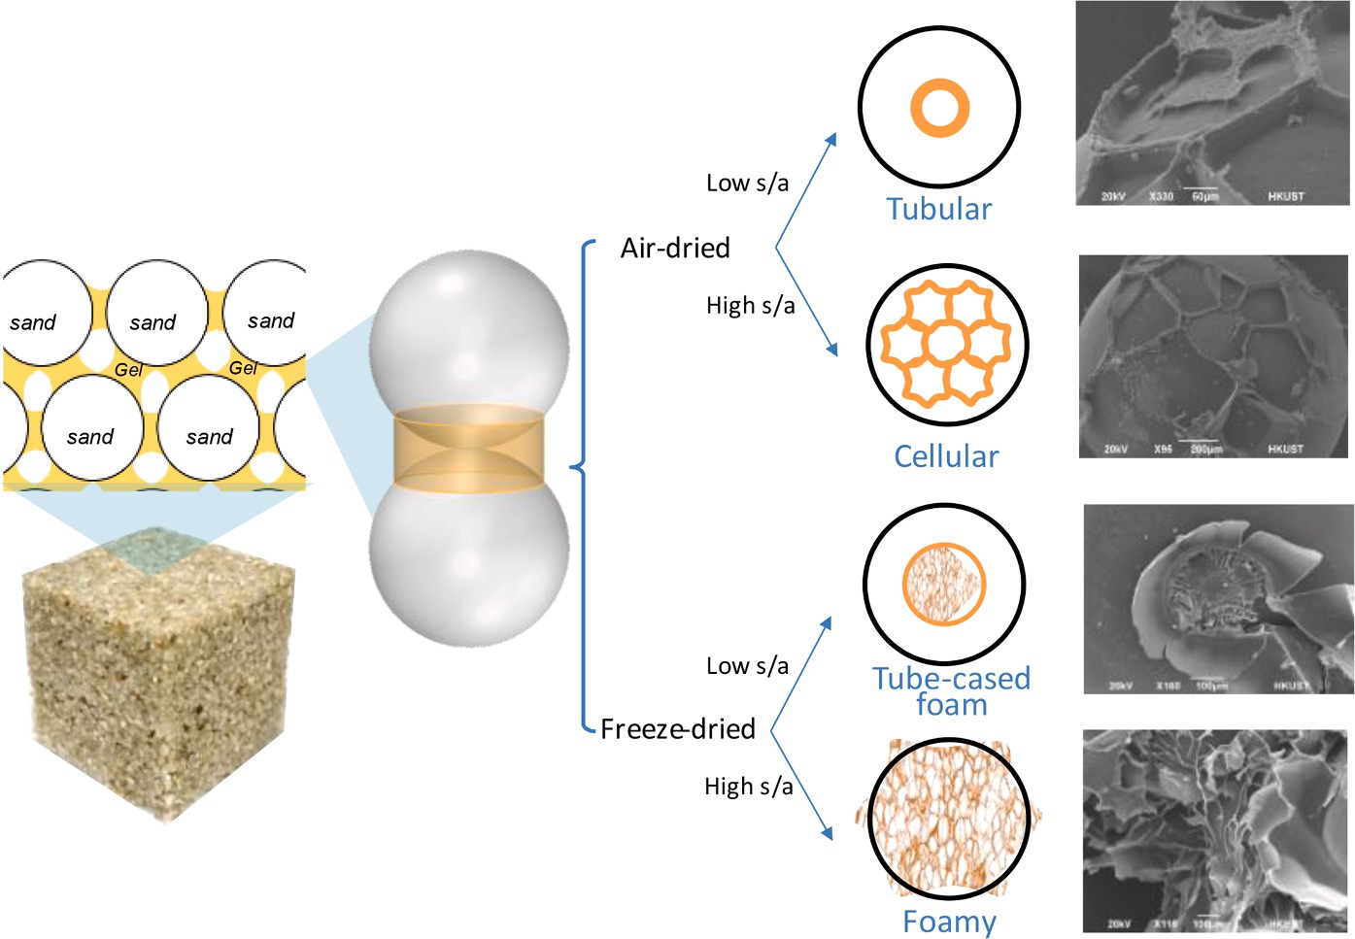

Fig. 1. The microstructural features of the hydrogel in HBC and their dependency on under sol-to-sand ratio and curing scheme: (a) low s/a, air dried; (b) low s/a, freeze-dried; (c) high s/a, air-dried; (d) high s/a, freeze-dried (Liu and Qiu, 2022).

and Qiu, 2022). However, it remains limited in its ability to quantitatively predict the mechanical behavior of multi-scaled porous HBCs based on the s/a ratio and environmental conditions (Liu and Qiu, 2022). Many composite models have successfully predicted the mechanical behavior of porous particulate composites. For example, based on the rule-of-mixture-based models like the Voigt model (Luo, 2022; Voigt, 1889), the Reuss model (Luo, 2022; Reuß, 1929), the Halpin-Tsai model (Affdl and Kardos, 1976), and etc., the effects of micro-level properties like pore structure (Alam, 2011; Li et al., 2021) and interfacial bonding (Sun et al., 2003; Liu et al., 2004; García et al., 2015) on bulk material can be considered and predicted. Additionally, classical continuity mechanics theories like the Mori-Tanaka approach (Benveniste, 1987), Eshelby inclusion theories (Eshelby, 1957; Tagliavia et al., 2010), and FEM simulation
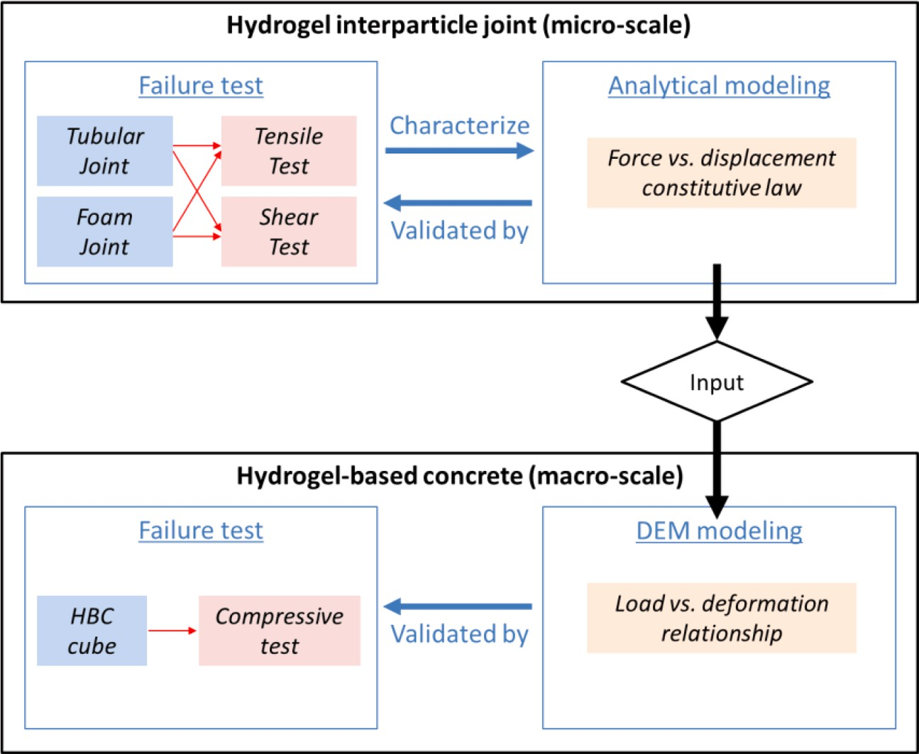

Fig. 2. Multi-scale experimental & modeling framework of this study.

(Xu et al., 2022) can also be used for modeling particulate composites. However, composite theories predict macro-level material behavior by a sense of proportionate superposition of micro-level properties, which makes it challenging to incorporate the specific microstructures explicitly and quantitatively.
The discrete element method (DEM) can naturally be used as muti-scale modeling, simulating macroscopic material properties of cemented granular materials such as concrete, rock, and ceramics by tracking the interaction of discrete elements at the microscale. Selecting appropriate microscale parameters, especially for complex microstructures, is critical and challenging for accurately pre- dicting macro parameters. The micro parameters are typically derived from the morphology and material properties of the binder materials. For example, cement binders in concrete and rocks are often treated as elastic and brittle solid cylinders (Potyondy and Cundall, 2004; Zhu and Tang, 2004; Holt et al., 2005). For composites with complex microstructure, microparameters are always derived through empirical trials and assumptions and calibrated by experimental or simulation design (Zhu et al., 2017; Zhu et al., 2019; Wang and Alonso-Marroquin, 2009; Dvorkin et al., 1994). For instance, the cementitious binder and interfacial transition zone (ITZ) in concrete are simplified as different groups of bonded small particles (Wang et al., 2020; Nitka and Tejchman, 2015). Statistical tools and machine-learning approaches are also used to calibrate microscale parameters (Jin et al., 2023; Klejment, 2021). However, current models rarely consider the variation of hydrogel microstructures and thus cannot account for the environmental dependency of HBC. While some existing models, such as Gibson and Lorna (2003) (Gibson, 2003), can predict the behavior of thin-tube structures or foamy continua, their feasibility in calculating the local microstructure in HBC is unknown.
To our best knowledge, there is no model for predicting the mechanical behaviors of the unique multi-scale cellular microstructures found in HBCs made with relatively low s/a (≤0.2), which limits its further engineering. In this study, we developed a multi-scale model to predict the bulk material properties of HBC. At the micro level, we studied the interparticle constitutive relationship by
direct testing and microstructure modeling on joints of HBC. At the macro level, we employed DEM by coupling micro-structure-based input to simulate the compressive behavior of the bulk material.

Multi-scale framework for studying HBC

A multi-scale framework for studying mechanical behaviors of HBC is proposed and given in Fig. 2 On the micro-scale, tensile and shear failure tests are conducted with two types of hydrogel interparticle joints, i.e., the tubular joint formed under ambient conditions and the foamy joint formed under freeze-drying conditions. Based on the microstructural failure modes revealed by the experiments, analytical models that predict the constitutive laws of joint force (F_{n}, F_{s}) vs. particle displacement (u_{n}, u_{s}) can be established, where “n” is for normal direction and “s” is for shear direction. These analytical models directly involve the geometries of the micro-tube and foam, and thus the effect of curing condition of HBC.
On the macro-scale, a numerical model based on the DEM is established to predict the mechanical behaviors of HBC as cemented granular particles. In this new DEM model, the interparticle joint behavior is determined with a LPM (Potyondy and Cundall, 2004), which engages the constitutive laws obtained from the micro-scale study; the variation of the joint properties is described by Weibull distribution. The DEM modeling results, i.e., compressive force vs. deformation of HBCs, are validated by the compressive failure test on HBC cubes.

Mechanical behavior of interparticle hydrogel joint

  - Experimental study of hydrogel joints

    - Experimental methodology
We fabricated and tested a special particle-to-particle specimen consisting of two contacted spherical glass beads (D₀=20 mm) and a hydrogel cylindrical joint. The joint was sharpened by filling a cylindrical mold (d₀=15 mm) with gelatin-based hydrosol (20 wt.%)
and curing the specimens under “air-drying (AD)” regime or “freeze-drying (FD)” regime (Table 1). More details regarding the curing methodology can be found in our previous work (Liu and Qiu, 2022). As shown in Fig. 3, after the AD curing, the hydrogel shrank into an hourglass shape with a hollow cavity inside and thin skins covering the polar region of the spheres; it is referred to as a “tubular” joint hereafter; after the FD curing, the hydrogel kept its cylindrical shape with cellular structure inside, it is referred to as “foamy” joint hereafter. Key geometric properties of the tube and foam structure formed are given in Table 2.
The tubular and foamy hydrogel joints were tested under tensile and shear loading until their failures. The testing set-ups are shown in Fig. 4. Both tensile and shear loadings were displacement-controlled (0.01 mm/s) to guarantee that there was no dynamic effect involved. For each joint type, at least six specimens were tested. Two notes regarding the methodology should be taken: first, spherical beads larger than the actual aggregate (1 mm) in HBC were used for accurate fabrication and geometric measurement; second, only tension and shear of the joint were involved because they are the dominant joint failure modes in a porous concrete under compression (Shen et al., 2016).

Table 1
Curing details of particle-to-particle joints.
Curing regime Temperature and air pressure history

Air-drying (AD) 23 ◦C, ~1 atm (14 days)
Freeze-drying (FD) —18 ◦C, ~1 atm (24 h) followed by —55 ◦C, 10 Pa (5 days)

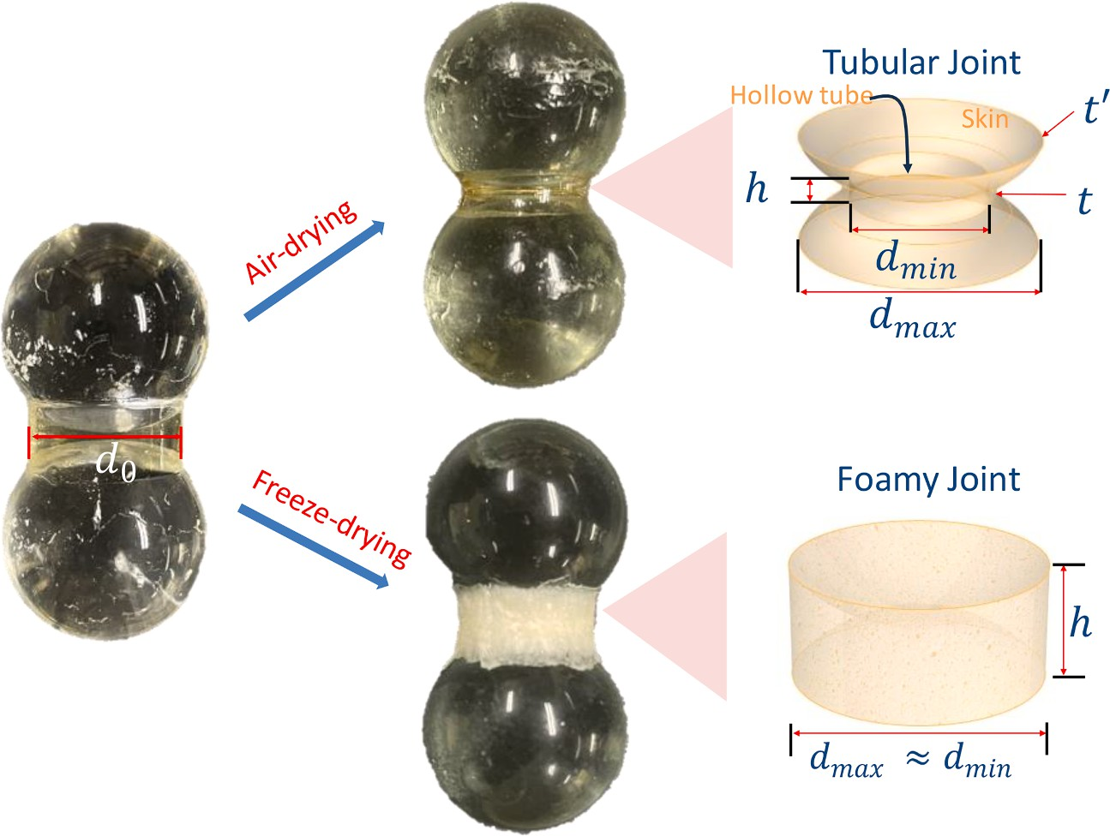

Fig. 3. Curing-formed the microstructures in hydrogel tubular/foamy joint.

Table 2
Geometric properties of the tube/foam formed in the hydrogel joint (unit: mm).
Curing | Joint | Original | Post-curing | Post-curing | Post-curing gel | Post-curing gel wall | Post-curing gel skin
regime | type | diameter d0 | maximum diameter | minimum diameter | wall height | thickness | thickness

dmax
dmin h t tʹ

AD Tubular 15.00 12.18 ± 0.78 9.67 ± 0.22 1.56 ± 0.11 0.41 ± 0.08 0.26 ± 0.03
FD Foamy 15.00 12.77 ± 0.12 12.77 ± 0.12 5.40 ± 0.62 – –

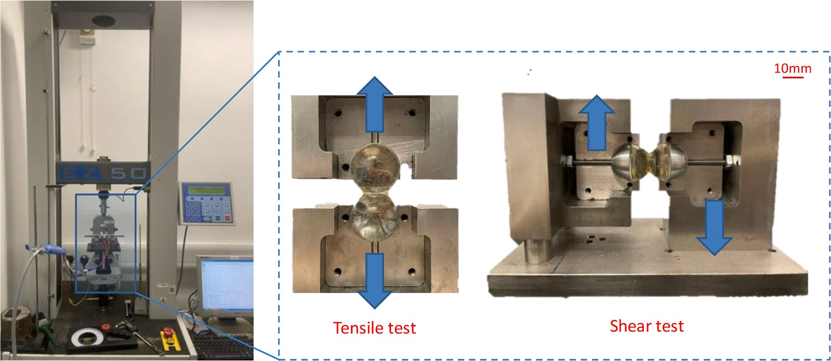

Fig. 4. Testing set-ups for the tensile and shear loading of particle-to-particle specimens.

    - Experimental results
Fig. 5 shows the typical applied force vs. particle displacement curves of hydrogel joints. As shown in Fig. 5a, the tensile behavior of the tubular joint was characterized by two-stage failure. In the first stage, the hydrogel tube underwent elastic elongation, and thus,
normal force F_{n} increased almost linearly with u_{n}, and the stiffness was named K_{n1.} When loading exceeded the first critical force Fʹ , i.
n
e., the skin-to-bead interfacial stress reached the debonding strength, the hydrogel skin started to peel at one side of the particle, and thus F_{n} slightly dropped. In the second stage, the interfacial crack propagated deeper, and F_{n} continued to increase with u_{n}. The normal

N. Liu et al.
Journal of the Mechanics and Physics of Solids 196 (2025) 105969
6

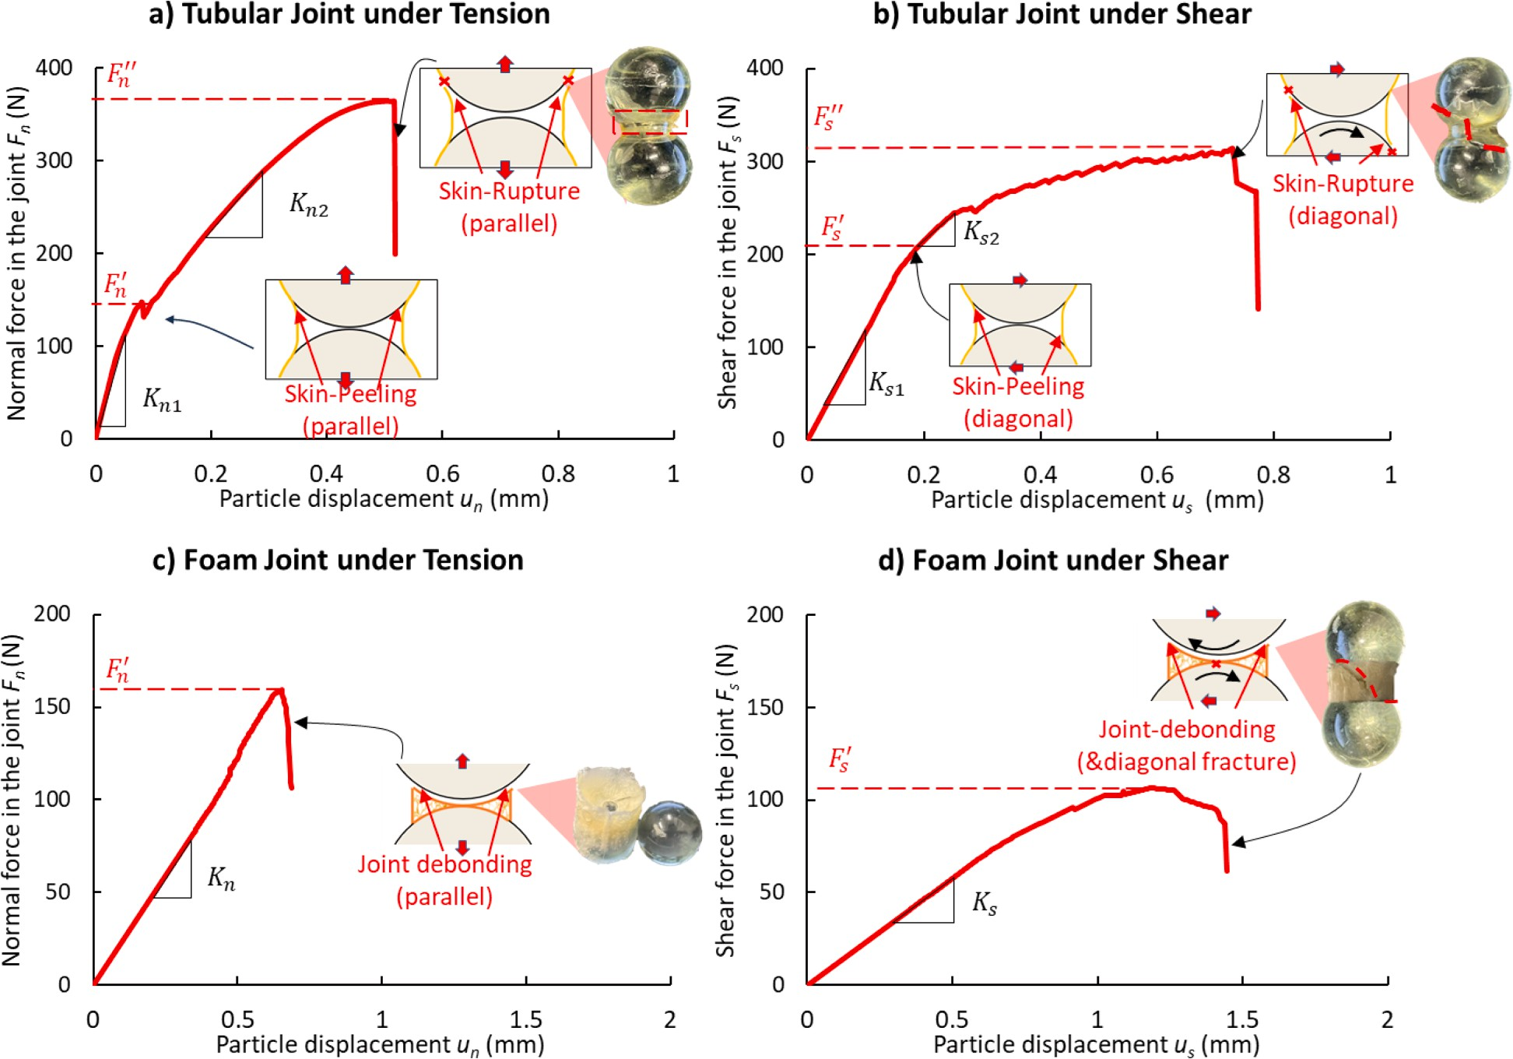

Fig. 5. Representative force-displacement (F vs. u) curves and schematic failure processes of interparticle hydrogel joint: (a) tubular joint under tension, (b) tubular joint under shearing, (c) foamy joint under tension, (d) foamy joint under shearing.

stiffness K_{n2} was only 1/3 to 1/2 of K_{n1} because the continuous debonding and elongation of the hydrogel skin led to additional interparticle displacement. As loading exceeded the second critical force F ʹ, i.e., the tensile stress in the debonded skin reached the
n
tensile strength of hydrogel, the tube ruptured at the circumference, and thus F_{n} suddenly dropped to zero.
As shown in Fig. 5b, the shear behavior of the tubular joint was characterized by two-stage failure as well, which is similar to tensile behaviors. In the first stage, the hydrogel tube underwent elastic shear deformation, and thus, normal force F_{s} increased almost linearly
with u_{s}, and the stiffness was named K_{s1}. When loading exceeded the first critical force Fʹ, the hydrogel skin started to peel diagonally
s
on both sides of the particle. In the second stage, the shear stiffness K_{s2} was mainly determined by continuous debonding and elon- gation of the hydrogel skin, which was comparable with K_{n2}. However, in the single-joint specimen, the bead rotated, and there was inevitable relative displacement between the bead and clampers. Such displacement decreased the slope and increased failure displacement. Such bead rotation would be well-constrained in the HBC composite because the particles are fixated at multiple gel
joints. Finally, as loading exceeded the second critical force F ʹ, i.e., the tube ruptured as a diagonal crack penetrated through, and thus,
s
shear force F_{s2} dropped back to zero.
As shown in Fig. 5c and 5 d, both the tensile and the shear behaviors of the foamy joint were characterized by a linear ramp followed by multiple drops of the force-displacement curve. The linear ramp is attributed to the elastic formation of hydrogel (K_{n}, K_{s}),
and the stepped drops are attributed to the intrinsic non-brittle failure of the cellular structure (Fʹ , Fʹ). The final failure of the joint
n s
happened as the hydrogel foam debonded from the particle circumferential failure at one side of the foam under tension or a diagonal rupture through the foam under shearing.

  - Analytical modeling of tubular hydrogel joints

In this study, we utilized gelatin hydrogel, one of the most commonly used hydrogels in everyday applications, to ensure con- sistency with previous research. Hydrogels encompass a wide range of water-containing polymeric materials characterized by their softness and stretchability. Numerous designs have been developed to impart varied mechanical properties to hydrogels, including high strength, extensive stretchability, and resistance to fracture (Zhou et al., 2023; Hu et al., 2015; Vernerey et al., 2018; Sun et al., 2012). Generally, hydrogels exhibit hardening and a loss of viscoelastic properties upon dehydration (Li et al., 2020). To determine the constitutive tensile relationship of fully dehydrated gelatin hydrogel, we conducted tensile tests on dogbone-shaped film samples. The results indicate that dehydrated gelatin can be approximated as a linear elastic material, which exhibits brittle fracture upon reaching its maximum tensile strength. In this section, we established constitutive relationships, specifically the relationship between applied force and deformation, through an analytical model to describe the complete failure process of tubular and foamy joints under tension and shear, as outlined in Section 3.1.

    - Tubular hydrogel joint under tension
In the elastic stage (Stage 1), F_{n1} can be calculated as the product of microstructural stiffness K_{n1} and the particle displacement u_{n}, assuming no other cause of deformation.
F_{n1} = K_{n1} ⋅ u_{n} (1)
The stiffness can be calculated as

K_{n1} = α
Eʹ ⋅ A_{j} (2)
h

where Eʹ is the equivalent elastic modulus of hydrogel in a tubular structure; A_{j} is the cross-sectional area of the tubular wall, which is calculated as πd_{min}t; α is a shape coefficient that quantifies the effect of changing a curved wall from a straight wall (Fig. 6). The Eʹ of a tube can be calculated with the actual elastic modulus of the hydrogel material E_{s} (Hoogenboom and Spaan, 2005; Liu et al., 2021).

4t
Eʹ
= ,̅3̅̅(d
min

+ 2t)
⋅ E_{s}

(3)

Therefore, the constitutive F_{n1} vs. u_{n} relationship in the skin-peeling stage can be calculated as

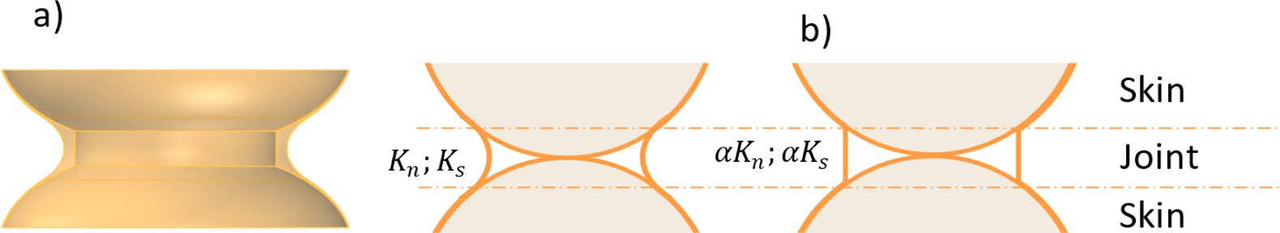

Fig. 6. Quantifying the effect of changing (a) curved wall to (b) straight wall by a shape coefficient α. The tubular wall is curved inward because of the air pressure difference in and out of the tube during curing.

F_{n1} =
4π ⋅ α ⋅ t² ⋅ d_{min}
,̅3̅̅ ⋅ h(d_{min} + 2t)
⋅ E_{s} ⋅ u_{n} (4)

In the skin-peeling stage (Stage 2), analytical formulas were derived based on four assumptions, i.e., (1) the peeling was sym- metrical, (2) the debonded skin was elastic material, (3) the particle was rigid material that had no deformation, (4) there was no sliding between the skin and the particle. The assumptions were used by other researchers when analyzing similar problems, like peeling a tape from a rigid substrate (Kendall, 1975; Afferrante et al., 2013; Begley et al., 2013; Liprandi et al., 2020). Fig. 7 shows the free-body diagrams of a quarter of the tubular joint in different stages of the skin-peeling process. At the beginning (Fig. 7a), F_{n2} is applied to the free part of the skin at the root point O; its effect on the bond part is ignorable. As the skin debonding (Fig. 7b), O moves
down by Δθ, a segment of skin with a length of ΔL(= rΔθ) is peeled and elastically elongated to λΔL (Hu et al., 2023) where stretch
λ
ratio is calculated as
F_{n2}
λ = 1 + ε = 1 + ( > 1) (5)
2π ⋅ r ⋅ sinθ ⋅ tʹ ⋅ E_{s}
where ε is the strain in the skin. As the newly freed part is very short, it will not be straightened to merge into the existing free part.
Because of the peeling and elongation, the loading point moves Oʹ up, and the force F_{n2} does work. It is important to note that when peeling begins, we assume that the circumferential deformation of the hollow tube, due to further stretching by the peeled skin, is
negligible, as the thickness of the hollow tube walls is significantly greater than that of the thin skin. Consequently, Oʹ will continue to
move upward after peeling, constrained by the tube. As the debonding crack extends deeper, the tensile stress at O increases until it exceeds the tensile strength and ruptures the hydrogel. The interfacial crack propagates when the energy release rate J is equal to or larger than the free energy of the skin-to-particle interface Γ. By considering an infinitesimal peeling process characterized by dθ, J is calculated as

J dW — dU_{e} dA_{p}
=

(6)

where dW is the work done by the force, dU_{e} is the elastic strain energy of the peeled segment of the skin, dA_{p} is the peeled surface area created by the crack propagation. They are calculated as Eqs. (7)-(9) (detailed calculations of Eqs. (7) and (8) can be found in Appendix).

dW =
F_{n2} ⋅ ΔL sinθ

F_{n2} ⋅ ΔL

F2
d dθ (7)
ε + n2
2πtʹ ⋅ E_{s} ⋅ sin³θ
F² ⋅ [sinθ + (θ — θ₀)cosθ]

dU_{e} =
sinθ
dε + n2
4πtʹ ⋅ E_{s} ⋅ sin⁴θ
dθ (8)

dA_{p} = 2πr² ⋅ sinθ ⋅ dθ (9)
Combining Eqs. (6)-(9), the results are simplified to
F² ⋅ [1 — (θ — θ₀) ⋅ cotθ]

J n2
= ₄
8π2 ⋅ r2 ⋅ tʹ ⋅ E_{s} ⋅ sin θ
(10)

Based on Eq. (10), Fʹ marking the beginning of skin-to-particle interface cracking, i.e., when θ = θ₀ = arcsin(d_{min} /2r), can be calculated by setting J = Γ, and written as
n

F ʹ = 2π ⋅ r ⋅ sin²θ₀
n
⋅ √̅t̅ʹ̅E̅̅̅s̅Γ̅̅̅
(11)

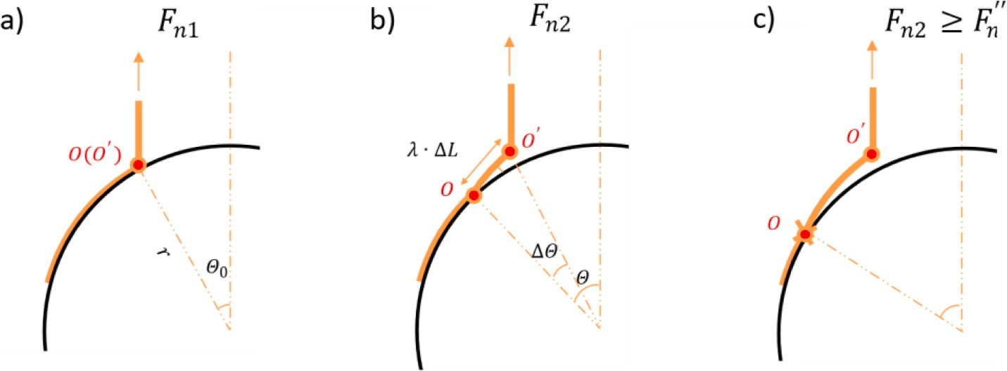

Fig. 7. Illustration of the skin-peeling process from spherical particle: (a) before peeling; (b) ongoing peeling; (c) rupture of peeled skin.

The displacement uʹ corresponding Fʹ to is calculated as

n n
ʹ
F
u ʹ = n

(12)

^{n} Kn1
Assuming J remains constant during the whole peeling process, the relationship between F_{n2} and θ in the skin-peeling stage is calculated as

F_{n2}(θ) =
√̅8̅̅π̅̅̅2̅̅r̅̅2̅̅s̅̅i̅n̅̅̅₄̅̅θ̅̅̅⋅̅̅̅t̅ʹ̅̅⋅̅̅̅E̅̅̅s̅̅⋅̅̅̅Γ̅̅

(13)

The relationship between u_{n} (i.e., the loading-point displacement in Fig. 7) and θ is calculated as
1 — (θ — θ₀) ⋅ cotθ
u_{n}(θ) = λΔL ⋅ sinθ — r ⋅ (cosθ₀ — cosθ) (14)
By combining Eqs. (13) and (14) and eliminating θ, the constitutive F_{n2} vs. u_{n} relationship in the skin-peeling stage can be determined.
In the skin-peeling stage, when F_{n2} increases to a critical magnitude F_{n} ʹ defined by the gel tensile strength σ_{f} , i.e.,
F ʹ = π ⋅ d_{max} ⋅ t ⋅ σ_{f} (15)
n
the force drops to zero. uʹ corresponding F ʹ to is calculated as
n n
uʹ = u_{n} θ F_{n2} = F ʹ)) (16)
n
n
where u_{n}(θ) is Eq. (14), and θ(F_{n2}) = F^{—1}(θ) is the inverse function of Eq. (13).
n2
Therefore, the overall constitutive relationship F_{n} vs. u_{n} can be summarized as

F_{n} =
⎧⎪⎨
F_{n1}, u_{n} ≤ uʹ F_{n2}, uʹ < u_{n} ≤ uʹ

(17)

n n
n
n
⎪⎩ 0, u_{n} > uʹ

    - Tubular hydrogel joint under shear
A two-stage F_{s}-u_{s} curve, similar to the tension curve, was observed in our experiment. In the elastic stage (Stage 1), F_{s1} can be calculated as the product of microstructural stiffness K_{s1} and the particle displacement u_{s}, assuming no other cause of deformation.
F_{s1} = K_{s1} ⋅ u_{s} (18)
The initial elastic shear deformation can be calculated similarly to tension deformation:

K_{s1} = α ⋅
Gʹ ⋅ Aj (19)
h

where Gʹ is the equivalent shear modulus of hydrogel in a tubular structure, which can be calculated with the actual elastic modulus of the hydrogel material G_{s} as (Hoogenboom and Spaan, 2005; Liu et al., 2021):

4t
Gʹ
= ,̅3̅̅(d
min

+ 2t)
⋅ G_{s}

(20)

Therefore, the constitutive F_{s1} vs. u_{s} relationship in the skin-peeling stage can be calculated as 4π ⋅ α ⋅ t² ⋅ d_{min}
F_{s1} = ,̅3̅̅ ⋅ h(dmin + 2t) ⋅ G_{s} ⋅ u_{s} (21)
Unlike its response to tension, the diagonal peeling induced particle rotation and, thus large displacement in the second stage. In the skin-peeling stage (Stage 2), analytical formulas should be derived based on the same assumptions as the tension case except for antisymmetric peeling in shear. However, due to the non-symmetrical shape and complicated stress field (Liprandi et al., 2020), it is challenging to derive explicit expressions. Therefore, we propose an analogy between skin peeling under tension and skin peeling under shear, and we derived the shear equation by taking the similar peeling process shown in the tensile failure. The peeling equation under shear is simplified as a linear equation with stiffness K_{s2} and calculated as

F = K
s2
∗ u + (1 — Ks2)Fʹ

(22)

where K_{s2} = β_{k}K_{s1}. The β_{k} is a constant obtained from experimental results, varying from 0.6 to 1.0. The critical peeling force Fʹ =
s
s2
s
Ks1
s
βʹ Fʹ . The βʹ varies from 1.2 to 1.8; it is larger than 1 because the direction of shear force tends to peel the skin at a smaller peeling
F n F
angle (Liprandi et al., 2020). uʹ corresponding to Fʹ is calculated as
s s

ʹ
F
u ʹ s1

^{s} = Ks1
The rapture failure force F ʹ is calculated by
s
(23)

F ʹ = π ⋅ d_{max} ⋅ t ⋅ τ_{f} (24)
s
The force then drops to zero. uʹcorresponding to F ʹ is calculated as

us ʹ
s s
ʹ ʹ
F — F
s s ʹ
+
u
=
Ks2 s

(25)

Therefore, the overall constitutive F_{s}-u_{s} relationship can be described bilinear piecewise and summarized as follows.

F_{s} =
⎧⎪⎨
F_{s1}, u_{s} ≤ uʹ F_{s2}, uʹ < u_{s} ≤ uʹ

(26)

s s
s
⎪⎩ 0, u_{s} > uʹ
s

    - Foamy hydrogel joint under tension and shear
Unlike air-dried joints, freeze-dried joints are foam structures with no adhesive film segments that adhere to particles uniformly. Previous researchers have utilized the Derjaguin, Muller, and Toporov (DMT) model (He et al., 2022; Peng et al., 2020) to study the debonding behaviors between two different materials where the stress distribution in the bonding area is even. With increasing loading, the joint undergoes linear elastic deformation, whose normal and shear stiffness are determined by

K_{n} =

K_{s} =
Eʹ ⋅ Aj (27)
h
Gʹ ⋅ Aj (28)
h

where Eʹ and Gʹ are equivalent elastic modulus and shear modulus of hydrogel in foam structure; A_{j} = πd_{min}/4. The Eʹ and Gʹ of foam can be calculated with the actual elastic modulus of the hydrogel material E_{s} (Gibson, 2003; Liu et al., 2021) as
Eʹ = C E ∗ 1 — ϕ )2 (29)
1 s
foam
Gʹ = C₂E_{s} ∗ 1 — ϕ_{foam})2 (30)

where ϕ_{foam} is the porosity of the foam, which is the most critical feature relevant to mechanical properties. ϕ_{foam} is the same for different mixing ratios, as the hydrogel has a constant water content before drying. C₁ and C₂ are proportionality constants for considering geometric constants, including cylindrical foamy joints with concave hemispherical ends and the morphology of the pores.
When the applied force exceeds the bonding force of joints, which are Fʹ in the normal direction and Fʹ in the shear direction, the
n s
joint experiences sudden debonding and the reaction force back to zero directly. Fʹ and Fʹ are given as
n n
Fʹ = A_{j}σ_{b} (31)
n
Fʹ = A_{j}τ_{b} (32)
s
where σ_{b} and τ_{b} are the equivalent bonding strength in the normal and shear direction. The corresponding displacements are given as
ʹ
F
uʹ n

_{n} = Kn
(33)

ʹ
F
uʹ s

_{s} = Ks
(34)

Therefore, the overall constitutive equations are summarized as follows:

F_{n} =
n
0, u_{n} ≥ uʹ
n
{ K_{n} ∗ u_{n}, u_{n} < uʹ
(35)

F_{s} =
s
0, u_{s} ≥ uʹ
s
{ K_{s} ∗ u_{s}, u_{s} < uʹ
(36)

  - Parameter calibration of the analytical model

The tensile strength and elastic modulus of dehydrated gelatin hydrogel, which was simplified as an elastic-brittle material, were determined through standard uniaxial tensile tests on air-dried dog-bone films. In the meanwhile, Poisson’s ratio (v) was obtained tested in tensile test on film samples. Thus, G was calculated by E/(2(1 + v). For calculating the elastic modulus of foam structure, we
did the MIP test for obtaining the properties of pore structures of foam, i.e. porosities. Additional material properties and empirical
parameters were derived from the experimental results using the formulas outlined in the preceding section. The input geometrical parameters of the joint are measured and provided in Table 2, and the input gel material properties and empirical coefficients are provided in Table 3. The analytical results are summarized in Table 4 and compared with the experimental results, which are illus- trated in Fig. 8. The results show that the analytical models can capture the bi-linear behavior of tubular joints and the linear behavior of foamy joints. They can accurately calculate the tensile/shear stiffness of the joints at different stages, as well as the critical forces corresponding to the transition and failure of the joints. One exception is the second stage of shear stiffness of the tubular joints. The K_{s2} predicted by the model is lower than that seen in the experiment. Another exception is the failure displacements of the tubular and foamy joints predicted by the model, which are smaller than those of the experimental results. They may be attributed to the additional bead rotation, which is inevitable in the single-joint specimen.

  - Validation of the analytical model and investigation on size effect

Since the particles used in the previous section are significantly larger than those employed in HBC, we investigated the potential size effects of joint and particle diameters, which also served to validate the calibrated model parameters. We fabricated one group using beads of the same size as the calibrated samples (D₀ = 20mm) and filled the joints with three different sizes: d₀=10, 15, and 20
mm. Another group of samples was created using beads of varying diameters (D0 = 5, 10, and 20mm) while filling the joints with
corresponding beads of the same size (d₀ = D₀). All samples were prepared using the same procedures and maintained the same
structural types as before, specifically tubular and foamy joints, with detailed geometric parameters measured and provided in Appendix A.
We employed the calibrated parameters from Table 3 to predict the behaviors of the joints with varying fresh diameters and particle diameters, validating these predictions against experimental results. The typical load versus deformation curves for tubular joints under tension are presented in Fig. 9 as representative results, while a summary of critical force and stiffness across all stages and cases can be found in Appendix A.
The results indicate that the analytical models effectively capture the bi-linear behavior of tubular joints and the linear behavior of foamy joints across all tested cases. The calibrated parameters are suitable for this modeling, allowing for accurate calculations of the tensile and shear stiffness of the joints at different stages, as well as the critical forces associated with the transition and failure of the joints. As previously noted, additional bead rotation is an unavoidable factor in the shear testing of single-joint specimens.
Overall, the model proves effective for predicting the behavior of joints with varying diameters corresponding to different mixing ratios. It is also scalable for the current sample sizes, as larger particle samples yield the same joint types as those found in HBC. The microstructure of the samples is several orders of magnitude smaller than the particles used in HBC, and the structural types and adhesive mechanisms remain consistent at this scale, as demonstrated in other similar studies (Cho et al., 2006; Lauke, 2008; Miled et al., 2007). This consistency ensures that the particle size in this test does not significantly impact the results.

Table 3
Summary of parameters for analytical equations of tubular and foamy joints.
Tubular joints
Elastic modulus of joint material | Es | 2 GPa*
Shear modulus of joint material | Gs | 1 GPa^{𝛙}
Poisson’s ratio | v | 0.26*
Shape coefficient of curved wall | α | 0.2^{𝛙}
Coefficient of peeling force in shear | βʹ | 1.8^{𝛙}
Softening coefficient of shear stiffness | β_{k} | 0.6^{𝛙}
Free interfacial adhesion energy | Γ | 189 N/mm^{𝛙}
Tensile strength of joint material | σ_{f} | 55.4 MPa*
Shear strength of joint material | τ_{f} | 44.3 MPa^{𝛙}
Foamy joints  Constant of foam in Eʹ | C1 | 0.3‡
Constant of foam in Gʹ | C2 | 0.18‡
Elastic modulus of joint material | Es | 2 GPa*
Shear modulus of joint material | Gs | 1 GPa^{𝛙}
Normal debonding strength | σ_{b} | 1.8 MPa*
Shear debonding strength | τ_{b} | 1.4 MPa*
Material porosity | ϕfoam | 0.79*

F

* Experimental results from direct test;
^{𝛙} Experiential value based on experimental results;
‡ Experiential value from reference (Gibson, 2003; Liu et al., 2021).

Table 4
Summary of interparticle joint test results.
Type Critical force
Fʹ(N)

Critical force
Fʹ(N)

Stiffness
K1 (N/mm)

Stiffness
K2 (N/mm)

Tube-tension 157.8 ± 18.5 349.3 ± 30.4 1661.2 ± 341.1 532.0 ± 64.1
Tube-shear 210.9 ± 29.8 327.0 ± 20.1 685.9 ± 228.9 298.1 ± 71.2
Foam-tension 148.2 ± 12.5 – 673.9 ± 156.2 –
Foam-shear 116.0 ± 21.4 – 101.9 ± 53.2 –

Mechanical behavior of hydrogel-based concrete (HBC)

  - Multi-scale discrete element method (DEM)-based HBC model

In this study, we developed a multi-scale DEM-based model to simulate the compressive behavior of HBC (Fig. 2). To define the interparticle relationship on a micro-level while considering the microstructure of joints, the DEM model utilized in this study adopted LPM. Each particle-joint-particle complex (Fig. 10) is treated as elastic particles bonded by elastic springs bonded in parallel in normal and shear directions, which are subsequently determined by the interactions between this complex and its adjacent particles. Under the combined axial, shear, bending, and torsion loadings, normal and shear stresses are generated at the interface between the two particles. The stresses are only born by the hard contact of the two particles (only compressive stress) and the deformation of the hydrogel joint. The model assumes the particle has much higher stiffness than the joint and will not break under loading. Therefore, the deformation and failure of the complex are determined by the stiffness and load capacity of the hydrogel joint. When the maximum stress, which is always generated at the joint periphery, exceeds its corresponding equivalent failure strength, the joint is set as a broken state and will be removed, and only hard contact between particles exists. Previously, the analogy of elastic beams has suc- cessfully predicted particles cemented by solid joints (Potyondy and Cundall, 2004; Holt et al., 2005). The method of incorporating the environment-dependent microstructures is presented as follows.
In our previous study, six HBC groups with different sol-to-aggregate ratios (s/a = 0.05, 0.1, and 0.2) and different curing histories
(air-drying and freeze-drying) were studied. The microstructures of hydrogel joints are highly mixing- and curing-dependent. They are classified into four types (Fig. 2), i.e., tubular (low s/a, air-dried), honeycomb (high s/a, air-dried), tube-cased foam (low s/a, freeze- dried), and foamy structure (high s/a, freeze-dried).
For the tubular joints, the constitutive laws (F vs. u) in normal and shear directions obtained in the last section are directly employed. However, complicated unsymmetric stress distribution appeared in the tubular joints under combined loading, which undermined the convergency of the numerical method. As a result, we had to simplify the bi-linear F-u curves into a linear curve. The
equivalent stiffness K_{neq} and K_{seq} for the tensile and shear curves were obtained by connecting the points of (0,0) and (uʹ, F ʹ).
For the foamy joints, the constitutive laws (F vs. u) in the last section can be directly employed to describe the interparticle behavior in the DEM model. For the honeycomb joints, we calculated their stiffness by assuming a hexagon cellular structure and calculated the elastic modulus and shear modulus using the following equations. (Gibson, 2003; Liu et al., 2021):

Eʹ = tE
l s

Gʹ = 0.
t
(37)

(38)

577 lG_{s}
Because gel fracture was the main failure mode and skin-peeling was rarely seen in experiments with honeycomb joints, we employed the DMT model to predict the joint failure. The method is the same as the one used for foamy joints.
For the tube-cased foam joints, we employed a composite model that incorporates the tubular case and foamy core as two parallel components. This model assumes that the interaction between the case and core is insignificant and would not alter the skin-peeling behavior of the tube. Particularly, the joint stiffness is calculated by linearly adding that of the tube and foam. However, the tube only controlled the failure because the foam typically exhibits smaller stiffness and allows for larger failure deformation. However, the tube could undergo significantly larger loading than the foam, and once the tube structure fails, the foam cannot sustain the large force and fails immediately. More details of failure criteria and how they were employed in the current model can be found in Appendix II.

  - Input parameters of the DEM-based model

    - The microstructural and material properties
The input dimensions of the interparticle joints are given in Table 5. The values were obtained by measuring the actual micro- structures in SEM images. Examples of the SEM images are given in Fig. 11. For each joint type, at least 5 SEM images with multiple joints were included. The equivalent stiffness and failure force of interparticle hydrogel joints formed with different s/a ratios and curing conditions are calculated and summarized in Table 6. They are used as interim parameters in the DEM model.

N. Liu et al.
Journal of the Mechanics and Physics of Solids 196 (2025) 105969
13

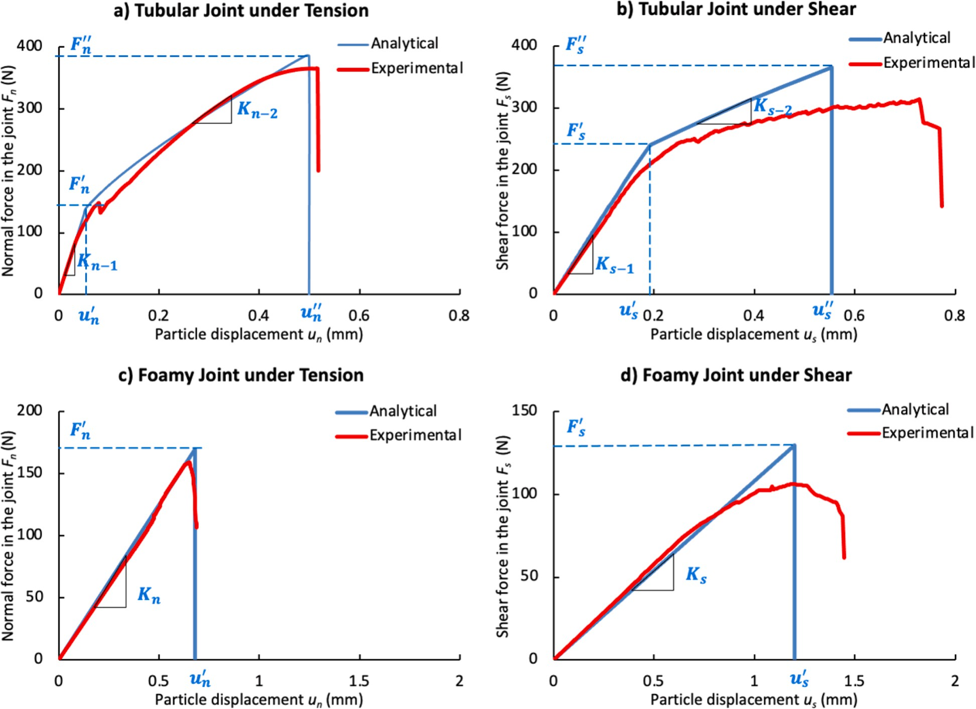

Fig. 8. Comparison between representative experimental and analytical force-displacement (F vs. u) curves of interparticle hydrogel joint: (a) tubular joint under tension, (b) tubular joint under shearing, (c) foamy joint under tension, (d) foamy joint under shearing.

N. Liu et al.
Journal of the Mechanics and Physics of Solids 196 (2025) 105969
14

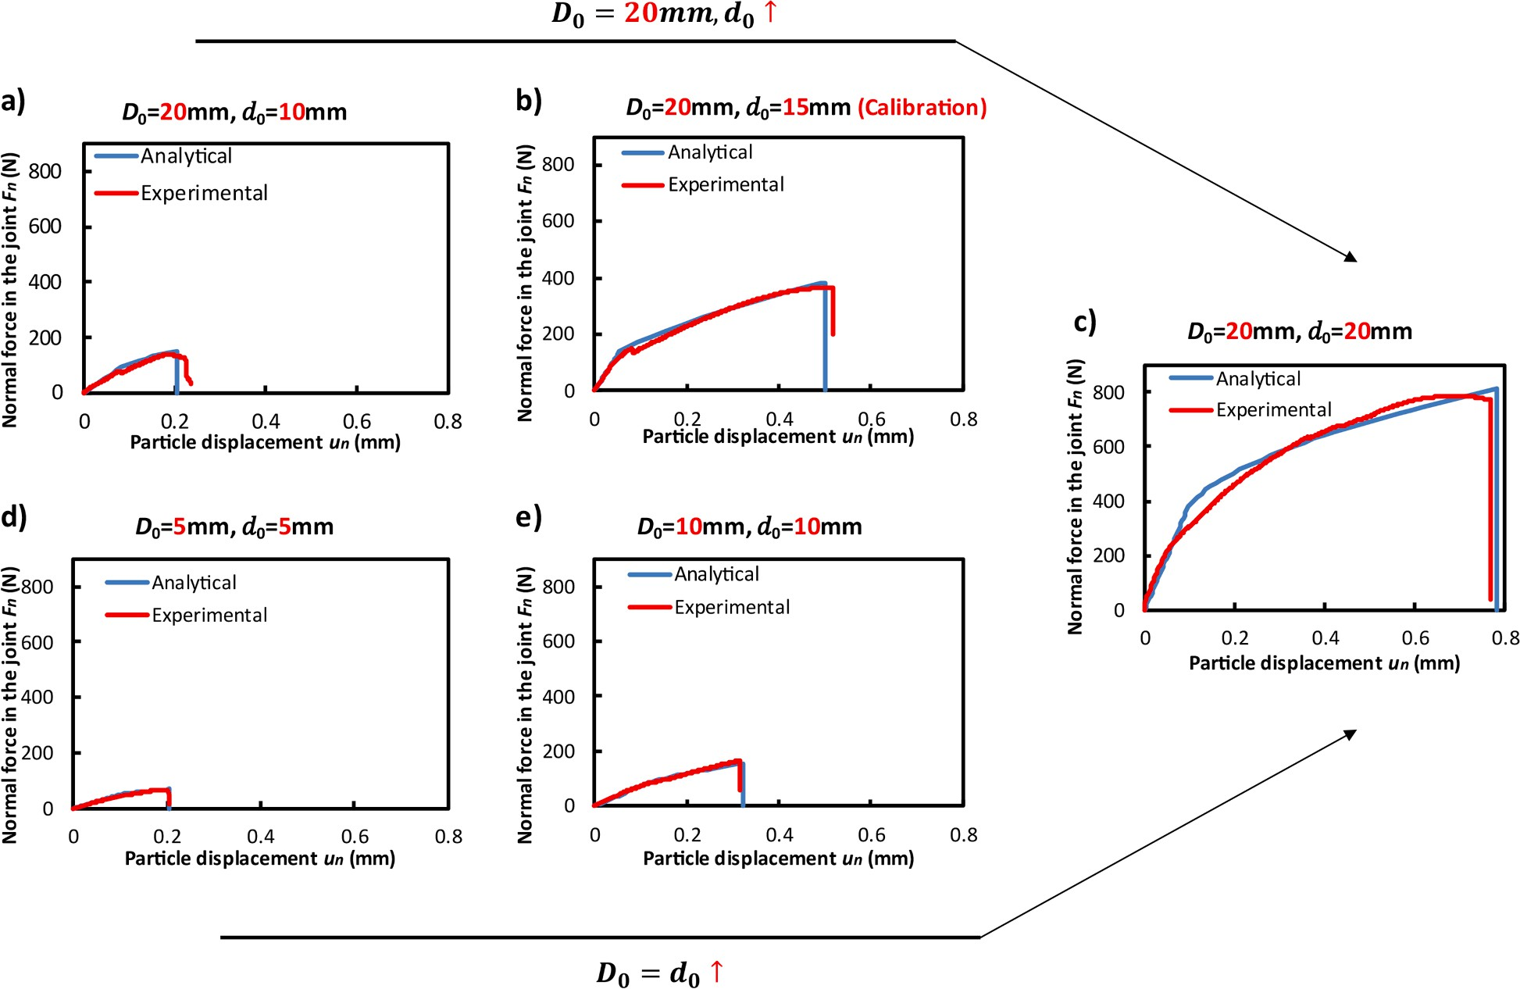

Fig. 9. Comparison between representative experimental and analytical force-displacement (F_{n} vs. u_{n}) curves of air-dried tubular joints with different d₀ and D₀ under tension.

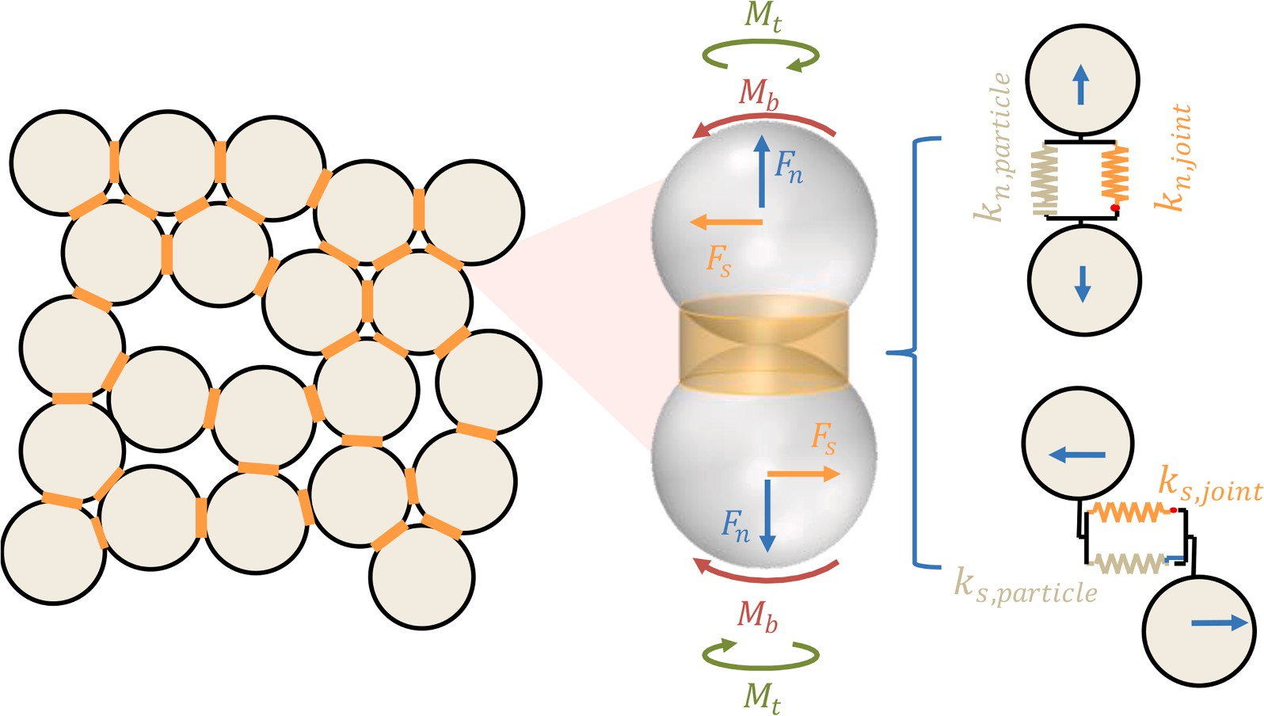

Fig. 10. Schematic of DEM model. Under the combined under combined axial, shear, bending, and torsion loadings, the joints and particles of the complex act in parallel.

4.2.3. Variation of hydrogel joint load capacity
The load capacity of hydrogel joints in HBC varies because of variations in particle size and microstructural dimensions. Weibull distribution has been widely used to quantify the variation of the joint properties in predicting the behaviors of cemented particles (Li et al., 2019; Liu et al., 2022). In this study, we employed Weibull probability distribution to quantify the tensile and shear strength of the hydrogel joints. The probability density function of bonding strength is given below.
ʹ m(Fʹ)_{m—1} [ (Fʹ)_{m}]
φ(F ) =
ʹ
F
ʹ
F
exp
—
ʹ
F
(39)

where Fʹ represents the variable of interest, which is the failure strength of joints under tensile or shear force. Fʹ is the scale parameter or reference value of the Weibull distribution, which is the average value of failure strength. m is the shape parameter that defines the
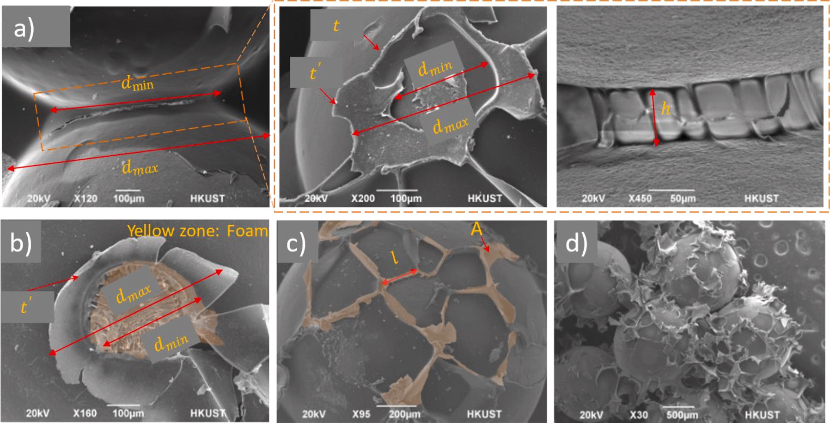

Fig. 11. Measurements of the critical dimensions in HBC microstructures: (a) tubular joints, (b) tube-cased foam joints, (c) honeycomb structure, and (d) foam structure.

Table 5
Input geometrical properties in the DEM model (unit: um).

Curing s/a Type dmin (μm)
dmax (μm)
Aj (mm²)
t (μm)
tʹ (μm)
h (μm)
l (μm)

Air-drying 0.05 Tubular 223.3 ± 98.2 290.60 ± 123.4 0.05 ± 0.02 6.0 ± 2.8 4.1 ± 2.3 39.87 ± 12.8 –
  - Tubular 314.2 ± 112.1 421.31 ± 192.7 0.10 ± 0.06 8.3 ± 3.9 6.1 ± 4.2 50.48 ± 17.8 –
  - Honeycomb – – 0.13 ± 0.04 9.8 ± 6.2 6.5 ± 3.5 114.3 ± 44.8 204.7 ± 102.2
Freeze-drying 0.05 Tube-Foam 253.3 ± 121.2 324.46 ±166.9 0.18 ± 0.09 3.6 ± 2.2 2.8 ± 2.1 80.3 ± 37.6 –
  - Tube-Foam 324.4 ± 145.2 456.33 ± 238.4 0.20 ± 0.11 4.8 ± 2.4 3.3 ± 2.9 85.9 ± 37.6 –
  - Foam 749.9 ± 215.6 749.9 ± 215.6 0.43 – – 338.5 ± 43.2 –

degree of homogeneity of modeling. The cumulative distribution functionΦ(Fʹ) can be expressed as:
ʹ [( Fʹ)_{m}]
Φ(F ) = 1 — exp
—
ʹ
F
(40)

Φ(Fʹ) is always in the range of [0,1], and its morphological curves are similar to a uniform distribution in the interval [0,1]. Therefore, the cumulative distribution function is assumed to obey uniform distribution (Li et al., 2019). Then, we reorganized the equation above and obtained:
Fʹ =

ʹ ʹ ¹
(41)

overline—F (ln(1 — Φ(F ))m
By substituting Eq. (41) into Eq. (39), and we can get the updated probability density function of the strength of bonds. As shown in Fig. 12a, with higher homogeneity index values, the objective parameters are concentrated in a narrower range. As shown in Fig. 12b, we tried to model HBC with homogeneity indices of 2, 6, and 8, which matched experimental data well when set m = 6.

  - Validation of the multi-scale DEM model

The unconfined uniaxial compressive behavior of the six HBC groups consisting of different microstructures is calculated with the new multi-scale DEM model. A 40 × 40 × 40 mm HBC cube incorporating 7963 particles and 31,853 joints was established. The particle size ranged from 1.0 mm to 1.3 mm, the weight being uniformly distributed within the range. The same size distribution in the
3
experiments was used for simulation. The elastic modulus and shear modulus of particles were set at 100 GPa and 50 GPa, respectively. The loading was displacement-controlled at 0.1 mm/s. The simulations stopped when the reaction force dropped to 30 % of the maximal loading.
The simulated compressive stress vs. strain relationship is compared with the experimental results. First, as shown in Fig. 12b, the model, without considering the joint quality variation, can accurately predict the compressive modulus of HBC but overestimate the compressive strength. Only after Weibull distribution was incorporated was the HBC strength captured. The simulated results of the three air-dried HBC groups (Fig. 13a to 13 c) and the three freeze-dried HBC groups (Fig. 13d to 13 f) are presented. Despite their differences in hydrogel joint microstructures, the new model can accurately capture the compressive behaviors, even to a very large compressive strain.
As shown in Fig. 14, the simulation results are slightly higher than the experimental data, particularly for the elastic modulus of air- dried HBC with a s/a ratio less than or equal to 0.1. This discrepancy may be attributed to the limitations of bond modeling. At lower mixing ratios, the hydrosol spreads and wets the particle surfaces but may not effectively form joints between the particles. Conse- quently, DEM models tend to overestimate the number of joints by determining them based on interparticle distances. This over- estimation may also arise from the oversimplification of the failure criteria for tubular joints. Specifically, we have applied the failure criteria of LPM, which decouples the failure criteria for shear and tensile forces. In the context of cemented granular materials, the non- uniform tensile stress generated by shear displacement during the initiation of tubular joints can diminish the tensile strength criteria, and vice versa (Shen et al., 2016; Shen et al., 2016). The peeling process under the asymmetry of tubular joints is complex and will be the focus of future research. Nevertheless, this modeling approach can still capture the fundamental relationships between mechanical properties and curing histories or mixing ratios, particularly when the s/a ratio is increased to 0.2, the simulation results align more closely with the experimental data. Overall, the model successfully captures the influence of the s/a ratio (0.05, 0.1, and 0.2) and environmental conditions on the elastic modulus and compressive strength of HBC (see Fig. 14b). Specifically, the findings indicate that: 1) as the s/a ratio increases, the elastic modulus initially increases and then decreases, while the compressive strength consis- tently increases; and 2) air-dried HBC exhibits greater elastic modulus and compressive strength compared to freeze-dried HBC (Liu and Qiu, 2022).
Fig. 15 compares the representative failure modes of HBC observed in both simulations and experiments. Both cases exhibited inclined microcracks during loading, with failure occurring due to crack localization. Minor differences were noted among the various groups, primarily influenced by the s/a ratio. When s/a < 0.2, the HBC displayed similar crack patterns, as illustrated in Fig. 15a,
where a single major crack was generated and evolved. In contrast, at s/a = 0.2, multiple cracks formed under compression, with the
number and angles of these cracks being randomly distributed. Additionally, a higher incidence of vertical cracks was observed in the

N. Liu et al.
Journal of the Mechanics and Physics of Solids 196 (2025) 105969
17

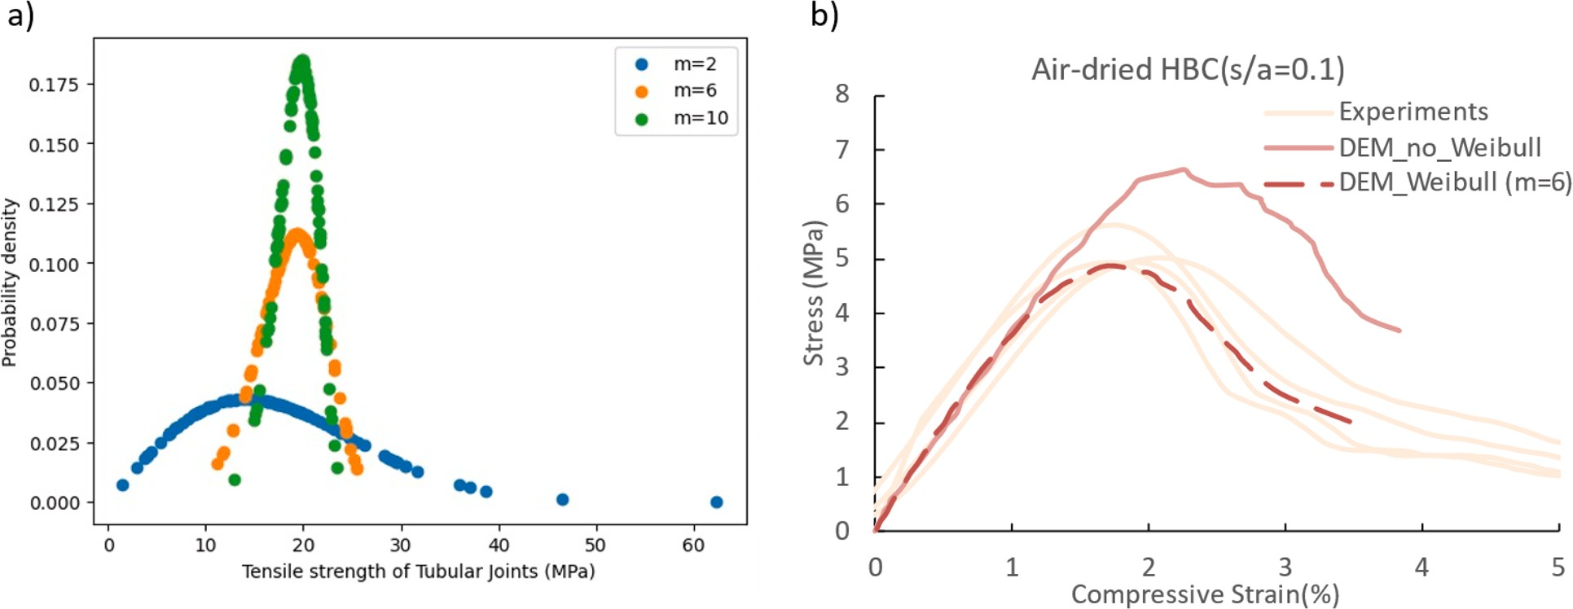

Fig. 12. (a) Weibull probability distribution curves of tensile strength with different homogeneity indices m; (b) Example of comparison of stress vs. strain curve of DEM simulations with/out com- bination of Weibull distribution on bonding strength and experimental results of air-dried HBC at s/a = 0.1(tubular joints).

N. Liu et al.
Journal of the Mechanics and Physics of Solids 196 (2025) 105969
18

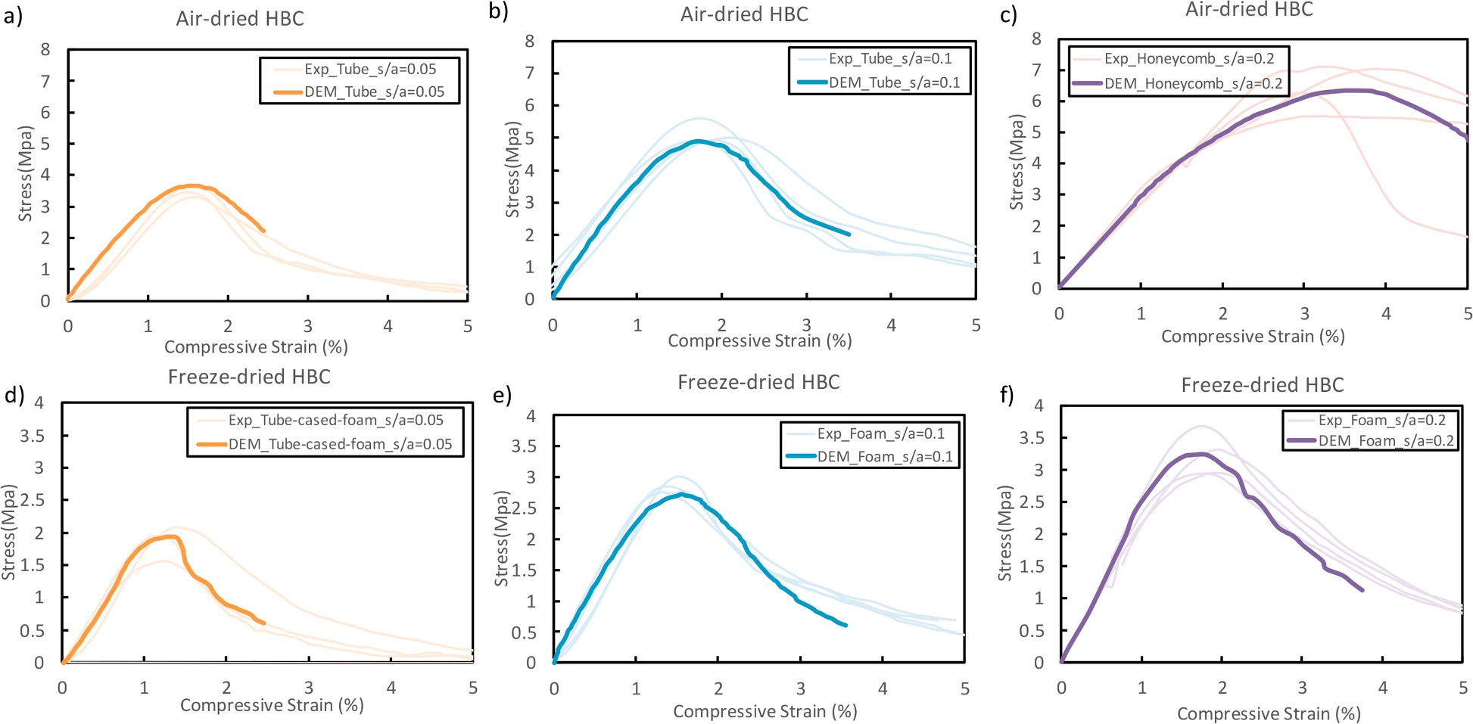

Fig. 13. Comparison of simulated results vs. experimental results for HBC with different sand-to-aggregate ratios, cured under different environmental conditions.

N. Liu et al.
Journal of the Mechanics and Physics of Solids 196 (2025) 105969
19

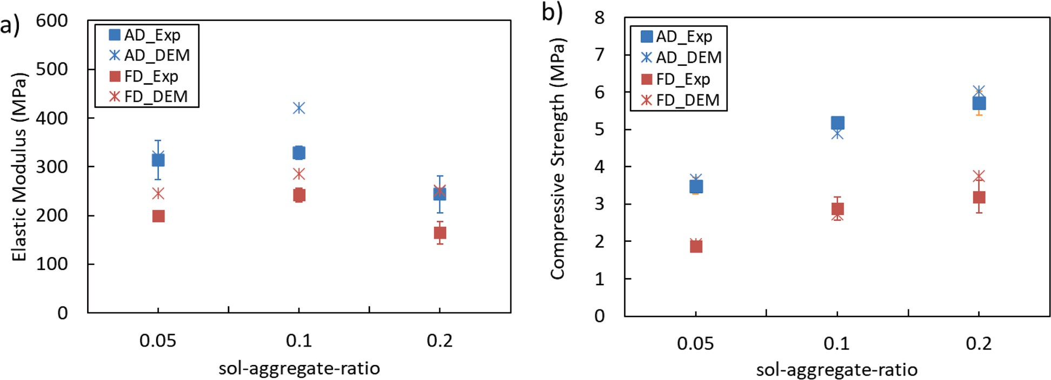

Fig. 14. Comparison of a) compressive elastic modulus and b) strength of HBC between the experimental and numerical results by influence of design/curing factors.

N. Liu et al. Journal of the Mechanics and Physics of Solids 196 (2025) 105969

s/a = 0.2 group.
As illustrated in Fig. 16, the frequency of joints in the two groups of HBC, as depicted in Fig. 15, is analyzed concerning their orientations before and after cracking. The joint orientation is defined as the angle between the bond axis and the horizontal plane, ranging from 0 to 90◦. The distribution of shear force in both groups exhibited minimal variation during the cracking process, with
most shear force magnitudes not exceeding the failure force, as shown in Table 6. Notably, the center of the normal force contour
shifted from the 0–20◦ range to the 20–60◦ range, accompanied by a reduction in compression force following cracking. This shift can be attributed to the initial concentration of the contact force chain along the vertical compression direction, which was subsequently released and deformed due to significant material deformation.
Regarding tensile force, the contour indicates that the peak value for air-dried HBC (s/a = 0.05) decreased after cracking, remaining concentrated around the 30–60◦ range. This suggests that the primary mode of cracking is due to tensile failure, with the main crack developing predominantly in vertical and sub-vertical orientations, a phenomenon also observed in other cemented
granular materials (Shen et al., 2022; Liu et al., 2005; Cui et al., 2020). In contrast, the tensile force distribution for freeze-dried HBC (s/a = 0.2) closely resembles that of air-dried HBC (s/a = 0.05) before cracking; however, post-cracking, the peak tensile force orientation became nearly uniformly distributed across all angles. This indicates that freeze-dried HBC (s/a = 0.2) tends to generate multiple cracks at random angles and positions. Furthermore, this behavior can be attributed to the significantly softer foamy joints in
freeze-dried HBC compared to the air-dried tubular joints, particularly in the shear direction. This softness facilitates greater inter- particle deformation and mitigates concentrations of local stress. Consequently, HBC, particularly freeze-dried HBC (s/a = 0.2), demonstrates enhanced ductility compared to traditional concrete, allowing for larger failure deformations without catastrophic failure, even when the post-cracking force drops to 30 % of the material’s strength.
The multiscale modeling demonstrates strong consistency with experimental data, validating that the modeling framework is effective for predicting the effects of curing conditions and mixing ratios based on microstructural characteristics. This framework can inform future microstructural design, particularly in the context of extreme environments on Mars. For instance, controlling the cooling temperature gradient can facilitate the formation of oriented foamy or honeycomb structures (Delesky et al., 2023; Guo et al., 2019; Wegst et al., 2010). Additionally, the depressurization process can influence the size and shape of tubular joints, thereby tailoring the plasticity of the composites (Wang et al., 2023; Wang et al., 2010). We are also developing bio-synthetic HBC with more complex microstructures that incorporate microcell engagement (Yi et al., 2022). Furthermore, this framework provides a general computational approach for generalized hydrogel-based granular materials, such as living building materials (Qiu et al., 2021; Delesky et al., 2023; Armistead et al., 2023).

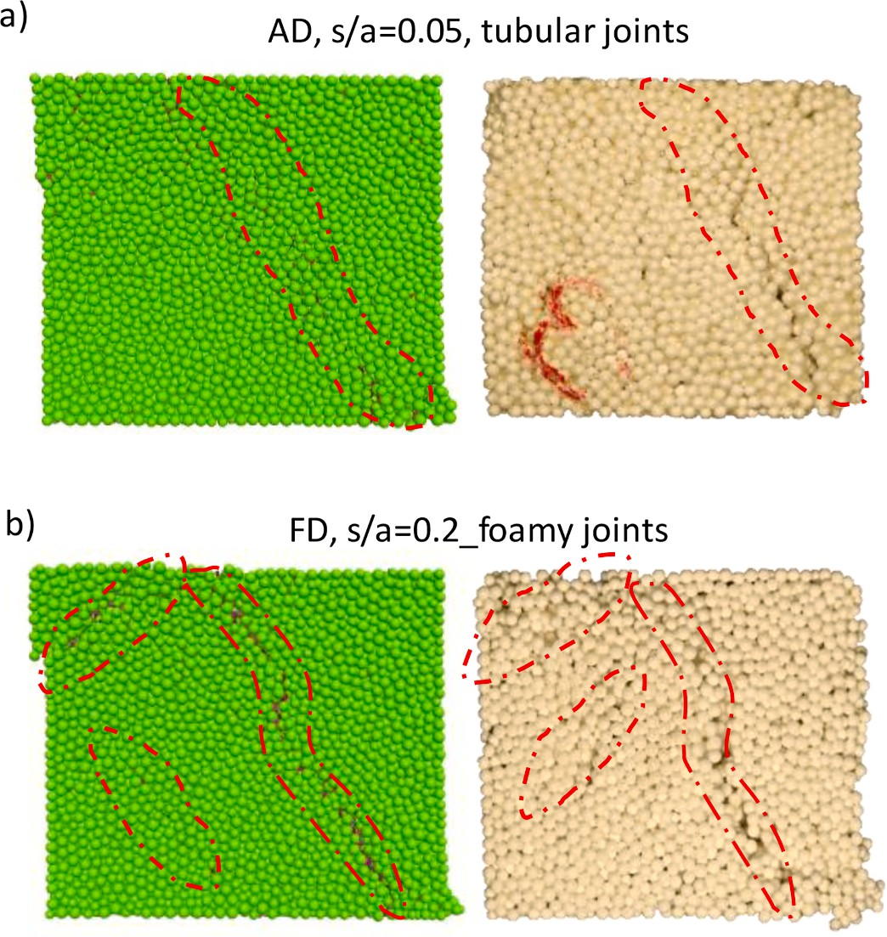

Fig. 15. Typical failure modes of HBC in simulated vs. experiment: a) single diagonal crack of air-dried HBC with s/a = 0.05; b) multiple cracks of freeze-dried HBC with s/a = 0.2.

20

N. Liu et al.
Journal of the Mechanics and Physics of Solids 196 (2025) 105969
21

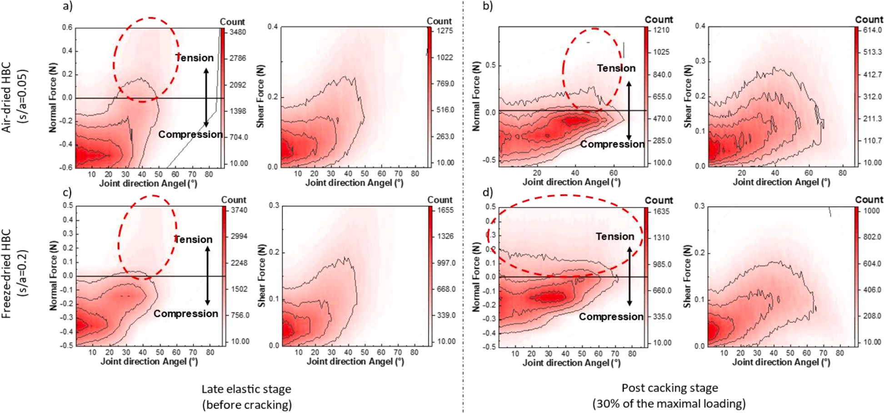

Fig. 16. Frequency distribution of joint force with joint directions at different stages of HBC (red dash circle marked the distribution area the maximum tensile force): (a) air-dried HBC (s/a = 0.05) just before cracking; (b) post cracking stage (30 % of the maximal loading) of air-dried HBC (s/a = 0.05); (c) freeze-dried HBC (s/a = 0.2) just before cracking; (d) post cracking stage (30 % of the maximal loading) of freeze-dried HBC (s/a = 0.2). The contours represent the number of bonds. Positive force represents tensile forces.

Table 6
The input joint properties in DEM.

n n
Curing | s/a | Type | Tension |  |  | Shear
 |  |  | Kneq  (N/mm) | Fʹ or Fʹʹ  (N) |  | Kseq  (N/mm) | Fʹ or Fʹʹ (N)  s s
Air-drying | 0.05 | Tubular | 8.72 | 0.83 |  | 5.45 | 0.42
 | 0.1 | Tubular | 10.71 | 1.69 |  | 6.68 | 1.35
 | 0.2 | Honeycomb | 10.18 | 3.05 |  | 6.43 | 2.38
Freeze-drying | 0.05 | Tube-Foam | 6.71 | 0.51 |  | 2.21 | 0.42
 | 0.1 | Tube-Foam | 7.79 | 0.71 |  | 2.61 | 0.55
 | 0.2 | Foam | 6.99 | 0.78 |  | 1.28 | 0.61

Summary

This work presents a new multi-scale DEM model for predicting the compressive behavior of hydrogel-based concrete (HBC), consisting of hard particles cemented by cylindrical hydrogel joints incorporating environment-dependent porous microstructures. The key features of this model are summarized as follows.
- Direct tensile and shear testing of tubular and foamy interparticle hydrogel joints were conducted to characterize the failure process. Analytical equations are derived to describe the constitutive force vs. displacement (F-u) relationships observed in the experiment. Particularly, the process of hydrogel skin peeling from the particle surface is determined by force and energy
equilibrium.
- In the DEM model, an elastic short beam model is adopted to predict the behaviors of the interparticle cylindrical joints under combined axial, transverse, and bending. The stiffness and load capacity of the short beams are modeled with the constitutive F-u relationships. Particularly, the characterized F-u relationships are directly used for tubular and foamy joints. For honeycomb joints,
the F-u relationship of foamy joints is adjusted by assuming the foams could be represented by hexagon cells. For tube-cased foam joints, a parallel composite model combining the F-u relationships of the tubular joint and the foamy joint is employed.
- The non-uniform hydrogel joint quality is considered by introducing Weibull distribution to quantify the variation of the tensile and
shear strengths of the joints. Without considering the joint quality variation, the DEM model can predict the compressive elastic modulus of HBC but overestimate the compressive strength.
- This new DEM model can successfully predict the compressive stress vs. strain behaviors of HBC, incorporating different hydrogel
microstructures formed because of the different sol-to-sand ratio, curing temperature, and curing air pressure. Therefore, it can be used to design and optimize the mix designs and curing process of HBC to achieve higher strength-per-gel value, which is extremely crucial for the potential application in extraterrestrial constructions.
- Future improvements can be made on this study. The geometric parameters of microstructure are mainly derived from scanning
electron microscopy (SEM) observations, and some simplifications are made to microstructure morphology and constitutive relationship, which may not always be accurate and convenient. Additionally, the detailed verifications between experimental and simulated data are not elaborated. In the future, high evolution X-ray CT will be employed to enhance the modeling of micro- structure, which will give geometric data a higher dimension and more parametric studies will be conducted. Additionally, the LPM bond models decouple interactions between normal and shear directions (Potyondy and Cundall, 2004; Shen et al., 2016), which limits their applicability in addressing the complex micro-level loading conditions of micro-joints. In the future, more compre- hensive contact modeling within the DEM will be developed and employed to achieve higher fidelity simulations.

CRediT authorship contribution statement

Ning Liu: Writing – original draft, Visualization, Validation, Software, Methodology, Investigation, Formal analysis, Data curation. Tianju Xue: Writing – review & editing. Jishen Qiu: Writing – review & editing, Writing – original draft, Validation, Supervision, Resources, Project administration, Methodology, Investigation, Funding acquisition, Formal analysis, Data curation.

Declaration of competing interest

The authors declare that they have no known competing financial interests or personal relationships that could have appeared to influence the work reported in this paper.

Appendix A. Detailed calculation of the peeling process of tubular joints under tension

For studying the effect of the diameters of joints, we used the bead with diameters D₀ = 20mm and filled joints with three different sizes, i.e. d₀=10, 15, and 20 mm. For studying the effect of the diameters of beads, we made another group of samples by using a set of beads with different diameters as D₀ = 5, 10, and 20mm and filling the joints with the same size of the corresponding beads (D₀ =
d₀). Key geometric properties of the tubes and foam structures formed of two groups are given in Table A1 and Table A2 corre- spondingly. A summary of critical force and stiffness across all stages and cases can be found in Fig. A1.

Table A1
Geometric properties of the tube/foam formed in the hydrogel joint (D₀=20 mm) (unit: mm).

Curing | Joint | Original | Post-curing | Post-curing | Post- curing gel | Post-curing gel wall | Post-curing gel skin
regime | type | diameter d0 | maximum diameter | minimum diameter | wall height | thickness | thickness

dmax
dmin h t tʹ

10 9.25 ± 0.30 7.45 ± 0.21 0.92 ± 0.23 0.20 ± 0.05 0.08 ± 0.03
AD Tubular 15 12.18 ± 0.78 9.67 ± 0.22 1.56 ± 0.11 0.41 ± 0.08 0.26 ± 0.03
20 14.32 ± 0.42 12.51 ± 0.31 2.71 ± 0.50 0.58 ± 0.10 0.37 ± 0.08
10 9.32 ± 0.18 9.32 ± 0.18 2.30 ± 0.16 – –
FD Foamy 15 12.77 ± 0.12 12.77 ± 0.12 5.40 ± 0.62 – –
20 17.38 ± 0.38 17.38 ± 0.38 11.3 ± 0.57 – –
Table A2
Geometric properties of the tube/foam formed in the hydrogel joint (D₀ = d₀) (unit: mm).

Curing | Joint | Particle | Post-curing | Post-curing | Post- curing gel | Post-curing gel wall | Post-curing gel skin
regime | type | diameter D0 | maximum diameter | minimum diameter | wall height | thickness | thickness

dmax
dmin h t tʹ

5 4.18 ± 0.21 2.97 ± 0.08 0.35 ± 0.01 0.12 ± 0.01 0.04 ± 0.01
AD Tubular 10 7.52 ± 0.28 5.35 ± 0.22 0.80 ± 0.14 0.26 ± 0.04 0.14 ± 0.03
20 14.32 ± 0.42 12.51 ± 0.31 2.71 ± 0.50 0.58 ± 0.10 0.37 ± 0.08
5 9.32 ± 0.18 9.32 ± 0.18 2.30 ± 0.16 – –
FD Foamy 10 12.77 ± 0.12 12.77 ± 0.12 5.40 ± 0.62 – –
20 17.38 ± 0.38 17.38 ± 0.38 11.3 ± 0.57 – –

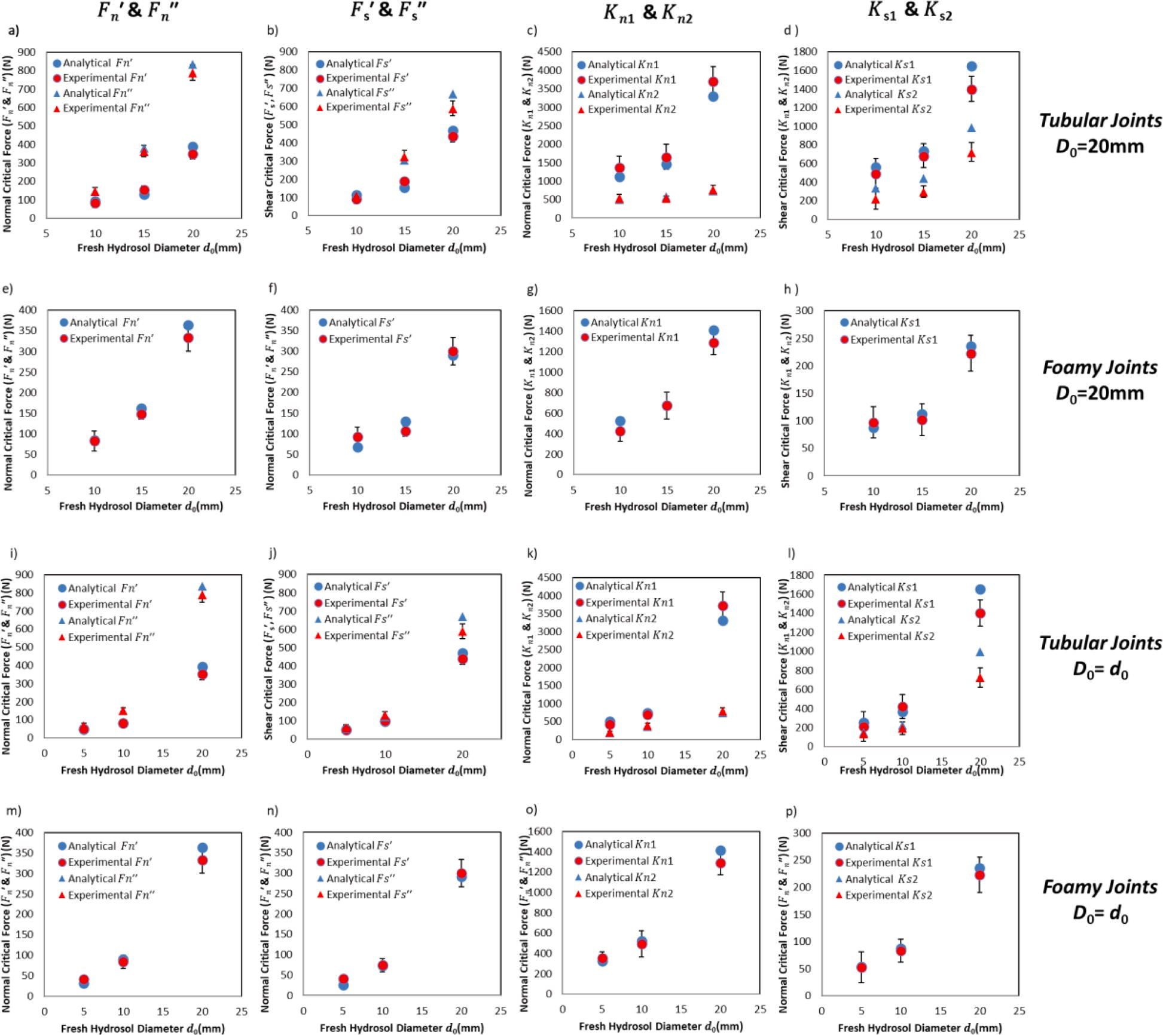
Fig. A1. Comparison between experimental and analytical results of different types of joints with different d₀ and D₀.

Appendix B. Detailed calculation of the peeling process of tubular joints under tension

B.1 Calculation of dW

The incremental work done by the applied force at point O(Oʹ) due to the infinitesimal peeling increment dΔL can be written as

dW = F_{n2} ⋅ d_{y}ʹ
O
(B.1–1)

where d ʹ is the incremental change in the vertical position of Oʹ that results from the incremental deformation of the peeling segment
y
O
and movement of the frontier of peeling y_{O}, which is given by
)
dy_{O}ʹ = d(λΔLsinθ) — dy_{O} = d(λΔLsinθ) — d(r(cosθ₀ — cosθ) = ϵsinθdΔL + ΔLsinθdϵ + λΔ Lcosθdθ (B.1–2) The deformation of the point Oʹ in the x direction can be ignored and set as 0 because of constraining of joints:
dx_{O}ʹ = d(λ ΔLcosθ) — dx₀ = d(λ ΔLcosθ) — d(r(sinθ — sinθ₀)) = εcosθdΔL + ΔLcosθdε — λ ΔLsinθdθ = 0 (B.1–3) Then, we can eliminate the dθ from equations B.1–2 and B.1–3 to obtain

dy ʹ = rεdθ + L₀dε

(AB1–4)

O

Thus,
sinθ

Fn2 L0

Fn2

dW = F_{n2} ⋅ d_{y}ʹ = sinθ dε + 2πsinθ3t E dθ (AB1–4a)
O
ʹ s

B.2. Calculation of dU_{e}

The change in strain energy in the detached segment of the skin is given by
dU_{e} = d(φ(λ) ⋅ 2πrtʹΔL) = 2πrtʹ(∂φ(λ) dλ ⋅ ΔL ⋅ sinθ + φ(λ)(sinθ ⋅ dΔL + cosθ ⋅ ΔL ⋅ dθ)) (B.2–1)
∂λ

where φ(λ) is the elastic energy density in the skin, given as
φ 1 2 F²
(λ) =
E_{s}ε
=
2 2
n2 4
ʹ2
(B.2–2)
2 8π r sin θt E_{s}

So the term ^{∂φ(λ)} in Eq. B.1–5 is calculated as
∂λ
∂φ(λ) = σ ʹ = F_{n2}

(B.2–3)

∂λ ^{O} 2πrsin2θtʹ
Thus,
F_{n2}ΔL F² (sinθ + (θ — θ₀)cosθ)

dU_{e} =
sinθ
dε + n2
4πrtʹE_{s}sin⁴θ
dθ (B.2–4)

Appendix C. Detailed governing equations of parallel linear models of DEM

C.1 Force-Displacement law of LPM

The force-displacement law of the bond model is described as follows:
(C.1–2)
where subscript j represents force and moment generated by joints and p is for the linear force generated by particles.
The bonding force can be resolved into a normal and shear force, and the bonding moment is resolved into a twisting and bending moment. As Fig. C1 shows, the force and displacement law of normal force, shear force, torsion moment, and bending moment of the bonding system updates with time steps as follows:
F^{j} := F^{j} + k^{j} Δu_{n} (C.1–3)
n
n
n

(C.1–4)
j j kj

Mt := Mt —
^{s} J_{j}Δθ_{t} (C.1–5)
A_{j}

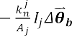
(C.1–6)

Where I_{j} is the moment of inertia of the joint cross-section; J_{j} is the polar moment of inertia of the joint cross-section. θ_{t} is torsion angle and θ_{b} is bending angle.

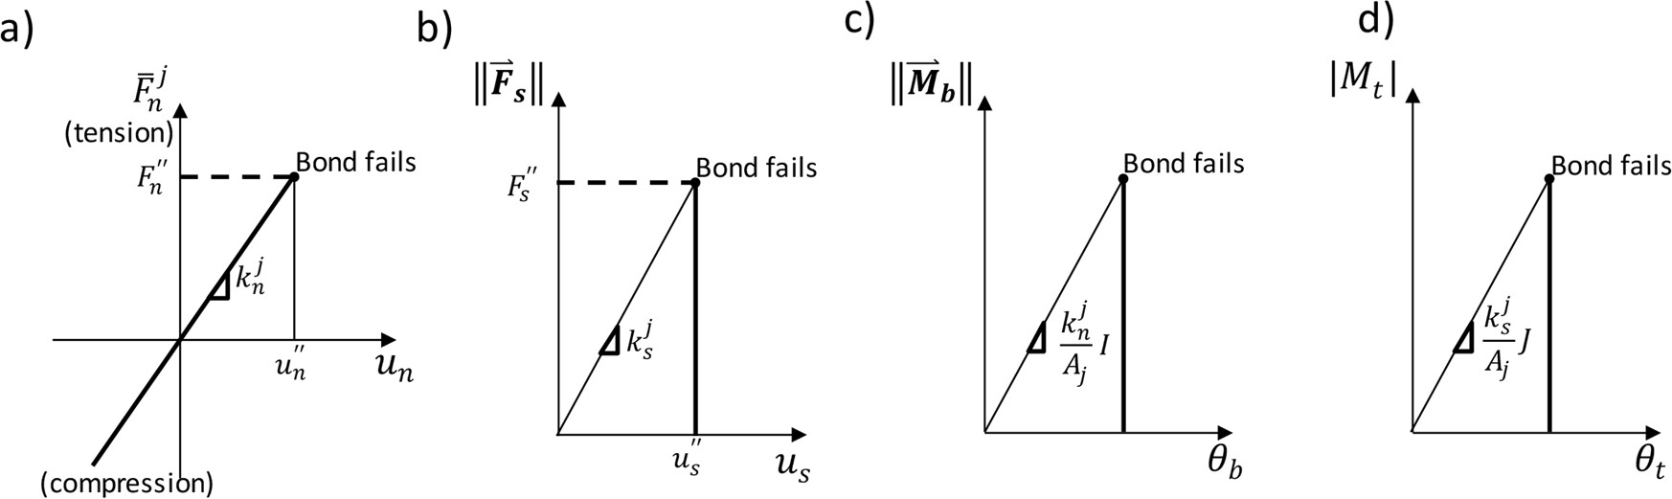
Fig. C1. Force-displacement laws for the parallel bond force and moment: a) normal direction, b) bending, and d) torsion (adopted from (Potyondy and Cundall, 2004)).
As Fig. C2 shows, if the tensile strength limit is exceeded (σ > σ_{eq}), the joints will break in tension. The shear strength is determined with τ_{c} = τ_{eq} — σ tanϕ and when shear strength is exceeded (τ > τ_{c}), the joints will break in shear. ϕ is the fraction angle of packed particles. Thus, the failure envelope is calculated as

(C.1–7)

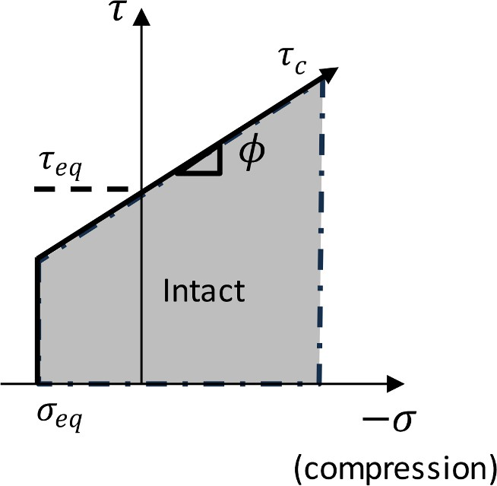
Fig. C2. Failure envelope for the joints (adopted from (Potyondy and Cundall, 2004)).

C.2. Moment of inertia

For tube and cylinder shapes, the moment of inertia I_{j} and polar moment of inertia J_{j} are calculated:
I_{tube} = 0.049 D⁴ — d⁴) (C.2–1)
I_{cylinder} = 0.049D⁴ (C.2–2)
J_{tube} = 0.098 D⁴ — d⁴) (C.2–3)
J_{cylinder} = 0.098D⁴ (C.2–4)
For the honeycomb structure, as shown in Fig. C3, we simplify it into shape by combining seven hollow hexagons and doing calculations.
Ihoneycomb = 7Ihexagon + 9Ahexagon D2 (C.2–5)

Jhoneycomb = 14Ihexagon + 18Ahexagon D2 (C.2–6)
Where I_{hexagon} = 0.054(D⁴ —d⁴) is the moment inertia of a single hexagon about its axis of symmetry and A_{hexagon} = 2.598(D² — d²).

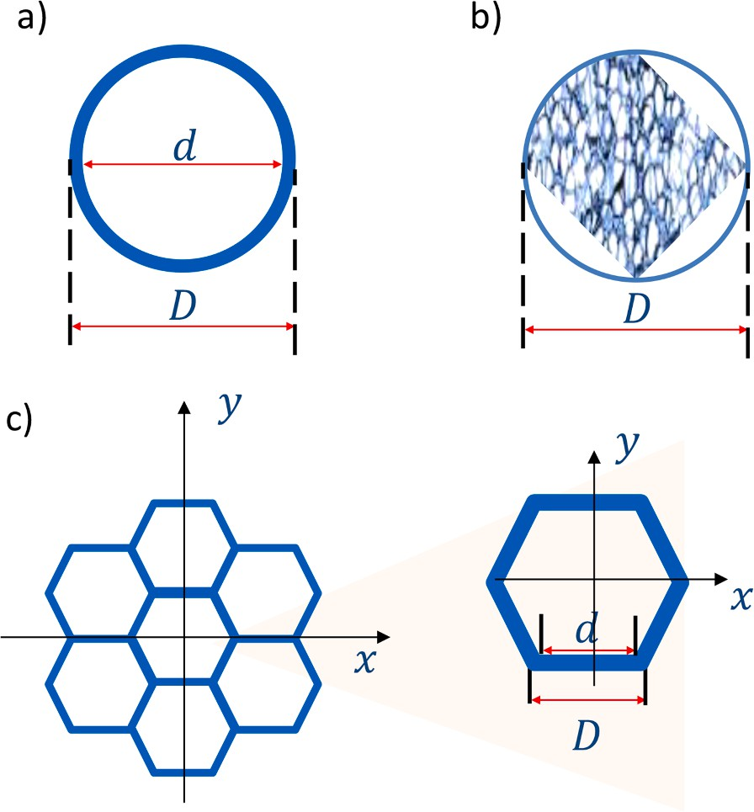
Fig. C3. Schematic representation of a) tube, b) foam, and c) honeycomb structure.

Data availability

Data will be made available on request.

References

Affdl, J.H., Kardos, J., 1976. The Halpin-Tsai equations: a review. Polym. Eng. Sci. 16 (5), 344–352.
Afferrante, L., Carbone, G., Demelio, G., Pugno, N., 2013. Adhesion of elastic thin films: double peeling of tapes versus axisymmetric peeling of membranes. Tribol.
Lett. 52, 439–447.
Alam, P., 2011. Porous particle-polymer composites. Adv. Compos. Mater.-Anal. Nat. Man-Made Mater 2, 29–54.
Armistead, S.J., Mikofsky, R.A., Srubar, W.V., 2023. Toward biomimetic and living earth materials. Matter. 6 (12), 4124–4127.
Begley, M.R., Collino, R.R., Israelachvili, J.N., McMeeking, R.M., 2013. Peeling of a tape with large deformations and frictional sliding. J. Mech. Phys. Solids 61 (5), 1265–1279.
Benveniste, Y., 1987. A new approach to the application of Mori-Tanaka’s theory in composite materials. Mech. Mater. 6 (2), 147–157.
Cho, J., Joshi, M., Sun, C., 2006. Effect of inclusion size on mechanical properties of polymeric composites with micro and nano particles. Compos. Sci. Technol. 66 (13), 1941–1952.
Cui, C., Wang, W., Jin, F., Huang, D., 2020. Discrete-element modeling of cemented granular material using mixed-mode cohesive zone model. J. Mater. Civil Eng. 32 (4), 04020031.
Delesky, E.A., Lobo, A.J., Srubar III, W.V., 2023. Measurement of ice-binding protein activity in highly alkaline environments. Ice Binding Proteins: Methods and Protocols. Springer, pp. 135–154.
Dvorkin, J., Nur, A., Yin, H., 1994. Effective properties of cemented granular materials. Mech. Mater. 18 (4), 351–366.
Eshelby, J.D., 1957. The determination of the elastic field of an ellipsoidal inclusion, and related problems. Proc. R. Soc. Lond. Ser. A. Math. Phys. Sci. 241 (1226), 376–396.
García, I., Mantiˇc, V., Graciani, E., 2015. A model for the prediction of debond onset in spherical-particle-reinforced composites under tension. Application of a
coupled stress and energy criterion. Compos. Sci. Technol. 106, 60–67.
Gibson, L.J., 2003. Cellular solids. Mrs Bull. 28 (4), 270–274.
Guo, N., Shen, P., Guo, R.-F., Jiang, Q.-C., 2019. Optimization of the properties in Al/SiC composites by tailoring microstructure through gelatin freeze casting. Mater.
Sci. Eng.: A 748, 286–293.
He, Z., Yang, Y., Jiang, H., 2022. Modeling interfacial instability patterns during debonding a rigid spherical indenter from thin elastic films. J. Mech. Phys. Solids 169, 105089.
Heveran, C.M., Williams, S.L., Qiu, J., Artier, J., Hubler, M.H., Cook, S.M., Cameron, J.C., Srubar, W.V., 2020. Biomineralization and successive regeneration of engineered living building materials. Matter. 2 (2), 481–494.
Holt, R., Kjølaas, J., Larsen, I., Li, L., Pillitteri, A.G., Sønstebø, E., 2005. Comparison between controlled laboratory experiments and discrete particle simulations of the mechanical behaviour of rock. Int. J. Rock Mech. Min. Sci. 42 (7–8), 985–995.
Hoogenboom, P., Spaan, R., 2005. Shear Stiffness and Maximum Shear Stress of Tubular Members. ISOPE International Ocean and Polar Engineering Conference.
Hu, X., Vatankhah-Varnoosfaderani, M., Zhou, J., Li, Q., Sheiko, S.S., 2015. Weak hydrogen bonding enables hard, strong, tough, and elastic hydrogels. Adv. Mater. 27 (43), 6899–6905.
Hu, Y., Leng, J., Jia, F., Liu, Y., 2023. Peeling behavior of a film on inner surface of a tube. Extreme Mech. Lett. 58, 101930.
Jin, Z., Chang, W., Li, Y., Wang, K., Fan, D., Zhao, L., 2023. Microparameters calibration for discrete element method based on gaussian processes response surface methodology. Processes 11 (10), 2944.
Karl, D., Cannon, K.M., Gurlo, A., 2022. Review of space resources processing for Mars missions: martian simulants, regolith bonding concepts and additive manufacturing. Open Ceramics 9, 100216.

Kendall, K., 1975. Thin-film peeling-the elastic term. J. Phys. D: Appl. Phys. 8 (13), 1449.
Klejment, P., 2021. Application of supervised machine learning as a method for identifying DEM contact law parameters. Math. Biosci. Eng. 18 (6), 7490–7505. Lauke, B., 2008. On the effect of particle size on fracture toughness of polymer composites. Compos. Sci. Technol. 68 (15–16), 3365–3372.
Li, H., Yang, J., Han, Y., Yang, C., Daemen, J., Li, P., 2019. Weibull grain-based model (W-GBM) for simulating heterogeneous mechanical characteristics of salt rock.
Eng. Anal. Bound. Elem. 108, 227–243.
Li, M., Chen, H., Lin, J., Zhang, R., Liu, L., 2021. Effects of the pore shape polydispersity on the percolation threshold and diffusivity of porous composites: theoretical and numerical studies. Powder Technol. 386, 382–393.
Li, Z., Liu, Z., Ng, T.Y., Sharma, P., 2020. The effect of water content on the elastic modulus and fracture energy of hydrogel. Extreme Mech. Lett. 35, 100617. Liprandi, D., Bosia, F., Pugno, N.M., 2020. A theoretical-numerical model for the peeling of elastic membranes. J. Mech. Phys. Solids 136, 103733.
Liu, H., Kou, S., Lindqvist, P.-A., 2005. Numerical studies on the inter-particle breakage of a confined particle assembly in rock crushing. Mech. Mater. 37 (9), 935–954.
Liu, H., Sun, L., Ju, J., 2004. An interfacial debonding model for particle-reinforced composites. Int. J. Damage Mech. 13 (2), 163–185.
Liu, J., Ma, F., Guo, J., Zhou, T., Song, Y., Li, F., 2022. Numerical simulation of failure behavior of brittle heterogeneous rock under uniaxial compression Test.
Materials (Basel) 15 (19), 7035.
Liu, N., Qiu, J., 2022. Effect of the freezing temperature and near-vacuum air pressure of Mars on the mechanical properties and microstructure of hydrogel-based concrete (HBC). Extreme Mech. Lett. 56, 101864.
Liu, Y., Liu, W., Gao, W., 2021. Out-of-plane shear property analysis of Nomex honeycomb sandwich structure. J. Reinf. Plast. Compos. 40 (3–4), 165–175. Luo, Y., 2022. Isotropized Voigt-Reuss model for prediction of elastic properties of particulate composites. Mech. Adv. Mater. Struct. 29 (25), 3934–3941.
Miled, K., Sab, K., Le Roy, R., 2007. Particle size effect on EPS lightweight concrete compressive strength: experimental investigation and modelling. Mech. Mater. 39 (3), 222–240.
Naser, M., 2019. Extraterrestrial construction materials. Prog. Mater. Sci. 105, 100577.
Nitka, M., Tejchman, J., 2015. Modelling of concrete behaviour in uniaxial compression and tension with DEM. Granul. Matter. 17, 145–164. Peng, B., Feng, X.-Q., Li, Q., 2020. Decohesion of a rigid flat punch from an elastic layer of finite thickness. J. Mech. Phys. Solids 139, 103937. Potyondy, D.O., Cundall, P., 2004. A bonded-particle model for rock. Int. J. Rock Mech. Min. Sci. 41 (8), 1329–1364.
Qiu, J., Artier, J., Cook, S., Srubar, W.V., Cameron, J.C., Hubler, M.H., 2021. Engineering living building materials for enhanced bacterial viability and mechanical properties. iScience (2), 24.
Reches, Y., 2019. Concrete on Mars: options, challenges, and solutions for binder-based construction on the Red Planet. Cement Concrete Compos. 104, 103349. Reuß, A., 1929. Berechnung der fließgrenze von mischkristallen auf grund der plastizita¨tsbedingung für einkristalle. ZAMM-J. Appl. Math. Mechanics/Zeitschrift für
Angewandte Mathematik und Mechanik 9 (1), 49–58.
Shen, Z., Huang, D., Wang, G., Zhao, Y., Jin, F., 2022. A mesoscale bond model for discrete element modeling of irregular cemented granular materials. Comput.
Geotech. 152, 105051.
Shen, Z., Jiang, M., Thornton, C., 2016. DEM simulation of bonded granular material. Part I: contact model and application to cemented sand. Comput. Geotech. 75, 192–209.
Shen, Z., Jiang, M., Wan, R., 2016. Numerical study of inter-particle bond failure by 3D discrete element method. Int. J. Numer. Anal. Methods Geomech. 40 (4), 523–545.
Sun, J.-Y., Zhao, X., Illeperuma, W.R., Chaudhuri, O., Oh, K.H., Mooney, D.J., Vlassak, J.J., Suo, Z., 2012. Highly stretchable and tough hydrogels. Nature 489 (7414), 133–136.
Sun, L., Ju, J., Liu, H., 2003. Elastoplastic modeling of metal matrix composites with evolutionary particle debonding. Mech. Mater. 35 (3–6), 559–569. Tagliavia, G., Porfiri, M., Gupta, N., 2010. Analysis of hollow inclusion–matrix debonding in particulate composites. Int. J. Solids Struct. 47 (16), 2164–2177. Vernerey, F.J., Brighenti, R., Long, R., Shen, T., 2018. Statistical damage mechanics of polymer networks. Macromolecules. 51 (17), 6609–6622.
Voigt, W., 1889. Ueber die Beziehung zwischen den beiden Elasticit¨atsconstanten isotroper Ko¨rper. Ann. Phys. 274 (12), 573–587.
Wan, L., Wendner, R., Cusatis, G., 2016. A novel material for in situ construction on Mars: experiments and numerical simulations. Constr. Build. Mater. 120, 222–231.
Wang, P., Gao, N., Ji, K., Stewart, L., Arson, C., 2020. DEM analysis on the role of aggregates on concrete strength. Comput. Geotech. 119, 103290.
Wang, R., Zhang, M., Mujumdar, A.S., 2010. Effects of vacuum and microwave freeze drying on microstructure and quality of potato slices. J. Food Eng. 101 (2), 131–139.
Wang, Y., Alonso-Marroquin, F., 2009. A finite deformation method for discrete modeling: particle rotation and parameter calibration. Granul. Matter. 11 (5), 331–343.
Wang, Z., Liu, J., Chen, P., Suo, Z., 2023. Osmotic instability in soft materials under well-controlled triaxial stress. J. Mech. Phys. Solids 172, 105195.
Wegst, U.G., Schecter, M., Donius, A.E., Hunger, P.M., 2010. Biomaterials by freeze casting. Philos. Trans. R. Soc. A: Math. Phys. Eng. Sci. 368 (1917), 2099–2121.
Xu, B., Wei, A., Ye, J., Sha, W., Guo, F., 2022. Transverse creep induced by interfacial diffusion in fiber-reinforced composites: a micromechanics model and computational validation. Int. J. Mech. Sci. 213, 106877.
Yi, Q., Dai, X., Park, B.M., Gu, J., Luo, J., Wang, R., Yu, C., Kou, S., Huang, J., Lakerveld, R., 2022. Directed assembly of genetically engineered eukaryotic cells into living functional materials via ultrahigh-affinity protein interactions. Sci. Adv. 8 (44), eade0073.
Zhou, T., Yuk, H., Hu, F., Wu, J., Tian, F., Roh, H., Shen, Z., Gu, G., Xu, J., Lu, B., 2023. 3D printable high-performance conducting polymer hydrogel for all-hydrogel bioelectronic interfaces. Nat. Mater. 22 (7), 895–902.
Zhu, R., Alam, S.Y., Loukili, A., 2019. A comprehensive approach for mesoscale discrete element modelling of mechanical and fracture behavior of concrete. Granul.
Matter. 21 (1), 5.
Zhu, W.C., Tang, C., 2004. Micromechanical model for simulating the fracture process of rock. Rock Mech. Rock Eng. 37, 25–56.
Zhu, X., Liu, W., He, X., 2017. The investigation of rock indentation simulation based on discrete element method. KSCE J. Civil Eng. 21, 1201–1212.

