DESIGN OF COMPOSITE SAMPLING SYSTEM FOR SURFACE SOIL OF EXTRATERRESTRIAL BODIES
by

Qi-Chen SUN a*, Zeng ZHAOa, Jun-Shan GONG a, Zhong-Wang YIN a,
Xiao-Ming LAI a, Hai-Bin YU a, Zhong-Xian ZHAO a, Chao WANG b, and Hui LV a
a Beijing Spacecrafts, Beijing, China
b Qian Xuesen Laboratory of Space Technology, China Academy of Space Technology, Beijing, China
Original scientific paper https://doi.org/10.2298/TSCI2502267S

Space resource development has become a frontier hot topic in international space exploration. Amidst the growing scarcity of Earth’s resources and rare metals, the harnessing of asteroid resources has risen to prominence as a principal avenue of exploration. The utilization of asteroid resources necessitates extensive regolith mining operations. Catering to the demands of extensive space activities, extra- terrestrial construction, and resource development, this paper presents the design and simulation analysis of an extraterrestrial surface regolith composite sampling system. The findings demonstrate that the composite sampling approach, which combines spiral drilling and transport with kinetic energy directional excitation, is highly effective. It is capable of collecting no less than 500 g within a mere 5 seconds at a rotation speed of 3000 rpm, while the reaction force exerted by the brush remains below 5 N, thus satisfying the requirement for a low reaction force.
Key words: asteroid sampling, composite sampling system, simulation analysis,
experimental verification

Introduction
Space resource development is an important goal for our country’s major scientific and technological projects such as planetary exploration and lunar space development [1]. The Chinese planetary exploration project is progressively aiming to harness the resources of near- Earth asteroids. Throughout billions of years, asteroids have borne witness to and documented the processes of planetary formation, collisions, and evolution, thereby carrying a wealth of cosmic information [2]. They are also rich in precious metals and rare elements [3], which have great value for utilization. To date, nearly 20 probes related to asteroids and comets have been launched globally. These probes have variously flown by small celestial bodies, orbited aster- oids, planned to land on asteroids, or sampled and returned, conducting scientific exploration of asteroids in diverse ways. Among these, asteroid sampling is a key technical method for explo- ration activities, and samples brought back to Earth can be studied in the most comprehensive and direct manner in laboratories.
Previously implemented or planned asteroid exploration has mainly focused on sci-
entific detection. With technological progress, space science and exploration have entered a new stage of space resource development. At present, humans have discovered more than 9000

* Corresponding author, e-mail: sun_qi_chen@163.com

near-Earth asteroids, which can be divided into three categories: carbonaceous asteroids, silica- ceous asteroids, and metallic asteroids [4]. Among the discovered near-Earth asteroids, carbo- naceous ones stand out for their abundance of elements like H, C, O, and N, offering a treasure trove of raw materials for space exploration. Metallic asteroids, meanwhile, are typically rich in elements such as iron and nickel, and some even harbor particularly rare metals, including platinum, cobalt, rhodium, and iridium, These celestial mineral resources hold significant eco- nomic potential [5].
This paper delves into the pressing demands of future space resource development and utilization, focusing on asteroid resource mining, and emphasizes the research on the large- scale mining and transportation technology of regolith particle resources on asteroids. It aims to provide raw materials for subsequent large-scale space activities, extraterrestrial construc- tion, and resource development, ensuring the feasibility, sustainability, and scalability of these activities.
Overview of asteroid sampling detection technology
Since the 21st century, countries such as Japan, Europe, and the USA have carried out multiple asteroid and comet detection and unmanned sampling missions. The sampling meth- ods, fig. 1, include projectile impact splash recovery, anchoring and drilling, gas excitation, and kinetic energy excitation [6]. The projectile impact splash recovery sampling is suitable for touch and go sampling detection methods, but the sampling efficiency is not high. Drill- ing sampling must rely on the large reaction force provided by the probe anchoring, and the sampling action is complex, the sampling time is long, and gas excitation sampling does not require motor drive, can maintain the original state of particles, has the characteristics of being exquisite, low energy, low reaction force, and high sampling efficiency, but it requires carrying gas resources and cannot achieve long-term and large-scale in-situ mining.
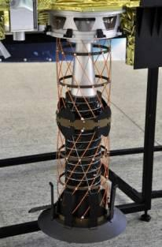
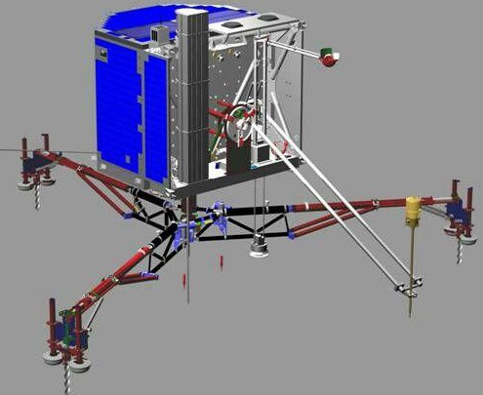
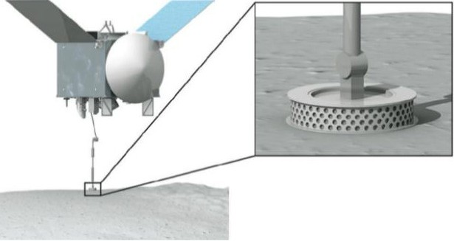
Figure 1. Asteroid sampling mode; (a) impact splash,
(b) drilling after anchoring, and (c) gas excitation
For the asteroid sampling tasks that have been implemented, the statistics are shown
in tab. 1.
Table 1. Implemented asteroid sampling mission
Mission name | Cycle | Target | Sampling method | Sampling method
Hayabusa [7] | 2003-2010 | Itokawa | Touch and go | Impact splash
Rosetta [8] | 2004-2014 | 67P | On-line drilling analysis | Drilling after anchoring
Hayabusa 2 [9] | 2014-2020 | Ryugu | Touch and go | Impact splash
OSIRIS-Rex [10] | 2016-2023 | Bennu | Touch and go | Gas excitation

Upon reviewing the executed sampling missions, Japan’s Hayabusa mission stands out for its pioneering effort in asteroid sampling, successfully returning samples from the as- teroid Itokawa. However, the quantity of material collected was minimal, with a total of ap- proximately 1500 particles, each measuring 0.001 mm in size [2]. Rosetta probe developed by ESA failed to complete the sampling task for comets with soft surface due to anchoring failure. Japan’s Hayabusa 2 released the lander MASCOT to the asteroid Ryuguon October 3, 2018, and sent back the highest-definition surface photo, showing that there are large and small stones on the surface of the asteroid Ryugu, and it is difficult to find a flat and soft area. The sampling difficulty greatly exceeded expectations, and the landing sampling plan was postponed for sev- eral tens of days. At the same time, the detection of Bennu asteroid by OSIRIS-Rex probe in the USA also found that the surface state of the asteroid is more complicated than expected, covered with large rocks, and the original sampling plan is also facing great difficulties.
Scheme design of sampling system
Asteroids possess several characteristics that complicate the process of sampling and resource development. They are relatively small in volume and mass, with weak surface gravity and irregular shapes, making attachment and fixation challenging. Additionally, the diversity of asteroid types introduces further uncertainty, as their surface geological features can vary significantly. Some asteroids are covered with soil, others with gravel, some with ice or ice-soil mixtures, and still others with large metallic rocks or hard basaltic formations. These varied characteristics not only increase the difficulty of sampling tasks but also necessitate sustainable practices for long-term resource development. Consequently, there is a clear need for ongoing technical research to overcome the challenges associated with large-scale asteroid exploitation.
Design of kinetic energy directional sampling
Kinetic energy directional sampling refers to the process where a motor drives a brush on a rotating shaft to spin at high speeds, interacting with sample particles to impart them with velocity and direct them into the sample channel. As depicted in fig. 2, the dual rotating shafts converge towards the center, with brushes installed on these shafts effectively scraping the regolith layer and small particles. This action propels the sample particles in a specific direc- tion; however, it is not capable of sampling entire rocks. This method leverages the rotational dynamics to collect and direct particles, which is crucial for the efficient collection of asteroid regolith in microgravity conditions.
Design of auger drilling transport sampling
Drilling sampling is a crucial technique for acquiring asteroid regolith at deeper lev- els. The operation of the drill tool involves a cutting process where debris is expelled through the action of an outer spiral flange. This mechanism ensures that the drill cuttings are compactly filled within the sampling spiral section, fulfilling the dual roles of collecting and transporting the extracted regolith, as illustrated in fig. 3. The drill tool incorporates a sampling spiral section designed for the collection of samples, featuring a small spiral angle and a deep groove spiral structure. This configuration is advantageous for retaining the collected regolith samples within the deep groove spiral sample storage cavity. However, it is acknowledged that there is scope for enhancing the sampling efficiency of this method, suggesting that while the current design is functional, future technological refinements could significantly boost its effectiveness.

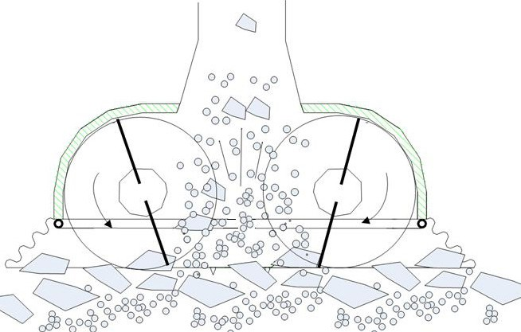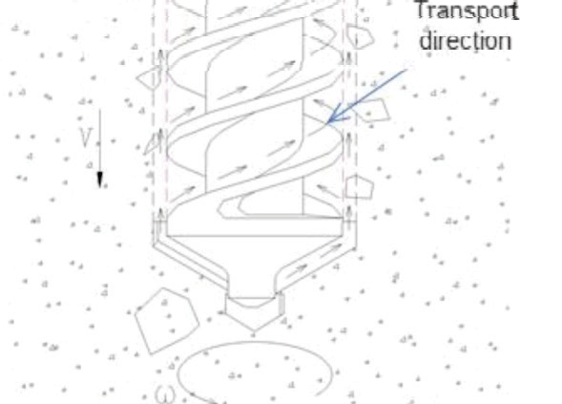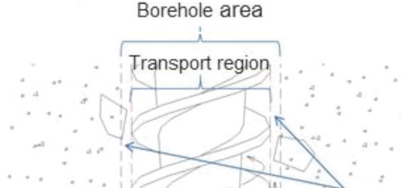
Figure 2. Kinetic energy directional sampling Figure 3. Drilling transport sampling

Design of compound sampling principle
The compound sampling method, as depicted in fig. 4, employs the technical princi- ples of auger drilling and directional kinetic energy collection. The drilling tool, when rotat- ed, performs subsurface drilling and excavation, enabling the crushing of entire rocks and the transportation of asteroid regolith. Once the surface is sufficiently crushed and a certain depth is reached, the high speed rotation of the brush imparts motion the particles, directing them towards the sample collection container. This approach effectively combines the strengths of both kinetic energy directional sampling and auger drilling transportation sampling, optimizing the process for efficient collection and containment of samples.
Scheme design of sampling system
Considering the microgravity environment and sampling requirements of asteroids, this paper adopts the principle of compound sampling to design the prototype. The sampling system prototype mainly consists of four parts: drilling unit, acquisition unit, sample channel and sample collection container. The specific system diagram and the functions of each part are shown in fig. 5.
















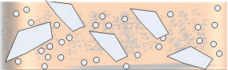



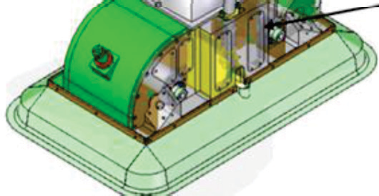
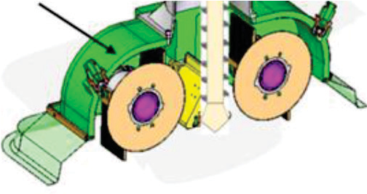










Figure 4. Compound sampling principle Figure 5. Composite asteroid sampling system

Simulation analysis and experiment
Analysis on collection efficiency of star soil samples
The collection and transportation simula- tion analysis of the composite sampling system for the surface layer of extraterrestrial celestial bodies was carried out, fig. 6. The constant feed speed was 0.01 m/s, and the collection effect of
Table 2. Sampling results at different speeds

Feed speed [ms^{–1}] | Speed [rpm] | Time [s] | Equivalent mass of particles collected [g]
0.01 | 1000 | 5 | 579.6
 | 2000 |  | 702.8
 | 3000 |  | 729.4

particles at different brush rotation speeds was analyzed. The results show that a high collection and transportation effect can be obtained by using the rotating speed of 3000 rpm, and the col- lection and transportation of 𝕍500 g can be completed in 5 second, tab. 2.
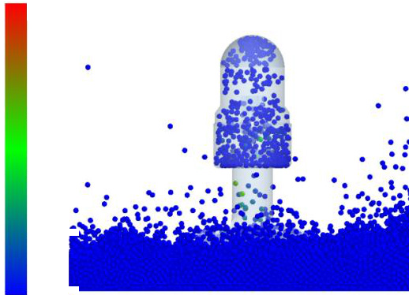

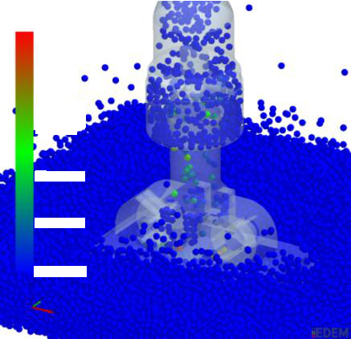
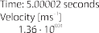
Figure 6. State diagram of acquisition and transportation at 3000 rpm

Kinetic energy sampling reaction force
During the sampling process, the inter- action process between the brush and the cat- alog is shown in fig. 7, and the reaction force in the sampling process will affect the stability of the system. The reaction force between the sampling system and the catalog will increase. Through calculation and analysis, the maxi- mum reaction force excited by the brush is 6.6 N in Z-axis, 0.78 N in X-axis and less than 1.3 N in Y-axis.
Conclusion

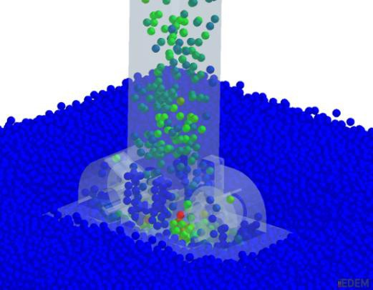
Figure 7. Analysis of reaction force of brush

To address the demands of large-scale asteroid resource extraction, this paper presents the design and simulation validation of a composite sampling system tailored for the surface layer of extraterrestrial bodies. The system integrates spiral drilling tool transportation with kinetic energy directional acquisition, demonstrating superior adaptability to the varied condi- tions of asteroid surfaces and enabling the mining of star soil at a certain depth. The composite sampling system achieves peak efficiency at a rotation speed of 3000 rpm, capable of collecting and transporting no less than 500 g within a mere 5 seconds. Notably, the brush generates the

most substantial reaction force in the Z-direction, with the peak value remaining below 7 N, making it well-suited for asteroid sampling operations that require minimal reaction forces.
Acknowledgment
This work was financially supported by Self-developed projects of the Aerospace Science and Technology Corporation and Key Projects of National Self Science Foundation (U21B2072).
References
- Wang, W., et al., Research on the Technology Architecture of Space Resource Exploitation, Journal of Astronautics, 44 (2023), 11, pp. 1621-1632
- Xu, W., et al., Scientific Significance and Prospect of Asteroid Deep Space Exploration, Advances in Earth Science, 20 (2005), 11, pp. 1183-1190
- Desai, P. N., et al., Sample Returns Missions in the Coming Decade, NASA Langley Technical Report Server, 2000
- Barucci, M. A., et al., Classification of Asteroids Using G-mode Analysis, Icarus, 72 (1987), 2,
pp. 304-324
- Lin, Q., et al., Discussion on Target Selection of Asteroid Exploration with High Mining Value, Chinese Space Science and Technology, 44 (2024), 3, pp. 89-97
- Zhang, Y., et al., The Analysis of Surface Dynamical Environments and Sampling Difficulties for Asteroid
2016 H03, Mechanics in Engineering, 43 (2021), 5, pp. 674-679
- Yada, T., et al., Hayabusa‐Returned Sample Curation in the Planetary Material Sample Curation Facility
of JAXA, Meteoritics and Planetary Science, 49 (2014), 2, pp. 135-153
- Knapmeyer, et al., Structure and Elastic Parameters of the Near Surface of Abydos Site on Comet 67P/Churyumov-Gerasimenko, as Obtained by SESAME/CASSE Listening to the MUPUS Insertion Phase, Icarus: International Journal of Solar System Studies, 310 (2018), Aug., pp. 165-193
- Tsuda, Y., et al., System Design of the Hayabusa 2 – Asteroid Sample Return Mission 1999 JU3, Acta Astronautica, 91 (2013), Oct.-Nov., pp. 356-362
- Lauretta, D. S., et al., The OSIRIS-REx: Sample Return from Asteroid (101955) Bennu, Space Science Reviews, 212 (2017), Aug., pp. 925-984

Paper submitted: November 24, 2024
Paper revised: November 30, 2024
Paper accepted: December 11, 2024

2025 Published by the Vinča Institute of Nuclear Sciences, Belgrade, Serbia. This is an open access article distributed under the CC BY-NC-ND 4.0 terms and conditions.

