

Automation in Construction 176 (2025) 106251
Contents lists available at ScienceDirect

Automation in Construction

journal homepage: www.elsevier.com/locate/autcon


Lunar base infrastructure construction: Challenges and future directions
Yifeng Xia ^{a,b,1}, Yuyue Gao ^{a,b,1}, Wenbin Han ^{a,b}, Xinyi Li ^{a,b}, Cheng Zhou ^{a,b,*},
Yan Zhou ^{a,b,*}, Lieyun Ding ^{a,b}
ª National Center of Technology Innovation for Digital Construction, Huazhong University of Science and Technology, Wuhan 430074, China
^{b} School of Civil and Hydraulic Engineering, Huazhong University of Science and Technology, Wuhan 430074, China

A R T I C L E I N F O

Keywords:
Extraterrestrial construction Extreme environment Resource utilization Structure design
A B S T R A C T

As deep space exploration advances, agencies such as National Aeronautics and Space Administration (NASA) and The European Space Agency (ESA), along with other nations, have developed mid-to-long-term plans for lunar habitation, including the construction of lunar infrastructure. This article reviews existing lunar con-struction concepts and designs, analyzing their importance for sustained human presence on the moon. It summarizes research progress in transportation, navigation and communication, energy, and habitation infra-structure, addressing construction processes, site selection, building materials, and structural design. Addition-ally, the article highlights the challenges and future directions in lunar infrastructure construction. There is an anticipation for more scholars to apply civil engineering expertise to deep space endeavors.

Introduction

Since the launch of the Soviet Union’s Luna 1 spacecraft in 1959, humanity’s exploration of the Moon has spanned over six decades, marking the beginning of a historic journey to unravel the mysteries of Earth’s closest celestial neighbor. The long-term goals of human space exploration encompass expanding scientific knowledge, driving tech-nological innovation, identifying potential habitats, and securing alter-native resource opportunities [1]. As the nearest extraterrestrial body, the Moon has emerged as a focal point for global space initiatives, leveraging its strategic advantages: abundant helium-3 resources, unique low-gravity environment, and role as a stepping stone for deep-space missions [2,3]. Multiple nations have unveiled plans to build lunar infrastructure to support long-term human presence, recognizing that lunar bases serve as ideal testbeds for Mars exploration technologies and directly influence the sustainability of deep-space endeavors.
Entering the 21st century, the United States has led efforts in lunar base and infrastructure development [4,5]. The Artemis Program, a cornerstone of U.S. lunar strategy, proceeds in two phases: the first phase establishes short-term residency via the Gateway space station, while the second phase involves constructing Artemis Base Camp at the lunar South Pole [6,7]. This comprehensive initiative includes designing habitats, communication and navigation systems, and energy supplies to
enable sustainable long-term stays and deep-space activities. Concur-rently, NASA’s strategic documents such as the Decadal Surveys and Moon to Mars Architecture emphasize lunar exploration as a core objective, positioning the Moon as a critical technology validation platform for Mars missions [1,2]. Internationally, the European Space
Agency (ESA) outlined the Terrae Novae 2030+ Exploration Strategy
Roadmap, aiming to return humans to the Moon by 2030 [8]. The Japan Aerospace Exploration Agency (JAXA) and Indian Space Research Or-ganization (ISRO), through the Artemis Accords, actively collaborate in U.S.-led lunar projects, contributing modules like HALO and enhancing international cooperation [9].
China, after successfully completing the first three phases of its lunar exploration program—including missions Chang’e-1 to Chang’e-5, which achieved orbiting, soft landing, rover exploration, and sample return—now advances to the fourth phase [10,11]. A key component is constructing an International Lunar Research Station (ILRS) through global partnerships [12,13]. The station will adopt a modular, expand-able design with living, energy, and scientific modules, striving to establish a sustainable long-term human presence on the Moon.
Constructing infrastructure in the Moon’s extreme environ-ment—characterized by high vacuum, microgravity, drastic tempera-ture fluctuations, and regolith with high hardness, low thermal conductivity, and strong electrostatic adhesion—requires overcoming

* Corresponding authors at: National Center of Technology Innovation for Digital Construction, Huazhong University of Science and Technology, Wuhan 430074, China.
E-mail address: charleschou@163.com (C. Zhou).
¹ These authors contributed equally.

https://doi.org/10.1016/j.autcon.2025.106251
Received 9 December 2024; Received in revised form 27 April 2025; Accepted 30 April 2025
Available online 8 May 2025
0926-5805/© 2025 Elsevier B.V. All rights are reserved, including those for text and data mining, AI training, and similar technologies.

bottlenecks in materials science, manufacturing processes, and intelli-gent equipment [14,15]. International research has focused on three technical clusters: multi-scale characterization of lunar regolith, autonomous construction processes for lunar environments, and intel-ligent construction equipment for lunar operations.
Based on in-situ exploration, sample return, and remote sensing data, the fundamental physical and chemical properties of lunar regolith have been preliminarily characterized. Regolith particles exhibit angular, sub-angular, or elongated shapes, with a chemical composition domi-
nated by SiO₂ and rich in Al₂O₃, FeO, MgO, and CaO. Analysis of
Chang’e-5 samples revealed basaltic debris containing micro-glass beads with nanoscale iron films, resulting in an exceptionally high friction coefficient [16].
Regarding simulant research, unlike the earliest lunar regolith sim-ulants that only focused on chemical composition matching, newly developed simulants not only exhibit closer physicomechanical property matching with real regolith but also feature chemical ratios more aligned with returned samples. Examples include China’s IGG-01 sim-
ulant [17], the first designed for Chang’e-5 medium-titanium basalt
regolith, achieving particle morphology, specific gravity, bulk density, angle of internal friction, and spectral property simulation through mechanical treatment and particle size grading; and Canada’s OB-1 simulant [18], with an average cohesion of 1.4 kPa and friction angle
of 41.2◦, facilitating the design and testing of future lunar drilling,
excavation, and construction equipment. Other mainstream simulants include the U.S. JSC series, NU-LHT-2 M, Japan’s MKS-1, and China’s HUST-1 and CUG [16,19].
However, destructive testing of real regolith remains limited, relying instead on non-contact measurements and multi-scale simulations, necessitating further research to fully characterize its behavior critical for determining base load-bearing capacity and structural longevity.
To achieve lunar material utilization and construct lunar infra-structure, specialized construction processes must be developed for the unique lunar environment. Current international research focuses on two core approaches: concrete-like material preparation and high-energy sintering techniques.
Concrete-like materials are formed by adding exogenous binders to lunar regolith, primarily including sulfur concrete [20], geopolymer concrete [21], and alkali-activated lunar regolith concrete [22]. The performance of these materials is highly dependent on the mineral composition and particle size distribution of the regolith. However, their in-situ utilization rate remains constrained due to the inability to locally produce binders under extraterrestrial conditions.
Beyond concrete-like materials, high-energy sintering technologies offer alternative pathways for regolith solidification, categorized into mold-based and mold-free sintering. Mold-based sintering methods, such as microwave sintering and hot-press sintering, transfer thermal energy via radiation or microwaves to melt and solidify regolith within molds [23,24]. Mold-free sintering employs additive manufacturing techniques like powder bed fusion and directed energy deposition, which utilize high-energy beams to sinter regolith layer-by-layer, pro-ducing high-strength construction materials [25,26].
Current lunar construction technologies exhibit parallel develop-mental trends: mold-based sintering prioritizes material strength and high in-situ utilization rates but lacks processing flexibility, whereas mold-free sintering enables large-scale and efficient construction with greater architectural adaptability.
To achieve unmanned autonomous construction on the lunar surface, specialized engineering systems must address extreme environmental challenges such as concentrated gravity, intense radiation, and perva-sive lunar dust erosion. Current international research and development focuses on three primary categories of specialized equipment: excava-tion and transport systems, mobile 3D printing platforms, and robotic masonry assemblers.
Excavation systems, exemplified by NASA’s RASSOR rover with its counter-rotating auger heads for optimized regolith excavation and the
electromagnetic levitation-based FLOAT transport system, prioritize resource extraction efficiency and large-scale material handling [27–29]. Mobile 3D printing technologies, such as ICON’s laser sintering devices that fuse regolith layers and the solar-powered FACS system achieved precising sintering under extreme temperatures, enable in-situ fabrication of structural components [6,30]. Robotic assemblers, including Huazhong University’s Super Manson robot capable of handling regolith bricks with high level accuracy and NASA JPL’s ATHLETE hexapod platform for terrain-adaptive assembly, demonstrate modular construction capabilities [14,30]. These technologies reflect a synergistic development strategy: excavation systems emphasize energy efficiency, while additive manufacturing and robotic assembly excel in precision and adaptability, supporting phased lunar base construction from resource extraction to habitation module deployment.
To address considerations of reproducibility and replicability, the introduction now incorporates a detailed account of bibliometric anal-ysis and systematic literature screening protocols. The search strategy was conducted across Web of Science and NASA Technical Reports Server databases, employing a structured query string (“lunar infra-structure OR lunar construction OR lunar communication OR lunar transportation OR lunar energy”), yielding an initial corpus of 780 records.
Publications were systematically reviewed at the topic level, with exclusions applied to those addressing non-related disciplines. Abstracts and conclusions of shortlisted papers underwent manual curation to validate their alignment with the study’s scope, specifically excluding works that: (1) did not pertain to in-situ lunar construction methodol-ogies; or (2) focused on non-infrastructure-related themes. A compre-hensive snowballing methodology—encompassing both forward citation tracking and backward reference mining—was implemented to mitigate sampling bias, yielding a final corpus of 134 highly relevant documents (2020–2024), including peer-reviewed articles, technical reports, and strategic whitepapers from international space agencies (e. g., NASA, ESA, CNSA).
To date, various countries have put forward numerous thoughts regarding the cutting - edge topic of lunar infrastructure construction. Cheng conducted an integrated analysis of in - situ resource utilization technologies for extraterrestrial construction, focusing on three different categories of in-situ resources: regolith resources, water-ice resources, and energy resources [31]. Zhou carried out research on the structural design of lunar bases in extreme temperature environments [32]. Li analyzed the existing Landing/Launching infrastructures, with a focus on describing the unique functions and main construction methods of each technical design [33]. Zhou et al. discussed the reliability and applicability of 13 typical construction materials in extreme extrater-restrial environments [34]. A comprehensive review of existing research shows that current reviews mostly concentrate on single technical di-mensions such as lunar in - situ resource utilization and the property regulation of lunar regolith construction materials, lacking a systematic integration of various lunar base infrastructures.
This paper synthesizes key concepts, analyzes international plans, and summarizes advancements in four critical domains—transportation, navigation/communication, energy, and habitation—highlighting their roles in enabling normalized transportation, reliable communication, sustainable energy, and long-term habitation (Fig. 1). By addressing technical challenges, this research provides essential support for estab-lishing permanent lunar bases and advancing humanity’s deep-space vision.

Transportation infrastructure

The exorbitant expenses associated with transporting goods and people between Earth and the Moon have emerged as a major obstacle in the advancement of lunar exploration and development [8,35–37]. As a result, there has been a concerted effort to explore standardized and cost-effective transportation technologies for this purpose. Within this

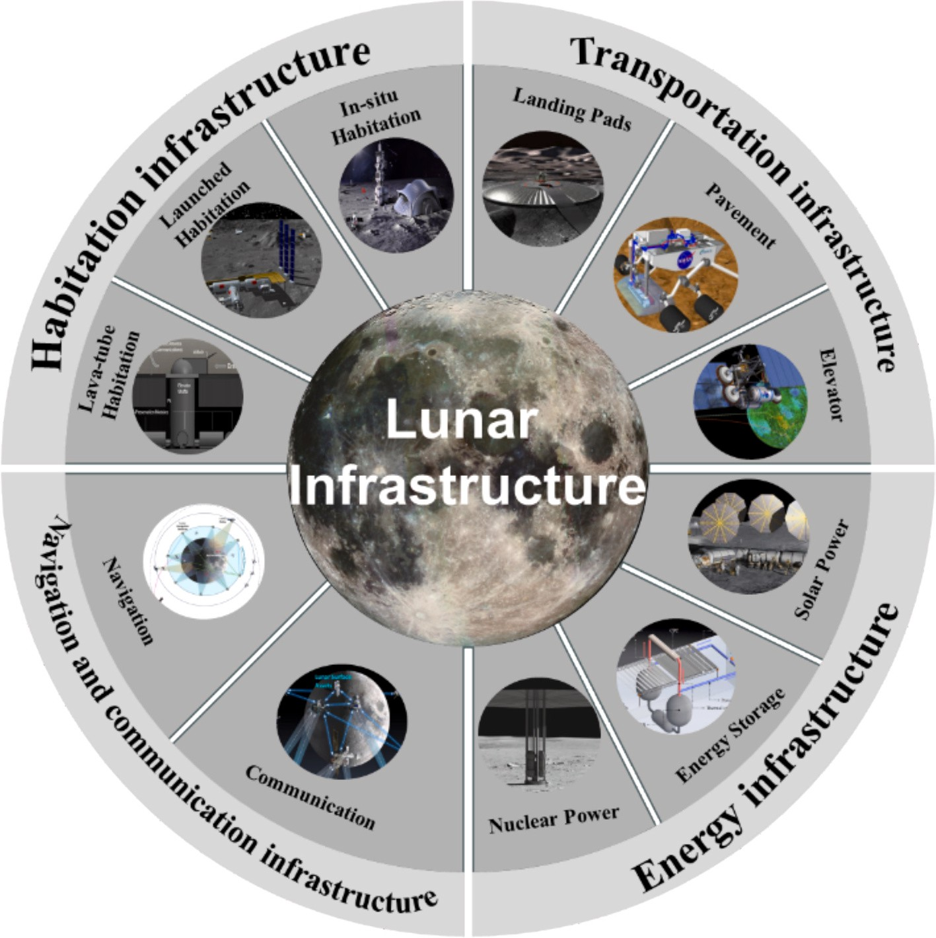

Fig. 1. Abstract diagram of Lunar infrastructure.

context, this chapter explores various construction schemes for future lunar transportation infrastructure, specifically focusing on landing and launching pads, roadbeds and pavements, and elevators. Given the crucial to construct lunar transportation infrastructure in the future, this chapter emphasizes schemes that are feasible for large-scale imple-mentation, possess high load-bearing capacities, and rely extensively on locally available resources.

  - Landing and launching pads

Lunar landing/launching pads are specialized structures that have been specifically designed and constructed to facilitate landing and launching activities on the surface of the moon [38–41]. The primary objective of these pads is to provide a stable and reliable surface for the safe landing and launching of spacecraft. The design of these landing/ launching pads must take into account a number of crucial factors, such as reducing lunar dust ejection, supporting the weight of the lander, and withstanding potential landing impact forces. Additionally, the design must also consider the extreme temperature variations on the moon, as well as the corrosion resistance and durability of the materials used.
In order to address these challenges, scientists and engineers are currently conducting research on various technologies and materials that can be used to establish scalable, high load-bearing, stable, and reliable landing/launching pad construction schemes. The construction of landing/launching pads can be categorized into two main methods: robotic teleoperation and in-situ manufacturing, both of which utilize lunar regolith.
For the robotic teleoperation method, Jekan and his colleagues proposed the use of a lunar rover equipped with multiple sensors and control modules. This rover would perform tasks such as relative
positioning, site leveling, boundary delineation, and revetment con-struction in the designated landing/launching pad area. They also con-ducted high-fidelity simulations of the contact dynamics of the lunar regolith layer Fig. 2(a) [42]. In terms of in-situ manufacturing using lunar regolith, Han and his team utilized vacuum sintering technology. They designed interlocking lunar landing pad bricks and carried out onboard experiments and finite element analysis. Their findings concluded that the thickness of the structure had a more significant impact on performance compared to the load position and size of the components Fig. 2(b) [43].
Furthermore, Rodrigo and his team proposed the use of laser selec-tive sintering technology to produce interlocking landing pad bricks directly on-site, effectively expanding the scale of infrastructure con-struction and enhancing efficiency Fig. 2(c) [15]. Additionally, research has also explored the use of lightweight materials such as metal meshes or advanced composite materials in the construction of deployable landing pads [6,44]. These materials provide the necessary strength and durability to withstand extreme conditions, while also minimizing the uplift of lunar dust. As human exploration and activities on the Moon continue to progress, the design and construction of landing and launch pads will become one of the pivotal tasks in the development of lunar infrastructure.

  - Roadbed and pavement

Lunar roadbed and pavement construction are vital projects that contribute to achieving stable traffic on the lunar surface and supporting the development of future lunar bases. The design of lunar roads must take into account the bearing capacity of the lunar surface, temperature fluctuations, and the potential wear and damage caused by lunar dust to

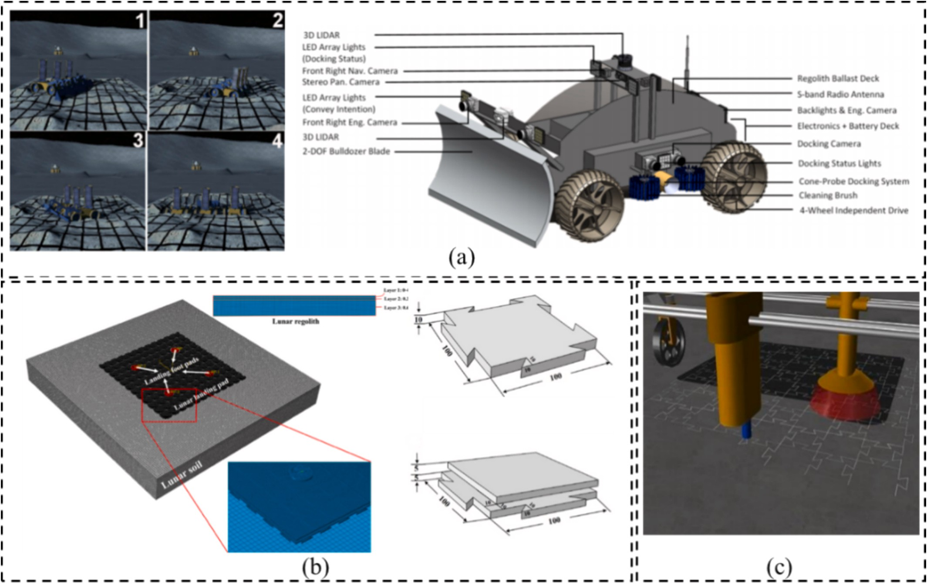

Fig. 2. (a) Right: simulation of rovers landing pad excavation operations; left: lunar excavation rover concept [42], (b) vacuum sintering of assembled topology interlocking lunar landing pad [43], (c) selective separation sintering of lunar pads [15].

mechanical equipment [45]. The roadbed and pavement may require reinforcement to prevent damage resulting from material expansion or contraction due to extreme temperature changes. At the same time, the design of the subgrade must minimize the lifting of lunar dust, as it can harm the surfaces of passing vehicles and nearby infrastructure. Utiliz-ing ISRU technology to obtain building materials is an appealing solu-tion on the Moon. Lunar soil can be compressed into a solid surface for roadbed and pavement construction or processed into construction materials such as lunar concrete [46]. The initial Lunar Road-Paving
Wagon vehicle employed two magnetrons that could be adjusted to different frequencies and powers. This allowed for effective sintering/ melting of lunar soil through microwave heating Fig. 3(a) [3]. Taylor and colleagues further optimized its design, and compared to solar or laser methods, its increased penetration depth results in a more solid surface that is suitable for industrial load-bearing structures Fig. 3(b) [25]. Juan-Carlos and others adopted a solar sintering method for road construction and confirmed the feasibility of using solar sintering technology in manufacturing large samples with interlocking

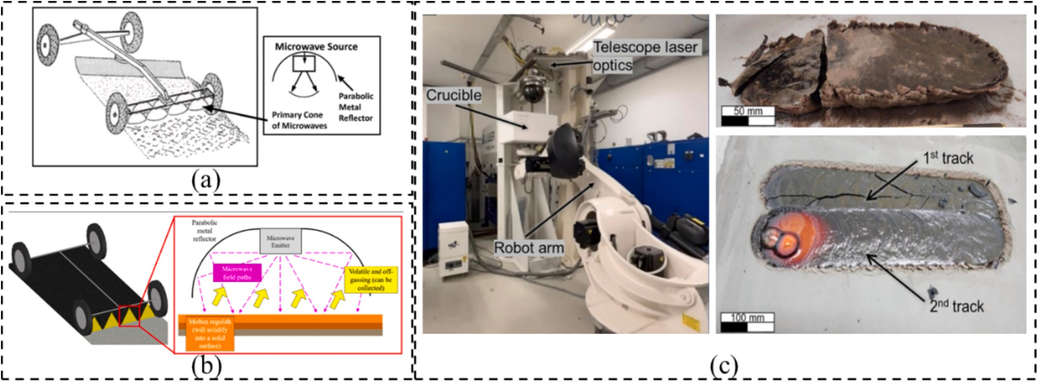

Fig. 3. (a) Microwave paving of lunar regolith [3], (b) lunar road-paving wagon with two sets of magnetrons [25], (c) laser melting of lunar regolith; laser melting samples after/during manufacturing [47].

capabilities through single-track and double-track sintering in an Earth-based simulation device Fig. 3(c) [47].

  - Elevators

In contrast to near-term landing infrastructure, space elevators represent an ambitious long-term concept, with implementation likely decades away. While theoretically transformative for cost-effective cislunar transportation, their realization hinges on overcoming funda-mental challenges in ultra-strong cable materials and orbital mechanics. The space elevator is a revolutionary concept in cislunar space transportation, offering an economical and efficient means to reach geosynchronous orbit directly from Earth’s surface through physical connection. The International Space Elevator Consortium has proposed the idea of the Galactic Harbor, where the space elevator’s cable is connected to an apex anchor and a port is established in geosynchronous orbit Fig. 4(a) [48]. The fundamental principle of the space elevator involves a cable anchored at a receiving station on Earth’s surface, extending to a space station in geosynchronous orbit Fig. 4(b) [49]. This cable maintains tension through the centrifugal force generated by Earth’s rotation, ensuring stability. Climbers or elevators can then
traverse this cable, using electric power or other propulsion methods to transport personnel, satellites, or cargo to space. The current space elevator climbing devices can be categorized as counterweight or climbing types. Counterweight space elevators effectively utilize gravi-tational potential energy for ascent within a low altitude range Fig. 4(c) [50], but encounter disturbances between cables at higher altitudes. Climber-type space elevators, on the other hand, can cause cable wear and a decrease in its lifespan Fig. 4(d) [50].
Unlike landing pads, which are already being prototyped through missions like Artemis, space elevators remain in the research and development phase, with key milestones—such as full-scale cable tes-ting—estimated to occur in the 2040s at the earliest. Despite being conceptualized over a century ago, the realization of a space elevator continues to face significant technical challenges, specifically in the development of materials with sufficient strength and lightness to construct the cable, as well as ensuring precise and safe operation of climbers. Recent advancements in nanotechnology and materials sci-ence, particularly in the development of carbon nanotubes and gra-phene, have reignited interest in the space elevator concept due to their exceptional strength and low mass.

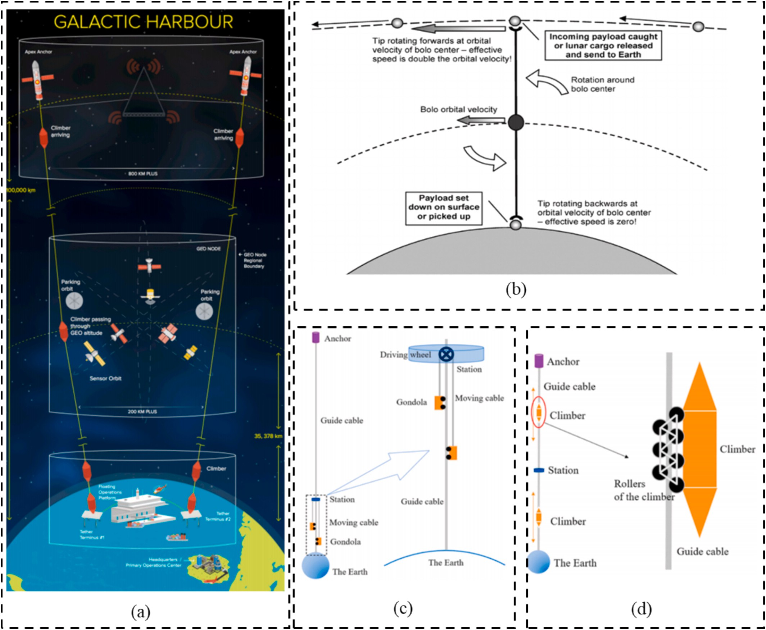

Fig. 4. (a) Galactic Harbor Concept [48], (b) elevators rotating at orbital velocity [49], (c) counterweight-type space elevator [50], (d) climber-type space elevator [50].

Navigation and communication infrastructure

In the future, exploration, resource extraction, and infrastructure development on the Moon will heavily rely on remotely operated robots. As a result, the establishment of a robust Communications, Positioning, and Navigation Technology (CPNT) infrastructure is of utmost impor-tance. This infrastructure is envisioned as an expandable system, start-ing with a few nodes in its initial phase to meet the requirements of early missions and gradually evolving to accommodate future needs. This chapter specifically addresses the existing architectural framework of the navigation and communication infrastructure, as well as its imple-mentation plans.

  - Navigation system

The Lunar Navigation Infrastructure plays a critical role in providing essential Positioning, Navigation, and Timing (PNT) information for activities in both lunar and cislunar space. Its primary purpose is to support various lunar missions, such as orbital spacecraft, landers, sur-face exploration tasks, as well as imaging and scientific data collection [51]. The aim is to enable these missions to accurately determine their location, velocity, and time, ensuring safe navigation both in lunar orbit and on the lunar surface [52].
Space agencies around the world have put forth proposals for lunar PNT architectures, and NASA’s lunar navigation architecture can be divided into two components: infrastructure and user-end functional-ities Fig. 5(a) [53]. The infrastructure component focuses on providing essential reference system components and radio navigation sources, including ground stations, satellites in Earth and lunar orbit, and assets on the lunar surface. These radio frequency (radiometric) sources, which have traditionally been used for navigation from near-Earth space to deep space, will be complemented by Global Navigation Satellite System (GNSS) services from Earth and traditional deep space signal tracking methods [54]. This combination of technologies will provide the necessary navigation data for lunar missions. Additionally, communi-cation relay satellites in lunar orbit will offer Earth-Moon and terrestrial PNT services, allowing for remote control of robots and rovers on the lunar surface. NASA plans to introduce PNT capabilities early on in the Artemis missions, initially relying on ground tracking and terrestrial elements, gradually expanding to services provided by relay satellites in lunar orbit Fig. 5(b) [55]. As the program progresses, the deployment of more relay satellites is anticipated, which will offer GNSS-like global lunar services, thus achieving comprehensive lunar PNT capabilities.
The construction and development of the navigation infrastructure
will require collaboration among multiple countries and institutions, resulting in a complex and highly interoperable organizational frame-work. The goal of this cooperation is to integrate resources and tech-nologies from all parties to establish a comprehensive lunar navigation system that can support future lunar and cislunar exploration activities [56,57]. Key contributors, including ESA, NASA, and others, will play significant roles and contribute essential technologies and facilities, including the Gateway and Orion spacecraft Fig. 5(c) [58]. Through this cross-border and cross-institutional cooperation, the lunar navigation architecture will be able to provide integrated PNT services that cover the Moon and cislunar space, thereby supporting future exploration missions and scientific research.

  - Communication system

Due to the escalating demand for sustainable development and uti-lization of the Moon, there is an emerging necessity for interplanetary communication within cislunar space. Meeting this demand requires the development of efficient and reliable communication systems, as well as the establishment of communication infrastructure, to ensure robust and secure communication capabilities for various missions and assets on the Moon and in its orbit [59]. A comprehensive review of existing research
confirms that the most mature and systematic communication archi-tecture currently available is LunaNet, developed by NASA’s Space Communications and Navigation (SCaN) program [60]. LunaNet is designed to support long-term lunar exploration activities and rapidly expand lunar network capabilities through the utilization of innovative networking technologies, standards, and an expandable framework. This enables industry, academia, and international partners to build and operate LunaNet nodes Fig. 6(a) [61]. Among its notable features, LunaNet offers network services that ensure uninterrupted data trans-mission and destination reach, even in potential signal disruption sce-narios, through the application of Delay/Disruption Tolerant Networking (DTN).
Furthermore, the communication infrastructure will employ 3GPP/ 5G cellular technology, enabling direct surface/local communication and efficient data routing through data aggregation for backhaul pur-poses Fig. 6(b) [55]. The construction of communication bases will primarily consist of RTG-powered fixed and mobile stations, as well as solar-powered mobile stations Fig. 6(c) [61]. Additionally, countries such as the USA and the UK have signed the Artemis Accords and various cooperation treaties to guarantee that lunar communication infrastruc-ture will incorporate interoperability standards. These standards will define a set of norms covering network service payload functions, DTN BP network layer routing functions between SmallSat nodes, and multi-layer protocol interfaces. However, the construction of lunar commu-nication infrastructure requires further demonstration, considering the impact of complex terrain conditions, such as temperature, lighting, craters, and slopes, on the construction of communication bases and the relevant technologies.

Energy infrastructure

Given the requirement for long-term human lunar presence and development, the establishment of a stable, reliable, and industrially scalable energy system is crucial. This chapter focuses on discussing potential energy supply solutions for future lunar bases, including solar power stations, nuclear power stations, and energy storage systems. Furthermore, considering the extreme cold and darkness experienced during lunar nights, it is crucial to have an energy infrastructure that can continuously provide energy throughout these periods.

  - Solar power station

The lunar surface offers abundant solar energy resources, particu-larly in areas such as the rims of Shackleton and de Gerlache craters in the Moon’s South Pole. These locations receive direct sunlight for over 80 % of the time, making them ideal for the construction of solar power stations [62–64]. NASA has proposed projects like TLT and VSAT Fig. 7
- that utilize in-Space Assembly (iSA) technology and Construction Robotic System (CRS) [65]. The goal of these projects is to establish six solar towers, each measuring 10 m in height, on the lunar surface. Together, these towers would generate a total of 100 kW of electricity. To address the issue of interruptions in solar power generation caused by the Moon’s rotation and orbit, Jeffery and others have put forward a specific scheme for uninterrupted solar power generation [66]. By taking advantage of the moon’s lack of atmosphere and its axial tilt near zero degrees relative to the ecliptic plane, they envision a
photovoltaic array installed around a 360◦ latitudinal ring that would
produce 10 MW of continuous power. This innovative approach offers a new perspective for selecting suitable sites for lunar solar power sta-tions. Furthermore, to reduce the weight and volume of solar panels during transportation, Jaime and colleagues have developed a solution involving folding solar panels for deployment on the lunar surface. This has resulted in a 56 % reduction in weight and material as Fig. 7(b) and Fig. 7(c) [67]. However, continuous solar power generation on the Moon is still limited by the conditions of sunlight exposure and the inability to manufacture core components on-site. These limitations present

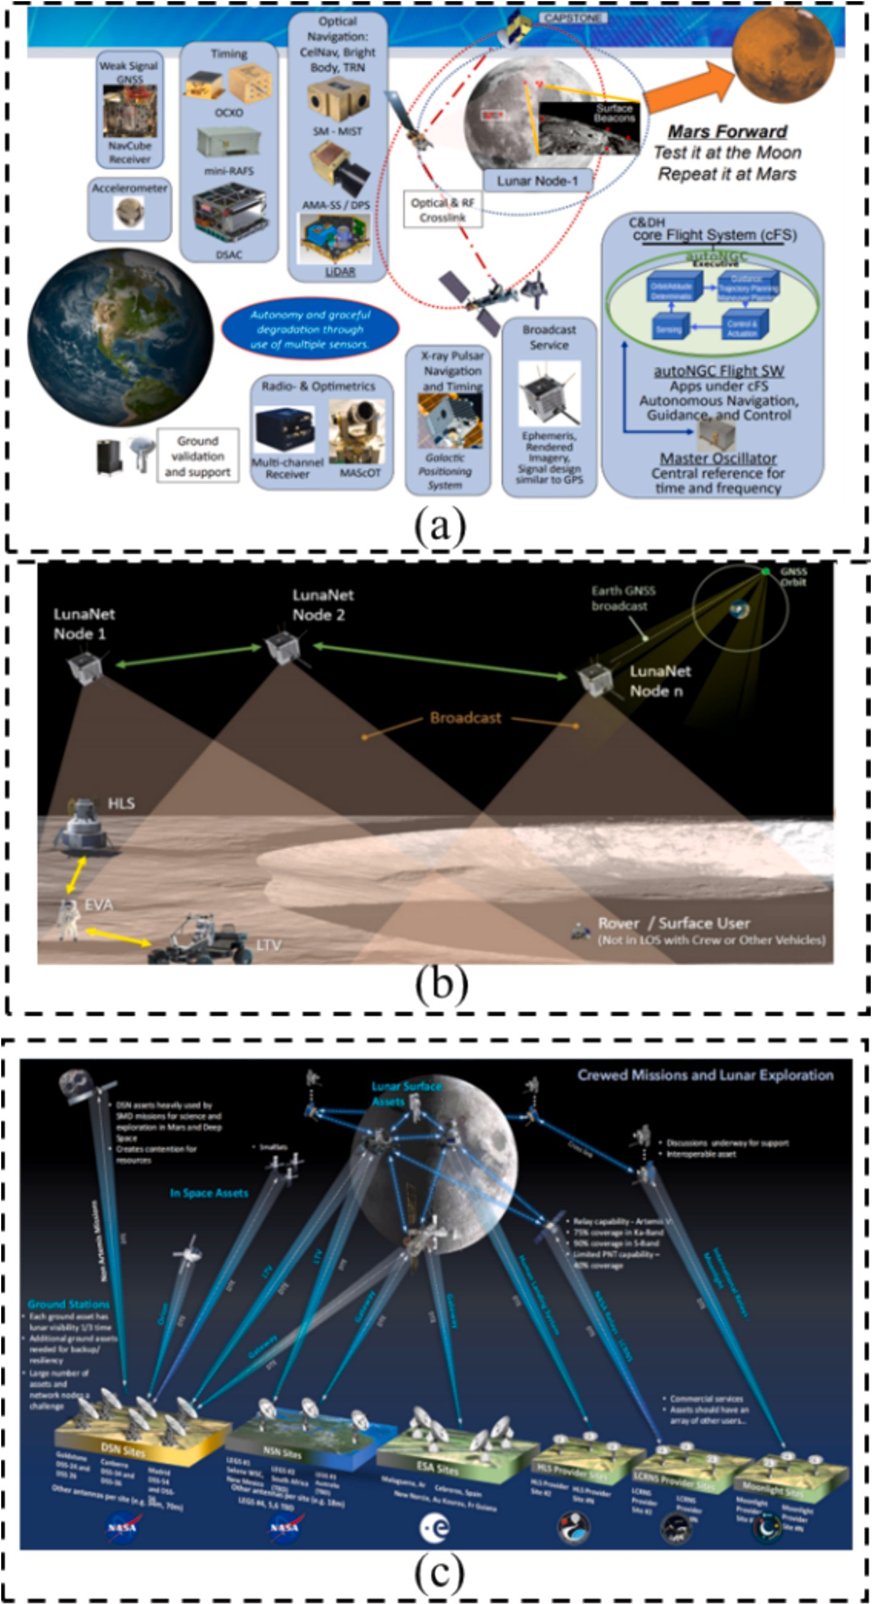

Fig. 5. (a) Autonomous navigation for future NASA missions [53], (b) artemis lunar surface navigation [55], (c) NASA’s communications and navigation archi-tecture [58].

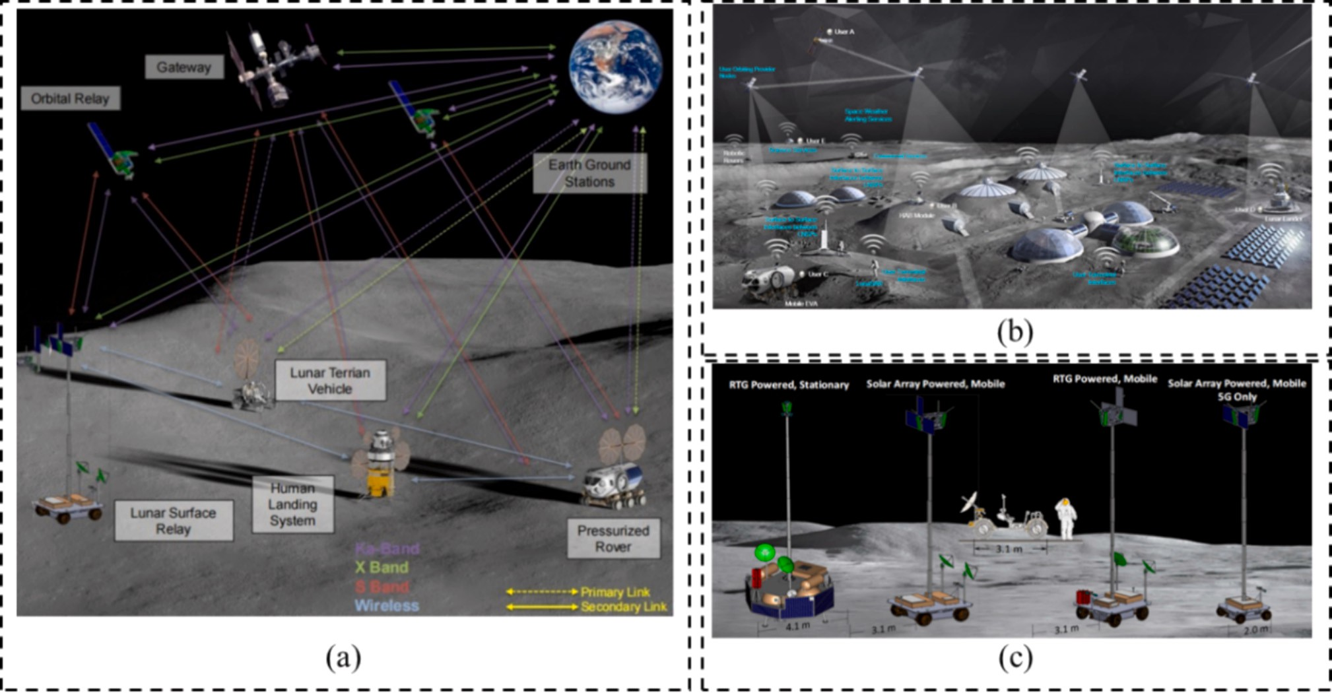

Fig. 6. (a) Communication architecture conceptual designs [61], (b) 3GPP/5G surface wireless network [55], (c) lunar surface network relay terminal [61].

significant challenges to current cargo transport capabilities and con-struction site selection schemes, necessitating further in-depth feasi-bility studies.

  - Nuclear power station

The sustainable development and utilization of the Moon require a continuous and stable energy supply. Nuclear power generation offers a reliable and stable energy source that is not dependent on solar irradi-ation, unlike solar power generation. It also does not face specific re-strictions on site selection for constructing nuclear power stations. Many institutions and organizations worldwide have proposed the use of nu-clear energy as an energy supply solution for lunar infrastructure [68]. For example, NASA has put forward a 40 kW nuclear reactor proposal Fig. 8(a) [69]. In order to meet the high requirements for radiation shielding, especially in inhabited bases, proposals have been made to use natural lunar regolith layers and processed regolith protective layers for shielding. The shielding employs a circular design horizontally Fig. 8
- and conical layers vertically Fig. 8(c), forming a lithium hydride shield weighing 6215 kg [70]. This method utilizes advanced materials engineering and construction techniques to ensure safety and efficiency. It has also been suggested to construct nuclear power plants at locations far from main bases to mitigate potential risks. This would require the development of long-distance power transmission systems, which in turn would increase construction costs and operational risks.
Currently, the design proposals for lunar nuclear power stations are still in the conceptual stage. They are only capable of providing a stable 40 kW power supply or face challenges in meeting transportation and deployment requirements on the lunar surface.

  - Energy storage system

Addressing the temperature variations on the Moon’s surface and the unpredictability of sunlight duration, the development of efficient and reliable energy storage solutions has become a fundamental challenge for the construction and operation of lunar bases [71]. Traditional battery technologies are inadequate for the extremely low temperatures experienced during lunar nights [72,73]. Current mainstream solutions
involve utilizing processed lunar regolith as an energy storage material, which provides electrical energy through thermal storage [74–76]. For example, Hu et al. have utilized helium as a working fluid to transfer heat between lunar regolith thermal storage tanks and a Stirling generator Fig. 9(a) [77]. Liu et al. have conducted further thermal analysis and optimization of the lunar regolith thermal energy storage system, incorporating insulation layers of lunar regolith on both sides of the storage chamber Fig. 9(b) [78]. By utilizing a 20 mm thick insulation layer, energy loss during lunar nights can be reduced to 5 %. In addition, research has been conducted on high-density batteries and regenerative fuel cell technologies. NASA has investigated various battery technolo-
gies, including advanced lithium-ion and lithium-sulfur batteries, which
maintain good performance and long-term energy storage capabilities in cold environments [79]. Regenerative fuel cells, with higher power density than traditional batteries and the ability to operate in extreme cold conditions, use solar energy during the day to electrolyze water into hydrogen and oxygen. These elements are then chemically recombined at night to release energy, accomplishing cyclical energy use Fig. 9(c) [80].
Despite advancements, current technologies still face challenges in terms of cost, efficiency, and compatibility [81,82]. Future energy storage solutions must make breakthroughs in increasing energy den-sity, reducing costs, and ensuring long-term stability and reliability in order to meet the growing energy requirements for lunar exploration and habitation.

Habitation infrastructure

Distinct from Earth’s conditions, the environmental characteristics of the Moon are significantly divergent, characterized by extreme vacuum states, drastic temperature fluctuations, and intense radiation levels.
Specifically, the surface atmospheric pressure on the Moon is approxi-mately 3 × 10^{—13} kPa, whereas on Mars it is 0.7 kPa, both significantly lower than Earth’s average atmospheric pressure. Furthermore, the temperature ranges from —170 ◦C to 110 ◦C on the Moon and from
—140 ◦C to 35 ◦C on Mars, greatly exceeding Earth’s temperature range
[83]. In response to these extreme environmental conditions, the aca-demic community has proposed various construction schemes for lunar

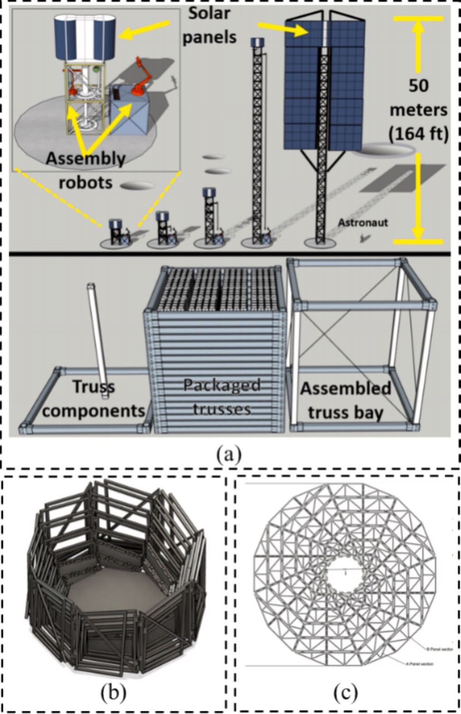

Fig. 7. (a) Tall lunar towers assembly sequence and packaging configuration [65], (b) compacted solar panels [67], (c) expanded solar panels [67].
habitation infrastructures, aimed at ensuring human survival in the Moon’s harsh environment [16,84–87]. These proposals include, but are not limited to, rigid structures, expandable structures, inflatable struc-tures, 3D printed structures, masonry assembly structures, and under-ground structures.

  - Launched habitation

Launching habitation involves transporting prefabricated structures from Earth to the lunar surface, where they can be assembled, unfolded, or inflated for later use [88–90]. These infrastructures primarily consist of rigid structures, expandable structures, and inflatable structures, each with its own advantages and drawbacks.
Expandable structures are launched in a folded state and then unfolded on the lunar surface using mechanical means such as hinge tension. This method maximizes usable space while minimizing trans-port volume, and allows for the structures to be retracted and reused as needed [91–93]. Notable examples include the SLE Fig. 10(a) and HLIS Fig. 10(b) designs, which utilize hinge-based mechanisms to signifi-cantly enhance livable area [91,94,95]. Other techniques, such as cy-lindrical stretch unfolding, are also employed to further optimize spatial efficiency.
Similar to expandable structures, inflatable habitats utilize flexible materials that are inflated or pressurized for deployment [96,97]. These structures are designed to occupy minimal volume during transit, thereby drastically reducing transportation loads. However, despite their advantage in space optimization, they pose challenges in terms of complexity and reduced protective capabilities against the harsh lunar environment. Further research is therefore necessary to assess and enhance their reliability [98]. For example, NASA’s TransHab inflatable habitat offers three levels of living space within a cylindrical structure Fig. 10(c), using multiple stacked layers for protection [99–101]. Additionally, scholars have explored spherical, cylindrical, and pillow-like inflatable structures.
Rigid structures can be fully assembled on Earth, eliminating the need for extensive construction on the Moon [102–105]. This makes them highly feasible and reliable with current technology. For instance, Guo’s proposed lunar base adopts a T-shaped layout similar to the China Space Station [106]. It consists of separate yet interconnected modules for living, laboratory, and support purposes. This design not only en-ables efficient logistics but also allows for future expansion of the base

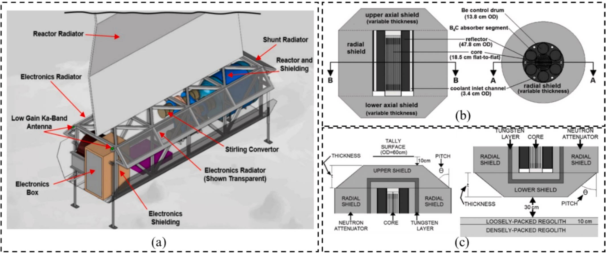

Fig. 8. (a) NASA fission surface power 40 kW reactor pallet [69], (b) axial and radial views of the FSP model [70], (c) upper and lower axial of anti-radiation shield [70].

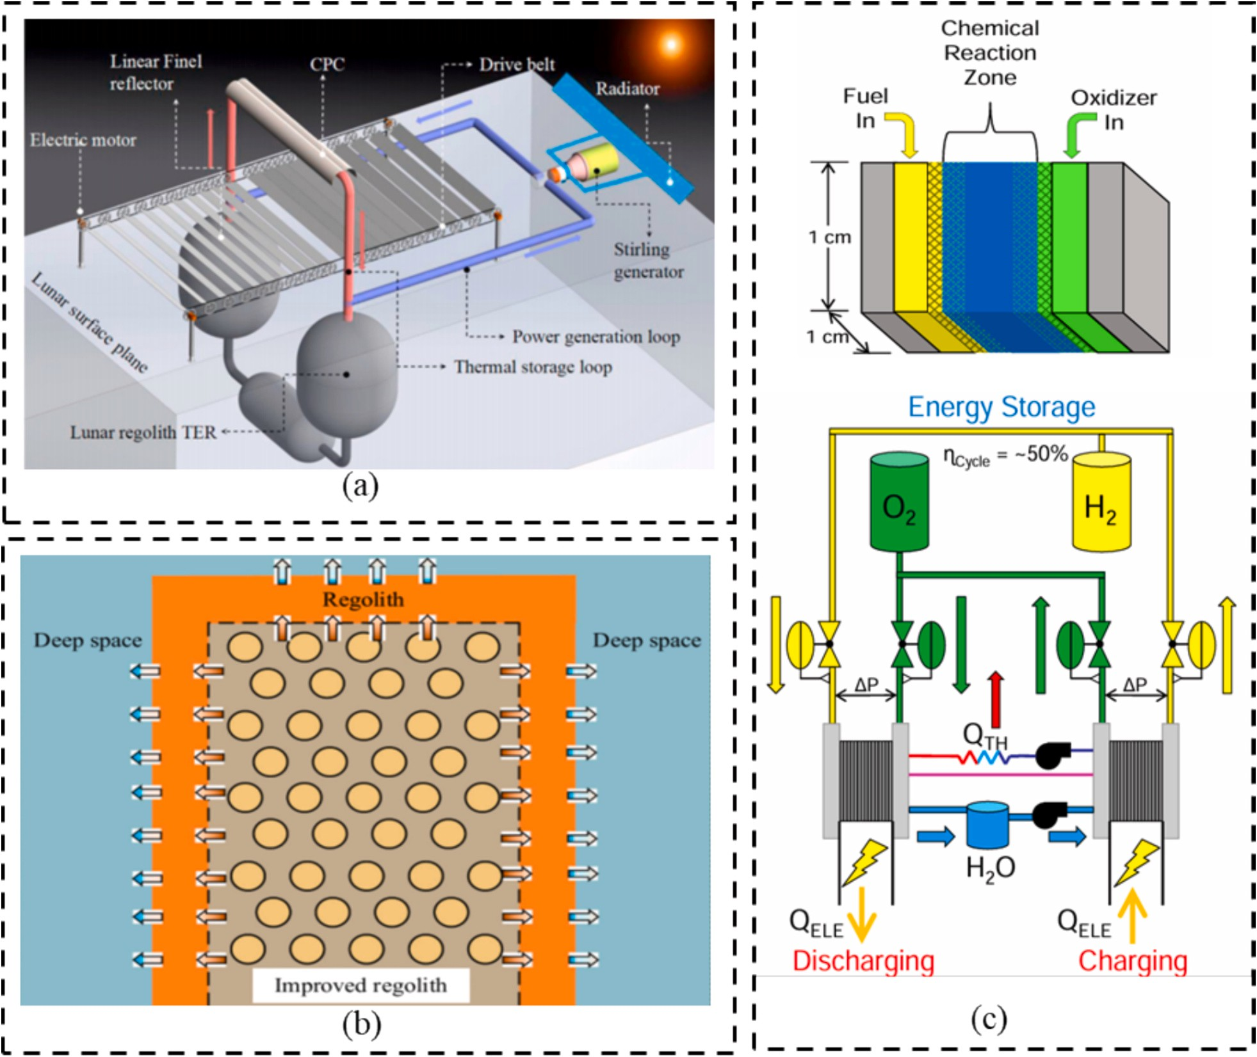

Fig. 9. (a) Solar thermal storage power generation system based on lunar ISRU [77], (b) layout of thermal insulation layer of heat storage [78], (c) NASA’s lunar regenerative fuel cell: basic unit cell and electrochemical systems [80].

Fig. 10(d).

  - In-situ habitation

Launching habitation heavily depends on prefabrication on Earth [88–90]. Consequently, various structural design proposals have been introduced that utilize lunar in-situ construction techniques [107–110]. The primary methods can be divided into two categories: 3D printing technology and masonry assembly technology.
3D printing technology, known for its high degree of automation and efficient use of in-situ materials, has been widely adopted in construct-ing habitations [111–114]. For example, NASA’s proposed “Lunar Lantern” Fig. 11(a) [115] focus on utilizing 3D printing as the core technology. Similarly, Huazhong University of Science and Technol-ogy’s “Lunar Ampullae” plan Fig. 11(b) utilizes lunar regolith to produce concrete for segmented 3D printing Fig. 11(c) [116]. Lunar Ampullae incorporates features such as shell, catenary dome ceilings, and internal ribbing, ensuring even distribution of structural loads while providing insulation, thermal protection, and radiation shielding [116]. Other projects, like Sinterhab and the ESA 3D Printing Lunar Base, also follow this approach [117,118].
Masonry assembly structures involve the construction of large-scale buildings by assembling in-situ manufactured bricks and other small modules. This technique, utilizing non-monolithic construction,
effectively reduces construction risks by avoiding failures from errors in any construction step. It facilitates rapid, assembly-line-like building. For example, NASA’s Voussoir dome structure Fig. 12(a) [119], composed of 33 small modules assembled by rovers Fig. 12(b) [120], and Huazhong University of Science and Technology’s “Xuan Wu” plan Fig. 12(c) [14], which assembles in-situ sintered bricks and arch com-ponents. These structures, primarily arch-shaped and covered with solar panels Fig. 12(d) [14], not only enhance load-bearing capacity but also provide spacious living areas while significantly reducing material usage.
The above structural designs are fundamentally based on lunar construction materials, technologies, and processes, and thus require validation tests to be conducted on the terrestrial surface. To date, do-mestic and international teams have established extraterrestrial envi-ronment simulation platforms and experimental facilities of varying scales to conduct preliminary validation and testing for deep-space exploration missions. The team led by Feng Peng has noted that the intense cosmic radiation environment accelerates the degradation of organic binders, advocating prioritization of inorganic solidification technologies for lunar construction.
Current research on the coupled effects of extreme lunar environ-ments on construction processes remains primarily theoretical. Existing terrestrial simulation platforms can typically replicate only one or a few combined environmental factors, falling short of integrating multiple

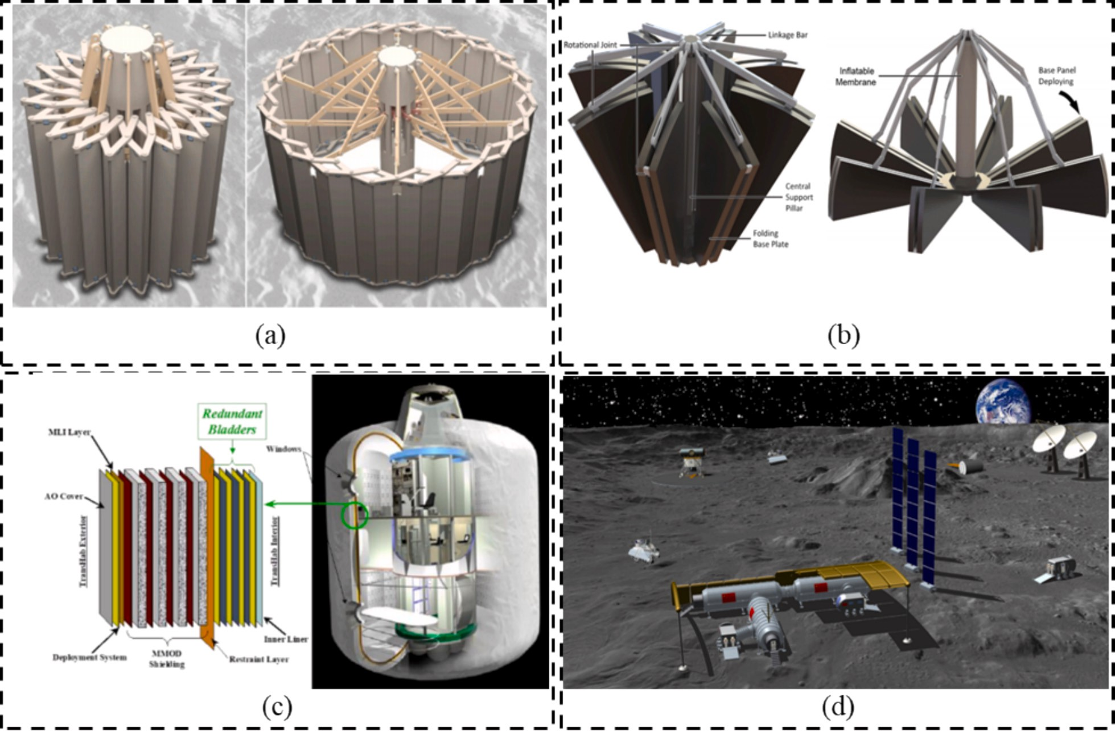

Fig. 10. (a) Deployable lunar structures with scissor-like elements (SLE) [91], (b) hybrid lunar inflatable structure (HLIS) [94], (c) TransHab structure [99], (d) integrated manned lunar base [106].
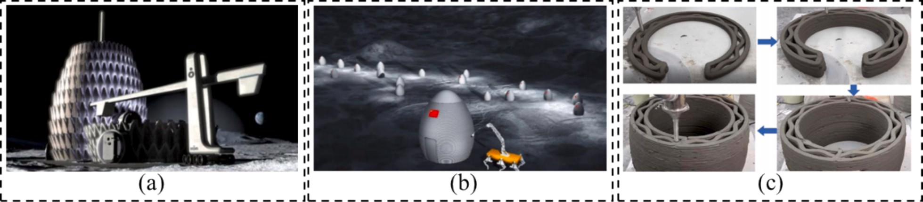

Fig. 11. (a) Lunar Lantern [115], (b) conceptual design of 3D printable lunar habitat structure: Lunar Ampullae [116], (c) process of segmented 3D printing of Lunar Ampullae [116].

extreme conditions such as microgravity, high radiation, and high vac-uum. Constrained by platform size, high-fidelity, large-scale validation of construction processes under combined high-radiation and micro-gravity environments remains unfeasible. To address these limitations, the Huazhong University of Science and Technology team has launched simulated lunar regolith bricks via the TZ-8 rocket for extravehicular exposure tests on China’s Space Station, aiming to validate mechanical and thermal degradation models of regolith-based materials under ra-diation and thermal cycling. This three-year in-orbit experiment is ongoing, with samples and test data yet to be retrieved.

  - Lava-tube based habitation

Lunar lava-tubes are subterranean hollow caves formed through geological activity and the flow of molten lava on the Moon [121–123]. During the process of lava flow, the outer layer cools and creates a thermal insulating layer, while the inner layer remains hot and con-tinues to flow. This eventually leads to the formation of a tube with a
rounded top and a flat bottom. The thick layers of basalt and lunar regolith that make up the ceiling of the tube provide natural shielding and thermal insulation for the interior space [124–127]. As a result, lava tubes have become a preferred option for selecting sites to construct lunar bases due to their protective and insulating properties [128–130]. Since the 1990s, the study of extraterrestrial lava tubes has made sig-nificant advancements with the use of remote sensing technology [131–134]. For example, the Japanese SELENE orbiter identified three skylights—openings that resulted from partial collapses in lava tubes [135–137]. India’s Chandrayaan-1 probe discovered that the width of the lava tubes can exceed 300 m at the top [138]. Similarly, the U.S. LRO documented an extensive lava tube that spans approximately 48 km [139–141]. By measuring the lunar subsurface gravitational field, GRAIL found that the width of lava tubes could theoretically reach several kilometers Project Olympus: Off-World Additive Construction for Lunar Surface Infrastructure. In addition, researchers like Robert have utilized semi-automatic methods to identify potential lava pits, with a particular focus on areas such as the lunar maria and highlands

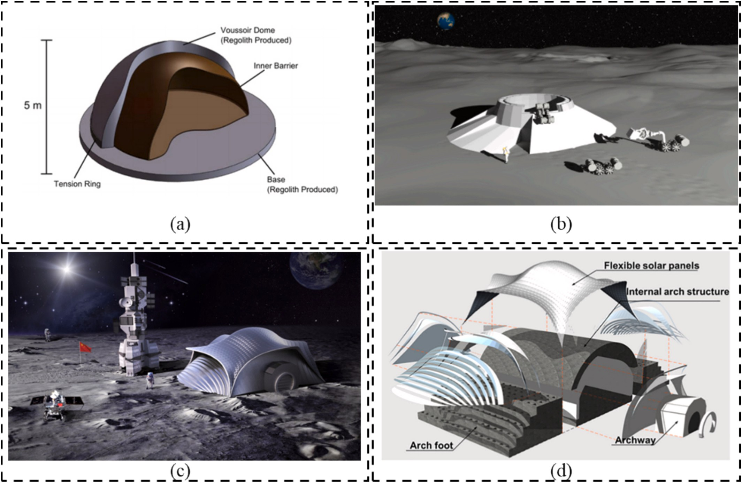

Fig. 12. (a) Voussoir dome structure [119], (b) using rovers to transport modular blocks [120], (c) conceptual design of the Xuanwu lunar habitation [14], (d) architectural breakdown map of the Xuanwu lunar habitation [14].

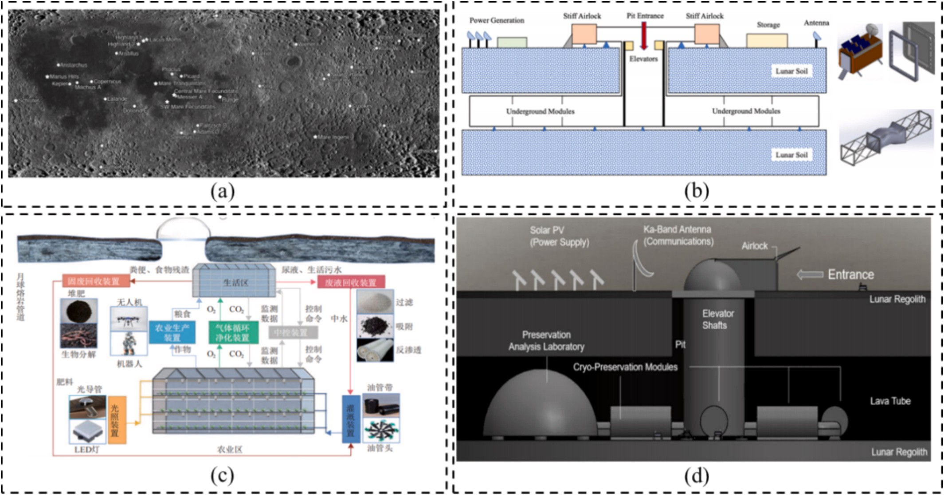

Fig. 13. (a) Map of the locations of known pits [142], (b) conceptual lunar base inside lava tubes, cabins, inflatable module, docking port [128], (c) structure composition of lunar farm [143], (d) lunar habitat based on lava tubes [144].

Fig. 13(a) [142].
Given that lunar lava tubes serve as natural barriers against moon dust erosion and micro-meteorite impacts, constructing habitation fa-cilities within them has become a new area of research focus. H. Kalita and others have proposed the concept of a lava-tube habitation, utilizing lava pits as entrances and expanding the use of underground spaces Fig. 13(b) [128]. This includes modules for life support, storage, and living modules, all connected through rigid airlocks. The team led by Xie Gengxin at Chongqing University has suggested leveraging the natural protection and minor internal temperature variations of lava tubes to establish lunar farms within them Fig. 13(c), ensuring a sustainable food supply for habitation [143]. Floress’s “Modern Ark” plan envisions a modular, expandable lunar base inside a lava tube for storing seeds and stem cells Fig. 13(d) [144].However, the utilization of extraterrestrial lava tubes as underground structures still presents significant risks and unknowns that require in-depth exploration. This exploration should focus on understanding their formation processes, internal structures, and environmental conditions. Xiao Long and colleagues recommend a combined exploration approach using orbiters, landers, and robots to study the geological and environmental differences between lunar and terrestrial lava tubes [145]. Additionally, since lava tubes are naturally formed, new considerations for habitation construction site selection arise. Further research and verification are necessary to determine the feasibility of using lava tubes for habitation.

Conlusions

This paper systematically reviewed the research progress, core challenges, and future directions of lunar infrastructure construction for moon bases, focusing on four key domains: transportation, navigation and communication, energy, and habitation. By integrating technolog-ical breakthroughs and existing international research programs, it re-veals the strategic significance of lunar infrastructure as a cornerstone for long-term human presence and deep-space exploration. The study finds that although technologies such as laser-sintered landing pads, solar power stations, and 3D-printed lunar regolith habitation modules demonstrate potential, four major challenges persist: (1) Unachieved to achieve multi-scale characterization and in-situ performance testing of authentic lunar regolith engineering properties; (2) the absence of reg-ular Earth-Moon transportations, with related facilities mostly in the conceptual stage; (3) insufficient scalable energy supply, with nuclear power designs limited to around 40 kW and solar power affected by lunar nights; (4) a shortage of high-availability communication and navigation systems, with unresolved issues of signal stability in complex topography and international interoperability; and (5) bottlenecks in life support technologies for long-term habitation, including material durability in microgravity and the efficiency of ecological recycling systems. A limitation of current research is its focus on isolated technical dimensions, lacking collaborative optimization among transportation, energy, and habitation systems. This paper synthesizes key recent con-cepts for lunar infrastructure, providing a systematic analysis of national and international plans and designs, with the aim of inspiring new ap-proaches for sustainable lunar exploration and development.

  - Challenges

    - Unachieved to produce large components using lunar regolith under extreme lunar environment.

To date, humanity has successfully retrieved over 300 kg of authentic lunar regolith samples. However, the scarcity of these samples severely limits scientists’ ability to characterization tests and investigate rego-lith’s formability and processing behavior. Nations possessing genuine lunar samples remain in preliminary exploration phases, primarily relying on simulated lunar regolith for studies on material consolidation. Current research predominantly focuses on laboratory-scale fabrication
of small components, whereas lunar infrastructure construction de-mands mass production of large-scale, densely compacted structural elements. This highlights the critical need to elucidate the in-situ for-mation mechanisms of regolith under extreme lunar conditions and develop uniform densification methods for bulk components. Further-more, existing regolith processing equipment and techniques lack operational stability in the harsh lunar environment. Overcoming challenges such as abrasive lunar dust, drastic thermal cycling, and achieving high-yield manufacturing of large, densely consolidated structures under 1/6 Earth gravity remains an unresolved frontier for enabling scalable infrastructure development on the Moon.

    - Lack of Regular Transportation for Crew/Elements between Earth and Moon and Limited Mobility on Lunar Surface.

Efficient transportation infrastructure is crucial for sustainable lunar resource development, yet the transportation between Earth and the Moon still lacks regular operation. Chapter two categorizes trans-portation infrastructure into landing/launching pads, roadbeds/pave-ments, and the space elevator, emphasizing the necessity of efficient transportation networks both within the lunar surface and between Earth and the Moon. However, lunar transportation infrastructure, including landing pads, remains in the conceptual stages, hindering large-scale development. Despite the crucial roles of sintering technol-ogy and robotics in construction, direct solar sintering fails to meet in-dustrial standards. This study argues that inadequate infrastructure construction and technology are the primary obstacles to transportation operations, posing significant challenges to achieving regular Earth-Moon transportation and facilitating mobility on the lunar surface.

    - Inability Scale to Support Continuous Power Utilization and In-dustrial Power Levels.

Reliable energy supply is essential for the sustainable development of the Moon. Solar stations must be strategically placed in continuously illuminated lunar regions, such as high-altitude sites near the south pole. However, solar power faces challenges during lunar nights. Nuclear stations offer constant power, but current designs are limited to around 40 kW, hindering scalability. Energy storage systems help mitigate en-ergy supply gaps during lunar nights, but extreme temperatures present challenges to existing batteries. Some studies propose using treated lunar regolith for heat storage, with natural lunar regolith acting as an insulation layer. Key challenges in energy infrastructure include deploying solar stations in continuously illuminated areas and the nascent conceptual stage of nuclear stations, which constrain extensive construction and prolonged utilization of the lunar surface.

    - Inadequate Provision of High-Availability CNPT Systems on Lunar Surface and Situational Awareness in Cislunar Space.

The current state of CPNT infrastructure falls short in providing high-availability communication or navigation capabilities. Teleoperated robots play critical roles in scientific exploration, resource utilization, and infrastructure construction, underscoring the vital need for robust CPNT infrastructures. However, the existing scarcity and technological limitations of CPNT infrastructure hinder essential services such as data relay, communication connectivity, and high-precision positioning, which are vital for lunar operations and Earth-Moon communication. The complex lunar topography poses challenges in establishing reliable communication, especially at lower altitudes. With the increasing deployment of hardware at the South Pole, the demand for communi-cation and navigation is set to rise, complicating the RF landscape. Concerns also arise regarding the interoperability among independently developed lunar communication infrastructures. This study emphasizes the urgency of advancing communication and navigation technology to ensure effectiveness while expanding infrastructure to meet the growing

demand.

    - Challenges Ensuring Humans Can Live on Moon for Extended Durations and Enabling Future Missions to Mars.

Constructing habitations on the Moon is essential for sustainable development and ensuring astronauts’ long-term survival. Proposed approaches include external rigid skeletons with inflatable interiors and in-situ protective shells made from lunar regolith. The exploration of lunar lava tubes as natural barriers against regolith corrosion and micrometeorite impacts offers potential for habitation. Ongoing studies focus on integrated designs for life support, escape, and resource recy-cling systems within habitation system frameworks. Habitation con-struction involves both structural and system design, shielding astronauts from lunar environmental challenges and ensuring their long-term viability. The primary challenge lies in developing strategies to protect against temperature variations, micrometeorite impacts, moon-quakes, and other adverse conditions while maintaining essential water and oxygen levels for prolonged lunar habitation.

  - Future directions

    - In-situ fabrication of high-strength, durable regolith-based con-struction materials utilizing abundant lunar resources.

Readily accessible and processable in-situ materials are critical to ensuring the economic viability and sustainable development of lunar surface construction. A key research focus will be how to process ma-terials such as lunar regolith, water, and rare-earth resources into concrete-like materials, sintered aggregates, glass fibers, metals, and alloys. Current research primarily employs simulated lunar regolith with physical and chemical properties similar to authentic regolith, including characterization of geotechnical bearing capacity, stability, shear strength, compressibility, and other physicochemical properties, as well as fabrication of regolith-based components through mechanical pre-treatment and sintering processes. By studying methods for in-situ preparation of construction materials on the lunar surface, this research will provide a foundation for integrated design and optimiza-tion of lunar structures, materials, and performance. With advancements in the formation mechanisms and property-control technologies of in-situ resources, the in-situ production of lunar construction materials will become a crucial scientific pillar for lunar surface construction.

    - Developing a sufficient number of lunar landing/launching sys-tems and low lifecycle cost roads.

Currently, achieving normalized, cost-effective, and highly efficient transportation between Earth and the Moon is a persistent challenge. The transportation capacity that connects Earth and the Moon is of significant importance for fostering sustainable lunar development. Ongoing research efforts are focused on developing normalized, cost-effective, and efficient transportation technologies. Special emphasis is placed on advancing long-distance, large-scale, and high-load mobile transportation capabilities on the Moon. The Earth-Moon transportation link plays a crucial role in facilitating the transfer of lunar resources, signifying Earth’s transition from a closed to an open ecosystem. This transition requires the establishment of propellant storage in Earth-Moon space, the construction of lunar landing/launching pads, and progress in automated construction methods. These technological ad-vancements pave the way for normalized space transportation, enabling the sustainable development and utilization of lunar resources for the benefit of Earth.

    - Allocating a distributed and highly efficient energy architecture with solar and nuclear power.
Currently, there is no technology available for independent, large-scale electricity generation on the moon’s surface. However, the need for a reliable and abundant power supply is crucial for sustaining lunar activities. Addressing these challenges requires collaborative efforts to navigate the complexities of constructing lunar energy infrastructure. The implementation of a highly distributed architecture is essential for effectively managing diverse energy infrastructures. A critical initial step in shaping the moon’s energy architecture is overcoming challenges in infrastructure construction and deployment. Recognizing the diffi-culties associated with long-distance energy supply on the lunar surface, it is crucial to strategically deploy energy infrastructures near surface installations to minimize distance and energy loss, ultimately enhancing overall efficiency. The envisioned lunar energy architectureincludes various energy forms, moving beyond sole reliance on solar or nuclear energy. Effective management and distribution within this distributed architecture remain vital for achieving industrial-scale energy supply on the moon.

    - Establishing ubiquitous networks on the lunar surface and reli-able interstellar communication.

The increasing need for interstellar communication and navigation in Earth-Moon space necessitates the growth of lunar communication and navigation infrastructure. This entails developing efficient tech-nologies and expanding existing infrastructure, ensuring interopera-bility among different developer facilities. Additionally, it is essential to enhance collaborative precision in communication, positioning, and navigation systems while fortifying resilience against solar wind and magnetic storms to foster sustainable lunar development. Moreover, considering the future demand for lunar communication, it becomes crucial to establish Wireless Fidelity base stations and lunar communi-cation relays on the lunar surface.

    - Maximizing the use of in-situ resources and establishing a life support system integrated with habitation construction.

This paper argues for the importance of maximizing ISRU technology in order to address the challenge of extended astronaut survival on the Moon. From a structural design perspective, this involves investigating the formation process of lunar regolith in microgravity environments, and optimizing technologies related to shape and properties. The focus is on identifying the most effective combination of building materials, consisting of diverse components, and utilizing various forming tech-niques to produce building materials with exceptional performance for habitation. From a system design perspective, the in-situ production of water and oxygen on the lunar surface is of utmost importance. This paper suggests the development of a multi-system integrated design methodology for habitation, which would facilitate the coordinated operation of water and oxygen circulation systems, temperature moni-toring, and control systems within confined spaces. The objective is to enhance the efficiency of space and energy utilization, ultimately achieving an open-source operation and a self-sustaining life support system. This approach is crucial for future lunar habitation, as it sup-ports the presence of astronauts over an extended period and prepares for future Mars exploration.

CRediT authorship contribution statement

Yifeng Xia: Writing – original draft, Data curation, Conceptualiza-tion. Yuyue Gao: Data curation, Writing – original draft, Conceptuali-zation. Wenbin Han: Methodology. Xinyi Li: Investigation. Cheng Zhou: Supervision, Resources. Yan Zhou: Methodology. Lieyun Ding: Funding acquisition.

Declaration of competing interest

The authors declare that they have no known competing financial interests or personal relationships that could have appeared to influence the work reported in this paper.

Acknowledgments

This work was supported by the National Key Research and Devel-opment Program of China (2021YFF0500300, 2023YFB3711300); Strategic Research and Consulting Project of the Chinese Academy of Engineering (2023 XZ-90, 2023-JB-09-10) and the Space Application System of China Manned Space Program (CLS-0703).

Data availability

Data will be made available on request.

References

- NASA, Moon to Mars Architecture Definition Document (ESDMD-001) – Revision A – Management Directive 01. https://www.nasa.gov/wp-content/uploads/20 24/01/rev-a-acr23-esdmd-001-m2madd.pdf?emrc=6630c93f67ed7, 2023.
- E. National Academies of Sciences, and Medicine, Decadal Surveys——Thriving
in Space: Ensuring the Future of Biological and Physcial Sciences Research. htt ps://nap.nationalacademies.org/catalog/26750/thriving-in-space-ensuring-th
e-future-of-biological-and-physical, 2023.
- L.A. Taylor, G.L. Kulcinski, Helium-3 on the moon for fusion energy: the Persian Gulf of the 21st century, Sol. Syst. Res. 33 (1999) 338. https://ui.adsabs.harvard. edu/abs/1999SoSyR..33..338T.
- V. Ehrenfried, The artemis lunar program overview, in: The Artemis Lunar Program, Springer, 2020, pp. 7–47, https://doi.org/10.1007/978-3-030-38513-2_2.
- S. Creech, J. Guidi, D. Elburn, Artemis, An overview of NASA’S activities to return humans to the Moon, in: 2022 IEEE Aerospace Conference (AERO) 2022, 2022, pp. 1–7, https://doi.org/10.1109/AERO53065.2022.9843277.
- R.G. Clinton, J.E. Edmunson, M. Fiske, M.R. Effinger, E. Jensen, J. Ballard, Overview of NASA’s Moon-to-Mars Planetary Autonomous Construction Technology (MMPACT) 2021, ASCEND, 2021, https://doi.org/10.2514/
6.2021–4072, 978–1–62410-612-5.
- P. Kessler, T. Prater, T. Nickens, D. Harris, Artemis deep space habitation: enabling a sustained human presence on the Moon and beyond, in: 2022 IEEE Aerospace Conference (AERO), 2022, pp. 1–12, https://doi.org/10.1109/ AERO53065.2022.9843393.
- ESA, Terrae Novae 2030+ Strategy Roadmap. https://esamultimedia.esa.int
/docs/HRE/Terrae_Novae_2030+strategy_roadmap.pdf, 2022.
- NASA, The Artemis Accords. https://www.nasa.gov/wp-content/uploads/2022
/11/Artemis-Accords-signed-13Oct2020.pdf?emrc=653a00, 2020.
- C. Zhou, Y. Jia, J. Liu, H. Li, Y. Fan, Z. Zhang, Y. Liu, Y. Jiang, B. Zhou, Z. He,
J. Yang, Y. Hu, Z. Liu, L. Qin, B. Lv, Z. Fu, J. Yan, C. Wang, Y. Zou, Scientific objectives and payloads of the lunar sample return mission—Chang’E-5, Adv. Space Res. 69 (2022) 823–836, https://doi.org/10.1016/j.asr.2021.09.001.
- W.R. Wu, Q. Wang, Y.H. Tang, G.B. Yu, J.Z. Liu, W. Zhang, Y.M. Ning, Design of Chang’E-4 lunar Farside soft-landing Mission, J. Deep Space Explor. 4 (2017) 111–117, https://doi.org/10.15982/j.issn.2095-7777.2017.02.002.
- Z.Y. Teng Hu, Mo Li, Carolyn H. van der Bogert, Zhizhong Kang, Xu Xiaojian, Harald Hiesinger, Possible sites for a Chinese international lunar Research Station in the lunar south polar region, Planet. Space Sci. 227 (2023) 105623, https:// doi.org/10.1016/j.pss.2022.105623.
- X. Wu, The international lunar Research Station: China’s new era of space cooperation and its new role in the space legal order, Space Policy 65 (2023), https://doi.org/10.1016/j.spacepol.2022.101537.
- C. Zhou, R. Chen, J. Xu, L. Ding, H. Luo, J. Fan, E.J. Chen, L. Cai, B. Tang, In-situ construction method for lunar habitation: Chinese super Mason, Autom. Constr. 104 (2019) 66–79, https://doi.org/10.1016/j.autcon.2019.03.024.
- R. Romo, C. Andersen, K. Defore, K. Zacny, M. Thangavelu, T. Lippitt, Planetary Lego: Designing a construction block from a regolith derived feedstock for in situ robotic manufacturing, Earth Space 2018 (2018) 289–296, https://doi.org/ 10.1061/9780784481899.029.
- L.D. Wenbin Han, Lixiong Cai, Junjie Zhu, Hanbin Luo, Tao Tang, Sintering of HUST-1 lunar regolith simulant, Constr. Build. Mater. 324 (2022) 126655, https://doi.org/10.1016/j.conbuildmat.2022.126655.
- R. Ruan, W. Yang, D. Zhang, H.-C. Tian, Q. Zhao, Y. Zou, B. Yu, A moderate-Ti lunar mare soil simulant: IGG-01, Acta Astronaut. 224 (2024) 148–160, https:// doi.org/10.1016/j.actaastro.2024.08.010.
- M.M. Battler, J.G. Spray, The Shawmere anorthosite and OB-1 as lunar highland regolith simulants, Planet. Space Sci. 57 (2009) 2128–2131, https://doi.org/ 10.1016/j.pss.2009.09.003.
- X. Zeng, C. He, A. Wilkinson, Geotechnical properties of NT-LHT-2M lunar Highland simulant, J. Aerosp. Eng. 23 (2010) 213–218, https://doi.org/10.1061/ (ASCE)AS.1943-5525.0000026.
- Z. Hu, T. Shi, M. Cen, J. Wang, X. Zhao, C. Zeng, Y. Zhou, Y. Fan, Y. Liu, Z. Zhao, Research progress on lunar and Martian concrete, Constr. Build. Mater. 343 (2022) 128117, https://doi.org/10.1016/j.conbuildmat.2022.128117.
- P.J. Collins, J. Edmunson, M. Fiske, A. Radlin´ska, Materials characterization of various lunar regolith simulants for use in geopolymer lunar concrete, Adv. Space Res. 69 (2022) 3941–3951, https://doi.org/10.1016/j.asr.2022.03.012.
- F. Pederson, L. Ellersick, H.-J. Kim, A review of lunar regolith based alkali activated materials and sintered regolith for use as a construction material, Acta Astronaut. 232 (2025) 502–515, https://doi.org/10.1016/j. actaastro.2025.03.032.
- C. Zhou, H. Tang, X. Li, X. Zeng, W. Yu, B. Mo, R. Li, J. Liu, Y. Zou, Effects of ilmenite on the properties of microwave-sintered lunar regolith simulant,
J. Aerosp. Eng. 34 (2021) 06021006, https://doi.org/10.1061/(ASCE)AS.1943-
5525.0001344.
- W. Han, Y. Zhou, F. Dang, C. Zhou, L. Ding, Spark plasma sintering of HUST-1 lunar regolith simulant and its thermal shock resistance properties, Adv. Space Res. 73 (2024) 1992–2003, https://doi.org/10.1016/j.asr.2023.11.027.
- M. Suhaizan, P. Shazwan, A. Tran, B.G. Exner, Falzon, regolith sintering and 3D printing for lunar construction: an extensive review on recent progress, Progr. Additive Manufact. 9 (2023) 1715–1736, https://doi.org/10.1007/s40964-023-
00537-1.
- Z. Zeng, Y. Zhou, S. Wen, C. Zhou, A review: additive manufacturing of wood-plastic composites, Cellulose 31 (2024) 5315–5341, https://doi.org/10.1007/ s10570-024-05916-7.
- E. Schaler, FLOAT — Flexible Levitation on a Track. https://www.nasa.gov/gen eral/float-flexible-levitation-on-a-track/, 2021.
- T.R.G.R. Mueller, RASSOR - Regolith Advanced Surface Systems Operations Robot. https://ntrs.nasa.gov/api/citations/20150022134/downloads/20150022 134.pdf, 2015.
- H. Li, Y. Gao, Y. Zhou, C. Zhou, Performance analysis of a bucket drum for lunar regolith collection in lunar base construction, Autom. Constr. 166 (2024) 105617, https://doi.org/10.1016/j.autcon.2024.105617.
- A.S. Howe, B. Wilcox, C. McQuin, D. Mittman, J. Townsend, R. Polit-Casillas,
T. Litwin, Modular additive construction using native materials, Earth Space 2015 (2014) 301–312, https://doi.org/10.1061/9780784479179.034.
- S. Cheng, Y. Gao, Y. Shi, L. Xiao, L. Ding, C. Zhou, Y. Zhou, Advances in in-situ resources utilization for extraterrestrial construction, Adv. Space Res. 74 (2024) 3297–3325, https://doi.org/10.1016/j.asr.2024.06.029.
- Y. Gao, Y. Zhou, S. Cheng, W. Han, C. Zhou, L. Ding, Performance of lunar shell structure for moonbase subjected to low gravity coupled with changing temperature, Fundam. Res. (2024), https://doi.org/10.1016/j.fmre.2024.08.005.
- X. Li, Y. Gao, Y. Zhou, W. Han, C. Zhou, A review on design and construction of the lunar launch/landing infrastructure, Adv. Space Res. 74 (2024) 4030–4049, https://doi.org/10.1016/j.asr.2024.07.006.
- C. Zhou, Y. Gao, Y. Zhou, W. She, Y. Shi, L. Ding, C. Miao, Properties and characteristics of regolith-based materials for extraterrestrial construction, Engineering 37 (2024) 159–181, https://doi.org/10.1016/j.eng.2023.11.019.
- S.K. Borowski, B.G. Sauls, Key Technologies, Systems, and Infrastructure Enabling Routine Travel From the Earth to the Moon – A Look Ahead at What’s Required 2021, ASCEND, 2021, https://doi.org/10.2514/6.2021-4212.
- H. Chen, H.W. Lee, K. Ho, Space transportation system and infrastructure design for regular interplanetary cargo missions, in: AIAA SPACE and Astronautics Forum and Exposition, 2017, https://doi.org/10.2514/6.2017-5197.
- C.N.S. Administration, International Lunar Research Station (ILRS) Guide for Partnership. https://www.cnsa.gov.cn/english/n6465652/n6465653/c6 812150/content.html, 2021.
- M.K. Zacny, Instant landing pads for lunar missions, Earth Space 2021 (2021) 1027–1032, https://doi.org/10.1061/9780784483374.094.
- A. Campbell, H. Carson, M.D. Soto, K. English, M. Fiske, L. Martin, V. Murai,
F. Ramirez, E. Romo, K. Schang, K. Smith, Lunar PAD - on the Development of a Unique ISRU-Based Planetary Landing Pad for Cratering and Dust Mitigation, AIAA Scitech 2021 Forum, 2021, https://doi.org/10.2514/6.2021-0356.
- C. Zhou, Y. Gao, E.J. Chen, L. Ding, W. Qin, Deep learning technologies for shield tunneling: challenges and opportunities, Autom. Constr. 154 (2023) 104982, https://doi.org/10.1016/j.autcon.2023.104982.
- K. You, C. Zhou, L. Ding, Deep learning technology for construction machinery and robotics, Autom. Constr. 150 (2023) 104852, https://doi.org/10.1016/j. autcon.2023.104852.
- J. Thangavelautham, Y. Xu, The design of autonomous robotic technologies for lunar launch and landing Pad (LLP) preparation, in: 2022 IEEE Aerospace Conference (AERO), 2022, pp. 1–13, https://doi.org/10.1109/ AERO53065.2022.9843755.
- W. Han, C. Zhang, J. Sun, C. Zhou, L. Ding, Experimental and numerical study on the structural behavior of assembled interlocking lunar landing pad, Acta Astronaut. 207 (2023) 77–88, https://doi.org/10.1016/j.actaastro.2023.03.001.
- S.J. Dyke, A. Sharma, E.M. Mount, A. Bobet, J.A. Ramirez, Establishing standards for lunar in situ resource utilization structural materials, AIAA J. 0 (2024) 1–10, https://doi.org/10.2514/1.J063816.
- A.V. Zakharov, L.M. Zelenyi, S.I. Popel, Lunar dust: properties and potential hazards, Sol. Syst. Res. 54 (2020) 455–476, https://doi.org/10.1134/ S0038094620060076.

- J.-M. Gosau, Regolith stabilization and building materials for the lunar surface, Earth Space 2012 (2012) 243–249, https://doi.org/10.1061/
9780784412190.028.
- Juan-Carlos Gine´s-Palomares, M. Fateri, Laser melting manufacturing of large elements of lunar regolith simulant for paving on the moon, Sci. Rep. 13 (2023) 15593, https://doi.org/10.1038/s41598-023-42008-1.
- P. Swan, C. Swan, M. Fitzgerald, V. Hall, J. Torla, M. Peet, Space Elevator is Transportation System of 21st Century, 2020, https://doi.org/10.13140/ RG.2.2.33568.00001, 978–1–71674-663-5.
- M.V. Pelt, Space Tethers and Space Elevators, Copernicus New York, NY, 2009, https://doi.org/10.1007/978-0-387-76556-3, 978-0-387-76555-6.
- T. Okino, Y. Yamagiwa, S. Arita, Y. Ishikawa, K. Otsuka, Three-dimensional analysis of a counterweight type space elevator, Acta Astronaut. 185 (2021) 132–139, https://doi.org/10.1016/j.actaastro.2021.04.040.
- A. Del´epaut, P. Giordano, J. Ventura-Traveset, D. Blonski, M. Scho¨nfeldt,
P. Schoonejans, S. Aziz, R. Walker, Use of GNSS for lunar missions and plans for lunar in-orbit development, Adv. Space Res. 66 (2020) 2739–2756, https://doi. org/10.1016/j.asr.2020.05.018.
- W. Wu, M. Chen, Z. Zhang, X. Liu, Y. Dong, Overview of deep space laser communication, SCIENCE CHINA Inf. Sci. 61 (2017) 040301, https://doi.org/ 10.1007/s11432-017-9216-0.
- D. Israel, LunaNet: NASA’s Communications and Navigation Architectural Framework for the Moon, Engineering Colloquium, 2021. https://ntrs.nasa. gov/citations/20210009874.
- L. Musumeci, F. Dovis, J.S. Silva, Design of a high sensitivity GNSS receiver for lunar missions, Adv. Space Res. 57 (2016) 2285–2313, https://doi.org/10.1016/ j.asr.2016.03.020.
- G.W. Heckler, A.J. Petro, Lunar Communication and Navigation Architecture: NASA Viewpoint, Meeting: Lunar Communications and Navigation Meeting with ESA. https://ntrs.nasa.gov/api/citations/20220002724/downloads/NASA%20 Lunar%20C%26N%20ESA%20Meeting%20Feb%2024%202022%20Petro.pdf, 2022.
- D.J. Israel, K.D. Mauldin, C.J. Roberts, J.W. Mitchell, A.A. Pulkkinen, L.V.
D. Cooper, M.A. Johnson, S.D. Christe, C.J. Gramling, LunaNet: a flexible and extensible lunar exploration communications and navigation infrastructure, in: 2020 IEEE Aerospace Conference, 2020, pp. 1–14, https://doi.org/10.1109/ AERO47225.2020.9172509.
- L.B. Winternitz, W.A. Bamford, A.C. Long, M. Hassouneh, GPS based autonomous navigation study for the lunar gateway, in: Annual American Astronautical Society (AAS) Guidance, Navigation, and Control Conference, 2019. https://ntrs. nasa.gov/api/citations/20190002311/downloads/20190002311.pdf.
- M. Zemba, K. Vaden, R. Reinhart, C. Gramling, G. Heckler, NASA’S Lunar Communications and Navigation Architecture: Human Lunar Return. https://ntrs
.nasa.gov/api/citations/20230016359/downloads/Lunar%20Communications% 20and%20Navigation%20Architecture.pdf, 2024.
- J. Thompson, H. Haygood, M. Kezirian, Design and analysis of lunar communication and navigation satellite constellation architectures, in: AIAA SPACE 2010 Conference & Exposition, 2012, https://doi.org/10.2514/ 6.2010–8644, 978–1–60086-966-2.
- L.M. Downes, T.J. Steiner, J.P. How, Neural network approach to crater detection for lunar terrain relative navigation, J. Aerospace Inf. Syst. 18 (2021) 391–403, https://doi.org/10.2514/1.I010884.
- M.C. Turnbull, Lunar surface network relay terminal: a lunar communications platform, in: AIAA International Communications Satellite Systems Conferences (ICSSC), 2023. https://ntrs.nasa.gov/api/citations/20230014675/downloa ds/20230014675%20Final%20Document%20121423.pdf.
- J. Fincannon, Lunar south pole illumination: review, reassessment, and power system implications, in: 5th International Energy Conversion Engineering Conference and Exhibit (IECEC), 2012, https://doi.org/10.2514/6.2007-4700.
- A.K. Ross, S. Ruppert, P. Gla¨ser, M. Elvis, Preliminary quantification of the available solar power near the lunar South Pole, Acta Astronaut. 211 (2023) 616–630, https://doi.org/10.1016/j.actaastro.2023.06.040.
- R. Centers, J. Schertz, D. Dickson, P. Gla¨ser, Bootstrapping a scalable power infrastructure for lunar mining, Earth Space 2021 (2021) 351–360, https://doi. org/10.1061/9780784483374.035.
- D.J. Tiffin, M.K. Mahlin, Tall lunar towers: systems analysis of a lunar-surface-assembled power, communication, and navigation infrastructure, in: ASCEND 2023, 2023, https://doi.org/10.2514/6.2023–4754, 978–1–62410-705-4.
- J.M. Gordon, Uninterrupted photovoltaic power for lunar colonization without the need for storage, Renew. Energy 187 (2022) 987–994, https://doi.org/ 10.1016/j.renene.2022.02.016.
- J. Rios, C. Velazquez, T. Rakotomanana, M. Kabir, J. Xu, Generative Design of a Novel Additively Manufactured Solar Array System for powering space equipment on the lunar surface, in: ASME 2021 International Mechanical Engineering Congress and Exposition Vol. 9, Engineering Education, 2021, https://doi.org/10.1115/imece2021-71221.
- A. Petrocelli, R.A. Bettinger, N.C. Kutz, C. Hartsfield, Atlas of historical and proposed nuclear devices and power systems in the earth-moon system and wider solar system, Prog. Nucl. Energy 164 (2023) 104857, https://doi.org/10.1016/j. pnucene.2023.104857.
- S. Oleson, T. Packard, E. Turnbull, M. Gibson, D. Rao, C. Barth, S. Wilson,
P. Schmitz, A. Colozza, B. Klefman, L. Tian, L. Mason, A Deployable 40 kWe Lunar Fission Surface Power Concept, 2022, https://doi.org/10.13182/NETS22-38629.
- A.E. Craft, J.C. King, Radiation shielding options for a nuclear reactor power system landed on the lunar surface, Nucl. Technol. 172 (2010) 255–272, https:// doi.org/10.13182/NT10-A10934.
- S. Ulamec, J. Biele, E. Trollope, How to survive a lunar night, Planet. Space Sci. 58 (2010) 1985–1995, https://doi.org/10.1016/j.pss.2010.09.024.
- J. Biswas, P.Q. Malzone, F. Ro¨ßler, Energy storage selection and operation for
night-time survival of small lunar surface systems, Acta Astronaut. 185 (2021) 308–318, https://doi.org/10.1016/j.actaastro.2021.04.042.
- A.D. Pathak, S. Saha, V.K. Bharti, M.M. Gaikwad, C.S. Sharma, A review on battery technology for space application, J. Energy Storage 61 (2023) 106792, https://doi.org/10.1016/j.est.2023.106792.
- Y. Liu, T. Shen, X. Lv, G. Zhang, C. Wang, J. Gu, X. Zhang, Q. Wang, Investigation on a lunar energy storage and conversion system based on the in-situ resources utilization, Energy 268 (2023) 126681, https://doi.org/10.1016/j. energy.2023.126681.
- M.F. Palos, P. Serra, S. Fereres, K. Stephenson, R. Gonz´alez-Cinca, Lunar ISRU
energy storage and electricity generation, Acta Astronaut. 170 (2020) 412–420, https://doi.org/10.1016/j.actaastro.2020.02.005.
- Z. Liu, K. Cheng, Z. Wang, C. Wang, J. Xu, Thermodynamic analysis and comparison of four type CBC-ORC energy systems with regenerator using improved lunar regolith for heat storage applied to lunar base, Appl. Therm. Eng. 236 (2024) 121500, https://doi.org/10.1016/j.applthermaleng.2023.121500.
- D. Hu, M. Li, Q. Li, A solar thermal storage power generation system based on lunar in-situ resources utilization: modeling and analysis, Energy 223 (2021) 120083, https://doi.org/10.1016/j.energy.2021.120083.
- Z. Liu, J. Wang, Z. Wang, T. Yan, Numerical analysis on lunar heat storage system: multi-objective optimization, heat storage capacity, and thermal insulation performance, J. Energy Storage 59 (2023) 106508, https://doi.org/ 10.1016/j.est.2022.106508.
- M.C. Smart, B.V. Ratnakumar, R.C. Ewell, S. Surampudi, F.J. Puglia,
R. Gitzendanner, The use of lithium-ion batteries for JPL’S Mars missions, Electrochim. Acta 268 (2018) 27–40, https://doi.org/10.1016/j. electacta.2018.02.020.
- I. Jakupca, NASA Activities in Fuel Cell and Hydrogen Technologies, Lunar Space Innovation Consortium (LSIC) Monthly Power Meeting. https://ntrs.nasa.go v/api/citations/20220004667/downloads/NASA%20Activities%20in% 20Hydrogen%20and%20Fuel%20Cell%20Technologies%20-%2020220320.pdf, 2022.
- X. Li, R. Li, L. Hu, S. Zhu, Y. Zhang, X. Cui, Y. Li, Performance analysis of a dish solar thermal power system with lunar regolith heat storage for continuous energy supply of lunar base, Energy 263 (2023) 126139, https://doi.org/ 10.1016/j.energy.2022.126139.
- C. Zhang, L. Shi, G. Pei, Y. Yao, K. Li, S. Zhou, G. Shu, Thermodynamic analysis of combined heating and power system with in-situ resource utilization for lunar base, Energy 284 (2023) 129230, https://doi.org/10.1016/j. energy.2023.129230.
- S. Lim, V.L. Prabhu, M. Anand, L.A. Taylor, Extra-terrestrial construction processes – advancements, opportunities and challenges, Adv. Space Res. 60 (2017) 1413–1429, https://doi.org/10.1016/j.asr.2017.06.038.
- H. Benaroya, L. Bernold, Engineering of lunar bases, Acta Astronaut. 62 (2008) 277–299, https://doi.org/10.1016/j.actaastro.2007.05.001.
- M.I. Allende, J.E. Miller, B.A. Davis, E.L. Christiansen, M.D. Lepech, D.J. Loftus, Prediction of micrometeoroid damage to lunar construction materials using numerical modeling of hypervelocity impact events, Int. J. Impact Eng. 138 (2020) 103499, https://doi.org/10.1016/j.ijimpeng.2020.103499.
- F. Ruess, J. Schaenzlin, H. Benaroya, Structural Design of a Lunar Habitat,
J. Aerosp. Eng. 19 (2006) 133–157, https://doi.org/10.1061/(ASCE)0893-1321
(2006)19:3(133).
- H. Benaroya, L. Bernold, K.M. Chua, Engineering, design and construction of lunar bases, J. Aerosp. Eng. 15 (2002) 33–45, https://doi.org/10.1061/(ASCE)
0893-1321(2002)15:2(33).
- H. Benaroya, Lunar habitats: a brief overview of issues and concepts, REACH 7-8 (2017) 14–33, https://doi.org/10.1016/j.reach.2018.08.002.
- J.C. Crusan, D.A. Craig, N.B. Herrmann, NASA’s deep space habitation strategy, in: 2017 IEEE Aerospace Conference, 2017, pp. 1–11, https://doi.org/10.1109/ AERO.2017.7943624.
- G. Flores, D. Harris, R. McCauley, S. Canerday, L. Ingram, N. Herrmann, Deep space habitation: establishing a sustainable human presence on the Moon and beyond, in: 2021 IEEE Aerospace Conference, 2021, pp. 1–7, https://doi.org/ 10.1109/AERO50100.2021.9438260.
- A. Lak, M. Asefi, A new deployable pantographic lunar habitat, Acta Astronaut. 192 (2022) 351–367, https://doi.org/10.1016/j.actaastro.2021.12.049.
- B. Wang, J. Zhu, S. Zhong, W. Liang, C. Guan, Space deployable mechanics: a review of structures and smart driving, Mater. Des. 237 (2024) 112557, https:// doi.org/10.1016/j.matdes.2023.112557.
- P. Gruber, S. H¨auplik, B. Imhof, K. O¨ zdemir, R. Waclavicek, M.A. Perino,
Deployable structures for a human lunar base, Acta Astronaut. 61 (2007) 484–495, https://doi.org/10.1016/j.actaastro.2007.01.055.
- R. Dronadula, H. Benaroya, Hybrid lunar inflatable structure, Acta Astronaut. 179 (2021) 42–55, https://doi.org/10.1016/j.actaastro.2020.10.039.
- L. Brennan, R. Siecinski, M. Tremayne, A. Patel, P. Patel, S. Singh, B. Basily,
H. Benaroya, Mechanical design of a lunar habitat structure and deployment mechanism, Acta Astronaut. 213 (2023) 102–120, https://doi.org/10.1016/j. actaastro.2023.09.001.
- N.I.K. Thomas Herzig, Wolfgang Macher, Gabor Bihari, Philipp Gl¨aser, Site selection, thermodynamics, environment and life support analysis for the PneumoPlanet inflatable lunar habitat concept, Planet. Space Sci. 224 (2022) 105595, https://doi.org/10.1016/j.pss.2022.105595.

- S. Krishnan, A polyhedral approach for design of inflatable lunar habitats, Earth Space 2021 (2021) 1004–1011, https://doi.org/10.1061/9780784483374.092.
- Y. Tu, Multi-spherical-surface geometric configurations and analyses of inflatable combined cable–membrane structure for lunar habitation, Adv. Space Res. 56 (2015) 1281–1287, https://doi.org/10.1016/j.asr.2015.06.027.
- M. Pedley, TransHab Materials Selection, Proceedings of the 4th Conference on Aerospace Materials, Processes, and Environmental Technology. https://ntrs. nasa.gov/api/citations/20010067265/downloads/20010067265.pdf, 2001.
- K.J. Kennedy, C.M. Adams, ISS TransHab: An Inflatable Habitat 2000, Space, 2012, pp. 89–100, https://doi.org/10.1061/40479(204)8.
- G.D. Badhwar, H. Huff, R. Wilkins, S. Thibeault, Comparison of graphite, aluminum, and TransHab shielding material characteristics in a high-energy neutron field, Radiat. Meas. (2002) 545–549, https://doi.org/10.1016/S1350-4487(01)00271-2.
- A.M. Jablonski, K.A. Ogden, Technical requirements for lunar structures,
J. Aerosp. Eng. 21 (2008) 72–90, https://doi.org/10.1061/(ASCE)0893-1321
(2008)21:2(72).
- L. Bowling, B. Horvath, C. Wohl, Integration of advanced structures and materials technologies for a robust lunar habitat, in: 2021 IEEE Aerospace Conference, 2021, pp. 1–13, https://doi.org/10.1109/AERO50100.2021.9438355.
- L. Toups, R. Gershman, B. Wilcox, J. Dorsey, Lunar Architecture Team: Phase 2 Architecture Option — 2 Habitation Concepts, Earth & Space 2008: Engineering, Science, Construction, and Operations in Challenging Environments, 2008,
pp. 1–16, https://doi.org/10.1061/40988(323)105.
- W. Grandl, Lunar Base, Stage 1, Acta Astronaut. 60 (2007) (2015) 554–560, https://doi.org/10.1016/j.actaastro.2006.09.031.
- G. Linli, L. Zhijie, Q. Bin, L. Lu, Y. Peijian, An overall tentative plan and construction blueprint of manned Lunar Base, Spacecraft Recov. Remote Sens. 35 (2014) 1–10. https://kns.cnki.net/kcms2/article/abstract?v=vRsBqZf6Hxg
7lIINjrNfhysoXtclK73c2yXiWWdPhD85jD7p6QPBu3RYNTpjRUPFBm0EUAC
fXqHq7aipT84Q3QsGap_O02X4-VYA7O5hM0GXQ7EvsrSlPtZdJrDJgzMQljh0M3 SyDhY=&uniplatform=NZKPT&language=CHS.
- S. Ulubeyli, Lunar shelter construction issues: the state-of-the-art towards 3D printing technologies, Acta Astronaut. 195 (2022) 318–343, https://doi.org/ 10.1016/j.actaastro.2022.03.033.
- G. Cesaretti, E. Dini, X.D. Kestelier, V. Colla, L. Pambaguian, Building components for an outpost on the lunar soil by means of a novel 3D printing technology, Acta Astronaut. (2014) 430–450, https://doi.org/10.1016/j.actaastro.2013.07.034.
- M. Isachenkov, S. Chugunov, I. Akhatov, I. Shishkovsky, Regolith-based additive manufacturing for sustainable development of lunar infrastructure – an overview, Acta Astronaut. 180 (2021) 650–678, https://doi.org/10.1016/j. actaastro.2021.01.005.
- D. Zhang, D. Zhou, G. Zhang, G. Shao, L. Li, 3D printing lunar architecture with a novel cable-driven printer, Acta Astronaut. 189 (2021) 671–678, https://doi.org/ 10.1016/j.actaastro.2021.09.034.
- B.A. Aguiar, A. Nisar, T. Thomas, C. Zhang, A. Agarwal, In-situ resource utilization of lunar highlands regolith via additive manufacturing using digital light processing, Ceram. Int. 49 (2023) 17283–17295, https://doi.org/10.1016/j. ceramint.2023.02.095.
- J. Osio-Norgaard, A.C. Hayes, G.L. Whiting, Sintering of 3D printable simulated lunar regolith magnesium oxychloride cements, Acta Astronaut. 183 (2021) 227–232, https://doi.org/10.1016/j.actaastro.2021.03.016.
- S.L. Taylor, A.E. Jakus, K.D. Koube, A.J. Ibeh, N.R. Geisendorfer, R.N. Shah, D.
C. Dunand, Sintering of micro-trusses created by extrusion-3D-printing of lunar regolith inks, Acta Astronaut. 143 (2018) 1–8, https://doi.org/10.1016/j. actaastro.2017.11.005.
- A. Meurisse, A. Makaya, C. Willsch, M. Sperl, Solar 3D printing of lunar regolith, Acta Astronaut. 152 (2018) 800–810, https://doi.org/10.1016/j. actaastro.2018.06.063.
- M. Yashar, W. Elshanshoury, M. Esfandabadi, D. Gomez-Fernandez, A. Guzeev,
V. Netti, A. Rajkumar, E. Jensen, J. Ballard, M. Moghimi Esfandabadi, Project Olympus: off-world additive construction for Lunar surface infrastructure, ICES 2021 (2021) 12–15. https://www.researchgate.net/publication/353742380_Pr oject_Olympus_Off-World_Additive_Construction_for_Lunar_Surface_Infrastructur e.
- Q. Chen, Y. Gao, L. Ding, C. Zhou, W. Han, Y. Zhou, Y. Shi, Genetic
algorithm–based multiobjective optimization for 3D printable design of a double-shell lunar habitat structure, J. Aerosp. Eng. 36 (2023) 04023069, https://doi. org/10.1061/JAEEEZ.ASENG-4755.
- T. Rousek, K. Eriksson, O. Doule, SinterHab, Acta Astronaut. 74 (2012) 98–111, https://doi.org/10.1016/j.actaastro.2011.10.009.
- N. Leach, 3D printing in space, Archit. Des. 84 (2014) 108–113, https://doi.org/ 10.1002/ad.1840.
- E.J. Faierson, K.V. Logan, B.K. Stewart, M.P. Hunt, Demonstration of concept for fabrication of lunar physical assets utilizing lunar regolith simulant and a geothermite reaction, Acta Astronaut. 67 (2010) 38–45, https://doi.org/10.1016/ j.actaastro.2009.12.006.
- N. Caluk, A. Azizinamini, Introduction to the concept of modular blocks for lunar infrastructure, Acta Astronaut. 207 (2023) 153–166, https://doi.org/10.1016/j. actaastro.2023.03.004.
- C.E. Roberts, T.K.P. Gregg, Rima Marius, the Moon: formation of lunar sinuous rilles by constructional and erosional processes, Icarus 317 (2019) 682–688, https://doi.org/10.1016/j.icarus.2018.02.033.
- M.H. Carr, The role of lava erosion in the formation of lunar rilles and Martian channels, Icarus 22 (1974) 1–23, https://doi.org/10.1016/0019-1035(74)90162-
6.
- F. Sauro, R. Pozzobon, M. Massironi, P.D.B.T. Santagata, J.D. Waele, Lava tubes on Earth, Moon and Mars: a review on their size and morphology revealed by comparative planetology, Earth Sci. Rev. 209 (2020) 103288, https://doi.org/ 10.1016/j.earscirev.2020.103288.
- M. Chwała, G. Komats, J. Haruyama, Structural stability of lunar lava tubes with consideration of variable cross-section geometry, Icarus 411 (2024) 115928, https://doi.org/10.1016/j.icarus.2023.115928.
- A.K. Theinat, A. Modiriasari, A. Bobet, H. Jay Melosh, S.J. Dyke, J. Ramirez,
A. Maghareh, D. Gomez, Lunar lava tubes: morphology to structural stability, Icarus 338 (2020) 113442, https://doi.org/10.1016/j.icarus.2019.113442.
- D.M. Blair, L. Chappaz, R. Sood, C. Milbury, A. Bobet, H.J. Melosh, K.C. Howell,
A.M. Freed, The structural stability of lunar lava tubes, Icarus (2017) 47–55, https://doi.org/10.1016/j.icarus.2016.10.008.
- D.G. Angelis, J.W. Wilson, M.S. Clowdsley, J.E. Nealy, D.H. Humes, J.M. Clem, Lunar lava tube radiation safety analysis, J. Radiat. Res. 43 (2002) S41–S45, https://doi.org/10.1269/jrr.43.S41.
- H. Kalita, A. Quintero, A. Wissing, B. Haugh, C. Angie, G. Nail, J. Wilson,
J. Richards, J. Landin, Evaluation of lunar pits and lava tubes for use as human habitats, Earth Space 2021 (2021) 944–957, https://doi.org/10.1061/
9780784483374.086.
- R.P. Martin, H. Benaroya, Pressurized lunar lava tubes for habitation, Acta Astronaut. 204 (2023) 157–174, https://doi.org/10.1016/j. actaastro.2022.12.013.
- C.R. Coombs, B.R. Hawke, A Search for Intact Lava Tubes on the Moon: Possible Lunar Base Habitats, the Second Conference on Lunar Bases and Space Activities of the 21st Century, 1. https://ntrs.nasa.gov/api/citations/19930008249/downlo ads/19930008249.pdf, 1992.
- V.R.B.W. Fink, D. Schulze-Makuch, C.W. Hamilton, M.A. Tarbell, Autonomous exploration of planetary lava tubes using a multi-rover framework, in: 2015 IEEE Aerospace Conference, 2015, pp. 1–9, https://doi.org/10.1109/ AERO.2015.7119315.
- P.F. Miaja, F. Navarro-Medina, D.G. Aller, G. Leo´n, A. Camanzo, C.M. Suarez, F.
G. Alonso, D. Nodar, F. Sauro, M. Bandecchi, L. Bessone, F. AguadoAgelet,
M. Arias, RoboCrane: a system for providing a power and a communication link between lunar surface and lunar caves for exploring robots, Acta Astronaut. 192 (2022) 30–46, https://doi.org/10.1016/j.actaastro.2021.11.023.
- E. Donini, L. Carrer, C. Gerekos, L. Bruzzone, F. Bovolo, An unsupervised fuzzy system for the automatic detection of candidate lava tubes in radar sounder data, IEEE Trans. Geosci. Remote Sens. 60 (2022) 1–19, https://doi.org/10.1109/ TGRS.2021.3062753.
- S. Pescaglia, R. Barbieri, G. Bortolato, P. Maggiore, P. Messidoro, R. Vittori, Analysis of the thermal environment in the LuNaDrone exploration mission of lunar lava tubes, in: 2023 IEEE 10th International Workshop on Metrology for AeroSpace (MetroAeroSpace), 2023, pp. 241–246, https://doi.org/10.1109/ MetroAeroSpace57412.2023.10189980.
- S. Jin, S. Arivazhagan, H. Araki, New results and questions of lunar exploration from SELENE, Chang’E-1, Chandrayaan-1 and LRO/LCROSS, Adv. Space Res. 52 (2013) 285–305, https://doi.org/10.1016/j.asr.2012.11.022.
- J. Haruyama, T. Matsunaga, M. Ohtake, T. Morota, Global lunar-surface mapping experiment using the lunar imager/spectrometer on SELENE, Earth Planets Space 60 (2008) 243–255, https://doi.org/10.1186/BF03352788.
- S. Sasaki, Y. Iijima, K. Tanaka, M. Kato, M. Hashimoto, H. Mizutani, Y. Takizawa, The SELENE mission: goals and status, Adv. Space Res. 31 (2003) 2335–2340, https://doi.org/10.1016/S0273-1177(03)00543-X.
- J.N. Goswami, M. Annadurai, Chandrayaan-1 mission to the moon, Acta Astronaut. 63 (2008) 1215–1220, https://doi.org/10.1016/j. actaastro.2008.05.013.
- J.W. Keller, N.E. Petro, R.R. Vondrak, The lunar reconnaissance orbiter Mission – six years of science and exploration at the moon, Icarus 273 (2016) 2–24, https:// doi.org/10.1016/j.icarus.2015.11.024.
- R. Vondrak, J. Keller, G. Chin, J. Garvin, Lunar reconnaissance orbiter (LRO): observations for lunar exploration and science, Space Sci. Rev. 150 (2010) 7–22, https://doi.org/10.1007/s11214-010-9631-5.
- M.E. Rumpf, H. Needham, S.A. Fagents, Thicknesses of lava flows in satellite images: comparison of layered mare units with terrestrial analogs, Icarus 350 (2020) 113853, https://doi.org/10.1016/j.icarus.2020.113853.
- R.V. Wagner, M.S. Robinson, Distribution, formation mechanisms, and significance of lunar pits, Icarus 237 (2014) 52–60, https://doi.org/10.1016/j. icarus.2014.04.002.
- H.Y. Xie Gengxin, Y.A.N. Ming, X.I.O.N.G. Xin, D.I.N.G. Jinghang, W.U. Liping, A tentative conception of building lunar farm with lava tube, J. Deep Space Explor. 10 (2023) 512–524, https://doi.org/10.15982/j.issn.2096-
9287.2023.20220060.
- D.-F. A´, C. Pedersen, Y. Xu, L. Williams, C.L. Chan, J. Thangavelautham, Lunar pits and lava tubes for a modern ark, in: 2021 IEEE Aerospace Conference 50100, 2021, pp. 1–10, https://doi.org/10.1109/AERO50100.2021.9438394.
- H.J. Xiao, J.W. Zhao, et al., Significance and preliminary proposal for exploring the lunar lava tubes, Sci. Sin. Phys. Mech. Astron. 11 (2018) 119602, https://doi. org/10.1360/SSPMA2018-00025.

