**RPN Unlimited Precision BCD Calculator**

**Assignment Description**

You are to write a simple RPN calculator for unlimited-precision unsigned integers, represented in **Binary Coded Decimal (BCD)**.

**Reverse Polish notation (RPN)** is a mathematical notation in which every operator follows all of its operands, for example "3 + 4 =" would be presented as **"3 4 +"**. For simplicity, each operator or number will appear on a separate line of input. For example, to enter a number 73 and then 80, and then add them, the user should type:  
  
73  
80  
+

Note that "73" will stored as 01110011, the hexadecimal representation of the actual bits is 0x73, and "80" will stored as 10000000, the hexadecimal representation of the actual bits is 0x80.

As shown above, in BCD the ASCII input is read such that each character represents a decimal digit, and each is then represented internally as a separate nibble (4 bits) quantity. The nibbles are then "packed" into bytes (2 nibbles, i.e. 2 BCD digits, per byte). This representation is somewhat wasteful, but simplifies the representation of numbers entered in decimal, because there is no need to do a full "decimal to binary" conversion of the entire number.

Operations are performed as is standard for an RPN calculator: any input number is pushed onto an **operand** stack, represented as an array (**not** the 80X86 machine stack), and each operation is performed on operands which are taken (and removed) from the stack. The result, if any, is pushed onto the operand stack. The output should contain no leading zeroes (but the input may have some leading zeroes).

**The operand stack size should be 5**, specified such that in order to change it to a different number only one line of code should be modified (hint: use EQU). You should print out "**Error: Operand Stack Overflow**" if the calculation attempts to push too many operands onto the stack, and "**Error: Insufficient Number of Arguments on Stack**" if an operation attempts to pop an empty stack.  
**Note:** if an operation was ended with error, The stack state should be the same as before performing the failed operation.

Your program should also count the number of operations (p, d, +, r, l) **successfully** performed. Number size is not bounded, except by the size of available memory.

The following section suggests a recommended implementation. You **must** use a linked list of "bytes" as shown below, but the actual implementation of the linked list (e.g. whether highest byte is first or last, singly connected or double connected) is up to you.

**Implementation of Unlimited Precision**

In order to support **unlimited precision**, each operand in the operand stack stores a linked list (of bytes) for each operand. A linked list (of bytes, in this case) is implemented as follows. You should, conceptually, have a "type" consisting of a pointer to next, and a byte of data. Since there are no types in assembly language, any memory block of the requisite size (5 in this case: 4 for the pointer, one for the byte of data) can be seen as an element of this type. To make sure the memory blocks are free before use, you should allocate them from free memory on the heap, using **malloc()**, just as you would do in C.

If an operation results in a carry from the most significant byte, additional bytes must be allocated to store the results. The operand stack is best implemented as an array of pointers - each pointing to the first element of the list representing the number, or null (a null pointer has value 0). The operand stack size should still be 5.  
  
Example:  
**123456** could be represented by the following linked list:  
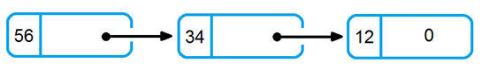

**The required operations**

The operations to be supported by your calculator are:

* Quit (q)
* Addition (unsigned) (+)
* Pop-and-print (p)
* Duplicate (d)
* Shift right (r),
* Shift left (l),

The '+', 'r' and 'l' operators each get 2 operands, and provide one result. The "duplicate" operator takes one operand and provides two results - duplicates of its input operand. Note that all operands are implicit, i.e. they are popped from the stack, and not specified in the command line. The result(s) is pushed onto the stack.  
Pop-and-print takes one operand, and provides no result. It just prints the value of the operand to the standard output in **decimal**, as ASCII characters, of course (e.g. BCD value of 00100011 in memory will be printed as '23'). 'p' print the prefix **">>"**, no **">>calc:"** (see example below).  
The 'r' and 'l' operators, work as follows. They both need two operands, the top of stack (TOS), which we call k, and the next from the TOS, which we call n. For both operators, if k is greater than 99, print an error **"Error: exponent too large"**, and abort the operation. Otherwise, do the following computation (removing the 2 elements from the stack, and pushing the result onto the stack): Executing 'r' computes (n **/** 2^k). Executing 'l' computes (n **\*** 2^k).  
  
**Tip:**

You may want to use the 'daa' instruction (see NASM manual) to help you do the addition in BCD. While you do not have to use this instruction, it may simplify your work considerably if you understand it…

You may want to execute print after dup in order to print the top value of the stack.

(Note that the values that appear in stack at the picture are represented at BCD notation)

* 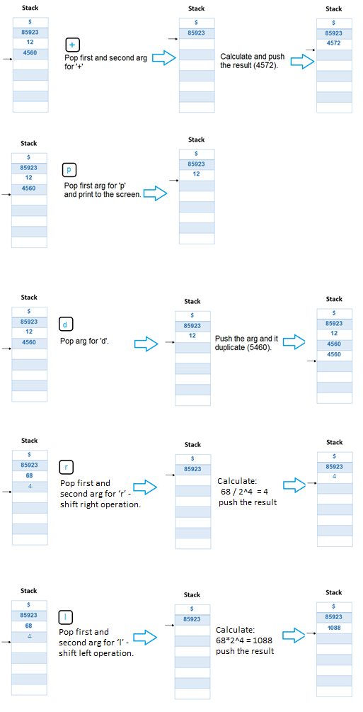

**Run example**

An example of user input and program output appears below. Comments (which will not appear in input or output) are preceded by ";". The calculator prompt to the user is "calc: "

>>calc: 9     ; user inputs a number  
>>calc: 1      ; user inputs another number  
>>calc: d      ; user enters "duplicate" operator  
>>calc: p      ; user enters pop-and-print-operator  
>>1  
>>calc: +      ; user enters "addition" operator, 10 is in top of (and is the sole element in) stack right after  
>>calc: d  
>>calc: p  
>>10  
>>calc: 23      ; user enters another number 23  
>>calc: +  
>>calc: d  
>>calc: p  
>>33            ; the sum  
>>calc: +  
>>**Error: Insufficient Number of Arguments on Stack**  
>>calc: 24      ; user inputs a number  
>>calc: 2     ; user inputs a number  
>>calc: r      ; user enters shift right operator  
>>calc: p  
>>6      ; 24 / (2^2) = 6  
>>calc: p  
>>33  
>>calc: q      ; Quit calculator  
11      ; Number of operations performed

**Additional Requirements**

Modularity is a requirement in this assignment. Thus, calculator functions, as well as input and output functions, must be programmed as procedures (subroutines). Additionally, printout of results should use the C library function printf(), and getting a line by using gets() or fgets(). Your code will be written **entirely in assembly language**. The "main" program (that you also need to write in assembly language) calls my_calc that is your primary procedure, and prints out the number of operations performed by my_calc. (Note that my_calc should count and return that number). If the user enters "q" at any time during the run of the program, your program should exit gracefully, by having my_calc returning the total number of operations performed, and using RET to return to the "main" code (which should print out that number before exiting).

In addition, you should implement a command line "-d" debug option. Your printout should look exactly as indicated above, except when the "-d" option is set, in which case you can and should print out to stderr various debugging messages (as a minimum, print out every number read from the user, and every result pushed onto the operand stack).

**Desired Output:**

* A successful calculation should present no additional output.
* Pop-and-print should print out the top member of the stack.
* If an action results in a stack overflow, your program must print (without the quotes): "**Error: Operand Stack Overflow**"
* If an action requires more arguments than currently available in the stack, your program should print: "**Error: Insufficient Number of Arguments on Stack**"
* if exponent argument for shift right/left exceeds one byte size, your program should print: "**Error: exponent too large**"
* In any case, if an error occurs, your program must return the stack to its previous state (such as in a case when an action that requires 2 arguments fails because there is only one argument in the stack, etc).

**Prototypes for C functions you can use**

* void exit(int status) // use exit to end the program. **NOT sys_exit!**
* char *fgets(char *str, int n, FILE *stream) // use fgets(buffer, BUFFERSIZE , stdin) to read from standard input
* int fprintf(FILE *stream, const char *format, arg list …) // use fprintf(stderr, …) to print to standard error (usually same as stdout)
* int printf(char *format, arg list …)
* void* malloc(size_t size) // size_t is unsigned int for our purpose
* void free(void *ptr)
* If you use those functions the beginning of your text section will be as follows (no _start label):

     extern exit  
     extern printf  
     extern fprintf  
     extern malloc  
     extern free  
     extern fgets  
     extern stderr  
     extern stdin  
     extern stdout  
  
section .text

     align 16  
     global main

main:  
      … ; your code

* Declare a label "main:" and "global main" in your assembly program.
* Declare "extern printf, extern malloc" and "extern fgets" so you will be able to use those functions in the program. Note that you also need to declare as extern the appropriate FILE pointers, such as stdin, so that you can provide them to fgets( ), etc.
* Compile and link your assembly file calc.s as follows:

nasm -f elf calc.s -o calc.o  
gcc -m32 -Wall -g calc.o -o calc

Note: a C source file is not needed, but you are using C standard library so you need a global label "main" as shown above. Gcc will link external C library functions to your assembly program.

**Assumptions and Minor requirements**

* You may assume that the number entry format is correct.
* Each input line is no more than 80 characters in length, with the operator and/or number beginning as the first character of the line.
* Use **exit** function of c library, when exiting the program.
* The program output, including **Errors**, should be printed to stdout. stderr will be used for the debugger output.

**Submission Instructions**

You are to submit a report