PROJECT REPORT
(Project Term January–May 2026)
AI APPLIANCE RECOMMENDER CHATBOT

Submitted by

Hrishikesh – Registration No: 12400528
Arun Prashath – Registration No: 12418280

Course Code: INT428
Under the Guidance of
Mentor Name: Tarun Singh

SCHOOL OF COMPUTER SCIENCE AND ENGINEERING

DECLARATION

We hereby declare that the project work entitled “AI Home Appliance Recommender Chatbot” is an authentic record of our own work carried out during the 2nd year as a part of the requirements for B.Tech in Computer Science and Engineering at Lovely Professional University, under the guidance of Mr. Tarun Singh. All the information furnished in this project report is based on our own work and is genuine to the best of our knowledge.

Name of Student 1: Hrishikesh R
Registration Number: 12400528
Name of Student 2: Arun Prashath
Registration Number: 12418280

CERTIFICATE

This is to certify that the declaration statement made by this group of students is correct to the best of my knowledge and belief. They have completed this Project under my guidance and supervision. The present work is the result of their original investigation, effort and study. No part of the work has ever been submitted for any other degree at any University.

ACKNOWLEDGEMENT

We sincerely thank our mentor for continuous guidance, technical support, and encouragement throughout this project. We also acknowledge Lovely Professional University for providing the necessary infrastructure and learning environment. Lastly, we thank each other for our teamwork, collaboration, and effort in completing this project successfully.

TABLE OF CONTENTS
1. INTRODUCTION 7
Objectives: 7
2. PROFILE OF THE PROBLEM 7
2.1 Problem Statement 7
2.2 Rationale 8
2.3 Scope 8
2.4 Limitations 8
3. EXISTING SYSTEM 8
3.1 Introduction 8
3.2 Existing Tools 8
3.3 DFD for Present System (Textual Explanation) 8
3.4 Drawbacks 9
3.5 Proposed System 9
4. PROBLEM ANALYSIS 9
4.1 Product Definition 9
4.2 Feasibility Analysis 9
4.3 Project Plan 10
5. SOFTWARE REQUIREMENT ANALYSIS 10
5.1 Introduction 10
5.2 General Description 10
5.3 Functional Requirements 10
5.4 Non-Functional Requirements 10
6. DESIGN 10
6.1 System Design 10
6.2 How Chatbot Works (NLP Flow) 11
6.3 Detailed Design 11
6.4 FLOWCHART (TEXTUAL EXPLANATION) 12
6.5 PSEUDOCODE 13
7. TESTING 14
7.1 Functional Testing 14
7.2 Structural Testing 14
7.3 Levels of Testing 14
7.4 Testing Scenarios 14
8. IMPLEMENTATION 14
8.1 Technologies Used 14
8.2 Implementation Details 14
8.3 Conversion Plan 15
8.4 Maintenance 15
9. PROJECT LEGACY 15
9.1 Current Status 15
9.2 Improvements 15
9.3 Lessons Learned 15
10. USER MANUAL 15
11. SOURCE CODE / SYSTEM SNAPSHOTS 16
11.1 Source code 16
11.2 Snapshots 25
12. BIBLIOGRAPHY 28

1. INTRODUCTION
Artificial Intelligence (AI) has significantly transformed decision-making systems by enabling machines to analyze user preferences and provide intelligent recommendations. Recommendation systems are widely used in e-commerce, entertainment platforms, and digital assistants. These systems reduce user effort by filtering large datasets and presenting only relevant options.
Chatbots are conversational interfaces that allow users to interact with systems in natural language. With the integration of Natural Language Processing (NLP), chatbots can understand user intent and respond intelligently. Modern applications increasingly rely on chatbots to provide personalized services.
The AI Appliance Recommender Chatbot combines both technologies. It allows users to input their requirements (e.g., budget, appliance type, features) in natural language and receive personalized recommendations.

Objectives:

- To design an intelligent chatbot capable of understanding user queries.
- To recommend appliances based on user preferences using logical or AI-based filtering.
- To simplify the decision-making process for users.
- To provide a scalable system that can be extended to multiple product categories.

2. PROFILE OF THE PROBLEM

2.1 Problem Statement
Selecting appliances like washing machines or refrigerators is challenging due to:
- Large number of available products
- Complex technical specifications
- Lack of personalized guidance
Users often rely on manual filters or reviews, which is time-consuming and inefficient.

2.2 Rationale
An AI chatbot can:
- Understand user needs conversationally
- Filter products intelligently
- Provide quick and relevant suggestions
This reduces cognitive load and improves user experience.

2.3 Scope
- Supports appliance recommendation (washing machines, refrigerators, etc.)
- Can be extended to e-commerce integration
- Can include ML models for advanced personalization

2.4 Limitations
- Depends on dataset quality
- Limited understanding of ambiguous queries
- Requires continuous updates for better accuracy

3. EXISTING SYSTEM

3.1 Introduction
Existing systems mainly rely on static filtering or recommendation algorithms without conversational interaction.

3.2 Existing Tools
- E-commerce filters (Amazon, Flipkart)
- Rule-based recommendation engines
- Collaborative filtering systems

3.3 DFD for Present System (Textual Explanation)
- User inputs search filters manually
- System retrieves products from database
- Results are displayed without personalization

3.4 Drawbacks
- No conversational interaction
- Requires manual filtering
- Limited personalization

3.5 Proposed System
- Chatbot interface
- NLP-based query understanding
- Dynamic recommendation logic

4. PROBLEM ANALYSIS

4.1 Product Definition
A chatbot that interacts with users and recommends appliances based on preferences such as:
- Budget
- Brand
- Features

4.2 Feasibility Analysis
- Technical Feasibility
- Python, NLP libraries available
- APIs can be integrated
- Economic Feasibility
- Low development cost
- Open-source tools used
- Operational Feasibility
- Easy to use chatbot interface
- Minimal user training required

4.3 Project Plan
- Requirement Analysis
- System Design
- Development
- Testing
- Deployment

5. SOFTWARE REQUIREMENT ANALYSIS

5.1 Introduction
Defines system requirements for development.

5.2 General Description
The system takes user input and provides recommendations via chatbot.

5.3 Functional Requirements
- Accept user input
- Process input using NLP
- Generate recommendations
- Display results

5.4 Non-Functional Requirements
- Fast response time
- User-friendly interface
- Reliable performance

6. DESIGN

6.1 System Design

The system follows a modular architecture consisting of three main components: User Interface (UI), NLP Processing Module, and Recommendation Engine. The user interacts with the chatbot through a Streamlit-based interface. The input is passed to the backend where Natural Language Processing techniques are applied to extract meaningful information.
The extracted parameters such as budget, family size, machine type, and load type (Top Load / Front Load) are then sent to the recommendation engine. The engine filters and ranks products from the dataset using predefined logic. Finally, results are displayed along with an AI-generated explanation and a detected filter summary showing the user what the chatbot understood.
System Flow:
User → Chat Interface → NLP Processing → Feature Extraction → Recommendation Engine → Ranking → Output Display

6.2 How Chatbot Works (NLP Flow)
Data Flow Diagram (DFD – Level 0)
The system consists of one main process: the chatbot system. The user provides input in natural language, which is processed by the system. The system interacts with the dataset and returns recommended products.
Flow:
User → Chatbot System → Product Dataset → Recommended Output
Data Flow Diagram (DFD – Level 1)
At a detailed level, the chatbot system is divided into multiple processes:
- Input Processing – Accepts user query
- NLP Module – Extracts intent and entities
- Recommendation Engine – Filters and ranks products
- Response Generator – Generates explanation using AI

6.3 Detailed Design
1. Input Processing Module
This module captures user input and converts it into lowercase text for uniform processing. It ensures that different input formats are handled consistently.
2. NLP Module
The NLP module uses regular expressions and keyword matching to extract important details:
- Budget (e.g., “under 20000”, “15k”)
- Family size (e.g., “family of 4”)
- Machine type (fully automatic/semi automatic)
- Load type (Top Load / Front Load) – detected using an expanded keyword list including variations such as “top-load”, “topload”, “top loading”, “top loader”, “front-load”, “frontload”, “front loading”, and “front loader”
This structured data is then passed to the recommendation engine.
3. Recommendation Engine
This is the core module of the system. It performs:
- Filtering: Based on price, capacity, and type
- Capacity Mapping: Converts family size into washing capacity
- Scoring: Products are ranked using a weighted formula
Example scoring logic:

Score = (Ratings * 0.6) + (1/Price * 20000) + (Capacity Score * 0.4)
- This ensures that highly rated, affordable, and suitable products are prioritize
4. Response Generation Module
After selecting top products, the system generates a user-friendly explanation using an AI model (Groq API with LLaMA 3.1 as primary, Ollama as local fallback). This makes recommendations more understandable and interactive. Additionally, the UI displays a “What I Understood” section that summarises the detected filters (load type, machine type, budget, family size) so the user can verify the chatbot interpreted their query correctly.

6.4 FLOWCHART (TEXTUAL EXPLANATION)
- Start
- User enters query
- Extract details using NLP (budget, family size, machine type, load type)
- Check if sufficient data available
  - If No → Ask user for more input
  - If Yes → Proceed
- Apply filters on dataset (price, capacity, machine type, load type)
- Rank products using scoring logic
- Generate AI response
- Display recommendations with load type / machine type badges and detected filter summary
- End

6.5 PSEUDOCODE

START
INPUT user_query
# Step 1: Extract details
budget, family, machine_type, load_type = extract_details(user_query)
IF family is NULL:
RETURN "Please specify family size"
# Step 2: Convert family to capacity
capacity = family_to_capacity(family)
# Step 3: Filter dataset
filtered_data = filter_products(dataset, budget, capacity, machine_type, load_type)
IF filtered_data is empty:
RETURN "No matching products found"
# Step 4: Rank products
ranked_products = sort_by_score(filtered_data)
# Step 5: Generate explanation
response = generate_ai_response(user_query, ranked_products)
DISPLAY ranked_products
DISPLAY response
END

7. TESTING

7.1 Functional Testing
- Input valid queries → correct output
- Input invalid queries → handled properly

7.2 Structural Testing
- Code logic tested module-wise

7.3 Levels of Testing
- Unit Testing: Individual modules
- Integration Testing: Combined modules
- System Testing: Full system

7.4 Testing Scenarios
- Budget-based query (e.g., “washing machine under 15000 for 4 people”)
- Load type query (e.g., “top load washing machine under 20000” or “front loader for family of 3”)
- Invalid input handling
Results
System correctly recommends appliances with acceptable response time.

8. IMPLEMENTATION

8.1 Technologies Used
- Python
- NLP libraries (NLTK/spaCy)
- Pandas for data handling
- Flask (optional backend)

8.2 Implementation Details
- Dataset stored in structured format
- Input processed via NLP
- Filtering logic applied
- Output displayed via chatbot

8.3 Conversion Plan
- Replace manual filtering with chatbot

8.4 Maintenance
- Update dataset
- Improve NLP accuracy

9. PROJECT LEGACY

9.1 Current Status
Working prototype developed

9.2 Improvements
- Add ML model
- Add more appliances
- Improve UI

9.3 Lessons Learned
- Importance of NLP
- Handling real-world data
- Team coordination

10. USER MANUAL
- Start application
- Enter query (e.g., “Budget 30k washing machine”)
- Chatbot processes input
- Recommendations displayed

11. SOURCE CODE / SYSTEM SNAPSHOTS

11.1 Source code
import streamlit as st
import pandas as pd
import re
import requests

# ADD YOUR GROQ KEY
GROQ_API_KEY = "your_groq_api_key_here"

df = pd.read_csv("cleaned_washingmachine.csv")

# -------------------------------
# AI RESPONSE
# -------------------------------
def generate_ai_response(user_input, recs):
recs_text = ""
for _, row in recs.iterrows():
recs_text += f"{row['Product Name']} (Rs.{int(row['Price'])}, Rating: {row['Ratings']})\n"

prompt = f"""
You are a smart shopping assistant.
User request: {user_input}
Recommended products:
{recs_text}
Rules:
- Only consider products that match user type (top load / front load / fully automatic / semi automatic)
- Explain briefly why they match
- Keep response short (4-5 lines)
"""

# GROQ (Primary)
try:
from groq import Groq
client = Groq(api_key=GROQ_API_KEY)
response = client.chat.completions.create(
model="llama-3.1-8b-instant",
messages=[{"role": "user", "content": prompt}]
)
return response.choices[0].message.content
except Exception as e:
print("Groq failed:", e)

# OLLAMA (Local Fallback)
try:
response = requests.post(
"http://localhost:11434/api/generate",
json={"model": "llama3", "prompt": prompt[:2000], "stream": False}
)
return response.json()['response']
except Exception as e:
print("Ollama failed:", e)

return "AI unavailable."

# -------------------------------
# INPUT PROCESSING (NLP ENGINE)
# -------------------------------
def extract_details(text):
text = text.lower()
budget = None
family = None
machine_type = None
load_type = None
min_price = None
max_price = None

# Price extraction
match = re.search(r'between (\d+) and (\d+)', text)
if match:
min_price = int(match.group(1))
max_price = int(match.group(2))

match = re.search(r'under\s*(\d+)', text)
if match:
budget = int(match.group(1))

match = re.search(r'(\d+)k', text)
if match:
budget = int(match.group(1)) * 1000

if "cheap" in text or "budget" in text:
budget = 15000

# Family size extraction
match = re.search(r'(\d+)\s*(people|members|persons)', text)
if match:
family = int(match.group(1))

match = re.search(r'family of (\d+)', text)
if match:
family = int(match.group(1))

if "small family" in text:
family = 2
elif "medium family" in text:
family = 4
elif "large family" in text:
family = 6

# Machine type extraction
if "fully automatic" in text:
machine_type = "Fully Automatic"
elif "semi automatic" in text:
machine_type = "Semi Automatic"

# Load type extraction (improved - detects multiple variations)
top_load_keywords = [
"top load", "top-load", "topload",
"top loading", "top-loading",
"tl ", " tl", "top loader"
]
front_load_keywords = [
"front load", "front-load", "frontload",
"front loading", "front-loading",
"fl ", " fl", "front loader"
]

for keyword in top_load_keywords:
if keyword in text:
load_type = "Top Load"
break

if load_type is None:
for keyword in front_load_keywords:
if keyword in text:
load_type = "Front Load"
break

best = "best" in text or "top rated" in text or "top-rated" in text

return budget, family, machine_type, min_price, max_price, best, load_type

def family_to_capacity(family):
if family <= 2:
return 6
elif family <= 4:
return 7
else:
return 8

# -------------------------------
# RECOMMENDATION ENGINE
# -------------------------------
def recommend(df, budget, capacity, machine_type=None, min_price=None,
max_price=None, best=False, load_type=None):
filtered = df.copy()

if min_price and max_price:
filtered = filtered[
(filtered['Price'] >= min_price) &
(filtered['Price'] <= max_price)
]
elif budget:
filtered = filtered[filtered['Price'] <= budget]

filtered = filtered[filtered['Washing Capacity'] >= capacity]

if machine_type:
filtered = filtered[
filtered['Function Type'].str.contains(machine_type, case=False, na=False)
]

# Load type filter (strict - returns empty if no match)
if load_type:
filtered = filtered[
filtered['Function Type'].str.contains(load_type, case=False, na=False)
]
if filtered.empty:
return pd.DataFrame()

filtered = filtered.drop_duplicates(subset=['Model Name'])

if filtered.empty:
return pd.DataFrame()

filtered['Capacity Score'] = 1 / (abs(filtered['Washing Capacity'] - capacity) + 1)
filtered['Score'] = (
filtered['Ratings'] * 0.6 +
(1 / filtered['Price']) * 20000 +
filtered['Capacity Score'] * 0.4
)

if best:
filtered = filtered.sort_values(by='Ratings', ascending=False)
else:
filtered = filtered.sort_values(by='Score', ascending=False)

return filtered.head(6)[['Product Name', 'Price', 'Ratings', 'Product_Url', 'Function Type']]

def chatbot_recommendation(df, text):
budget, family, machine_type, min_price, max_price, best, load_type = extract_details(text)

if family is None:
return None, None, None

capacity = family_to_capacity(family)
recs = recommend(df, budget, capacity, machine_type, min_price, max_price, best, load_type)
ai_response = generate_ai_response(text, recs)

# Build detected filters summary for UI display
detected = []
if load_type:
detected.append(f"Load Type: {load_type}")
if machine_type:
detected.append(f"Type: {machine_type}")
if min_price and max_price:
detected.append(f"Budget: Rs.{min_price:,} - Rs.{max_price:,}")
elif budget:
detected.append(f"Budget: under Rs.{budget:,}")
if family:
detected.append(f"Family Size: {family} people -> {family_to_capacity(family)} kg+")

return recs, ai_response, detected

# -------------------------------
# UI
# -------------------------------
st.set_page_config(page_title="AI Washing Machine Recommender", page_icon="[basket]")
st.title("[basket] AI Washing Machine Recommender")
st.markdown("### Tell me what you need")

st.info(
"Example queries:\n"
"- Top load washing machine under 15000 for 3 people\n"
"- Front load fully automatic for family of 4\n"
"- Best semi automatic under 20k for large family"
)

with st.form("form"):
user_input = st.text_input("Describe what you want:")
submit = st.form_submit_button("Get Recommendations")

if submit:
if user_input.strip() == "":
st.warning("Please enter something")
else:
with st.spinner("Finding best options..."):
recs, ai_text, detected = chatbot_recommendation(df, user_input)

# Show detected filter summary
if detected:
st.markdown("---")
st.markdown("### What I Understood From Your Query")
cols = st.columns(len(detected))
for i, item in enumerate(detected):
cols[i].markdown(item)

if recs is None or recs.empty:
st.warning("No exact matching products found. Try relaxing filters.")
else:
st.success(f"Found {len(recs)} matching products")
st.markdown("### AI Recommendation Summary")
st.write(ai_text)
st.markdown("---")
st.markdown("### Recommended Products")

for _, row in recs.iterrows():
with st.container():
st.subheader(row['Product Name'])
func_type = str(row.get('Function Type', ''))
if func_type and func_type != 'nan':
if "Top Load" in func_type:
st.markdown("Top Load")
elif "Front Load" in func_type:
st.markdown("Front Load")
if "Fully Automatic" in func_type:
st.markdown("Fully Automatic")
elif "Semi Automatic" in func_type:
st.markdown("Semi Automatic")
st.write(f"Price: Rs.{int(row['Price'])}")
st.write(f"Rating: {row['Ratings']}")
st.markdown(f"[View Product]({row['Product_Url']})")
st.write("---")

11.2 Snapshots
- Chat interface
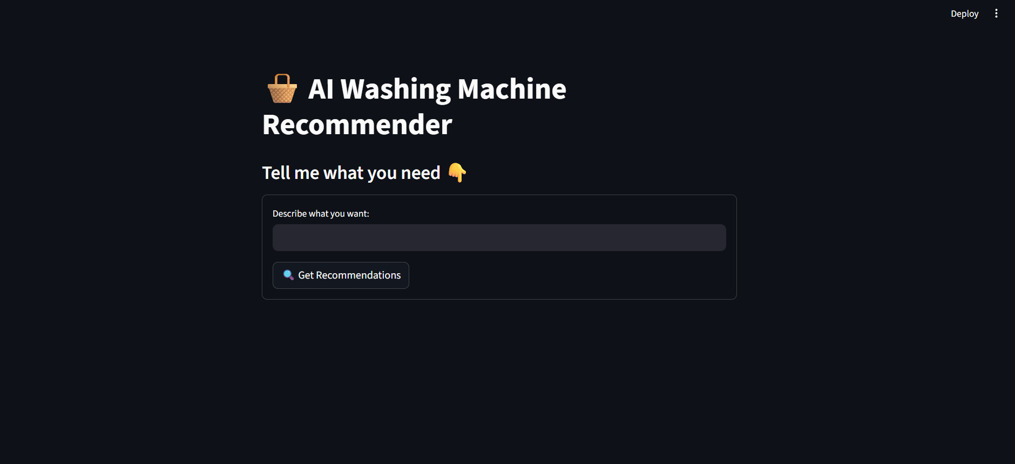

- Recommendation results

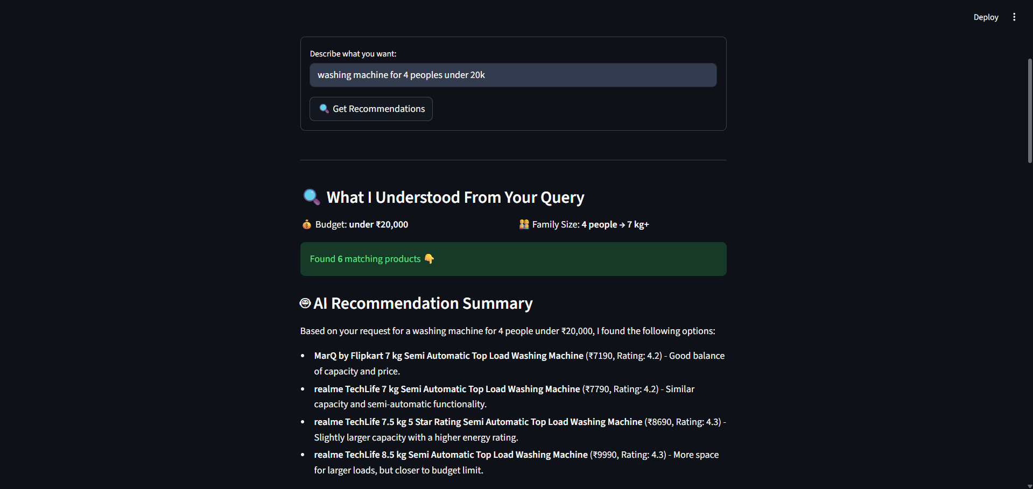
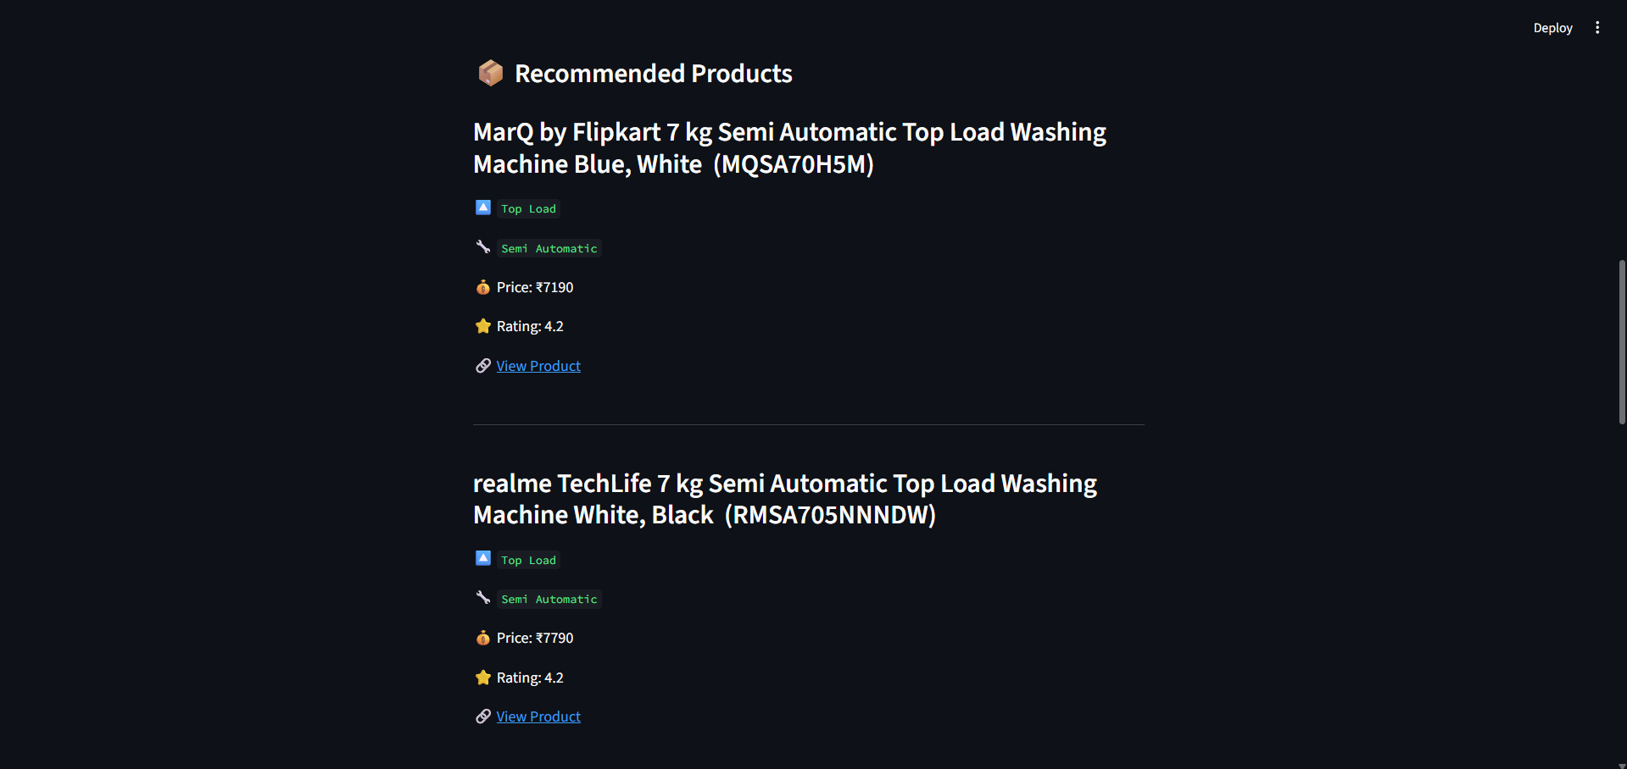
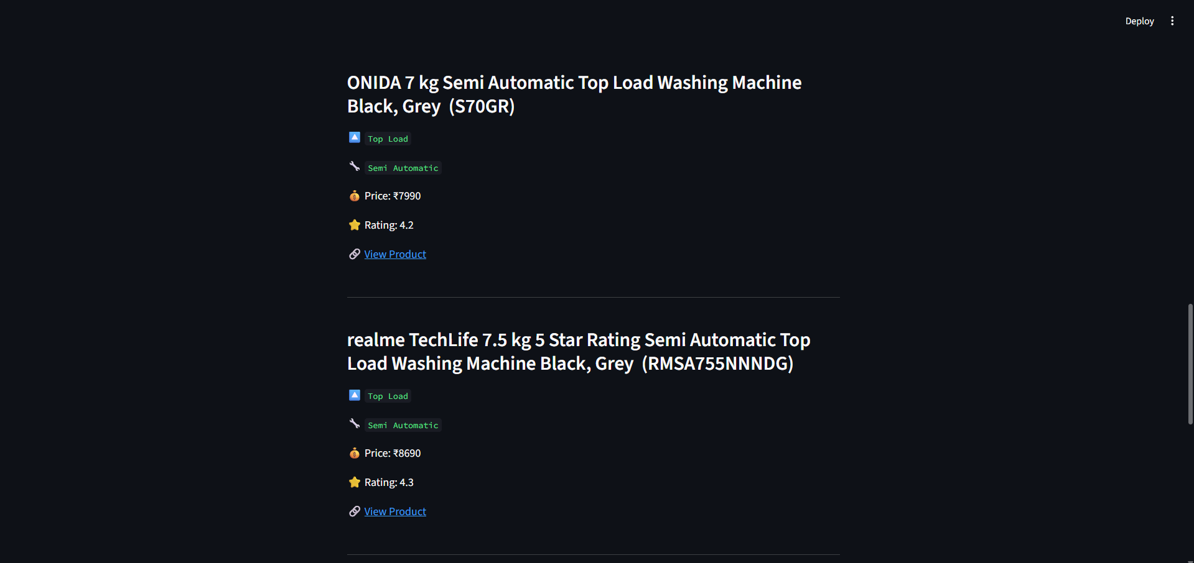
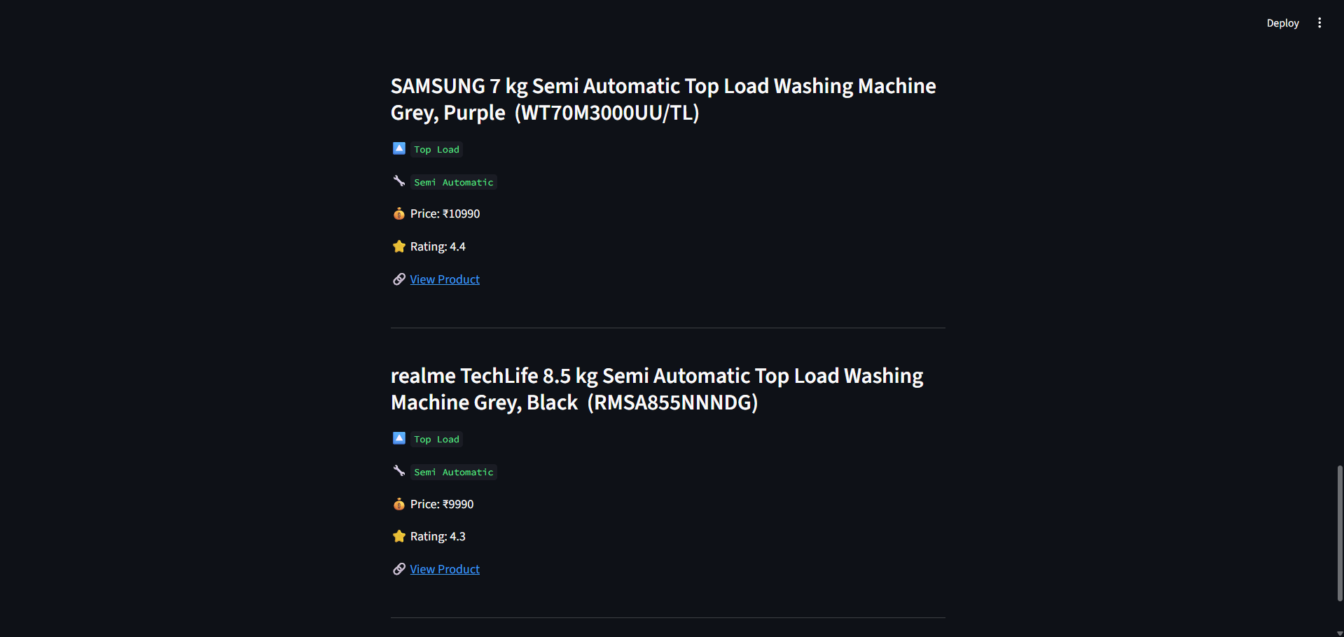

- Dataset view
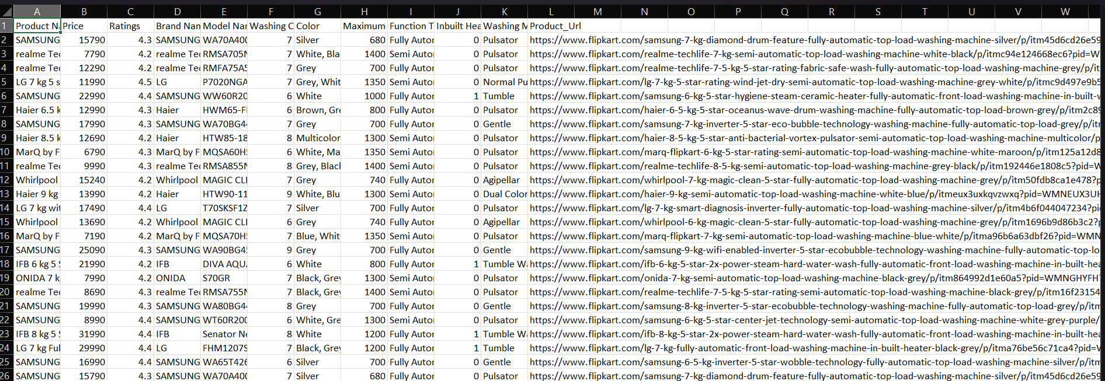

12. BIBLIOGRAPHY
- [1] Russell, S., & Norvig, P. (2020). Artificial Intelligence: A Modern Approach (4th ed.). Pearson Education.
- [2] Bird, S., Klein, E., & Loper, E. (2009). Natural Language Processing with Python: Analyzing Text with the Natural Language Toolkit. O'Reilly Media. Retrieved from https://www.nltk.org/book/
- [3] Honnibal, M., & Montani, I. (2017). spaCy 2: Natural language understanding with Bloom embeddings, convolutional neural networks and incremental parsing. spaCy Documentation. Retrieved from https://spacy.io/
- [4] Ricci, F., Rokach, L., & Shapira, B. (2015). Recommender Systems Handbook (2nd ed.). Springer.
- [5] Adomavicius, G., & Tuzhilin, A. (2005). Toward the next generation of recommender systems: A survey of the state-of-the-art and possible extensions. IEEE Transactions on Knowledge and Data Engineering, 17(6), 734–749. https://doi.org/10.1109/TKDE.2005.99
- [6] Zhang, S., Yao, L., Sun, A., & Tay, Y. (2019). Deep learning based recommender system: A survey and new perspectives. ACM Computing Surveys, 52(1), 1–38. https://doi.org/10.1145/3285029
- [7] Koren, Y., Bell, R., & Volinsky, C. (2009). Matrix factorization techniques for recommender systems. IEEE Computer, 42(8), 30–37. https://doi.org/10.1109/MC.2009.263
- [8] Meta AI. (2023). LLaMA: Open and efficient foundation language models. Retrieved from https://ai.meta.com/llama/
- [9] Groq Inc. (2024). Groq API Documentation — LLaMA 3.1 Inference. Retrieved from https://console.groq.com/docs
- [10] McKinney, W. (2010). Data structures for statistical computing in Python. Proceedings of the 9th Python in Science Conference, 56–61. https://doi.org/10.25080/Majora-92bf1922-00a
- [11] Streamlit Inc. (2024). Streamlit Documentation — Build and share data apps. Retrieved from https://docs.streamlit.io/
- [12] Flipkart. (2024). Product listings — Washing machines. Retrieved from https://www.flipkart.com

