**Functional Specification Document**

**-**

**BetGame**

Table of contents

1. Login screen 4

2. Forgotten Password 4

3. Registration screen 5

3.1 Required information: 5

3.2 Optional Information: 5

4. User home 6

4.1 Menu items: 6

4.2 Tickets 6

5. Creating a new game 7

5.1 Name of the game 7

5.2 Tournament type 7

5.3 Groups and teams 7

5.4 Fixtures 8

5.5 Rules 9

5.6 Attendees 9

5.7 Define Custom tournament type 10

6. Notification bar 11

7. Game portal – With user role 12

7.1 Tips for the next round 12

7.2 Game standings 12

7.3 Standings of the tournament 13

7.4 The fixtures round by round 13

8 Game portal – With Admin role 14

8.1 Opening screen 14

8.2 Content switching 14

8.3 Provide Match Results 14

8.4 Fixtures 15

Revision History

|  |  |  |  |
| --- | --- | --- | --- |
| Version | Date | Author | Description |
| 0.1 | 2014.07.15 | Geza Nagy | Document base |
| 0.2 | 2014.07.30 | Geza Nagy | Continued |
| 1.0 | 2014.08.17 | Geza Nagy | v1.0 |
|  |  |  |  |

# Login screen

This is the first site what the user can see. The only content of this site is a traditional login form which has two inputs: Username and password.

With this information the application identifies the user and after the “Login” texted button. If the given credential is valid, the controller behind the front end forwards him/her to the home screen which belongs to him/her.

There are two other item on the login screen. A link for registration which shows a modal with the purpose of gathering information of the user who want to join the site.

The other is also a reference for sending a reminder email if the already registered user has forgotten his/her password.

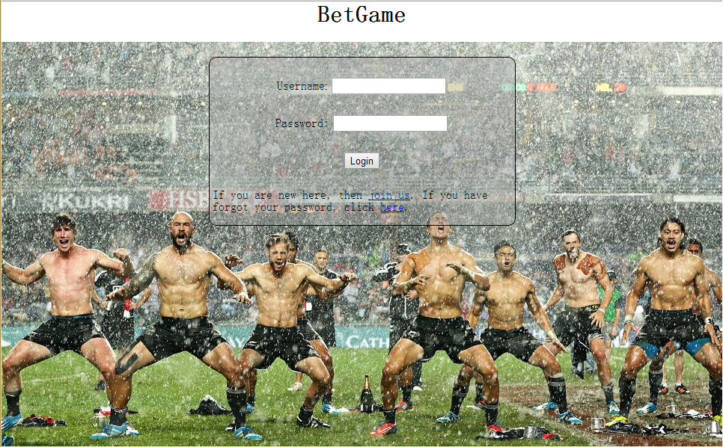

# Forgotten Password

It’s a simple modal with an input text field, labels with instructions and a button.

The input field is for the e-mail the user provided at registration. When the user clicks the “Send Reminder” button, the application send an auto-generated message to the given e-mail and contains the password which belongs to the person who owns that e-mail address.

[TODO: Screen should be inserted here…]

# Registration screen

It is also a modal window which contains a form. This form collects the required and optional information about the user who want to register.

## 3.1 Required information:

* Nickname
* Password
* E-mail address
* The user accepts the “Privacy Policy” and the “Terms and Conditions” documents

## 3.2 Optional Information:

* Avatar

The password field requires confirmation. For this there must be a plus one input for confirmation, and the registration form has to validate that the two text field has the same value. The password field is not a traditional text field but a password type input. The e-mail address must be checked if it’s already registered by an existing user. Every field except the avatar is required and if the user want to register without giving these data the post must fail and the missing fields have to be highlighted.

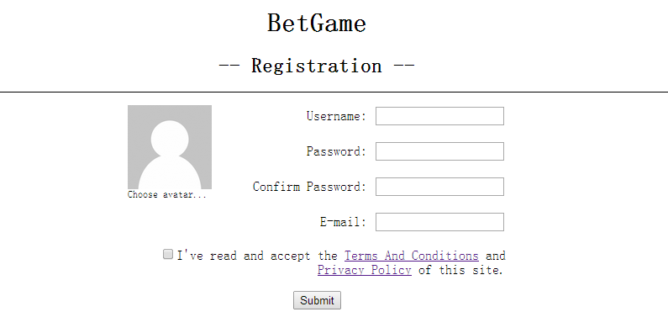

# User home

The user home is basically a dashboard. There is a menu with items for navigation, a dashboard with fancy tickets and a notification bar. Every ticket symbolize a game where the user is registered and one more special ticket for create a new game. The notification bar placed next to the ticket panel and contains the latest news and invitations related to the games the user are involved.

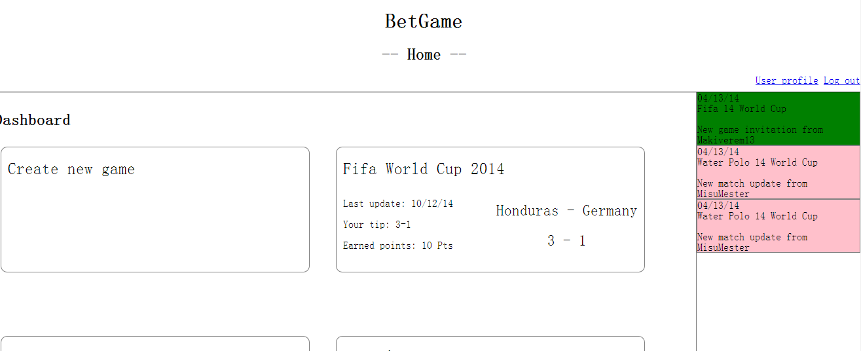

## 4.1 Menu items:

* Profile settings
* Logout



## 4.2 Tickets

The dashboard contains at least one ticket. This ticket titled with “Create new Game” is special from the point of view:

* It’s not contains game specific information
* Redirects to the create new game form instead of the specific game’s portal

The other tickets are belong to games the user attended or created. By clicking on one of these boxes the application redirects to the game portal user or admin view depends on the logged in user is the owner or not. It’s important these boxes contains information about what happened last with the game:

* The date of last update
* The user’s tip if there was any
* The result of the tip
* Match details: teams, result

# Creating a new game

Creating a game is maybe the most complicated part of the application. The admin has to configure the whole game step by step. Must note here that almost everything will be editable till the tournament begins.

User has to define the followings:

* Name of the game
* Tournament type
* List of the teams and the groups
* Fixtures
* Rules
* Additional questions beside the rules
* Attendees

## 5.1 Name of the game

It’s a simple text box. What has defined here by the admin will show for every user who attends the game when everything happens under the tournament. On the game ticket or the notification bar.

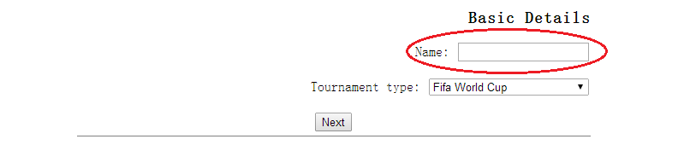

## 5.2 Tournament type

It’s an important from the flow’s perspective. This is a simple drop down where the user can choose from the basic concepts taken from international tournaments/leagues. This defines the number of groups and teams, the fixtures.

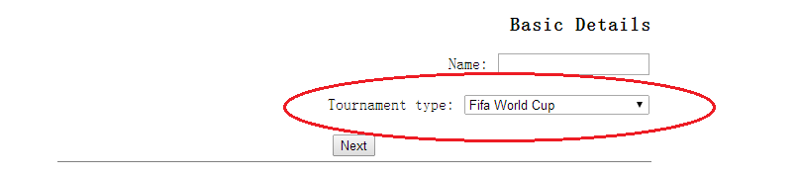

## 5.3 Groups and teams

Depends on the previous step the groups have to be visible here. Every group has an input text field by default reserved for a team name placed in that group. When the user has entered a team name and press the Enter button, the input is going to switch to a label and another text field will be shown below if the group hasn’t reached the maximum number of participants. The user can modify an already given name by clicking on it twice and the label transforms to an editable field. Necessary to check there should be no duplication among the team names.

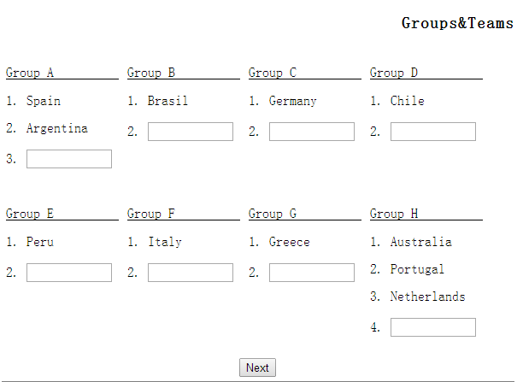

## 5.4 Fixtures

First of all what should be checked here by the user is the pairings round by round. The specific turn can be chosen by a drop down. After the user selected an option it shows the matches generated by the system. Every pairing is fully editable. The opponents can be modified by a drop down which contains the teams from the specific group if we are speaking of group stage, or if we are in knock out there are keywords which identify the very team by the result of the previous turn. To make this easy to handle and understand tooltips are placed over these keywords. If it’s good/done then come the date of the matches. For simplify this there are date pickers for all the inputs. At one time only one round’s matches are shown.

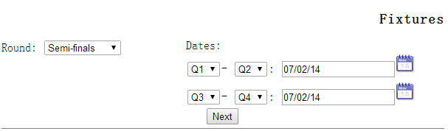

## 5.5 Rules

Two types of rules have been defined. There are predefined- and custom user defined ones. For the application given rules have to be extended only with the scores they worth. These are basically can be count from the result of the match. For the custom ones have to be defined a question beside the score. This question will be asked from the user match by match and the answer must be chosen from a list. This list contains the all the answers provided by the players. Every predefined rule has a checkbox checked by default and the user can choose which one would be kept. The custom ones can be removed by the remove button which appears when the cursor is over the line of the specific rule.

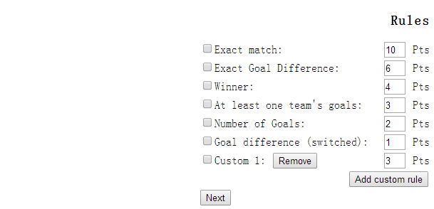

## 5.6 Attendees

This section has two part. One is a text input/button combo where the user can add new attendee. When He/she pushes the button, there must be a check if it’s a valid user name. Nice to have feature is to be an autocomplete function which advice names while the user is typing. If the addition is successful, a tag has to be shown represents the player will be invited into the game. If the user want to remove an invite he needs only to click on the ‘X’ inside the specific tag. In addition if the user move the cursor over a tag a tooltip will be shown which contains information of the latest games of the player.

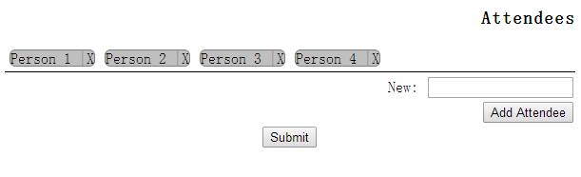

## 5.7 Define Custom tournament type

Not included in v1.0

# Notification bar

The notification bar get visible when the user log in. It’s placed in the right side of the screen and remains there till the user log out. Two basic functionality this bar has to serve. First of all it shows notifications from the games the user attended.

This messages can be the followings:

* Invite for a new game
* Anything what the Admin did on a game the user attended (match results given, fixture changes, etc.)
* Warning to make the tips for the matches coming

These notifications are in a descending order by submit date. This bar paginated if there are so much messages. Each notification can be removed by an x icon in their top right corner. A message contains its submission date, the game it belongs to, the submitter and a unique message for every kind of the types it can be. Every message type has a specific color.

The second functionality is navigation. When the user clicks on it, the site must forward the control to the specific site to the specific part which is referred by the target notification.

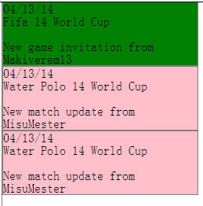

# Game portal – With user role

The game portal shows everything what the user should see about a game:

* Tips for the next round
* Game standings
* Standings of the tournament
* The fixtures round by round

This items are showed in an accordion by default the first section is visible: The tips to go. The notification bar is also visible on the right side.

## Tips for the next round

This section is showed in the same time with the game standings table. In this part the user can administrate his tips for the next round of the tournament. Every match is in a separate line and these lines contains the specific match’s date, the deadline of the tip and two input field to provide the expected result of the match. Every tip has a Send button so the user can send the guesses on by one or the other option is the send all button below the list.

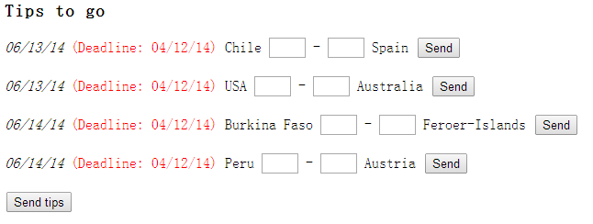

## Game standings

A simple table which automatically calculated by the app. Contains the standings of the betting game. The first column represents the place, the second is the name of the player and the third is the score earned by the players. The last section is evaluated by the achieved points match by match.

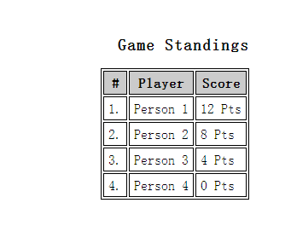

## Standings of the tournament

This is the part of the portal where the user can check the standings of the tournament. With the purpose of make it well visible the information is shown separately. There is a drop down where it can be selected which stage of the tournament we want to see: Groups, semifinals and so on. In the group stage there are also links for each group so only one group standing is visible at one time.

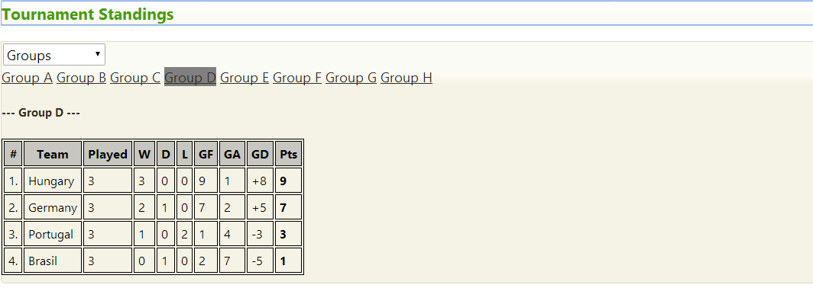

## The fixtures round by round

The last part of the game portal. This panel is simply shows the results of the matches round by round. The shown information of a match here is:

* The date of the match
* The opponents
* The result of the match
* The tip of the user
* The achieved points by the user

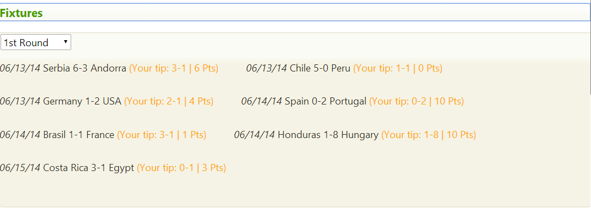

# Game portal – With Admin role

If the user owns the game he/she’s watching then the default view is this. The basic of the admin portal is the same as the user view but there are some other editable contents.

## 8.1 Opening screen

First of all when the user come to the page a modal greets him/her and contains the matches which are waiting for administration. Only those events are here which were in the past and the results should be known. Every match has its own send button to submit the inputs and there is a send all button below the list. This is an optional stage at this point so there is a “Later” button to postpone this administration task for another time.

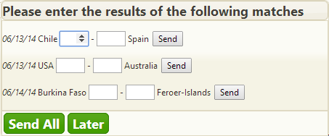

## 8.2 Content switching

The admin can also take part of the game and play with the others. To achieve this a switching button is placed just under the header and with this the user can change the admin view to the user one.

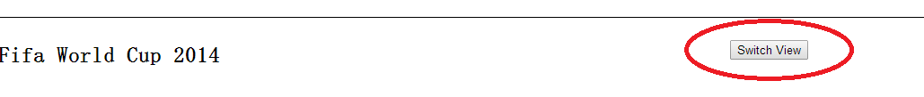

## 8.3 Provide Match Results

This part contains the same as the modal which greets the admin with two extension. First, the standings of the game is also visible here. Second, the custom questions the admin provided when the game created are can be answered here. All the answers the players texted are visible here and the correct ones can be chosen.

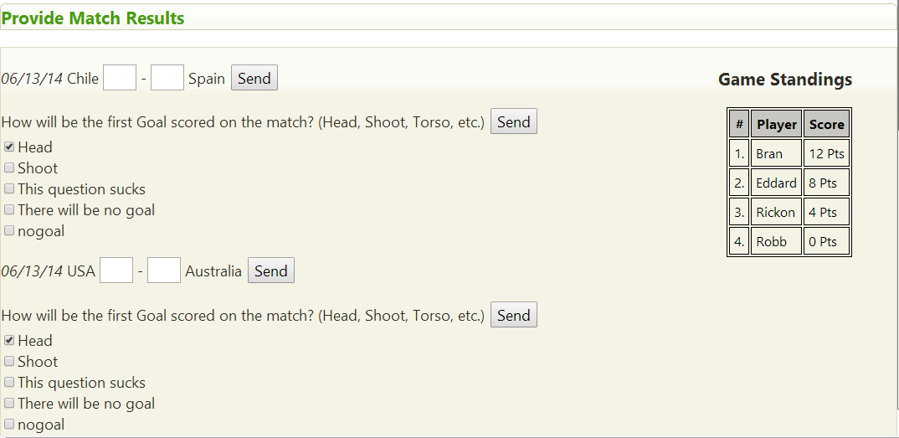

## 8.4 Fixtures

The fixtures part is also different. The dates are predefined input textboxes where the user can edit the actual date of the game. The chosen opponents for the game are also modifiable, from a drop down which contains the possible teams related to the chosen round and the other chosen team.

