

USER’S MANUAL

PiMyRide

David O’Regan - 10331017 Alan Kehoe - 10735389

22nd Of March 2013

Revision Sheet

Revision Sheet

|  |  |  |
| --- | --- | --- |
| Release No. | Date | Revision Description |
| Rev. 0 | 22/11/2012 | User’s Manual Template and Checklist |
| Rev. 1 | 05/02/2013 | Conversion to WORD 2007 format |
| Rev. 2 | 01/03/2013 | Spell Check & Punctuation |
|  |  |  |
|  |  |  |
|  |  |  |
|  |  |  |

# Welcome to the PiMyRide system. This manual is a tool we have provided for you (User) to familiarize your self with the product.

We hope you thoroughly enjoy using our system as much as we have enjoyed making it.

- David O’Regan & Alan Kehoe

PiMyRide USER'S MANUAL

TABLE OF CONTENTS

* 1. System Overview 1
  2. Project References 2
  3. Authorized Use Permission 2

along with this program. If not, se[e http://www.gnu.org/licenses](http://www.gnu.org/licenses) 2

* 1. Points of Contact 2
  2. Acronyms and Abbreviations 2
  3. Setting up your Pi 1
  4. Installing the Pi into the car 1
  5. Installing Manager (GUI) 2
  6. Booting 2
  7. Using logged data 2
  8. Trouble Shooting 3
  9. Launching 2
  10. Trouble Shooting 3

1.0 GENERAL INFORMATION

1.0 GENERAL INFORMATION

* 1. System Overview

## The PiMyRide system aims to do three things:

1. Log data from your car
2. Provide you with real-time feed-back via the LCD display
3. Graph & Trend your car’s stored data in the provided Log Manager Application

Summary System Breakdown:

The system comes divided into a few main parts.

* + [Raspberry Pi Model B](https://www.adafruit.com/products/998)
  + [Adafruit character LCD Plate](http://www.adafruit.com/products/1115)
* PiMyRide Logger Software
* PiMyRide Manager Software

This manual will cover the installation and use of the PiMyRide system in full.

* 1. Project References

[1] Alan Kehoe; [alankehoe111@hotmail.com](mailto:alankehoe111@hotmail.com) Project Creator [2] David O’Regan; [davidoregan91@gmail.com](mailto:davidoregan91@gmail.com) Project Creator [3] Brian Stone; [brian.stone@computing.dcu.ie](mailto:brian.stone@computing.dcu.ie) Project Supervisor

* 1. Authorized Use Permission

This program is free software: you can redistribute it and/or modify

it under the terms of the GNU General Public License as published by the Free Software Foundation, either version 3 of the License, or

(at your option) any later version.

This program is distributed in the hope that it will be useful,

but WITHOUT ANY WARRANTY; without even the implied warranty of MERCHANTABILITY or FITNESS FOR A PARTICULAR PURPOSE. See the

GNU General Public License for more details.

You should have received a copy of the GNU General Public License along with this program. If not, see <http://www.gnu.org/licenses>

* 1. Points of Contact

[1] Alan Kehoe; [alankehoe111@gmail.com](mailto:alankehoe111@gmail.com) Project Creator [2] David O’Regan; [davidoregan91@gmail.com](mailto:davidoregan91@gmail.com) Project Creator

* 1. Acronyms and Abbreviations

PiMyRide: The finished system name. Pi: The actual Raspberry Pi, model B.

LCD: The 16x16 character screen that is connected to the Pi.

GUI: The software application that was developed to manage the CSV data files. Trend: The performance of the car, as seen on a graph.

CSV: Comma separated variation. A data file, columns are separated by a comma or semi-colon.

2.0 GETTING STARTED (INSTALL)

2.0 GETTING STARTED

This section will take you through both the PiMyRide system set up and installation.

* 1. Setting up your Pi

To configure your system, please refer to the instillation guide provided:

<http://www.pimyride.com/?page_id=40>

* 1. Installing the Pi into the car

Now that your PiMyRide system is built, it needs to be installed into the car. First, locate your OBDII connection port and connect the OBDII cable (Image A)

connection into the car diagnostic (OBDII) port. (Please refer to 2.2.1 to locate your OBDII port)

Second, Please connect the power cord (Image B) into your cars cigarette lighter. Lastly, please place your PiMyRide system with the LCD screen in a location you

can clearly see. We recommend mounting the system to the dashboard.

**Please see manual end for picture reference

* + 1. [OBDII Port Location]

Please refer to this guide if you are unsure of your OBDII port location:

<http://www.outilsobdfacile.com/location-plug-connector-obd.php>

* + 1. [Confirm power & system operation]

With all the previous steps followed, please turn on your ignition and wait for a few seconds. If you followed the guide correctly, you should see the LCD screen light up.

Please study the LCD, if the figures for MPG & Speed begin to cycle, you have installed the system properly.

* 1. Installing Manager (GUI)

To install the PiMyRide manager, please identify your local operating system and refer to the relevant install i.e. Linux or Mac

2.3.1[Linux]

1. Please open your command prompt or terminal(Applications) and paste the following:

|  |  |
| --- | --- |
| 1  2  3 | **sudo** **apt-get update**  **sudo** **apt-get upgrade**  **sudo** **apt-get install** python-wxversion |

1. Install the PiMyRide Manager Application and happy logging!
   * <http://www.pimyride.com/?page_id=6>
     1. [Mac]

1) Please go to the wxpython site:

* Download this version of wxpython [wxPython2.9-osx-cocoa-py2.7](http://downloads.sourceforge.net/wxpython/wxPython2.9-osx-2.9.4.0-cocoa-py2.7.dmg)
* Mount the disk image (Double Click)

Open a terminal window and issue the following command

**sudo** installer -pkg **/**Volumes**/**wxPython2.9-osx-2.9.4.0-cocoa-py2.7**/**wxPython2.9-osx-cocoa-py2.7.pkg**/** -target **/**

3.0 USING THE LOGGER (Pi)

3.0 USING THE LOGGER (PI)

In this section we will cover the use of the actual hardware in the PiMyRide system. If you have not already installed the system into your car, please do this first before continuing. See section 2.2.

* 1. Booting

Once the system has been installed properly the PiMyRide logger will boot and start on ignition of the car, no manual operation is needed here.

* + 1. [Confirm data reading]

Now that the system is running, please direct your attention to the LCD screen, if the light is on and values are appearing, the system is in operation.

* 1. Using logged data

As you drive, the PiMyRide system will create a log file logging travel data. When you have completed your journey you will need to get your log files off your Raspberry Pi, Connect your Raspberry Pi to your local network and use an sftp client to transfer the files, [FileZilla](http://filezilla-project.org/) is an easy to use sftp and ftp client. The log files will be used next in conjunction with the PiMyRide Manager, see section 4.0.

* 1. Trouble Shooting

If you are experience some issues with your PiMyRide system, please refer to the section that most describes your issue below.

* + 1. [No Power to raspberry Pi]
       1. Please ensure you have correctly inserted the power cable.
       2. Please ensure your power cable is not damaged.

3) Please ensure your power cable is correctly wired.

* + 1. [No power to LCD]
       1. Please ensure your PiMyRide system has power.
       2. Please ensure your LCD is not damaged.
       3. Please ensure your LCD is attached to the system properly.
    2. [No values on LCD screen]
       1. Please ensure your PiMyRide system has power.
       2. Please ensure your OBDII cable is correctly inserted.
       3. Please ensure your OBDII cable/port is not damaged.
    3. [No log file being created]
       1. Please ensure your PiMyRide system has power.
       2. Please ensure your OBDII cable is correctly inserted.
       3. Please ensure your OBDII cable/port is not damaged.

4.0 USING THE MANAGER (GUI)

4.0 USING THE MANAGER

In this section we will cover the use of the PiMyRide Manager application in the PiMyRide system. If you have not already installed the system onto your computer, please do this first before continuing. See section 2.3.

* 1. Launching

Once you have downloaded the manager software onto your computer, launch it by double clicking the icon.

* + 1. [Navigation]

Once the system launches, you will be able to navigate your system for stored files using the tree in the left panel (Image C). In order to get your log files you will need to connect to the Raspberry Pi via sftp using a client such as [FileZilla](http://filezilla-project.org/). For ease, we recommend you transfer the files into a folder of your own creation.

* + 1. [Log file selection]

To open a log file, which will appear in the right panel. Please use the “Open” (Image D) button in the bottom left or the open feature from the “file” menu (Image E).

* + 1. [Trending & graph generation]

Once you have opened your log file, you can now generate trending graphs to see your cars performance. Simply open a log file, see section 4.1.2 and then use the “Trend” button (Image F) to open the graph selection (Image G). Once at this menu, please select the graph you want to see.

**Please do not try to use the graph function without first opening a log file.

* 1. Trouble Shooting

If you are experience some issues with your PiMyRide manager software, please refer to the section that most describes your issue below.

* + 1. [Application wont open]
       1. Please ensure you have downloaded the newest version.

2) Please ensure the file is not corrupted.

3) Please ensure you download the version that is compatible to your OS.

* + 1. [Log files wont open]
       1. Please ensure your PiMyRide system is making correct log files.
       2. Please ensure the log file is not corrupted.
       3. Please ensure you are opening a log file (.csv) and not a text file.
    2. [Cannot use graph’s]
       1. Please ensure you have opened a valid log file.
       2. Please ensure the chosen log file is not corrupted.
       3. Please ensure you are using the most up to date Manager software.

5.0 Image References

Image A

Image B

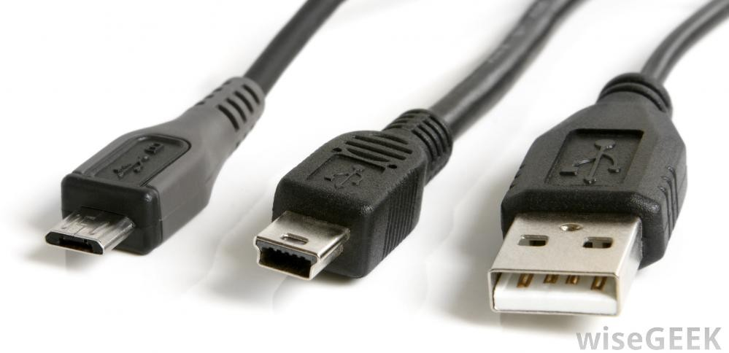

Image C/D/E

5.0 Image References

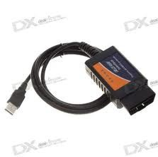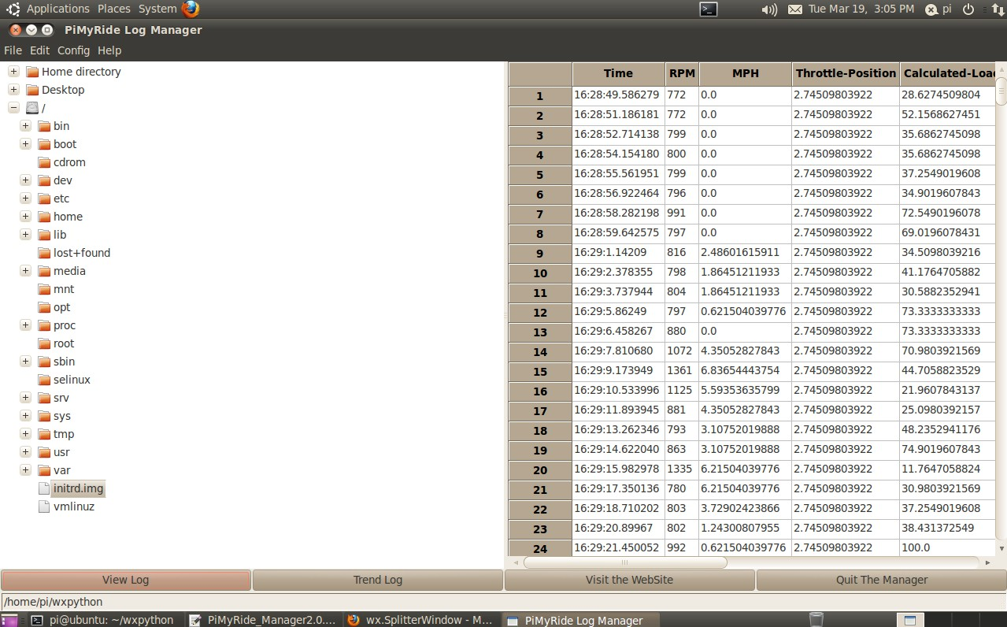

Image F

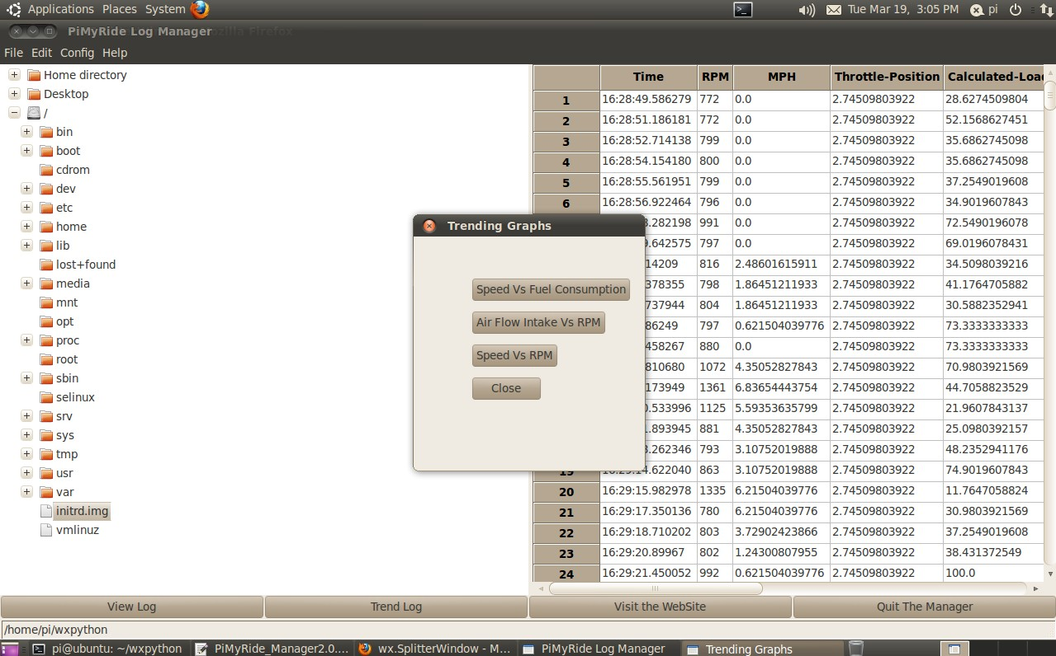

Image G

