|01

**Board of Elections** The City of New York

**Using your Smartphone, download a**

**FREE QR Reader. Once downloaded, open the application and click the QR code to discover the Board’s website.**

Introduction

The Board is headed by ten Commissioners, two

from each borough representing both major political parties for a term of four years appointed by the New York City Council...

**... A similar bipartisan arrangement of over 351 deputies, clerks and other personnel ensures that no one party controls the Board of Elections. The Board appoints an executive staff consisting of an Executive Director, Deputy Executive Director and other senior staff managers charged with the responsibility to oversee the operations of the Board on a daily basis. Together, the executive and support staffs**

**provide a wide range of electoral services to residents in Manhattan,**

**The Bronx, Brooklyn, Queens and Staten Island.**

**The Commissioners of Elections meet every Tuesday at the Executive Office, in addition to the special hearings, legislative sessions and specific issue-oriented meetings (electronic voting, election legislation,**

**labor management, rules and budget) during the calendar year.**

Board of Elections | The City of New York

Annual Report 2014

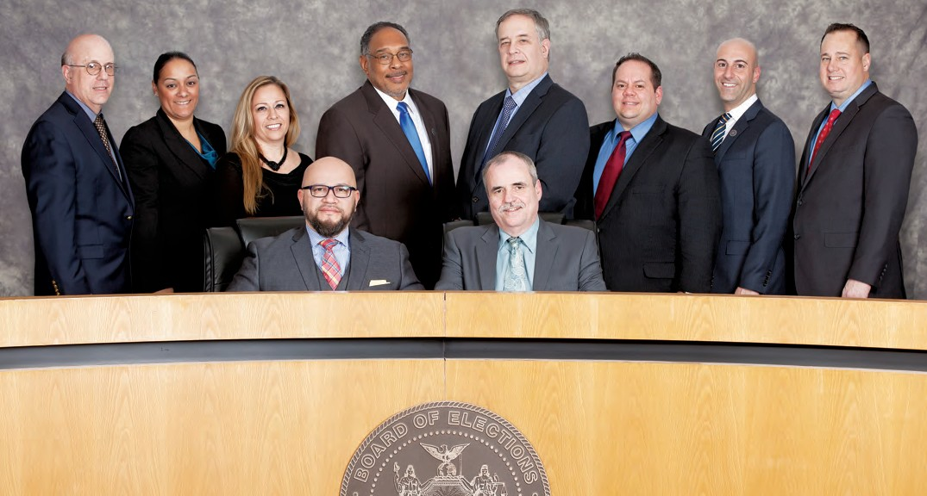

Commissioners of Elections in the City of New York

BOROUGH

PARTY

**MARIA R. GUASTELLA MICHAEL MICHEL, SECRETARY**

**JOSE MIGUEL ARAUJO, PRESIDENT RONALD CASTORINA**

**SIMON SHAMOUN JOHN FLATEAU BIANKA PEREZ MICHAEL R. RENDINO ALAN SCHULKIN FREDERIC M. UMANE**

Staten Island Queens Queens Staten Island Brooklyn Brooklyn Bronx Bronx Manhattan Manhattan

Democrat Republican Democrat Republican Republican Democrat Democrat Republican Democrat Republican

**NOTE:** Gregory C. Soumas, Esq. served as President of the Board of Elections in the City of New York from January to August 2014. Julie Dent served as Commissioner to Kings County from January to October 2014.

From left to right (top row):

Alan Schulkin, Bianka Perez, Maria Guastella, John Flateau, Ph.D., Frederick Umane, Ronald Castorina,

Simon Shamoun, Michael R. Rendino

(bottom row):

Jose Miguel Araujo, Michael Michel

02|03

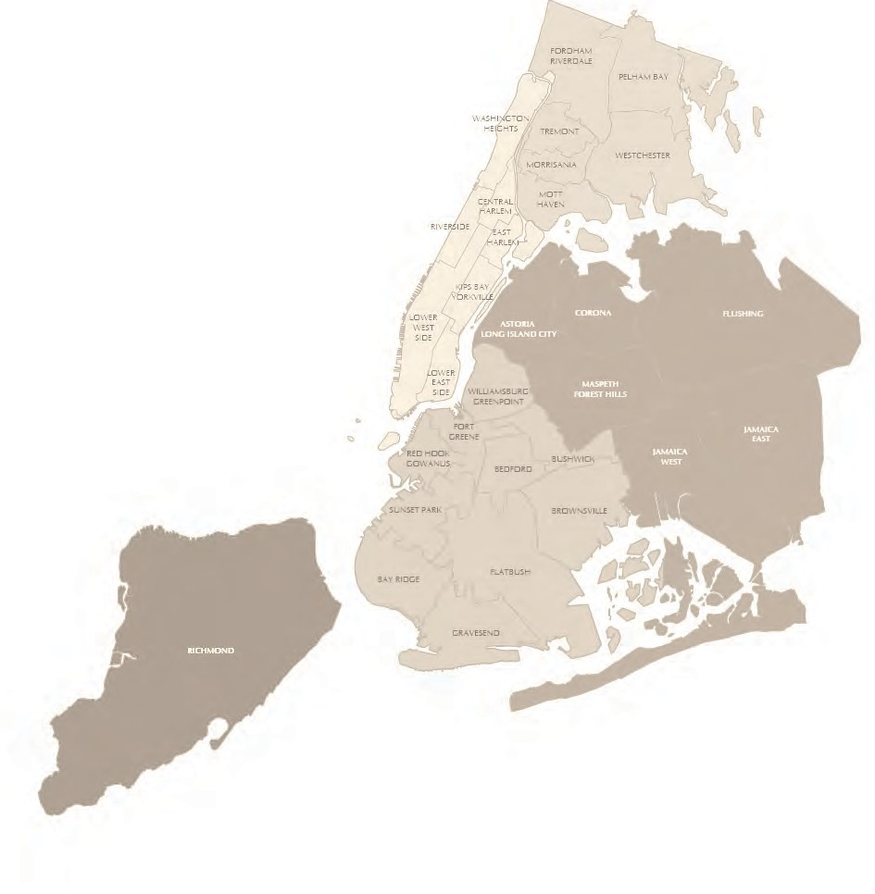

Mission Statement

**The Board of Elections in the City of New York,**

**as provided under Section 3-200 of the New York State Election Law,**

**is responsible:**

1. **To conduct fair and honest elections, from local to federal levels;**
2. **To enfranchise all eligible New Yorkers to register to vote and to practice those rights;**
3. **Toconduct elections, certify the canvass and to retain the official records;**
4. **Voter outreach and education.**

**Briefly stated, this means:**

**First,** the preparation of the ballot for Primary, Special and General Elections to the extent that all vacancies for public office and party positions may be filled.

**Second,** that qualified voters may exercise their right to franchise and that every opportunity be given to voters to execute that right and to vote for

whom they choose.

**Third,** that the votes of the electorate at Primary, Special and General Elections be properly canvassed and that a true count be given for each candidate

voted for.

**Finally,** that we make every effort to inform and educate the voting public of their rights as a voter and also to reach out to all Americans to instruct

them in the voting process.

The following pages of this report will illustrate some of the duties as

classified in the above synopsis.

Board of Elections | The City of New York

Annual Report 2014

**Jose Miguel Araujo,**

President for Year 2014

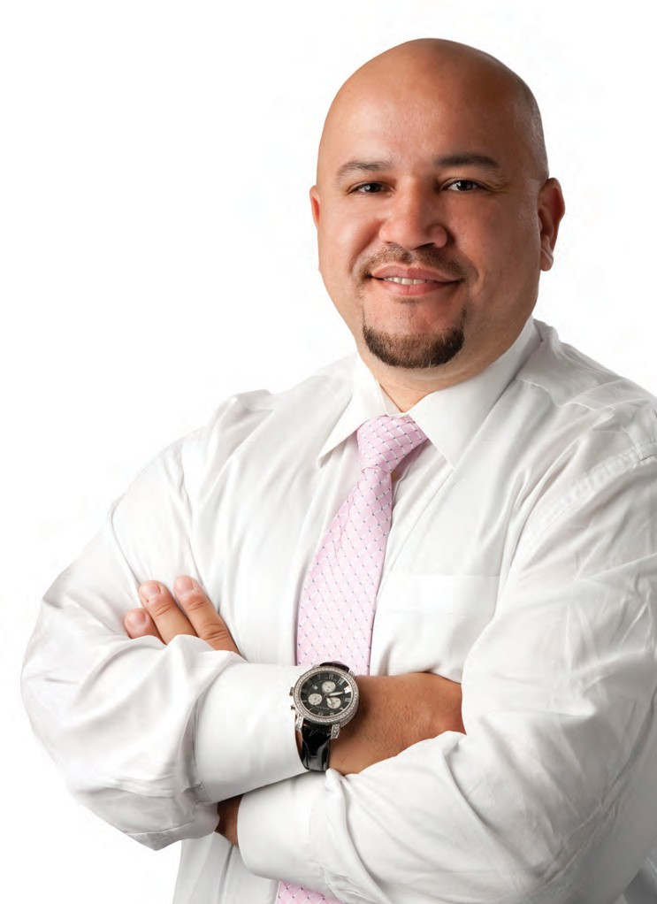

President’s Message

The Board of Elections in the City of New York entered 2014 with a goal to continue its commitment to provide open and honest elections to its constituents, and ended the year having accomplished that goal. In our efforts to ensure this, the hard working Board of Elections’ staff worked tirelessly through a busy and often hotly contested election season. Thanks to the support of our Executive Director Michael J. Ryan, Deputy Executive Director Dawn Sandow, and Administrative Manager Pamela Perkins, the Board was able to see that the Congressional Primary, Federal Primary, and the General Election were all conducted in accordance with the standard we have set for ourselves.

Internally, the Board faced several managerial changes, each of which was transitioned into smoothly and effectively. The year 2014 also saw the implementation of the CityTime System, replacing our old system of paper time cards with electronic timekeeping. Once again, the transition to the new system was a success, a feat that could not have been achieved without the efforts of our staff.

The following Annual Report will present many of the advancements and accomplishments made during the year in much greater detail, in hopes that it highlights our goal of making the voting process

fair and efficient for all voters. We encourage all interested parties to visit our website for more information including various appendices not included in this printed version.

In certain ways, 2014 was our most successful election season in quite some time, largely thanks to the introduction of VICKi (Voter Information Center Kiosk), a new system created by our EVS Department, designed to make finding your voting information easier and faster on Election Day, as well as the launch of a pilot program utilizing our computerized tablets to upload unofficial election night results to our website in record time; I would like to thank our MIS, EDO, EVS and VEOU Departments, under the direction of Executive Management.

Respectfully submitted,

Thanks must also be given to our poll workers, everyday people whose belief in democracy and conducting fair, open and honest elections motivate them to work tirelessly on election days to ensure every vote counts. This job is strenuous but ultimately rewarding, and each year we hope that their efforts inspire others to answer the call of democracy by serving as a poll worker.

04|05

Brooklyn

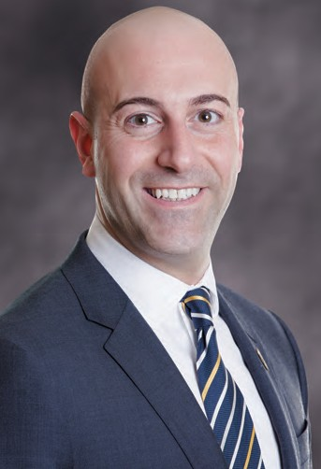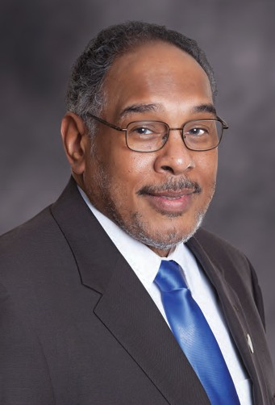

**SIMON SHAMOUN,** Commissioner

Simon Shamoun is the New York City Board of Election’s Republican representative from Brooklyn, appointed by the New York City Council in 2013.

The son of immigrants, Mr. Shamoun is a product of both public and private schools including P.S. 104, Monsignor Farrell High School, Pace University and CUNY School of Law.

Mr. Shamoun is a partner at the law firm of Kampessis & Shamoun, representing clients in real estate and business matters and is admitted to practice law in New York and New Jersey and in the Southern and Eastern District Courts of New York.

Mr. Shamoun serves on the board of directors at the St. Nicholas Home adult residence in Bay Ridge, Brooklyn and is also a board member of the Salaam Club of New York, a charitable organization.

**JOHN FLATEAU,** Commissioner

Dr. John Flateau is a Commissioner of the NYC Board Of Elections. He is a Professor of Public Administration and Political Science; and Director, Census Information Center at Medgar Evers College, CUNY. He was Chief of Staff and campaign coordinator for Mayor David Dinkins; Senior Vice President, Empire State Development Corp.; Executive Director, NYS Black, Hispanic & Asian Legislative Caucus; and instructor, District Council 37 AFSCME.

He is a Fellow, National Academy of Public Administration; member, National Conference of Black Political Scientists; former member of NYS LATFOR which conducted congressional and state legislative redistricting and ended prison based gerrymandering; and was a Commissioner, NYC Districting Commission. He was Deputy Secretary for Intergovernmental Relations, NYS Senate, co-managing the 2010 Census and Federal Stimulus Program. He was Chairman, US Census Advisory Committee On the Black Population; and Co-Chair, NYC Black Advisory Committee, Census 2000.

He is a strategist on seminal federal, state and local elections; electoral reform; and landmark voting rights litigation empowering communities of color. He is an architect of NYC and NYS statutory programs for job creation, business finance and government contracts for Minority and Women businesses. John has a BA in English Literature, New York University; MPA, Baruch College;

M. Phil., M.A. and Ph.D. in Political Science in American Politics and Public Policy from The Graduate Center, CUNY. He is a member of Bridge St. AWME Church, the NAACP, VIDA and Brooklyn’s Bedford Stuyvesant community.

Staten Island

Board of Elections | The City of New York

Annual Report 2014

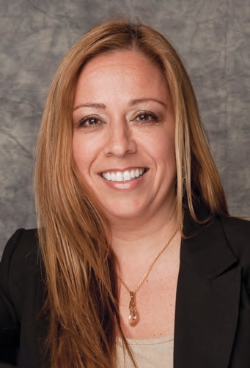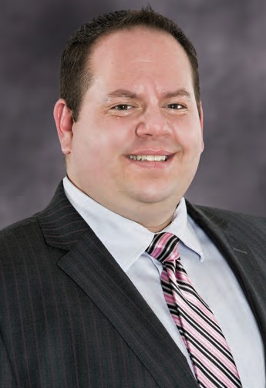

**MARIA R. GUASTELLA ESQ.,** Commissioner

Maria R. Guastella is the Staten Island Democratic Commissioner and was unanimously appointed to the Board of Elections in the City of New York in 2011 by the New York City Council.

In January, 2012, she was duly elected President of the Commissioners of the Board of Elections in the City of New York.

Ms. Guastella began her legal career in 1994 working for the Legal Aid Society, Criminal Defense Division as a staff attorney. In 2001, Ms. Guastella opened her own law office and specializes in criminal defense litigation.

Ms. Guastella is a graduate of John Jay College of Criminal Justice and received her Juris Doctorate from City University of New York School of Law. She is admitted to practice law in the State of New York and the Southern and Eastern Districts of New York.

Ms. Guastella resides in Staten Island with her husband and two children.

**RONALD CASTORINA,** Commissioner

Ronald Castorina, Jr., Esq. came to the Board of Elections in 2013, where he was appointed to be the Republican Commissioner for Richmond County. Prior to his service with the Board, Castorina served as counsel for Council Member Vincent Ignizio, and had previously worked as a law clerk and a research assistant for the State Supreme Court.

Castorina graduated in 2001 from St. Francis College in Brooklyn, where he received a B.A. for Political Science & Philosophy. He received a juris doctor from State University of New York at Buffalo School of Law in 2004.

In addition to his political and legal works, Castorina also serves as a 1st Lt. in the New York Guard, Army Division.

Mr. Castorina currently resides in Staten Island, and is head of the Law Offices of Ronald Castorina, Jr., where he practices in both Brooklyn and Staten Island.

06|07

Bronx

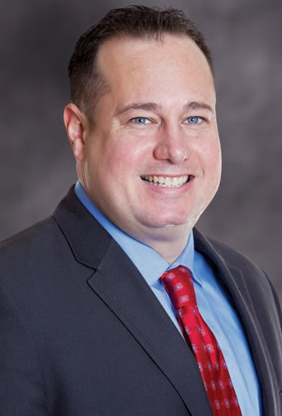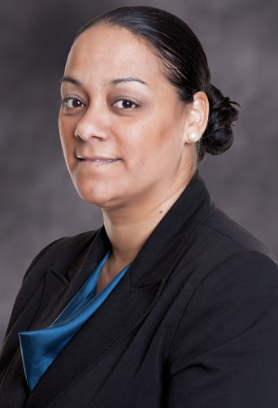

**MICHAEL A. RENDINO,** Commissioner

Mike Rendino is the Bronx Republican Commissioner. A lifelong resident of the borough, Mr. Rendino has long been an active member in his community, serving as Chairman of the Economic Development Committee as well as Merchant Representative of the 161 Street Business Improvement District.

Mr. Rendino worked as a firefighter before injuries sustained during the September 11th relief effort forced him into retirement. Since then, he has become heavily involved in local politics, working on Mayor Michael Bloomberg’s 2009 reelection campaign before running for New York State Assembly in 2010.

A graduate of St. John’s University, he has a degree in sports management. In addition to his tireless community activism, Rendino runs a very successful small business located near Yankee Stadium.

**BIANKA PEREZ,** Commissioner

Bianka Perez is the Bronx Democratic Commissioner of the New York City Board of Elections. She is also the sole owner of the Law Office of Bianka Perez. Her law office, which is located in the Bronx, was established in 2004 and specializes in Family, Criminal, Divorce, Wills/Trusts/Estates and Accident/Personal Injury matters. She served as Administrative Law Judge with the Office of Administrative Trials and Hearing from 2012 to 2014.

Ms. Perez received her Doctorate in Law at New York Law School in 2000 and her B.A. from John Jay College of Criminal Justice CUNY in 1995, where she graduated Summa Cum Laude. She is admitted to both the New York Bar and New Jersey Bar.

She served as President of the Dominican Bar Association from 2012-2013 and as Parliamentarian of the Bronx County Democratic Committee from 2012 to 2014. Ms. Perez has served on many voluntary legal clinics in her community and won distinctive awards for her community service. In 2012 she received the Manhattan Borough President’s Hispanic Heritage Award and the Dominican Independence Award from Councilman Robert Jackson. In 2013 she received the International Women’s Day Award from Centro Altagracia De Fe y Justicia, a Certificate of Merit from the New York City Comptroller John Liu for her community work, and the Universidad UNAPEC Award from the Dominican Republic for her professional accomplishments as a Dominican attorney in the United States.

She was born in the United States, her parents are from the Dominican Republic and came to the United States in the 1970s. Ms. Perez currently resides in the Bronx with her husband and children.

Manhattan

Board of Elections | The City of New York

Annual Report 2014

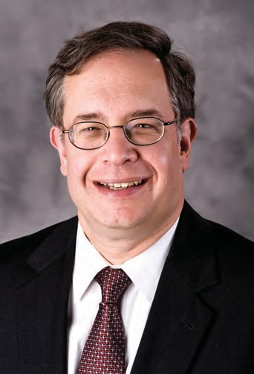

**FREDERIC M. UMANE ESQ.,** Commissioner

Frederic M. Umane has served as a commissioner of the New York City Board of Elections since 1995. A Republican from Manhattan, he was president of the Board during the 2005 mayoral election and has been active in local politics for more than twenty years.

An attorney, Mr. Umane is a partner at Zeichner Ellman & Krause and heads the firm’s transactional banking, corporate and real estate group. He has substantial experience in bank regulatory matters and issues involving mortgage fraud, automobile and hotel finances.

Mr. Umane is admitted to the practice of law in New York State and the federal courts. He is an active member of the American Bar Association as well as the Associations of the Bar of the City of New York and New York State.

He received his J.D. from Albany Law School and his B.A. from Union University. Mr. Umane is married to Susan Umane and they have two children, Ryan and Bradley.

**ALAN SCHULKIN,** Commissioner

Alan Schulkin was appointed as the Democratic Commissioner to Manhattan County in September 2014. Prior to assuming this position, he had been the Deputy Chief Clerk at the Manhattan Borough Office of the Board of Elections in the City of New York since April 2014.

A graduate of University of Charleston, W. Va., Mr. Schulkin worked as a supervisor at the NYS Department of Social Services for 20 years, before transferring to the Department of Health, where he oversaw the audits of Medicare providers. He worked there for 10 years, when he was transferred to the Office of Medicaid Inspector General.

Mr. Schulkin currently resides in Manhattan.

08|09

Queens

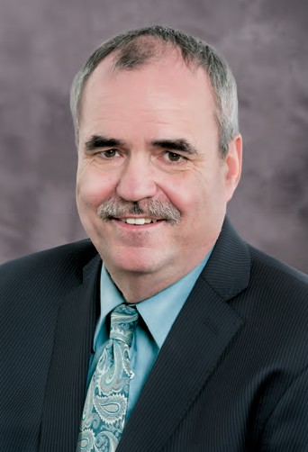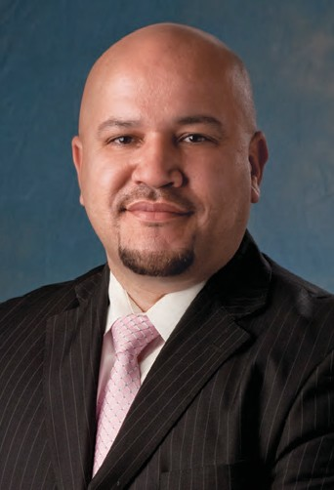

**MICHAEL MICHEL,** Secretary

Michael Michel came to Christ the King as Financial Director in 1992. He has since been appointed Director of Operations at Christ the King High School in 1994 and in 2006 was appointed President of Christ the King. Michael founded and serves as President of the Christ the King Daycare / Continuing Education.

In 2013, the City Council appointed Michael Queens Republican Commissioner of the NYC Board of Elections. In March 2014, Michael was also appointed to serve on the Board of All Faiths Cemetery.

Michael currently resides in Middle Village, NY, with his wife, the former Erika Schaefer, and his two daughters Janine and Laura.

**JOSE MIGUEL ARAUJO ESQ.,** President

Jose Miguel Araujo was appointed to the New York City Board of Elections in 2008 and serves as the Democrat representative from Queens. He is currently serving as president.

A Democrat, Mr. Araujo graduated from John Jay College of Criminal Justice with a Bachelor of Science Degree in Criminal Justice. He went on to receive his Juris Doctorate from the City University of New York School of Law and is a practicing attorney in the areas concerning Criminal Guardianship/Article 81 of the Mental Hygiene Law, Wills and Estate and Real Estate.

As a member of the Board’s Public Education Subcommittee, he was integral in the implementation of the citywide public education campaign intended to inform New Yorkers of new changes to the voting system resulting from the Congressional Help America Vote Act.

Mr. Araujo and his wife Rita live in Queens with their four sons Justen, Joel, Ricardo and Ariel.

Executive Management

Senior Staff (Alphabetically Listed)

Annual Report 2014

**PAMELA GREEN PERKINS**

Administrative Manager

Board of Elections | The City of New York

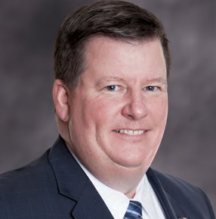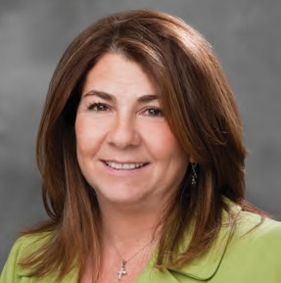

**NINA CRISPINO**

Director of Personnel / Records Management Officer

**STEVEN B. DENKBERG**

Counsel to the Commissioners

**MARIE FABRIZI**

Director of Equipment

**STEVEN FERGUSON**

Director of Management Information Services

**BETH FOSSELLA**

Coordinator of Voter Registration Activities

**TROY JOHNSON**

Coordinator of Candidate Records Unit

**DANIEL LAVELLE**

Coordinator of Customer Service

**DEBRA LEIBLE**

Coordinator of Election Day Operations

**KENNETH MOLTNER**

Counsel to the Commissioners

**JOHN NAUDUS**

Director of Electronic Voting Systems

**JOHN P. O’GRADY**

Chief Voting Machine Technician

**STEVEN H. RICHMAN**

General Counsel

**THOMAS SATTIE**

Ballot Management Supervisor

**RAPHAEL SAVINO**

Deputy General Counsel / Director of Campaign Finance Enforcement

**NICHOLAS SQUICCIARINI**

Facilities Manager

**GERALD SULLIVAN**

Finance Officer

**SHERWIN SUSS**

Agency Chief Contracting Officer

**VALERIE VAZQUEZ**

Director of Communications & Public Affairs

**MICHAEL J. RYAN**

Executive Director

**DAWN SANDOW**

Deputy Executive Director

Administrative Management

Borough Offices

10|11

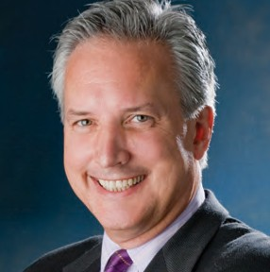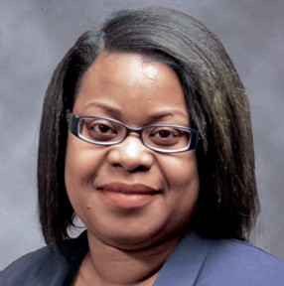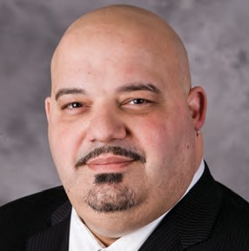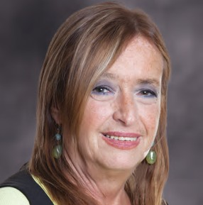

**MANHATTAN**

200 Varick Street, New York, NY 10014 (212) 886-2100

**GREG LEHMAN**

Chief Clerk

**ALVIN SAMUELS** (not pictured) Deputy Chief Clerk

**BRONX**

1780 Grand Concourse, Bronx, NY 10457

(718) 299-9017

**ANTHONY RIBUSTELLO** (left)

Deputy Chief Clerk

**MARRICKA SCOTT-MCFADDEN** (right)

Deputy Chief Clerk

**BROOKLYN**

345 Adams Street, Brooklyn, NY 11201

(718) 797-8800

**DIANE HASLETT-RUDIANO** (left)

Chief Clerk

**BETTY ANN CANIZIO-AQIL** (right)

Deputy Chief Clerk

Annual Report 2014

Board of Elections | The City of New York

Borough Offices Cont’d

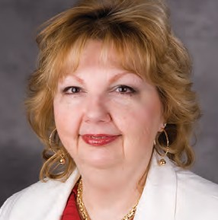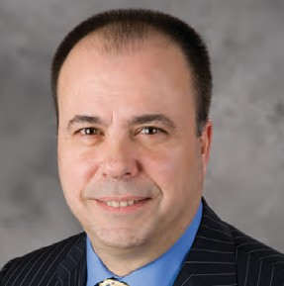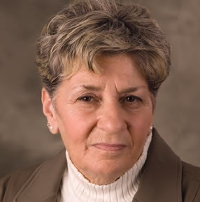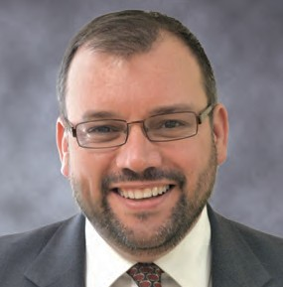

**QUEENS**

126-06 Queens Blvd, Kew Gardens, NY 11415 (718) 730-6730

**BARBARA CONACCHIO** (left)

Chief Clerk

**BART HAGGERTY** (right)

Deputy Chief Clerk

**STATEN ISLAND**

1 Edgewater Plaza, 4th Fl., Staten Island, NY 10305 (718) 876-0079

**SHEILA DELGIORNO** (left)

Chief Clerk

**ANTHONY ANDRIULLI** (right)

Deputy Chief Clerk

12|13

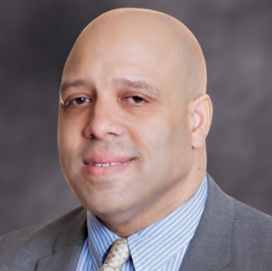

Candidate Records Unit

The Candidate Records Unit (CRU) of the Board of Elections in the City of New York is responsible for the receiving, recording, processing and tracking of all candidate and objector document filings as well as proofing of candidate names that achieve ballot status for Primary, General and Special Election events.

The CRU staff maintains candidate status on all these items in order to ensure an accurate ballot. The staff prepares, reviews, updates and corrects errors identified on all reports that provide data for the creation of all ballot proofs.

The unit also has a limited responsibility for receiving, recording and monitoring candidate compliance documents for In-Lieu-Of filers only as part of the Campaign Financial Disclosure requirements. CRU received 271 financial disclosure reports from various candidates, political party committees and political action committees in 2014. CRU staff sends non-compliance notices to treasurers by US Certified Mail as well as notifying non-compliant candidates by regular First Class Mail. Non-compliant candidates and committees are reported to the Commissioners of Elections.

**TROY JOHNSON**

Coordinator, Candidate Records Unit

**Campaign Finance Summary**

**New York**

**Bronx**

**Kings**

**Queens**

**Richmond**

**Total**

**Number of County Committee Filers**

3

5

12

7

4

31

**Number of Candidate Filers**

0

2

0

2

0

4

**Number of PAC Filers**

6

0

0

0

0

6

**Total Number of Filings Received**

56

31

94

58

32

271

**Total Number of In-Lieu-Of Filings**

5

2

5

5

1

18

**Number of Five-Day Letters Sent**

51

21

90

52

8

222

**Number of Delinquent Filings**

96

40

180

100

13

429

**Number Referred to County Attorney or DA**

0

0

0

0

0

0

**Nominating Petitions**

**New York**

**Bronx**

**Kings**

**Queens**

**Richmond**

**Total**

**Number Received**

22

3

5

7

1

38

**Number Challenged**

0

0

3

0

3

6

**Number of Specs Filed**

0

0

3

0

2

5

**Number Invalidated by Board**

12

16

14

3

1

46

**Number of Court Cases**

0

0

2

0

0

2

**Number of Court Cases Upholding Board Position**

0

0

2

0

0

2

**Number of Court Cases Reversing Board Position**

0

0

0

0

0

0

Candidate Records Unit Cont’d

Board of Elections | The City of New York

Annual Report 2014

14|15

Candidate Records Unit Cont’d

**GENERAL ELECTIONS TURNOUT**

**Registered Voters**

**Voter Turnout**

**Percentage**

**2014 Governor**

4,151,378

1,042.968

25%

**2013 Mayor**

4,245,309

1,102,400

26%

**2012 President**

4, 224, 811

2, 447, 897

58%

**2011 Judicial**

3,999,941

184,265

5%

**2010 Governor**

4,081,567

1,366,982

33.49%

**2009 Mayor**

4,095,561

1,154,802

28.2%

**2008 President**

4,119,923

2,615,770

61.45%

**2007 Judicial**

3,856,342

Non-citywide

Non-citywide

**2006 Governor**

3,799,353

1,244,874

32.77%

**2005 Mayor**

3,944,831

1,315,360

33.34%

**2004 President**

4,002,497

2,459,652

61%

**2003 Council**

3,667,266

Non-citywide

Non-citywide

**2002 Governor**

3,832,437

1,415,095

37%

**2001 Mayor**

3,715,022

1,520,443

41%

**2000 President**

3,672,265

2,282,944

62%

**1999 Judicial**

3,426,017

Non-citywide

Non-citywide

**1998 Governor**

3,415,858

1,537,010

45%

**1997 Mayor**

3,514,974

1,409,347

40%

**1996 President**

3,532,348

2,028,013

57%

**1995 Judicial**

3,151,812

Non-citywide

Non-citywide

**1994 Governor**

3,246,464

1,576,160

48%

**1993 Mayor**

3,301,683

1,898,437

57%

**1992 President**

3,360,568

2,211,473

66%

**1991 Council**

2,962,958

Non-citywide

Non-citywide

**1990 Governor**

3,052,259

1,159,134

38%

**1989 Mayor**

3,183,741

1,899,845

60%

**1988 President**

3,017,013

2,126,418

70%

**1987 Judicial**

2,514,605

Non-citywide

Non-citywide

**1986 Governor**

2,614,470

1,288,842

49%

**1985 Mayor**

2,842,517

1,170,904

41%

Annual Report 2014

Board of Elections | The City of New York

Candidate Records Unit Cont’d

**GENERAL ELECTIONS TURNOUT**

**Registered Voters**

**Voter Turnout**

**Percentage**

**1984 President**

3,014,459

2,340,181

78%

**1983 Judicial**

2,489,526

Non-citywide

Non-citywide

**1982 Governor**

2,544,394

1,685,956

66%

**1981 Mayor**

2,345,001

1,305,368

56%

**1980 President**

2,525,464

2,013,164

80%

**1979 Judicial**

2,237,193

Non-citywide

Non-citywide

**1978 Governor**

2,714,331

1,526,574

56%

**1977 Mayor**

2,887,530

1,486,536

51%

**1976 President**

2,720,105

2,143,345

79%

**1975 Judicial**

2,912,126

Non-citywide

Non-citywide

**1974 Governor**

3,161,656

1,822,567

58%

**1973 Mayor**

3,565,147

1,790,053

50%

**1972 President**

3,067,749

2,267,237

73%

**1971 Judicial**

3,068,015

Non-citywide

Non-citywide

**1970 Governor**

3,046,373

2,290,020

75%

**1969 Mayor**

3,026,745

2,458,203

81%

**1965 Mayor**

3,281,689

2,652,451

80%

**1961 Mayor**

3,239,879

2,467,546

76%

**1957 Mayor**

2,442,888

2,224,054

91%

**1953 Mayor**

2,369,858

2,244,146

93%

16|17

Turnout Summary Federal Primary Election – 06/24/2014

**Turnout vs. Enrollment**

**Turnout by Ballot Type**

**Eligible Active Voters as of 06/05/2014**

**Public Counter**

**Eme**

**Abs/Mil**

**Fed**

**FWAB**

**Pres**

**Aff**

**BMD Aff**

**NY**

289,975

43,866

0

847

193

4

0

537

10

**BX**

319,406

18,491

3

595

78

8

0

236

5

**KG**

183,308

6,356

0

280

159

0

0

42

1

**QN**

292,264

9,968

0

1,117

121

0

0

42

0

**Total**

**1,084,953**

**78,681**

**3**

**2,839**

**551**

**12**

**0**

**857**

**16**

**Turnout**

**Eligible Active Voters as of 06/05/2014**

**NY**

45,457

289,975

16%

**BX**

19,416

319,406

6%

**KG**

6,838

183,308

4%

**QN**

11,248

292,264

4%

**Total**

**82,959**

**1,084,953**

**8%**

Board of Elections | The City of New York

Annual Report 2014

Turnout Summary September Primary Election – 09/09/2014

**Turnout vs. Enrollment**

**Turnout by Ballot Type**

**Eligible Active Voters as of 08/21/2014**

**Public Counter**

**Eme**

**Abs/Mil**

**Fed**

**FWAB**

**Pres**

**Aff**

**BMD Aff**

**NY**

623,742

80,747

1

3,157

0

0

0

473

8

**BX**

492,859

47,583

0

1,750

0

0

0

423

8

**KG**

944,414

98,402

0

3,138

0

0

0

771

26

**QN**

669,658

64,047

9

3,474

0

0

0

356

0

**RH**

120,019

6,326

0

1,044

0

0

0

18

2

**TOTAL**

**2,850,692**

**297,105**

**10**

**12,563**

**0**

**0**

**0**

**2,041**

**44**

**Turnout**

**Eligible Active Voters as of 08/21/2014**

**NY**

84,386

623,742

14%

**BX**

49,764

492,859

10%

**KG**

102,337

944,414

11%

**QN**

67,886

669,658

10%

**RH**

7,390

120,019

6%

**TOTAL**

**311,763**

**2,850,692**

**11%**

18|19

Turnout Summary General Election – 11/04/2014

**Turnout vs. Enrollment**

**Turnout by Ballot Type**

**Eligible Active Voters as of 10/16/2014**

**Public Counter**

**Eme**

**Abs/Mil**

**Fed**

**FWAB**

**Pres**

**Aff**

**BMD Aff**

**NY**

917,852

249,746

14

7,193

3,499

144

0

3,797

63

**BX**

640,299

135,537

11

3,092

418

8

0

2,553

34

**KG**

1,298,763

297,552

46

5,766

1,436

0

0

4,576

40

**QN**

1,029,657

235,028

2

7,142

1,302

7

0

2,548

0

**RH**

264,807

77,274

3

3,303

222

0

0

596

16

**TOTAL**

**4,151,378**

**995,137**

**76**

**26,496**

**6,877**

**159**

**0**

**14,070**

**153**

**Turnout**

**Eligible Active Voters as of 10/16/2014**

**NY**

264,456

917,852

29%

**BX**

141,653

640,299

22%

**KG**

309,416

1,298,763

24%

**QN**

246,029

1,029,657

24%

**RH**

81,414

264,807

31%

**TOTAL**

**1,042,968**

**4,151,378**

**25%**

Communications and Public Affairs

Board of Elections | The City of New York

Annual Report 2014

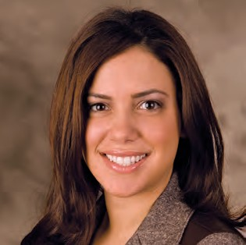

One of the Board’s top priorities is to ensure that every Election Day is implemented as smoothly as possible. To raise awareness and understanding about the new voting system, the Board conducted a comprehensive public education campaign to prepare voters prior to the 2010 Election. Building on the foundation created during the 2010 campaign, the Board continued its education efforts in 2014 to ensure New York City voters were becoming more familiar with using the new voting system during the 2014 Election cycle.

The 2010 Election marked the first time voters used the new voting system and as a result, was also the first time poll workers assisted voters using a paper ballot. Lessons were learned and used to prepare and strengthen procedures for future elections. As a trained poll worker corps is an essential element of any successful Election Day, the Board took steps to provide poll workers with the knowledge and tools necessary to successfully implement the Election. A key element of this preparation was a heavy focus on poll worker and interpreter recruitment to assist in replenishing a robust poll worker corps. As a result, the Board’s 2014 public education campaign centered on a multi-pronged approach:

**VALERIE VAZQUEZ**

Director of Communications and Public Affairs

**1.** Continued voter education to raise awareness and prepare voters to use the new voting system;

**2.** Recruitment of eligible New York City voters to serve as poll workers and interpreters and to provide them with real time experience with voters using the new system on Election Day; and

**3.** Increasing voter registration by attempting to register new voters at all scheduled outreach events.

The 2014 Public Education Program targeted voters in all five boroughs. This included first time voters as well as senior citizens, multicultural voters, and voters with disabilities. By Federal mandate, all public educational material was provided in English, Spanish, Chinese, Korean and Bengali.

The public education campaign continued to use and build upon a surround-sound communications approach that delivered key messages and engaged targeted audiences in voter education efforts and recruitment opportunities. Due to New York City’s diverse voter population, the Board implemented a campaign that integrated a range of tactics including stakeholder engagement, digital outreach, materials development and earned media.

**2014 Public Education Campaign Goals**

Continue to Educate NYC Voters

Recruit New Poll Workers/ Register new Voters

* The Board’s outreach team continued to proactively engage local community groups throughout New York City in addition to elected officials to encourage voter education and poll worker recruitment.

20|21

Communications and Public Affairs Cont’d

* Bipartisan Outreach team members attended events across

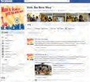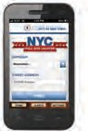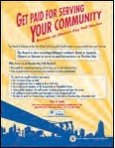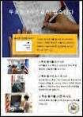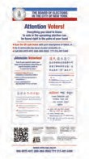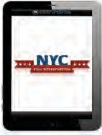

* The outreach team staffed community events throughout all five boroughs to educate voters about the new voting system, recruit eligible residents to serve as poll workers or interpreters, as well as register voters.

the city to encourage eligible voters to serve as poll workers while educating and preparing voters for Election Day.

* Outreach was continued to key stakeholders to enlist their support in educating audiences about the new voting system and encouraging poll worker applicants.
* On Election Day, the team engaged with NYC voters through timely Facebook postings and Twitter messages starting when the poll sites opened and continuing until the poll sites closed.
* Social media engagement was ramped up to further grow the Board’s digital audiences and stakeholders.

The home page of the Board’s website prominently features tools and resources working towards the Board’s priorities — including public education on voting the new way, poll site locator, and sample ballots, as well as information on voter registration, poll worker recruitment, and absentee voting. The website also features sections devoted to specific audiences, such as voters, candidates, and poll workers. With the click of the mouse, users will also be able

* Educational materials in multiple languages were distributed at community events and made available on the Board’s website.
* Targeted media outreach was conducted that focused on providing information about the new voting system and encouraging eligible voters to serve as poll workers and interpreters. Campaign highlights such as an online voter survey, the posting of online sample ballots and the distribution of voter tips prior to Election Day were pitched to the media to help spread information to all NYC voters.

to translate the entire NYC BOE website into Spanish, Chinese, Russian, Korean, or Bengali, enlarge their text and share the entire webpage with a friend. The website also highlights the Board’s social media pages and allows readers to sign up for email updates from the BOE. The Board’s website had a total of 936,425 visits, with 189,394 clicks to the poll site locator.

Additional highlights of the 2014 public education campaign include:

The Board created an information poster alerting voters that everything they need to know about voting can be found in the palm of their hand, either by calling our Phone Bank or scanning our new QR Code with their

* The Board’s continued posting of online sample ballots marked a milestone in the Board’s efforts to assist in preparing voters to use the new voting system.

Smartphone or tablet which takes them directly to the BOE website. The poster was placed in various locations and

poll sites throughout the city. On Election Day, the Board launched a pilot program to allow Executive Office Monitoring teams to remotely complete a poll site survey using a wireless digital

tablet for every site they visit. This program provided us with valuable data that will allow us to develop an updated version to be deployed in our next pilot that will be expanded to include AD Monitor teams.

Communications and Public Affairs Cont’d

Board of Elections | The City of New York

Annual Report 2014

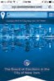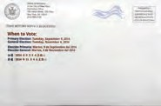

[**WWW.NYC.POLLSITELOCATOR.COM**](http://WWW.NYC.POLLSITELOCATOR.COM/)

Poll Site Locator (PSL) is a web application optimized for viewing on a smartphone, tablet or desktop screen. With one simple address search from any device, voters have instant access to the latest poll site information from wherever they are. They see where to vote — along with Google Maps™ directions from their current location or home address, a list of upcoming elections, a full contest list, access to a sample ballot and much more.

**BOROUGH LEARNING CENTERS**

Voters were also encouraged to visit a Learning Center in their local Board’s Borough Office to have a hands-on experience with the new voting system. Trained staff are available to guide voters through voting on a paper ballot, using the scanner and using the Ballot Marking Device.

The Learning Center locations and hours are shown below:

If changes occur, be it through unplanned events or regular redistricting, voters can subscribe to email alerts. The site handles all the leg-work so that election officials can just sync the site and sit back while all their Change Notices are delivered electronically. Voters using Poll Site Locator are up-to-date, confident and empowered on Election Day. Covering the Election Period from the September Primary through the General Election in November we had over 231,000 visits to our PSL representing over 180,000 unique visitors. The totals for the year from its installation in August to the end of 2014 the figures are over 255,000 visits representing over 195,000 unique visitors.

**Bronx Board of Elections Borough Office**

1780 Grand Concourse, 5th Floor Bronx, NY 10457

**Regular Hours:** Monday - Friday, 9:00 a.m. – 5:00 p.m.

**Brooklyn Board of Elections Borough Office**

345 Adams Street, 4th Floor Brooklyn, NY 11201

**Regular Hours:** Monday - Friday, 9:00 a.m. – 5:00 p.m.

**NEW DESIGN OF DEDICATED MAILING PRIOR TO GENERAL ELECTION:**

As a result of concerns expressed by voters and others, the Board requested funding from the City to send an additional notice to all voters with their poll site information prior to 2014 General Election.

**Manhattan Board of Elections Borough Office**

200 Varick St., 10th Floor New York, NY 10014

**Regular Hours:** Monday - Friday, 9:00 a.m. – 5:00 p.m.

In an effort to improve communications with the voters, the annual Voter Information Notice Mailer was significantly changed in the past year. Originally, all five languages were printed in one mailer and distributed to all voters. The new version provided the following segmentation:

**Queens Board of Elections Borough Office**

126-06 Queens Boulevard, 1st Floor Kew Gardens, NY 11415

**Regular Hours:** Monday - Friday, 9:00 a.m. – 5:00 p.m.

* Queens voters received the Voter Information Notice in all five covered languages: English, Spanish, Chinese, Korean, and Bengali

**Staten Island Board of Elections Borough Office**

1 Edgewater Plaza, 4th Floor Staten Island, NY 10305

**Regular Hours:** Monday - Friday, 9:00 a.m. – 5:00 p.m.

* Bronx and Staten Island voters received the Voter Information Notice in English and Spanish
* Manhattan and Brooklyn voters received the Voter Information Notice in English, Spanish and Chinese

By using this targeted approach that reflects the federal language assistance requests, the Board was able to more effectively deliver information to the voters and create better print efficiencies for current and future mailings.

22|23



Voter Registration

As the Coordinator of the Voter Registration Department, my staff and I are responsible for all activities that pertain to registering people to vote in the five boroughs of New York City. This includes:

* Overseeing the Boroughs’ responsibility to maintain the records of all registered voters. The total number of registered voters in the City of New York for **2014** according to the New York State Board of Elections Data Base is **4,568,362**. These numbers include both Active and Inactive voters (Active voters – **4,160,000**; Inactive voters – **408,362**). These figures are run on April 1st and November 1st of each year and are posted on the New York State Board of Elections website.

**BETH FOSSELLA**

Coordinator, Voter Registration

* Reaching out to all eligible voters in the City of New York, making them aware of the importance of being a registered voter and how much their vote counts. This is accomplished through:
  1. Conducting registration drives at various community activities (i.e. street fairs, job fairs, community organization meetings, senior citizen community centers) and providing material that will help explain the process of voting.
  2. Distribution of voter registration material to the public. It is to be noted that all voter registration materials are produced in English and are translated, in accordance with NYS Election Law, into four languages of Spanish, Chinese, Korean and Bengali.
* Providing and making sure that all registration material is updated in accordance with New York State Election Law.
* Sorting all registration applications according to the following: Borough, time stamp, tracking numbers and coding – Registration, Department of Motor Vehicles, Agency Code “9” selected city agencies, Code “D”- Department of Education (CUNY). The registrations are put in borough order and distributed to the boroughs on a daily basis, for borough processing into the voter system.
  + Borough
  + Time Stamp
  + Tracking numbers and coding
    1. Registration
    2. DMV
    3. Agency Code 9 (Selected City Agencies)
    4. Code D (BOE) (CUNY)

Board of Elections | The City of New York

Annual Report 2014

Voter Registration Cont’d

* In 2002, Congress passed and the President of the United States signed into law the “Help America Vote Act” (HAVA). This was the means by which the Federal government committed to fund sweeping election reforms which would enhance the voting process in this country. Previously, a potential voter was not asked to provide a means of identification when filling out a registration application. Once HAVA took effect, identification was required. Effective January 1, 2006 all first time voter registrations within the State of New York have to provide the same information heretofore requested of voters who registered by mail after January 1, 2003. In order to accommodate the voter, the registration application was redesigned to provide a box where this HAVA ID information was required. Those who did not provided the necessary identification information, would receive a “First Time Voter Letter,” asking them to provide the identification information. If no identification is sent by the time of the election, the voter will be asked to provide this information at the poll site, and if they still did not provide it, they would not be allowed to vote on the (Scanner), but would have to vote by affidavit ballot.

**CODE 9 – AGENCY REGISTRATION**

In May 2000, the New York City Council passed legislation ( Local Law 29) which requires that 20 City agencies provide voter registration forms to agency clients, contractors and sub-contractors with whom the agency deals with on a daily basis.

The law requires that the Board of Elections supply these agencies with all the material they will need in the performance of these tasks, i.e. registration forms, display boxes, booklets, posters in all languages that are required by law (English, Spanish, Chinese, Korean and Bengali). The total number of Code “9” registration applications that were given out in **2014** was **410,550**.

**TOTAL NUMBER OF CODE “9” PROCESSED BY BOROUGHS IN 2014**

* Ordering and tracking all voter registration materials located in the Manhattan Voting Machine Facility ( main storage facility for voter registration material) as well as material that is stored in the Borough and General Office.
* Making sure that all Voter Registration material is updated in English and translated into the four languages required by law, Spanish, Chinese Korean and Bengali.

**CUNY (THE CITY UNIVERSITY OF NEW YORK)**

CUNY requested **69,000** Code “D” registration forms to be delivered to the main offices of the CUNY schools. The “Code “D” registration applications contain a small box at the upper Left hand corner of the registration application with the letter “D” in it. This enables the Board to track how many of these registrations are processed. Total Number of Code “D” Applications processed by boroughs in **2014**.

* In 2010 the State Board of Elections re-designed the registration application to include “Organ Donor” information that is sent to the Board of Health on a weekly basis.
* In 2013 the State Board of Elections re-designed the Voter Registration Application to include e-mail address which is now box #7.
* In 2011 the State Board of Elections re-designed the absentee ballot application.
* Providing and updating all voter registration information that must be put up on the Board of Election’s website. This information is done in English, Spanish, Chinese, Korean and Bengali.

**TOTAL NUMBER OF REGISTRATIONS RECEIVED IN GENERAL OFFICE 2014 FOR THE 5 BOROUGHS**

* **Providing Russian translation “Registration and Voting” booklet on the website which contains an English registration application, with instructions in Russian. This provision was made in compliance with Section 3-506 of the New York State Election Law and went into effect as of January 1, 2010.**

REG

125,413

DMV

44,343

AGENCY

24,076

CODE 9

4,119

CODE D

6,983

Manhattan

1,100

Bronx

1,481

Brooklyn

2,313

Queens

2,703

Staten Island

736

Manhattan

1,060

Bronx

1,515

Brooklyn

853

Queens

764

Staten Island

115

**NUMBER OF CANCELLATION NOTICES SENT TO OTHER COUNTIES 43,984**

**NUMBER OF INACTIVE VOTERS ON FILE AS OF DECEMBER 31, 2014 402,020**

**NUMBER OF SPECIAL FEDERAL VOTERS ON FILE IN THE COUNTIES 2,642**

**NUMBER OF PERM/DISABLED VOTERS ON FILE IN THE COUNTIES 23,903**

**NUMBER OF CANCEL NOTICES SENT TO SBOE FOR OTHER STATES 15,093**

**TOTAL NUMBER OF REGISTRATIONS CANCELLED 183,730**

**NUMBER OF NEW REGISTRANTS PROCESSED 145,809**

**NUMBER OF MOVERS WITHIN COUNTY PROCESSED 175,037**

**TOTAL NUMBER OF ENROLLMENT CHANGES 34,077**

24|25

Voter Registration Cont’d

**2014 CONFIRMATION NOTICES**

The Confirmation Notices are sent out to the voters whose Information Notices were returned to the Board of Election as Undeliverable. Confirmation Notices are sent to check whether a voter is indeed not living at the address which appeared on the Information Notices.

**REGISTRATION SUMMARY FROM ALL SOURCES IN 2014**

If the Confirmation Notices is returned as undeliverable, then the voter is made INACTIVE. The Inactive code is **X**. This voter goes from an Active to an Inactive (A to X) status. Total for **2014** – There were **1,764** placed into this status.

**CANCELLATIONS**

**LIBRARIES AND POST OFFICES**

In January we began the distribution of our usual supply of registration forms (in all five languages) to all the libraries and post offices in New York City. Included with these were posters, a display box and order forms which could be faxed to us requesting replacement supplies.

**GENERAL INFORMATION**

The total number of Registration Forms distributed for **2014** were as follows:

Post Offices – 226

**TOTAL - 64,410 registrations**

Libraries – 217

**TOTAL - 61,845 registrations**

**The New York State Board of Elections produces the enrollment figures for all counties on their web site on April 1st and November 1st of each year. In order to access these figures you can go to:**

* **Go to** [**www.vote.nyc.ny.us**](http://www.vote.nyc.ny.us/)
* **Link to State Board –** [**www.elections.state.ny.us**](http://www.elections.state.ny.us/)
* **Enrollment totals for 5 boroughs as of November 1, 2014**

**NUMBER OF MILITARY VOTERS ON FILE IN THE COUNTIES 2,642**

**TOTAL NUMBER OF DUPLICATES 16,307**

Board of Elections | The City of New York

Annual Report 2014

Voter Registration Cont’d

**INFORMATION REGARDING MAILINGS THAT WERE SENT FROM THE GENERAL OFFICE – 2014**

* Please note that the numbers in the chart reflect both active and inactive voters.

**OUTREACH 2014 EVENTS**

**Queens**

Queens Central Public Library Brooklyn Heights Library North Forest Park Library Mitchell-Linden Library Flushing Library

Bayside Library

World Forum Event for Asian Americans: Abundant Elderly Life Bay Terrace Library

Chatpati Mela Festival 2014

The 69th Korean Independence Day Celebration Chatpati Mela by CHHAYA CDC

The Korean Festival at Flushing Meadow Corona Park

Flushing Library with Chinese American Voters Association of USA

**Manhattan**

Taiwan Tourism and International Travel Festival

Asian Pacific Islander American Public Affairs Association & Chinese Chamber of Commerce of New York, Inc. 2014 Summer Internship Workshop Annual Chinatown Family Health & Immigration Day

Korean Town Festival

**Brooklyn**

Senator Marty Golden’s 12th Annual Asian Heritage Celebration

**Borough**

**New Voters Acknowledgements**

**Changes Acknowledgements**

**Transfers**

**Confirmations**

**Cancellation**

**TOTAL**

Manhattan

39,089

24,097

56,538

700

7,542

127,966

Bronx

29,470

14,525

31,419

642

5,048

81,104

Brooklyn

41,200

26,027

60,694

1,685

6,072

135,678

Queens

32,531

16,584

55,418

16

4,628

109,177

Staten Island

8,212

7,642

14,852

727

748

32,181

**TOTALS**

**150,502**

**88,875**

**218,921**

**3,770**

**24,038**

**486,106**

26|27

Voter Registration Cont’d

**VOTER REGISTRATION OUTREACH EVENTS**

**Bronx**

The Harriet Tubman Charter School Job

Fair Police Athletic League Job Fair

Westchester Square Fair

Throgs Neck Merchant Association Street Fair

Fiesta Health Fair coordinated by Councilmember Fernando Cabrera

Outreach for the National Alliance of Postal Federal Employees

Outreach for the Independence Party

“Walk the Oval” a Community Health Fair

The Bronx Deliverance Center of Faith Community Day

Stadium Street Fair

Annual Night Out Against Crime

The Bronx Museum of Art “Boogie on the Boulevard”

Community Board 7

Community Board 9

Community Board 4

Community Board 2

Community Board 5

Community Board 1

Community Board 12

Law week 2014

Career Fair

National Night Out Against Crime

National Night Out Against Crime

Job Fair — Holiday Inn Midtown Hotel 440 West 57th Street, New York, NY 10019

Job Fair — Malcolm X & Dr Betty Shabazz Center 3940 Broadway New York, NY 10032 Town Hall Meeting on Healthcare

Demo Student Government Naturalization Ceremony

Job Fair — The NYC Department for the Aging 2 Lafayette Street 6th Fl New York, NY 10007 Job Fair — BMCC The University of NY 199 Chambers Street New York, NY 10007

Coe for Attorney Demo Voting Machines

Job Fair — Holiday Inn Midtown Hotel 440 West 57th Street, New York, NY 10019 Naturalization Ceremony

**Queens**

Job Fair (American Legion Post 483)

Parent Engagement Expo (Eagle Academy Foundation) Community Job Fair (Boys & Girls Club of Metro Queens) Job Fair (Senator Joseph Addabbo)

Resource and Job Fair (Plight of Veterans) Law Week 2014

50+/Senior Job Fair

Job Fair — Queens Community House 108-25 62nd Drive Forest Hills Health Wellness and Resource Fair

1st Annual St Albans Family Day National Night Out Against Crime Sean Bell Family Day

Job Fair (Boys and Girl Club) — Metro Queens 110-04 Atlantic Ave Richmond Hill, NY 11419 Job Fair — Rockaway Arverne By the Sea YMCA 207 Beach 73 Street Arverne, NY 11692 Workshop

Veterans Job Fair

**Manhattan**

Borough of Manhattan Community College Spring Career Fair First Baptist Church

Naturalization Ceremonies for National Voter Registration Day! NYC Campaign Finance Board

Naturalization Ceremony Progress High School

14th Annual Juneteenth Festival Breukelen Day Event

Job Fair — Holiday Inn Midtown Hotel 440 West 57th Street, New York, NY 10019 Naturalization Ceremony

Forum on Politics & Governance Lesson Naturalization Ceremony

Job Fair — BMCC The University of NY 199 Chambers Street New York, NY 10007 Naturalization Ceremony

Job Fair — Holiday Inn Midtown Hotel 440 West 57th Street, New York, NY 10019 Law week 2014

Job Fair — Riverbank State Park Cultural Theater 679 Riverside Drive, New York, NY 10031 Naturalization Ceremony

Job Fair — Mid Manhattan Adult Learning Center 212 West 120th ST. New York, NY 10017 Health Fair 2014

**Staten Island** LBGT Event Boardwalk Bash Back to the Beach Law Event

**Brooklyn**

Federation of Brooklyn Block Association

24th Annual Family Support, Brooklyn College, Student Union Bldg. Campus Rd. Juneteenth Festival, Cuyler Gore Park on Fulton and Green Avenue

It Takes a Community to Raise a Child 3rd Avenue Summer Stroll I

3rd Avenue Summer Stroll II National Night Out Against Crime

Unity Community Fair Brooklyn Public Library Brooklyn Public Library - Carroll Gardens Branch

Board of Elections | The City of New York

Annual Report 2014

Voter Registration Cont’d

Brooklyn Public Library Home Crest Branch Fort Hamilton Military Base - H2H Job Fair Community Board 4

Brooklyn Public Library - Kings Highway Bedford Public Library

Sheraton Brooklyn NY Hotel Brooklyn Public Library National Night Out

Youth America Inc. Medgar Evers College College Fair

Law Week 2014

Capp Prep Bringing Families Together 23rd Annual Yoth Conference

25th Annual Brooklyn Family Support Fair Shape Up Bushwick Parade & Festival National Night Out Against Crime

Town Hall Show Push for Peace Back to School Health & Resources

Job Fair — NYU Polytechnic Institute 6 Metro Tech Center Brooklyn, NY 11201 Youth Conference Employment Fair

NYC Campaign Finance Board Naturalization Ceremony State Committee Woman 29th Assembly District

Council Woman Vanessa L. Gibson & Bronx Borough President Rubén Díaz, Jr. NY City Bar Access to Justice NY State Courts

Brooklyn Community Board 14 Community Counseling and Mediation Rangel Career Fair

Adolescent Education Program

Office of Adult and Continuing Education NYS Senator Joe Addabbo’s Senior Job Fair 25th Annual Brooklyn Family Support Fair Shape Up Bushwick Parade & Festival Community Links Baltic Street AEH, Inc Congressman Charles Rangel

NYC Campaign Finance Board Naturalization Ceremony Brooklyn Resource Fair

New Mount Zion Baptist Church All Nations Apostolic Tabernacle Job Expo

Back to School Health Fair

68 Pct. Community Council National Night Out Against Crime 123 Precinct (Staten Island)

110th Precinct Community Council (National Night Out Against Crime) 46 Precinct Community Council Bronx

Friends of the 13th Precinct (Manhattan)

National Career Fair

NYC Campaign Finance Board Naturalization Ceremony

Street Soldier Lisa Evers & Borough President Eric L. Adams Town Hall Senator Adriano Espaillat 31st SD Job Fair

Harlem Health and Wellness Expo

Nicole Paultre Bell – When it’s real, it’s forever (Sean Bell Family Day)

Council Member Darlene Mealy Not Just Hoops Inc & The Utica Ave. Merchants Association NYCC Council Member Darlene Senior Demo Mealy

NY Works Career Expo

Baruch College Accessibility Event NYC Dept of Aging Senator Addabbo Job Fair

NYC League of Women Voters

Borough of Manhattan Community College The Liederkranz Foundation

Job Expo

NYC Campaign Finance Board Naturalization Ceremony Workshop Elmcor

Tribecca Film Festival Richmond County Fair

Holy Trinity St Nicholas Church “Greek Fair”

**1994-2014 TOTAL OF REGISTERED VOTERS IN NEW YORK CITY BY BOROUGH**

28|29

Voter Registration Cont’d

**ACTIVE REGISTRATION – 2014**

Active/Inactive Voters

**2004**

**2005**

**2006**

**2007**

**2008**

**2009**

**2010**

**2011**

**2012**

**2013**

**2014**

Manhattan

1,110,217

1,083,330

1,099,027

1,020,216

1,137,092

1,067,602

1,083,138

1,034,163

1,109,781

1,077,586

1,049,505

Brooklyn

1,329,900

1,297,665

1,317,470

1,261,774

1,394,937

1,357,640

1,392,965

1,341,565

1,424,479

1,417,767

1,413,359

Queens

1,092,384

1,059,371

1,045,684

984,793

1,090,420

1,081,422

1,100,884

1,083,493

1,116,578

1,122,721

1,100,204

Bronx

695,932

680,661

690,491

647,824

717,957

685,848

696,246

664,369

710,436

712,273

724,576

Richmond

265,988

262,249

265,050

254,569

274,526

270,145

275,729

268,181

279,148

279,558

280,718

**TOTALS**

**4,494,421**

**4,383,276**

**4,417,722**

**4,169,176**

**4,614,932**

**4,462,657**

**4,548,962**

**4,391,771**

**4,640,422**

**4,609,905**

**4,568,362**

Active/Inactive Voters

**1994**

**1995**

**1996**

**1997**

**1998**

**1999**

**2000**

**2001**

**2002**

**2003**

Manhattan

773,837

749,385

846,524

822,859

802,581

786,091

876,120

876,216

1,010,007

970,302

Brooklyn

972,206

944,409

1,066,012

1,048,316

1,024,067

998,084

1,095,963

1,109,941

1,271,743

1,220,751

Queens

790,954

757,267

849,854

851,128

840,703

830,926

902,459

927,354

1,038,926

1,012,298

Bronx

503,443

497,187

558,216

565,461

539,021

522,669

568,751

576,982

663,867

637,864

Richmond

204,339

203,564

211,742

227,210

209,486

217,978

227,355

229,938

252,560

246,689

**TOTALS**

**3,244,779**

**3,151,812**

**3,532,348**

**3,514,974**

**3,415,858**

**3,355,748**

**3,670,648**

**3,720,431**

**4,237,103**

**4,087,904**

**Borough**

**Democratic**

**Republican**

**Independence**

**Conservative**

**Working Families**

**Other**

**Blank**

**Green**

Manhattan

636,635

88,920

28,523

1,733

2,043

408

160,434

1,791

Bronx

498,090

38,308

12,884

2,927

2,643

94

85,995

435

Kings

929,222

113,818

28,619

4,599

5,291

367

216,662

2,501

Queens

677,943

118,052

26,294

5,404

3,260

227

199,358

1,311

Staten Island

121,062

76,257

9,203

4,237

1,088

93

52,945

324

**Citywide**

**2,862,952**

**435,355**

**105,523**

**18,900**

**14,325**

**1,189**

**715,394**

**6,362**

Election Day Operations

Board of Elections | The City of New York

Annual Report 2014

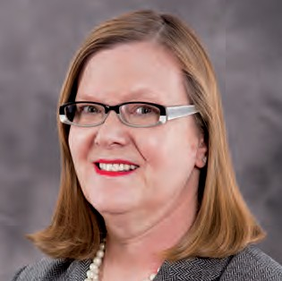

**POLL WORKER RECRUITMENT AND OUTREACH**

This department is charged with the responsibility for recruiting, training, assigning and tracking the performance of individuals who staff the polls and serve voters on Election Day. There are several different Poll Worker positions varying in qualifications and degrees of responsibility:

COORDINATORS are placed in polling sites to serve as the manager, to troubleshoot any problems and ensure that Election Day procedures are being followed. Their goal is to see that voters receive courteous, prompt and proper service.

INFORMATION CLERKS are placed at sites with multiple EDs to help direct and guide voters to their correct voting districts and poll sites by using street directories and poll site lists.

**DEBRA LEIBLE**

Coordinator, Election Day Operations

DOOR CLERKS are assigned to polling places with alternate accessible entrances, where doors cannot remain open, or where other assistance is required.

ED/AD TABLE INSPECTORS and POLL CLERKS are the backbone of the Board’s Election Day workforce. There are two INSPECTORS at each Election District or board, one enrolled Democrat and one Republican — a system of “checks and balances” that is required by New York State Election Law. POLL CLERKS are similarly divided and are mainly used as needed in the voting process in EDs where there are more than 750 registered voters.

SCANNER INSPECTORS verify that the scanners have not been tampered with, set-up and open the polls on the scanners for voting and assist voters if needed. There are two (2) inspectors per scanner; one (1) Democrat and one (1) Republican.

BMD INSPECTORS ensure the privacy booths and BMD are set up properly. They keep the booths clear of electioneering materials and are there to assist the voters if requested. There are two (2) Inspectors, one enrolled Democrat and one enrolled Republican.

30|31

Election Day Operations Cont’d

INTERPRETERS assist voters with limited English proficiency at poll sites in various neighborhoods in New York City and are a major component of the Board’s Language Assistance Program. The Board provides Spanish, Chinese (Cantonese/Mandarin), Korean and Bengali/Hindi interpreters in targeted areas in conjunction with the plan based on recent census data.

Once the Polls Close, the ENR Team awaits the arrival of Police Officers transporting the Large Yellow Scanner Voting Records Bag, which contains the Portable Memory Device (PMD), the Zero Report and the Results Tape. The ENR team uses the Radio Frequency Identification (RFID) Station to verify that the all of the Small Yellow Scanner Pouches and PMDs have been delivered. Once verified, the ENR Team uses the Election Night Reporting Laptop to upload and transmit the Results to the Board of Elections.

A.D. POLL SITE MONITORS are a bi-partisan team of specially trained Poll Workers who monitor an Assembly District on Election Day.

While the Coordinators, Inspectors, Poll Clerks and Information Clerks are required by law to be both a citizen and a registered voter, the Interpreters and Door Clerks do not have such a requirement. County Committee applicants make up a great portion of the total complement needed to staff the polls but thousands of positions still must be filled. To this end, the Board trains and assigns poll workers recruited from various sources, including the City University of New York and numerous civic and advocacy groups. Poll Worker applicants also submit forms obtained from the Board’s phone bank, Borough Offices, nyc.electiondayworker.com, or by indicating interest in serving when completing their Voter Registration applications.

ELECTION NIGHT REPORTING CLERKS (ENR) Every Police Precinct in New York City has a four person bipartisan Election Night Reporting Team (ENR Team) assigned to report at 7pm. The ENR Team is responsible for the setup and testing of the Equipment prior to the close of Polls.

**POLL WORKER TRAINING AND INITIATIVES**

During 2014, we had one hundred fifty eight (158) available Adjunct Trainers to conduct Poll Worker training by conducting 2,397 classes at 92 sites throughout New York City. These classes train the Poll Workers to use the Poll Worker Procedures Book, visual aids, various voter information forms and materials used in elections. Also included in the training session was a demonstration of the AutoMARK Ballot Marking Device (BMD) and a demonstration on the Optical Scanner voting system. In total, the Board assigned 91,019 workers to class and trained approximately 47,141 Poll Workers in 2014. We continued to use laminated step by step materials on using the BMD, Scanners and Serving the Voter that were available at poll sites. The purpose of these cards is to make it easier for the Poll Workers to open and close the BMD and Scanners simply by working in teams of two— one reading the instructions step by step and the other performing the required steps.

The Poll Worker Procedures Book replaced the Poll Worker Manual and the Poll Worker Summary Guide. It contains a section concerning diversity and incorporates the customer service training from the Poll Worker classes. The poll site signage provides voter information and assistance in all five (5) mandated languages based on what is required in each borough. These multi-language materials include the “How to Use the Scanner” and NYS Voter Bill of Rights.

**NURSING HOMES PROGRAM**

The Board of Elections provides special services to Nursing Care Residential Facilities and their occupants. During the 2014 Federal Primary, State Primary and General Election, Board staff made 293 visits to Nursing Home facilities and delivered 12,072 Absentee Ballots to residents of these facilities.

**EDO DEPARTMENT**

EDO Department staff assists with educating voters on the BMD, Scanner and Election procedures. They organize demonstrations of equipment throughout the five boroughs as well as attend recruitment events for Poll Workers. In 2014, they recruited 3,000 Poll Workers.

Board of Elections | The City of New York

Annual Report 2014

Election Day Operations Cont’d

**2014 POLL WORKER COVERAGE ANALYSIS**

* P = POSITIONS
* A = ASSIGNMENTS
* W = WORKED

**Poll Worker Positions**

**Federal Primary - 06/24/2014**

**Primary Election - 09/09/2014**

**General Election - 11/04/2014**

*

P

A

W

P

A

W

P

A

W

AD Poll Site Monitor

96

100

95

396

388

386

396

394

387

AM Door Clerk

0

0

0

0

0

0

7

8

6

AM Information Clerk

0

0

0

0

0

0

3

3

1

AM Inspector

0

0

0

0

0

0

4

4

3

AM Inspector - BMD/PB

0

0

0

0

0

0

4

4

1

AM Inspector - Scanner

0

0

0

0

0

0

6

6

5

AM Inspector - Table

0

0

0

0

0

0

14

14

9

Bengali Interpreter

22

21

19

88

87

75

88

88

85

Chinese Interpreter

259

255

206

974

813

702

987

901

756

Coordinator

529

529

526

1,462

1,401

1,417

1,478

1,475

1,466

Custodian

78

71

63

195

119

168

196

152

146

Door Clerk

463

458

364

1,388

1,365

1,212

1,441

1,426

1,229

Election Night Reporting Clerk

176

177

169

320

306

298

330

316

312

Field/Office/Zone Coordinator

10

10

8

10

0

3

10

2

3

Hindi Interpreter

40

40

31

112

110

95

112

109

92

Information Clerk

350

348

274

1,046

890

832

1,105

1,059

969

Inspector - Relief

680

672

370

2,492

1,942

1,178

1,334

1,229

729

Election Day Operations Cont’d

**2014 POLL WORKER COVERAGE ANALYSIS**

32|33

* P = POSITIONS
* A = ASSIGNMENTS
* W = WORKED

# Assigned to Train – 91,019

# Trained – 47,141

**Poll Worker Positions**

**Federal Primary - 06/24/2014**

**Primary Election - 09/09/2014**

**General Election - 11/04/2014**

*

P

A

W

P

A

W

P

A

W

Inspector BMD-Privacy Booth

566

555

273

1,702

1,411

826

1,534

1,399

754

Inspector Table

3,458

3,428

3,569

10,056

9,065

10,082

10,198

9,884

10,930

Inspector-Scanner

2,212

2,184

1,788

5,862

5,106

4,719

7,330

6,947

6,244

Korean Interpreter

30

30

23

194

148

137

196

194

167

PM Door Clerk

0

0

0

0

0

0

7

6

5

PM Information Clerk

0

0

0

0

0

0

3

3

4

PM Inspector

0

0

0

0

0

0

4

4

2

PM Inspector - BMD/PB

0

0

0

0

0

0

4

4

2

PM Inspector - Scanner

0

0

0

0

0

0

6

6

2

PM Inspector - Table

0

0

0

0

0

0

14

14

11

Poll Clerk - Relief

780

767

418

1,748

1,443

813

3,068

2,773

1,446

Poll Clerk BMD

356

354

189

780

558

380

944

830

527

Poll Clerk Scanner

148

146

117

332

233

176

324

287

207

Spanish Interpreter

444

434

360

1,107

950

839

1,128

1,102

952

**TOTALS**

**11,772**

**11,637**

**8,894**

**31,814**

**27,525**

**24,398**

**34,150**

**32,419**

**27,494**

Board of Elections | The City of New York

Annual Report 2014

Election Day Operations Cont’d

**1ST TIME POLL WORKERS IN 2014 — FEDERAL PRIMARY 06/24/2014**

**1ST TIME POLL WORKERS IN 2014 — PRIMARY ELECTION 09/09/2014**

**1ST TIME POLL WORKERS IN 2014 — GENERAL ELECTION 11/04/2014**

**County**

**Worked**

**First Timers**

**% of Total**

**BX**

4,286

438

10.22

**KG**

8,867

1,108

12.50

**NY**

5,713

887

15.00

**QN**

6,986

473

15.53

**RH**

1,632

184

11.27

**County**

**Worked**

**First Timers**

**% of Total**

**BX**

4,090

852

20.83

**NY**

7,744

1,269

16.39

**NY**

4,685

664

14.17

**QN**

6,480

879

13.56

**RH**

1,397

148

10.59

**County**

**Worked**

**First Timers**

**% of Total**

**BX**

2,177

38

1.75

**KG**

1,785

26

1.46

**NY**

2,248

64

2.85

**QN**

2,684

34

1.27

34|35

Election Day Operations Cont’d

**2014 BOE / COUNTY POLL WORKERS — FEDERAL PRIMARY 06/24/2014**

**2014 BOE / COUNTY POLL WORKERS — GENERAL 11/04/2014**

**2014 BOE / COUNTY POLL WORKERS — PRIMARY 09/09/2014**

**County**

**Appointed by**

**Workers**

**NY**

County

1,497

**NY**

BOE

3,188

**BX**

County

1,701

**BX**

BOE

2,389

**KG**

County

3,405

**KG**

BOE

4,339

**QN**

County

1,137

**QN**

BOE

5,343

**RH**

County

322

**RH**

BOE

1,075

**County**

**Appointed by**

**Workers**

**NY**

County

1,594

**NY**

BOE

4,119

**BX**

County

1,739

**BX**

BOE

2,547

**KG**

County

3,684

**KG**

BOE

5,183

**QN**

County

1,196

**QN**

BOE

5,790

**RH**

County

340

**RH**

BOE

1,292

**County**

**Appointed by**

**Workers**

**NY**

County

1,064

**NY**

BOE

1,184

**BX**

County

1,321

**BX**

BOE

856

**KG**

County

809

**KG**

BOE

976

**QN**

County

620

**QN**

BOE

2,064

Board of Elections | The City of New York

Annual Report 2014

Election Day Operations Cont’d

**# OF INTERPRETERS, LOCATIONS & COST PER ELECTION**

**Federal Primary 06/24/2014**

**Primary Election 09/09/2014**

**General Election 11/04/2014**

**New York**

# OF LOCATIONS

111

186

234

# OF INTERPRETERS

192

299

394

COST

$38,400.00

$59,800.00

$78,800.00

**Bronx**

# OF LOCATIONS

89

158

146

# OF INTERPRETERS

90

158

148

COST

$18,000.00

$31,600.00

$29,600.00

**Brooklyn**

# OF LOCATIONS

81

312

326

# OF INTERPRETERS

141

519

539

COST

$28,200.00

$103,800.00

$107,800.00

**Queens**

# OF LOCATIONS

98

241

251

# OF INTERPRETERS

216

832

924

COST

$43,200.00

$166,400.00

$184,800.00

**Staten Island**

# OF LOCATIONS

N/A

40

44

# OF INTERPRETERS

N/A

40

46

COST

N/A

$8,000.00

$9,200.00

36|37

Election Day Operations Cont’d

**2014 POLL WORKER INSPECTOR VACANCY**

**Election**

**Inspector Vacancy**

**Positions**

**% Vacant**

**Federal Primary - 06/24/2014**

Manhattan

455

2,120

21.46

Bronx

560

2,300

24.35

Brooklyn

290

1,562

18.57

Queens

172

2,218

7.75

**9/9/2014 - Local**

Manhattan

1,821

5,262

34.61

Bronx

622

3,864

16.10

Brooklyn

1,622

7,392

21.94

Queens

584

5,216

11.20

Staten Island

150

1,238

12.12

**11/4/2014 - General**

Manhattan

1,325

5,592

23.69

Bronx

597

4,046

14.76

Brooklyn

1,126

7,938

14.18

Queens

720

5,768

12.48

Staten Island

167

1,444

11.57

Board of Elections | The City of New York

Annual Report 2014

Election Day Operations Cont’d

**2014 POLL WORKER TEST PASSING RATE — GENERAL ELECTION 11/04/2014**

**2014 POLL WORKER TEST PASSING RATE — FEDERAL PRIMARY 06/24/2014**

**2014 POLL WORKER TEST PASSING RATE — PRIMARY ELECTION 09/09/2014**

**County**

**Worked**

**Passed**

**% Passed**

**NY**

4,632

4,631

99.98

**BX**

4,054

4,054

100.00

**KG**

7,699

7,696

99.96

**QN**

6,454

6,453

99.98

**RH**

1,384

1,384

100.00

**County**

**Worked**

**Passed**

**% Passed**

**NY**

5,657

5,656

99.98

**BX**

4,252

4,251

99.98

**KG**

8,817

8,813

99.95

**QN**

6,982

6,982

100.00

**RH**

1,612

1,612

100.00

**County**

**Worked**

**Passed**

**% Passed**

**NY**

2,220

2,220

100.00

**BX**

2,160

2,160

100.00

**KG**

1,770

1,769

99.94

**QN**

2,679

2,679

100.00

38|39

Election Day Operations Cont’d

**2014 POLL WORKER COMPLAINTS BY CATEGORY**

* All pollworkers with complaints regarding behavioral issues were called in and some were dismissed

* All pollworkers with complaints regarding not following proper procedures were brought in for additional training

**Borough**

**Complaints That Poll Workers Were Rude/Behavior Issues\***

**Complaints That Poll Workers Were Not Following Proper Procedures\***

**Manhattan**

56

85

**Bronx**

19

27

**Brooklyn**

110

63

**Queens**

17

33

**Staten Island**

11

25

**Total**

**213**

**233**

Board of Elections | The City of New York

Annual Report 2014

Election Day Operations Cont’d

**2014 STANDBY USAGE — FEDERAL PRIMARY 06/24/2014**

**2014 STANDBY USAGE — GENERAL ELECTION 11/04/2014**

**2014 STANDBY USAGE — PRIMARY ELECTION 09/09/2014**

**County**

**Standby Pool**

**Poll Workers Used From Standby Pool**

**% Of Standby Pool Used**

**NY**

231

206

89.18

**BX**

138

138

100.00

**KG**

142

130

91.55

**QN**

257

245

95.33

**RH**

50

44

88.00

**County**

**Standby Pool**

**Poll Workers Used From Standby Pool**

**% Of Standby Pool Used**

**NY**

299

267

89.30

**BX**

154

154

100.00

**KG**

291

288

98.97

**QN**

360

350

97.22

**RH**

43

43

100.00

**County**

**Standby Pool**

**Poll Workers Used From Standby Pool**

**% Of Standby Pool Used**

**NY**

152

138

90.79

**BX**

203

203

100.00

**KG**

149

138

92.62

**QN**

135

128

94.81

40|41

Election Day Operations Cont’d

**2014 POLL WORKER APPLICATIONS RECEIVED**

**Poll Worker Application Source County Apps Tested %**

ElectionDayWorker.com

BX

540

197

36.48

ElectionDayWorker.com

KG

738

304

41.19

ElectionDayWorker.com

NY

393

188

47.84

ElectionDayWorker.com

QN

474

99

20.89

ElectionDayWorker.com

RH

98

63

64.28

ElectionDayWorker.com via B-EDO

BX

1

0

0.00

ElectionDayWorker.com via B-EDO

KG

131

67

51.14

ElectionDayWorker.com via B-EDO

NY

1

1

100.00

ElectionDayWorker.com via B-EDO

QN

0

0

0.00

ElectionDayWorker.com via B-EDO

RH

0

0

0.00

ElectionDayWorker.com via BX BOE

BX

1

0

0.00

ElectionDayWorker.com via BX BOE

KG

0

0

0.00

ElectionDayWorker.com via BX BOE

NY

0

0

0.00

ElectionDayWorker.com via BX BOE

QN

0

0

0.00

ElectionDayWorker.com via BX BOE

RH

0

0

0.00

ElectionDayWorker.com via Community Organization

BX

0

0

0.00

ElectionDayWorker.com via Community Organization

KG

1

1

100.00

ElectionDayWorker.com via Community Organization

NY

0

0

0.00

ElectionDayWorker.com via Community Organization

QN

0

0

0.00

ElectionDayWorker.com via Community Organization

RH

0

0

0.00

ElectionDayWorker.com via County Organization

BX

4

4

100.00

ElectionDayWorker.com via County Organization

KG

22

19

86.36

ElectionDayWorker.com via County Organization

NY

9

9

100.00

ElectionDayWorker.com via County Organization

QN

6

4

66.67

ElectionDayWorker.com via County Organization

RH

1

1

100.00

ElectionDayWorker.com via CUNY

BX

51

13

25.49

ElectionDayWorker.com via CUNY

KG

98

38

38.77

ElectionDayWorker.com via CUNY

NY

31

9

29.03

ElectionDayWorker.com via CUNY

QN

121

28

23.14

ElectionDayWorker.com via CUNY

RH

11

4

36.36

ElectionDayWorker.com via Direct Mailing

BX

3

3

100.00

ElectionDayWorker.com via Direct Mailing

KG

0

0

0.00

ElectionDayWorker.com via Direct Mailing

NY

1

1

100.00

ElectionDayWorker.com via Direct Mailing

QN

16

10

62.50

ElectionDayWorker.com via Direct Mailing

RH

0

0

0.00

ElectionDayWorker.com via Event Recruitment Drive (ERD)

BX

1

0

0.00

ElectionDayWorker.com via Event Recruitment Drive (ERD)

KG

0

0

0.00

ElectionDayWorker.com via Event Recruitment Drive (ERD)

NY

2

2

100.00

ElectionDayWorker.com via Event Recruitment Drive (ERD)

QN

0

0

0.00

ElectionDayWorker.com via Event Recruitment Drive (ERD)

RH

0

0

0.00

ElectionDayWorker.com via HPWA

BX

1

1

100.00

ElectionDayWorker.com via HPWA

KG

3

1

33.34

ElectionDayWorker.com via HPWA

NY

2

2

100.00

ElectionDayWorker.com via HPWA

QN

2

2

100.00

ElectionDayWorker.com via HPWA

RH

0

0

0.00

ElectionDayWorker.com via HPWA-CUNY

BX

0

0

0.00

ElectionDayWorker.com via HPWA-CUNY

KG

1

0

0.00

ElectionDayWorker.com via HPWA-CUNY

NY

0

0

0.00

ElectionDayWorker.com via HPWA-CUNY

QN

0

0

0.00

ElectionDayWorker.com via HPWA-CUNY

RH

0

0

0.00

**Poll Worker Application Source County Apps Tested %**

2014DirectMail

BX

103

40

38.83

2014DirectMail

KG

0

0

0.00

2014DirectMail

NY

0

0

0.00

2014DirectMail

QN

10

4

40.00

2014DirectMail

RH

0

0

0.00

B-EDO

BX

2

1

50.00

B-EDO

KG

1,195

677

56.65

B-EDO

NY

9

8

88.90

B-EDO

QN

7

3

42.86

B-EDO

RH

1

1

100.00

BX BOE

BX

104

44

42.30

BX BOE

KG

0

0

0.00

BX BOE

NY

0

0

0.00

BX BOE

QN

0

0

0.00

BX BOE

RH

0

0

0.00

Citizens Union

BX

0

0

0.00

Citizens Union

KG

0

0

0.00

Citizens Union

NY

0

0

0.00

Citizens Union

QN

1

1

100.00

Citizens Union

RH

0

0

0.00

Community Organization

BX

3

2

66.67

Community Organization

KG

2

0

0.00

Community Organization

NY

8

3

37.50

Community Organization

QN

1

1

100.00

Community Organization

RH

0

0

0.00

County Organization

BX

292

196

67.12

County Organization

KG

481

327

67.98

County Organization

NY

204

128

62.75

County Organization

QN

127

96

75.59

County Organization

RH

9

6

66.67

CUNY

BX

3

2

66.67

CUNY

KG

0

0

0.00

CUNY

NY

8

3

37.50

CUNY

QN

1

1

100.00

CUNY

RH

1

0

0.00

Deputized

BX

0

0

0.00

Deputized

KG

10

5

50.00

Deputized

NY

0

0

0.00

Deputized

QN

3

3

100.00

Deputized

RH

4

0

0.00

Direct Mailing

BX

113

53

46.90

Direct Mailing

KG

9

5

55.55

Direct Mailing

NY

33

15

45.45

Direct Mailing

QN

836

270

32.30

Direct Mailing

RH

0

0

0.00

EDOTransDepartment

BX

0

0

0.00

EDOTransDepartment

KG

1

0

0.00

EDOTransDepartment

NY

0

0

0.00

EDOTransDepartment

QN

5

2

40.00

EDOTransDepartment

RH

0

0

0.00

Board of Elections | The City of New York

Annual Report 2014

Election Day Operations Cont’d

**Poll Worker Application Source County Apps Tested %**

ElectionDayWorker.com via Section 203

BX

0

0

0.00

ElectionDayWorker.com via Section 203

KG

9

8

88.89

ElectionDayWorker.com via Section 203

NY

3

2

66.67

ElectionDayWorker.com via Section 203

QN

12

7

58.33

ElectionDayWorker.com via Section 203

RH

0

0

0.00

ElectionDayWorker.com via SIBR

BX

0

0

0.00

ElectionDayWorker.com via SIBR

KG

0

0

0.00

ElectionDayWorker.com via SIBR

NY

0

0

0.00

ElectionDayWorker.com via SIBR

QN

0

0

0.00

ElectionDayWorker.com via SIBR

RH

1

1

100.00

ElectionDayWorker.com via State Board of Elections

BX

13

7

53.84

ElectionDayWorker.com via State Board of Elections

KG

23

11

47.83

ElectionDayWorker.com via State Board of Elections

NY

9

6

66.67

ElectionDayWorker.com via State Board of Elections

QN

14

4

28.57

ElectionDayWorker.com via State Board of Elections

RH

4

0

0.00

ElectionDayWorker.com via Web Site

BX

517

186

35.98

ElectionDayWorker.com via Web Site

KG

1,096

483

44.07

ElectionDayWorker.com via Web Site

NY

327

178

54.43

ElectionDayWorker.com via Web Site

QN

761

202

26.54

ElectionDayWorker.com via Web Site

RH

105

32

31.43

Event Recruitment Drive (ERD)

BX

12

3

25.00

Event Recruitment Drive (ERD)

KG

0

0

0.00

Event Recruitment Drive (ERD)

NY

19

2

10.53

Event Recruitment Drive (ERD)

QN

6

2

33.33

Event Recruitment Drive (ERD)

RH

16

9

56.25

HPWA

BX

66

16

24.24

HPWA

KG

85

19

22.35

HPWA

NY

40

12

30.00

HPWA

QN

73

17

23.29

HPWA

RH

4

2

50.00

HPWA-CUNY

BX

8

3

37.50

HPWA-CUNY

KG

7

1

14.28

HPWA-CUNY

NY

3

1

33.33

HPWA-CUNY

QN

0

0

0.00

HPWA-CUNY

RH

2

1

50.00

Hunter College

BX

0

0

0.00

Hunter College

KG

1

1

100.00

Hunter College

NY

0

0

0.00

Hunter College

QN

0

0

0.00

Hunter College

RH

0

0

0.00

KAVC

BX

0

0

0.00

KAVC

KG

1

1

100.00

KAVC

NY

0

0

0.00

KAVC

QN

0

0

0.00

KAVC

RH

0

0

0.00

KG BOE

BX

0

0

0.00

KG BOE

KG

84

42

50.00

KG BOE

NY

1

1

100.00

KG BOE

QN

0

0

0.00

KG BOE

RH

0

0

0.00

**Poll Worker Application Source County Apps Tested %**

ElectionDayWorker.com via KG BOE

BX

0

0

0.00

ElectionDayWorker.com via KG BOE

KG

2

1

50.00

ElectionDayWorker.com via KG BOE

NY

0

0

0.00

ElectionDayWorker.com via KG BOE

QN

0

0

0.00

ElectionDayWorker.com via KG BOE

RH

0

0

0.00

ElectionDayWorker.com via League of Women Voters

BX

3

2

66.67

ElectionDayWorker.com via League of Women Voters

KG

3

0

0.00

ElectionDayWorker.com via League of Women Voters

NY

1

1

100.00

ElectionDayWorker.com via League of Women Voters

QN

1

0

0.00

ElectionDayWorker.com via League of Women Voters

RH

0

0

0.00

ElectionDayWorker.com via NY BOE

BX

0

0

0.00

ElectionDayWorker.com via NY BOE

KG

0

0

0.00

ElectionDayWorker.com via NY BOE

NY

40

28

70.00

ElectionDayWorker.com via NY BOE

QN

0

0

0.00

ElectionDayWorker.com via NY BOE

RH

0

0

0.00

ElectionDayWorker.com via Other

BX

12

9

75.00

ElectionDayWorker.com via Other

KG

8

7

87.50

ElectionDayWorker.com via Other

NY

9

7

77.78

ElectionDayWorker.com via Other

QN

1

1

100.00

ElectionDayWorker.com via Other

RH

8

3

37.50

ElectionDayWorker.com via Phone Bank

BX

3

2

66.67

ElectionDayWorker.com via Phone Bank

KG

1

0

0.00

ElectionDayWorker.com via Phone Bank

NY

1

1

100.00

ElectionDayWorker.com via Phone Bank

QN

0

0

0.00

ElectionDayWorker.com via Phone Bank

RH

0

0

0.00

ElectionDayWorker.com via QUEENSRC2014

BX

0

0

0.00

ElectionDayWorker.com via QUEENSRC2014

KG

0

0

0.00

ElectionDayWorker.com via QUEENSRC2014

NY

0

0

0.00

ElectionDayWorker.com via QUEENSRC2014

QN

1

1

100.00

ElectionDayWorker.com via QUEENSRC2014

RH

0

0

0.00

ElectionDayWorker.com via Registration

BX

0

0

0.00

ElectionDayWorker.com via Registration

KG

0

0

0.00

ElectionDayWorker.com via Registration

NY

1

1

100.00

ElectionDayWorker.com via Registration

QN

0

0

0.00

ElectionDayWorker.com via Registration

RH

0

0

0.00

ElectionDayWorker.com via RH BOE

BX

0

0

0.00

ElectionDayWorker.com via RH BOE

KG

0

0

0.00

ElectionDayWorker.com via RH BOE

NY

2

1

50.00

ElectionDayWorker.com via RH BOE

QN

0

0

0.00

ElectionDayWorker.com via RH BOE

RH

0

0

0.00

ElectionDayWorker.com via ROBO2014G

BX

14

10

71.43

ElectionDayWorker.com via ROBO2014G

KG

59

24

40.68

ElectionDayWorker.com via ROBO2014G

NY

685

389

56.79

ElectionDayWorker.com via ROBO2014G

QN

55

28

50.91

ElectionDayWorker.com via ROBO2014G

RH

0

0

0.00

ElectionDayWorker.com via ROBO2014P

BX

2

2

100.00

ElectionDayWorker.com via ROBO2014P

KG

293

146

49.83

ElectionDayWorker.com via ROBO2014P

NY

176

92

52.27

ElectionDayWorker.com via ROBO2014P

QN

1

1

100.00

ElectionDayWorker.com via ROBO2014P

RH

0

0

0.00

42|43

Election Day Operations Cont’d

**Poll Worker Application Source County Apps Tested %**

ROBO2014G

BX

13

7

53.85

ROBO2014G

KG

27

16

59.26

ROBO2014G

NY

9

5

55.55

ROBO2014G

QN

1

1

100.00

ROBO2014G

RH

0

0

0.00

ROBO2014P

BX

11

11

100.00

ROBO2014P

KG

164

137

83.54

ROBO2014P

NY

1

1

100.00

ROBO2014P

QN

0

0

0.00

ROBO2014P

RH

1

1

100.00

Section 203

BX

0

0

0.00

Section 203

KG

0

0

0.00

Section 203

NY

0

0

0.00

Section 203

QN

1

0

0.00

Section 203

RH

0

0

0.00

SIBR

BX

0

0

0.00

SIBR

KG

0

0

0.00

SIBR

NY

0

0

0.00

SIBR

QN

0

0

0.00

SIBR

RH

57

29

50.88

Veteran

BX

1

1

100.00

Veteran

KG

0

0

0.00

Veteran

NY

0

0

0.00

Veteran

QN

0

0

0.00

Veteran

RH

0

0

0.00

Web Site

BX

286

136

47.55

Web Site

KG

13

5

38.46

Web Site

NY

31

15

48.39

Web Site

QN

63

37

58.73

Web Site

RH

8

3

37.50

**Poll Worker Application Source County Apps Tested %**

LaGuardia Community College

BX

0

0

0.00

LaGuardia Community College

KG

1

1

100.00

LaGuardia Community College

NY

0

0

0.00

LaGuardia Community College

QN

0

0

0.00

LaGuardia Community College

RH

0

0

0.00

Newspaper Ad

BX

0

0

0.00

Newspaper Ad

KG

0

0

0.00

Newspaper Ad

NY

8

6

75.00

Newspaper Ad

QN

0

0

0.00

Newspaper Ad

RH

0

0

0.00

NY BOE

BX

9

2

22.22

NY BOE

KG

20

4

20.00

NY BOE

NY

1,112

581

52.25

NY BOE

QN

6

4

66.67

NY BOE

RH

2

2

100.00

NYPIRG

BX

6

2

33.33

NYPIRG

KG

0

0

0.00

NYPIRG

NY

0

0

0.00

NYPIRG

QN

0

0

0.00

NYPIRG

RH

0

0

0.00

Other

BX

950

411

43.26

Other

KG

400

199

49.75

Other

NY

126

64

50.79

Other

QN

84

57

67.86

Other

RH

269

156

57.99

Phone Bank

BX

67

31

46.27

Phone Bank

KG

6

3

50.00

Phone Bank

NY

13

9

69.23

Phone Bank

QN

27

14

51.85

Phone Bank

RH

20

6

30.00

QN BOE

BX

0

0

0.00

QN BOE

KG

0

0

0.00

QN BOE

NY

0

0

0.00

QN BOE

QN

15

8

53.33

QN BOE

RH

0

0

0.00

QUEENSRC2014

BX

0

0

0.00

QUEENSRC2014

KG

0

0

0.00

QUEENSRC2014

NY

0

0

0.00

QUEENSRC2014

QN

19

15

78.95

QUEENSRC2014

RH

0

0

0.00

Registration

BX

1

1

100.00

Registration

KG

2

0

0.00

Registration

NY

13

5

38.46

Registration

QN

1

0

0.00

Registration

RH

0

0

0.00

RH BOE

BX

0

0

0.00

RH BOE

KG

1

0

0.00

RH BOE

NY

0

0

0.00

RH BOE

QN

0

0

0.00

RH BOE

RH

0

0

0.00

Voting Equipment Operations Unit/Poll Site Management

Board of Elections | The City of New York

Annual Report 2014

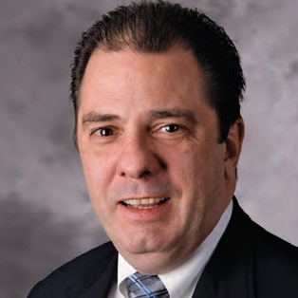

**VOTING MACHINE FACILITIES**

As in the past, Voting Machine Facility Staff continues to be more efficient in preparing the equipment for an election. The Staff have improved their knowledge of the scanners and BMDs, reducing the average time to test and prepare a scanner down to 50 to 60 minutes, from 60 -70 minutes just two (2) years ago.

This year the Board of Elections (BOE) implemented a citywide Election Day incident tracking system (Election Day Responder) using tablets. This allowed the Board to track and respond to Election Day incidents more efficiently. If a problem occurred, the Voting Machine Staff with the assistance of ES&S (the voting machine manufacturer) were able to address problems within 25 to 35 minutes, a decrease of approximately half the time from the previous year.

**JOHN P. O’GRADY**

Chief Voting Machine Technician

Voting Equipment Operations Unit/Poll Site Management Cont’d

This year the Voting Machine Facilities had to prepare all equipment required for one (1) Federal Primary and two (2) Citywide Elections.

44|45

The Board of Elections received calls, and replaced, on Election Day the following Scanners and Ballot Marking Devices:

Note: All pollsites were assigned at least one BMD.

**Election**

**DS 200 Scanners**

**Ballot Marking Devices**

**Calls**

**Replaced**

**Calls**

**Replaced**

**Number**

**Percentage**

**Number**

**Percentage**

June 24, 2014, Federal Primary Election

1,180

8

.67 %

25

1

.21 %

September 9, 2014, State Primary Election

507

6

.19 %

156

5

.39 %

November 4, 2014, General Election

1,163

15

.39 %

322

30

2.34 %

**Election**

**DS 200 Scanners**

**Ballot Marking Device**

**ED Transportation Carts**

**Privacy Booths**

June 24, 2014, Federal Primary Election

1,180

466

1,862

4,486

September 9, 2014, State Primary Election

3,097

1,271

5,029

11,997

November 4, 2014, General Election

3,830

1,277

5,106

16,099

Board of Elections | The City of New York

Annual Report 2014

Voting Equipment Operations Unit/Poll Site Management Cont’d

In addition, the Board of Elections received and documented the following Election Day Calls:

Pollsites that began processing voters after 6:00 am on Election Day:

The VEOU throughout the year continued to support and provide all the materials (i.e. reports, supplies and technical support) for the Voting Machine Facility staff.

**Election**

**Poll Site**

**Open on Time**

**Open Late**

**Number**

**Percentage**

**Number**

**Percentage**

June 24, 2014, Federal Primary Election

461

450

97.61 %

11

2.38 %

September 9, 2014, State Primary Election

1,241

1,241

100%

0

0 %

November 4, 2014, General Election

1,241

1,241

100 %

0

0 %

**Election**

**Poll Site**

**Poll Workers**

**Supplies**

**Procedure Question**

**ED Supply Carts**

**Accessibility Issues**

**Other**

June 24, 2014, Federal Primary Election

223

473

342

19

11

38

10

September 9, 2014, State Primary Election

362

1,375

858

54

71

168

133

November 4, 2014, General Election

291

1,248

818

111

59

190

97

**Total Election Day Calls for the Year**

**876**

**3,096**

**2,018**

**184**

**141**

**396**

**240**

46|47

Voting Equipment Operations Unit/Poll Site Management Cont’d

**POLL SITES**

In 2014, the Board of Elections VEOU-Poll Site Division goals were:

* Poll site schematics were prepared to show the placement of the ADA Directional signs for voters with disabilities to find the accessible entrance. Floor plans were also included to show the placement of the equipment for the election.
* To continue making polling sites, paths of travel, entrances, exits, and voting areas accessible to individuals with disabilities.
* Additional training by the surveyors was conducted in the Coordinator class to understand ADA compliance requirements.
* To ensure that each polling site is accessible, contains appropriate square footage, accessible entrance is visible, technology friendly, reliable and contains a survey that includes: schematics and floor plans for the placement of the Election Day equipment.
* Issued Special Instructions for Voting Machine Technicians to identify ADA problems during their Poll Sites visits.
* The Election Day Poll Site Accessibility Problem Reporting was enhanced. Problems identified by the new tracking system, and were followed up on.

Federal Court Order Implementation:

In response to the requirements of the United Spinal Association Court Order, the BOE met with Evan Terry Associates (ETA) the court appointed experts to discuss their survey instrument and process for conducting the surveys. The result of these early meetings was that the ETA survey instrument and procedures were enhanced. Together we reached several agreements (videos, expanded ETA survey questions, surveying by zones) and several other changes that have significantly improved the quality of information that we receive in their surveys. We accomplished these changes and maintained compliance with the requirements of the court order.

* Poll Sites determined to be inaccessible have been canceled and new Poll Sites obtained. In some instances Election Districts were moved and/or consolidated to accessible poll sites.
* A Training program was developed and implemented on the proper identification, of parts needed for the installation of all ramp related equipment.
* As in the past, frequent meetings throughout 2014 with the New York City Housing Authority and the Department of Education, were held to help facilitate ADA compliance.

The Board of Elections has identified and begun to modify system changes that will be required in order for the BOE to implement the solutions needed to eliminate accessibility barriers at poll sites identified during surveys. The solutions that will be implemented are additional staffing at poll sites on Election Day and/or equipment.

* During 2014 the Board of Elections was able to survey the following number of Poll Sites for ADA compliance:

The VEOU Department plans to implement the new changes in the system during 2015 as the result of the surveys.

To accomplish these goals the Board of Elections this year introduced or enhanced the following:

* Sent to boroughs “ADA Supply Envelopes” that contained Special Instructions for Coordinators and tools to ensure that the proper placement of equipment and the pathways are ADA accessible and compliant.
* The ADA Special Instructions for Coordinators were condensed. These instructions were used to complete the ADA Journals and Accessibility Complaint Logs. Additional instructions were also included for polling sites that have Alternate Entrances, no Alternate Entrances, and for the use of Door Bells to be in compliance with ADA requirements.

**Borough**

**Poll Sites Surveyed in 2014**

Manhattan

134

Bronx

5

Brooklyn

8

Queens

14

Staten Island

7

**Citywide**

**168**

Facilities Operations

Board of Elections | The City of New York

Annual Report 2014

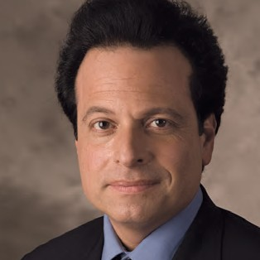

In 2014 the Facilities Department began the renovation of our General Office at 32/42 Broadway, which upon completion, includes all new paint and flooring along with bathroom and kitchen upgrades.

Department of Citywide Administrative Services (DCAS) and The Board had a kickoff meeting in Queens to begin the move of the Queens Borough Office from their current location at 126-06 Queens Blvd. to the new location at 118-35 Queens Blvd. on floors 11, part of 10, as well as an area designated for customer service in the lobby.

Additionally, the building our Manhattan VMF is located in at 450 West 33rd Street is being renovated. Upgrades include an entire new glass façade to the building’s exterior, new lobbies, elevators and mechanical rooms. New paint, flooring repairs and other upgrades will be provided to the Board as recompense for our inconvenience during this large scale renovation.

**NICHOLAS SQUICCIARINI**

Facilities Manager

Finally, City Time was installed and instituted in all Board offices in 2014.

48|49

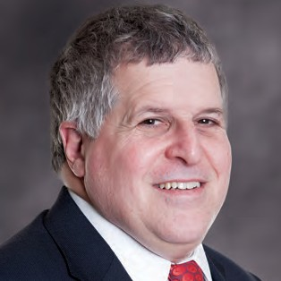

Procurement Department

The Procurement Department’s function is to oversee and process all of the Board of Election contracts for goods and services to ensure compliance with the New York City Procurement Policy Board Rules (known as the PPB).

The PPB was developed to ensure that all city agencies’ procurement practices are uniform in application; and provide fair and equitable treatment to all persons doing business with the city.

**VENDOR DATABASE**

The Board continues to expand its database of vendors. The Board continues to investigate ways to increase competition for goods and services and cost savings for the agency. The Board also avails itself of the many DCAS Citywide and State OGS contracts where cost savings can be maximized.

**SHERWIN SUSS**

Agency Chief Contracting Officer

**PREFERRED SOURCE SOLUTIONS**

The Board continues to aggressively expand its use of Preferred Source providers through NYS Industries for the Disabled (NYSID), receiving excellent services at competitive prices while providing employment to New Yorkers with disabilities.

One of our recent successes with the NYSID vendor is our current contract with SHRED ability, which employs people with disabilities at its local shredding facility. With the legally-mandated shift to a paper-based electronic voting system in 2010, the Board had to devise a means to securely destroy millions of ballots following their retention period. SHRED ability has removed, shredded, and re-cycled over 350 tons of paper from our warehouses at lower rates than any other company.

Where possible and applicable, the Board strives to use local or NY based companies. In this way the Board contributes to the overall economic multiplier effect that plays a vital and supportive role in NY’s economy.

Board of Elections | The City of New York

Annual Report 2014

Electronic Voting Systems Department



*“The mission of the Electronic Voting Systems (EVS) Department is to administer and support the Board’s computerized voting systems during pre- and post-election activities conducted in each of the five counties in the City of New York.”*

The Board’s computerized voting systems administered and supported by the EVS Department include the Central Scanning and Tabulation System for Absentee, Military, Federal, Presidential and Affidavit Ballots; the Election Management System for Ballot Marking Devices (BMD); and the Poll Site Voting System (PVS) used at the poll sites on Election Day. EVS prepares these systems by populating them with the data needed for each election. EVS also works with the system providers to ensure all systems meet the unique requirements of the New York City Election process. In addition, EVS helps develop enhancements (subject to State Board of Elections (SBOE) approval and certification) that improve upon the smooth operation of the systems.

**JOHN NAUDUS**

Director, Electronic Voting Systems

EVS provides assistance and support during pre- and post-election activities in each county. Some of these activities include:

* Testing the Central Scanning and Tabulation System for Absentee, Military, Federal, Presidential and Affidavit Ballots
* Writing the Portable Memory Devices (PMD) with the specific data parameters required for each election
* Reading the PMDs that contain the results from each Poll Site Voting System scanners
* Re-canvassing election results
* Canvassing ballots for Write-in Votes
* Auditing the Poll Site Voting System results
* Auditing the Central Scanning and Tabulation System for paper ballots
* Canvassing Absentee, Military, Federal, Presidential and Affidavit Ballots

The Board conducted three elections in the year 2014: the June Federal Primary, the September State and Local Primary and the November General Election. The Poll Site Voting System (PVS), the Ballot marking Devices (BMD), and the Central Scanning and Tabulation System for Absentee, Military, Federal, Presidential and Affidavit Ballots were used in all three elections.

50|51

Electronic Voting Systems Department Cont’d

**UNOFFICIAL ELECTION NIGHT RESULTS REPORTING**

At the close of polls on Election Night, materials used at all poll sites were packaged, sealed and given to the NYPD. The NYPD then transported the materials to the police precincts that same night. Bi-partisan teams of Board personnel received the materials at each precinct. The materials included the Portable Memory Devices (PMDs) used in the Poll Site Voting System on Election Day. The PMDs were tracked using Radio-frequency identification (RFID) equipment and then routed to another bi-partisan team, where the PMDs were read into dedicated laptops specifically prepared to gather unofficial Election Night Results (ENR). At the end of the process, the bi-partisan teams returned the election materials to the NYPD for transport to the Board’s Voting Machine Facilities (VMF).

The ENR website was viewed on each election night after the closing of the polls (from 9:00pm to 9:00am the next morning) as follows:

**Election**

June Federal Primary

September State and Local Primary General Election

**Number of views**

130,077

290,586

164,431

See **Figure 3** for an illustration of the number of views the ENR website received on election night.

The ENR Laptops transmitted the unofficial election night results to a Secure File Transfer Protocol (SFTP) server at the General Office. Election Reporting Manager (ERM) servers at the General Office read the unofficial election results from the SFTP server. At periodic intervals throughout election night, the unofficial results were electronically transferred to the Board’s ENR website, the SBOE, the Board’s central election management system and the media.

**ARCHIVAL OF PORTABLE MEMORY DEVICE (PMD) DATA**

With Board approval, EVS made it possible to re-use Portable Memory Devices (PMD) prior to the two year maturity date required by *Election law §3-222*. *Preservation of Ballots and Records of Voting Machines*. To achieve this goal, EVS developed and implemented a strategy to retrieve data from PMDs used in an election or testing and stored the data on a dedicated server. The server maintains the data retrieved from the PMDs for the mandated two year timeframe, and the PMDs are prepared for use in the next election. To accomplish this task, EVS developed the software used to extract the data from the PMDs. EVS also developed detailed procedures and tracking materials to use in conjunction with this software.

On the night of the General Election, in addition to using the ENR Laptops at the precincts, the Board implemented a Pilot Program for the electronic transmission of unofficial election night results directly from the poll sites after the closing of the polls. In over 200 poll sites throughout the five counties, teams of bi-partisan Board personnel used Android Tablets, with software developed by EVS, to transmit unofficial election results directly from the poll sites to an SFTP server at the General Office. The Board received results from 22% of the PVS systems from the closing of the polls at 9:00pm until 9:30pm. The outcome was a significant improvement in time from the results received from less the one percent of the PVS systems, within the same timeframe on the night of the 2013 General Election. This Pilot Program provided a more efficient distribution of unofficial election night results.

Teams of bi-partisan personnel completed this work in each of the five counties using the software, procedures and tracking materials provided by EVS. EVS provided on-site guidance and support throughout the entire archival process.

**BALLOTS**

For all of the Elections in 2014 combined, more than 1,430,000 ballots were cast in the city of New York. About 66,000 ballots were Absentee, Military, Federal and Affidavit ballots that were processed by the central scanning and tabulation system, or manually tabulated. In addition, more than 1,370,000 paper ballots were cast at poll sites, and scanned and tabulated by the Poll Site Voting System (PVS). See **Figure 4** for an illustration of the ballots cast in 2014.

For a breakdown of the use of both the ENR Laptops and the Android Tablets for obtaining unofficial election night results, please see **Figures 1 and 2**.

**UNOFFICIAL ELECTION NIGHT RESULTS WEBSITE**

The Board published unofficial Election Night Results (ENR) on its website for all elections in 2014. EVS developed the ENR website to work in tandem with the ENR reporting process. The Board electronically updated this website at periodic intervals, making the latest unofficial election night results available for public viewing.

EVS continues to explore and develop innovative ways to improve the Board’s computerized voting systems and enhance the voting experience for the City of New York. Please see **Figure 5** for a historic perspective of the mechanical and electronic voting systems used since the founding of the Board of Elections in the City of New York.

Figure 3

Board of Elections | The City of New York

Annual Report 2014

Electronic Voting Systems Department Cont’d

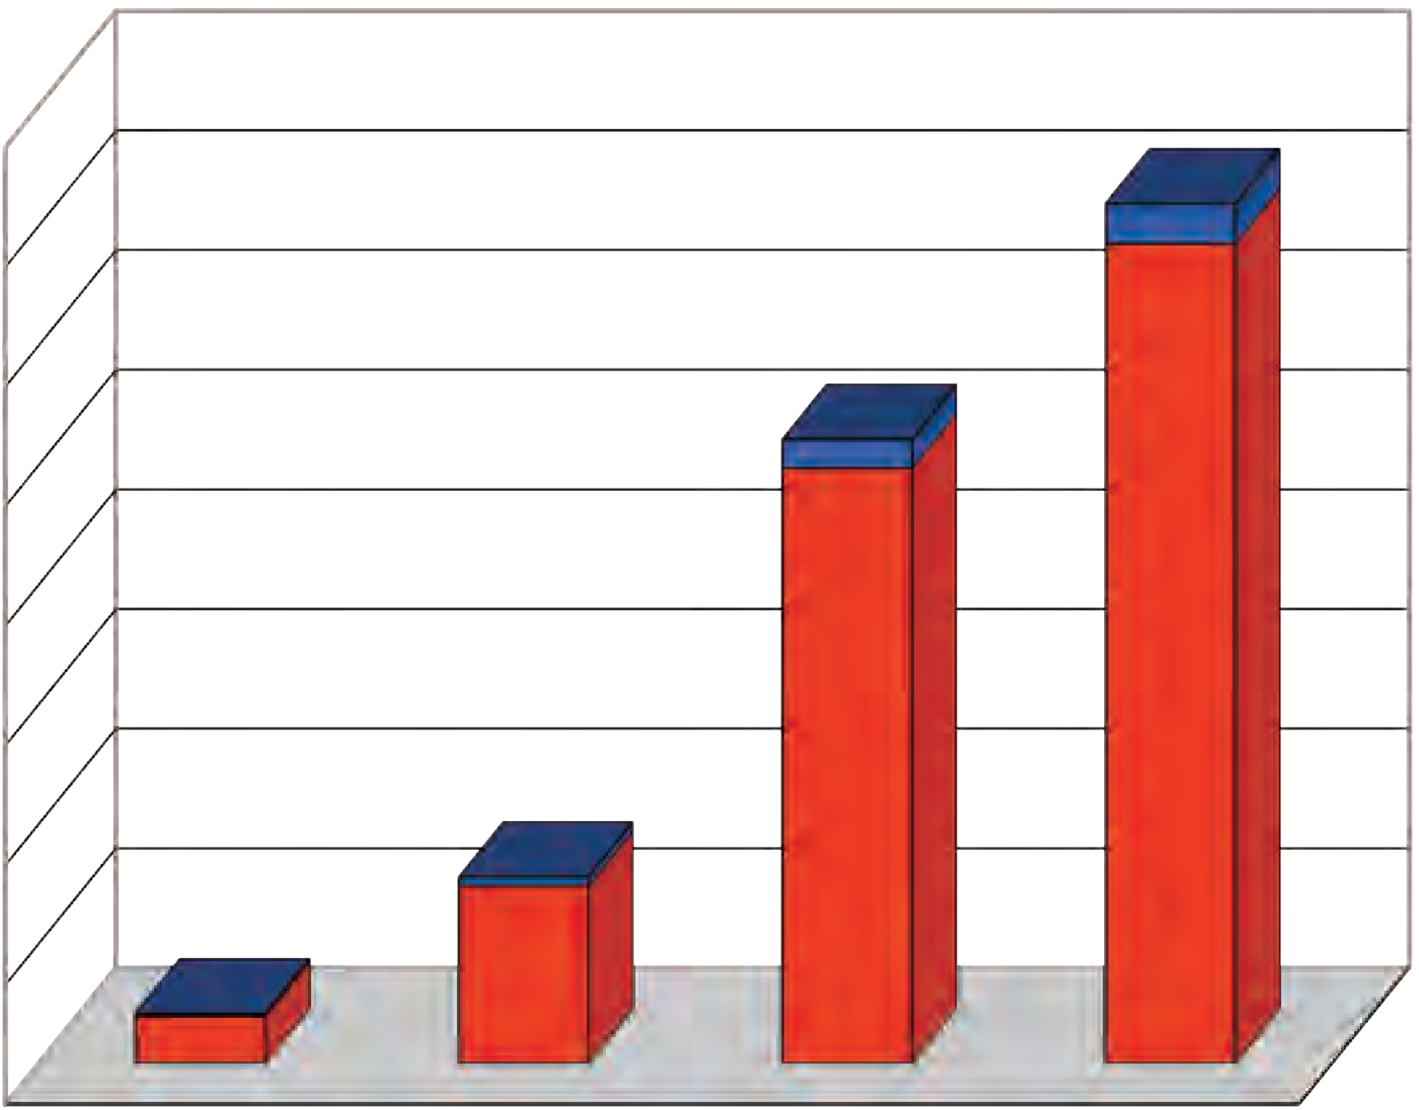

Figure 1

* Could not be read due to improper closing of the Pollsite Voting System (PVS)

** PMD not delivered to Precinct to be read

*** Hardware malfunction

Figure 2

Figure 4

**PMDs  Rec**   **eived**

Number  of  Hits

ENR  Web  Site  Hits  Compared  -­‐  ElecEon  Night  9PM  to  9AM

90,000

2014  General

80,000   2014  Primary

2014  Federal  Primary

70,000

60,000

50,000

40,000

30,000

20,000

10,000

0

21:00  -­‐  21:59  22:00  -­‐  22:59  23:00  -­‐  23:59  00:00  -­‐  00:59  01:00  -­‐  01:59  02:00  -­‐  02:59  03:00  -­‐  03:59  04:00  -­‐  04:59  05:00  -­‐  05:59  06:00  -­‐  06:59  07:00  -­‐  07:59  08:00  -­‐  08:59

**Ballots Tabulated in 2014 Elections**

**1,600,000**

**1,400,000**

**1,200,000**

**1,000,000**

**800,000**

**600,000**

**400,000**

**200,000**

**0**

**Federal Primary State & Local Primary General Election All Elections**

Ballots tabulated by the central scanning system or manually

Ballots tabulated by the Poll Site Voting System (PVS)

ENR  Time  Series  Compared

450

400

350

300

250

200

150

100

50

0

9:00   PM

9:10   PM

9:20   PM

9:30   PM

9:40   PM

9:50   PM

10:00   PM

10:10   PM

10:20   PM

10:30   PM

10:40   PM

10:50   PM

11:00   PM

11:10   PM

11:20   PM

11:30   PM

11:40   PM

11:50   PM

12:00   AM

12:10   AM

12:20   AM

12:30   AM

12:40   AM

12:50   AM

1:00   AM

1:10   AM

1:20   AM

1:30   AM

1:40   AM

1:50   AM

2:00   AM

2014  General

11

327

381

153

80

122

159

251

264

273

292

305

269

240

180

102

106

95

55

22

22

8

0

0

5

19

15

0

0

0

0

2014  Primary

0

1

6

50

127

173

185

255

258

310

291

266

251

184

140

107

71

69

52

43

33

31

25

21

26

15

8

5

6

1

0

2014  Federal

0

0

0

11

16

55

103

104

113

125

122

108

121

75

70

57

29

11

12

6

4

4

6

2

2

0

0

0

0

0

0

2013  General

0

0

0

10

13

35

81

108

155

223

272

282

319

339

297

300

273

206

200

191

125

113

84

52

52

30

42

22

16

12

7

**Election Night Results Portable Memory Device (PMD) Count**

Total PMDs Used

PMD Data Received

Percentage Received

PMD Data Received with Errors*

PMD Data Not Received**

PMD Malfunctions***

**Federal Primary**

1,185

1,155

97.47%

7

30

0

**State & Local Primary**

3,105

3,058

98.49%

48

47

0

**General**

3,845

3,782

98.36%

26

63

0

52|53

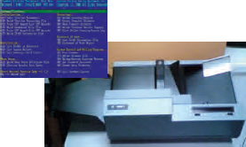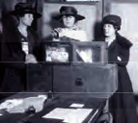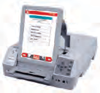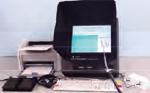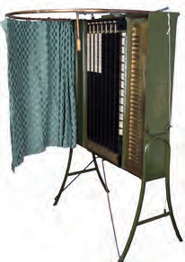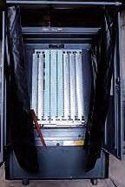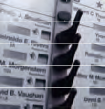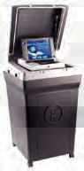

Electronic Voting Systems Department Cont’d

Figure 5

****



 

 

   

    

    

    

    

 

   

    

    

    

       

     

    

     

  





Board of Elections | The City of New York

Annual Report 2014

Personnel and Records Management

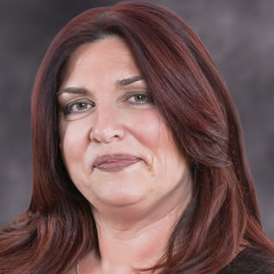

The Personnel Department is responsible for the well being of all employees at the Board of Elections. As a new employee is processed, in addition to completing the appropriate paperwork, both the Policies and Procedures Handbook and Conflict of Interest Board (COIB) Manual are provided and an Identification Card is issued.

Health Insurance, Management Benefits Fund, Deferred Compensation and Pension Benefits are the responsibilities of the Personnel Department as well as the processing of all Workers’ Compensation claims. All benefits are updated as needed throughout the tenure of the BOE employee. Verification of Employment and Unemployment Benefits applications are also processed through this Department.

**NINA CRISPINO**

Director of Personnel / Records Management Officer

For those employees in need of counseling, referrals are made through this office to the Employee Assistance Program (EAP). To encourage employees in need of the varied services offered by the EAP and make them comfortable about seeking help, a high level of confidentiality must be maintained.

Fact-finding inquiries are held when there is a complaint of harassment. What action, if any, is determined by a bipartisan panel, consisting of the Director of Personnel and a member of the Legal Department and/or other staff member.

Matters of discipline fall under the jurisdiction of the Personnel Department. Alleged Violations of the Policies and Procedures Manual are investigated and hearings held as necessary.

Disciplinary hearings are conducted and actions are taken under the direction of the Commissioners of Elections. If a hearing determines that a violation has occurred, the employee may be reprimanded or disciplined. The disciplinary actions may include probation, suspension or termination.

The Director of Personnel also serves as the Records Management Officer for the Agency. Monitoring the storage and disposal of Agency Records following the guidelines set forth by the NYS Retention and Disposition Schedule.

54|55



Finance

The work of the Finance Office, probably uniquely, is not really keyed to the Election cycle. Rather than having a “busy season” the Finance Office does a fairly consistent volume of work at every point in the year.

The Finance Office is divided into two sections:

**1) PERSONAL SERVICES (PS)**

Personal services are the payroll section. Payroll data is accumulated from the five borough offices, Voting machine facilities and the General office and is processed. There is a constant liaison between the various responsibility centers. There is also a natural overlap between the work of the PS section and the board’s Personnel Department.

**GERALD SULLIVAN**

Finance Officer

**2) OTHER THAN PERSONAL SERVICES (OTPS)**

The O.T.P.S. section is the accounts payable section. Approved bills are accumulated from the various managers and paid. Finance works closely with the Agency Purchasing Department.

The Finance Department prepares reports and handles special projects as required. Finance plays a key role in all aspects of the Agency’s budgeting process. In addition the Finance Office drafts letters and testimony for Management for those subjects that fall within our sphere of responsibility. The Finance Officer accompanies and assists management when testimony relative to fiscal matters is given.

The Finance Department provides the fiscal infrastructure for the smooth running of all day to day operations of the New York City Board of Elections.

**FISCAL YEAR 2014 BUDGET HIGHLIGHTS**

In Fiscal Year 2014 the Board of Elections conducted the following election events: a Citywide Primary, Run-Off Election for Public Advocate, a Citywide General Election, and a Federal Congressional Primary. The Federal Congressional Primary Election took place in the last week of the fiscal year. Due to the hard work and cooperation of the New York City Council and the Office of Management and Budget, the Board was able to overcome any fiscal hurdles.

Finance Cont’d

Board of Elections | The City of New York

Annual Report 2014

**Voting Machine Trucking & Transportation 5%**

**Other 9%**

**Payroll 23%**

**Postage 2%**

**Uncommitted Poll Worker Funds**

**6%**

**Poll Workers 18%**

**Printing 11%**

**Rent 14%**

In the spring of 2014 the Commissioners of the Board of Elections unanimously selected the Office of Payroll Administration (OPA) sponsored CityTime web-based timekeeping system to replace the “time card/punch clock” method of recording Board of Election employee time.

**FINANCIAL ANALYSIS FOR FISCAL YEAR 2014**

(A New York City Fiscal Year runs from July 1st to June 30th of the following calendar year)

An inter-departmental Project Team was established here at the Board to carry out the mandate of the Commissioners. The Project Team (spearheaded by the Board’s Finance Department) included the Payroll, Management Information Systems and Facility Management departments. This team was tasked with coordinating with OPA, Financial Information Services Agency (FISA) and the Department of Information Technology and Telecommunications (DoITT) the installation of the hardware/ software (hand scanners and personal computer connectivity to OPA’s website); the training of BoE personnel in the functionality and utilization of the CityTime system; and the implementation of the system at all BoE facilities.

**BOARD OF ELECTIONS BUDGET BREAKDOWN FY14**

Thanks to the efforts of the General Office Project Team along with the cooperation of the Chiefs and Deputy Chiefs and administrative staff of the five borough offices implementation of the CityTime system was successfully completed at all of the Board’s facilities by February 2015.

**Uncommitted Funds**

**12%**

**ELECTIONS RELATED COST FOR CALENDAR YEAR 2014**

**Federal Congressional Primary - 6/24/14**

**Primary - 9/9/13**

**General Election - 11/4/14**

**Advertising**

$86,068

$355,039

$375,970

**Ballot Printing**

$682,577

$1,950,407

$4,563,409

**Election Event Printing**

$205,017

$597,191

$470,561

**Technical Support**

$477,000

$820,000

$849,015

**Voting Equipment Trucking**

$338,752

$1,039,612

$1,221,219

**Election Day Staff Transportation**

$240,868

$482,132

$517,004

**Rentals of Poll Site Furniture**

$43,236

$108,897

$124,506

**Postage - Notice to Voters**

$0

$886,982

$886,982

**Miscellaneous Election Event Equipment**

$0

$162,255

$698

**Poll Site Rental**

$30,490

$1,800

$134,615

**Poll Workers**

$1,836,908

$5,058,243

$5,673,737

**Total**

**$3,940,916**

**$11,462,558**

**$14,817,716**

**FY14 Adopted Budget**

**FY14 Final Budget**

Personal Services

$63,117,347

$70,517,347

Other Than Personal Services

$72,874,940

$71,365,642

Total

$135,992,287

$141,882,989

Staff

368

368

56|57

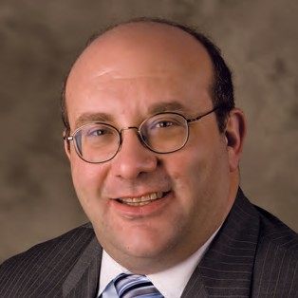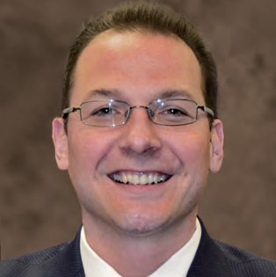

Legal Department

The Legal Department provides legal counsel to the Commissioners of Elections and to the Board’s executive staff on a wide range of matters relating to ballot access, the conduct of elections, and governmental agency administration.

**ADMINISTRATION**

The Legal Department drafts for consideration and adoption by the Commissioners all election calendars. The Legal Department drafts for consideration and adoption by the Commissioners proposed Rules for Designating and Independent Nominating Petitions. In addition, the Legal Department recommends to the Commissioners revisions of formal Board policies and procedures to ensure legal compliance.

**LEGISLATIVE ACTIVITIES**

The Legal Department regularly monitors all legislative and judicial action that impacts election administration and advises the Commissioners on all legal developments affecting the administration of elections, including statutory compliance with State and Federal mandates related to the Voting Rights Act and the Help America Vote Act and related judicial directives. In addition, the Legal Department drafts for consideration by the Commissioners the Board’s annual proposal of legislative amendments for presentation to, and consideration by, the State legislative leaders.

**STEVEN H. RICHMAN**

General Counsel

**RAPHAEL SAVINO**

Deputy General Counsel / Director of Campaign Finance Enforcement

**COMPLIANCE ACTIVITIES**

The Legal Department advises the Commissioners on all elements of the Board’s compliance with the federal Voting Rights Act. Any change in election administration affecting voter election participation in a covered county* must be approved in advance by the Department of Justice. To ensure compliance with the Voting Rights Act, the Legal Department oversees the preparation and filing of all applications to be submitted to the Civil Rights Division of the United States Department of Justice and the Legal Department advises the Commissioners accordingly.

**BALLOT ACCESS**

In addition to drafting the proposed Rules for Designating and Independent Nominating Petitions, the Legal Department oversees all aspects of the process for candidate filing and Board review of nomination petitions. In addition to overseeing this Board function, the Legal Department acts as liaison with the Board’s trial counsel in connection with any judicial review of related Board function.

**LITIGATION**

The Legal Department acts as the Board’s liaison with the Board’s trial counsel on all matters of litigation involving the Board of Elections, its operations, and personnel.

* In New York City the counties covered by the Voting Rights Act are New York County, Kings County, and Bronx County.

Board of Elections | The City of New York

Annual Report 2014

Management Information Systems Department (MIS)



**OVERVIEW**

The MIS Department had another full and challenging year in 2014. The three major election events compressed all our activities and initiatives, requiring maximization of all our limited resources. Challenges required the Department to respond to short deadlines, while at the same time, providing ongoing operational support, systems enhancements and major new development. As we have for some time in 2014 we were again working with staff limitations, and a full spectrum of installing new hardware, systems software, server operational structure and data network facilities for Executive Office (EO) and Disaster Recover (DR) data centers. While at the same time upgrading, developing and installing new and advanced computing capabilities such as mobile and cloud computing.

**STEVEN FERGUSON**

Director, MIS

We began the process of upgrading to new redistricting software for use in our maintenance and future production of districting information and maps. What we accomplished in 2014 would not have been possible without the dedication and efforts of key staff members and our consulting/development group (IMI, SageSmith and N-Tier).

**MIS AREAS OF RESPONSIBILITIES**

The MIS Department is responsible for all BOE **Election Information Systems (EIS)**, operations and management of two major data centers, user support, email and data security systems, data networks, phone systems and the print shop. In addition we continue to maintain the redistricting program and maintain and updated district information and interfacing with City Planning.

**MIS INFORMATION SYSTEMS DEVELOPMENT PROGRAMS 2014**

The following is a summary of our major information systems and operational support programs for 2014. These programs included planning, requirements determination, design, development, testing, training and implementation within the integrated framework of our **Election Information Systems (EIS)**. The major subsystems include **AVID**, **S-Elect/S-Elect 7** and the new mobile application subsystems **M-Elect**.

58|59

Management Information Systems Department (MIS) Cont’d

EIS CORE S-ELECT/S-ELECT 7 SUB-SYSTEMS DEVELOPMENT & EXTENSIONS

There were also a number of significant enhancements to S-Elect particularly in the Poll Worker and Call Center modules. SageSmith also consulting with IMI and n-Tier in assisting MIS in a major new operational program regarding Virtual Machine rollout, installation of fully-qualified resource naming and the voter registration database redesign. The following are the major 2014 enhancements to the EIS Core S-ELECT/ S-ELECT 7 Sub-Systems.

**6.**

**Candidate**

a.

b.

c.

d.

e.

f.

g.

Enhanced Court Ledger Report Created new Ballot Ordering Report Removed Language from Lotting Enhance Multiple Designation Letter

Added Filters to Financial Non-compliance Report Enhanced Contest List Approval Process Redesigned COV capture for better processing

**1.**

**2.**

**3.**

**Modernized Encryption**

**Incorporated new Unused ED/AD table Created Faster more Robust Scanning Solution**

a. Handled two new ADA documents

**Poll Worker**

**7.**

**Election Night Reporting**

1. Added QR Code to ENR Clerk Certificate
2. Changed ENR progress from stick-based to site-based

**Results**

1. Enhanced discrepancy page for mouse over details
2. Added Federal Military Write-In capability

**Call Center**

**8.**

**4.**

a.

b.

c.

d.

e.

f.

g.

h.

i.

j.

k.

l.

m.

n.

o.

p.

q.

r.

s.

Added cell phone to phone search Added standby report

Added prompt to Payroll Signer “Are you sure you want to sign as?” Updated assignment of Support Staff by Site List

Created Event Site List Report

Incorporated changes to Poll Worker Pay File Streamlined App flow navigation

Updated Notice to Work, Notice to Train, Renewal and Availability Notices Changed Order of First name and Last Name

Streamlined load of Facility Rooms for PW Class page Added new Trainer Report

Added Warning when an employee ID is already taken

Added an option to choose positions that will receive Work Notices Sped up last renewal processing

Created “Hold payment” mechanism off signoff of payroll file Automated Special Absentee Process

Added Report for Training Supply Needs based on poll worker population Added more slots for Assistant Trainers to a class

Added facility to automatically pay an assistant trainer like a trainer

**9.**

a.

b.

c.

d.

e.

f.

g.

h.

i.

j.

k.

Suppress duplicated on resource workload Removed print button on resource workload

Made all created/assigned/resolved by names uniform Added Technician Phone Number to Technician Page

Added coordinators and cell phones to Poll Site Details in Tracker drill down Enhanced Event Support Team Report

Added SUR to type key in Support Staff page

Added a naming guide next to the name field on Support Team page Added County Filter to Support Staff page

Added filter for Personnel Type to Support Staff Page Optimized call counting to use “exists”

EIS MOBILE SUB-SYSTEM DEVELOPMENT & EXTENSIONS

The 2014 saw significant new development and enhancements to EIS Mobile applications including ElectionResponder.com, ElectionDayWorker.com and PollSiteLocator.com permitting them to work on any device using a modern browser without the need of hosting a mobile and desktop solution for each site. These enhancements to our EIS Mobile Suite include:

**5.**

**Facility**

a.

b.

c.

d.

Added School Building ID to General Tab

Added Facility Equipment Requirement Change to Facility Activity Added Indicator of Unused EDADs in Facility ED Info Tab

Added Batch BDEL decision Processing

**1.**

**Election Day Worker**

a.

b.

c.

d.

e.

f.

Added Employee ID to Compare Page Updated password strength algorithm Enhanced Emailing

Added Change and Availability Numbers to Queue Stats

Added User-definable Effective and Expiration Date Processing for Applications Added Renewal Processing

Board of Elections | The City of New York

Annual Report 2014

Management Information Systems Department (MIS) Cont’d

g.

h.

i.

j.

k.

l.

m.

n.

o.

p.

q.

r.

s.

t.

Added Availability Notice Subsystem Added Notice To Train Subsystem Added Notice To Work Subsystem Added Class Cancellation Subsystem

Added Log for Verified and Compared Applications Enhanced User interface (removed growls)

Added Primary Navigation Enhanced Password Reset Added Poll Worker Dashboard

Added “On Hold” to applicant status and queues Added Poll Worker “Change Request” transaction Handle addresses outside of the city

Added User Email Change Process

User Interface Overhauled to use Responsive Design enabling use of any modern device

t.

User Interface Overhauled to use Responsive Design enabling use of any modern device

Created a Homepage with Sign in and Password Recovery

Enhanced system to auto-detect Production or Training Data Sources Incorporated Technical Support Email/Kayako Support

Enhanced “My Ticket” queue to include open and resolved status Added a sign up page for AD Monitors and Techs

Added Failover partner for Database

u.

v.

w.

x.

y.

z.

**3.**

**Poll Site Locator**

a.

b.

c.

d.

Added Language to Ballot Styles Enhanced Emailing

Created “Street Finder” application

User Interface Overhauled to use Responsive Design enabling use of any modern device

**4.**

**Election Hub**

a.

b.

c.

d.

e.

f.

g.

Updated live map to use different colors for opened and resolved Enhanced Emailing Process to Hub

Added Web hooks to log Email activity Added Chron Scheduling to Hub Services

Created Hub Services – for handling asynchronous activities for Hub Restricted audit of Encrypted fields

Added Cover Image to Branding Page

**2.**

**Election Responder**

a.

b.

c.

Added a Call Type Filter to Ticket Queue Added Responder Profile Page

Added a CC2 External Contact Registration Mechanism (for ES&S workers and others)

Added visual indicator for oldest ticket and a new ticket indicator Obtained (from S-Elect) and displayed Poll worker’s full name in ELR where appropriate

Optimized flow to ensure comments are optional

Added a flag in Call Incident Table to indicate ELR involvement for better reporting Optimized Ticket retrieval by creating a Ticket Summary Class for CC2 and ELR Improved Navigation after ticket creation

Added “Accessibility” Speed Ticket option in site detail Added position context for non-vacant coverage items Created a management-level view on a map

Updated wording for Robot Detector

Enhanced Ticket Search Box with ticket number placeholder Changed registration to use Production settings only Enhanced Dashboard

Mapped ELR User ID into Select User table Added Surrender Reasons for Tickets Enhanced Rover list to indicate “My Tickets”

d.

e.

**5.**

**Built an admin info request form Election API**

a. Enhanced Emailing

**Election Street**

a. Created Sample project for users

**Slink Sync**

a. Added Wizard to create slink sets to soft-code data synchronization

f.

g.

h.

i.

j.

k.

l.

m.

n.

o.

p.

q.

r.

s.

**6.**

**7.**

EIS CORE AVID SUB-SYSTEM DEVELOPMENT & EXTENSIONS

AVID Registration 2014 development activities can be divided into three areas. First, we added a few new user-requested features to AVID Voter Registration. Second, we modified AVID to take advantage of new technical platform upgrades deployed at the BOE. Third, we developed new modules and completely re-wrote AVID to exploit a new, less paper-intensive future.

1. **New User Features** – The following user features were added to improve the absentee process, NVRA statistics gathering, and culling the voter rolls:
   1. New nursing home module to produce facility enrollment and ensure nursing home residents are coded with correct absentee type.

60|61

Management Information Systems Department (MIS) Cont’d

b.

Additional absentee types processing for poll workers and new fields for MOVE (Military and Overseas Voter Empowerment) voter support.

b.

Also in December 2014, we tested AVID 5.1 with the new Satellite components optimized for electronic transactions and new administration and security functions. Importantly, we have designed the backend with robust queueing architecture. One of the advantages of this approach is that we will be publishing an API (scheduled for the first quarter of 2015) to permit authorized systems to send electronic transmissions through the Cloud to the Board of Elections. We have had early discussions with CUNY to perhaps being an early adopter for this new interface.

In December 2014, we began preliminary development and testing of a new online voter registration web application as part of the EIS Mobile AVID subsystem. The Online Voter Registration is designed to be a website for any New York City resident to securely keep his or her voter registration up date with a PC, tablet, or phone. This includes regular, military, and overseas voters. The website offers translations for registration document processing in English, Spanish, Chinese, Korean, and Bengali. Further, the voter will be able to use the website to fill out applications to request regular, military, overseas, and special presidential absentee ballots.

As we move into 2015 it is important to note, as part of our EIS Mobile - AVID Satellite architecture, the web applications are also designed to be used as a possible tablet-based kiosk for New York City agencies covered by the Pro Voter law. With proper security credentials, the website’s review registration screen can be called with parameters set by an external system such as one in a city agency. The voter information would be prefilled from the parameters. The voter might need only to select his/her desired political affiliation, sign the tablet and the transaction will be sent to the Board of Elections in real time. Deploying agency kiosks will obviously involve cooperative design work with each Agency, but we have invested significantly in design and programming to be ready on our end.

c.

New functions and reporting for cancelling voters Administration deceased lists.

Improved rollup and NVRA Report statistics to state. Added Bengali language translations to voter notices.

from

Social

Security

d.

e.

**2.**

**Platform Upgrades**

a.

We made some AVID database design changes and modified stored procedures to take advantage of a major SQL database version upgrade. Made minor AVID modifications, tested, and deployed AVID running in a virtual server environment.

Upgraded AVID technical architecture to latest development patterns and toolsets during re-write. These new methods improve testing and make system modification much easier in the future.

c.

b.

c.

**3.**

**Major New Direction** – In recent years the voter registration process has moved steadily from a paper-based, labor intensive document management effort toward a platform for electronic document and transaction management. In a 2013 project dubbed “AVID Satellite,” we spent significant time envisioning and redesigning our voter registration system and extensions to accommodate this new reality. In 2014, we developed new programs and re-coded AVID and companion modules to meet many of these new design objectives. Specifically, the AVID Satellite design for voter registration anticipated automated processing of the following transactions:

d.

a.

b.

c.

d.

e.

f.

Duplicate, death, and felon notifications from the NY State Board of Elections Department of Motor Vehicle Registrations

Online Voter Registrations from voters

City Agency based registration transactions CUNY originated registration transactions Electronic Poll book transactions

BOE STAFF APPLICATION SUPPORT & DEVELOPMENT

MIS continues to support BOE Staff applications including a number of which were modified and/or extended in 2014:

**4.**

**External Voter Registration Submission** – While we started processing electronic duplicate, death, and felon notifications from the state using AVID Version 4.0 in 2013, we have made great strides toward meeting many of the other external submissions goals in 2014:

a. In March 2014, we put into production a module that queries the Department of Motor Vehicles for electronic voter registration transactions. The module reformats the data for BOE use and adds the transactions to the AVID work in process queue. To date, we have saved significant processing time on more than 50,000 registration documents received over the DMV interface. It is important to note that the AVID system still enforces the bi-partisan review and consent of all transactions including the new electronic ones.

1.

2.

3.

4.

Employee Car Tracking Applications Finance Invoice Tracking System

Testing and evaluating RFID Infrastructure

Continues operational support and testing of Election Night PMD RFID tracking Application

Voter Registration Tracking Systems Enhancements Front Counter

5.

6.

Management Information Systems Department (MIS) Cont’d

Board of Elections | The City of New York

Annual Report 2014

**DATA CENTER & GENERAL SUPPORT**

MIS is responsible for the management and operations of our two major Data Centers (Executive Office (EO) & Disaster Recovery Site (DR). These responsibilities include the maintenance and operation of the hardware, systems software, network and backup facilities including:

3.

**Begin implementation of the LAN & WAN infrastructure for the CityTime Application** agency-wide. Complete installation at the Executive Office, at the Queens Borough, at the Bronx Borough, and at the Staten Island Borough by December 2014.

**Begin implementation of Broadband Internet links** at all Borough Offices and VMFs. Complete installation at the Manhattan Borough and the Bronx Borough by December 2014.

**For all boroughs, streamline and then standardize the Main Telephone Numbers** and the Prompts associated with the Election-Day Call-Center Hotlines.

4.

1.

MIS Infrastructure, Data Centers, System Software, Data Security, Backup Operations and Processing Support

Maintaining all Application Authorizations and Access Security Management and Operation of the Help Desk Process

Maintaining and Managing the internal Email and Exchange System

5.

2.

3.

4.

**PRINT SHOP**

In 2014 the Print Shop processed expanded volumes of publications such as Street Finders, Enrollment Books, Political Calendars, Voter Cards, Poll worker Letters, Poll Site Accessibility Letters, Poll Site Change Notices, Renewal Notices, Notices to Train, Notice to Work, Coordinator Handbooks, Availability Notices, CRU Letters, Transmittal Receipts and Poll Books in support of election events. The Print Shop has been an important facility for the Board’s communication with our voting public, political constituencies and in support of the election process.

**In 2014 two key technical staff individuals (Antonio Ortiz and Craig Churaman with the support help of Louis Mejia) installed a major reconstruction of our server structure incorporating VM technology which provided a dynamic storage and processing capability resulting in a cost effective use of our physical server capacity.**

MIS Operations completed the upgrading of our entire server infrastructure at both data centers and upgrading the system software operating and database systems. Operations are in the process of upgrading all workstations to Windows 7 operating system and the upgrading of Internet Explorer (IE) to the more advanced versions, a critical requirement to our EIS applications.

The E-Mail and Exchange system is under review to assess new and expanding requirement for interfacing with multiple email facilities while maintain the integrity and security of our internal system. We will continue to test and implement appropriate changes into 2015.

**DATA NETWORK & VOICE SYSTEM**

This year we completed a number of significant projects which included:

1.

**Agency-wide WAN upgrade** from low bandwidth (4.5Mbits) T1 circuits to high bandwidth (50Mbits) EPL circuits. Also, as part of the LAN/WAN Optimization we replaced all 100Mbits Core Switches at all remote locations with Gigabit Ethernet Switches with capability to implement Access Control Lists if required in the future.

**Migrate all workstations and printers** on all 3 floors at the Executive Office to a Staging Network, and prepare the Executive Office for new VLANs (to be introduced in early 2015). Creating VLANs at the Executive Office will help (a) reduce and contain unnecessary broadcast traffic, (b) enhance delivery of key applications such as AVID and S-Elect to all users, (c) facilitate new applications such as Web-Ex and Video Conferencing, (d) allow quicker trouble-shooting and problem isolation, and (e) enhance overall security and regulation of data-traffic via ACL (Access Control Lists) applied to specific VLANs.

2.

TTY (212) 487-5496

62|63

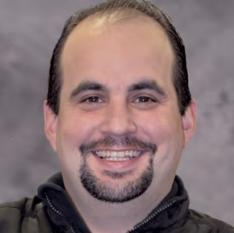

Customer Service

“The mission of the Customer Service Department (CS) is to provide information requested by any and all New York City residents.”

The CS Department is comprised of three components: (1) Inbound Call Center; (2) Reception Counter; and (3) Online Inquiry. The Department is operational throughout the year to accommodate any requests. CS provides language support in English, Spanish, Cantonese, Mandarin, Korean, Bengali, Hindi and Punjabi. CS handles a diverse range of calls, e-mails, on-line chat requests and in-person inquiries. These include requests concerning anything from a voter’s registration status or poll site location, to information about the Poll Site Voting System. In addition, the Department also supports field staff and poll workers in tracking and resolving incidents that occur at the poll sites during an election.

**DANIEL LAVELLE**

Coordinator of Customer Service

**TOTALS FOR 2014**

*New Functions added in the last quarter of 2013 include web chat and email. These applications can be found on the Board’s website vote.nyc.ny.us under the contact us page .*

**PHONE BANK**

(866) VOTE-NYC (866) 868-3692

**End of Year Call Totals 1/1/2014-12/31/2014**

Total Number of Calls

24,758

Webchat

1,062

Email

1,565

Board of Elections | The City of New York

Annual Report 2014



Ballot Management Department

The Ballot Management Department is responsible for the proofing, ordering, delivery, and maintenance of all ballots used in elections in the City of New York. Additionally, we work in conjunction with the Board’s Language Assistance Program’s Coordinator and Deputy Coordinators to ensure all ballots are translated properly and in a timely manner into all languages required by Section 203 of the Federal Voting Rights Act.

In 2014 the Board conducted three elections: a Federal Primary, State and Local Primary, and General Election. Beginning with the General Election, at the direction of the Board’s Commissioners and Executive Management we began printing ballots in no more than three languages. This meant that in while 4 of the 5 counties in the City of New York saw no change to their ballot, in Queens County as many as 3 different versions of the ballot were produced. The idea was to enhance readability of all languages on all ballots in all counties. The use of this methodology was successful; as the Board was able to produce ballots with a 50% larger font size for candidate names than it would have under the former guidelines.

**THOMAS SATTIE**

Ballot Management Supervisor

Still, in 2014 the Ballot Management Department continued to work with various advocacy and good government groups to improve the design and readability of the Election Day ballot. As a result of this effort, the Board submitted numerous recommendations for law changes to the New York State Legislature to address concerns such as small type, difficult to follow instructions, and overall readability.

All told, the Board spent approximately $6.5 million dollars for ballots to conduct the 2014 Elections, continuing to decrease the amount ballots cost for the City of New York.

In closing, the Ballot Management Department hopes to continue its mission of producing clear and easy to understand ballots for all voters in the City of New York to vote on and have their voices heard.