CONTENTS

1. COPYRIGHTS & CREDITS 2
2. INSTALLATION AND UNINSTALLATION 3
3. THE SCENERY CONFIGURATION TOOL 5
4. F.A.Q. 10
5. SUPPORT AND LINKS 11

COPYRIGHTS & CREDITS

This product and all its associated files are copyright ©Richer Simulations (www.facebook.com/richersimulations/). Any trademarks and/or logos displayed within this scenery package are property of their respective holders and are being used solely with the purpose of representing reality.
The information provided within this document, and the scenery package, is not intended for real world navigation.
Special thanks again to my testers, and of course, the fans who readily provided the information I needed to complete this project.
Special mention to Arno Gerretsen for his Autogen Configuration Manager and Jeffrey Staehli, AKA 12bPilot, for SODE, which are both distributed with this package.
In addition, thanks again go to you, the customers, who continue to support Richer Simulations.

INSTALLATION AND UNINSTALLATION

Installation

Immediately after running the installation setup, the Richer Simulations Scenery Configuration Tool (RSSCT.exe) will run. This tool will check to see if the Autogen Configuration Merger and SODE tools are installed on your system, and if not, allow you to install them if they are required for your installed products. It will also allow you to configure your product. See the Scenery Configuration Tool section for more details. The tool can also be manually run from Config\ folder.
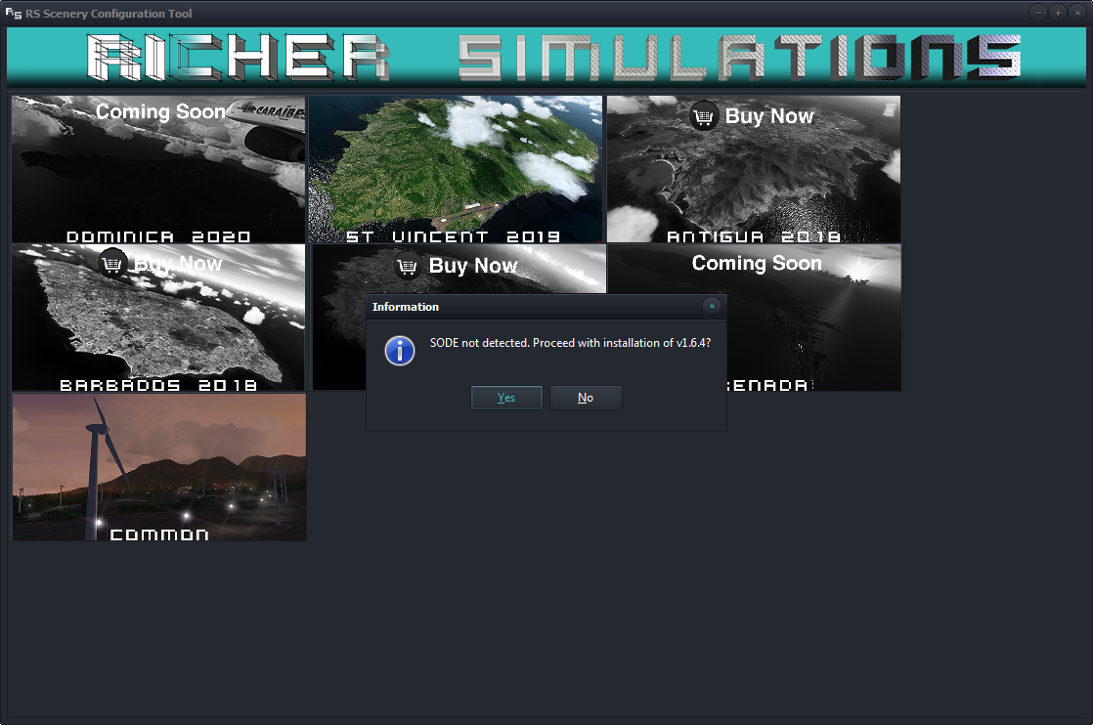

USERS OF LEGACY SIMULATORS (FSX, FSX-SE, P3DV1/2/3) WILL RECEIVE A MESSAGE TO PATCH THEIR PRODUCT. THIS IS NECESSARY BEFORE THE SIM IS RUN.
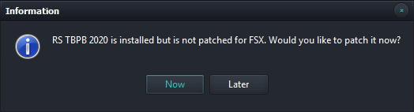
THE PATCH CAN ALSO BE DOWNLOADED BY CLICKING THE BUTTON ON THE PRODUCT PAGE OF THE TOOL.

WHEN THE RSSCT TOOL IS FIRST RUN IT WILL ASK YOU TO CONFIRM THE ADDITION OF YOUR PRODUCTS TO THE SCENERY LIBRARY.
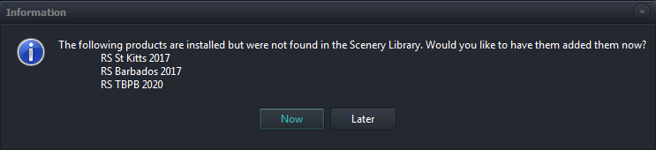 Note: *Users of P3Dv4.x will automatically have the product added via the add-on.xml.

Autogen Configuration Merger
The Autogen Configuration Merger tool is necessary so that the custom autogen trees, buildings and/or vehicles needed for the scenery can be added to your simulator. The Autogen Configuration Merger will ask for an installation path. Simply click OK.
The first time your simulator runs, you will be prompted that a new tool is running and asked to trust this tool. Since a new scenery with new autogen has been installed, a restart of your sim may be needed.
The custom autogen should now appear within the scenery. The user manual has been included in the Richer Simulations\Docs folder for more details.

SODE
The SODE tool is necessary so that functioning custom ground polygons, jetways, grass and other objects can be added to your P3D/FSX simulator.
Please follow the instructions provided in the SODE User Guide. A copy can be found in Richer Simulations\Docs.

Uninstallation
Simply run the uninstaller to remove the product completely.

THE SCENERY CONFIGURATION TOOL
This tool allows you to enable and disable features of any product installed. It can be run by opening Richer Simulations\Config\RSSCT.exe (or RS_Common\Config\RSSCT.exe for X-Plane).
It now replaces any configuration tool provided with previous Richer Simulation products.

Ensure that your simulator is closed before you make any changes. Changes occur automatically as each option is selected.

When the tool is run for the first time, it will check to see whether installed products have been added to the Scenery Library, whether the Autogen Configuration Merger is correctly installed and whether SODE is required (depending on your installed products).

Click on any image to configure your product, or on any button to purchase:

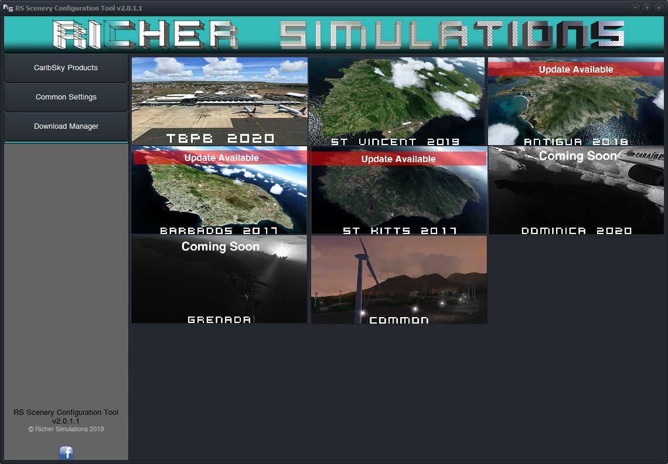

Configuring your product:
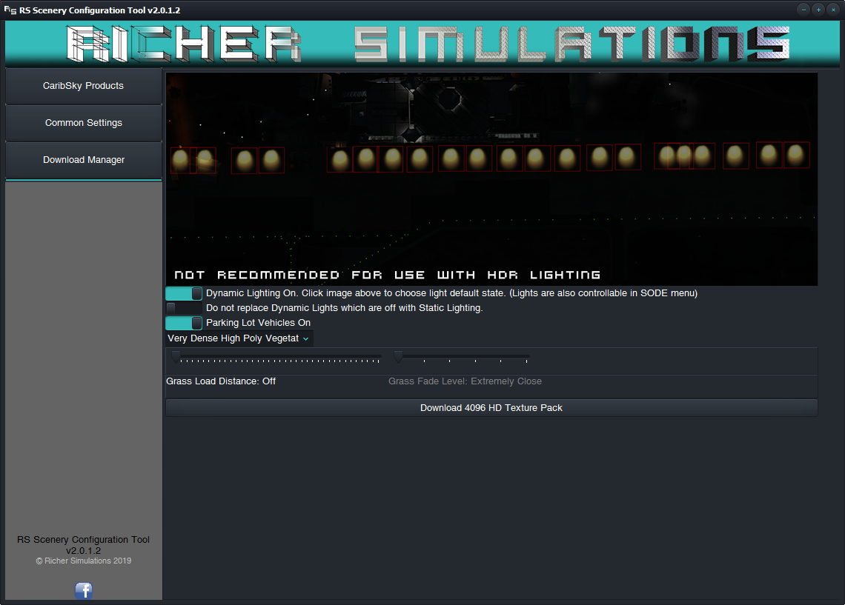
The screen above shows an example product configuration screen. Different products offer different configurations but some common options include:
- Dynamic Light’s default state: This can be set in the sim by clicking on the red squares in the image. They can also be toggled on/off inside the sim by using the SODE menu.
- Pre-rendered (static) light splashes and shadows can also be turned on for each Dynamic Light which is not loaded into the sim, in order to improve performance. HOWEVER, THIS IS NOT RECOMMENED FOR USE WITH HDR LIGHTING IN P3D.
Note: *Legacy sim users (FSX, P3Dv1/2/3) will use Static Lighting by default. X-Plane users have dynamic lights permanently enabled.
- Objects that are not immediately visible from the runway/tarmac such as the high-poly trees and parking lot vehicles can be switched off.
- 3D Grass draw distance: Only grass that is nearest to the aircraft will be loaded. The distance at which grass is loaded into the sim can be increased for higher end systems. However, you may notice the grass popping into view. To mitigate this, the grass can be faded out gradually. Simply increase/decrease the Grass Fade slider in order to find the sweet spot where the grass no longer pops into view for the distance you have chosen.
- Most products primarily uses 2048 textures. These can be replaced with 4096 Ultra HD textures.
Configuring Common Settings:
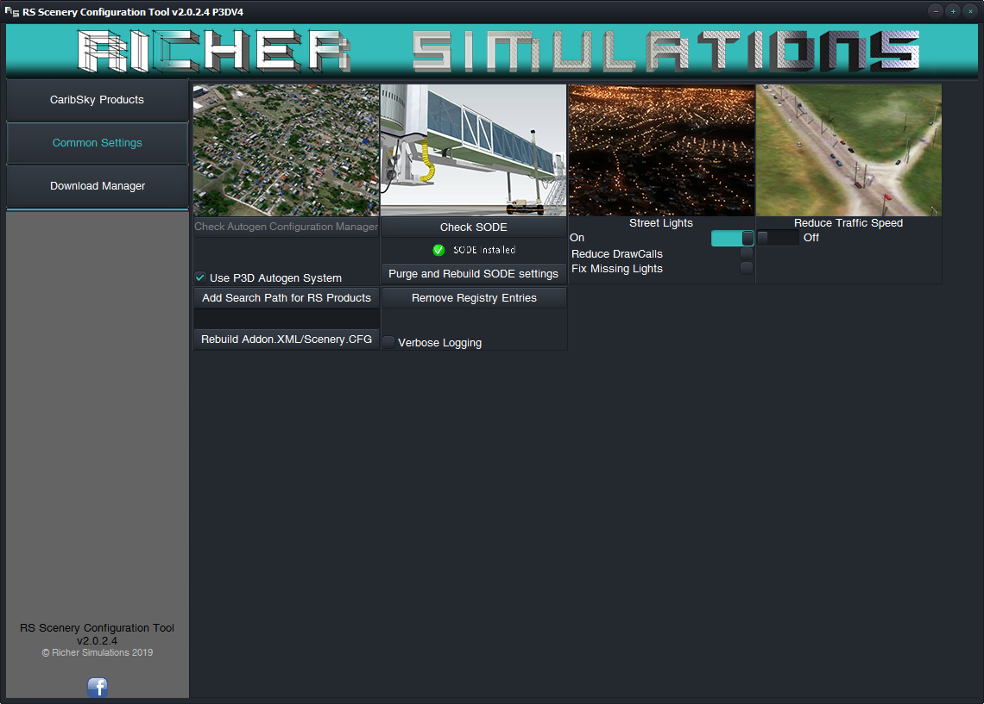

The screen above shows settings common to all Caribsky products. It also allows you to check for proper functioning/installation of ACM and SODE tools. (Users of X-Plane will not see options for ACM, SODE, Street Lights or Traffic Speed)

- Products which utilize SODE (for jetway, runway/apron and 3D grass placement) may experience missing/untextured objects. Use the button to fix these issues.

- P3Dv4.4+ users have the option to use the P3D Autogen system (via the add-on.xml). However, a bug exists where other 3rd party add-ons may override other autogen add-ons, resulting in missing autogen in some regions. You can override P3Ds autogen system and use ACM to merge autogen definitions by unchecking this checkbox.

- Products which may have been installed elsewhere can be added to the RSSCT tool if it does not find them automatically by clicking on the button

- Street Lights can be turned on or off. You can also chose to use a version of the lights which uses less drawcalls and polygons (Light halos only; no light-poles; 1 color at distance).
Users of very high autogen building density settings may experience large swaths of missing lights. This is a limitation of the sim to display only 4500 autogen objects per cell. You can chose to increase this to 5000.
Note:
  - Reducing your simulator’s Autogen settings will also reduce the number of streetlights that appear.

- The Reduce Traffic Speed option, gives a more realistic depiction of vehicle speed in the Caribbean.
Note:
It reduces the speed of all traffic in the Simulator Region (All of Central America and The Caribbean).
The default speed will be reduced to 40 km/h; however, a custom speed can be used by editing the value within the LegacyTrafficLow.txt or P3DTrafficLow.txt files within the Richer Simulations\Config folder.
The Download Manager:
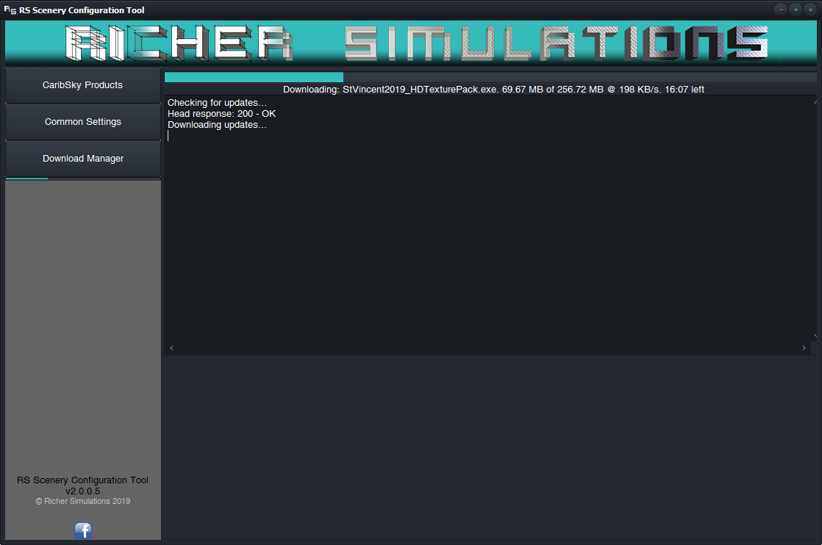
Here you can monitor the progress of any updates being downloaded.

It will notify you if there are any updates for the Scenery Configuration tool, and if there are any patches to your scenery.
Available updates will be presented on the CaribSky Products screen.

Updates to the Manager will be performed automatically after a successful download and restart of the tool. Patches to the scenery will run and ask for your confirmation before install.

Troubleshooting the download manager and the configuration tool can be done by opening the log (RSSCT.log) it writes into \Config\. Any error/success messages will be found within.

F.A.Q.

  - Q: After installing the product, I do not see any changes within my sim. Why?
A: Ensure that the products have been added to the Scenery Library. The RSSCT tool will do this automatically after it has been run and updated.

  - Q: The product appears, but has no custom autogen. Why?
A: Ensure that the Autogen Configuration Merger has been installed. This is confirmed by clicking on the button in the Common Settings section of the Scenery Configuration tool. See Section 4 for details.

  - Q: Is this scenery compatible with UTX, GEX and FS Global and Orbx Products?
A: Yes. This scenery does not make use of landclass and has its own custom mesh. A custom regions file is also provided to remove conflicts with Orbx regions. No conflicts should arise if they are given a higher priority in the Scenery Library.

  - Q: Where can I find charts and other airport information?
A: Charts are usually provided in the \Docs\ folder of each product.

SUPPORT AND LINKS

Support can be obtained via email at:
richersimulations@gmail.com
You can also find announcements and updates on our Facebook page: www.facebook.com/richersimulations
And our Instagram Page:
www.instagram.com/richersimulations

