CA2 PRESENTATION BUILD PACK

LuxLLM-Agent
Complete PPT Content Manuscript
Decision-Trace and Action-Verification (DTAV) for Lux AI Season 3
Student | Ze Wang · 201868809
Supervisor | Dr Meng Fang
Module | COMP702 — Project Video and Q&A
Prepared | 18 August 2026 · standard timeline

Deliverable purpose
Use this document to build the slides manually. It contains the exact English slide copy, a complete narration, timing, live-demo actions, image filenames, cropping guidance, evidence boundaries and final checks. The main seven slides are designed for a 9:00–9:30 recording, safely below the 10-minute CA2 limit.

Terminology rule
DTAV is a project-specific method name. Present it as the Decision-Trace and Action-Verification method developed in this project, not as an established research term and not as access to hidden chain-of-thought.

How to use this pack
Create a new 16:9 PowerPoint and work through Slides 1–7 in order. Copy only the content in each ‘Copy directly onto the slide’ box onto the visible slide. Put the English narration in Presenter Notes, and follow the layout and live-action instructions while recording.
- Create the seven main slides before adding animation or transitions.
- Insert the supplied PNG files from the image asset folder; never stretch them non-proportionally.
- Use the complete narration as a first draft, then replace difficult words with expressions you can say naturally.
- Record a timed rehearsal. Aim for 9:00–9:30, because 11:00 triggers a 10-point penalty and 15:00 or longer receives zero under the published CA2 guidance.
- Keep the three optional backup slides after the conclusion. Do not narrate them unless a marker asks during Q&A.

Recommended visual system
- Canvas: 16:9 widescreen, white or very light grey background.
- Colours: navy #163B59 for titles, blue #2E74B5 for DTAV, amber #F4B942 for verifier/fallback, green #37A866 for executed actions, muted red only for rejection.
- Type: Aptos/Aptos Display. Slide titles 34–40 pt; body 20–24 pt; captions 14–16 pt; headline numbers 44–54 pt.
- Density: one claim per slide. Prefer one large screenshot or one simple pipeline over grids of small panels.
- Transitions: use only Fade. Avoid motion paths, decorative icons and text animation that competes with the live demo.

Nine-minute run sheet
No. | Section | Target | What the viewer should learn
1 | Title + ethics | 0:25 | What the project is and why it is ethically A0.
2 | Game challenge + RQ | 1:10 | Why direct prompting is a meaningful baseline.
3 | Direct Prompt vs DTAV | 1:10 | What is controlled and what differs.
4 | Viewer + live demo | 3:00 | How a recorded proposal becomes an inspected action.
5 | Code boundaries | 1:00 | Where state, decision and execution control are separated.
6 | Formal evidence | 1:30 | What the matched experiment supports.
7 | Answer + limitations | 0:55 | What can and cannot be concluded.

Slide 1 — Title and ethical compliance
SECTION  SLIDE 1 | TIME  0:00–0:25 | PURPOSE  Identify the software, method, student and ethical category immediately.

Copy directly onto the slide
LuxLLM-Agent
An Inspectable LLM-Based Method for Lux AI Season 3
Decision-Trace and Action-Verification (DTAV)
Ze Wang · 201868809
Supervisor: Dr Meng Fang · COMP702
ETHICAL CATEGORY A0 — No human/animal-derived data and no human participants. University ethical guidance followed.

Layout and build instructions
- Use a clean title slide with the project name at upper left and a small DTAV subtitle below it.
- Place the A0 ethical statement in a clearly visible footer band. It must be readable without zooming.
- Do not place a game screenshot on this slide; the title and ethical declaration are the visual focus.

English narration script
Hello, my name is Ze Wang. This project is LuxLLM-Agent, an inspectable LLM-based method for decision-making in Lux AI Season 3. The project-specific method is called Decision-Trace and Action-Verification, or DTAV. The project uses no human participants and no data derived from humans or animals, so its ethical category is A0, and I followed the University of Liverpool ethical guidance.

Recording cue
Pause for one second after saying “DTAV”, then move to Slide 2. Keep this opening calm and under 25 seconds.

Slide 2 — Game challenge and research question
SECTION  SLIDE 2 | TIME  0:25–1:35 | PURPOSE  Define the game characteristics and establish the direct-prompting research problem.

Copy directly onto the slide
Why this game challenges directly prompted LLMs
PARTIALLY OBSERVABLE — information is incomplete and changes over time
MULTI-UNIT — several units require coordinated actions
LONG-HORIZON — exploration, relic discovery and scoring interact
RULE-CONSTRAINED — actions must satisfy map, energy and legality constraints
RESEARCH QUESTION
How effectively can directly prompted LLMs make decisions in a partially observable, multi-agent, long-horizon and rule-constrained strategy game such as Lux AI Season 3, and how can the project-specific DTAV method address the observed limitations?

Layout and image
- Use a 55/45 split: concise challenge text on the left and the Player View screenshot on the right.
- Keep the screenshot uncropped or crop only the outer browser margin. Preserve the map, right-side HUD and bottom playback controls.
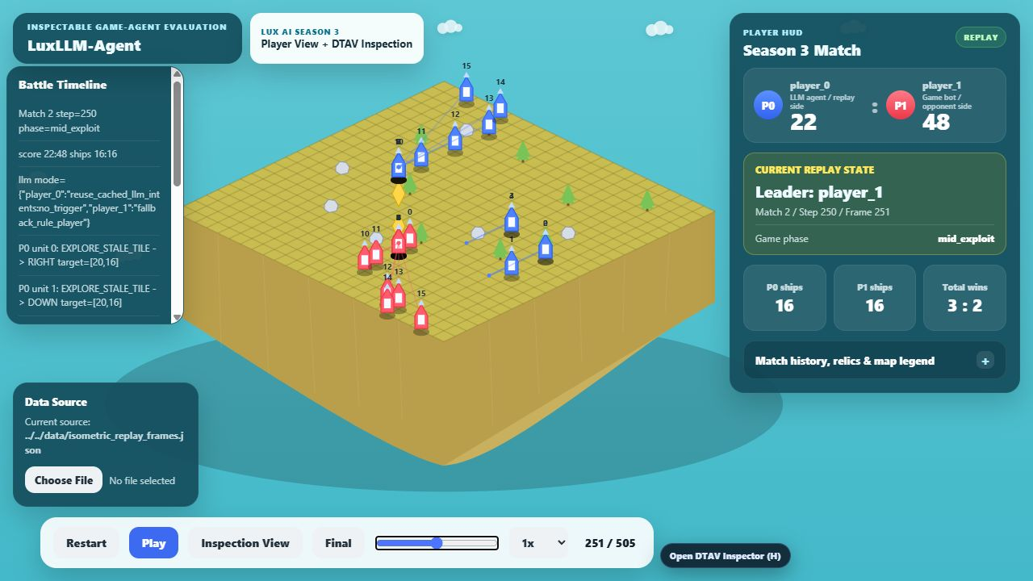
Asset 01 — Player-facing mid-match replay. Recommended main image for Slide 2.

English narration script
Lux AI Season 3 is a useful test environment because the challenge is not simply to answer one question correctly. The world is partially observable, the agent must coordinate several units, and current exploration decisions affect later scoring. At the same time, every action must obey the game’s positional, energy and action-shape constraints.
A directly prompted language model therefore has to compress state, maintain a strategic objective, produce decisions for multiple units and remain legal over a long sequence. This motivates my research question: how effectively can directly prompted LLMs make decisions in this type of game, and how can the project-specific DTAV method address the limitations that appear? The screenshot shows the player-facing replay view, where the map, score, phase, units and match progress are visible together.

Evidence/source notes
- docs/research_scope_20260814.md
- docs/ca2/ppt_assets_20260818/01_player_view_midgame.png

Slide 3 — Controlled method comparison
SECTION  SLIDE 3 | TIME  1:35–2:45 | PURPOSE  Explain the baseline and DTAV without presenting DTAV as an established external term.

Copy directly onto the slide
A matched comparison isolates the project method
DIRECT PROMPT
Compact observation → LLM response → minimum legal-action adapter → environment action
DTAV
Compact observation → structured proposal → validation / normalisation / cache / risk checks → verified or fallback action → trace + replay evidence
CONTROLLED SETUP
Same Qwen3-32B model · 50 matched seeds · swapped player roles · 100 matches per method · temperature 0 · same prompt budget and call schedule

Layout and build instructions
- Build two horizontal pipelines with native PowerPoint rounded rectangles and arrows. Direct Prompt is grey; DTAV uses blue, amber and green stages.
- Place the controlled setup in a thin footer band. It prevents the result from looking like a comparison of different models or different seeds.
- Add a small label: ‘DTAV = project-specific method name’. This implements the supervisor’s terminology feedback.

English narration script
I compare two methods using the same model and matched experimental conditions. In the Direct Prompt baseline, a compact observation is sent to Qwen3-32B, and the response passes only through the minimum adapter needed to create legal environment actions. In DTAV, the model instead proposes bounded unit intents. Deterministic stages then parse and normalise the response, validate its structure, reuse a valid cached decision between scheduled calls, filter risky targets and select a fallback when necessary. The final action and its provenance are linked to the replay.
The comparison uses fifty matched environment seeds with player roles swapped, so each method completes one hundred matches. The model, temperature, prompt budget and call schedule are controlled. DTAV is the name of the method developed in this project; I am not presenting ‘structured decision tracing’ as an established external concept.

Evidence/source notes
- docs/direct_prompt_dtav_experiment_guide.md
- scripts/run_paired_experiment.py
- reports/direct_prompt_vs_dtav_comparison.json

Slide 4 — DTAV Viewer and live demonstration
SECTION  SLIDE 4 | TIME  2:45–5:45 | PURPOSE  Demonstrate the operational audit path and the improved player-centred interface.

Copy directly onto the slide
The Viewer connects each proposal to the action that reached the game
1 · PROPOSAL ATTEMPT — source, model, objective, reason and unit intents
2 · DETERMINISTIC CHECKS — schema result, normalisation, risk posture and fallback reason
3 · EXECUTED STATE — replay score and action summary show what reached the environment
OPERATIONAL TRACE, NOT HIDDEN CHAIN-OF-THOUGHT

Layout and image
- Use the intervention screenshot at large size. Label it ‘Replay-linked verifier intervention example’.
- This retained replay shows a rejected proposal and deterministic fallback. It is useful because it demonstrates that the system records interventions as well as successful paths.
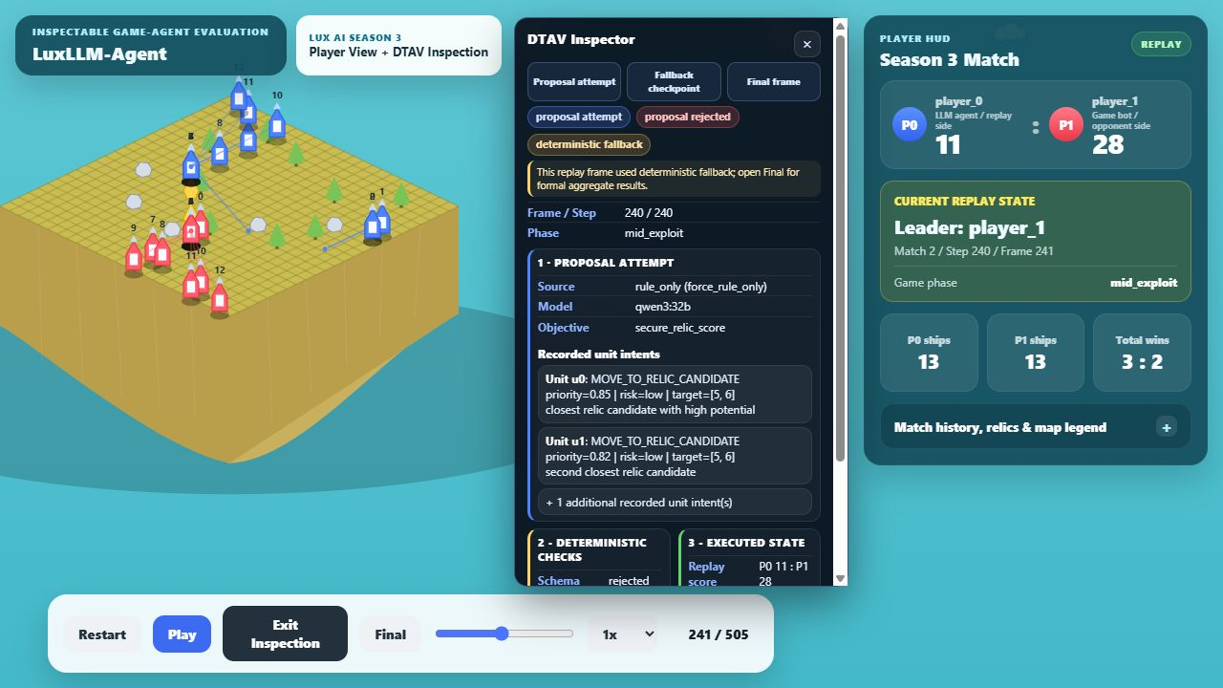
Asset 02 — Replay-linked proposal rejection and deterministic fallback. Recommended main image for Slide 4.

Live Viewer actions
- Switch from PowerPoint to the running Viewer in Player View. Do not expose the browser address bar or desktop notifications.
- Point to the enlarged Player HUD: current score, leader, phase, ships, total wins and match score summary.
- Press Play for approximately five seconds, then pause on a non-zero mid-match frame.
- Open the DTAV Inspector with the on-screen control or H key. Confirm that the Inspector and Player HUD are visible simultaneously and do not overlap.
- Point through Proposal Attempt, Deterministic Checks and Executed State. Use this rejection/fallback frame to show an observable intervention.
- Close the Inspector, return to PowerPoint and continue to Slide 5.

English narration script
The Viewer is the main inspection interface. I redesigned it from a player’s perspective: the map remains central, while the enlarged HUD shows the score, leader, phase, ships, total wins and match history. Less important information is placed in expandable details so it is available for replay analysis without obscuring the map.
I will now play a short part of the replay. The timeline changes with the game state, and the progress control lets an evaluator move to a specific frame. I can then open the DTAV Inspector while keeping the Player HUD visible.
The first section records the proposal attempt: who made it, which model or decision source was used, the current objective, the reason field and the recorded unit intents. The second section records deterministic checks, including whether the schema was accepted, whether normalisation or fallback was required, and whether a risk filter changed the proposed target. The third section records the executed state, including the replay score and a summary of the actions that actually reached the environment.
This example is deliberately an intervention case. The proposal was rejected and the deterministic fallback supplied the executed action. The value is that the evaluator can see that intervention instead of receiving only a final move or a win rate. The trace is a predefined operational audit record. It does not expose or claim to reconstruct the model’s hidden chain-of-thought.

Evidence/source notes
- docs/viewers/s3_isometric_battle_viewer_v09n12d_trace_overlay.html
- data/run008_decision_trace_overlay.json
- docs/ca2/ppt_assets_20260818/02_dtav_inspector_intervention.png

Slide 5 — Implementation boundaries
SECTION  SLIDE 5 | TIME  5:45–6:45 | PURPOSE  Show that the LLM does not directly control the environment action path.

Copy directly onto the slide
Three code boundaries keep execution control outside the LLM
STATE — state_summarizer.py
Converts raw observations and memory into bounded strategic features.
DECIDE — llm_decider.py
Requests bounded intents; parses, validates and normalises the response.
EXECUTE — agent.py
Applies cache, verifier, risk filter and fallback before legal actions.

Layout and build instructions
- Use three large blocks labelled STATE, DECIDE and EXECUTE, connected left to right with arrows.
- Do not paste a full IDE screenshot onto the slide. The live code demonstration should show only three short, pre-positioned regions.

Live code actions
- Open `src/agent/state_summarizer.py` at the function that creates bounded observation features. Show 15–25 lines.
- Open `src/agent/llm_decider.py` at JSON parsing / intent validation / normalisation. Show 15–25 lines.
- Open `src/agent/agent.py` at the cache, verifier, risk-filter or fallback branch immediately before action construction. Show 15–25 lines.
- Return to Slide 6 without scrolling through unrelated files.

English narration script
The implementation separates three responsibilities. The state summariser converts raw Lux observations and memory into a bounded strategic description. The LLM decider requests a constrained response and handles parsing, validation and normalisation. Finally, the agent execution layer applies cached decisions, verification, risk filtering and deterministic fallback before constructing legal Lux actions.
These boundaries are important because the language model proposes strategy, but it does not receive unrestricted control over the environment action array. They also make testing easier: state summarisation, response handling and final execution can be inspected and tested separately.

Evidence/source notes
- src/agent/state_summarizer.py
- src/agent/llm_decider.py
- src/agent/agent.py
- tests/test_agent_core.py

Slide 6 — Formal empirical evidence
SECTION  SLIDE 6 | TIME  6:45–8:15 | PURPOSE  Present the matched outcome and trace evidence with appropriate statistical caution.

Copy directly onto the slide
A matched comparison favours DTAV under the tested setup
48% — DIRECT PROMPT — 48 wins / 100 matches — Wilson 95% CI 38.5%–57.7%
63% — DTAV — 63 wins / 100 matches — Wilson 95% CI 53.2%–71.8%
+15 pp — MATCHED EFFECT — paired bootstrap 95% CI +6 to +25 percentage points
McNemar exact p = .0059 (6 Direct-Prompt-only wins; 21 DTAV-only wins)
SUPPORTING EVIDENCE — post-check validity 86.1% → 99.9%; trace completeness and replay linkage 100% for both methods

Layout and image
- Make 48%, 63% and +15 pp the three largest objects on the slide. Place the chart beneath them at approximately one-third slide height.
- Use green for the matched effect, but do not use the word ‘proves’. The evidence is bounded to the recorded model, seeds and configuration.
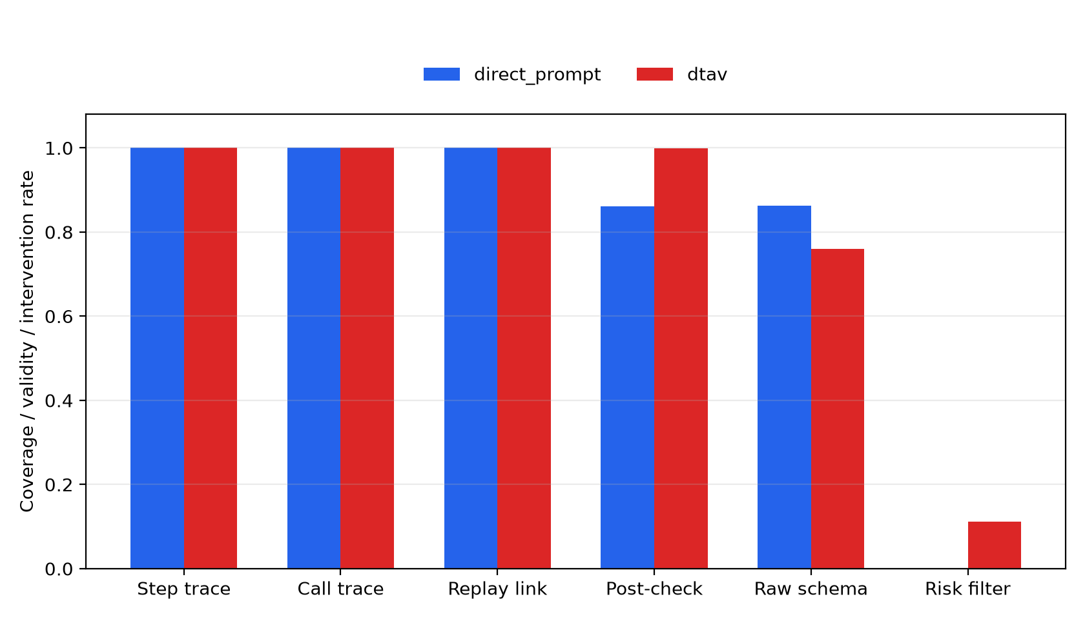
Asset 03 — Supporting framework evidence rates. Use below the three headline outcome numbers.

English narration script
The formal experiment uses Qwen3-32B, fifty matched seeds and swapped player roles, giving one hundred matches for each method. Direct Prompt won forty-eight matches, a forty-eight percent win rate with a Wilson interval from approximately thirty-eight point five to fifty-seven point seven percent. DTAV won sixty-three matches, with an interval from approximately fifty-three point two to seventy-one point eight percent.
The matched effect is an increase of fifteen percentage points for DTAV. The paired bootstrap interval is plus six to plus twenty-five percentage points. There were six strata where only Direct Prompt won and twenty-one where only DTAV won; the exact McNemar p-value is point zero zero five nine. Under this recorded setup, the matched comparison therefore favours DTAV.
The framework evidence helps explain what changed operationally. Post-check structured validity increased from eighty-six point one percent to ninety-nine point nine percent. Both methods retained complete step traces and complete replay linkage. DTAV also reused valid cached intents between scheduled calls and visibly recorded verifier interventions. However, this is a comparison of two method bundles, not a claim that every individual DTAV component independently caused the outcome, and it is not a hardware-independent or universal model ranking.

Evidence/source notes
- reports/direct_prompt_vs_dtav_comparison.json
- reports/direct_prompt_vs_dtav_trace_analysis.json
- reports/direct_prompt_vs_dtav_trace_metrics.csv
- reports/direct_prompt_vs_dtav_figures/framework_evidence_rates.png

Slide 7 — Answer, contribution and limitations
SECTION  SLIDE 7 | TIME  8:15–9:10 | PURPOSE  Answer the research question without overclaiming and close on the project contribution.

Copy directly onto the slide
DTAV improves usable decisions while preserving an inspectable action path
ANSWER
Under the recorded setup, direct prompting could produce usable calls but did not sustain strategy effectively without frequent rule fallback. DTAV improved structured-call usability and strategy continuity while retaining a replay-linked operational audit path.
CONTRIBUTION
A reproducible LLM-based method and Viewer for inspecting proposal → verification → executed action → replay state.
LIMITATIONS
One game and one main model in the method comparison · method-bundle comparison · operational traces, not hidden reasoning · no universal model ranking

Layout and build instructions
- Place the answer in one large upper block. Put Contribution and Limitations in two smaller blocks beneath it.
- End with the GitHub link in a small footer: `github.com/zewang-liverpool/luxllm-agent-demo`.

English narration script
To answer the research question, direct prompting was able to produce many usable calls, but under the scheduled-call protocol it did not sustain strategy effectively without frequent rule fallback. DTAV improved post-check usability, reused valid decisions between calls, and maintained strategic continuity while preserving a complete, replay-linked operational path from proposal through deterministic verification to executed action.
The contribution is therefore not a general claim that one language model solves all strategy games. It is a reproducible LLM-based method, implementation and Viewer for this partially observable, multi-unit and rule-constrained game. The main limitations are that the method comparison uses one game and one main model, it compares method bundles rather than isolating every component, and the traces explain recorded operations rather than hidden model reasoning. Thank you for watching.

Evidence/source notes
- https://github.com/zewang-liverpool/luxllm-agent-demo
- reports/direct_prompt_vs_dtav_trace_analysis.md

Optional backup slides for Q&A
Do not narrate these in the main video
Keep these after Slide 7 so they are available during the Q&A session. They do not count toward the planned nine-minute recording unless shown.

Backup A — Decision-source distribution
Why scheduled direct prompting still uses many rule steps
Direct Prompt: fresh LLM calls 2,284; rule-fallback steps 95.5%; cache disabled.
DTAV: fresh LLM calls 2,325; cached-intent steps 89.8%; rule-fallback steps 5.6%.
Important: 95.5% rule-fallback steps does not mean that 95.5% of Direct Prompt LLM calls failed. Most game steps did not trigger a fresh call and the baseline intentionally disabled cross-step strategic cache reuse.
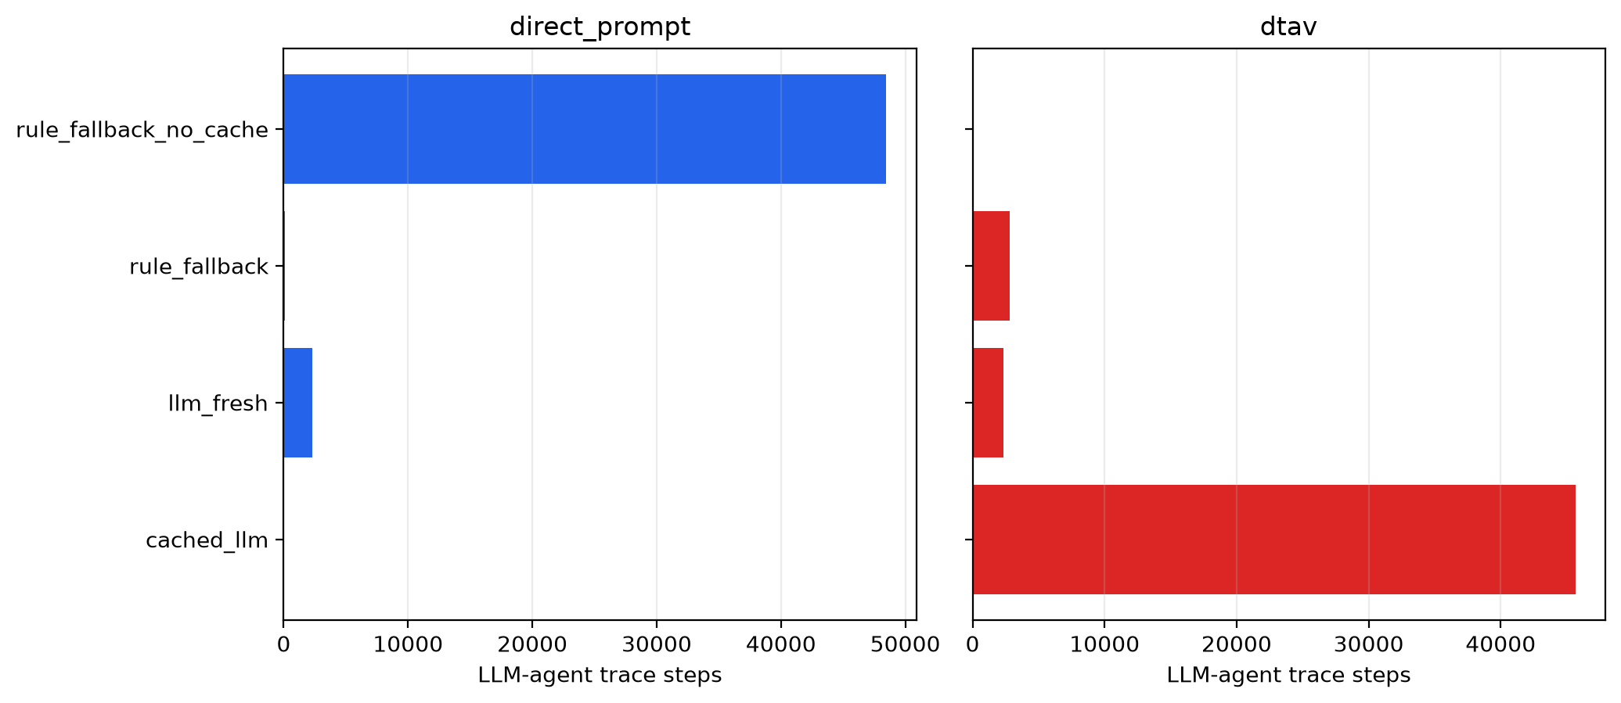
Asset 04 — Decision-source distribution. Recommended for a backup/Q&A slide.

Backup B — Additional model coverage
Qwen3-32B vs DeepSeek-R1-32B direct model battle
100 completed matches across 50 matched seeds with swapped roles.
Qwen 54 wins; DeepSeek 46 wins; Wilson 95% CI for Qwen 44.3%–63.4%; match-level p = .4841.
4,676 / 4,676 calls valid after recorded checks; trace and replay linkage 100%.
Interpretation: additional framework/model coverage, not evidence of a reliable general model ranking.
Suggested Q&A answer: “I added DeepSeek-R1-32B and a direct Qwen-versus-DeepSeek experiment to test whether the same inspection and verification framework supports another reasoning-oriented model. The result did not establish a reliable winner, but it demonstrated complete trace coverage, post-check call validity and replay linkage across both models.”

Backup C — Reproducibility and testing
REPRODUCIBILITY
Pinned/recorded Python environment, model and Ollama metadata, seeds, roles, prompt controls, source commit, Slurm accounting and retained match histories.
AUTOMATED CHECKS
35 local tests pass; result validators check completeness, role-swapped seed pairs, model call coverage and trace integrity.
ARCHIVED EVIDENCE
Formal Barkla2 results were transferred locally with required summaries, environment metadata, match histories, analyses and figures present.

Image asset catalogue
All supplied files are stored in: D:\PythonProject\lux_llm_agent\docs\ca2\ppt_assets_20260818
File | Slide | Meaning / caution
01_player_view_midgame.png | Main Slide 2 | Player-facing mid-match replay with meaningful non-zero score, ships, phase and progress.
02_dtav_inspector_intervention.png | Main Slide 4 | Replay-linked rejection/fallback intervention. Do not label it as a valid fresh LLM decision.
03_framework_evidence_rates.png | Main Slide 6 | Supporting evidence chart; keep the headline 48%, 63% and +15 pp larger than the chart.
04_decision_source_distribution.png | Backup A | Technical distribution chart for Q&A; explain the scheduled-call baseline before discussing fallback rate.

Cropping rules
- Use Crop → Fit first. Only use Crop → Fill if the screenshot remains readable after preserving the right HUD and bottom controls.
- Do not cover screenshots with opaque text boxes. If a label is necessary, place it in a separate band above or below the image.
- For the Inspector screenshot, preserve the tags, proposal context, deterministic checks and executed-state area; these are the evidence chain.
- For charts, keep labels and legends readable at normal slideshow size. Do not enlarge the chart beyond its native aspect ratio.

Recording and final verification checklist

Before recording
- ☐ The title slide includes the A0 ethical-compliance statement.
- ☐ The research question uses the game-centred wording and identifies DTAV as the project-specific method.
- ☐ Slide 3 states the matched controls and uses the same model for both methods.
- ☐ The Viewer loads from the local HTTP server and Play, Final, Inspector and H-key controls work.
- ☐ Player HUD and DTAV Inspector can be shown at the same time without overlap.
- ☐ The Viewer is pre-positioned on a non-zero frame and notifications are disabled.
- ☐ The three code files are already open at the intended lines with at least 18–20 px editor text.
- ☐ Microphone input is correct. Narration is in your own voice; no text-to-speech is used.

During recording
- ☐ Speak at a calm 125–145 words per minute and pause briefly after every headline number.
- ☐ Say ‘under the recorded setup’ before interpreting the matched result.
- ☐ Call the Slide 4 screenshot an intervention/fallback example, not a valid fresh LLM decision.
- ☐ Explain that the trace is an operational audit record and not hidden chain-of-thought.
- ☐ Avoid scrolling through long files; show only the selected code boundaries.
- ☐ Finish between 9:00 and 9:30. Never submit a video of 11:00 or longer.

After recording
- ☐ Watch the exported video from beginning to end with headphones.
- ☐ Confirm that every slide, chart label, HUD metric and code line is readable at 100% playback size.
- ☐ Confirm that no address bar, password, private notification, email or personal account is visible.
- ☐ Confirm that audio is continuous and your own voice is clear without clipping.
- ☐ Check the exact duration and retain the final file locally before uploading it to the CA2 Canvas assignment.
- ☐ After upload, reopen or download the submitted file and verify that it plays.

Short Q&A defence statements
Why not call this structured decision tracing?
It is not presented as an established term. DTAV is the project-specific method name for the operational record linking observations, proposals, deterministic checks, executed actions and replay state.
Does the trace reveal model reasoning?
No. It records selected inputs, outputs, validation decisions and execution results. It does not expose hidden chain-of-thought.
Why is Direct Prompt a fair baseline?
The same model, seeds, swapped roles, prompt budget, temperature and scheduled-call protocol are controlled. The baseline removes DTAV’s persistent verified strategy path while retaining the minimum action adapter required to run the game.
What does p = .0059 mean?
Under the matched recorded setup, the imbalance between Direct-Prompt-only and DTAV-only wins would be unlikely under equal paired performance. It supports an association in this experiment, not a universal causal claim.
What is the main contribution?
A reproducible game-agent method and Viewer that combine LLM proposals with deterministic action control and replay-linked operational evidence.

Final files
PPT content manuscript: D:\PythonProject\lux_llm_agent\docs\ca2\LuxLLM_Agent_CA2_PPT_Content_Manuscript_20260818.docx
Image assets: D:\PythonProject\lux_llm_agent\docs\ca2\ppt_assets_20260818
Repository: https://github.com/zewang-liverpool/luxllm-agent-demo

