# BONAFIDE CERTIFICATE

This is to certify that this project titled **AUTOMATIC LICENSE NUMBER PLATE RECOGNITION** in partial fulfillment of the requirements for the degree of BACHELOR OF ENGINEERING IN SOFTWARE ENGINEERING is a bonafide work of **Ajit Baniya, Bibek Bhattarai** and **Dipesh Gautam** under the supervision of **Er. Krishna Khadka**. It is further certified that this work doesn’t form part of any other project work on the basis of which a degree or award was conferred on any earlier occasion on this by any other candidate.

**Date of Evaluation**: 08/25/2024

|  |  |
| --- | --- |
| ……………………………...…  Er. ………………  External Examiner  Assistant Professor  School of Engineering,  Pokhara University |  |
| ……………………………...…  Er. Krishna Khadka  (Supervisor) | ……………………………...…  Er. Rajendra Bahadur Thapa  Project Head  Research Management Cell |

# ACKNOWLEDGEMENT

In the accomplishment of this project successfully, we want to thank all the people who have contributed their time and effort to guide us throughout the development of the web application named ‘Automatic License Number Plate Recognition’.

Primarily, we would like to express our special thanks of gratitude who initially guide us in this project, our teachers and supervisor Er. Krishna Khadka who gave us the golden opportunity to do this wonderful project on the topic of Automatic License Number Plate Recognition, which also helped us in doing a lot of research and we came to know about so many new tools and technologies.

Secondly, we would also like to thank our parents and friends who helped us a lot in finalizing this project within the limited time frame.

Thank You

# ABSTRACT

Nepal has seen an exponential increase in the number of publicly and privately owned

vehicles over the past decade but, a lack in the advancement of technology to keep track of these vehicles. As per current conditions, the task of tracking the vehicle number plate is a manual process which has proven to be time-consuming and tedious with sub-par results.

Keeping this in mind, we have created a system namely “Automatic License Number Plate Recognition” that automates the process of license plate identification and recognition. The system makes use of different algorithms for plate localization and character segmentation along with machine learning techniques for character recognition. This helps eliminate the manual process of having to identify the vehicle number plate.

**Keywords: Machine learning, character segmentation, localization, character recognition.**

**TABLE OF CONTENT**

BONAFIDE CERTIFICATE i

ACKNOWLEDGEMENT ii

ABSTRACT iii

LIST OF FIGURES vi

LIST OF TABLES vii

CHAPTER 1 INTRODUCTION 1

1.1 Introduction 1

1.2 Problem Statement 2

1.3 Objectives 2

1.4 Implications 2

CHAPTER 2 LITERATURE REVIEW 3

2.1 Literature Review 3

CHAPTER 3 TOOLS AND METHODOLOGY 5

3.1 Required Tools 5

3.2 Methodology 6

3.3 Use Case Diagram 9

KEY SCREENSHOTS 10

CHAPTER 4 FINDINGS, RESULT AND ANALYSIS 12

4.1 Testing 12

4.1.1 Test Results 12

4.2 Outcome 13

4.3 Analysis 14

CHAPTER 5 CONCLUSION AND RECOMMENDATION 15

5.1 Conclusion 15

5.2 Future Recommendations 15

Bibliography 17

APPENDICES 18

# LIST OF FIGURES

Figure 1: Software Development Life Cycle 6

Figure 2: Use Case Diagram 9

Figure 3: Expected Output 10

# LIST OF TABLES

Table 1: Gantt Chart 11

# CHAPTER 1 INTRODUCTION

## Introduction

In recent years, the advancement of computer vision technologies has paved the way for innovative applications in various fields, including transportation, security, and automation. One such application is the automatic detection and recognition of license plates from images or video streams. This technology is crucial in enhancing efficiency and accuracy in tasks such as toll collection, parking management, and law enforcement.

The primary objective of this project is to develop a robust Automatic License Number Plate Recognition System (ALNPR) using computer vision techniques. The system will employ algorithms to automatically locate and recognize license plates within images or video frames. This involves several key tasks, including image preprocessing, license plate localization, and optionally, character segmentation and recognition.

Through this project, we aim to explore fundamental concepts in image processing, pattern recognition, and machine learning. By implementing and integrating these techniques into a cohesive system, we endeavor to achieve accurate and real-time detection of license plates under various environmental conditions and scenarios.

The outcomes of this project will not only demonstrate practical skills in computer vision and software development but also contribute to the broader discourse on the applications and implications of automated license plate detection systems in modern society.

## Problem Statement

The traffic control and management system have undergone significant development in the past decade; however, it still exhibits shortcomings, particularly in leveraging modern technology. The current approach employed by the Nepal Traffic Police for identifying vehicles relies on a manual process, necessitating substantial human resources. Unfortunately, the outcomes have not met expectations relative to the resources invested, given the arduous nature of the vehicle number plate tracking process. Our examination reveals that the Nepal Traffic Office has integrated approximately 3000 CCTV cameras across the country, complemented by high-resolution cameras strategically placed in traffic-congested areas to monitor daily traffic patterns. While this system effectively regulates unauthorized lane crossing, there is a notable absence of an automated license plate recognition system in the current landscape.

## Objectives

* + - To develop the system to identify and recognize the vehicle number plate.

## Implications

The project has wide range of implications which are as:

* Utilizing the system for the automated detection and recognition of license plates to monitor vehicles.
* It has the potential to optimize the utilization of traffic resources effectively.

# CHAPTER 2 LITERATURE REVIEW

## 2.1 Literature Review

The major challenge of the traditional learning based and or tracking-by-detection methods is the false positive matches that lead to wrong association of the tracks. The reason is that those methods are based on applying an appearance model or object detector at all possible windows around the target, and the object detection in the current frame as our base learner because they have been demonstrated to be able to extract local visual features (structures) and they are widely used in various visual recognition applications. Different from fully connected neural networks, CNNs force the extraction of local features by restricting the receptive fields of hidden units to be local, since images have strong 2-D local structures. From the conventional shift-invariant CNN we move to improved shift variant architecture. Shift-invariant CNN can make them suitable for recognition or detection tasks but inappropriate for tracking tasks. (Shruthi, 2011)

Automatic Number Plate Recognition is comprised of four main sections: image

preprocessing, number (license) plate extraction (localization), character segmentation andcharacter recognition. ANPR can be used to store the images captured by the cameras as well as the text from the license plate, with some configurable memory. ANPR technology tends to be region-specific, owing to plate variation from place to place. The ANPR system that extracts a license plate number from a given image can be composed of four stages. The first stage is to acquire the car image using a camera. The parameters of the camera, such as the type of camera, camera resolution, shutter speed, orientation, and light, have to be considered. The second stage is to extract the license plate from the image based on some features, such as the boundary, the color, or the existence of the characters. The third stage is to segment the license plate and extract the characters by projecting their color information, labeling them, or matching their positions with templates. The final stage is to recognize the extracted characters by template matching or using classifiers, such as neural networks. (A. Jain, 2015)

The number plates used in Nepal are usually of two formats, one containing all the

characters in a single row and the other containing two rows of characters. Characters are selected from Devnagari script. Here, we propose a complete number plate recognition pipeline that automatically localizes, normalizes and segments number plates from vehicle images; segments characters from detected number plates and passes them to classification system for labeling. Classification system implements SVM based machine learning algorithms for learning and prediction. Plate localization and segmentation are again not researched much for handling all the situations. Nepali number plate characters are selected from the pool of 29 characters in a specific order. The order defines various characteristics of the number plates such as vehicle type and vehicle load. (A. Pant, 2018)

The earlier stages require higher accuracy since a failure would probably lead to another

failure in the subsequent stages. YOLO is a realtime object detector that achieved

impressive results in terms of speed/accuracy trade-off in the Pascal VOC and Microsoft COCO detection tasks. We locate the vehicles in the input image and then their LPs within the vehicle bounding box. Considering that the bottleneck of ALPR systems is the LP recognition stage. Afterward, all LP characters are recognized simultaneously, i.e., the entire LP patch is fed into the network, avoiding the challenging character segmentation task. We eliminate various constraints commonly found in ALPR systems by training a single network for each task using images from several datasets, which were collected under different conditions and reproduce distinct real-world applications. Moreover, we perform several data augmentation tricks and modified the chosen networks (e.g., we explored various models with changes in the input size, as well as in the number of layers, filters, output classes, and anchors) aiming to achieve the best speed/accuracy trade-off at each stage. (L. Rayson, 2019)

A report present a significant advancement in the field of license plate recognition through their work on "Devnagari License Plate Detection, Classification and Recognition using Deep Learning." This report explores the application of deep learning techniques to detect, classify, and recognize Devnagari license plates, addressing a gap in the recognition of non-Latin script plates. The authors employ advanced neural network architectures to improve accuracy and efficiency in recognizing the Devnagari script, which is crucial for regions where such plates are standard. Their work highlights the effectiveness of deep learning models in handling complex visual features and variations inherent in license plate designs. The study contributes valuable insights into enhancing recognition systems for diverse script types, offering a robust framework that could be extended to other scripts and applications in automated vehicle identification. (Pankaj Raj Dawadi, 2021)

# CHAPTER 3 TOOLS AND METHODOLOGY

## Required Tools

To develop our system, the following tools will be used accordingly:

Python:

Python, a versatile programming language, serves as the primary coding language for implementing the Automatic License Number Plate Recognition, offering a rich ecosystem of libraries and frameworks.

FastApi:

FastAPI is a modern, fast (high-performance), web framework for building APIs with Python based on standard Python type hints.

NumPy:

NumPy, a fundamental library for numerical computing in Python, plays a crucial role in handling mathematical operations and array manipulations within the ALNPR codebase.

TensorFlow:

TensorFlow, a powerful open-source machine learning framework, is utilized for constructing and training deep neural networks, enabling the integration of advanced deep learning models into the ALNPR.

OpenCV:

OpenCV, a versatile computer vision library, is employed to process image and video data from cameras or sensors, facilitating tasks such as number plate detection and recognition in the ALNPR.

YOLOv8:

YOLOv8, also known as YOLOv4-tiny, is a compact yet powerful variant of the YOLO (You Only Look Once) object detection model. It is designed to deliver fast and efficient real-time object detection capabilities. Built upon the YOLOv4 architecture, YOLOv8 prioritizes speed and suitability for deployment on resource-constrained devices, making it ideal for applications requiring rapid detection and classification of objects in images or video streams.

## Methodology

The project has followed the Software Development Life Cycle (SDLC), a structured process defining various stages in software development to ensure the delivery of a high-quality product. Utilizing the Incremental Model, we integrated the SDLC process.

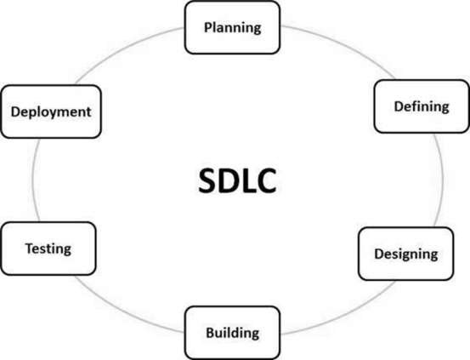

***Figure 1: Software Development Life Cycle***

Methodology used for the license number plate detection are:

Image Acquisition:

The process starts with capturing an image or a series of images containing vehicles using cameras installed in strategic locations such as toll booths, traffic intersections, or police vehicles.

Pre-processing:

The acquired images may undergo preprocessing steps to enhance their quality and make subsequent analysis more effective. This can include operations like resizing, noise reduction, and contrast adjustment.

License Plate Localization:

This step involves detecting the region within the image where the license plate is located. This is often done using techniques such as edge detection, morphological operations, or machine learning-based object detection algorithms like Haar cascades or more advanced deep learning-based models (e.g., YOLO, SSD).

Character Segmentation:

Once the license plate region is identified, the characters on the plate need to be segmented from the rest of the image. Techniques such as thresholding, contour analysis, or neural networks can be used to separate characters effectively.

Character Recognition:

After segmentation, optical character recognition (OCR) techniques are applied to recognize each character in the segmented regions. OCR algorithms typically use pattern recognition and feature extraction methods to interpret the characters.

Post-processing:

After character recognition, post-processing techniques may be applied to refine the recognized characters, correct errors, and improve overall accuracy. This could involve dictionary checks (verifying against a list of valid license plate formats), context-based corrections.

## Use Case Diagram

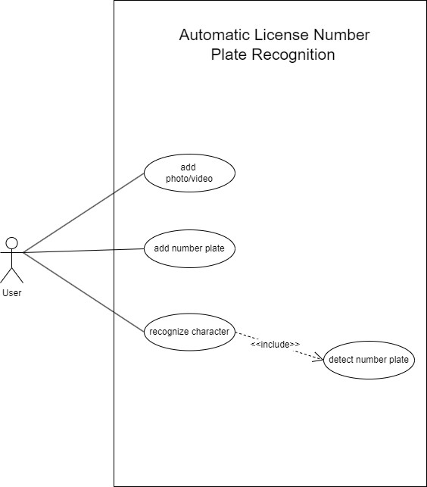

***Figure 2: Use Case Diagram***

# KEY SCREENSHOTS

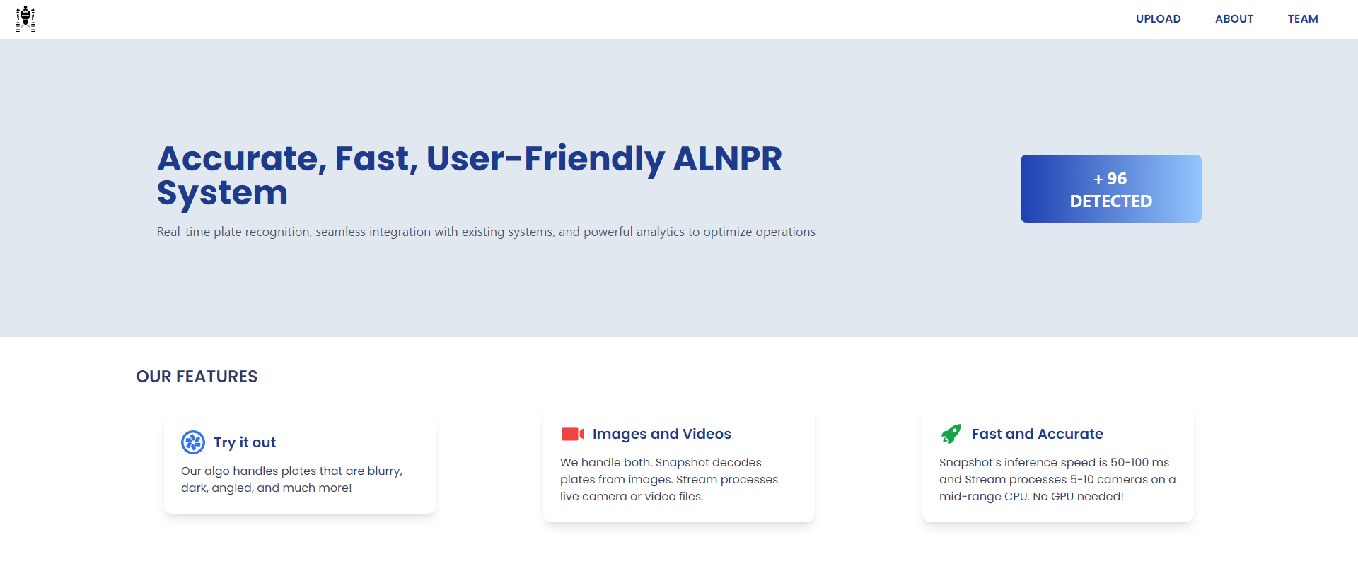

***Screenshot 1: Home Page***

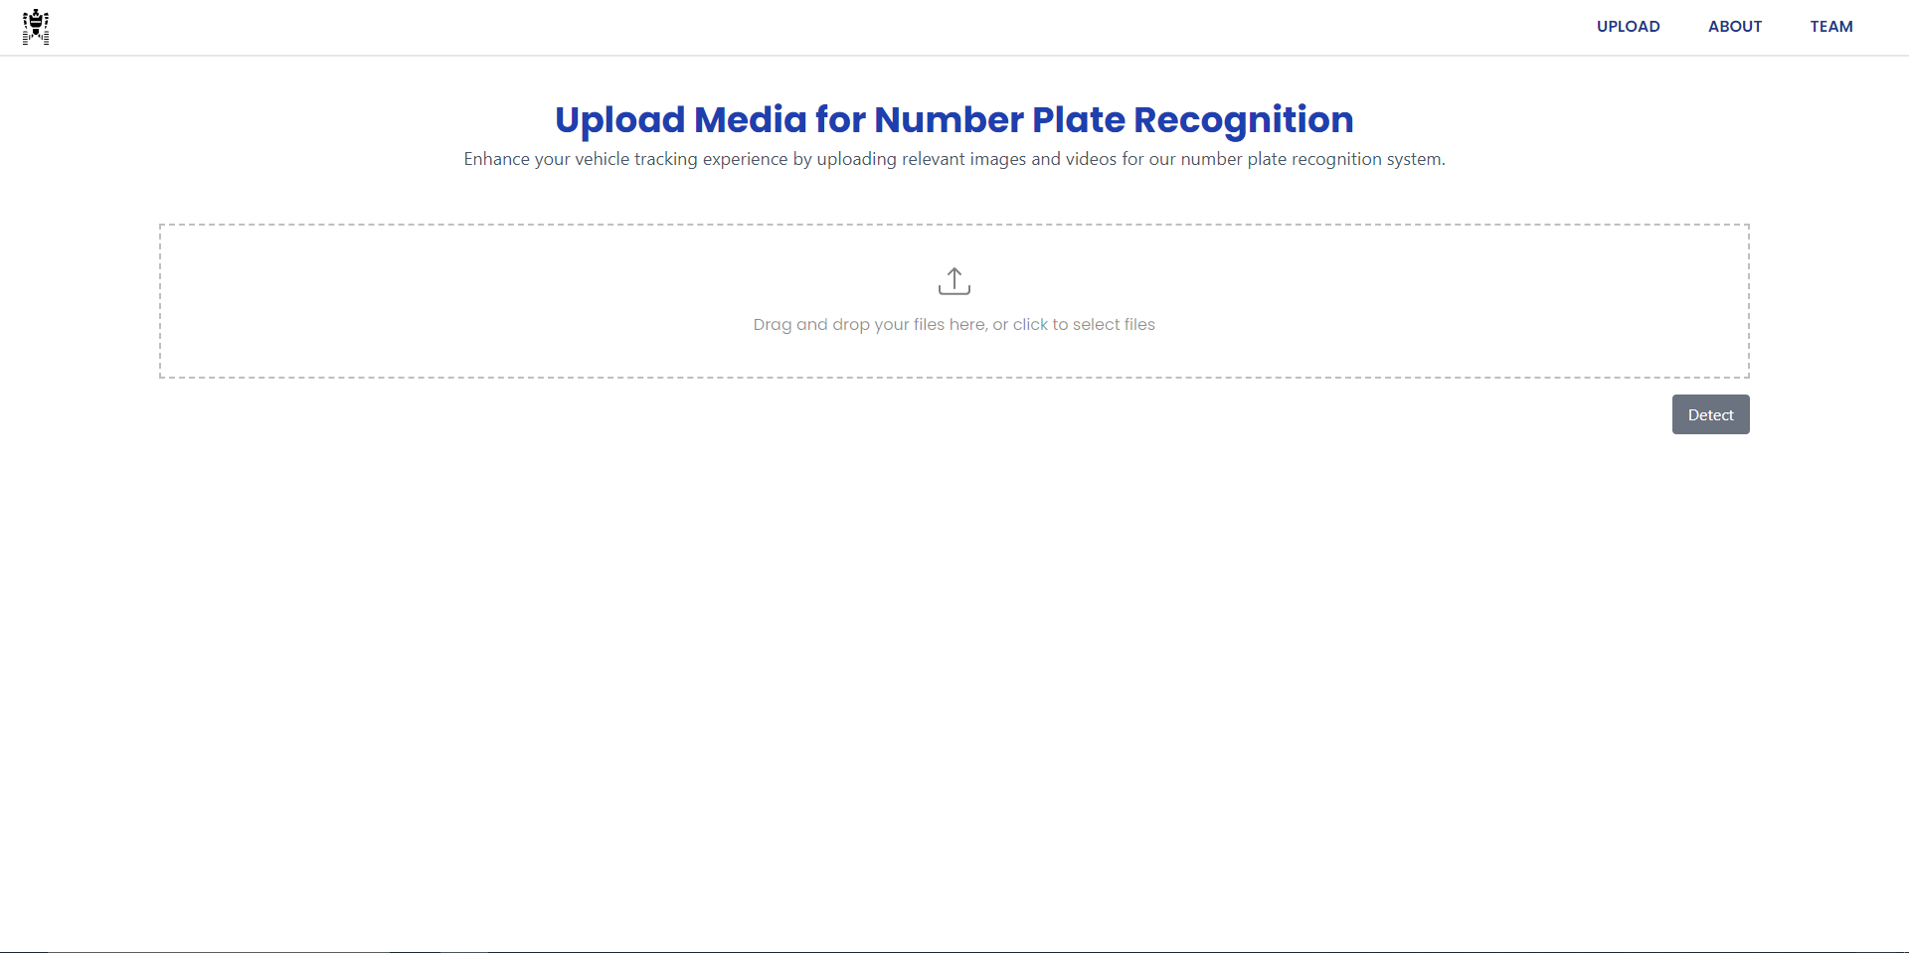

***Screenshot 2: Upload Number Plate***

# CHAPTER 4 FINDINGS, RESULT AND ANALYSIS

## Testing

Software testing is a phenomenon to evaluate the functionality of a software application with an intent to find whether the developed software met its condition or not. It also identifies the defects to ensure that the product is defect-free in order to produce a quality product. The overall aim for testing a system is to ensure that the system meets its entire functional requirement and to check its performance. The accuracy of the program can be tested with some varying data, testing gives assurance that the new system can achieve its objectives and purpose. Testing is basically an attempt of executing program to find bugs. It consists of various types for which a system is subjected to but the ones to be carried out are the testing objectives. The test plan presents the test in details through identifying the test case areas within the system.

## Test Results

**Table 1: Upload Image Test**

|  |  |  |  |  |  |
| --- | --- | --- | --- | --- | --- |
| **Test**  **Scenario** | **Test Steps** | **Test Details** | **Expected**  **Results** | **Actual**  **Result** | **Pass/Fail** |
| Check upload the image. | Upload image | Image uploaded. | Upload success. | Image uploaded. | Pass |

**Table 2: Detection Test**

|  |  |  |  |  |  |
| --- | --- | --- | --- | --- | --- |
| **Test**  **Scenario** | **Test Steps** | **Test Details** | **Expected**  **Results** | **Actual**  **Result** | **Pass/Fail** |
| Check number plate detection. | Upload image | Number plate detect. | Detection success.  . | Number plate detected. | Pass |

**Table 3: Recognition Test**

|  |  |  |  |  |  |
| --- | --- | --- | --- | --- | --- |
| **Test**  **Scenario** | **Test Steps** | **Test Details** | **Expected**  **Results** | **Actual**  **Result** | **Pass/Fail** |
| Check the character recognition. | Recognize characters from detected number plate. | Recognize character. | Recognition success. | Recognized character displayed. | Pass |

## Outcome

* Enhanced Vehicle Identification and Security: The ALNPR system will significantly improve vehicle identification accuracy and security by providing reliable and real-time recognition of license plates. This capability will bolster security measures and streamline processes in various applications such as law enforcement, traffic management, and access control.
* Optimized Traffic Management and Enforcement: By automating the recognition and detection of license plates, the system will helps in efficient traffic management and enforcement. This includes improved monitoring of traffic flow, better enforcement of regulations, and quicker response to incidents, leading to a safer and more organized transportation environment.

## Analysis

Automatic License Number Plate Recognition system is an error free and secure web application to identify and recognize the number plates. This web application has been passed through various testing to provide users an error free and pleasant software. Testing is critical for ensuring that any software is free of bugs and determine the functionality and usability of the software, its user-friendliness. This application has passed from end to end of all essential tests and has offered a proper output as expected by users.

# CHAPTER 5 CONCLUSION AND RECOMMENDATION

## Conclusion

In conclusion, the development of our Automatic License Number Plate Recognition (ALNPR) system has been a fulfilling journey marked by innovation, accuracy, and practical application. Our project focused on key aspects such as precision, efficiency, and reliability to ensure effective vehicle identification. By utilizing advanced algorithms and state-of-the-art technology, our ALNPR system offers robust and accurate license number plate recognition, addressing critical needs in security and traffic management.

In the ever-evolving digital landscape, our ALNPR system plays a significant role in enhancing vehicle tracking, streamlining traffic control, and providing essential data for various applications. Beyond fulfilling the fundamental objectives of license plate recognition, the system is distinguished by its high accuracy, real-time processing, and versatility across different environments. Looking ahead, we remain dedicated to continuous advancement. By integrating user feedback and embracing emerging technologies, we aim to refine and expand our system to meet the dynamic needs of our users.

Our commitment to innovation and practical solutions is at the heart of the ALNPR project. We take pride in the system’s achievements and are excited about its potential impact. As we continue to develop and enhance the ALNPR system, we look forward to exploring new opportunities and driving further advancements to support a safer and more efficient future.

## Future Recommendations

As a future work, some additional stuff could be implemented and integrated into the application code making it more practical, reliable and convenient to use. Since this project still has plenty of room to grow. To further enhance the Automatic License Number Plate Recognition (ALNPR) project, a shift from traditional segmentation and connected component analysis to single-slot detection could significantly improve system performance. Single-slot detection, which focuses on identifying and processing the license plate as a whole unit, can streamline the recognition process by reducing the complexity associated with breaking down the plate into individual components. This approach could lead to more accurate and faster detection, particularly in varied and challenging environments.

Additionally, refining the number plate recognition by incorporating specific fonts can enhance the system's accuracy. By training the ALNPR system to recognize and interpret different license plate fonts, it will be better equipped to handle diverse plate designs across regions. This font-specific refinement will improve the system's ability to correctly identify and process license plates, thereby reducing errors and increasing overall reliability.

Implementing these advancements will not only enhance the precision of license plate recognition but also contribute to a more efficient and robust ALNPR system capable of addressing a wider range of real-world scenarios.

In the future, the Automatic License Number Plate Recognition (ALNPR) project could be adapted to recognize embossed number plates, which feature raised characters and unique textures. This enhancement would broaden the system’s applicability, allowing it to effectively process and interpret a wider range of license plate formats.

# Bibliography

S. Shruthi, "Vehicle Tracking using Convolutional Neural Network," World Congress on Engineering, London, 2011.

A. Jain and J. Kundargi, "Automatic Number Plate Recognition Using Artificial Neural Network," International Research Journal of Engineering and Technology (IRJET), vol.

2, 2015.

A. Pant, P. Gyawali, and S. Acharya, "Automatic Number Plate Recognition with

Support Vector Machines," Kathmandu, 2018.

L. Rayson, L. Zanlorensi, G. Goncalves, E. Todt, W. Schwartz and D. Menotti, "An Efficient and Layout-Independent Automatic License Plate Recognition System Based on the YOLO Detector," Department of Informatics, Federal University of Paran´a, Curitiba, Brazil, 2019.

P. R. Dawadi, B. K. Bal, and M. Pokharel, "Devnagari License Plate Detection, Classification and Recognition using Deep Learning," Kathmandu, 2021.

DrawIO: <https://draw.io>

# APPENDICES

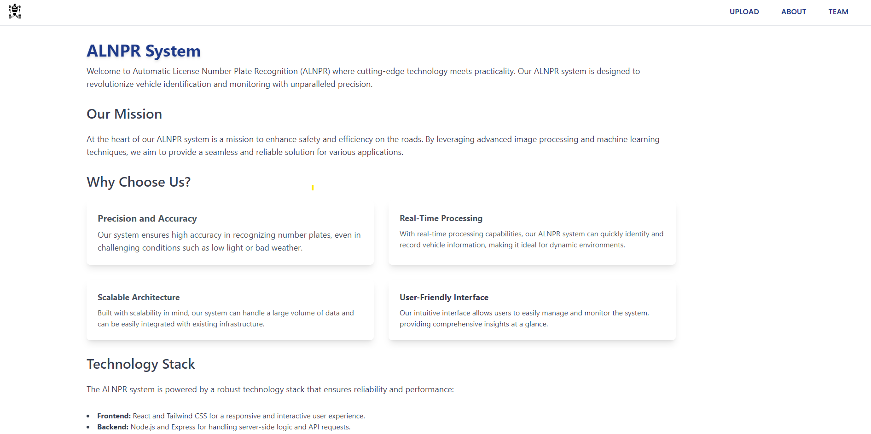***Appendix 1: About us***

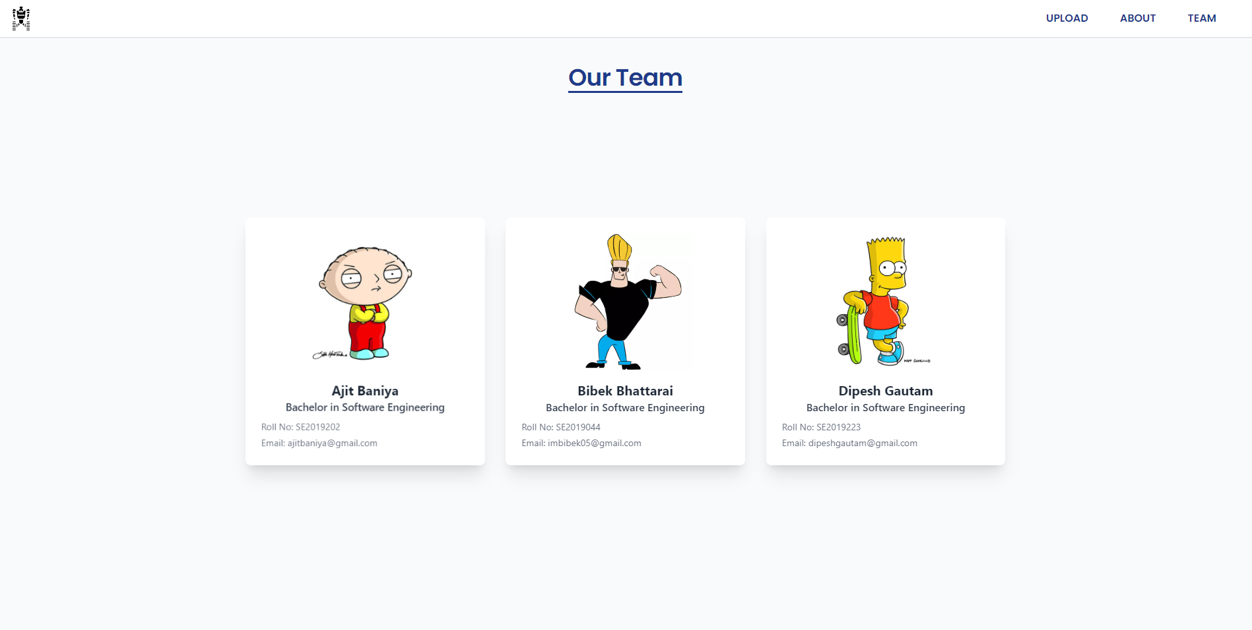

***Appendix 2: Our Team***