CodeRover – An RC Mobile Car

By

Eng. Zeyad Youssef Shaban

Student ID: 221004741

Eng. Waleed Amgad

Student ID: 221005961

1.Objective
This project implements a small RC car platform controlled from a desktop web GUI and an ESP32 firmware stack. The system includes:
- A Unity differential-drive simulation used during algorithm development.
- A web-based GUI with a joystick and a Hoink button.
- Data logging into a local SQLite database of joystick inputs (x, y) for later analysis on how the car travelled.
- ESP32 firmware exposing a BLE GATT service to receive joystick commands and forwarding hoink commands to an Arduino via UART.
- Arduino firmware that actuates the honk on user command.

2.Project Description
Our project uses esp32 to receive signals from the mobile app (x, y coordinates representing the joystick position) through Bluetooth connection (BLE GATT), then the esp32 maps those coords to set the Velocity of left and right motors, difference in velocities will cause difference in the car orientation which allows the car to rotate (Differential Driver mechanism)
Additionally, if the user pressed a “hoink” the esp32 transmits the signal to Arduino through UART and the Arduino will take the action of hoinking.

3. Hardware Component List
- 2x Motors
- 2x Wheels
- 4x 3.7v lithium batteries
- 1x 3.7v Lithium battery holder
- 1x Esp32
- 1x Arduino uno
- 1x H-Bridge L298 Module
- Car chassis
- Wires (lots of them…)

4.Design
4.1 Physics Simulation
In order to have an easier time testing our algorithms we developed a Unity based simulator for a differential driver car.
The mathematics of the simulation was straightforward with reference to the Wikipedia page on differential wheel robot
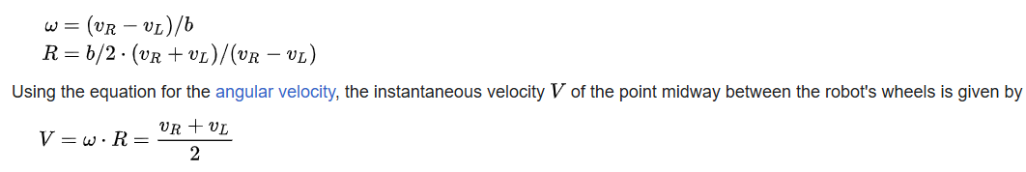
Where b is the base width
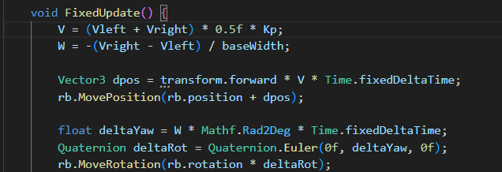

This simulation allowed us to test to test more advanced solutions, for example to make the body go to a specific target point it was just about finding the Vector pointing from our current position to the target and turning this vector into a parallel component and a perpendicular component to the body local axis through Vector decomposition, the parallel component would be facing with in the same car’s direction so it determines the velocity directly
While the perpendicular component is reached through changing the car’s angular velocity, the omega
Referencing to the equations in the wiki page we can find the values of Velocity of the right and left motor to satisfy the needed velocity and angular velocity
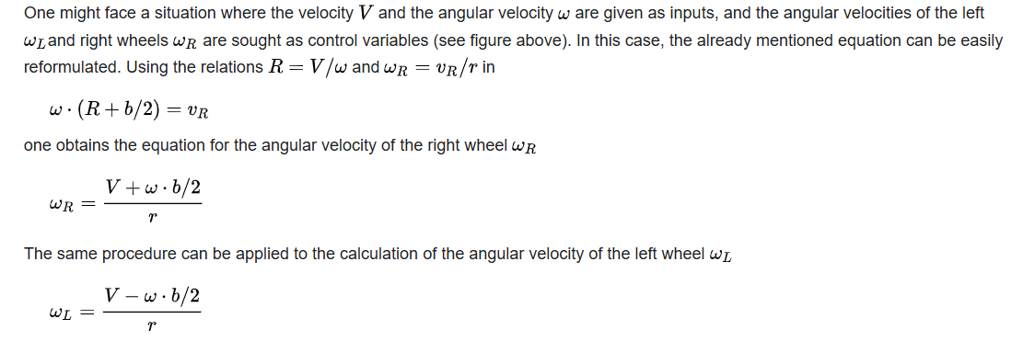
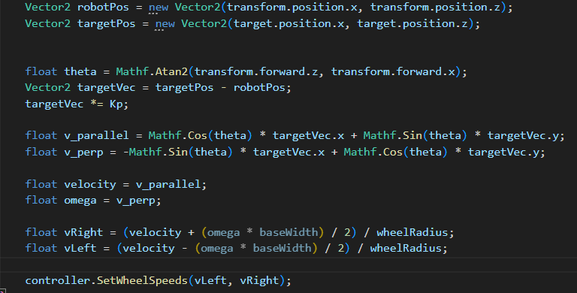

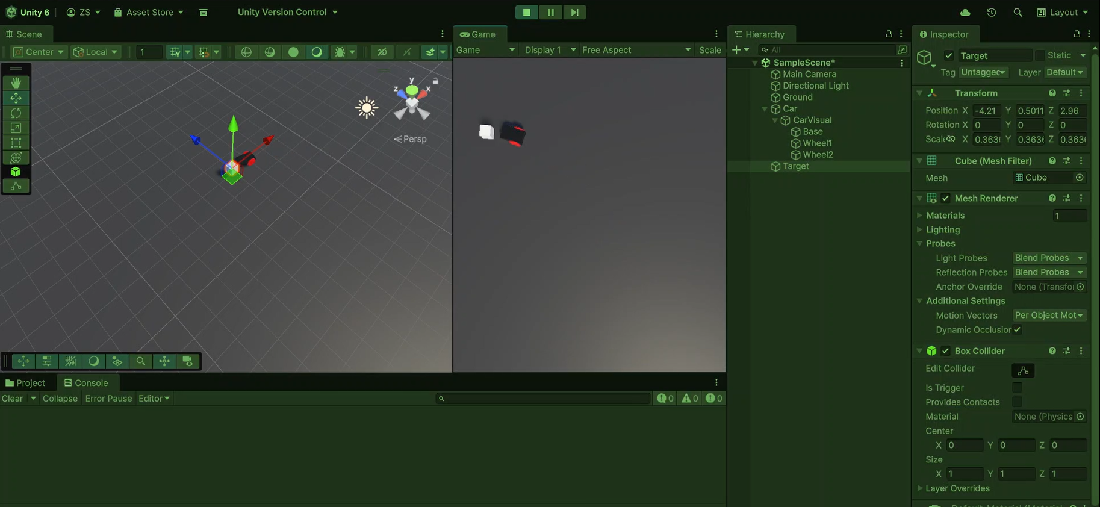
Our only issue implementing this algorithm in real world was due to how hard it was to get the actual car position, so as of now we sticked with a simple joystick controller in real life instead of a full autonomous system although such one is completely possible and was already tested in simulation

4.2 Hardware simulation
We used Multisim in order to understand the behavior of H-Bridge and how it controls the motors
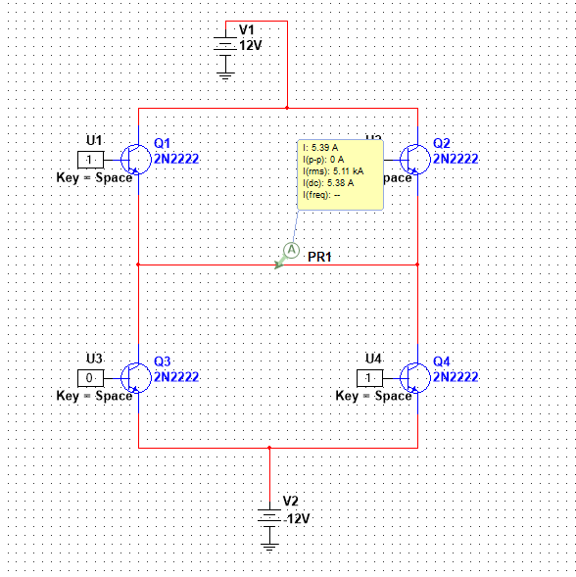
Hbridge is about 4 NPN transistors forming a n H shape, if the top left and bottom right were closed switches and the others were open the electricity will flow through motor from left to right
If the top right and bottom left where closed switches and the others were open the electricity would flow from right to left, basically causing the motor to spin in reversed direction
Putting digital high on bottom right and bottom left (or top right and top left, but not both) would cause voltage difference to be zero and thus stopping the motor immediately
Lowering how “closed” the electronic switch is will cause less voltage difference, less voltage difference will cause motors to spin slower which allows us to control speed
The ESP32 was connected directly to the HBridge 4 inputs to control there speeds, and was connected to the 5V pin to get its own power supply, an external 3.7v x 4 external battery was supplied to the motors through the HBridge (and powering up the ESP32 and the arduino) and all sharing a common connected ground

4.3 Real world implementation
Regarding real world on we decided to use a joystick to control the car movement for simplicity, a Joystick have both x and y axis constrained between -1 and 1 where the origin is at <0,0>, the joystick itself was simple CSS/HTML/Javascript design, it searches for the esp32 bluetooth through its characteristic UUID, once the connection is establishes we send the joystick data to the esp
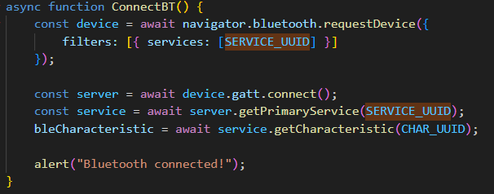
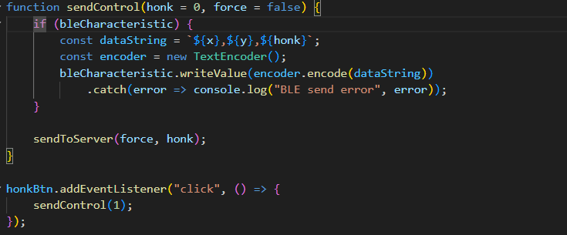

We set the ESP32 pin responsible for motor controls as PWM pin and mapped the joystick readings accordingly to match the speed, we calculate a vector representing the joystick position and calculating its magnitude to determine velocity, while for the difference of motors velocity we (1-x) * full velocity to reduce the motor speed on the side we want to turn in, if we want to turn left we reduce the left motor’s speed, if we want to turn right we reduce the speed of the right motor
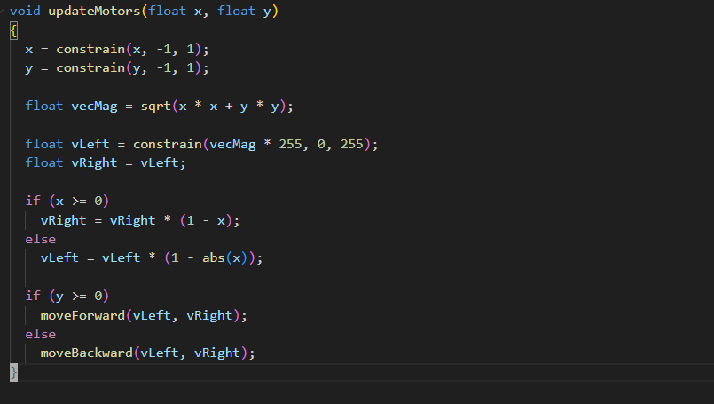

Finally we save the joystick readings into a local database, the javascript client calls our backend server written in Python FastAPI
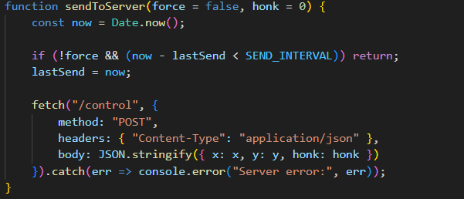

We can view the logs we have saved by fetching the fastAPI
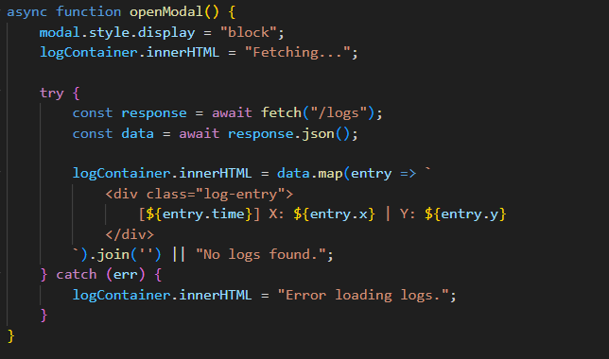
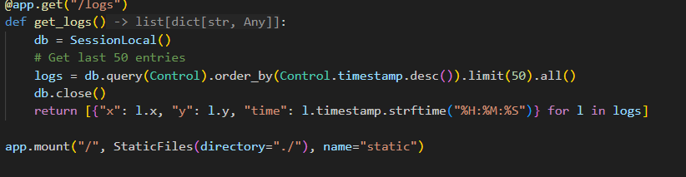

5.Circuit Diagram:
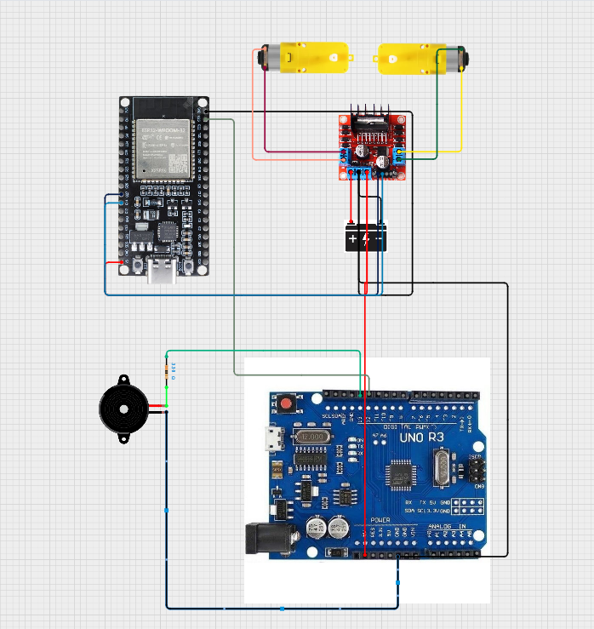

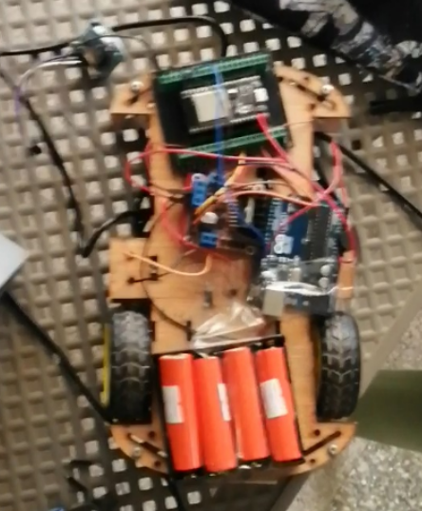

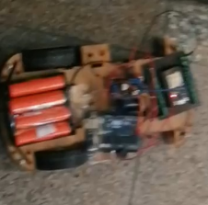

6. Procedure:
First assemble the car model, attach esp32, Arduino, hbridge and the system battery, attach motors and wheels at the back
Connect +ve battery pin to the hbridge +12v, and -ve to gnd
Connect esp32 5V to +5V in hbridge and ESP GND to H-Bridge GND
Connect the right motor to Output1, Output2 on the H-Bridge
Connect esp32 GPIO27 -> In1, GPIO 14 -> in2
Connect esp32 GPIO 12 -> In3, GPIO 13 -> in4
Connect Arduino Gnd to H-Bridge GND (all of Arduino, esp, and battery should have common GND)
Connect Arduino +5v to H-Bridge +5v
Connect external buzzer to a resistance 330 ohm in series to arduino’s pin 13
Connect arduinos pin 12 to Esp32 GPIO 23
Open the server script and run uvicorn server:app then open localhost:8000
Press the Connect button and select “ESP” (note if it wasn’t showing press the En button on esp32 to reset the Bluetooth connection)
Start moving the Joystick to control the car

7.GUI:
We used FastAPI to set up a server to receive the <x,y> coordinates and save them to a based database
Each table entry contains the timestamp, the <x,y> coordinates and a unique identifier
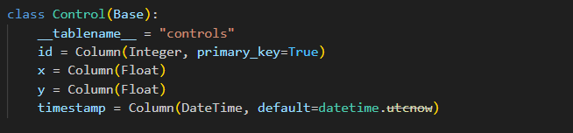
When the server receives a request from the client to save a “Control” instance we create a new entry and save it..
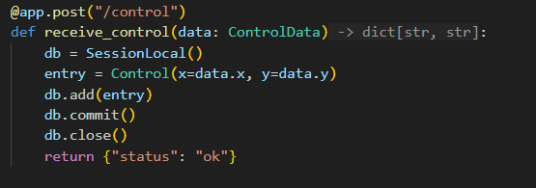

We handle an API for the client to request the log data

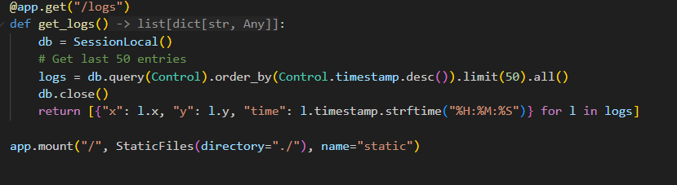

Note that all of the data sent and received are in JSON format which is standard for APIs

8.GUI:
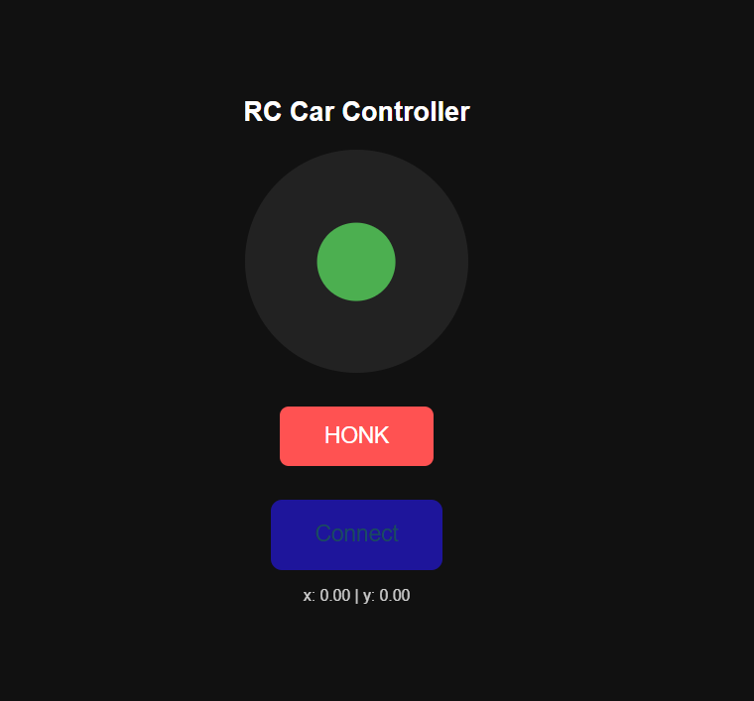
Virtual Joystick
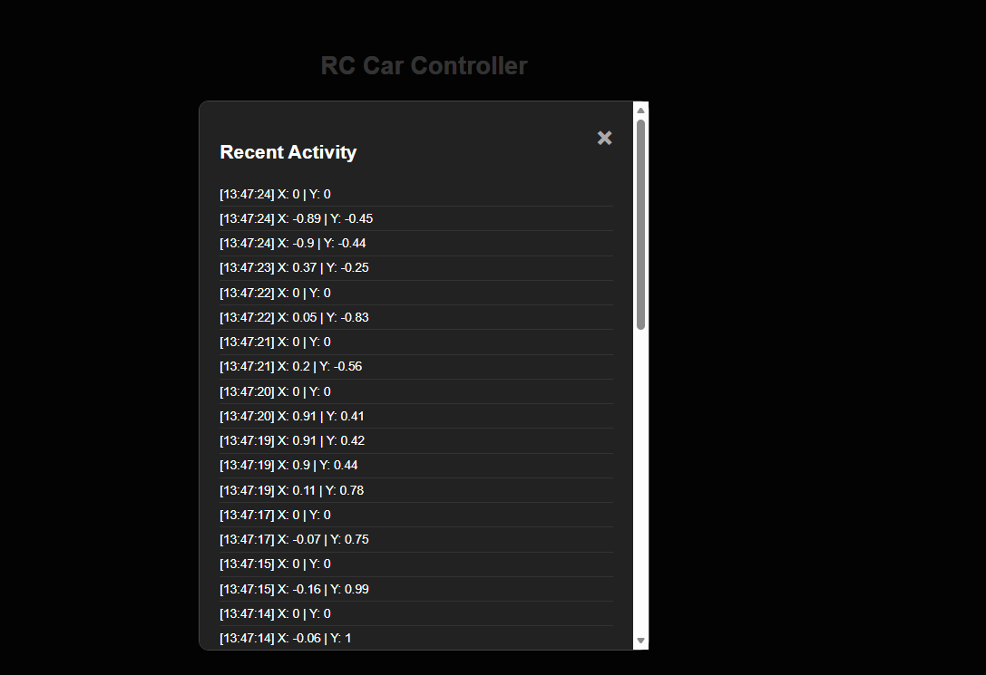
Previous logs for the car movements in terms of joystick control <x,y>

9.Resources:
Differential wheeled robot - Wikipedia

